screen shot:

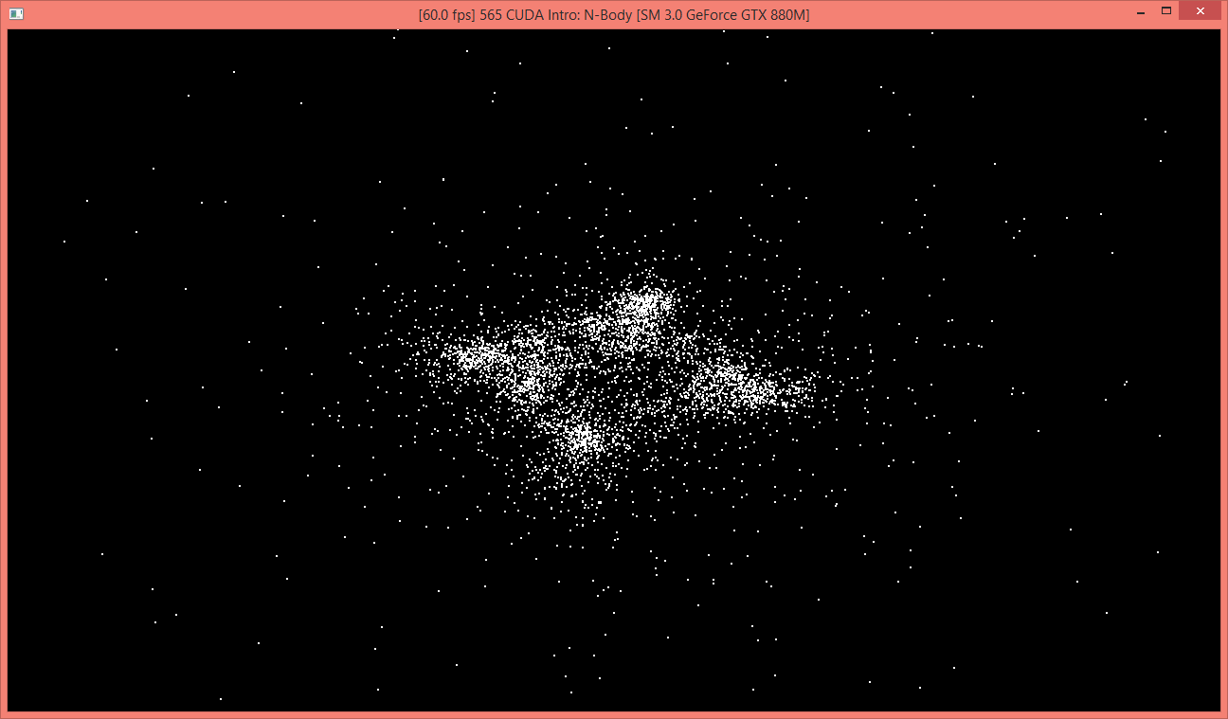enable visualizaiton:

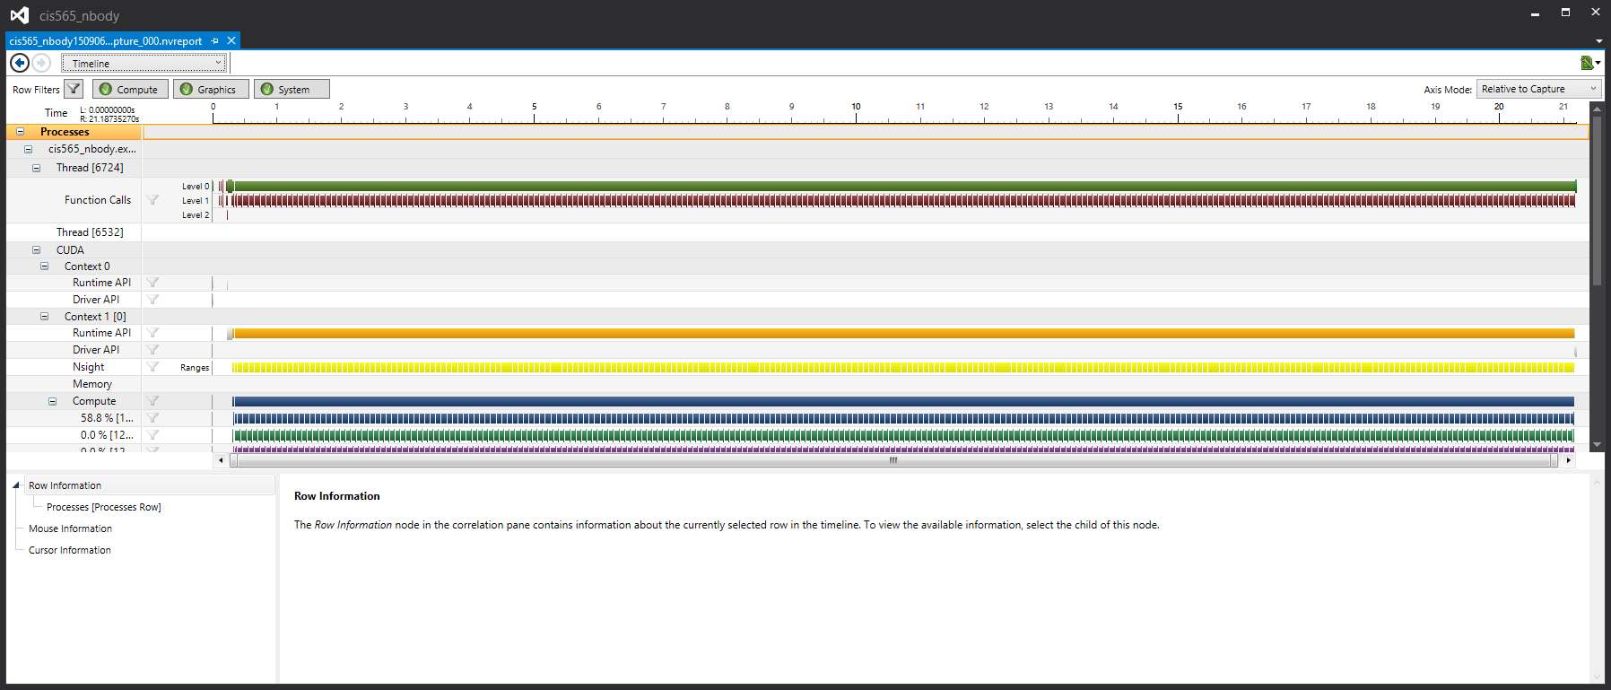

disable visualization:

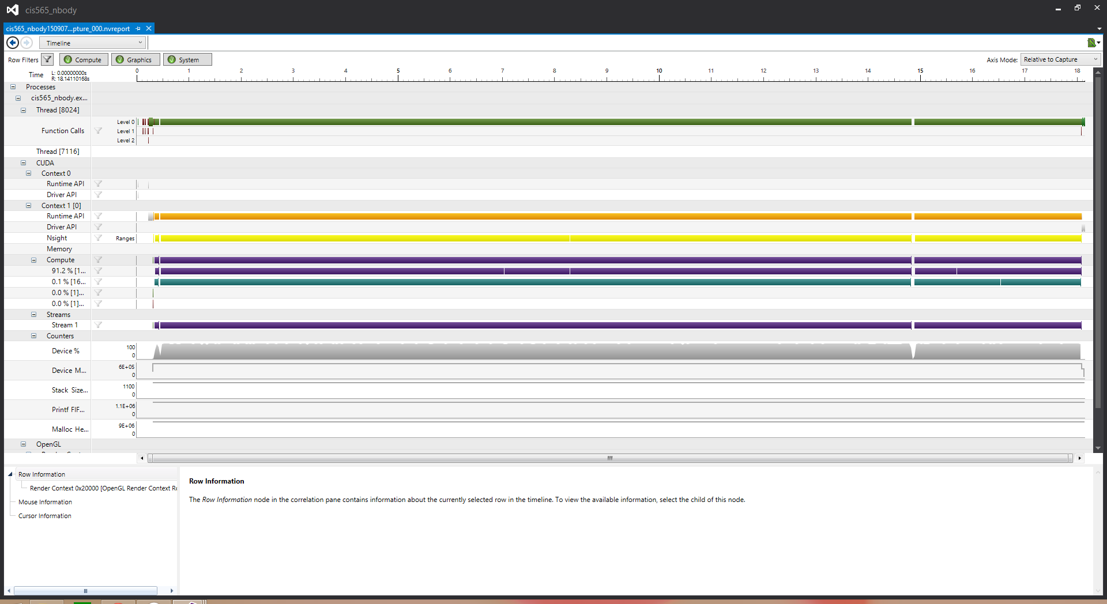

change blocksize to 256 (base 128)

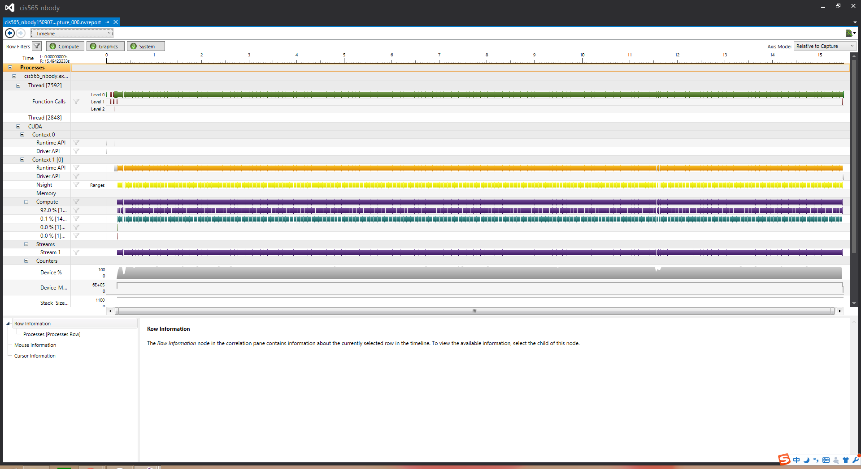

change blocksize to 64 (base 128)

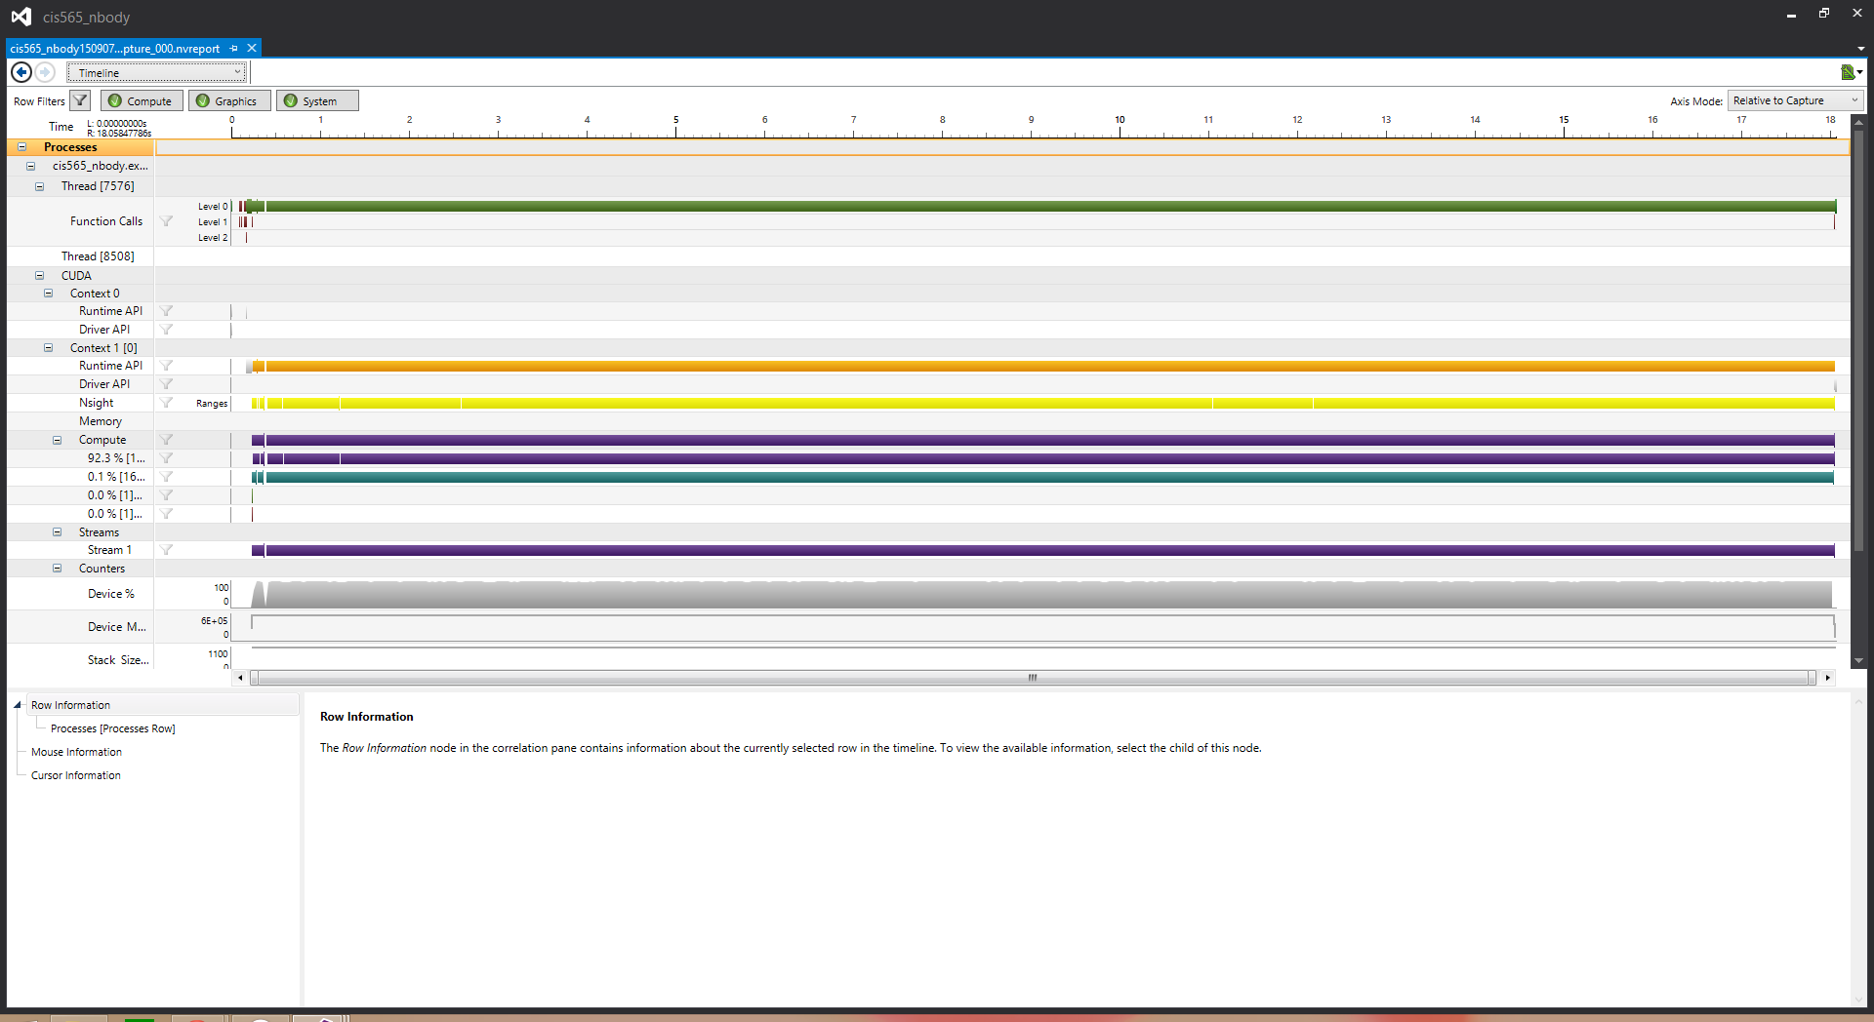

change num of planets to 2000 (base 5000)

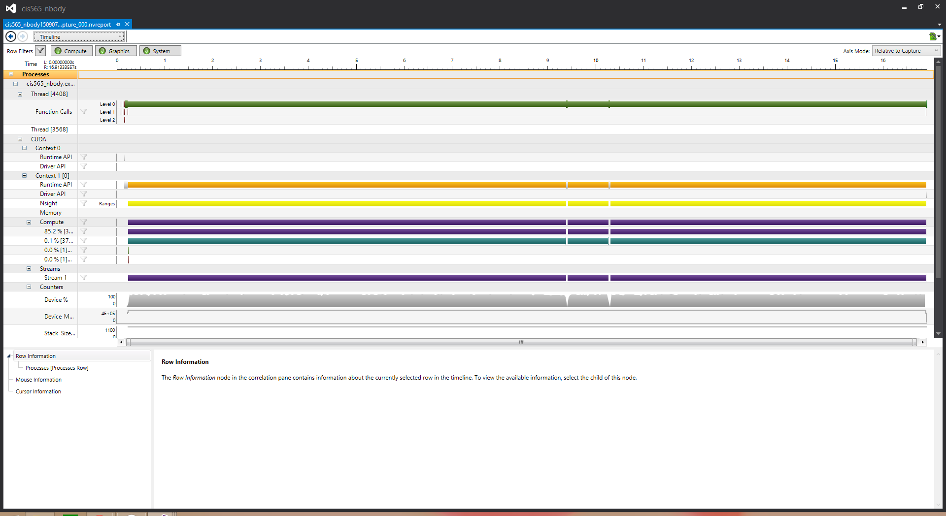

change num of planets to 10000 (base 5000)

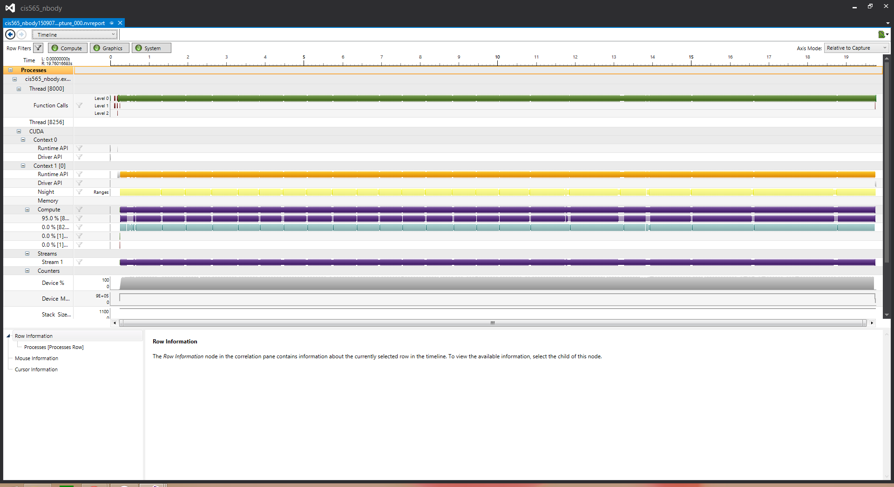

Q&A

1. Increase the tile and block sizes will increase the performance to a certain amount but will stay the same after a certain threshold. When the computation unit is not enough for the task, increasing the number will increase the performace, but when computation units are more than enough, increasing the number will not affect the performance.
2. the more the planets, the worse the performance. Because when adding more planets into the scene, we need more computation.
3. If the number of the parallel computation number is small, I think CPU will win in the comparison; while if the parallel computation number is large, I think GPU will win the comparison. The tradeoff lies between the computation and the context switch. When number of computation is small, the bottleneck will be the context switch. If the number of computation is large, the bottleneck will be the computation itself.