**Rendering in Marmoset Toolbag: A Game Engine for Artists**

Jeff Russell, Marmoset

Guest Lecture in Computer Graphics

Monday, April 28th, 6-7:30pm

SIG Lab Conference Room

Marmoset Toolbag is a real-time rendering application for preview, editing, and presentation of 3D artwork. This talk will discuss the rendering techniques employed in Toolbag, the practical considerations of their implementation, and a comparison of Toolbag to modern game engines. Techniques covered will include importance sampling for image-based lighting, screen-space ray tracing, area light sources and shadows, a shader permutation system, temporal supersampling, cross-platform development, and more.

  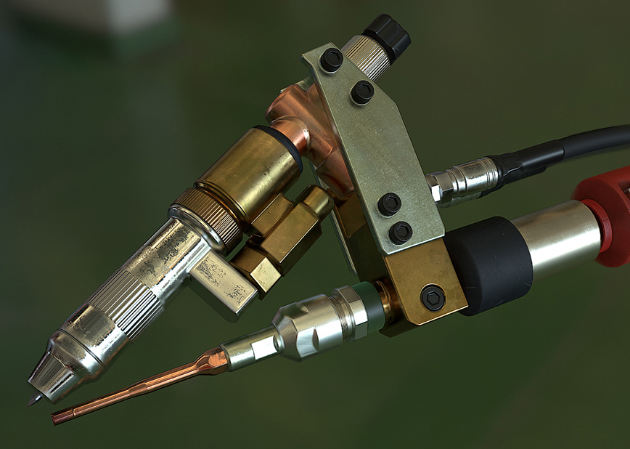

## Jeff Russell

Jeff Russell is a founder and engineer at Marmoset, focusing on real-time rendering systems for games and art. He has worked in game development since 2005, mostly as an independent, creating commercial rendering systems and engines on a variety of platforms.

Penn contact:

Patrick Cozzi

CIS 700

pcozzi@seas.upenn.edu