Metaball Musical Fountain

Introduction

* The metaballs homework assignment was an assignment where I had the opportunity to read about an interesting algorithm that could be extended in many ways to produce various creative results. This inherently is what motivated me to take up this project.

Goal

* With this project, I intend to re-create a static scene based on the picture below but with metaballs as the waterfall as well as some ambient music and smart texturing to bring the scene to life.

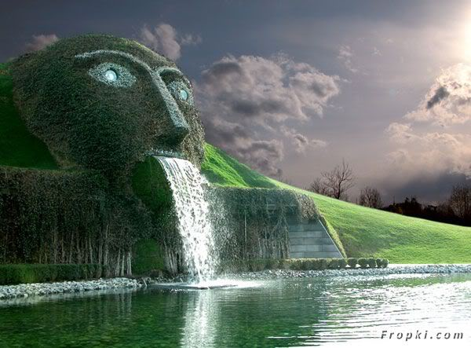

Inspiration/Reference

* <http://www.ro.me/tech/metaball-playground>
* <http://jamie-wong.com/2016/07/06/metaballs-and-webgl/>
* <https://threejs.org/examples/webgl_marchingcubes.html>

Specification

* Metaballs
  + Metaballs will originate from a specified location
  + The metaballs will move in specified directions that will emulate a waterfall like movement

Techniques

* Metaballs:
  + I’ll be referencing some of the resources we used for the initial metaballs assignment again to further understand the theory behind how metaballs are formed.
    - <http://paulbourke.net/geometry/polygonise/>
    - <https://developer.nvidia.com/gpugems/GPUGems3/gpugems3_ch01.html>
    - <http://jamie-wong.com/2014/08/19/metaballs-and-marching-squares/>
* Noise generated Terrain:
  + I will use perlin noise to generate a terrain.
* Music:
  + I will be incorporate ambient music in the background using a javascript sound library.

Design

[marching_cube_LUT.js]

* Marching Cube look up tables

[metaball.js]

* Implementation of metaball features

[noise.js]

* Implementation of perlin noise terrain

[main.js]

* Incorporate scene set up

[framework.js]

* Implement javascript framework

Timeline

[marching_cubes.js]

* Implementation and set up of metaballs simulation
* Milestone 1: Set up metaballs to sprout from a specified location and animate in such a way that emulates a waterfall.
* Milestone 2: Incorporate more compositional components into the scene such as other objects. Position the camera layout and create a more realistic looking waterfall by sprouting more and more metaballs.
* Till final submission: Polish the simulation with shaders and other effects