**Final Report**

**A) Student Information:**

* **(1A)** Name: Andy Henry
  + ID: 23022607
  + Address: 127-05 115th Ave
  + Cell: 929-326-5293
* **(1B)** Name: Hammad Maqsood
  + ID:
  + Address:
  + cell
* **(1C)** CISC 4900: Spring 2020

**Supervisor Contact Info:**

* **(1A)** Name: Colven Benjamin
  + Email: cbprofbenjamin9@gmail.com
  + Phone: 917-407-6818

**B) Individual Task:**

* Andy Henry - Frontend, Database, Documentation
* Hammad Maqsood- Backend, Deployment, Version-control

**C) Supervisor Relationship:** CISC 3810 Professor (Fall 2019)

**D) Project Description**

* **Introduction:** Our focus on this project was to create a fully developed pharmaceutical management system using front-end, back-end, and database technologies. The task of our website is assisting Pharmacist and associate to make daily duties a lot more efficient. From patient lookup, inventory management, transaction management, as well as system management.
* **General Problem:** Neither one of us had web development experience or have done fully functional pages in the past. Nor were we comfortable with version-control and remote multitasking.
* **Solution:** Initially we spent weeks to a month simply studying web development, and efficient workflows to benefit us both. From doing research on frontend frameworks, backend frameworks, and the advantages and disadvantages to database. We decide to keep the project relatively simple because of the abundance of resources on YouTube and other sites, so using HTML, CSS, JS, and PHP as opposed to using JavaScript frameworks like React.js, and Node.js or even python frameworks like Django.
* **Scope of Work Performed:** 
  + Created Sample Database for practice purposes(Hammad)
  + Began Web development research- (Andy, Hammad)
  + Created mock front end pages for prototyping and testing –(Andy)
  + Installing Xampp, and larval and php dependency to practice PHP-(Hammad)
  + Continued php, Laravel, GIT research –(Hammad)
  + Continued Front-end ,MySQL, GIT research –(Andy)
  + Changing Database from Oracle SQL to MySQL for better project hosting –(Andy)
  + Creating GitHub Repository for better version control and multitasking-(Hammad)
  + Switching workflow to Visual Studio code, and Phpstorm from JetBrains for better file structure. – (Andy, Hammad)
  + Optimizing repository with Master branch, and our individual branches –(Andy, Hammad)
  + Began process of developing final front-end pages and DB – (Andy)
  + Began process of developing final backend functionality(Hammad)
  + Continuously pushing and pulling to and from GitHub Repository-(Hammad,Andy)
  + Final touches to the project and finishing development.

**F) Program Documentation:**

**Frontend:**

* **File Structure**

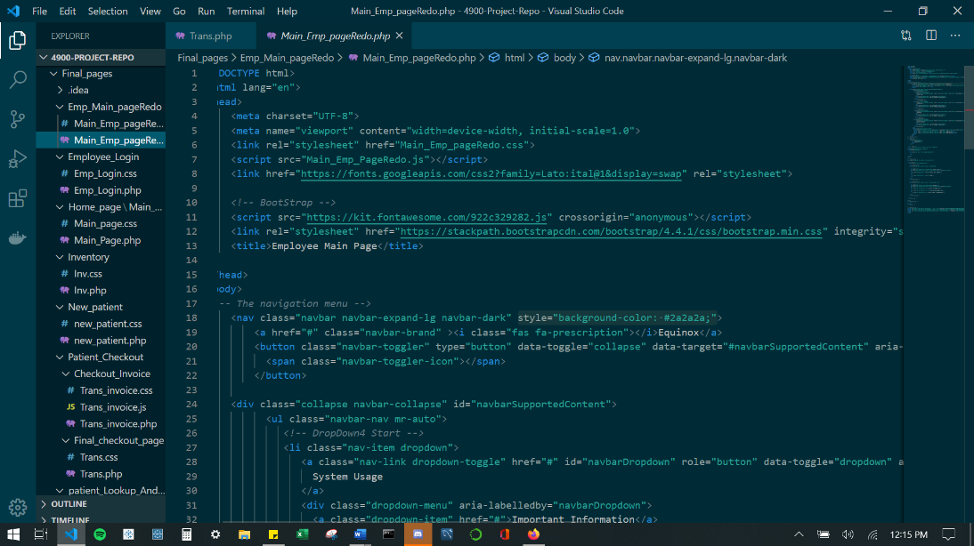

**Database:**

* **Tables:**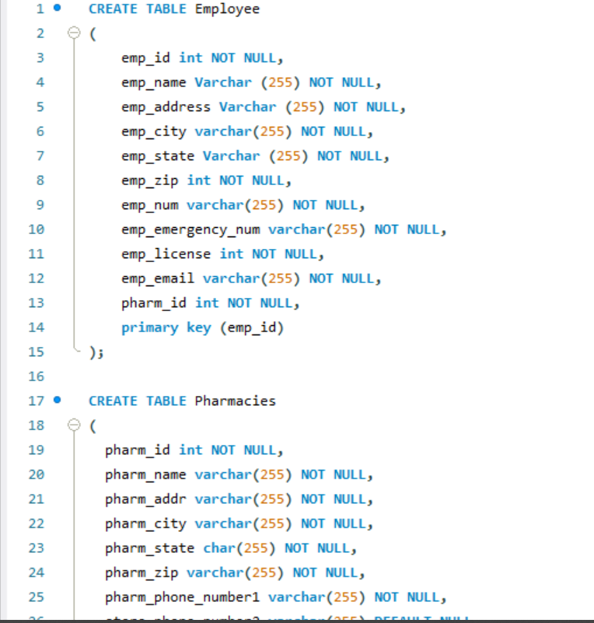
  + **Scheme:**

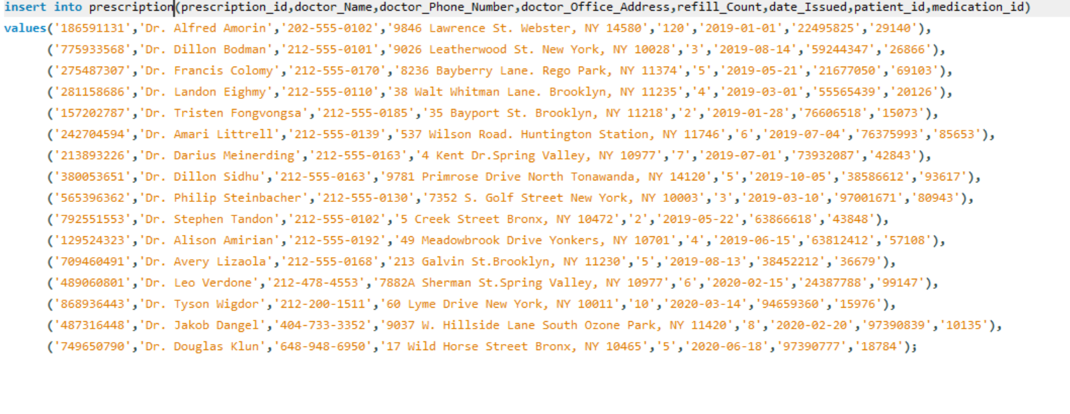

* + **Views**

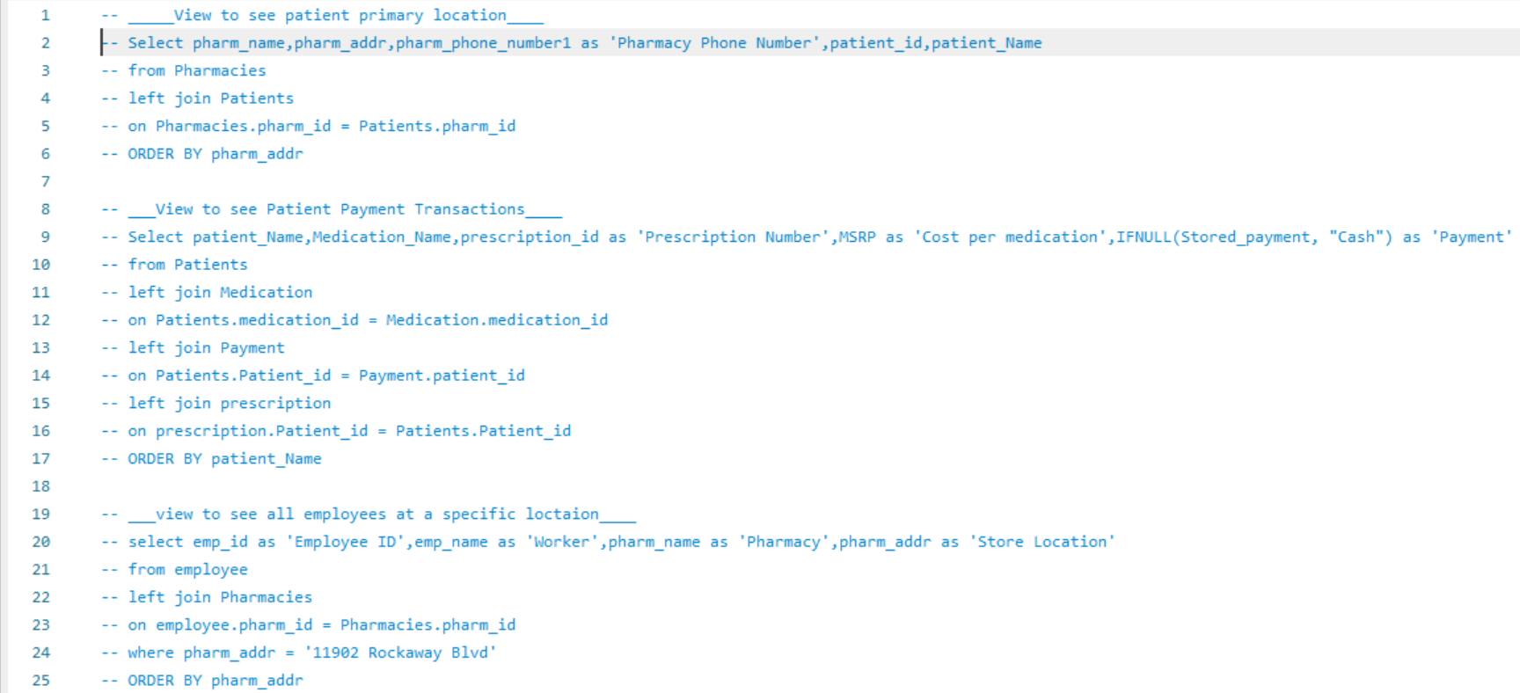

**Backend:**

**Resources:**

* + HTML 5, CSS, JS, Bootstrap 4, PHP, MySQL, VS code, GitHub, Phpstorm
  + [**https://www.udemy.com/course/the-web-developer-bootcamp/**](https://www.udemy.com/course/the-web-developer-bootcamp/)
  + [**https://www.udemy.com/course/the-ultimate-mysql-bootcamp-go-from-sql-beginner-to-expert/**](https://www.udemy.com/course/the-ultimate-mysql-bootcamp-go-from-sql-beginner-to-expert/)
  + Git/GitHub **-** [**https://www.youtube.com/watch?v=SWYqp7iY_Tc**](https://www.youtube.com/watch?v=SWYqp7iY_Tc)
  + Xampp **-** [**https://www.youtube.com/watch?v=xdvVKywGlc0&t=575s**](https://www.youtube.com/watch?v=xdvVKywGlc0&t=575s)
  + Frontend References **-** [**https://www.w3schools.com/**](https://www.w3schools.com/)
  + Git References **-** [**https://www.thegeekstuff.com/2017/06/git-branch/**](https://www.thegeekstuff.com/2017/06/git-branch/)
  + Php dependency- https://getcomposer.org/

**H) Evaluation:** Learning web development from scratch was rather difficult. We spent a lot of our time simply doing research and familiarizing ourselves with syntax, functions, and terminology. After finishing the project we both feel a lot more comfortable with web development and find it relatively interesting. We plan to keep learning and enhancing our skills to move forward in the field.