LOUIS HOFF_26654156, DIDINTLE MASIBI_26719517, NTSAKO CHAUKE_26170744

Gitdegree

INTRODUCTION TO COMPILER CONSTRUCTION_marie simulator

**AIM**

The aim of this lab was to write a program in assembly using the MARIE Simulator to find the sum of a given equation and observe the output.

**INTRODUCTION**

MARIE, **M**achine **A**rchitecture that is **R**eally **I**ntuitive and **E**asy in full is a machine architecture and assembly language that has a web-based version to allow students to access and utilize MARIE Stimulator with ease for learning purposes.

In this particular lab a program was written in assembly language using MARIE Simulator to find the sum of variables X, Y and Z. These variables were assigned the values 25, 44 and 22 respectively, the CPU data path was observed.

**PROCEDURE**

* First of all we started by setting the ORG of our program to be 000.
* Secondly we loaded variable X (LOAD X) into the program.
* Thirdly we added variable Y (ADD Y) to variable X
* We then subtracted variable Z (SUBT Z) from the sum made previously.
* We went on to store the output of X + Y - Z on variable W (STORE W)
* After that we initialised values to our variables with decimals (DEC) as shown in the figure 1.

**RESULTS**

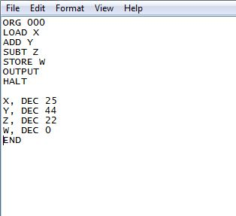

**Fig 1. MARIE Simulator program**

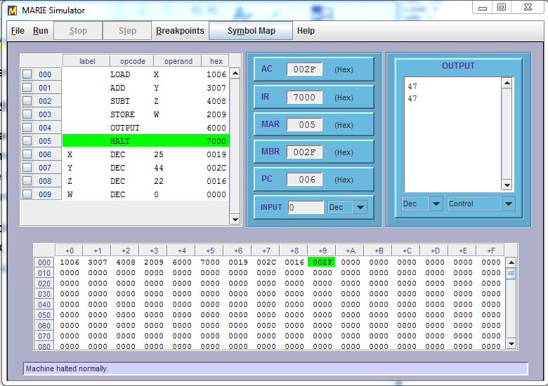

**Fig 2. MARIE Simulator**

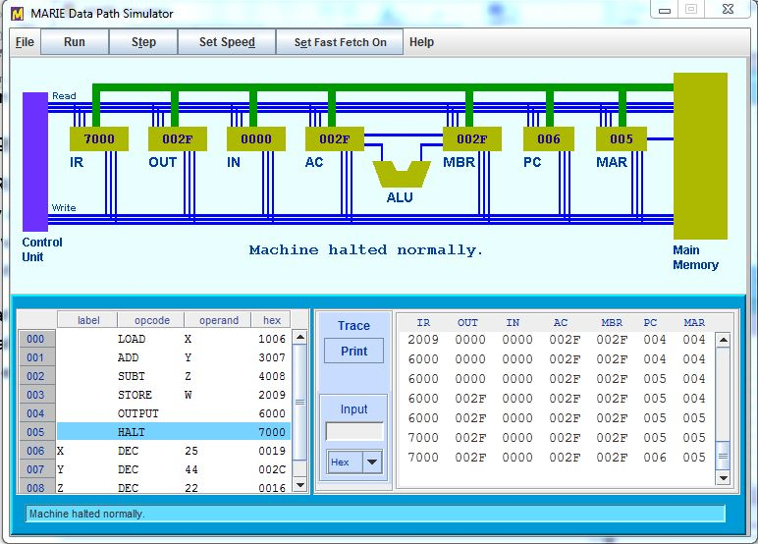

**Fig 3. MARIE Simulator DATAPATH_1**

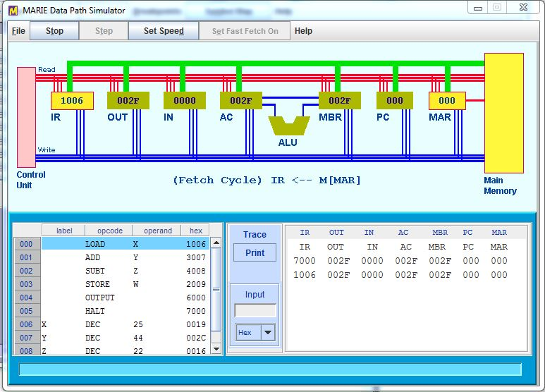

**Fig 4. MARIE Simulator DATAPATH_2**

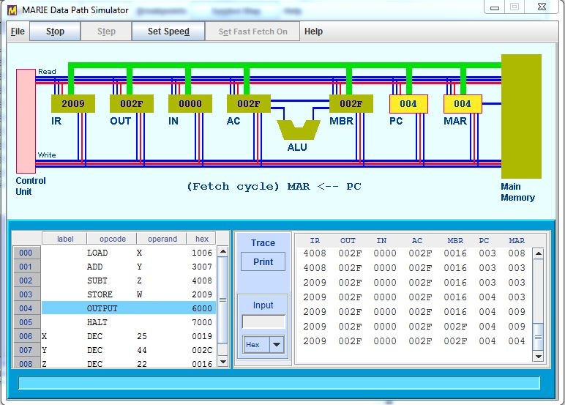

**Fig 5. MARIE Simulator DATAPATH_3**

**CONCLUSION**

In this lab practical wrote a program in assembly using the MARIE Simulator to find the sum of a given equation and observe the output.

The outputs are shown in the images above. The output of the program was displaying expected results in decimal (DEC) form. The program was expected to evaluate the expression W = X + Y – Z.