**Title: Introduction to compiler**

**Aim**

To perform arithmetic operations using Marie simulator.

**Introduction**

In this practical we looked on performing different arithmetic operations, loading variables on the memory of the simulator then run and display the output. We will be using the Marie simulator and assembler code editor to run our code.

**Method**

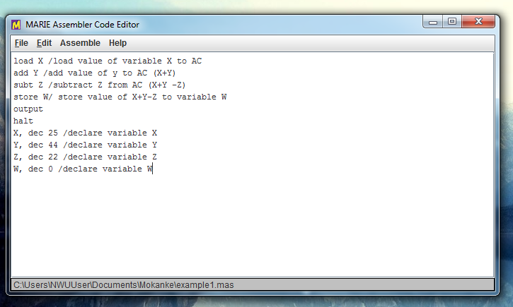

We use assemble code editor to write and edit code.

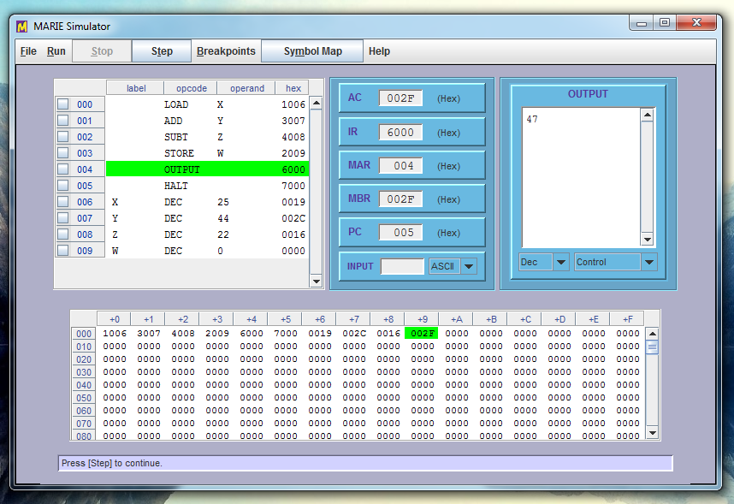

Simulator runs the existing code and gives the output, by default the output is in ASCII form but can be changed to decimal form.

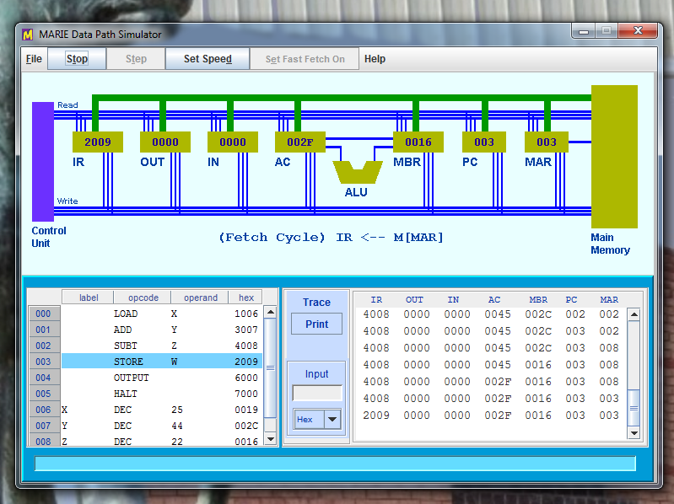

The purpose of data path visualizes an understanding of how instructions and micro-instructions relate to signal of sequence.