Group name: The-Boss

Topic: Introduction to compiler (assembler language).

Aim: To convert assembly language (using mnemonics) into machine language (which consists entirely of binary values, or strings of 0s and 1s). Assemblers take a programmer’s assembly language program, which is really a symbolic representation of the binary numbers, and convert it into binary instructions, or the machine code equivalent.

Introduction: A Complier: A compiler translates something from one language into another, for example, a Java program into machine code.

The MARIE is a very simple assembly language that is used in class rooms. It comes with a graphical simulator/debugger and a graphical Data Path simulator.

MARIE’s Architecture: The machine running MARIE has AC: The accumulator (AC) is special memory cell that numbers are loaded into and out of and adding takes place. PC: The program counter (PC) is a special memory cell that contains an address/index to the memory cell containing the current instruction being executed. After an instruction is executed, this index is incremented so that it indexes the next instruction. A jump involves changing the PC to the index of a different instruction. Results: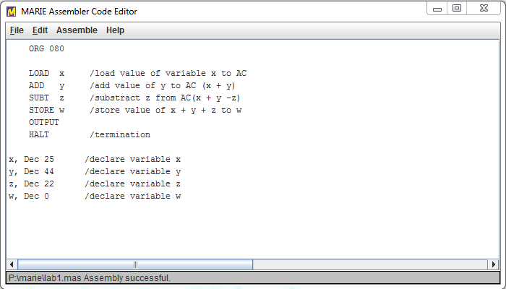Figure 1: The Assembler editor containing the commands showing step by step how the program will run.

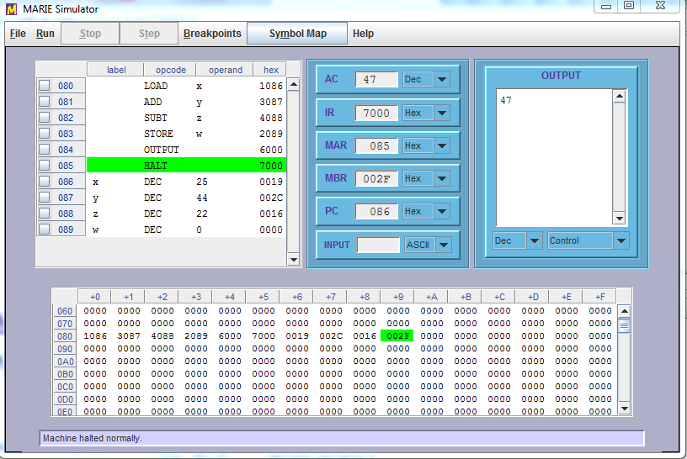

Figure 2: The program : w = x + y – z is loaded on the simulator from Marie assembler code editor and it is suppose to show the output of the declare decimal variables of the code written on the editor.

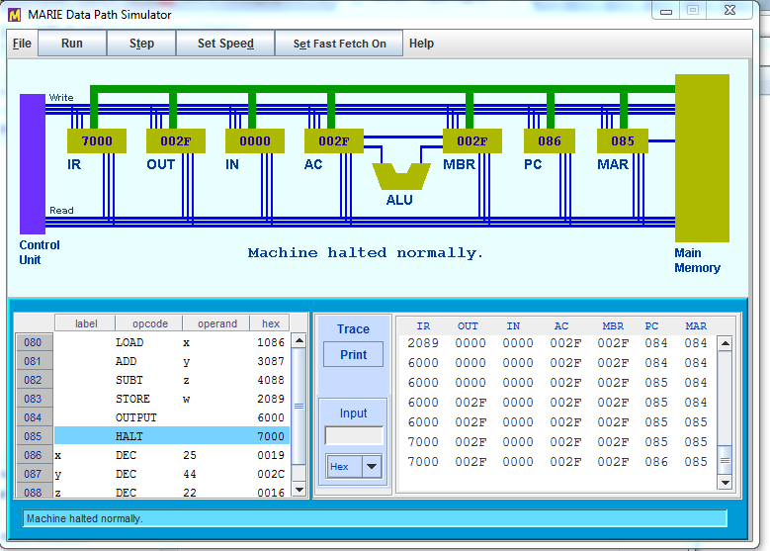

Figure 3: A data path simulator showing visuals of how instructions relate to sequence of signals.

Conclusion: The code that was uploaded on the MARIE simulator halted successfully which showed the output stored on the AC. The same code was loaded on the data path simulator which halted normally.