**CISM 314: INTRODUCTION TO COMPILER DESIGN**

**LAB 4 REPORT: PARSING AND TRANSLATING BINARY EXPRESSIONS**

**KTD GROUP**: Kamogelo Moatshe: 25676164

: Tsepo Ndlovu: 25969269

: Desire Nyathi : 27041999

**Objectives:**

The objective of this practical is extend the cradle.pas code that we have been working with during lab sessions with procedures that will enable the compiler that we are writing to pass and translate general expressions that involve addition and subtraction.

**TOOLS:**

TPascal4, Sublime Text Build 3143 x64 Setup, DOSBox0.74-win32 and cmder

**Method**:

For this Lab 4 practical, we used sublime text as our text editor, and we used Tpascal 4 as the language we use to write or design our compiler. And lastly we used DOSBox to load and run our compiler designer code.

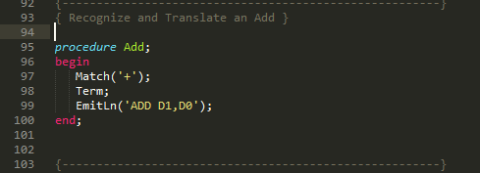

Figure 1: Add procedure

Figure 1 shows the first procedure we added to cradle.pas code that we have been working with during lab sessions .This procedure will make the compiler that we are writing to recognize and parse arithmetic addition expression.

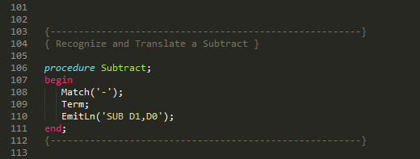

Figure 2 : Subtraction procedure

Figure 2 shows the second procedure we added on the cradle.pas which the subtraction of arithmetic expression procedure. This procedure will make the compiler that we are writing to recognize and parse arithmetic expressions that require subtraction functionality when being compiled.

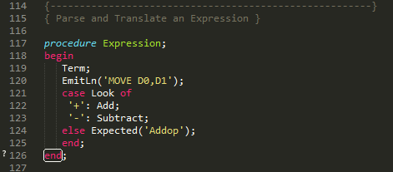

Figure 3: Parse and translating an expression procedure

Figure 3 shows the third procedure that we added to the cradle.pas code.This procedure handles any number of terms.

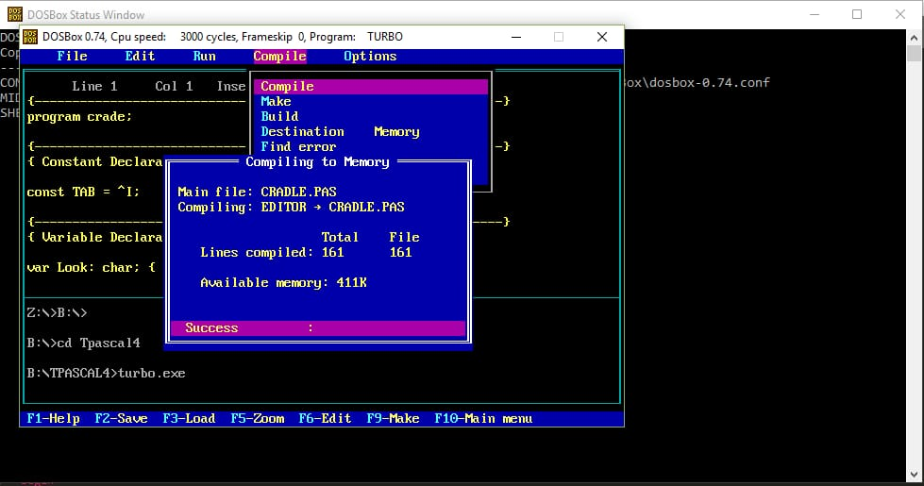

Figure 4 : Code in DOSBox

Figure 4 shows the cradle.pas code in DOSBox.After adding the three procuders we loaded the cradle.pas into the DOS.Box and the compiled it.

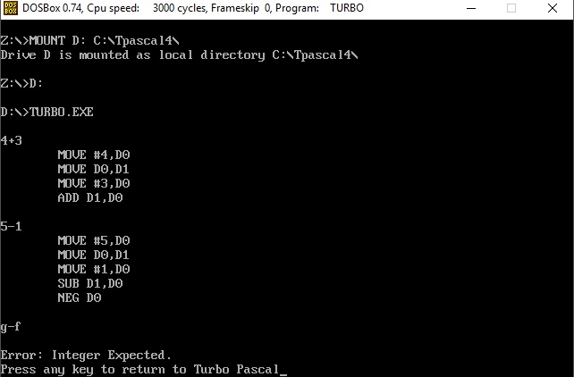

**Analyzing the output:**

The MOVE signifies a task where the primary number is moved into the enlist D0, D0 is then moved into D1 leaving D0 exhaust, the second number is then put into the vacant enlist D0. The ADD task is then used to include D0 and D1. Subtraction additionally adopts a comparative strategy in any case, the subtraction procedure subtracts D1 (which has the main contention: 5) from D0. NEG DO is to make sure that we don’t get an incorrect or wrong answer.