

**GROUP MEMBERS**

1. **MATLAPENG NP 27441393**
2. **KOK KD 26797445**
3. **MPOFU**

Introduction

This report is written to show our working application program which to passes and translates general expressions that involve addition and subtraction. The screenshots below will be showing the outputs of the working program.

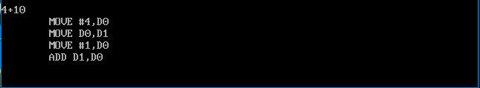

Figure 1. Addition

Figure 1. Above show the output of the application when you add two numbers together.

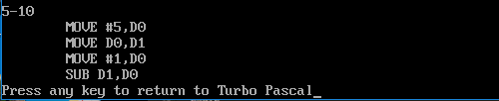

Figure 2. Subtraction

Figure 2 above shows the output of the application when you subtract two numbers.