**Group: Tera-Bytes**

**Topic: Compiler Implementation**.

**Aim:** To implement a compiler that parses mathematical expressions (in particular addition and subtraction.

**Introduction:**

A compiler is a program that translates a high level programming language into machine code. To implement this program a “cradle” (a file written in PASCAL) is used. Cradle contains functions and procedures that handle I/O and error-handling routines, as-well as binary expressions that enable the program to parse and translate mathematical expressions (in particular addition and subtraction) involving two numbers.

**Body:**

Requirements:

1. DOS-BOX ( disk operating system)

2. Tpascal4

3. Text-editor (Sublime text)

Steps:

1. DOS-BOX and the text editor where downloaded and installed .

2. Tpascal4 was downloaded and the file was extracted to the C drive.

3. The cradle file was copied into the Tpascal4 folder.

4. DOS-BOX was opened and the commands (below) were executed.

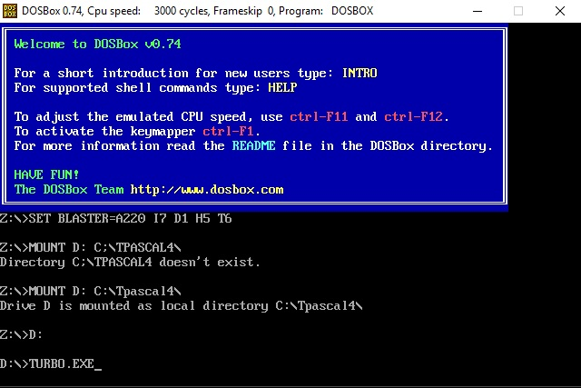

Figure 1: Mounting of new drive

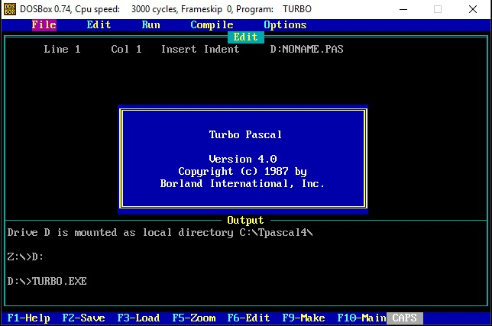

Figure 2: Turbo pascal running

5. “cradle.pas” was loaded.

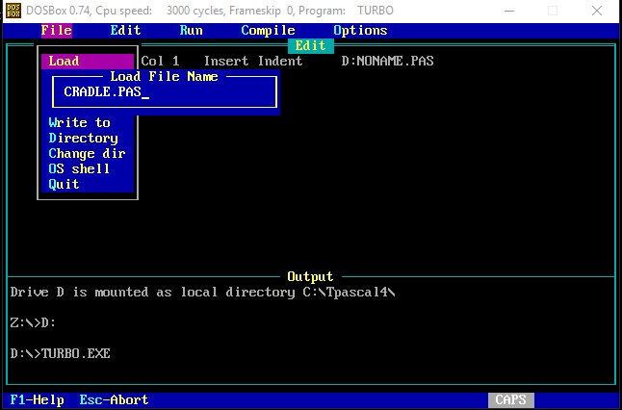

Figure 3: Loading cradle program

6. Cradle was compiled and run.

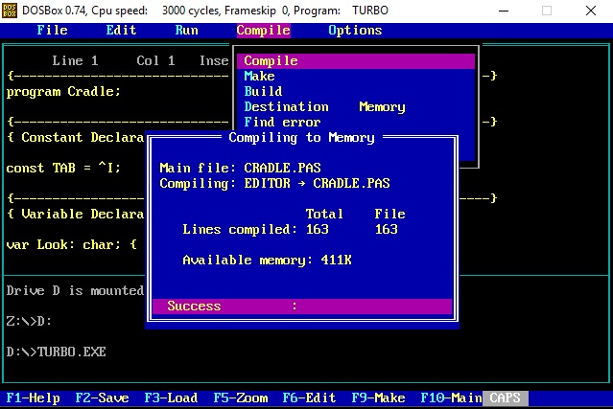

Figure 4: Cradle program loaded

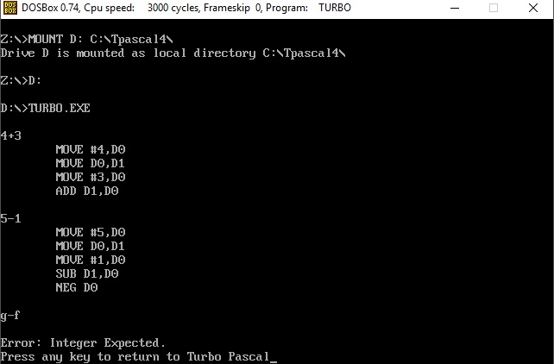

Figure 5: Input and Output

**Analysis of output:**

The output is a set of assembler language statements that define the set of operations to be performed on the numbers being added or subtracted. The MOVE denotes an operation where the first number is moved into the register D0, D0 is then moved into D1 leaving D0 empty, the second number is then placed into the empty register D0. The ADD operation is then used to add D0 and D1. Subtraction also takes a similar approach however, the subtraction process subtracts D1 (which has the first argument: 5) from D0 (which has the second argument: 1) which is not correct, and thus NEG D0 is used to ensure that we do not encounter an incorrect result, it “negates” the second term.

**Conclusion:**

Using primitive technologies (DOS-BOX and Tpascal4) its possible to implement a compiler that parses mathematical expressions. However the primitive interface that the disk operating system offers is limiting (accepts only input from a keyboard) and fails to recognize other input devices.