9/23/02 Adam Seeger

Manual for the Seegerizer (Electron Beam Lithography Program)
Image of the main control panel for the Seegerizer
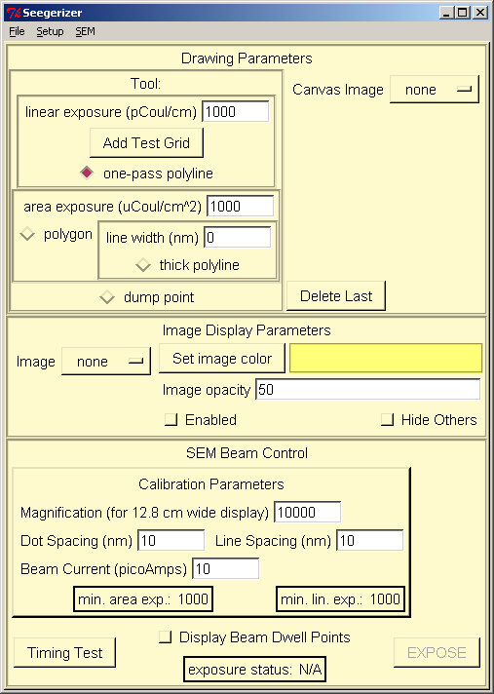:

This document describes the intended procedure for using the Seegerizer to control an SEM for doing electron beam lithography. The typical order of operations when using the Seegerizer is given as follows:

- Load a planning image acquired earlier showing details where you need to see them for laying out the pattern.
- Draw a pattern relative to the planning image
- Set exposure parameters and enter related SEM information
- Acquire an alignment image
- Align the planning image with the alignment image
- Run timing test for the pattern
- Expose the pattern

In the rest of this document I will describe in more detail what is involved in each of these steps.

Planning images
Because it is difficult to see many details of a surface in an SEM image when the sample is covered with PMMA, it is helpful to acquire planning images of the sample using either an AFM or SEM before coating it with PMMA. These images can be loaded into the Seegerizer through the File→ Open Image File menu item. After an image is loaded, it can be viewed in the pattern editor window by selecting it in the Image Display Parameters section of the main control panel and clicking on the Enabled checkbox.

Displaying images in the pattern editor window
The pattern editor window displays a specific region in the world. This region may be reduced (to magnify the view) or expanded (to demagnify the view) by typing ‘z’ or ‘Z’ respectively when the pattern editor window is in focus (i.e. when it is the top window). These zoom controls can be used even while in the middle of drawing a shape to help with placing a point more precisely. The appearance of all images displayed in the pattern editor window can be controlled through the Image Display Parameters section of the main control panel. Here is a summary of the functions in the control panel that affect the image appearance:
Image selector: selects the image to which controls refer
Enabled checkbox: determines whether or not the selected image is displayed
Hide Others checkbox: determines whether all images besides the selected image will be displayed
Set Image Color: allows a tint color to be set for the selected image
Image opacity: specifies the opacity of the currently selected image

Selecting a canvas image
Before you draw a pattern, it is important to select a canvas image to which you will link the pattern. As a drawing is constructed, the program stores the points in the pattern relative to the canvas image. If the canvas image is translated or rotated during the alignment stage, the pattern will be translated and rotated in the same way. In the Canvas Image selector, make sure you have the planning image selected.

Drawing the pattern
Now you should have a planning image displayed in the pattern editor window and selected as the canvas image. The next step is to draw an exposure pattern on top of the image. There are two basic categories of shapes: linear exposure shapes and area dose shapes. Linear dose shapes have a dose that is in units of pCoul/cm and area dose shapes have dose that is in terms of uCoul/cm2. Examples of area and linear dose shapes are shown in the following figure:
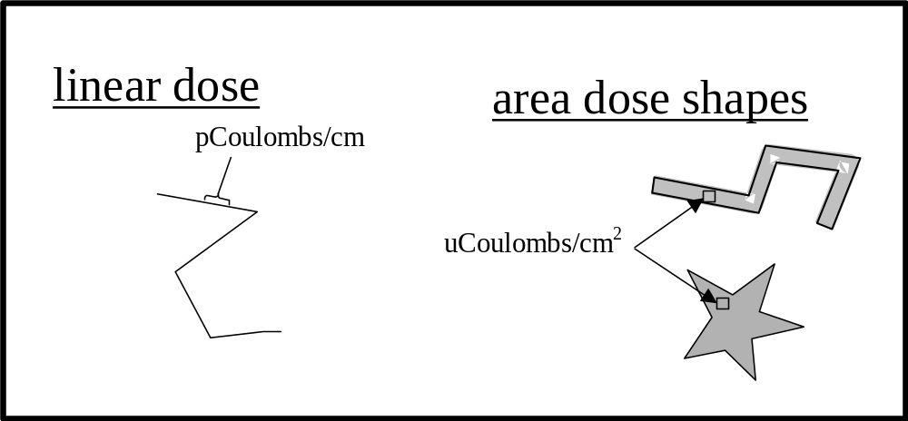
The reason for allowing dose to be specified in two different ways is that the conversion between these two definitions of dose may depend on unknown parameters such as the beam width so the proper dose must be determined by separate experiments for the two classes of shapes. The different types of shapes that one may draw are one-pass polyline (linear dose), polygon (area dose) and thick polyline (area dose).
The type of shape to draw is specified by selecting the corresponding radio button. After selecting a shape type, you should select the dose (in either the area exposure entry or linear exposure entry) and if the shape is a thick polyline enter the desired line width. To create the shape, click with the left mouse button in the pattern editor window to place a vertex. Continue clicking with the left mouse button to add as many vertices as you would like (note: you can hold the left mouse button down and drag to interactively place each new vertex). When you are done with the shape, click with the right mouse button anywhere in the pattern editor window to signal to the program that you are done. If you make a mistake and would like to delete the last drawn shape, press the “Delete Last” button to undo the last shape. Here is a brief description of the other controls in the Drawing Parameters section of the main control panel:
dump point radio button: this selects the dump point tool. The beam will dwell for 0.001 seconds at each vertex placed using the dump point tool.
Add Test Grid button: This will automatically place a nice regular grid over the scan region. You may find this useful for measuring alignment errors or scan distortion.

Set exposure parameters and enter related SEM information
- Set magnification: Enter the magnification that you plan to enter in the Hitachi control panel for both acquiring a calibration image and exposing the pattern in the Magnification entry box located on the main control pane.
- Set beam current: Determine the beam current that will be used during exposure by using a Faraday cup or other appropriate method (this should be the current at the sample, not the value reported in the Hitachi user interface). Enter this value in the Beam Current entry box.
- Set the desired dot and line spacing of dwell points used to build up each shape by entering values in the Dot Spacing and Line Spacing entry boxes. Read the following description to understand the meaning of these parameters.
Dot spacing and line spacing determine the spacing of dwell points used to build up each shape. The dwell point geometry is shown in the following figure:
When dot spacing and line spacing are decreased, it is necessary to decrease the dwell time for each dwell point. Since there is a non-zero minimum dwell time, for any given dot and line spacing there is a minimum linear and area dose. These minimum doses are displayed at the bottom of the Calibration Parameters section and it is important to make sure that the dose settings you have selected for all the shapes in the pattern do not go below the minimum doses.
area exposure dose = current*(dwell time)
(dot spacing)*(area spacing)
thick line
polygon
line spacing
dot spacing
line spacing
dot spacing
dot spacing
single pass line
linear exposure dose
beam focus determines width
= current*(dwell time)
(dot spacing)

Acquiring an alignment image
Some background:
At this point, the program knows what pattern you want to create and where to put it relative to the planning image but it doesn’t know enough to put the pattern in the right place on the actual sample because there is no mapping defined to go from the points in the planning image to the corresponding voltages applied to the SEM scan coils. By acquiring an SEM alignment image we get a mapping between scan coil voltages (proportional to the x and y dimensions of the image) and sample points of interest that are visible in that image. The Seegerizer can then expose a pattern relative to those points of interest. This alignment method assumes that the scan coordinates do not drift significantly between the acquisition of an alignment image and the exposure of the pattern. Minimization of the time between alignment and exposure can be very important for getting the exposed pattern to appear in the right place. For a very complicated pattern you may even wish to break up the pattern into smaller pieces (repeating the steps in this document for each sub pattern) so that the alignment remains reasonably good for all parts of the pattern. Otherwise, drift may cause realignment.

Procedure:
Before acquiring an image within the Seegerizer, it is necessary to tell the program the approximate magnification but this should have been done already in a previous step. Any image that is acquired is tagged with the current magnification. Also, it is very important to unpause the beam in the Hitachi interface just before you take an image or the external scan control will not be able to scan the beam.

Here is a list of the rest of the controls in the SEM Image Acquisition:
Aquire Image button: This triggers acquisition of an image using the current settings. Before pressing this button, you should make sure the beam is unpaused in the Hitachi interface. When you press the button, the Seegerizer will automatically take external control of the scan generator so the image in the Hitachi display will appear messed up. After the image acquisition is complete, the external control will be disabled and the image on the Hitachi display should appear normal.
Acquire Continuously checkbox: If enabled and the Acquire Image button is pushed, images will be acquired continuously as fast as possible until the checkbox is disabled.
Overwrite Old Data: If enabled, acquired images will be automatically stored into a single data buffer specific to the current image size. The name of this image buffer will be automatically set by the program and displayed in the Data Buffer label. If disabled, the program will allocate a sequence of up to 100 image buffers to store each new image as it comes in. In fact old data will be overwritten if more than 100 images are acquired.
Resolution radio buttons: This control lets you select one of the available resolutions from 64x50 and power-of-2 multiples up to 4096x3200.
Pixel Integration: This sets the pixel dwell time in nanoseconds. Making this larger will make the image less noisy but will also increase the exposure (which can be calculated if one knows the beam current).

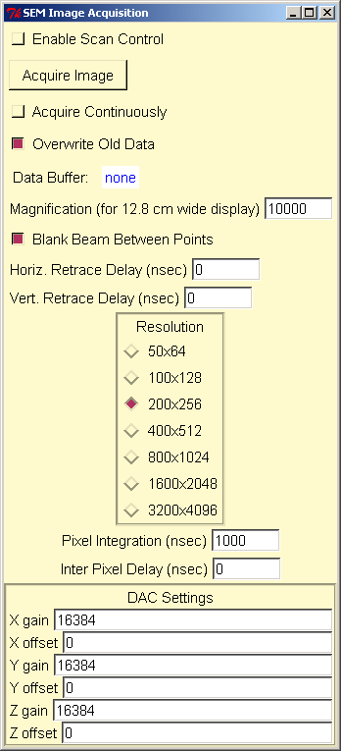

Image Alignment

After planning images have been loaded and an SEM alignment image has been acquired one would typically want to define the mapping between the SEM alignment image and the planning images so that the SEM exposes the pattern in the right place. To start, bring up the Registration control panel by selecting the Setup→ Alignment menu item. Select the SEM alignment image as the Topography (or Reference) image and one of the planning images as the Projection (or Adjustable) image.
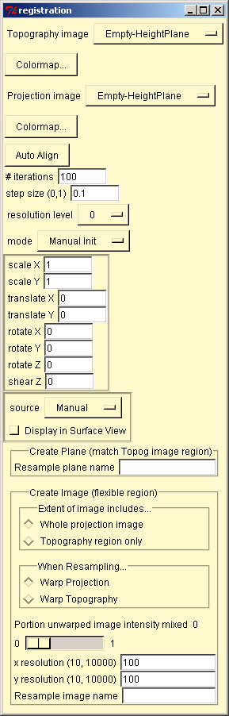

A transformation is determined by defining a set of corresponding points for the two images. To do this, one may click with the left mouse button in either window. A point will be displayed in both windows as a crosshair with a number next to it. The crosshair will have a yellow square around it if the corresponding point is currently selected. There is always exactly one point that is selected. If you click the left mouse button at some place in the image that doesn’t lie within the rectangle for any cross hair then a new point will be created. To move a point, click with the left mouse button as close to the center of the cross hairs for that point as you can and drag the crosshairs to the new location. To select a point, simply click near the center of the cross hairs for that point (you must at least be within the region that would be outlined by the yellow selection square). To delete the currently selected point, press the backspace key or drag that point out of the window. When a point is deleted, one of the remaining points, if there are any, will be selected automatically.
The following figure shows an example of three corresponding points defined in the reference and adjustable windows.
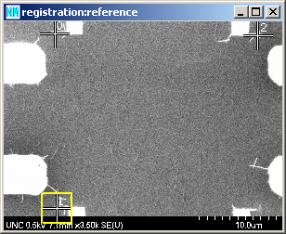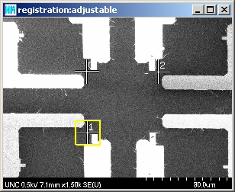

As correspondence points are created and moved, the program automatically responds by computing a new transformation that minimizes the sum of squared distances between points in the adjustable image and the corresponding points transformed from the reference image. If only one correspondence point is defined, then the transformation will be a pure translation (x and y components) with two degrees of freedom. If two correspondence points are defined, the transformation will be a combination of translation (x and y), rotation (z) and uniform scaling (scaling in x and y by the same amount) for a total of 4 degrees of freedom. If three or more correspondence points are defined, the transformation will be a combination of translation (x and y), rotation (z), scaling (x and y), and shear (z) for a total of 6 degrees of freedom.

One may resize or change the aspect ratio of the two image windows with no effect on the relation between the correspondence points and the associated images. You will see the relative positions of the cross hairs in each window stay the same (e.g. a point in the center of the image will remain in the center as the window shape is changed). To zoom in a window, move the mouse to the position about which you would like to zoom and press the “z” or “Z” key on the keyboard. Zooming in to see more detail at some part of an image is useful to position a correspondence point more precisely.

If the adjustable image is currently displayed in the Pattern Editor window, you should be able to see it move as the transformation is changed. The registration control panel features described so far should be sufficient for those who are only interested in using the Seegerizer for lithography but if you would like to know all the details please see the registration manual.

Pattern Exposure
At this point you should have the pattern you wish to expose displayed in the pattern editor window in the desired relation to the freshly acquired SEM calibration image.
Tell the program to compute timing information for the exposure operation by pressing the Timing Test button at the bottom of the main control panel. During the timing test, the program will measure how long it takes to draw the pattern (without actually controlling the beam) and will compute what compensating delays to insert into the drawing operation so that the proper doses are delivered. After the timing test is complete, the EXPOSE button will be enabled. Before pressing the EXPOSE button, make sure the beam is unpaused in the Hitachi interface. Press the EXPOSE button to start exposing the pattern. The Seegerizer will take control of the beam and the image on the Hitachi screen will look messed up. When the exposure is done, the scan control should be automatically relinquished to the Hitachi interface and the image should appear normal again on the Hitachi screen.

There are a few more features not described above which may be useful. In the File menu, it is possible to save a pattern and reload it using the Save Pattern File and Open Pattern File menu items. You can save a color image of the pattern editor window using the Save Editor Window menu item. Also, you can save any image buffers including those containing acquired SEM images through the Save Image File menu item.
