**Content Provider**

Description:

Android Provide content provider that allows one app to share it is data with another apps in the phone. Because every Android app has it specific data that only the same app could access to it, while in same case, we need to share app data with another apps. For instance; contact app has all contact names and number, many other apps need to access to theses data so contact app have to put the phones number in content provider so other apps could access and read it. Also the phone SMS app is another example for content provider share.

The problem is that, if we develop app has shared data, we have to make sure ,what is this data, and with whom we will share especially the sensitive data. For example, if we saved the Credit card info for user in content providers, so our another apps in the phone could use it without ask user to enter it again, we have to encrypt this data because, it easy to read by another apps.

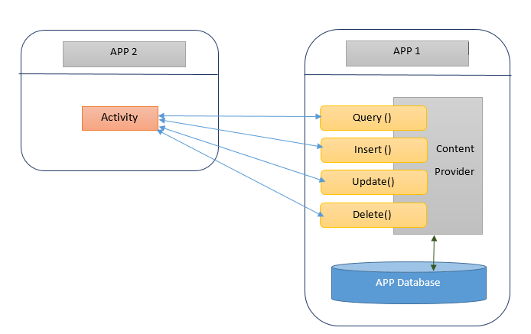

We will demonstrate example, showing one apps store student name and age in content provider then we will show how we will share this data only with our apps to read, also we will should how it is easy to read by hacker if we did not encrypt data then we discus protection.

**Steps to work**

**Our sender app : this app will write content provider**

1-Create new project named “contentproviders”, and the make sure to remember package name.

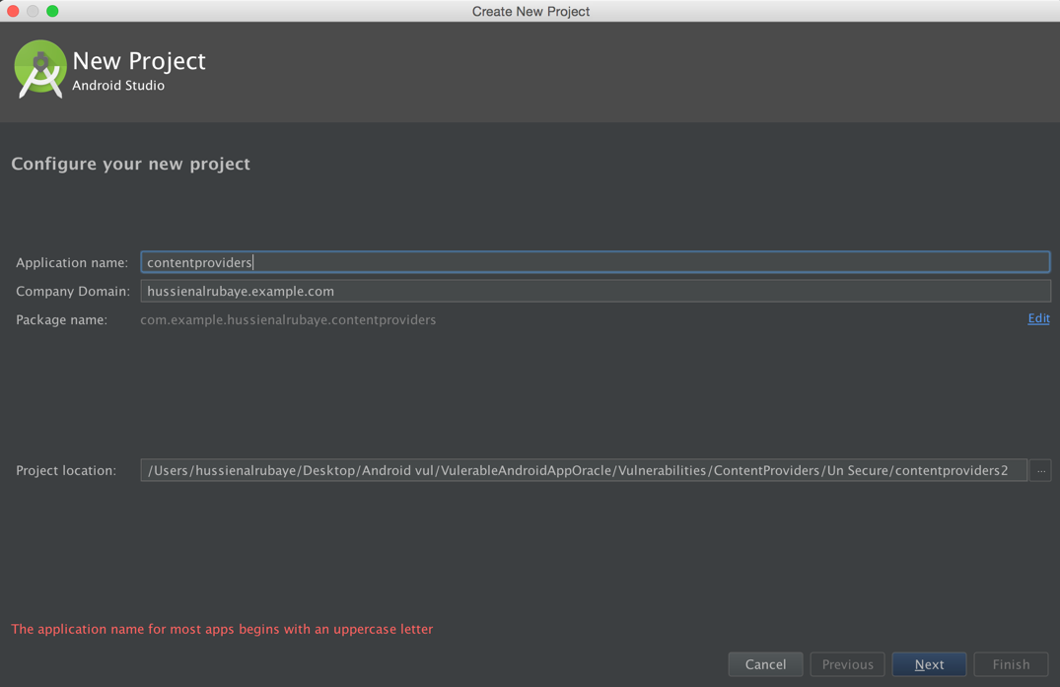

2- select project from type Blank Activity

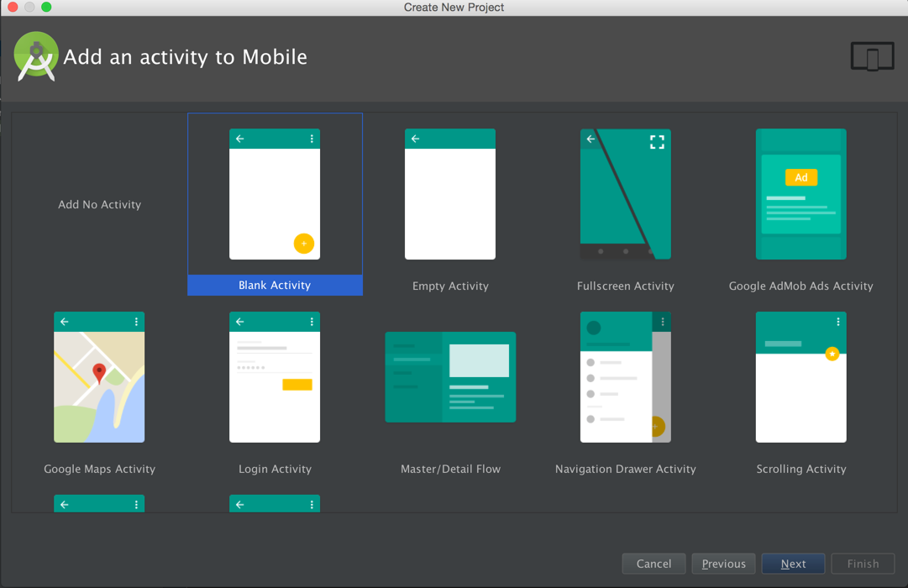

3- Design the app to be like this

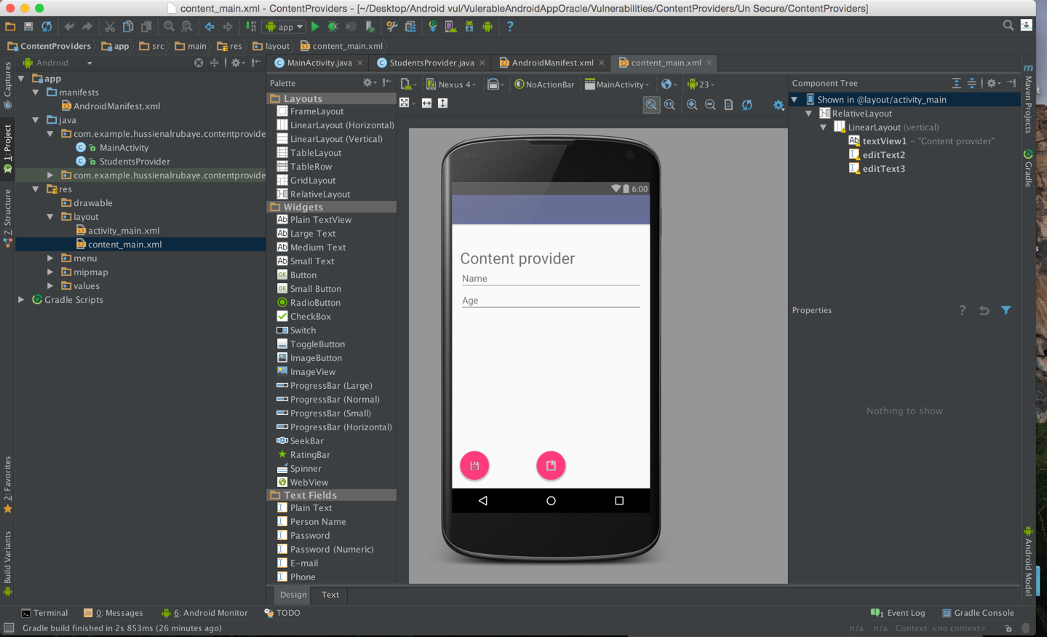

4- update **Content_main.xml** to be like this

|  |
| --- |
| Java |
| <?xml version="1.0" encoding="utf-8"?> <RelativeLayout xmlns:android="http://schemas.android.com/apk/res/android"  xmlns:app="http://schemas.android.com/apk/res-auto"  xmlns:tools="http://schemas.android.com/tools"  android:layout_width="match_parent"  android:layout_height="match_parent"  android:paddingBottom="@dimen/activity_vertical_margin"  android:paddingLeft="@dimen/activity_horizontal_margin"  android:paddingRight="@dimen/activity_horizontal_margin"  android:paddingTop="@dimen/activity_vertical_margin"  app:layout_behavior="@string/appbar_scrolling_view_behavior"  tools:context="com.example.hussienalrubaye.contentproviders.MainActivity"  tools:showIn="@layout/activity_main">    <LinearLayout  android:textAlignment="center"  android:orientation="vertical"  android:layout_width="match_parent"  android:layout_height="match_parent"  android:paddingTop="33dp">   <TextView  android:id="@+id/textView1"  android:layout_width="wrap_content"  android:layout_height="wrap_content"  android:text="Content provider"  android:layout_alignParentTop="true"  android:layout_centerHorizontal="true"  android:textSize="30dp" />    <EditText  android:layout_width="fill_parent"  android:layout_height="wrap_content"  android:id="@+id/editText2"  android:layout_alignTop="@+id/editText"  android:layout_alignLeft="@+id/textView1"  android:layout_alignStart="@+id/textView1"  android:layout_alignRight="@+id/textView1"  android:layout_alignEnd="@+id/textView1"  android:hint="Name"  />   <EditText  android:layout_width="fill_parent"  android:layout_height="wrap_content"  android:id="@+id/editText3"  android:layout_below="@+id/editText"  android:layout_alignLeft="@+id/editText2"  android:layout_alignStart="@+id/editText2"  android:layout_alignRight="@+id/editText2"  android:layout_alignEnd="@+id/editText2"  android:hint="Age"  />   </LinearLayout> </RelativeLayout> |

5- update **Activity_main.xml** to be like this

|  |
| --- |
| Java |
| <?xml version="1.0" encoding="utf-8"?> <android.support.design.widget.CoordinatorLayout xmlns:android="http://schemas.android.com/apk/res/android"  xmlns:app="http://schemas.android.com/apk/res-auto"  xmlns:tools="http://schemas.android.com/tools"  android:layout_width="match_parent"  android:layout_height="match_parent"  android:fitsSystemWindows="true"  tools:context="com.example.hussienalrubaye.contentproviders.MainActivity">   <android.support.design.widget.AppBarLayout  android:layout_width="match_parent"  android:layout_height="wrap_content"  android:theme="@style/AppTheme.AppBarOverlay">   <android.support.v7.widget.Toolbar  android:id="@+id/toolbar"  android:layout_width="match_parent"  android:layout_height="?attr/actionBarSize"  android:background="?attr/colorPrimary"  app:popupTheme="@style/AppTheme.PopupOverlay" />   </android.support.design.widget.AppBarLayout>   <include layout="@layout/content_main" />   <android.support.design.widget.FloatingActionButton  android:id="@+id/fbSave"  android:layout_width="wrap_content"  android:layout_height="wrap_content"  android:layout_gravity="bottom|left"  android:layout_margin="@dimen/fab_margin"  android:src="@android:drawable/ic_menu_save" />  <android.support.design.widget.FloatingActionButton  android:id="@+id/fbQuery"  android:layout_width="wrap_content"  android:layout_height="wrap_content"  android:layout_gravity="bottom"  android:layout_margin="@dimen/fab_margin"  android:src="@android:drawable/ic_input_get"  />   </android.support.design.widget.CoordinatorLayout> |

6- add class named “**StudentProvider.java**”

|  |
| --- |
| Java |
| package com.example.hussienalrubaye.contentproviders;  */**  * Created by hussienalrubaye on 3/6/16.  */* import java.util.HashMap;  import android.content.ContentProvider; import android.content.ContentUris; import android.content.ContentValues; import android.content.Context; import android.content.UriMatcher;  import android.database.Cursor; import android.database.SQLException; import android.database.sqlite.SQLiteDatabase; import android.database.sqlite.SQLiteOpenHelper; import android.database.sqlite.SQLiteQueryBuilder;  import android.net.Uri; import android.text.TextUtils;  public class StudentsProvider extends ContentProvider {   static final String *PROVIDER_NAME* = "com.example.provider.College";  static final String *URL* = "content://" + *PROVIDER_NAME* + "/students";  static final Uri *CONTENT_URI* = Uri.*parse*(*URL*);   static final String *_ID* = "_id";  static final String *NAME* = "name";  static final String *Age* = "age";   private static HashMap<String, String> *STUDENTS_PROJECTION_MAP*;   static final int *STUDENTS* = 1;  static final int *STUDENT_ID* = 2;   static final UriMatcher *uriMatcher*;  static{  *uriMatcher* = new UriMatcher(UriMatcher.*NO_MATCH*);  *uriMatcher*.addURI(*PROVIDER_NAME*, "students", *STUDENTS*);  *uriMatcher*.addURI(*PROVIDER_NAME*, "students/#", *STUDENT_ID*);  }   */**  * Database specific constant declarations  */* private SQLiteDatabase db;  static final String *DATABASE_NAME* = "College";  static final String *STUDENTS_TABLE_NAME* = "students";  static final int *DATABASE_VERSION* = 1;  static final String *CREATE_DB_TABLE* =  " CREATE TABLE IF NOT EXISTS " + *STUDENTS_TABLE_NAME* +  " (_id INTEGER PRIMARY KEY AUTOINCREMENT, " +  " name TEXT NOT NULL, " +  " age TEXT NOT NULL);";   */**  * Helper class that actually creates and manages  * the provider's underlying data repository.  */* private static class DatabaseHelper extends SQLiteOpenHelper {  DatabaseHelper(Context context){  super(context, *DATABASE_NAME*, null, *DATABASE_VERSION*);  }   @Override  public void onCreate(SQLiteDatabase db)  {  db.execSQL(*CREATE_DB_TABLE*);  }   @Override  public void onUpgrade(SQLiteDatabase db, int oldVersion, int newVersion) {  db.execSQL("DROP TABLE IF EXISTS " + *STUDENTS_TABLE_NAME*);  onCreate(db);  }  }   @Override  public boolean onCreate() {  Context context = getContext();  DatabaseHelper dbHelper = new DatabaseHelper(context);   */**  * Create a write able database which will trigger its  * creation if it doesn't already exist.  */* db = dbHelper.getWritableDatabase();  return (db == null)? false:true;  }   @Override  public Uri insert(Uri uri, ContentValues values)  {  */**  * Add a new student record  */* long rowID = db.insert( *STUDENTS_TABLE_NAME*, "", values);   */**  * If record is added successfully  */* if (rowID > 0)  {  Uri _uri = ContentUris.*withAppendedId*(*CONTENT_URI*, rowID);  getContext().getContentResolver().notifyChange(_uri, null);  return _uri;  }  throw new SQLException("Failed to add a record into " + uri);  }  /*  //selection select "name=12 and age =122"  // String[] projection = new String[] { "_id", "name", "age" };  String selection = " age in (?, ?, ?)";  String selectionArgs[] = new String[]{"1","2","3"};  */  @Override  public Cursor query(Uri uri, String[] projection, String selection,String[] selectionArgs, String sortOrder)  {  SQLiteQueryBuilder qb = new SQLiteQueryBuilder();  qb.setTables(*STUDENTS_TABLE_NAME*);   switch (*uriMatcher*.match(uri)) {  case *STUDENTS*:  qb.setProjectionMap(*STUDENTS_PROJECTION_MAP*);  break;   case *STUDENT_ID*:  qb.appendWhere( *_ID* + "=" + uri.getPathSegments().get(1));  break;   default:  throw new IllegalArgumentException("Unknown URI " + uri);  }   if (sortOrder == null || sortOrder == ""){  */**  * By default sort on student names  */* sortOrder = *NAME*;  }  Cursor c = qb.query(db, projection, selection, selectionArgs,null, null, sortOrder);   */**  * register to watch a content URI for changes  */* c.setNotificationUri(getContext().getContentResolver(), uri);  return c;  }   @Override  public int delete(Uri uri, String selection, String[] selectionArgs)  {  int count = 0;   switch (*uriMatcher*.match(uri)){  case *STUDENTS*:  count = db.delete(*STUDENTS_TABLE_NAME*, selection, selectionArgs);  break;   case *STUDENT_ID*:  String id = uri.getPathSegments().get(1);  count = db.delete( *STUDENTS_TABLE_NAME*, *_ID* + " = " + id +  (!TextUtils.*isEmpty*(selection) ? " AND (" + selection + ')' : ""), selectionArgs);  break;   default:  throw new IllegalArgumentException("Unknown URI " + uri);  }   getContext().getContentResolver().notifyChange(uri, null);  return count;  }   @Override  public int update(Uri uri, ContentValues values, String selection, String[] selectionArgs)  {  int count = 0;   switch (*uriMatcher*.match(uri)){  case *STUDENTS*:  count = db.update(*STUDENTS_TABLE_NAME*, values, selection, selectionArgs);  break;   case *STUDENT_ID*:  count = db.update(*STUDENTS_TABLE_NAME*, values, *_ID* + " = " + uri.getPathSegments().get(1) +  (!TextUtils.*isEmpty*(selection) ? " AND (" +selection + ')' : ""), selectionArgs);  break;   default:  throw new IllegalArgumentException("Unknown URI " + uri );  }  getContext().getContentResolver().notifyChange(uri, null);  return count;  }   @Override  public String getType(Uri uri) {  switch (*uriMatcher*.match(uri)){  */**  * Get all student records (dir)  * http://developer.android.com/reference/android/content/UriMatcher.html  */* case *STUDENTS*:  return "vnd.android.cursor.dir/vnd.example.students";   */**  * Get a particular student(item)  */* case *STUDENT_ID*:  return "vnd.android.cursor.item/vnd.example.students";   default:  throw new IllegalArgumentException("Unsupported URI: " + uri);  } }} |

7- Update **Manifest.xml** to be like this

|  |
| --- |
| Java |
| <?xml version="1.0" encoding="utf-8"?> <manifest xmlns:android="http://schemas.android.com/apk/res/android"  package="com.example.hussienalrubaye.contentproviders">   <application  android:allowBackup="true"  android:icon="@mipmap/ic_launcher"  android:label="@string/app_name"  android:supportsRtl="true"  android:theme="@style/AppTheme">  <activity  android:name=".MainActivity"  android:label="@string/app_name"  android:theme="@style/AppTheme.NoActionBar">  <intent-filter>  <action android:name="android.intent.action.MAIN" />   <category android:name="android.intent.category.LAUNCHER" />  </intent-filter>  </activity>  <provider  android:authorities="com.example.provider.College"  android:name="StudentsProvider" android:exported="true"  />  </application>  </manifest> |

8- update **MainActivity.java** to be like this

|  |
| --- |
| Java |
| public class MainActivity extends AppCompatActivity {   @Override  protected void onCreate(Bundle savedInstanceState) {  super.onCreate(savedInstanceState);  setContentView(R.layout.*activity_main*);  Toolbar toolbar = (Toolbar) findViewById(R.id.*toolbar*);  setSupportActionBar(toolbar);   FloatingActionButton fabAdd = (FloatingActionButton) findViewById(R.id.*fbSave*);  fabAdd.setOnClickListener(new View.OnClickListener() {  @Override  public void onClick(View view) {  // add new record  Add();  }  });  FloatingActionButton fbQuery = (FloatingActionButton) findViewById(R.id.*fbQuery*);  fbQuery.setOnClickListener(new View.OnClickListener() {  @Override  public void onClick(View view) {  //load all records  QueryGet();  }  });  }   // Retrieve student records  String URL = "content://com.example.provider.College/students";   public void Add() {  // Add a new student record  ContentValues values = new ContentValues(); // insert value  values.put(StudentsProvider.*NAME*, ((EditText)findViewById(R.id.*editText2*)).getText().toString());   values.put(StudentsProvider.*Age*,  ((EditText)findViewById(R.id.*editText3*)).getText().toString()); // define the play to insert the values in  Uri uri = getContentResolver().insert(  StudentsProvider.*CONTENT_URI*, values); // display messages  Toast.*makeText*(getBaseContext(),  uri.toString(), Toast.*LENGTH_LONG*).show();  }   public void QueryGet() {   // define content provider url to read from  Uri students = Uri.*parse*(URL); // get data ordered by name  Cursor c = getContentResolver().query(students, null, null, null, "name"); // move through all items  if (c.moveToFirst()) {  do{  // load the record name and age and id  Toast.*makeText*(this,  c.getString(c.getColumnIndex(StudentsProvider.*_ID*)) +  ", " + c.getString(c.getColumnIndex( StudentsProvider.*NAME*)) +  ", " + c.getString(c.getColumnIndex( StudentsProvider.*Age*)),  Toast.*LENGTH_SHORT*).show();  } while (c.moveToNext());  }  } } |

5- Run the app you will see this output, add one student name “Hussein, age “27”

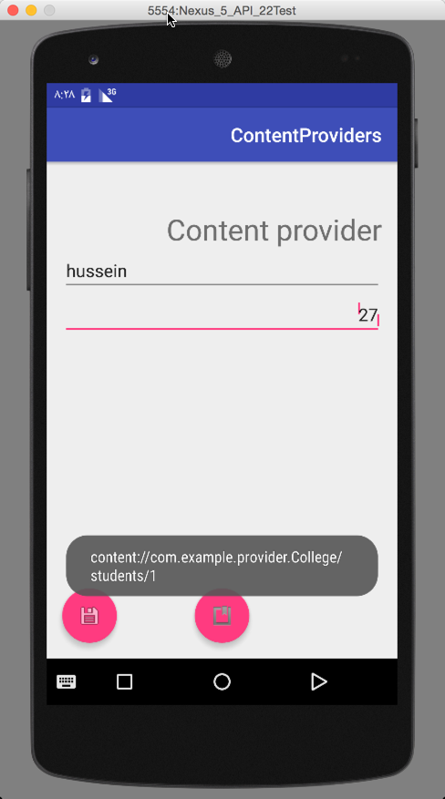

**Our receiver app: this app will read from content provider**

1-Create new project named “contentprovidershacker”, and the make sure to remember package name.

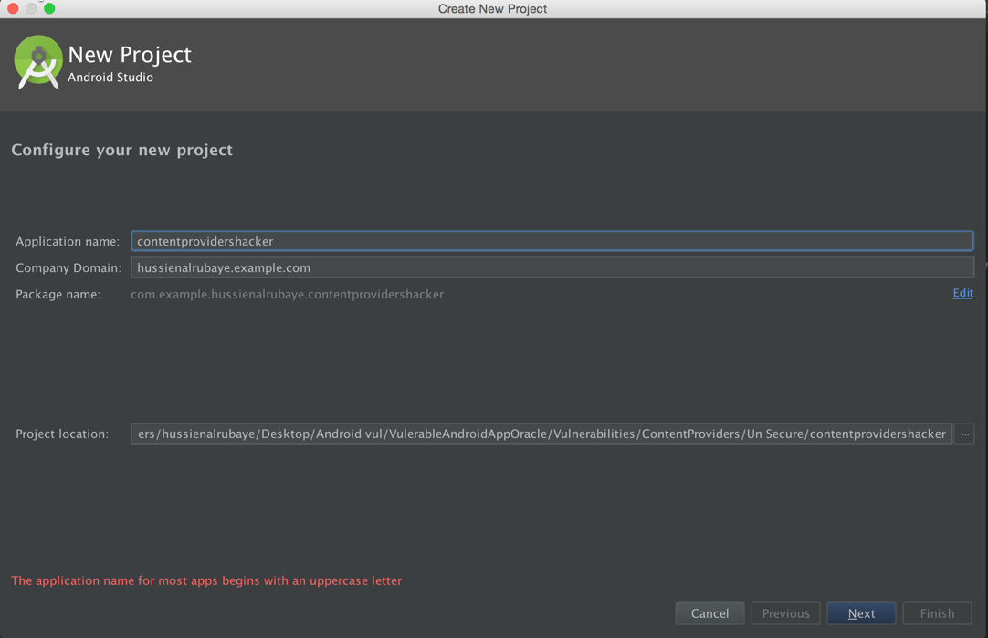

2- select project from type Blank Activity



3- we Design the app to be like this

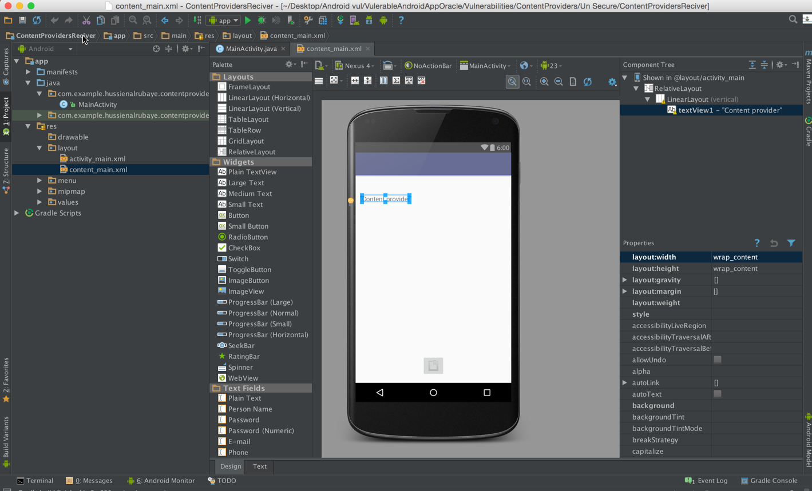

4- update **Content_main.xml** to be like this

|  |
| --- |
| Java |
| <?xml version="1.0" encoding="utf-8"?> <RelativeLayout xmlns:android="http://schemas.android.com/apk/res/android"  xmlns:app="http://schemas.android.com/apk/res-auto"  xmlns:tools="http://schemas.android.com/tools"  android:layout_width="match_parent"  android:layout_height="match_parent"  android:paddingBottom="@dimen/activity_vertical_margin"  android:paddingLeft="@dimen/activity_horizontal_margin"  android:paddingRight="@dimen/activity_horizontal_margin"  android:paddingTop="@dimen/activity_vertical_margin"  app:layout_behavior="@string/appbar_scrolling_view_behavior"  tools:context="com.example.hussienalrubaye.contentprovidershacker.MainActivity"  tools:showIn="@layout/activity_main">   <LinearLayout  android:textAlignment="center"  android:orientation="vertical"  android:layout_width="match_parent"  android:layout_height="match_parent"  android:paddingTop="33dp">   <TextView  android:id="@+id/textView1"  android:layout_width="wrap_content"  android:layout_height="wrap_content"  android:text="Content provider"  android:layout_alignParentTop="true"  android:layout_centerHorizontal="true"  android:textSize="16dp" />      </LinearLayout> </RelativeLayout> |

5- update **Activity_main.xml** to be like this

|  |
| --- |
| Java |
| <?xml version="1.0" encoding="utf-8"?> <android.support.design.widget.CoordinatorLayout xmlns:android="http://schemas.android.com/apk/res/android"  xmlns:app="http://schemas.android.com/apk/res-auto"  xmlns:tools="http://schemas.android.com/tools"  android:layout_width="match_parent"  android:layout_height="match_parent"  android:fitsSystemWindows="true"  tools:context="com.example.hussienalrubaye.contentprovidershacker.MainActivity">   <android.support.design.widget.AppBarLayout  android:layout_width="match_parent"  android:layout_height="wrap_content"  android:theme="@style/AppTheme.AppBarOverlay">   <android.support.v7.widget.Toolbar  android:id="@+id/toolbar"  android:layout_width="match_parent"  android:layout_height="?attr/actionBarSize"  android:background="?attr/colorPrimary"  app:popupTheme="@style/AppTheme.PopupOverlay" />   </android.support.design.widget.AppBarLayout>   <include layout="@layout/content_main" />    <android.support.design.widget.FloatingActionButton  android:id="@+id/fbQuery"  android:layout_width="wrap_content"  android:layout_height="wrap_content"  android:layout_gravity="bottom"  android:layout_margin="@dimen/fab_margin"  android:src="@android:drawable/ic_input_get"  />  </android.support.design.widget.CoordinatorLayout> |

6- add class named “**MainActivity.java**”

|  |
| --- |
| Java |
| public class MainActivity extends AppCompatActivity { TextView textView1;  @Override  protected void onCreate(Bundle savedInstanceState) {  super.onCreate(savedInstanceState);  setContentView(R.layout.*activity_main*);  Toolbar toolbar = (Toolbar) findViewById(R.id.*toolbar*);  setSupportActionBar(toolbar);  textView1=(TextView)findViewById(R.id.*textView1*);   FloatingActionButton fbQuery = (FloatingActionButton) findViewById(R.id.*fbQuery*);  fbQuery.setOnClickListener(new View.OnClickListener() {  @Override  public void onClick(View view) {  QueryGet();  }  });  }   // Retrieve student records  String URL = "content://com.example.provider.College/students";  static final String *_ID* = "_id";  static final String *NAME* = "name";  static final String *GRADE* = "age";    public void QueryGet() {    Uri students = Uri.*parse*(URL);  Cursor c = getContentResolver().query(students, null, null, null, "name"); String data="";  if (c.moveToFirst()) {  do{  data+=(c.getString(c.getColumnIndex( *_ID*)) +  ", " + c.getString(c.getColumnIndex( *NAME*)) +  ", " + c.getString(c.getColumnIndex( *GRADE*)));  } while (c.moveToNext());    }  textView1.setText(data);  } } |

Run the app and click the button you will see the content data stored

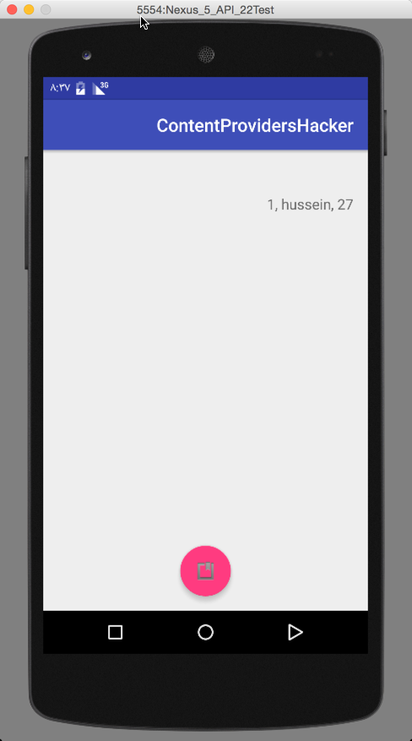

**Hacker Work:**

It easy to the hacker to read this data by opening the app manifest.xml file and read the content provider URL, then going to the terminal “adb” and run this command.

**./adb shell**

**Content query --uri “content provider url”**

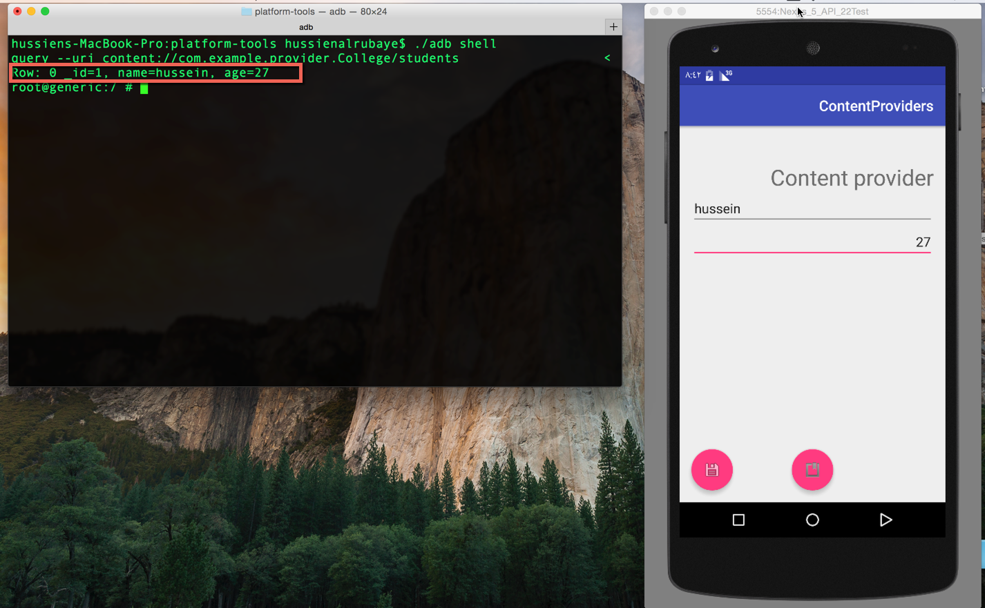

**How to protect our Data:**

we have to encrypt and decrypt the data, so when we save into content provider we have to encrypt and when we read we have to decrypt.

1- Update MaiActivity.java in “contentProvidershacker” to be like this

|  |
| --- |
| Java |
| public class MainActivity extends AppCompatActivity { TextView textView1;  @Override  protected void onCreate(Bundle savedInstanceState) {  super.onCreate(savedInstanceState);  setContentView(R.layout.*activity_main*);  Toolbar toolbar = (Toolbar) findViewById(R.id.*toolbar*);  setSupportActionBar(toolbar);  textView1=(TextView)findViewById(R.id.*textView1*);   FloatingActionButton fbQuery = (FloatingActionButton) findViewById(R.id.*fbQuery*);  fbQuery.setOnClickListener(new View.OnClickListener() {  @Override  public void onClick(View view) {  QueryGet();  }  });  }   // Retrieve student records  String URL = "content://com.example.provider.College/students";  static final String *_ID* = "_id";  static final String *NAME* = "name";  static final String *GRADE* = "age";    public void QueryGet() {    Uri students = Uri.*parse*(URL);  Cursor c = getContentResolver().query(students, null, null, null, "name"); String data="";  if (c.moveToFirst()) {  do{  data+=(c.getString(c.getColumnIndex( *_ID*)) +  ", " + cipher(c.getString(c.getColumnIndex( *NAME*)) ,-10)+  ", " + cipher(c.getString(c.getColumnIndex( *GRADE*)),-10));  } while (c.moveToNext());    }  textView1.setText(data);  }   // cipher encryption add shift for key  public String cipher(String msg, int shift) {  String s = "";  int len = msg.length(); // get string length  for (int x = 0; x < len; x++) {  char c = (char) (msg.charAt(x) + shift); // shift every character  s += c; // append the characters  }  return s;  } } |

2- Update MaiActivity.java in “contentProviders” to be like this

|  |
| --- |
| Java |
| public class MainActivity extends AppCompatActivity {   @Override  protected void onCreate(Bundle savedInstanceState) {  super.onCreate(savedInstanceState);  setContentView(R.layout.*activity_main*);  Toolbar toolbar = (Toolbar) findViewById(R.id.*toolbar*);  setSupportActionBar(toolbar);   FloatingActionButton fabAdd = (FloatingActionButton) findViewById(R.id.*fbSave*);  fabAdd.setOnClickListener(new View.OnClickListener() {  @Override  public void onClick(View view) {  Add();  }  });  FloatingActionButton fbQuery = (FloatingActionButton) findViewById(R.id.*fbQuery*);  fbQuery.setOnClickListener(new View.OnClickListener() {  @Override  public void onClick(View view) {  QueryGet();  }  });  }   // Retrieve student records  String URL = "content://com.example.provider.College/students";   public void Add() {  // Add a new student record  ContentValues values = new ContentValues(); // insert value  values.put(StudentsProvider.*NAME*,  cipher(((EditText) findViewById(R.id.*editText2*)).getText().toString(), 10));   values.put(StudentsProvider.*Age*,  cipher(((EditText) findViewById(R.id.*editText3*)).getText().toString(), 10)); // define the play to insert the values in  Uri uri = getContentResolver().insert(  StudentsProvider.*CONTENT_URI*, values); // display messages  Toast.*makeText*(getBaseContext(),  uri.toString(), Toast.*LENGTH_LONG*).show();  }   public void QueryGet() {    Uri students = Uri.*parse*(URL);   Cursor c = getContentResolver().query(students, null, null, null, "name");   if (c.moveToFirst()) {  do {  Toast.*makeText*(this,  c.getString(c.getColumnIndex(StudentsProvider.*_ID*))+  ", " + cipher(c.getString(c.getColumnIndex(StudentsProvider.*NAME*)),-10)  +  ", " +cipher( c.getString(c.getColumnIndex(StudentsProvider.*Age*)),-10) ,  Toast.*LENGTH_SHORT*).show();  } while (c.moveToNext());  }  }   // cipher encryption add shift for key  public String cipher(String msg, int shift) {  String s = "";  int len = msg.length(); // get string length  for (int x = 0; x < len; x++) {  char c = (char) (msg.charAt(x) + shift); // shift every character  s += c; // append the characters  }  return s;  }   } |

**Results:**

Run the apps and see, as we see the hacker cannot read the data.



