**Secure HTTP Requests**

**Description:**

In Android, we use HTTP to exchange data between client and server. Sometimes, we send sensitive data, like username and password or user location from client to server over HTTP. Keep in mind that this request will move over the network. When this data is in transit, it is very easy for a hacker to intercept. Many people could interrupt and read this request data, so we must protect it.

We will demonstrate an example of how to send sensitive data between client to server over HTTP. We will then explain how hackers could read this data, along with suggestions of how to protect against this.

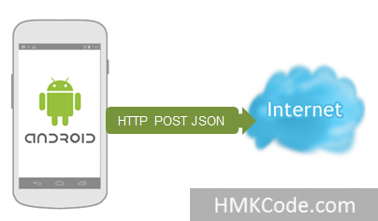

**Steps to build the app:**

1. In Android Studio, create a new project, named “HTTPInsecure”. Take note of the package name, as we will be needing this later in the tutorial. Click next.

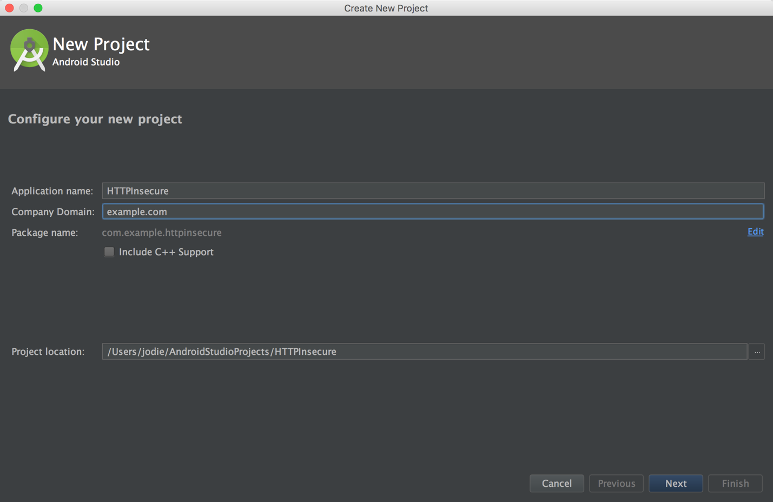

On the next page, click next. The default API level will suffice for our needs right now.

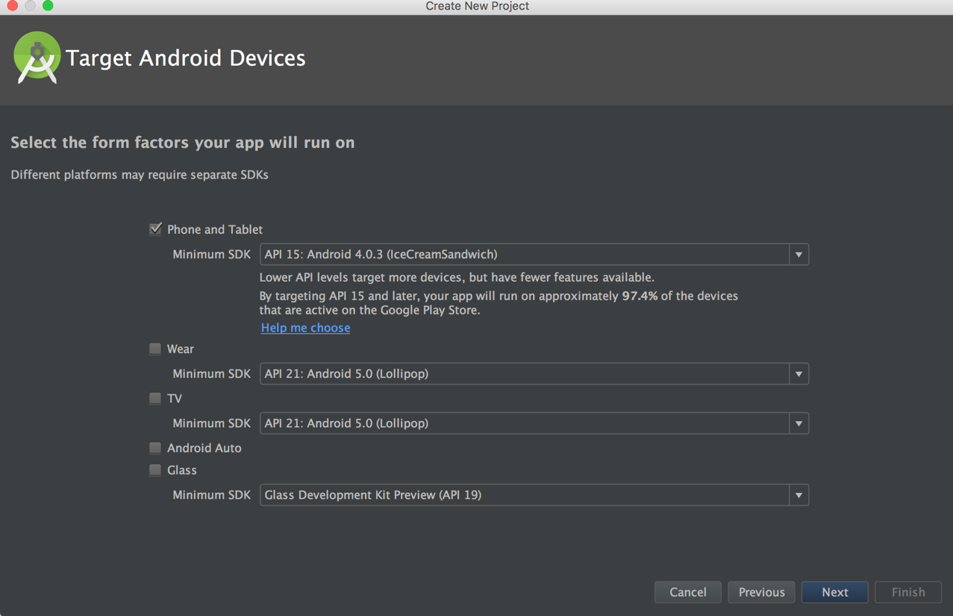

1. Select project type “Empty Activity”.

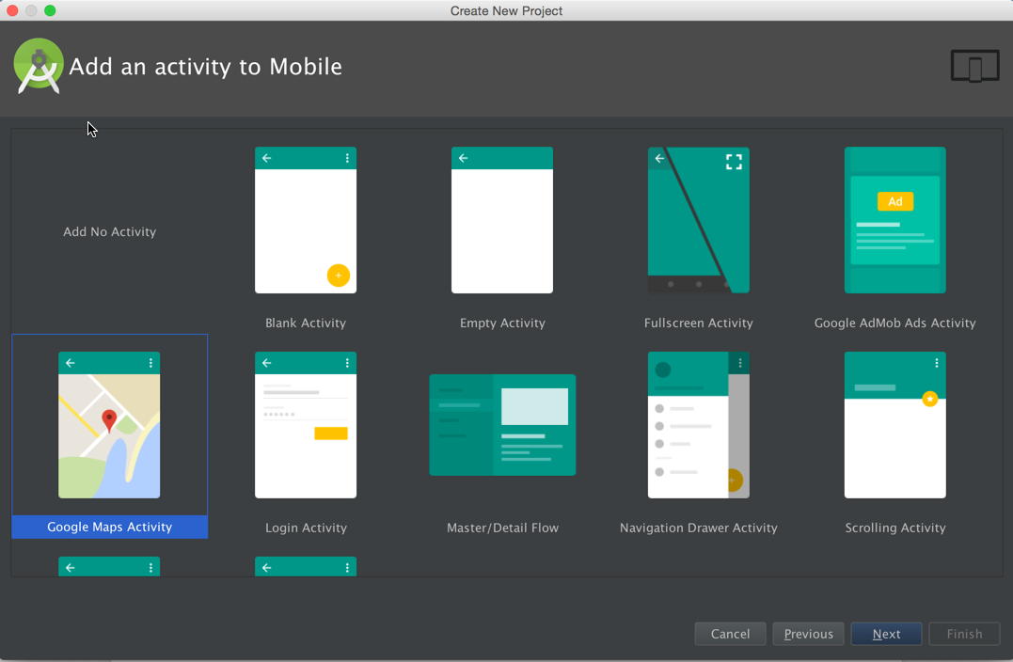

1. Our project will look like this when we are finished with the layout.

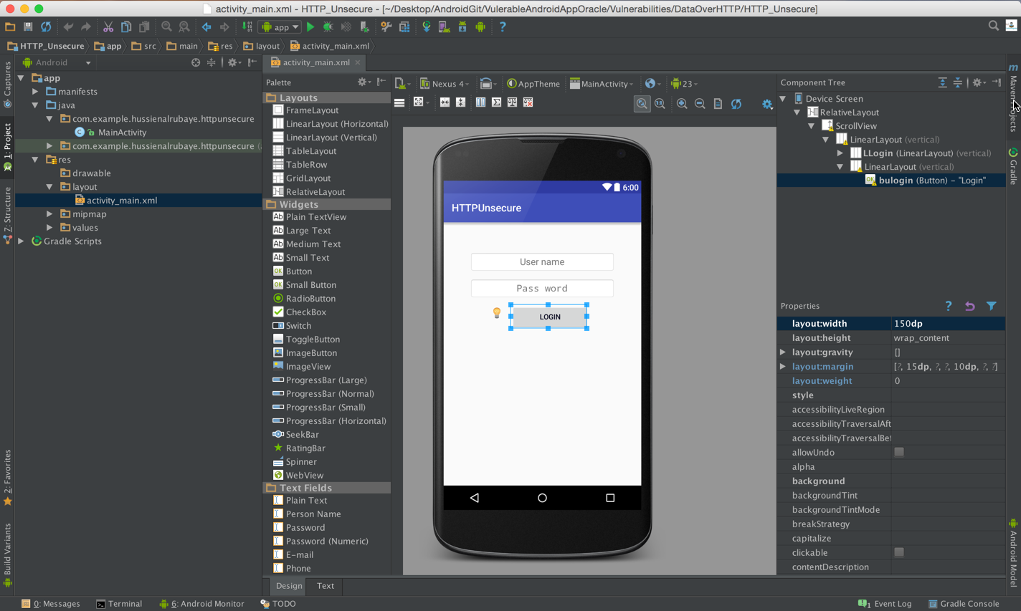

To do this, we will update **activity_main.xml** with the code below. The **activity_main.xml** file can be found under “res/layout” in the folders in the panel to the left.

Click the “Text” tab, found in the middle near the bottom of the window to see the text view of the XML file. By default, it shows you the Design view first, which is what’s currently visible in the picture above.

|  |
| --- |
| *<?***xml version="1.0" encoding="utf-8"***?>* <**RelativeLayout xmlns:android="http://schemas.android.com/apk/res/android"  xmlns:tools="http://schemas.android.com/tools"  android:layout_width="match_parent"  android:layout_height="match_parent"  android:paddingBottom="@dimen/activity_vertical_margin"  android:paddingLeft="@dimen/activity_horizontal_margin"  android:paddingRight="@dimen/activity_horizontal_margin"  android:paddingTop="@dimen/activity_vertical_margin"  tools:context="com.example.httpinsecure.MainActivity"**>   <**ScrollView  android:layout_width="fill_parent"  android:layout_height="wrap_content"  android:layout_weight="1"**>   <**LinearLayout  android:orientation="vertical"  android:layout_width="fill_parent"  android:layout_height="fill_parent"  android:paddingTop="30dp"  android:paddingLeft="15dp"  android:paddingRight="15dp"**>   <**LinearLayout  android:orientation="vertical"  android:layout_width="fill_parent"  android:layout_height="wrap_content"  android:id="@+id/LLogin"  android:layout_marginTop="7dp"  android:paddingLeft="20dp"  android:paddingTop="4dp"  android:paddingRight="20dp"**>   <**LinearLayout  android:orientation="vertical"  android:layout_width="fill_parent"  android:layout_height="wrap_content"  android:touchscreenBlocksFocus="false"  android:layout_marginBottom="2dp"**>   <**EditText  android:gravity="center"  android:maxLength="50"  android:layout_width="fill_parent"  android:layout_height="wrap_content"  android:inputType="text"  android:ems="10"  android:id="@+id/EDTUserName"  android:layout_weight="1"  android:textColor="#ff1a102c"  android:background="@android:drawable/editbox_background"  android:textSize="18dp"  android:hint="Username"  android:paddingBottom="9dp"  android:paddingTop="9dp"  android:layout_marginBottom="10dp"**/>  </**LinearLayout**>     <**LinearLayout  android:orientation="vertical"  android:layout_width="fill_parent"  android:layout_height="wrap_content"  android:touchscreenBlocksFocus="false"  android:layout_marginBottom="2dp"**>   <**EditText  android:gravity="center"  android:maxLength="50"  android:layout_width="fill_parent"  android:layout_height="wrap_content"  android:ems="10"  android:id="@+id/EDTpassword"  android:layout_weight="1"  android:textColor="#ff1a102c"  android:background="@android:drawable/editbox_background"  android:textSize="18dp"  android:hint="Password"  android:paddingBottom="9dp"  android:paddingTop="9dp"  android:layout_marginBottom="10dp"  android:inputType="textPassword"** />  </**LinearLayout**>  </**LinearLayout**>   <**LinearLayout  android:textAlignment="center"  android:gravity="center"  android:orientation="vertical"  android:layout_width="match_parent"  android:layout_height="match_parent"**>  <**Button  android:layout_width="150dp"  android:layout_height="wrap_content"  android:text="Login"  android:id="@+id/bulogin"  android:drawablePadding="4dp"  android:layout_marginBottom="10dp"  android:textColor="#ff06071c"  android:onClick="buloginckic"  android:layout_weight="0"  android:layout_marginLeft="15dp"** />  </**LinearLayout**>  </**LinearLayout**>  </**ScrollView**> </**RelativeLayout**> |

1. Next, update the **MainActivity.java** file with the code below. The **MainActivity.java** file can be found under the path “app/java/com.example.httpinsecure”.

|  |
| --- |
| **package** com.example.httpinsecure;  **import** android.support.v7.app.AppCompatActivity; **import** android.os.AsyncTask; **import** android.os.Bundle; **import** android.widget.EditText; **import** android.widget.Toast; **import** android.view.View;  **import** java.io.BufferedInputStream; **import** java.io.BufferedReader; **import** java.io.InputStream; **import** java.io.InputStreamReader; **import** java.net.HttpURLConnection; **import** java.net.URL;  **public class** MainActivity **extends** AppCompatActivity {  @Override  **protected void** onCreate(Bundle savedInstanceState) {  **super**.onCreate(savedInstanceState);  setContentView(R.layout.***activity_main***);  }   **public void** buloginckic(View view) {  *//get user name and password* EditText UserName=(EditText)findViewById(R.id.***EDTUserName***);  EditText Password=(EditText)findViewById(R.id.***EDTpassword***);  *// send user name and password over the http* String url=**"http://sellingportal.alruabye.net/UsersWS.asmx/Login?UserName="**+ UserName.getText().toString() +**"&Password="**+ Password.getText().toString();  *// start background task* **new** MyAsyncTaskGetNews().execute(url, **"news"**);  }    *// get news from server* **public class** MyAsyncTaskGetNews **extends** AsyncTask<String, String, String> {  @Override  **protected void** onPreExecute() {  *//before works* }  @Override  **protected** String doInBackground(String... params) {**try** {  String NewsData;  *//define the url we have to connect with* URL url = **new** URL(params[0]);  *//make connect with url and send request* HttpURLConnection urlConnection = (HttpURLConnection) url.openConnection();  *//waiting for 7000ms for response* urlConnection.setConnectTimeout(7000);*//set timeout to 5 seconds* **try** {  *//getting the response data* InputStream in = **new** BufferedInputStream(urlConnection.getInputStream());  *//convert the stream to string* NewsData = *ConvertInputToStringNoChange*(in);  *//send to display data* publishProgress(NewsData);  } **finally** {  *//end connection* urlConnection.disconnect();  }   } **catch** (Exception ex){}  **return null**;  }   **protected void** onProgressUpdate(String... progress) {  **try** {  *//display response data* Toast.*makeText*(getApplicationContext(),progress[0],Toast.***LENGTH_LONG***).show();  } **catch** (Exception ex) {  }  }   **protected void** onPostExecute(String result2) {   }  }   *// this method convert any stream to string* **public static** String ConvertInputToStringNoChange(InputStream inputStream) {  BufferedReader bureader=**new** BufferedReader( **new** InputStreamReader(inputStream));  String line ;  String linereultcal=**""**;   **try** {  **while**((line=bureader.readLine())!=**null**) {   linereultcal+=line;   }  inputStream.close();  } **catch** (Exception ex) {}   **return** linereultcal;  } } |

1. Add permission to access the internet to **Manifest.xml**, found under “app/manifests/”.

The highlighted line is the way we’re going to add the permission.

|  |
| --- |
| *<?***xml version="1.0" encoding="utf-8"***?>* <**manifest xmlns:android="http://schemas.android.com/apk/res/android"  package="com.example.httpinsecure"**>   <**uses-permission android:name="android.permission.INTERNET"**></**uses-permission**>  <**application  android:allowBackup="true"  android:icon="@mipmap/ic_launcher"  android:label="@string/app_name"  android:supportsRtl="true"  android:theme="@style/AppTheme"**>  <**activity android:name=".MainActivity"**>  <**intent-filter**>  <**action android:name="android.intent.action.MAIN"** />   <**category android:name="android.intent.category.LAUNCHER"** />  </**intent-filter**>  </**activity**>*<!-- ATTENTION: This was auto-generated to add Google Play services to your project for  App Indexing. See https://g.co/AppIndexing/AndroidStudio for more information. -->* <**meta-data  android:name="com.google.android.gms.version"  android:value="@integer/google_play_services_version"** />  </**application**>  </**manifest**> |

See the image below to see how to start the virtual device and run the app. You may need to click “Create New Virtual Device” if you have nothing under your list of **Available Virtual Devices.**

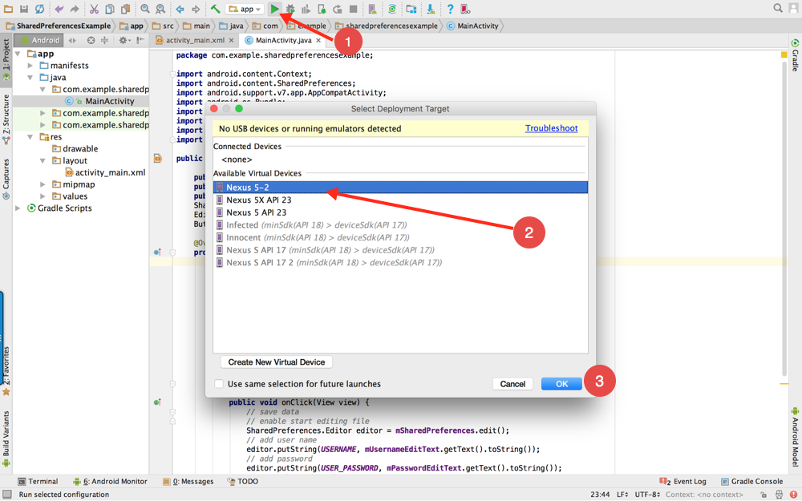

When the app comes up (which may take a while), enter username “Hussein” and password “abc”.

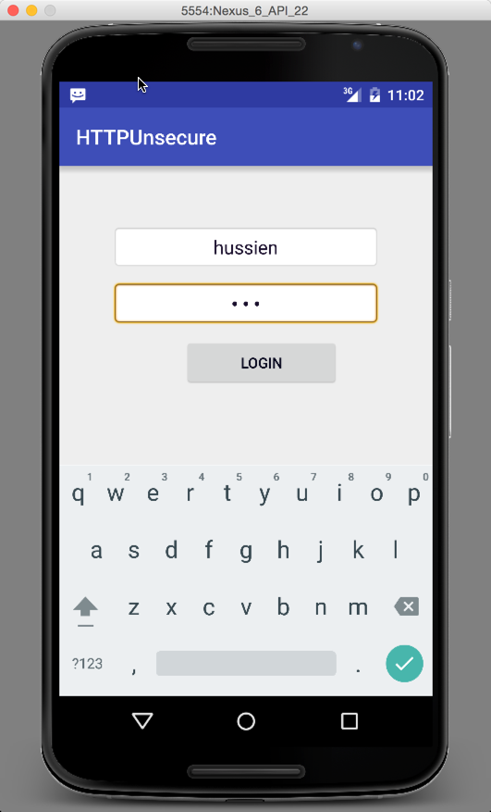

**How the data is vulnerable:**

When this data is in transit, it is very easy for a hacker to intercept and read the data. We will use [Fiddler](http://tech.vg.no/2014/06/04/how-to-monitor-http-traffic-from-your-android-phone-through-fiddler/) app to monitor traffic. Click link to install it. Follow the instructions given by the company that makes Fiddler in order to use it.

When we run it, we see that the username and password is available.

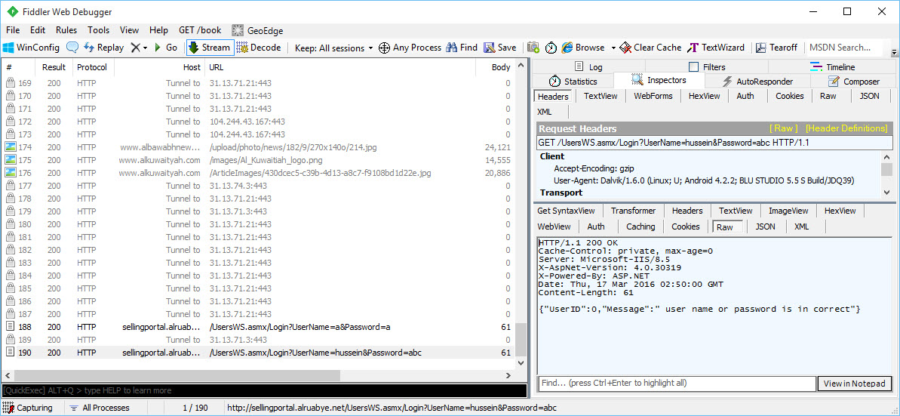

**How do we protect our app data in transit, then?**

We should use HTTPS when sending data over the network.

In order to use HTTPS, all we need to do is call **openConnection()** on a URL with “https” in front of it, then cast the resulting connection to HttpsURLConnection.

Here is the HTTP version of our code:

|  |
| --- |
| **public void** buloginckic(View view) {  *//get user name and password* EditText UserName=(EditText)findViewById(R.id.***EDTUserName***);  EditText Password=(EditText)findViewById(R.id.***EDTpassword***);  *// send user name and password over the http* String url=**"http://sellingportal.alruabye.net/UsersWS.asmx/Login?UserName="**+ UserName.getText().toString() +**"&Password="**+ Password.getText().toString();  *// start background task* **new** MyAsyncTaskGetNews().execute(url, **"news"**);  }   *// get news from server* **public class** MyAsyncTaskGetNews **extends** AsyncTask<String, String, String> {  @Override  **protected** String doInBackground(String... params) {**try** {  String NewsData;  *//define the url we have to connect with* URL url = **new** URL(params[0]);  *//make connect with url and send request* HttpURLConnection urlConnection = (HttpURLConnection) url.openConnection();  *//waiting for 7000ms for response* urlConnection.setConnectTimeout(7000);*//set timeout to 5 seconds* |

The relevant lines are highlighted above – some code has been omitted for clarity.

Unfortunately, the website we have been using (in our example code) to submit our username/password over does not support HTTPS, so we will not be able to demonstrate it in our current code. Below is a code sample of how HTTPS would be accomplished.

|  |
| --- |
| URL url = **new** URL(**"https://en.wikipedia.org/wiki/Main_Page"**); HttpsURLConnection urlConnection = (HttpsURLConnection) url.openConnection(); **try** {  InputStream in = **new** BufferedInputStream(urlConnection.getInputStream());  readStream(in); } **finally** {  urlConnection.disconnect(); } |

Of course, we would then need to import **javax.net.ssl.HttpsURLConnection** instead of **java.net.HttpURLConnection**.

**Resources**

For more information, consult these links:

1. [HttpURLConnection Android API Reference](https://developer.android.com/reference/java/net/HttpURLConnection.html)
2. [Security with HTTPS and SSL](https://developer.android.com/training/articles/security-ssl.html)