The two apps we build as part of this walkthrough are examples of a vulnerable service and how an unauthorized app can bind to it to get data. Services could be triggered when the system starts, or be triggered by an activity within the app. They could also be started when bound to by another app.

For simplicity, we’ll have an app with an Activity and a Service. The Activity shall have Buttons to start and stop the service. We’ll have toast notifications indicating that the buttons are indeed starting and stopping our service. We shall observe the Android Monitor to view results until we have a client app binding to the service to view data returned.

Steps to build the **Service**:

1. Open Android Studio and create new Android project and name it “MyVulnerableService”. Make sure to save the package name somewhere on your computer since you will need it in a later stage of this tutorial. Click next.

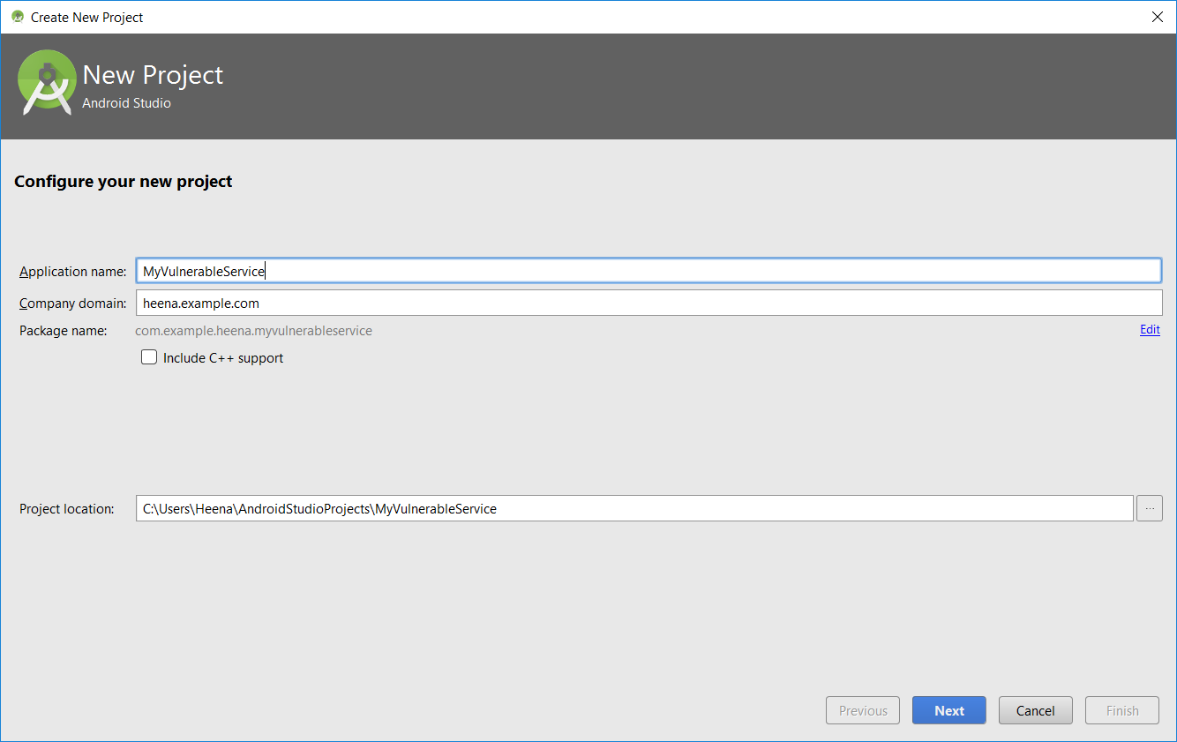

1. Set the Minimum SDK to API Level 15 or whatever your default is, and then click Next.

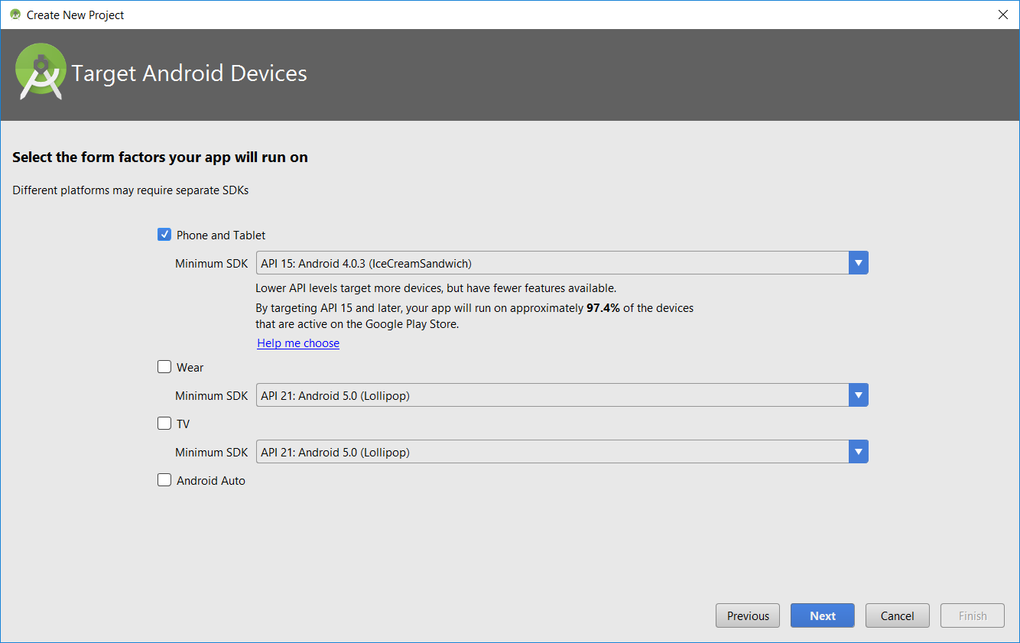

1. Select Empty Activity, click on next and then finish to start the project

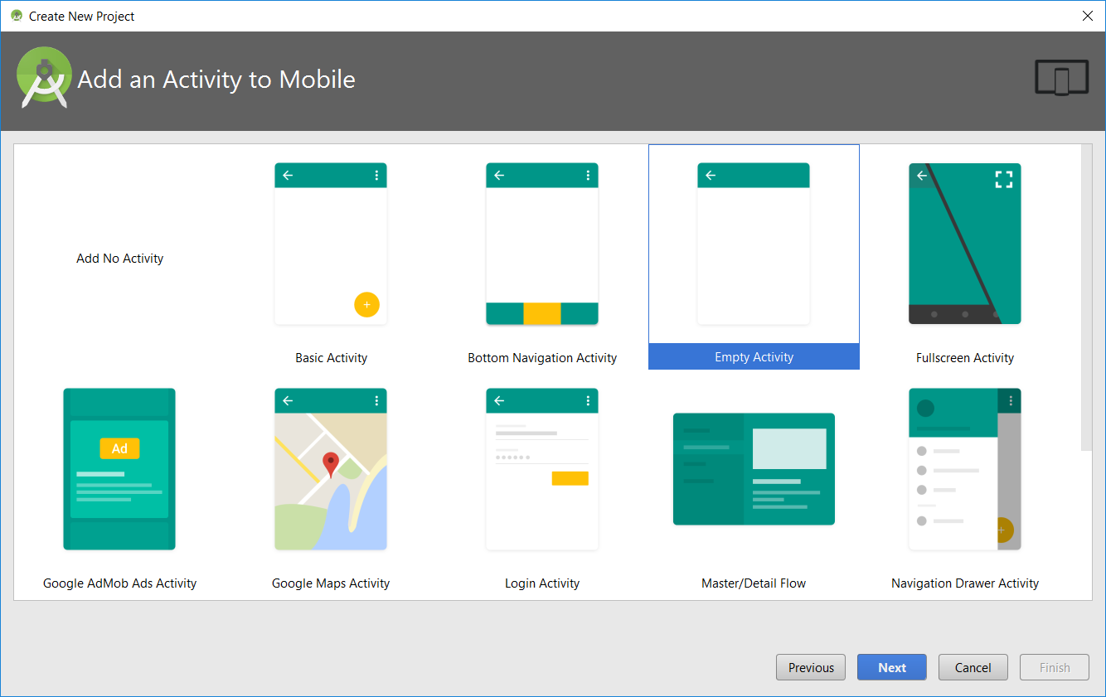

1. Open activity_main.xml which you’ll find under app/res/layout. Delete the “Hello World” TextView.
2. Let’s create an Activity that will allow the user to Start and Stop the service. Add 2 Buttons to a Relative Layout. We shall get to the details of these how we use them in our activity later in the tutorial. The code below adds the 2 Buttons to the layout.

|  |
| --- |
| *<?***xml version="1.0" encoding="utf-8"***?>* <**RelativeLayout xmlns:android="http://schemas.android.com/apk/res/android"  xmlns:app="http://schemas.android.com/apk/res-auto"  xmlns:tools="http://schemas.android.com/tools"  android:layout_width="match_parent"  android:layout_height="match_parent"  android:paddingTop="20dp"  android:paddingBottom="20dp"  android:paddingLeft="20dp"  android:paddingRight="20dp"  tools:context="** **your.package.name.myvulnerableservice.MainActivity"**>   <**Button  android:layout_width="match_parent"  android:layout_height="wrap_content"  android:text="@string/start_service_btn"  android:id="@+id/StartServiceBtn"** />   <**Button  android:layout_width="match_parent"  android:layout_height="wrap_content"  android:text="@string/stop_service_btn"  android:id="@+id/StopServiceBtn"  android:layout_below="@+id/StartServiceBtn"  android:layout_marginTop="10dp"**/>  </**RelativeLayout**> |

1. The highlighted lines represent properties text and id that specify the text that goes on the button and the Id that identifies those buttons on the activity. The Id is created and assigned here. We shall see how to use the Id when we write code for our Activity. However, the text that goes on the buttons shouldn’t be hard-coded in this file, but should be obtained from a different file that maintains all such strings. Add the following lines of code to the strings.xml file under res/values.

|  |
| --- |
| <**resources**>  <**string name="app_name"**>MyVulnerableService</**string**>  <**string name="start_service_btn"**>Start Service</**string**>  <**string name="stop_service_btn"**>Stop Service</**string**> </**resources**> |

1. Let’s write a service that generates random numbers continuously once we start the service and continues to do so until we stop it. Under app/java, right click on the folder that contains MainActivity i.e. your.package.name.myvulnerableservice. Select New and then select Java Class. Give it the name “MyVulnerableService” and click OK. Leave the rest of the defaults as they are. Alternatively, you could create a new Service from the Menu which will extend Android’s Service class for you and provide some you with some methods you need to override.

Copy and paste the following code into your MyVulnerableService.java file. Make sure the package name at the top of the file is where your file lives.

|  |
| --- |
| **package** your.package.name.myvulnerableservice; **import** android.app.Service; **import** android.content.Intent; **import** android.os.Handler; **import** android.os.IBinder; **import** android.os.Message; **import** android.os.Messenger; **import** android.os.RemoteException; **import** android.support.annotation.Nullable; **import** android.util.Log; **import** android.widget.Toast;   **public class** MyVulnerableService **extends** Service{   **private** Messenger **messenger**=**new** Messenger(**new** RequestHandler());  **public static final int *REQUEST_COUNT*** = 0;  **public boolean isServiceRunning**=**false**;  **private int random** = 0 ;   @Override  **public int** onStartCommand(Intent intent, **int** flags, **int** startId) {  **isServiceRunning** = **true**;  Thread service_thread = **new** Thread(**new** Runnable() {  @Override  **public void** run() {  startRandomNumGenerationService();  }  });  service_thread.start();  **return *START_STICKY***;  }   @Nullable  @Override  **public** IBinder onBind(Intent intent) {  **return messenger**.getBinder();  }   @Override  **public void** onDestroy() {  **super**.onDestroy();  stopRandomNumGenerationService();  }   **private static class** RequestHandler **extends** Handler {  @Override  **public void** handleMessage(Message message){  **switch** (message.**what**){  **case *REQUEST_COUNT***:  Message message_to_send = Message.*obtain*(**null**,***REQUEST_COUNT***);  message_to_send.**arg1** = *getRandomNumber*();  **try**{  message.**replyTo**.send(message_to_send);  }**catch** (RemoteException e){  Log.*i*(**"My Service"**,e.getMessage());  }  }   **super**.handleMessage(message);  }  }   **private void** startRandomNumGenerationService(){  **while**(**isServiceRunning**){  **try**{  Thread.*sleep*(1000);  **if**(**isServiceRunning**){  **random** = *getRandomNumber*();  Log.*i*(**"My Math Service"**,**"New Random Number is :"**+ **random**);  }  }**catch** (InterruptedException e){  Log.*i*(**"My Math Service"**,**"Service Thread Interrupted"**);  }  }  }   **private void** stopRandomNumGenerationService(){  **isServiceRunning** = **false**;  Toast.*makeText*(getApplicationContext(),**"Math Service Stopped"**, Toast.***LENGTH_SHORT***).show();  }   **public static int** getRandomNumber() {  **return** (**int**)(Math.*random*()*100+1);  }  } |

1. Let’s add this service to our manifest file. This being a bound service, we want to have another app we create communicate with this service. It is for this reason, we shall have the android:exported attribute of the service set to true. This is usually accompanied by Intent filters within the service declaration but you can no longer have implicit intents trigger services. Doing so will trigger an exception. This was added as part of Android 5.0 (API level 21), as a security feature to prevent other apps from accessing this service by using an implicit intent. However, constructing an explicit intent is not too difficult either. This allows other apps to gain access to service. We’ll get to one such dangerous activity later in this tutorial.

For now, copy and paste the following code into the AndroidManifest.xml file under app/manifests.

|  |
| --- |
| *<?***xml version="1.0" encoding="utf-8"***?>* <**manifest xmlns:android="http://schemas.android.com/apk/res/android"  package="** **your.package.name.myvulnerableservice"**>  <**application  android:allowBackup="true"  android:icon="@mipmap/ic_launcher"  android:label="@string/app_name"  android:roundIcon="@mipmap/ic_launcher_round"  android:supportsRtl="true"  android:theme="@style/AppTheme"**>  <**activity android:name=".MainActivity"**>  <**intent-filter**>  <**action android:name="android.intent.action.MAIN"** />  <**category android:name="android.intent.category.LAUNCHER"** />  </**intent-filter**>  </**activity**>  <**service  android:name=".MyVulnerableService"  android:exported="true"**>  </**service**>  </**application**> </**manifest**> |

You only need to add the highlighted portion to your manifest file. The rest should already be in there, since your activity is added to the manifest by default.

1. Let’s go ahead and write the code for our Activity. This will allow us to start and stop the service. Copy and paste the following code in your MainActivity.java file.

|  |
| --- |
| **package** your.package.name.myvulnerableservice;  **import** android.content.Context; **import** android.content.Intent; **import** android.support.v7.app.AppCompatActivity; **import** android.os.Bundle; **import** android.view.View; **import** android.widget.Button; **import** android.widget.Toast;  **public class** MainActivity **extends** AppCompatActivity **implements** View.OnClickListener {   **private** Button **serviceStartBtn**, **serviceStopBtn**;  **private** Context **context**;  **private** Intent **intent**;   @Override  **protected void** onCreate(Bundle savedInstanceState) {  **super**.onCreate(savedInstanceState);  setContentView(R.layout.***activity_main***);   **serviceStartBtn** = (Button) findViewById(R.id.***StartServiceBtn***);  **serviceStartBtn**.setOnClickListener(**this**);   **serviceStopBtn** = (Button) findViewById(R.id.***StopServiceBtn***);  **serviceStopBtn**.setOnClickListener(**this**);   **context** = getApplicationContext();   **intent** = **new** Intent(getApplicationContext(),MyVulnerableService.**class**);   }   @Override  **public void** onClick(View view){  **switch** (view.getId()){  **case** R.id.***StartServiceBtn***:startService(**intent**);  Toast.*makeText*(**context**,**"Math Service Started"**,Toast.***LENGTH_SHORT***).show();  **break**;  **case** R.id.***StopServiceBtn***: stopService(**intent**);  **break**;  **default**:  **break**;  }  } } |

The highlighted section shows you how we’re accessing the Buttons on our Activity by id. And how they’re used to start and stop the service.

1. Let’s test our service. Click on the run icon on the toolbar. You should have the emulator show up in a minute with the Activity and the start and stop service buttons.

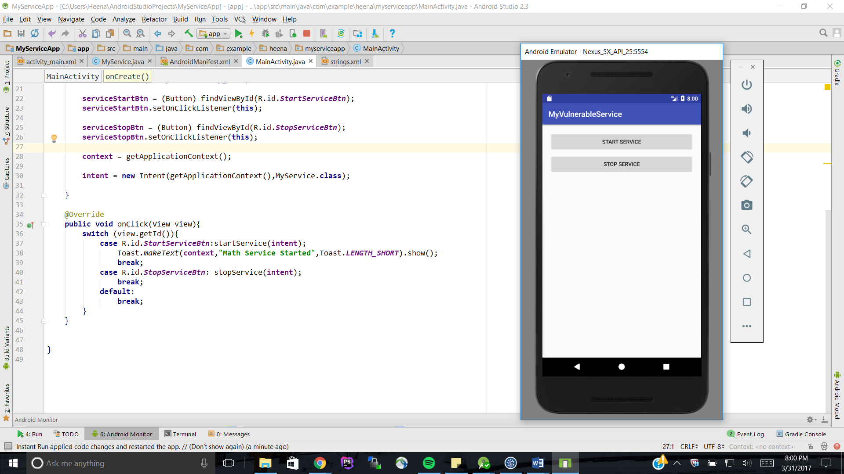

Click on the Start Service Button – a Toast should show up indicating the service has started running. Stopping the service will also show a similar toast.

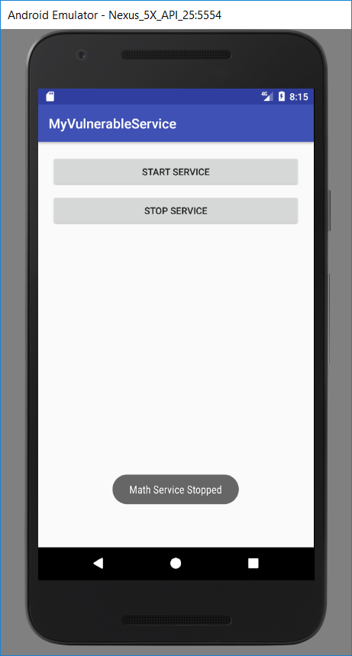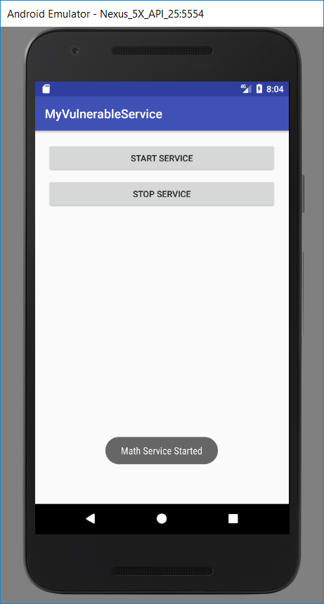

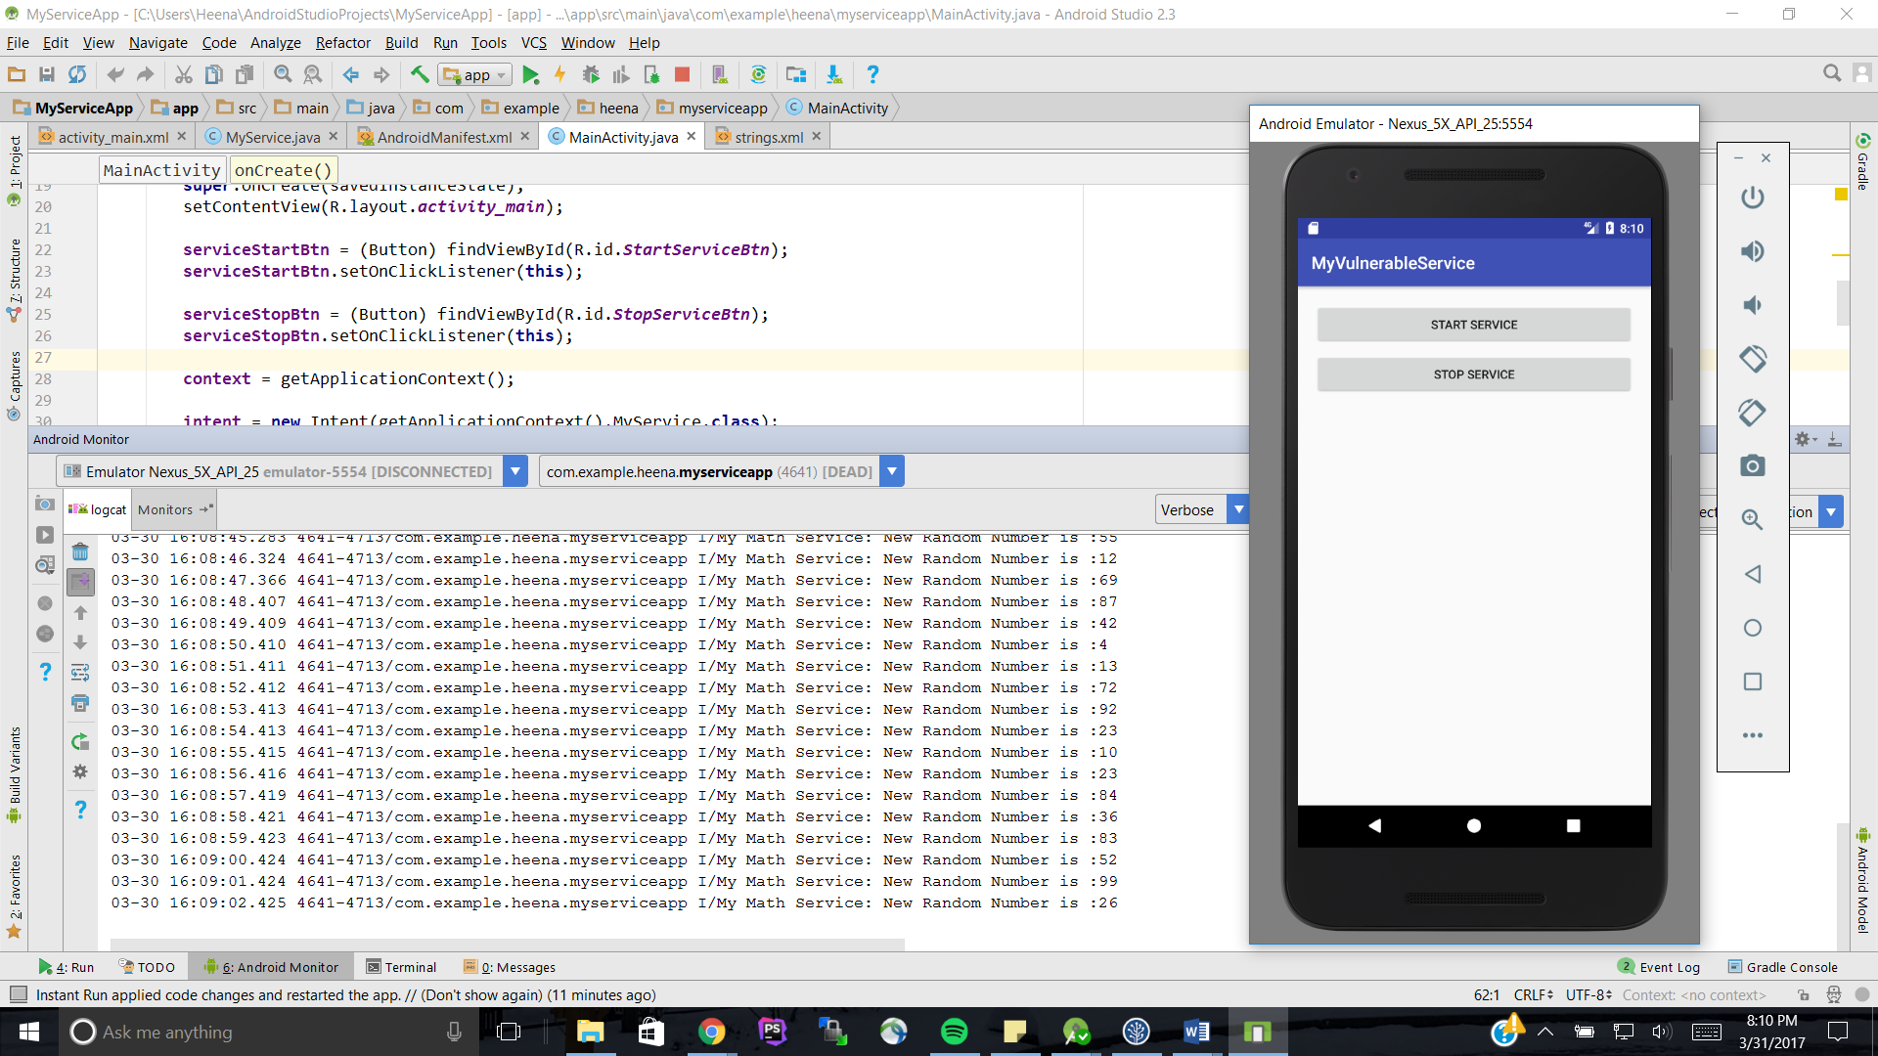Observe the Android Monitor and you should see the service running, displaying random numbers.

Let’s build the client app that will bind to the service we just created and try and get data back from the service.

Steps to build the **Client app**:

1. 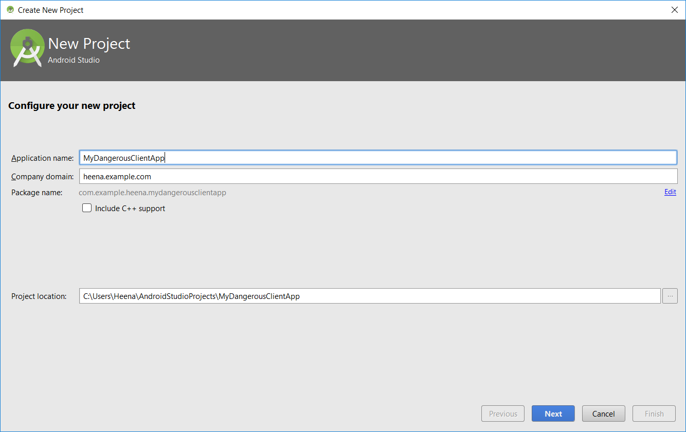Open Android Studio and create new Android project and name it “MyDangerousClientApp”. Make sure to save the package name somewhere on your computer since you will need it in a later stage of this tutorial. Click next.
2. Set the Minimum SDK to API Level 15 or whatever your default is, and then click Next.
3. Select Empty Activity, click on next and then finish to start the project
4. Open activity_main.xml which you’ll find under app/res/layout. Delete the “Hello World” TextView.
5. Let’s create an Activity that will allow the user to Bind to the service and Start the service. Add 2 Buttons to a Relative Layout just like we did for the service. We’ll also add a textView that will display the random number returned by the service to this app. We shall get to the details of these how we use these buttons in our activity later in the tutorial. The code below adds these 2 Buttons and the TextView to the layout.

|  |
| --- |
| *<?***xml version="1.0" encoding="utf-8"***?>* <**RelativeLayout xmlns:android="http://schemas.android.com/apk/res/android"  xmlns:app="http://schemas.android.com/apk/res-auto"  xmlns:tools="http://schemas.android.com/tools"  android:layout_width="match_parent"  android:layout_height="match_parent"  android:paddingTop="20dp"  android:paddingBottom="20dp"  android:paddingLeft="20dp"  android:paddingRight="20dp"  tools:context="your.package.name.MainActivity"**>   <**Button  android:layout_width="match_parent"  android:layout_height="wrap_content"  android:text="@string/bind_to_service_btn"  android:id="@+id/BindToServiceBtn"** />   <**Button  android:layout_width="match_parent"  android:layout_height="wrap_content"  android:text="@string/invoke_service_btn"  android:id="@+id/InvokeServiceBtn"  android:layout_below="@+id/BindToServiceBtn"  android:layout_marginTop="10dp"**/>    <**TextView  android:layout_width="match_parent"  android:layout_height="wrap_content"  android:layout_alignParentTop="true"  android:layout_below="@+id/InvokeServiceBtn"  android:textSize = "20sp"  android:layout_marginTop="120dp"  android:id="@+id/ResultView"**/>  </**RelativeLayout**> |

1. Let’s add the strings that represents text that goes on the buttons. Copy and paste the following lines of code to the strings.xml file under res/values.

|  |
| --- |
| <**resources**>  <**string name="app_name"**>MyDangerousClientApp</**string**>  <**string name="invoke_service_btn"**>Get New Random Number</**string**>  <**string name="bind_to_service_btn"**>Bind to Math Service</**string**> </**resources**> |

1. Let’s add the activity to the manifest file. Copy and paste the following lines of code to the AndroidManifest.xml file.

|  |
| --- |
| *<?***xml version="1.0" encoding="utf-8"***?>* <**manifest xmlns:android="http://schemas.android.com/apk/res/android"  package="your.package.name.mydangerousclientapp"**>   <**application  android:allowBackup="true"  android:icon="@mipmap/ic_launcher"  android:label="@string/app_name"  android:roundIcon="@mipmap/ic_launcher_round"  android:supportsRtl="true"  android:theme="@style/AppTheme"**>  <**activity android:name=".MainActivity"**>  <**intent-filter**>  <**action android:name="android.intent.action.MAIN"** />  <**category android:name="android.intent.category.LAUNCHER"** />  </**intent-filter**>  </**activity**>  </**application**>  </**manifest**> |

1. We know that we cannot access a service without having an explicit intent. Creating an explicit intent requires the package name and the app name that contains the service. Any external app doesn’t generally know the package name of the service. However, there are many ways of determining the package name given the app name in code. There are also apps on the Play Store that can give you the package names of all apps on your device !

This makes it trivial to create an explicit intent and bind to the service. (assuming the class name of the service is same as that of the app name here)

Now since our service has its exported attribute set to true, any app can create the explicit intent from the package name and start the service.This is how our dangerous app works!

Copy and paste the following code into the MainActivity.java file.

|  |
| --- |
| **package** your.package.name.mydangerousclientapp;  **import** android.content.ComponentName; **import** android.content.Intent; **import** android.content.ServiceConnection; **import** android.content.pm.ApplicationInfo; **import** android.content.pm.PackageManager; **import** android.os.Handler; **import** android.os.IBinder; **import** android.os.Message; **import** android.os.Messenger; **import** android.os.RemoteException; **import** android.support.v7.app.AppCompatActivity; **import** android.os.Bundle; **import** android.util.Log; **import** android.view.View; **import** android.widget.Button; **import** android.widget.TextView; **import** android.widget.Toast;  **import** java.util.List;  **public class** MainActivity **extends** AppCompatActivity **implements** View.OnClickListener {   **private boolean isBound**;  **private int randomVal**;  *// This application will only invoke the math services getRandomNumber function* **private static final int *GET_RANDOMNUM_FLAG*** = 0 ;  **private static final** String ***RUN_SERVICE*** = **"RUNSERVICE"**;   **private** Button **bindToServiceBtn**, **invokeServiceBtn**;  **private** TextView **viewResult**;   Messenger **requestMessenger**, **responseMessenger**;  **private** Intent **intent**;    @Override  **protected void** onCreate(Bundle savedInstanceState) {  **super**.onCreate(savedInstanceState);  setContentView(R.layout.***activity_main***);   **viewResult** = (TextView)findViewById(R.id.***ResultView***);  **bindToServiceBtn** = (Button)findViewById(R.id.***BindToServiceBtn***);  **bindToServiceBtn**.setOnClickListener(**this**);  **invokeServiceBtn** = (Button)findViewById(R.id.***InvokeServiceBtn***);  **invokeServiceBtn**.setOnClickListener(**this**);    **final** PackageManager pm = getPackageManager();   *//get a list of installed apps.* List<ApplicationInfo> applications = pm.getInstalledApplications(PackageManager.***GET_META_DATA***);   **for** (ApplicationInfo applicationInfo: applications) {   CharSequence appName = pm.getApplicationLabel(applicationInfo);   **if**((appName).equals(**"MyVulnerableService"**))  {  **intent** = **new** Intent();  **intent**.setComponent(**new** ComponentName(applicationInfo.**packageName**,applicationInfo.**packageName** + **"."**+appName));  **break**;  }  **else**{  **continue**;  }  }  }  ServiceConnection **serviceConnection** = **new** ServiceConnection() {  @Override  **public void** onServiceConnected(ComponentName arg0, IBinder binder) {  *//wrap the binder returned from the onBind method in the Service* **requestMessenger**=**new** Messenger(binder);  */*wrap the Handler that will handle the response being sent from the service*/* **responseMessenger**=**new** Messenger(**new** ResponseHandler());  **isBound**=**true**;  }  @Override  **public void** onServiceDisconnected(ComponentName arg0) {  **requestMessenger**=**null**;  **responseMessenger**=**null**;  **isBound** = **false**;  }  };   **private class** ResponseHandler **extends** Handler{   @Override  **public void** handleMessage(Message message) {  **randomVal** = 0;  */*message sent from the messenger  that holds an instance of the Binder  returned from the onBind Method of the service*/* **switch** (message.**what**){  **case *GET_RANDOMNUM_FLAG***:  **randomVal** = message.**arg1**;  **viewResult**.setText(**"Math Service - Random number is "** + **randomVal**);  **break**;  **default**:  **break**;   }  **super**.handleMessage(message);  }  }    **private void** bindToService(){  //*bind to the service using the explicit intent we created*  bindService(**intent**,**serviceConnection**,***BIND_AUTO_CREATE***);  Toast.*makeText*(getApplicationContext(),**"Bound to Math Service"**,Toast.***LENGTH_SHORT***).show();  }    **private void** fetchNewRandomNum(){  **if**(**isBound**){  Message request = Message.*obtain*(**null**,***GET_RANDOMNUM_FLAG***);  */*Message's replyTo attribute takes a messenger indicating  which messenger the reply should be sent to  once we have received something from the service*/* **try**{  *//set receiving messenger* request.**replyTo** = **responseMessenger**;  *//send request to service* **requestMessenger**.send(request);  }**catch** (RemoteException e){  Log.*i*(**"My Dangerous Client App"**,e.getMessage());  }   }  }   @Override  **public void** onClick(View view){  **switch** (view.getId()){  **case** R.id.***BindToServiceBtn***: bindToService();  **break**;  **case** R.id.***InvokeServiceBtn***: fetchNewRandomNum();  **break**;  **default**:**break**;  }  } } |

1. Let’s test our dangerous app. We first start the service app like we did earlier in this tutorial.

We then start the “dangerous” client app, bind to the service and run it. Since our service is exported without any restrictions to enable access any app can do what our dangerous app does. Run the app. You should see the activity display the 2 buttons we added

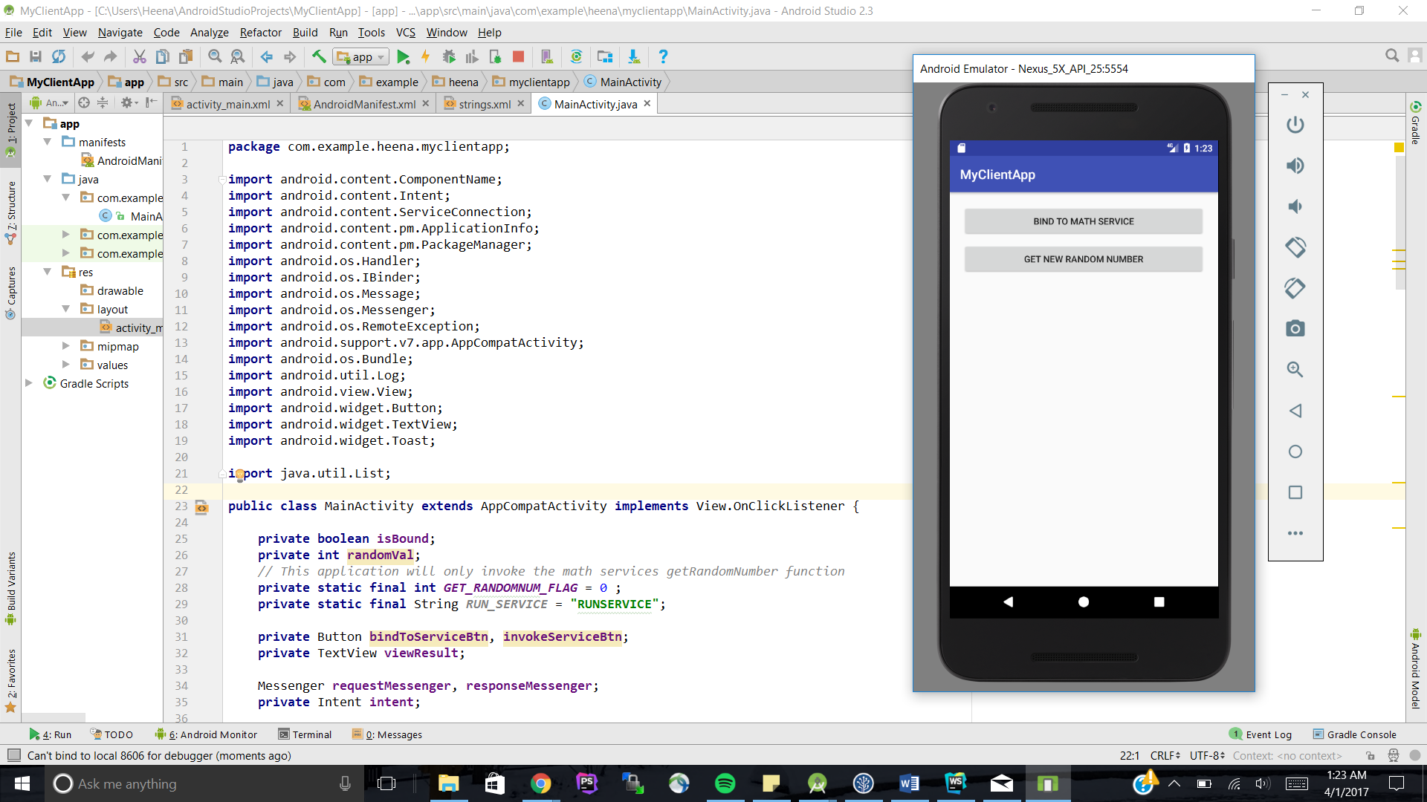

Then bind to the service before getting a new random number.

