





MS4.1 TenSyGrid Toolbox Roadmap
By: CITCEA UPC | Confidential
This research was funded by CETPartnership, the Clean Energy Transition Partnership under the 2023 joint call for research proposals, co funded by the European Commission (GA 101 069750) and with the funding organizations detailed on https://cetpartnership.eu/funding-agencies-and-call-modules


Tensors for System Analysis of
Converter-dominated Power Grids

About TenSyGrid
The demand for the power grid in Europe is undergoing profound changes due to an increasing number of decentralized feed-in points and the fluctuating supply from renewable energies. This complexity in interactions between power grid components poses a challenge for maintaining system stability. To address this, the European project TenSyGrid is developing a toolbox for direct stability assessment using multilinear models to capture the complex dynamics of power grid components. The objective is to support grid operators in assessing large power grids primarily powered by renewable energy. The toolbox will be compatible with existing commercial software packages to facilitate integration into current workflows.

Project title | Tensors for System Analysis of Converter-dominated Power Grids
Programme | Horizon Europe - Clean Energy Transition Partnership (CETP)
Project number | CETP-FP-2023-00138
Project type | Research-oriented approach (ROA)
Call module | CM2023-02 Energy system flexibility: renewables production, storage and system integration
Transition initiative | TRI1 Net-zero emissions energy system
Project start | 01.12.2024
Project duration | 3 years
Coordinator | Fraunhofer IWES
Project website | www.tensygrid.eu

Consortium





(Project Coordinator)

About this document
Milestone number | MS4.1
Title | Completed TenSyGrid Toolbox Roadmap
Work package | WP4 TenSyGrid Toolbox Development
Leading partner | Universitat Politècnica de Catalunya (UPC)
Author(s) | Alexandre Gràcia-Calvo; Carlos Herrera Vázquez; Eduardo Prieto-Araujo
Contributors | Technical input from eRoots, Fraunhofer IWES, HAW and UM through the project work
Reviewer(s) | UM (review pending)
Version | 1.1.0
Due date of milestone | 30.11.2026
Version date | 06.11.2026
Review status | Use-case catalogue completed; consortium review pending
WP leader acceptance | Pending

Dissemination level
PU | Public
CO | Confidential. Only for members of the consortium, CETP, EC and Funding agencies | X

Milestone MS4.1

Completed TenSyGrid Toolbox Roadmap
UPC has identified and documented fourteen toolbox use cases in D4.1, which has been submitted. Five core cases are functional in the Stability Monitor GUI. These outputs provide the application catalogue and working core supporting MS4.1.

Use case discovery
The use cases were developed from the experience of CITCEA-UPC and the TenSyGrid consortium. Their relevance was validated through discussions with industrial stakeholders representing network operators, equipment manufacturers and consultants.

Results
The five implemented cases cover small-signal analysis, system-status and eigenvalue screening, critical-mode diagnosis, bus-voltage checks and N-1 contingency assessment. D4.1 documents these cases and nine proposed extensions, including their objectives, methods and expected outputs. Figures 1 to 3 illustrate network and method selection, result inspection and contingency comparison.

Further development
The catalogue is not a commitment to implement every proposed case. The consortium will select the most important extensions according to user needs, priority and technical feasibility. Research-oriented options, particularly region-of-attraction assessment, remain conditional on further investigation; their feasibility within the project has not yet been established.

Means of verification
The submitted D4.1 provides the detailed catalogue and stakeholder findings. The repository contains the functional GUI and supporting analysis scripts.
TenSyGrid Public Deliverables
TenSyGrid Public Repository

GUI workflow
The GUI supports network and calculation-method selection (Figure 1), system-status and eigenvalue inspection (Figure 2), and contingency comparison (Figure 3). The screenshots illustrate different study runs.
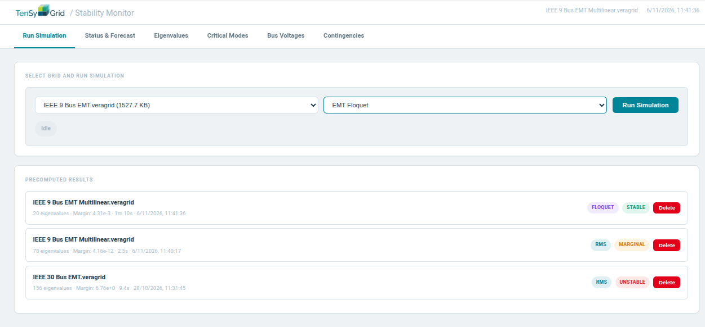
Figure 1. UC-01 network and calculation-method selection, with saved analysis results.
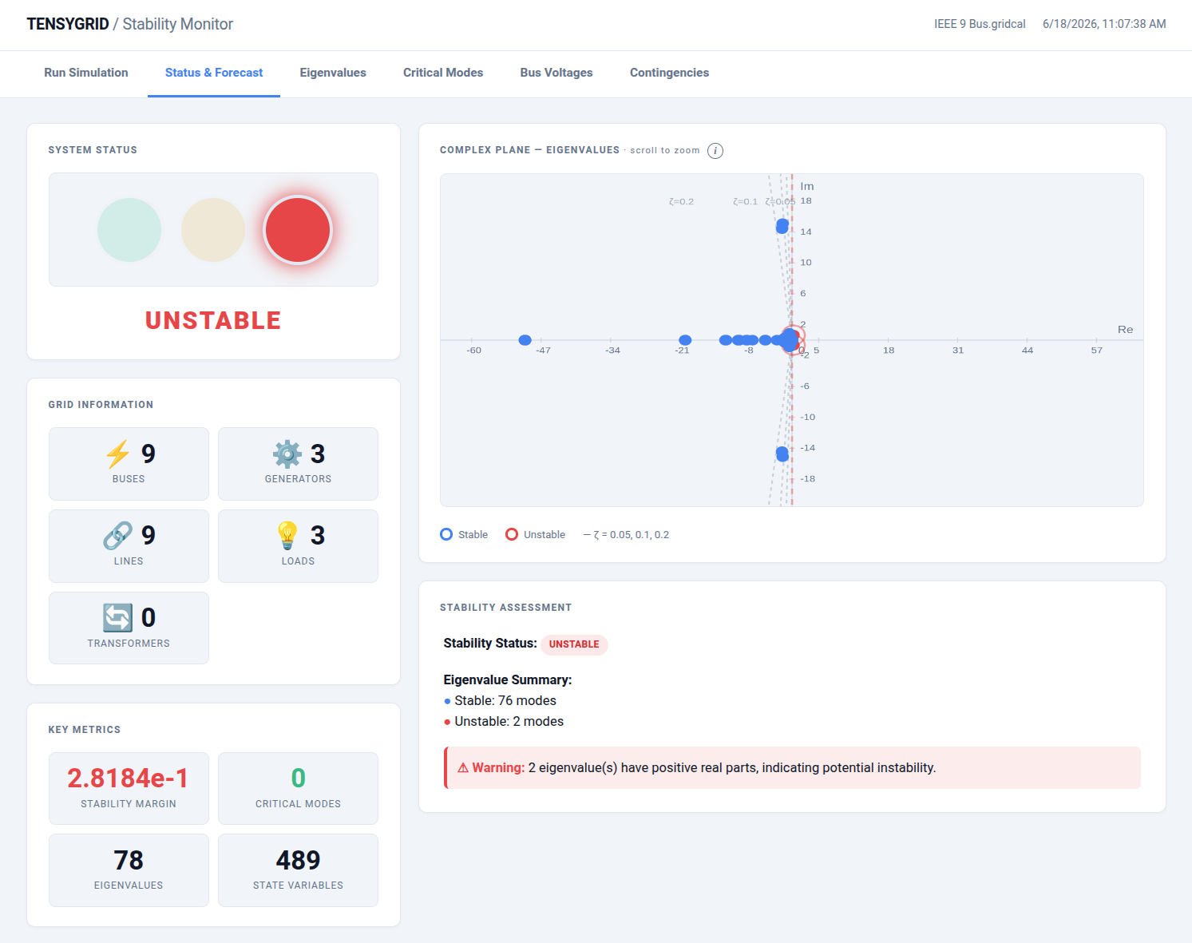
Figure 2. UC-02 system overview and eigenvalue screening. Source: D4.1.

GUI workflow continued
Figure 3 illustrates UC-05 on an IEEE 9-bus EMT multilinear example. After a generator outage, the displayed result changes from a stable base case to an unstable case with eight unstable eigenvalues.
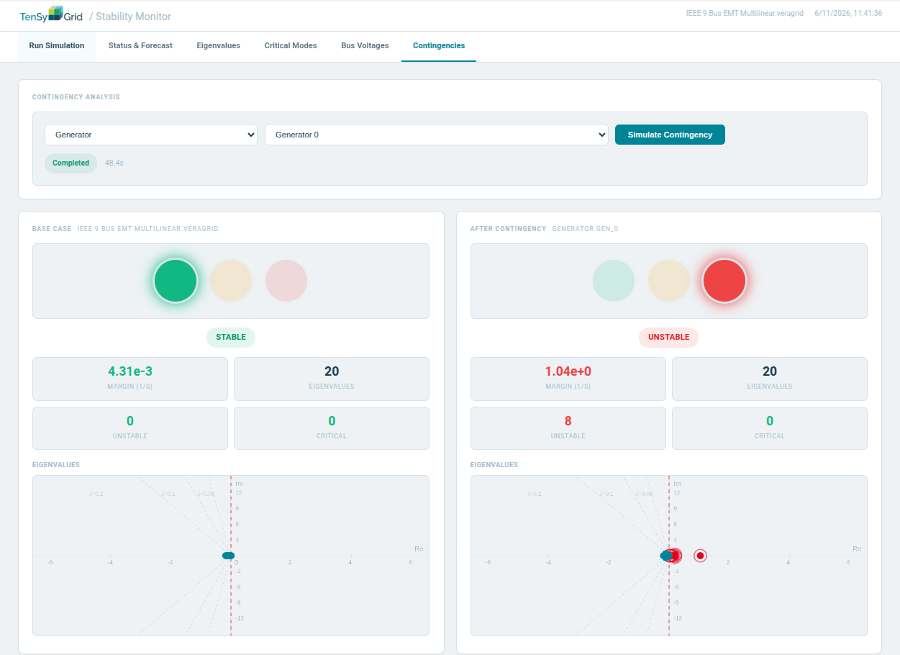
Figure 3. UC-05 comparison of the base case and generator-outage result.

Conclusion
The submitted use-case catalogue and five functional GUI cases are the documented outputs supporting MS4.1. Subsequent development will focus on selected extensions, based on their importance, priority and technical feasibility.

