Set 2 – Insurance Claims Processing
Name : Chitharthaa A
Date : 30/10/2026

1. Problem Overview
An insurer handles claims in large volumes, and three practical problems come up again and again. Every claim must move through a fixed sequence of approval stages. The same claim is often filed twice, with only small differences in how the policy number was typed. And after a flood or a storm hits one region, the daily claim count can rise sharply for several days in a row. On top of this, two regional offices maintain separate, already-sorted claim lists that eventually have to be combined.
Each of these problems maps cleanly onto a standard technique. The sections that follow treat them one at a time: a binary search tree for storing claim IDs, hashing for spotting duplicates, breadth-first and depth-first search on the approval graph, a sliding window for claim spikes, and two pointers for merging the regional lists. For every task, I describe the reasoning, give the pseudocode, list the test cases and state the running cost.
The working program is written in Python and was executed on the Programiz online compiler; its output appears in Section 8.

2. Task 1 – Binary Search Tree of Claim IDs

2.1 Approach
Claim IDs are stored in a binary search tree, which follows one ordering rule at every node: smaller IDs sit in the left subtree and larger IDs sit in the right subtree. When an ID that already exists is inserted a second time, the insert simply stops without adding a node, so each claim appears in the tree exactly once.
Searching uses the same rule. Starting from the root, the target is compared with the current node and the search moves left or right accordingly. It ends either at the matching node or at an empty link, in which case the ID is not present.

2.2 The Three Traversals
- Inorder (Left, Root, Right): the left subtree is visited first, then the node itself, then the right subtree.
- Preorder (Root, Left, Right): the node is visited before its children. This order is handy when the tree has to be copied or written out, because rebuilding from it gives back the same shape.
- Postorder (Left, Right, Root): the node is visited after both children, which is the natural order for freeing or deleting a tree.
Which traversal gives claims in sorted order? Inorder. At any node, every ID in its left subtree is smaller and every ID in its right subtree is larger, so printing left side, then node, then right side can only produce ascending order. In the test run, the IDs were inserted as 50, 30, 70, 20, 40, 60, 80, and inorder printed them back as 20, 30, 40, 50, 60, 70, 80.

2.3 Pseudocode
PROCEDURE INSERT(root, id)
IF root is NULL THEN
RETURN new Node(id)
IF id < root.key THEN
root.left ← INSERT(root.left, id)
ELSE IF id > root.key THEN
root.right ← INSERT(root.right, id)
RETURN root // equal id is skipped
FUNCTION SEARCH(root, id)
WHILE root is not NULL AND root.key ≠ id DO
IF id < root.key THEN root ← root.left
ELSE root ← root.right
RETURN (root is not NULL)
PROCEDURE INORDER(node)
IF node is not NULL THEN
INORDER(node.left); PRINT node.key; INORDER(node.right)
PROCEDURE PREORDER(node)
IF node is not NULL THEN
PRINT node.key; PREORDER(node.left); PREORDER(node.right)
PROCEDURE POSTORDER(node)
IF node is not NULL THEN
POSTORDER(node.left); POSTORDER(node.right); PRINT node.key

2.4 Test Cases
1. Normal insert: Input – 50, 30, 70, 20, 40, 60, 80; Expected Result – Inorder: 20 30 40 50 60 70 80; Actual Result – Matched.
2. Duplicate ID: Input – 40 inserted twice; Expected Result – Stored only once; Actual Result – Matched.
3. Search found: Input – Search 60; Expected Result – True; Actual Result – True.
4. Search missing: Input – Search 65; Expected Result – False; Actual Result – False.
5. Empty input: Input – Empty tree; Expected Result – Traversal = [ ], search = False; Actual Result – Matched.

3. Task 2 – Detecting Duplicate Claims Using Hashing

3.1 Approach
For this task, two claims count as the same claim when they share a policy number and an incident date, even if the policy number was entered as "POL 123" in one and "pol123" in the other. To make such entries comparable, each value is normalised first: all spaces are stripped and the letters are converted to upper case. The normalised (policy, date) pair then serves as the key.
A hash table, here a Python dictionary, records the first claim seen for every key. Each incoming claim is normalised and looked up. A hit means the claim repeats an earlier one, so it is reported along with the original; a miss means it is new, so its key is stored. Because a dictionary lookup costs constant time on average, the whole batch is checked in one pass, whereas comparing every claim against every other would take quadratic time.

3.2 How Collisions Are Handled
A collision occurs when two different keys hash to the same slot. Hash tables usually resolve this in one of two ways:
- Separate chaining: every slot holds a short list, and colliding keys are appended to it. A lookup scans only that list.
- Open addressing: when a slot is occupied, the table probes further slots in a fixed sequence until it reaches an empty one. Python’s dictionary is built on this scheme.
Either way, the table confirms a match by comparing the stored key itself, not just its hash value, so two unrelated claims are never flagged as duplicates merely because their hashes coincide. The table also resizes once it fills beyond a set load, which keeps collisions infrequent.

3.3 Pseudocode
FUNCTION MAKE_KEY(policy, date)
p ← policy with all spaces removed, in UPPER case
d ← date with all spaces removed
RETURN (p, d)
FUNCTION FIND_DUPLICATES(claims)
seen ← empty hash table
dups ← empty list
FOR each (id, policy, date) IN claims DO
key ← MAKE_KEY(policy, date)
IF key exists in seen THEN
ADD (id, seen[key]) TO dups
ELSE
seen[key] ← id
RETURN dups

3.4 Test Cases
1. Case difference: Input – C1 "POL 123", C2 "pol123", same date; Expected Result – C2 duplicate of C1; Actual Result – Matched.
2. Spacing difference: Input – C5 "POL 1 23", same date; Expected Result – C5 duplicate of C1; Actual Result – Matched.
3. Different policy: Input – C3 "POL124"; Expected Result – Not a duplicate; Actual Result – Not reported.
4. Different date: Input – C4 " Pol 123 ", 2026-10-02; Expected Result – Not a duplicate; Actual Result – Not reported.
5. Empty input: Input – No claims; Expected Result – [ ]; Actual Result – [ ].

4. Task 3 – Claim Approval Stages as a Directed Graph

4.1 Approach
Each approval stage becomes a node, and a directed edge from one stage to another means a claim is allowed to move in that direction. The graph is kept as an adjacency list. In the example used here, a claim moves from Registration to Assessment; from Assessment it either goes to a Surveyor or, when the amount is small, directly to Settlement.
Shortest path with BFS: Breadth-first search uses a queue and explores the graph one level at a time, so every stage is first reached through the fewest possible edges. The first time the target stage comes off the queue, the path found is therefore a shortest one. A parent record for each stage lets the route be traced back once the target is reached.
Loop detection with DFS: A loop would let a claim cycle between stages without ever being settled. Depth-first search follows a single route as deep as it can go, marking each stage as "in progress" on entry and "done" on exit. Reaching a stage that is still "in progress" means the search has returned to a stage on its own current route, which can only happen if the graph contains a cycle.

4.2 Pseudocode
FUNCTION BFS_PATH(graph, start, goal)
IF start not in graph THEN RETURN empty path
parent[start] ← NULL
queue ← [start]
WHILE queue is not empty DO
cur ← remove front of queue
IF cur = goal THEN
follow parent links from goal back to start
RETURN the path in reverse
FOR each next IN graph[cur] DO
IF next has no parent entry THEN
parent[next] ← cur
add next to back of queue
RETURN empty path
FUNCTION HAS_LOOP(graph)
state ← empty // 1 = in progress, 2 = done
FUNCTION DFS(u)
state[u] ← 1
FOR each v IN graph[u] DO
IF state[v] = 1 THEN RETURN TRUE
IF v not visited AND DFS(v) THEN RETURN TRUE
state[u] ← 2
RETURN FALSE
FOR each stage u IN graph DO
IF u not visited AND DFS(u) THEN RETURN TRUE
RETURN FALSE

4.3 Test Cases
1. Shortest path: Input – Registration to Settlement; Expected Result – Registration → Assessment → Settlement; Actual Result – Matched.
2. No loop: Input – Normal stage graph; Expected Result – False; Actual Result – False.
3. Loop added: Input – Edge Surveyor → Assessment; Expected Result – True; Actual Result – True.
4. Empty input: Input – Empty graph; Expected Result – Path [ ], loop False; Actual Result – Matched.

5. Task 4 – Longest Run of Days with More Than 100 Claims

5.1 Approach
The input is the claim count for each day, in date order, and the goal is the longest unbroken stretch of days on which every count exceeds 100. A sliding window finds this in a single pass. The window’s right edge advances one day at a time. While each new day is above 100, the window simply grows. The moment a day with 100 or fewer claims appears, the streak ends, so the left edge jumps to the following day and a fresh window begins. The window’s length is checked after every step, and the largest length seen is kept as the answer.
With the data 80, 120, 150, 90, 130, 140, 160, 110, 70, two streaks appear: (120, 150), lasting 2 days, and (130, 140, 160, 110), lasting 4 days. The answer is therefore 4.

5.2 Pseudocode
FUNCTION LONGEST_RUN(daily, limit = 100)
best ← 0
left ← 0
FOR right ← 0 TO length(daily) − 1 DO
IF daily[right] ≤ limit THEN
left ← right + 1 // streak broken
best ← MAX(best, right − left + 1)
RETURN best

5.3 Test Cases
1. Normal data: Input – 80, 120, 150, 90, 130, 140, 160, 110, 70; Expected Result – 4; Actual Result – 4.
2. Empty input: Input – [ ]; Expected Result – 0; Actual Result – 0.

6. Task 5 – Merging Two Sorted Claim Lists

6.1 Approach
Both regional offices supply their claims already sorted by ID, so concatenating the lists and sorting again would discard work that has already been done. Instead, one pointer is placed at the start of each list. At every step the two current IDs are compared, the smaller is appended to the result, and only that pointer advances. When either list is exhausted, the remainder of the other is already in order and is appended as it stands. An ID present in both lists, such as 105 in the test data, is kept twice and the two copies end up side by side.

6.2 Pseudocode
FUNCTION MERGE(a, b)
i ← 0, j ← 0
result ← empty list
WHILE i < length(a) AND j < length(b) DO
IF a[i] ≤ b[j] THEN
ADD a[i] TO result; i ← i + 1
ELSE
ADD b[j] TO result; j ← j + 1
ADD remaining items of a TO result
ADD remaining items of b TO result
RETURN result

6.3 Test Cases
1. Normal merge: Input – [101, 105, 110, 120] and [102, 105, 115]; Expected Result – [101, 102, 105, 105, 110, 115, 120]; Actual Result – Matched.
2. Duplicate across lists: Input – 105 in both lists; Expected Result – Both copies kept, in order; Actual Result – Matched.
3. One list empty: Input – [ ] and [3,7]; Expected Result – [3,7]; Actual Result – [3,7].
4. Both empty: Input – [ ] and [ ]; Expected Result – [ ]; Actual Result – [ ].

7. Complexity Analysis
In the list below, n and m are input sizes, h is the height of the tree, V is the number of approval stages and E is the number of transitions between them.
1. BST: Operation – Insert / Search; Time – O(h): O(log n) average, O(n) worst; Space – O(h) for recursion.
2. BST: Operation – Inorder / Preorder / Postorder; Time – O(n); Space – O(h).
3. Hashing: Operation – Find duplicates; Time – O(n) average; Space – O(n).
4. Graph: Operation – BFS shortest path; Time – O(V + E); Space – O(V).
5. Graph: Operation – DFS loop check; Time – O(V + E); Space – O(V).
6. Sliding window: Operation – Longest run > 100; Time – O(n); Space – O(1).
7. Two pointers: Operation – Merge two lists; Time – O(n + m); Space – O(n + m) for the result.
A plain BST degrades to O(n) only when IDs arrive in already-sorted order, since every new node then lands on the same side and the tree becomes a chain. A self-balancing variant such as an AVL tree would hold searches at O(log n); for the scale of this case study, the plain version is sufficient.

- Searching and storing: The BST takes O(log n) time per insert or search on average, but drops to O(n) if claim IDs arrive already sorted, because the tree becomes a chain. Hashing avoids this problem and finds duplicates in O(n) total time, using O(n) extra space for the table.
- Approval stages: Both BFS (shortest path) and DFS (loop check) visit each stage and each transition at most once, so each runs in O(V + E) time. Each needs O(V) space for the queue, recursion stack and visited markers.
- Spike detection and merging: The sliding window passes over the daily counts once in O(n) time and uses only O(1) extra space, since it stores just two indexes and the best length. The two-pointer merge runs in O(n + m) time, which beats the O((n + m) log(n + m)) cost of joining the lists and sorting them again.
- Overall efficiency: Every solution runs in linear time or better, apart from the worst case of the unbalanced BST. None of them compares every claim against every other claim, so they would still run quickly when the daily claim volume grows into the thousands.

8. Program Output
The full program was run on the Programiz online Python compiler. The screenshot shows the output of all five tasks, including the empty-input and duplicate cases.

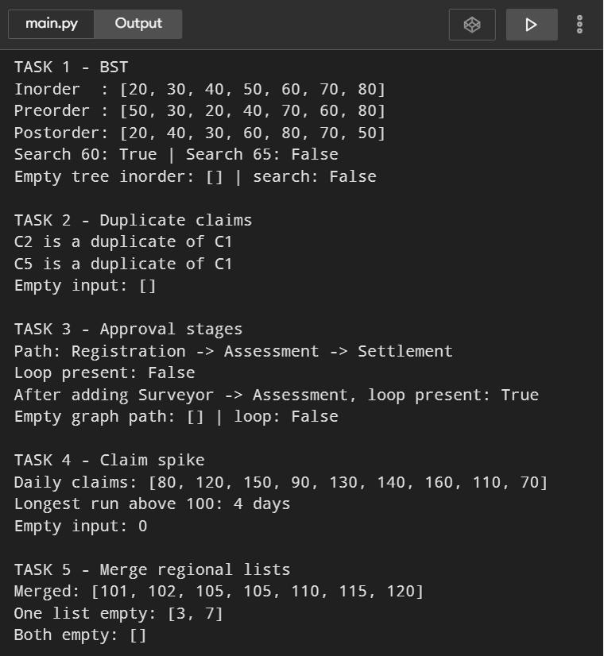

Figure 1: Output of the program on the Programiz online compiler

