**CE 650 C – PROJECT PROPOSAL**

The proposed project will evaluate the data that is collected through the archives for the I-405 corridor, Seattle, Washington. The following are some of the analysis measures that can be performed on the data.

1. Cause of the incidents
2. Correlation between the incident cause and weather (Impact of visibility condition on the incidents)
3. Difference in speed of the segment before and after the occurrence of the incident

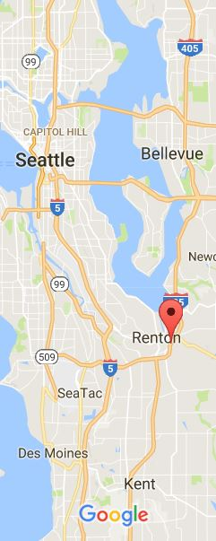

I-405 Seattle, Washington, USA

Data Size: 27.1 GB

Data Obtained from: Research Data Exchange, US DoT.

LINK:

https://www.its-rde.net/index.php/rdedataenvironment/10101