**Parallel Computation of Performance Based Operations Assessment of Adaptive Control Implementation.**

**Anjana AVR**

Department of Civil, Construction, and Environmental Engineering

Iowa State University

394 Town Engineering, Ames, IA 50011

Tel: 515-294-2140; Email: [anjana31@iastate.edu](mailto:anjana31@iastate.edu)

**Tingting Huang**

Department of Civil, Construction, and Environmental Engineering

Iowa State University

394 Town Engineering, Ames, IA 50011

Tel: 515-294-2140; Email: [thuang1@iastate.edu](mailto:thuang1@iastate.edu)

**Anuj Sharma (Corresponding Author)**

Department of Civil, Construction, and Environmental Engineering

Iowa State University

394 Town Engineering, Ames, IA 50011

Tel: 515-294-2140; Email: [anujs@iastate.edu](mailto:anujs@iastate.edu)

Keywords: traffic signal, performance measures, arterial roads, progression, big data

Submitted for publication on June, 2017

**Abstract**

The traditional method of operating signalized intersections by using time of day plans is still widely practiced. The efficiency of this method is limited as it cannot adapt to the varying traffic demand. Adaptive signal control is one potential solution, as the timing plans in this method change according to the varying traffic demand, and provides optimum timing plans for each phase wise movement, hence ensuring maximum operational efficiency. One of the basic requirements to understand the working, efficiency and limitations of an adaptive signal control is to evaluate the system under various performance measures. However, issues such as under or over utilization of a phase, impact of pedestrian traffic and their corresponding timing plans etc., pose challenges towards achieving maximum efficiency. For these issues an aggregated analysis would not help in determining the cause of a problem due to a phase in particular, and hence in this study a phase wise analysis is performed. In the recent times of technological advancements in big data it has paved the way for collection and storage of large volumes of traffic data. This also helps in achieving movement specific analysis for the large historic data that is collected. The study area for this study are multiple corridors in West Des Moines area. In this analysis of signalized intersections, the data is initially filtered for potential errors of data logging. Following this, performance measures such as phase failures, longwait, cycle and green duration, delay, queue length and two way progression are calculated to detect anomalies in a recurring pattern. Through these measures, it would be easy to identify any under-performance of the system and its cause and propose corrective measures. Implementation of such a system would help in reducing resources involved in retiming of signal plans, reduce user costs and environmental impacts.

1. **Introduction**

Operation efficiency has for a long time said be one the priorities amongst the highway system performance measurement. In an era when data collection and storage is said be the next big step in advancement of technology. The efficiency in operation can be analyzed using the massive data that can be collected through surveillance cameras, signal controllers, also publicly available user generated data. This study focuses on evaluating the performance measures of adaptive traffic signals that are installed in a certain region near West Des Moines, Iowa. The data has been provided by INSYNC Adaptive System Control. The first of the two objectives of this study is to examine a group of performance measures based on phase by phase analysis using the data that was recorded in real time, in order to interpret the performance of a signal by the required decision makers. Secondly, it also aims at handling special events over saturated conditions in the road network, aging of signal plans by improving the adaptive plans to adjust automatically over the years rather than manually changing it every three to five years.

In an era where data storage has become low cost and affordable, the whole data set can be used for analysis. When this amount of data needs to be analyzed be it real time or historical data is involved the analysis is performed using data scalable techniques or parallel computation is said in a study by Gkiotsalitis et al., [1]. The original size of the data set that is used for analysis is not so big that it needs to be analyzed using big data methods, however in future the same analysis methods are to be used for larger data sets then it is more preferred to develop the codes that are needed for analysis using scripting languages such as Apache Pig rather than manual calculation or traditional methods. Also when decision making agencies have a budget constraint the most preferred method for a sincere evaluation of the existing infrastructure is through performance measures. When multiples signals at multiple intersections need to be analyzed a generic study would not help the traffic engineer in understanding the cause of the problem, for example if there is bottle neck congestion downstream, a generic analysis would not help in understanding which phase is causing the failure if the detector occupancies are averaged over a time period.

**2.** **Literature Review**

## 2.1 Performance Measures for Arterial Roads

A study by Smaglik et al., [2] focused on developing a data collection module that could collect the detector and phase state changes at a high resolution which could further be used for developing arterial performance measures. Performance measures such as delay, capacity utilization, arterial progression, served volumes etc., on a cycle-by-cycle basis were developed in this study. A study by Day et al., [3] focused on event based performance measures while analyzing five alternative operational strategies of traffic signal control. While using discrete high resolution traffic event data, the study focused on developing control system–agnostic performance measures. The study reported augmenting delay measurements with event-based performance measures and analyzed the effect adaptive traffic signal control strategy on traffic performance. Another study by Day [4] et al., focused on analyzing outcome-based measures of arterial-system performance based on integration of fundamental traffic engineering concepts with traffic signal system detection and controller status information. The study reported arterial level analysis of capacity performance measures and it is used in determining the specific phases in a signalized arterial corridor that are experiencing problem. With the help of rich data obtained from traffic signal networks and using the same to develop performance measures, the study focused on identifying the intersections in the network that have capacity and progression deficiencies and their possible recurrence, opportunities for mitigating these deficiencies, possibilities of making changes to the cycle lengths, offsets etc.

Zhang et al., [5] developed a utility model for analyzing the performance and reliability of travel time of emergency vehicles. The study used simple measures for analyzing data such as mean, median, standard deviation, distribution etc. It also focused on analyzing the relationship of travel time with different variables such as link length, time of day etc. The study validated the proposed model by implementing the same for different case studies and analyzing the travel time performance. Hubbard et al., [6] reported a study on performance measures for pedestrian activity and its incorporation into the traffic signal infrastructure. The study focused on analyzing how the pedestrian performance measures can be integrated with the existing vehicle performance measures, and how this approach can be used to improve the level of service for both vehicles and pedestrians under different traffic conditions. Performance measures such as right turn flow rate during pedestrian interval, left turn flow rate during pedestrian interval, vehicle occupancy of crosswalk during pedestrian interval etc., were developed in this study and were used for conducting analysis related to pedestrian safety.

2.2 Parallel Computation Techniques

Johnston and Chronopoulos [7] implemented a highway traffic flow simulation model that was developed using continuum modeling of traffic dynamics. This model was then mapped onto a parallel computer architecture and was implemented on the Cray T3E parallel computer. The study demonstrated parallelization of the traffic flow simulation component in a real-time system for macroscopic models. Xia et al., [8] reported a study on traffic state estimation using data fusion method, where the Sydney Coordinated Adaptive Traffic System (SCATS) data and Global Positioning System (GPS) data were used and executed on Cyber Infrastructure resources to test the accuracy of developed parallel computational domain. This study reported use of a load-balancing strategy for facilitating parallelization for the analysis of big traffic data. From a main computational domain, load-balanced sub-domains were obtained by the octree structure which were further used for parallel computing.

2.3 Big Data techniques in Transportation Engineering

Big Data using ITS technologies has the capability to provide more detailed insights of operations efficiency as well as in efficiency, which can reflect the overall performance of the whole system thereafter zooming into the desired locations to understand the cause of inefficiency and rectify them to avoid it in future. This section of the literature review gives a broader perspective into the role of big data in the field of Transportation Engineering. Shi et al., [9] performed a study on improving the system performance of urban expressways by archiving traffic flow parameters every 1 minute and then analyzing the time specific factors which were affecting the system directly and indirectly. With the help large amount of archived data reliability analysis was performed to select a time to send in the warnings into the system.

From a study by Martin et al., [10], it can be said that detection technologies can be broadly classified into three types in roadway, off roadway and over roadway technologies. The first type is the inductive loop detector technology, even though the implementation of loop detector dates back in time and its popularity in usage globally its benefits get derailed because of its major setback of traffic disruption during installation and high failure rates in adverse weather conditions. Secondly, probe vehicles are considered as over-roadway technologies common examples being Global Positioning System (GPS), cellular phones, connected vehicles, etc. Since only part of the vehicles are equipped with in-vehicle devices the accuracy of the data needs to be checked. Finally, an over roadway sensor is mounted is the one that is mounted along the roadway with an offset from the nearest lane. When compared to the in roadway sensors they have very less installation effects to the existing traffic flow. Chen et al., [11] suggests that the big data technologies can be used for incident detection, congestion reduction and travel time estimation. It also suggests that it would be of great benefit when using the large amount of data for traffic simulation especially during calibration and validation. From the literature reviewed, many gaps were found in using big data technology and parallel computation techniques to compute phase wise performance measures for arterial road networks which is addressed in this paper.

3. Methodology

## 3.1 Data Description

The data used for this study was given by a private vendor from West Des Moines. It is a high resolution data which includes timestamp for every phase change, green duration, volume count for every 15 mins, the wait time for the first vehicle in the queue and queue length for all the phase wise movements that are present in each location, delay and Level Of Service (LOS). This dataset is a comprehensive data for the year 2015 and January 2016 for 61 intersections in 7 different corridors.

|  |  |
| --- | --- |
| **CORRIDOR** | **INTERSECTION** |
| ***1st STREET CORRIODOR*** | Grand 1st Street |
| Ashworth 1st Street |
| **NORTH JORDAN CREEK PARKWAY** | University |
| I-80 South ramp |
| I – 80 North ramp |
| Vista drive |
| Westown |
| Office Plaza drive |
| Ashworth road |
| Woodland Avenue |
| Aspen drive |
| **SOUTH JORDAN CREEK PARKWAY** | EP True |
| Wells Fargo |
| Coach light |
| Mills Civic |
| Bridgewood |
| SJC Parkway and Cascade |
| **VALLEY WEST DRIVE** | University Ave |
| Westown Parkway |
| I-235 South ramp |
| Westown PI |
| Target-Hyvee |
| Woodland Ave |
| Sylvania drive |
| Ashworth |
| I-235 North ramp |
| **MILLS CIVIC PARKWAY** | 50th Street |
| 51st Street |
| I-35 Interchange |
| West Glen/Glen Oaks Ent. |
| Stagecoach Dr. |
| 64th St |
| 68th St |
| Fuller |
| 60th St |
| Prarie View |
| Aviva Ent. |
| Wells fargo/ Jordan Creek |
| ***22nd STREET*** | I-235 South ramp |
| I-235 North ramp |
| University Ave |
| Westown Pkwy |
| Kingman Ave |
| **UNIVERSITY** | 3700 |
| 59TH Place |
| 60th Street |
| I- 80/35 East ramp |
| 50th street |
| 68th Street |
| West lakes Parkway |
| Farm Bureau |
| 4500 |
| 92nd St |
| I- 80/35 West ramp |
| 142nd St |
| 4700 |
| 28th Street |
| 25th Street |
| 42nd Street |
| Forest Ave |
| 31st Street |

*Table3.1 Corridor and Intersections list – Available data*

However after the quality check for the obtained data was performed it was noted that data was available only for March, October, November, December in the year 2015 and January of 2016. For the purpose of this study only the wait time, green duration, time-stamp, volume, wait time and queue is used for calculating the various measures. Also to maintain uniformity and ease for analysis the NEMA phasing is used to understand each movement to its name.

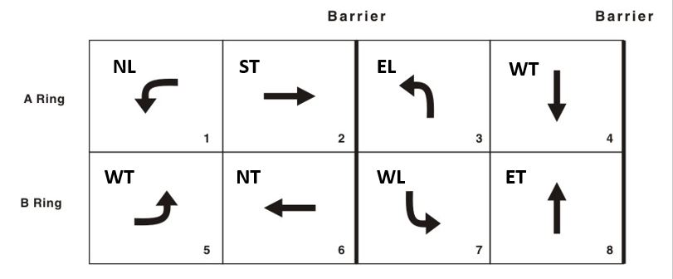

*Figure 3.1 NEMA Phasing*

3.2 Calculation of Measures

This section explains in detail the methodology used for computing the various measures used for analyzing the data.

*3.2.1 Sensor Data Evaluation*

Before the other measures are calculated the quality of the data is analyzed to find out any potential errors that can be eliminated before analysis. The measure that is used for elimination involves the wait time and queue length at the start of the green. The logic used in this measure is that if the arrival rate on red is larger than the saturated arrival rate then it means that number of vehicles that have arrived during the red wait time is more, which is physically not possible to accommodate given the wait time of the first vehicle in queue this considered as an error.

(1)

w< h*q

w = wait time for the first vehicle at the onset of green

h = saturated headway, (2 sec)

Q= queue length at the onset of green

*3.2.2 Long wait*

The wait time of the first vehicle in the queue provided in the dataset is used to estimate if it is more than 60 seconds. This measure is used to understand the turning movements. Using this measure we calculate the average wait time for a particular phase and also the number of times a vehicle experiencing long wait is calculated. This measure is defined as Longwait.

(2)

w > 60 = longwait

*3.2.3 Cycle length*

Cycle length is the amount of time it takes a traffic signal to serve every phase for which there is demand. Where signal coordination is required, cycle length is usually kept constant to maintain flow patterns, with green indications synchronized for coordinated movements. Under free actuated operation, each phase is served as vehicles place calls for them, and cycle length varies from cycle to cycle. A certain movement is considered, in case of this study the through movements phase 2 and phase 6 i.e. ST and NT are considered for calculation. The point where the movement starts and then repeats itself again is considered as a cycle.

*3.2.4 Green Duration*

Green duration is the amount of time in which the green indication is given to a particular phase. This quantity is important in the calculation of the capacity provided to each phase. The raw data consists of green duration for each phase under the column name ‘Duration’. While calculating this measure the green time is combined for those recurring phases and summed together to understand the measure in totality. It can also be measured by the difference between the timestamps of the current and next phase. However, the first method is more preferred because while analyzing using Apache Pig sequential analysis was not possible due to the way the data was provided.

*3.2.5 g/C Vs v/s ratio*

In addition to the green duration measure, to better understand the percentage of green for every phase the g/C ratio was calculated. Using the cycle length that was calculated previously and the green duration that was obtained from the sheet the g/C ratio was calculated. Even though most of the phases show values less than 0.5 for the ratio a concrete conclusion on the adequacy of green cannot be made. In order to make that decision the g/c ratio must be compared with the v/s ratio, where if the former is lesser than the latter. In such a condition the green time provided can be considered as in sufficient.

*3.2.6 Queue*

To calculate this measure, we used the data provided in the ‘Queue’ column. The total queue length for each phase and every hour of the day is calculated to understand trends varying over the day and also peak hours.

*3.2.7 Delay*

The original data set has two different types of sheets with data stored in it, the first is called ‘History’ and the other is called as ‘TMC’. From the TMC sheet the volumes are used for calculation and the queue and wait times are taken from the History sheet. A saturation flow rate of 1800 veh/hr is assumed for the value of ‘s’. The arrival rate on green is calculated using the summation of volumes from TMC sheet and summation of queues in History sheet using the equation (4).

𝑣𝑔 = (𝑉 − ∑ 𝑞𝑖)/∑ g𝑖

(3)

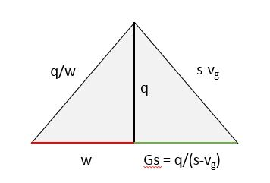

*Figure 3.2 Queue Polygon method parameters representation*

(4)

Total Delay=0.5*q*(w + (q/(s-vg)))

q is the queue length,

w is the waiting time for first vehicle in queue,

s is the saturation flow rate

vg is the arrival rate on green

𝑉 is the vehicle counts for a particular 15-min interval,  
𝑞𝑖 is the queue length in i𝑡ℎ cycle in that 15-min interval,  
g𝑖 is the green time in i𝑡ℎ cycle in that 15-min interval

Using the vg calculated for the delay measure using the equation (3) we try to understand if the volume or queue length is over estimated or under estimated or accurate. If vg <0 then it can be said volume is less than queue therefore either the volume data is underestimated or queue length is overestimated. Whereas if vg > s then the condition is vice versa. However if any of the two situation occurs it is considered to be an error.

*3.2.8 Progression*

In order to understand better the concept of progression the impact of the platoons are also discussed. It is separated into four different categories namely Head interference, Tail interference, both of them occurring at the same time and finally none occurring, along with these interferences the bandwidth is also calculated to understand the green band that is created between the movement of two intersections. The methodology used for calculating progression is given in fig. ,

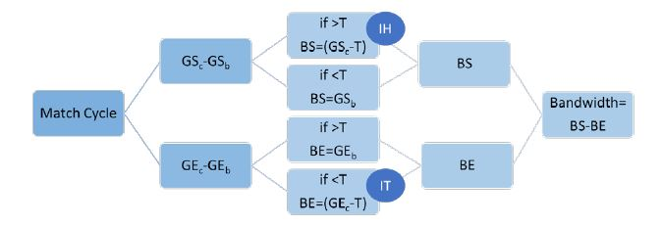

*Figure 3.3 Progression Calculation Flow Chart*

**4. Results and Discussion**

4.1 Individual Intersection Performance Highlights

Fig. shows the sensor data evaluation for the North Jordan Creek Parkway corridor. From this plot it can be clearly inferred that data errors are observed only during peak periods, more during the evening peak hours i.e. when high volumes of vehicles are observed. Also it can be noted that the sensor data is completely wrong for the University avenue intersection especially during the day time. The heat map is green when

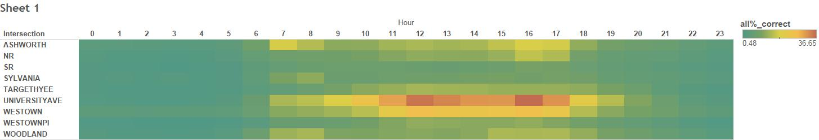

*Fig. 4.1 Sensor Data Evaluation heat map – North Jordan Creek Parkway*

The following plot shows us the average cycle failure for the Westown Parkway intersection for each day of the week. From this plot it can be inferred that cycle failure occurs mostly during the peak period for the turning movements whereas there are more number of failures for all the days and most of the hours other than night time (10:00 PM – 06:00 AM) of the week recorded for the West bound through movement.

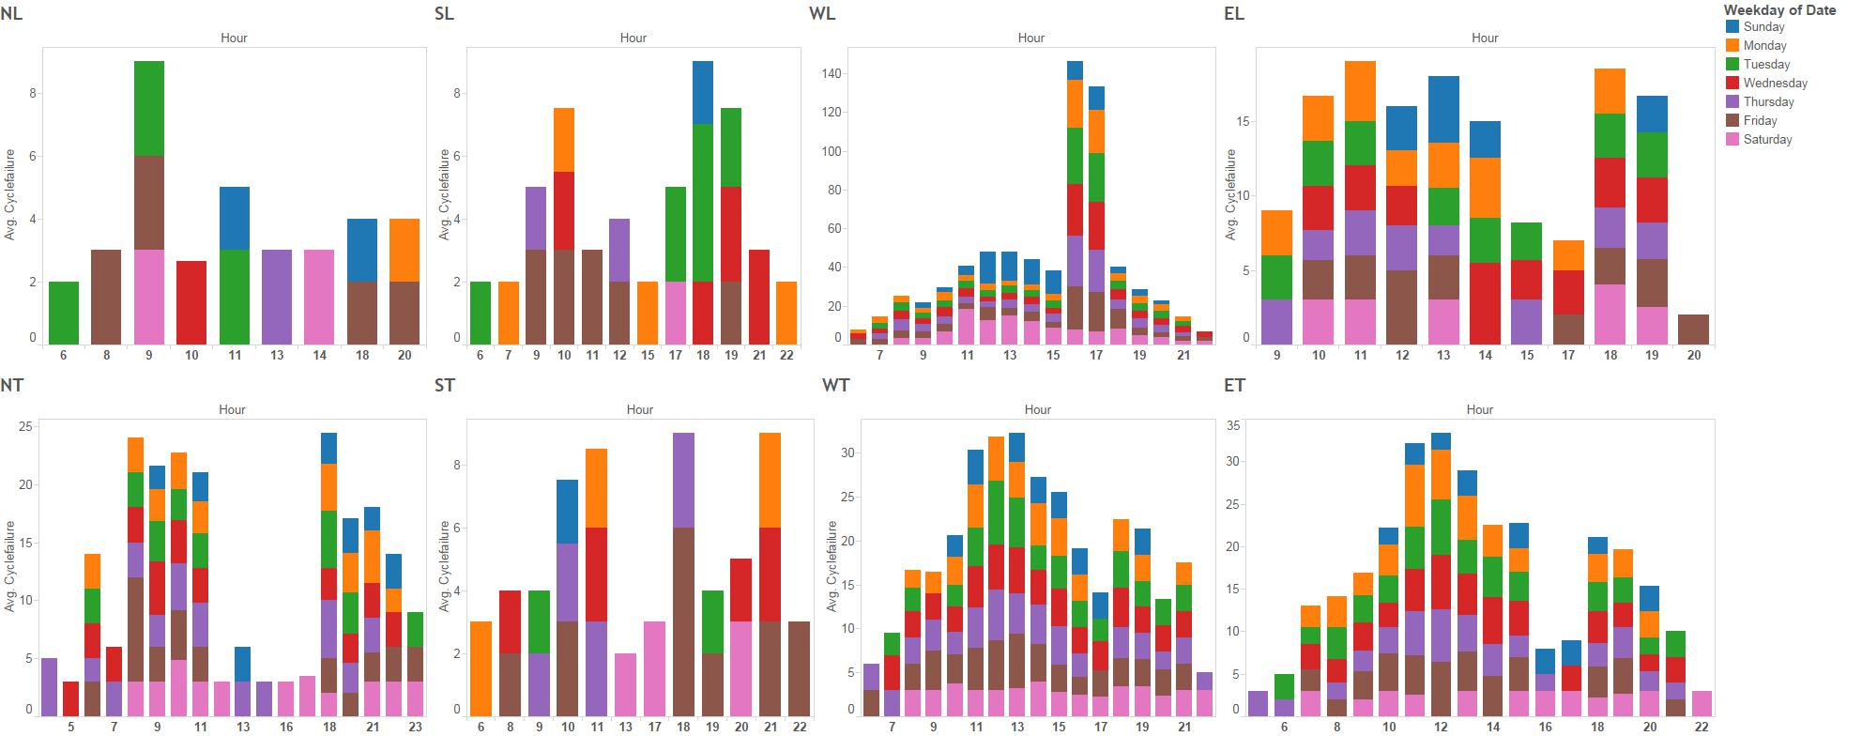

*Fig. 4.2 Phase wise analysis of cycle failure – Westown Parkway*

4.2 Comparison between Corridors

4.3 Intersection Ranking

**5. Conclusion**

**In this draft of the paper only a few highlights have been provided for a couple of intersection highlights. Detailed analysis on corridor comparison and intersection ranking will be added in the near future, after which the conclusion for the paper will be reported. **

**6. Future Work**

Despite that this study has conducted an extensive phase wise analysis for each measure discussed, there are many more measures that can be used for analyzing the performance of the arterial road networks. However big data applications can easily make it possible to extend this study into a real time analysis in future. Also to fully understand the power of big data application it is extremely important to test these measures on larger datasets than what is used in this study. Finally, as a future scope of work incorporating videos to a real time analysis will help in visualizing the condition of a road network that was analyzed using the high resolution data.

7. References

1. Gkiotsalitis, K., et al., *A utility- maximaization model for retrieving users' willingness to travel for participating in activities from big data.* Transportation Research Part C:Emerging Technologies, 2015. p. 265-277.

2. Smaglik, E., et al., *Event-based data collection for generating actuated controller performance measures.* Transportation Research Record: Journal of the Transportation Research Board, 2007(2035): p. 97-106.

3. Day, C., et al., *Performance measures for adaptive signal control: Case study of system-in-the-loop simulation.* Transportation Research Record: Journal of the Transportation Research Board, 2012(2311): p. 1-15.

4. Day, C., J. Sturdevant, and D. Bullock, *Outcome-oriented performance measures for management of signalized arterial capacity.* Transportation Research Record: Journal of the Transportation Research Board, 2010(2192): p. 24-36.

5. Zhang, Z., et al., *Performance measure for reliable travel time of emergency vehicles.* Transportation Research Part C: Emerging Technologies, 2016. **65**: p. 97-110.

6. Hubbard, S., D. Bullock, and C. Day, *Integration of real-time pedestrian performance measures into existing infrastructure of traffic signal system.* Transportation Research Record: Journal of the Transportation Research Board, 2008(2080): p. 37-47.

7. Johnston, C.M. and A.T. Chronopoulos. *The parallelization of a highway traffic flow simulation*. in *Frontiers of Massively Parallel Computation, 1999. Frontiers' 99. The Seventh Symposium on the*. 1999. IEEE.

8. Xia, Y., J. Chen, and C. Wang, *Formalizing computational intensity of big traffic data understanding and analysis for parallel computing.* Neurocomputing, 2015. **169**: p. 158-168.

9. Shi, Q., Aty, M.A., *Big Data applications in real time traffic operation and safety monitoring and improvement on urban expressways*. Transportation Research Part C: Emerging Technologies, 2015. p. 380-394.

10. Martin, P.T., Feng, Y., Wang, X., *Detector Technology Evaluation*. Mountain-Plains Consortium. 2003.

11. Chen, C., Ma, J., Susilo, Y., Liu, Y., Wang M., The promises of big data and small data for travel behavior analysis. Transportation Research Part C: Emerging Technologies, 2016. p. 285-289.