

**The Commonwealth of Massachusetts**

**Municipal Records Retention Manual**

A Publication of the Supervisor of Records

and the Records Management Unit

2011 Edition

William Francis Galvin

Secretary of the Commonwealth

**www.sec.state.ma.us/arc/arcrmu/rmuidx.htm**



**Updated: February 10, 2011**



**Table of Contents**

**FOREWORD ...............................................................................................................................................................5**

**REVISIONS TO THE CURRENT EDITION ..........................................................................................................7**

**HOW TO USE THIS BOOK......................................................................................................................................9**

**RECORDS MANAGEMENT ..................................................................................................................................11**

F REQUENTLY A SKED Q UESTIONS (FAQ) .................................................................................................................11

I NTRODUCTION AND H ISTORICAL O VERVIEW ..........................................................................................................13

I NVENTORY AND A PPRAISAL ....................................................................................................................................15

R ECORDS I NVENTORY W ORKSHEET .........................................................................................................................19

R ECORDS D ISPOSITION .............................................................................................................................................21

**RECORD RETENTION SCHEDULES..................................................................................................................23**

01 R ECORDS IN C OMMON .........................................................................................................................................23

02 A CCOUNTANT /A UDITOR ......................................................................................................................................31

03 B OARD OF A PPEALS ............................................................................................................................................33

04 B OARD OF A SSESSORS .........................................................................................................................................35

05 B OARD OF H EALTH .............................................................................................................................................41

06 B UILDING I NSPECTOR ..........................................................................................................................................43

07 C ITY AND T OWN C LERKS ....................................................................................................................................45

08 C OLLECTOR .........................................................................................................................................................53

09 C ONSERVATION C OMMISSION .............................................................................................................................57

10 C OUNCIL ON A GING ............................................................................................................................................59

11 D EPARTMENT OF P UBLIC W ORKS ........................................................................................................................61

12 F IRE D EPARTMENTS AND F IRE D ISTRICTS ...........................................................................................................63

13 H ISTORICAL C OMMISSION AND H ISTORIC D ISTRICT C OMMISSION ......................................................................67

14 L ICENSING B OARD ..............................................................................................................................................69

15 P LANNING B OARD ...............................................................................................................................................71

16 P OLICE D EPARTMENT ..........................................................................................................................................73

17 P UBLIC L IBRARY .................................................................................................................................................77

18 P URCHASING .......................................................................................................................................................79

19 R ETIREMENT B OARD ...........................................................................................................................................81

20 S CHOOL D EPARTMENT ........................................................................................................................................85

21 S EALERS OF W EIGHTS AND M EASURES ...............................................................................................................87

22 S ELECTMEN .........................................................................................................................................................89

23 S HELLFISH C ONSTABLE .......................................................................................................................................91

24 T REASURER .........................................................................................................................................................93

25 V ETERANS ’ S ERVICE A GENT ...............................................................................................................................97

**SELECTED SUPERVISOR OF RECORDS BULLETINS ..................................................................................99**

F EES FOR A CCESS AND C OPYING OF E LECTRONIC P UBLIC R ECORDS .....................................................................101

E LECTRONIC M AIL .................................................................................................................................................103

A PPLICATION OF THE P UBLIC R ECORDS L AW TO E LECTRONIC R ECORDS A CCESS .................................................105

B ACKING UP AND A RCHIVING OF E LECTRONIC R ECORDS ......................................................................................107

M INUTES OF M EETINGS ..........................................................................................................................................109

3



R EQUIREMENT TO M AINTAIN M INUTES OF M EETINGS IN W RITTEN F ORMAT .........................................................111

R ECORDING M ATERIAL FOR P ERMANENT P APER R ECORDS R EQUIREMENT TO U SE A RCHIVAL P APER AND

A RCHIVAL I NK .......................................................................................................................................................113

D ESIGNATION OF R ECORDS C USTODIAN ................................................................................................................115

R ECORDING M ATERIAL FOR P ERMANENT P UBLIC R ECORDS ..................................................................................117

S ECURITY AND C USTODY OF R ECORDS C REATED O UTSIDE THE T OWN H ALL ........................................................119

R EQUIREMENT TO M ANAGE R ECORDS C REATED U NDER G OVERNMENT C ONTRACTS ...........................................121

M AINTENANCE OF R ECORDS S TORAGE A REAS ......................................................................................................123

P ERFORMANCE S TANDARDS OF S AFES AND V AULTS .............................................................................................125

R ECORDS S ECURITY ...............................................................................................................................................129

**RECORD SERIES BY RETENTION PERIOD...................................................................................................139**

R ETAIN U NTIL A DMINISTRATIVE U SE C EASES .......................................................................................................139

30 D AYS A FTER A CTIVITY .....................................................................................................................................140

1 M ONTH A FTER A CTIVITY ....................................................................................................................................140

60 D AYS A FTER A CTIVITY .....................................................................................................................................140

6 M ONTHS A FTER A CTIVITY ..................................................................................................................................140

1 Y EARS A FTER A CTIVITY .....................................................................................................................................141

22 M ONTHS A FTER A CTIVITY ................................................................................................................................144

2 Y EARS A FTER A CTIVITY .....................................................................................................................................144

3 Y EARS A FTER A CTIVITY .....................................................................................................................................144

4 Y EARS A FTER A CTIVITY .....................................................................................................................................147

5 Y EARS A FTER A CTIVITY .....................................................................................................................................147

6 Y EARS A FTER A CTIVITY .....................................................................................................................................148

7 Y EARS A FTER A CTIVITY .....................................................................................................................................148

10 Y EARS A FTER A CTIVITY ...................................................................................................................................151

11 Y EARS A FTER A CTIVITY ...................................................................................................................................151

20 Y EARS A FTER A CTIVITY ...................................................................................................................................152

30 Y EARS A FTER A CTIVITY ...................................................................................................................................152

50 Y EARS A FTER A CTIVITY ...................................................................................................................................152

60 Y EARS A FTER A CTIVITY ...................................................................................................................................152

D URATION OF A PPOINTMENT .................................................................................................................................152

L IFE OF B UILDING /A GREEMENT /I NSTALLATION ....................................................................................................152

R ETAIN U NTIL S UBSEQUENT E VENT ......................................................................................................................153

R ETAIN U NTIL C OMPLETION OF P ROSECUTION AND E XHAUSTION OF A PPEALS .....................................................156

R ETAIN U NTIL F INAL S ETTLEMENT /A UDIT ............................................................................................................156

P ERMANENT ...........................................................................................................................................................159

**GLOSSARY OF SPECIAL TERMS .....................................................................................................................167**

**FORMS ....................................................................................................................................................................169**

RMU-2 A PPLICATION FOR D ESTRUCTION P ERMISSION ..........................................................................................171

RMU-1E A PPLICATION FOR E LECTRONIC S YSTEMS I NFORMATION M ANAGEMENT P LAN .....................................173

RMU-2E A PPLICATION FOR S CANNING AND D ESTRUCTION P ERMISSION ..............................................................175

RMU-2M A PPLICATION FOR M ICROFILMING AND D ESTRUCTION P ERMISSION .....................................................177

RMU-4 R ECORDS L IAISON O FFICER D ESIGNATION ...............................................................................................179

4



**FOREWORD**

City and town government in Massachusetts has given the Commonwealth a proud

heritage. Throughout its history Massachusetts local government has performed vital functions in

the safeguarding of citizens’ constitutional rights, the protection of persons and property, the

regulation of business and utilities, the performance of public works, the maintenance of public

solvency, and the provision of health, educational, social and recreational services. The

knowledge and awareness of this heritage will be ensured by the preservation of the records that

document it. The professional management of the local government records of the

Commonwealth will safeguard that information which is vital to administrative efficiency, fiscal

accountability, the legal rights of citizens and, by no means least, the local history of the

Commonwealth. It is to that end that this *Municipal Records Retention Manual* is dedicated.

The professional staff of my office has produced the *Manual* as a guide for local records

custodians in the maintenance of records under their care. The *Manual* contains advice and

guidance in the development of programs of records management in its major components: the

organization of records including the inventorying and appraisal of records; the disposal of

records which have become valueless and obsolete; the protection and security of records by

means of fire-resistive equipment and procedures to safeguard records against theft and

vandalism; and the conservation of records in order to ensure the longevity of the physical

integrity of permanent or archival records.

It is my pleasure to present to the cities and towns this *Manual* . Its use will assist the

cities and towns in the twin goals of improving management by improving records management,

and preserving the vital information of our historic past.

William Francis Galvin

Secretary of the Commonwealth

5



**REVISIONS TO THE CURRENT EDITION**

This revision of the schedule reflects an effort by the Records Management Unit to

simplify the process of municipal records management. Certain schedules were combined, and

many had series moved to the updated and expanded *Administration, Personnel and Records in*

*Common* schedule. If you are unable to find a record series once located in a particular schedule,

please refer to the Records in Common Schedule, as it will likely be located there.

An appendix that contains copies of relevant bulletins issued by the Supervisor of

Records has been added. Additionally, there is now a listing of all records series sorted by

retention period.

Please contact the Records Management Unit if you have specific questions regarding

your schedule.

A note about the Open Meeting Law (OML). The new OML became effective July 1,

2010, and may be found at MGL c. 30A, §§ 18-25. Revisions to this schedule have been made

to reflect new record creation and retention requirements. Please see the Records In Common

Schedule (01.070-01.081) for more information.

The new section sets retention requirements for records created by public bodies subject

to the OML. Such public bodies may also create records that are not reflected in this section, and

should refer to other sections of this schedule for retention requirements regarding those other

records.

7



**HOW TO USE THIS BOOK**

This book is created under the authority granted to the Supervisor of Records in the

Massachusetts General Laws, Chapter 66, Section 8. This book does not apply to records held by

most state governmental entities. Such entities should consult the *Statewide Records Retention*

*Schedule* , or the State Records Conservation Board for more information.

The schedules contained in this book supersede all municipal disposal schedules and

records management manuals previously published by the Secretary of the Commonwealth.

Municipal government records may be destroyed if such records are “administrative use”

records, as defined within the schedules, SPR Bulletins or the Glossary in this book. Destruction

of records not labeled “administrative use” may only be destroyed with the advance written

consent of the Supervisor of Records.

Any requests for destruction of records made to the Supervisor of Records must be made

using the forms contained in this edition. Use of any other schedules or forms subsequent to the

publication date may be rejected by the Supervisor of Records or the Records Management Unit.

Any references in this book to the Massachusetts General Laws (MGL) or the Code of

Massachusetts Regulations (CMR) refer to the current edition of each respective law or

regulation. Please note that the laws and regulations in this book are not official copies of such

law or regulation. Users should consult the official edition of each respective law or regulation

for more information. A copy of the CMR may be obtained from the State Bookstore, located in

the Massachusetts State House.

It is important to note that this schedule is only a guide, and is not intended to be a

comprehensive schedule of all records held by municipal government within the Commonwealth.

Record types, retention periods, and the description of records change over time. It is incumbent

upon all custodians of records to review the schedules found in this book on a regular basis, and

provide amendments to the Supervisor of Records and the Records Management Unit on a

regular basis. Any proposed additions, modifications, or deletions to the schedules must be sent

to:

Records Management Unit

Massachusetts Archives at Columbia Point

220 Morrissey Blvd.

Boston, MA 02125

(617) 727-2816

Supervisor of Records

Public Records Division

One Ashburton Place, Room 1719

Boston, Massachusetts 02108

(617) 727-2832

9



**RECORDS MANAGEMENT**

**Frequently Asked Questions (FAQ)**

**WHAT IS A PUBLIC RECORD?**

The term “public records” is broadly defined to include “books, papers, maps, photographs, recorded

tapes, financial statements, statistical tabulations, or other documentary materials or data, regardless

of physical form or characteristics, made or received by any” public employee. For a complete

definition, see MGL c. 4, § 7 (26).

**WHAT IS A HISTORICAL RECORD?**

Records created prior to 1870 are considered to be historical records and may not be destroyed.

**CAN MUNICIPAL RECORDS BE STORED AT THE STATE ARCHIVES?**

The State Archives is the repository of records that document the activities of state agencies only.

Municipalities are responsible for the management, storage, and security of their records pursuant to

MGL, c. 66, known as the Public Records Law.

**HOW CAN I DETERMINE THE AMOUNT OF CUBIC FEET OF MY RECORDS?**

A standard file cabinet drawer is the equivalent of two cubic feet. For more information, see the

Cubic Feet Equivalency Chart in this book.

**MUST I SHRED RECORDS THAT HAVE BEEN APPROVED FOR DESTRUCTION?**

There is no statutory requirement to burn, shred, or pulverize obsolete records. However, there is

nothing that prevents you from shredding records provided you have obtained written authorization

to dispose of obsolete records from the Supervisor of Records. Government entities are advised to

treat the destruction of personal information with great caution.

**WHAT IS RECORDS DISPOSITION?**

Disposition is the regular and rational process by which records are removed from the office when

they are no longer active.

**MAY I RECYCLE RECORDS THAT HAVE BEEN APPROVED FOR DESTRUCTION?**

Such records may be recycled provided you have obtained written authorization to dispose of

obsolete records from the Supervisor of Records.

**HOW DO I KNOW IF A RECORD IS PUBLIC?**

You may contact the Public Records Division for more information on how to determine whether a

record is exempt from public access:

Division of Public Records

One Ashburton Place, Room 1719

Boston, MA 02108

Telephone: (617) 727-2832

Fax: (617) 727-5914

www.sec.state.ma.us/pre/preidx.htm

11



**Introduction and Historical Overview**

Introduction

Many factors have contributed to the dramatic increase in the volume of records output

by government offices. As government expands and becomes more complex, so does the

creation, maintenance, and preservation of records. The science of records management includes

creation, maintenance, and preservation and seeks to assist records custodians in the maintenance

and disposal of records.

What is “records management?” It is an administrative plan or function in which records

are logically categorized or arranged for easy retrieval, use, and destruction. Where there is

records management, there are systematic procedures for the creation, utilization, and disposition

of records. These procedures facilitate the rapid and economic retrieval of data for the

administration of any organization. The objectives in managing records are to make the records

serve the purpose for which they were created as cheaply and effectively as possible, and to

make proper disposition of them after they have served their purpose.

Historical Overview

The history of records management services for local government in the Commonwealth

may be traced back to an 1884 resolve by the General Court calling for a report on public

records. This resulted in the temporary position of a commissioner who surveyed conditions and

inventoried records throughout the state. The report, written by Carroll D. Wright, published in

1889, listed records, examined records-keeping techniques, and made specific recommendations

for improvement.

The original 1884 resolve was extended in 1889 and led to the issuance of further reports,

the creation of a permanent position of Commissioner of Public Records, and the passage of

Chapter 333 of 1892. This act was the basis of what has become the current Public Records Law.

The first permanent Commissioner of Public Records was Robert T. Swan, who

continued the work Wright had started. Commissioner Swan issued annual reports and

established what may have been a firm basis of future concern for public documents.

With the passage of Chapter 3450 of the Acts of 1919, the public records function was

relocated in the Office of the Secretary of the Commonwealth. At the same time, the position of

Supervisor of Records was created, but the responsibilities for examining the care and custody of

public records in towns ceased to have the importance they had under Commissioners Wright

and Swan.

In the 1970s, the importance of the state’s role in applying active supervision and

providing technical assistance to local government records was at last recognized. By 1974, a

local records program was instituted in the Division of Public Records with the creation of a

team of records analysts.

The Records Management Team (RMT) undertook a survey of the main business offices

in the cities and towns and developed a series of records retention/disposition schedules for

municipal departments. By 1978, the RMT had surveyed all 351 municipalities, assessing

organization and security, and recommending and requiring proper methods for the arrangement,

13



storage, preservation, and disposal of municipal records. From 1978 to 1982, follow-up surveys

were conducted with a view toward gauging the performance of municipalities in meeting the

requirements and recommendations of the initial survey and toward making further

recommendations regarding immediate records management needs.

Analysis of the six-year program has shown that there has been a marked improvement in

the organization and security of local public records. A large number of cities and towns had

constructed new vaults or up-graded existing ones, or acquired class-rated safes and fire-resistive

cabinets. Some municipalities restored the physical integrity of their older historical records by

undertaking conservation programs. Others have inventoried their records, a vital step in the

development of progressive management policies.

Supervisor of Records; On-Going Services

Although improvements in the management of records across the Commonwealth have

been impressive, there remains much room for further advances. The Secretary of the

Commonwealth recognizes the need to place competent, professional help at the disposal of local

records custodians, and the need to promote a close working relationship with local government

in the development of records management programs. In the early 1980s, the Secretary

transferred the RMT, known today as the Records Management Unit (RMU), to the Archives

Division with a view toward pooling the expertise of records managers and archivists. In this

manner, a more informed and effective service can be provided to all agencies of the

Commonwealth. The RMU is now a separate section of the Archives Division and continues to

carry out the record management responsibilities of the Supervisor of Records.

To assist cities and towns in the establishment of their own records management

programs, the Supervisor has authorized the publication of this *Municipal Records Retention*

*Manual* . The *Manual* includes sections on records organization, records disposition, security, and

conservation. The *Manual* is intended to serve as both encouragement to municipalities to carry

out their responsibilities under Massachusetts General Laws, Chapter 66 and a stimulus for

thought and discussion on how records management practices can be improved. It is hoped that

records custodians find it a useful, informative, and effective tool in facilitating the vital tasks of

government.

14



**Inventory and Appraisal**

Inventory

The basis of any records management program is effective reference and security control

of records. The means to establish this control is a thorough records inventory. With the

completion of an inventory, the custodian will have definite knowledge of the types of records

held, their inclusive dates, volume, the type of information they contain and the location of the

records. Once the inventory has been compiled, an annual updating will keep the inventory

current. Thenceforth, the inventory can be used in conjunction with the applicable retention

schedules to ensure that:

(a) Departmental records are safely stored and readily available;

(b) Long-term records are preserved;

(c) Obsolete records are disposed of properly.

The first step is to appoint a records officer. This person may be the department head, or

in the case of larger offices embracing several divisions, a records coordinator. In the case of

multi-division offices, representatives from each division should be included in the planning

stage of the inventory so that the program can be explained and understood. See, MGL c. 66, § 6

(all governmental entities must appoint a custodian of records).

In conducting the inventory, current records should be examined before non-current

records since officials will be more familiar with them. It is important that all records are

inventoried; none should be overlooked because of their seeming unimportance or

disorganization.

The inventory should proceed in a systematic manner, with information immediately and

clearly recorded on a worksheet. Separate worksheets should be completed for every records

series. A record series may be defined as a set of records organized or filed in accordance with a

single filing system. For example, general correspondence organized in a series of alphabetically

arranged folders constitutes a records series. Separate worksheets should also be completed for

parts of a single record series found in different locations.

After completing an inventory of the records, worksheets may be arranged alphabetically

by title of records series, by location, or in a more complex fashion based on a classification of

the records by type. Photocopying the forms will allow for multiple approaches to the

organization of the worksheets.

The following inventory worksheet may be useful since it clearly identifies the types of

information being sought. Instructions for its use follow and explain the procedures for

identifying and describing records.

Appraisal

With the completion of a records inventory, custodians move on to the next step in their

records program, that of appraisal. The appraisal of records is one of the most significant steps in

a records program, as it is the point at which definitive judgments are made about the enduring

values of records. These judgments will lead to decisions on the retention of the records.

15



First, consult the retention schedules. If the records series in question is listed, then the

custodian need only take action based upon the prescribed retention period. Records the retention

period of which has expired may be disposed of in accordance with the procedures listed in this

*Manual* .

If the records series in question is not listed on the schedule, then the custodian should be

prepared to appraise the material. The appraisal process should be performed by those persons

directly responsible for the creation and use of the records. The assistance of the Supervisor of

Records or the RMU may be sought as needed.

During appraisal, records possessing one or more of the following values will have

recommendations to be preserved permanently, or for a period of time until an event, or until a

combination of an event and a time period.

1. Administrative Value

A record possesses administrative value if it helps the office perform essential functions

now or in the future. The custodian should ask, “At what point in time will this record

cease to be of potential administrative value? Is this administrative value found in any

other records which will be retained?”

2. Legal value

A record possesses legal value if it documents a legal right or obligation of a citizen, of

the office or of the municipality. A record will lose that value at the point in time when

that legal right ceases, or ceases to be enforceable under current law. The official should

ask, “At what point in time will this record, or records series, cease to document any

enforceable legal rights? Are these rights documented by any other records which will be

retained?”

3. Fiscal Value

A record possesses fiscal value if it uniquely documents or verifies the spending or

receipt of public monies. Many records lose fiscal value at the point in time when they

are audited. The official should ask, “At what point in time will this record, or records

series, no longer be needed to document the transfer or payment or encumbrance or other

action pertaining to the sending or receipt of public monies? Is that information

documented in another record which may be more appropriate to keep?”

When municipal officials have completed their appraisal of a records series based on the

foregoing criteria, there still remains one more value to be sought in the records. Consultation

with the Supervisor of Records may be particularly appropriate in testing for this value, which

can be the most subjective value to verify through the appraisal process.

4. Historical Value

The application of this value is fundamentally a search in the records series for possible

cultural values to posterity. Does the records series provide valuable information on

persons, events, or subjects? Does the series provide valuable information on the key

operations of a significant municipal office? Generally, records that document the

16



operation, procedures, policies, or organization of municipal government or contain

significant factual information will possess historical value. This value, however, also

must be tested against such other considerations as the uniqueness of the records, the

volume (and consequent preservation and storage costs) of the records, the importance of

the information, the accessibility of the information (in light of the volume or

understandability or format of the material) and the likelihood that the material will

actually be used by future historians or other researchers.

In addition, it is essential to note that state law (MGL, c. 66, § 8) establishes that no

public record created prior to 1870 may be destroyed. All such records are considered to

have historical value requiring their permanent retention.

Records series may have no significance under any of these values, or they may be

established which will satisfy the longest retention period required under any of the values.

Permanently valuable records series should be retained under appropriate conditions to ensure

their long-term preservation. They should be well identified, available to researchers and given

proper preservation treatment (including possible microfilming). Records series with limited

retention periods that have not yet been satisfied should receive appropriate care in the interim.

Those records should be disposed of at the end of that period. Those records series that can be

immediately disposed of should be dealt with in a manner consistent with the procedures set

forth in the *Manual* chapter on Records Disposition.

17



The Commonwealth of Massachusetts

**William Francis Galvin**

Secretary of the Commonwealth

Records Management Unit – Massachusetts Archives at Columbia Point

220 Morrissey Blvd., Boston, Massachusetts 02125-3384

Email: rmu@sec.state.ma.us

Website: www.sec.state.ma.us

Phone: 617-727-2816 Fax: 617-288-8429

**FORM RMU-IW – RECORDS INVENTORY WORKSHEET**

**1.** Department: _______________________________ Division: ___________________________ Section: ____________________

**2.** Title of Records Series:________________________________________________________________________________________

**3.** Description of records series (content, purpose, etc.) _________________________________________________________________

**4.** Location of records: __________________________________________________________________________________________

**5.** Earliest date/latest date: _______________________________________________________________________________________

**6.** Volume: ___________________________________ cu. ft. **7.** Annual Accumulation ______________________________ cu. ft.

**8.** Arrangement: Chronological Alphabetical by ____________ Numerical by ___________ Other ____________

**9.** Size of records: ____________ **10.** Format of records: Typewritten Handwritten Other:___________________

**11.** Reference frequency (insert numbers and circle appropriate words):

______ times - daily, weekly, monthly, yearly, for ______ months, years. Never after __________________________________

**12.** Information available elsewhere?_ Yes No If yes, where?_ _______________________________________________________

**13.** Microfilmed?_ Yes No If yes, explain?_ _____________________________________________________________________

**14.** Are records indexed?_ Yes No If yes, identify?_ _____________________________________________________________

**15.** How stored: Filing cabinets Shelves Boxes Other ___________________________________________________

**16.** Condition of Records?_ Good Poor Explain any problem. ____________________________________________________

**17.** Records on retention schedule?_

Yes No If YES, retention period _______ and schedule number. If NO, suggested retention period and justification. _______

**18.** Condition of storage area (security, fireproof, alarms, environment, etc.)?_

Good Poor Explain any problems?_ ____________________________________________________________________

**19.** Additional comments: _______________________________________________________________________________________

**20.** Name of person completing worksheet: __________________________________________________ Date: __________________

RMUIW 1/13/11



**Instructions for the Use of Records Inventory Worksheet**

**1.** **Department, Division, Section:** This information places the records in their organizational setting. Some

departments will have no divisional or sectional breakdowns.

**2.** **Title of records series:** The series title should be as specific and descriptive as possible. General terms, such as

“reports,” “requisitions,” or “correspondence” should be avoided. Examination of the appropriate departmental

retention schedules will give examples of various record series titles. For clarity in applying these schedules, the

same titles should be used whenever possible.

**3.** **Description of records series:** This provision is for information on content, purpose, function, creation, use

and other information that will clarify the type of data included in the records series.

**4.** **Location of records:** The location should be given as exactly as possible – including the room, file cabinet,

shelf, etc. Use separate worksheets for parts of a records series that are found in different locations.

**5.** **Earliest date/latest date:** The earliest and latest dates of the records.

**6.** **Volume:** Measure how much space the records occupy. Use cubic feet as the measure of volume. (See cubic

foot equivalency chart in appendix to this section.)

**7.** **Annual accumulation:** The volume of records created annually.

**8.** **Arrangement:** Explain how the various records in the series are arranged, whether alphabetically by folder

headings, chronologically, numerically, or by some other system.

**9.** **Size of records:** The width, height, and in cases of bound volumes, thickness.

**10.** **Format of records:** Are the records handwritten, typewritten, or on magnetic tape, audio tape, etc.?_

**11.** **Reference frequency:** How often are the records consulted?_ This information is important for establishing the

proper retention period for the series.

**12.** **Information available elsewhere:** Is the same information found in other records series?_ This is also important

for establishing the proper retention period for the series.

**13.** **Microfilmed:** Have the records been microfilmed?_ If so, what portion of them?_ What type of microfilm?_

**14.** **Indexed:** Have the records been indexed?_ Indicate indexing identification.

**15.** **How stored:** Identify the types of storage equipment that are used to hold the records.

**16.** **Condition of records:** Are the records in good or poor condition?_ Explain any problem in their condition, i.e.,

mold, acid degeneration, discoloration, water damage, brittleness, insect or rodent infestation or damage, etc.

**17.** **Records on retention schedule:** Have the records already been schedule for retention/disposition purposes?_ If

not, the individual completing the worksheet should suggest such a retention period (permanent, destroy after

five years, destroy after audit, etc.) and provide a justification for the suggested period. This is not the finial

retention period that will be established, but only a suggestion based on immediate impressions – a suggestion

subject to later revisions.

**18.** **Condition of storage area:** Is the storage area in good or poor condition?_ What problems exist (e.g., lack of

security, no alarms, not fireproof, high temperature, low humidity, dirt, etc.)?_

**19.** **Additional comments:** This provision is for any additional comments that the person completing the work-

sheet wishes to make. Any important information not noted on the worksheet?_ Any significant research or

historical value to the records or parts of them?_

**20.** **Name of person completing worksheet; date of inventory:** These provisions are self-explanatory.

RMUIW 12/21/10



**Records Disposition**

Advantages

Once records have been inventoried and appraised and a sound, intellectual control has

been established over records holdings, it is then possible to develop systematic procedures for

the disposal of records that have become obsolete.

The disposal of records in accordance with state records retention schedules will result in

the removal of large quantities of obsolete records from among the many records series in each

municipal office. The freeing of space and attendant staff time to service records will contribute

to significant savings. The savings can be considered annually, as municipal offices will never

again be required to maintain those records on which disposal procedures have been enacted. So

long as schedules are regularly implemented, the re-accumulation of such records will be

prevented.

A well thought out program of records retention and disposition will:

(a) Ensure that records are kept as long as they are required;

(b) Result in the destruction of obsolete material;

(c) Facilitate the rapid retrieval of information;

(d) Clear space for more productive use and prevent the accumulation of unnecessary

records;

(e) Eliminate potential fire hazards caused by the clutter and over-crowding of obsolete

records;

(f) Effect cost savings by freeing floor space, reducing staff time required to service

records and eliminating the need to purchase additional filing equipment to house

useless records.

Procedures

In Massachusetts, all government offices are required to obtain authorization before

destroying records. Chapter 66, Section 8 of the General Laws provides for the preservation of

the records of the commonwealth, counties, cities, and towns and expressly prohibits the

destruction of any records “without the written approval of the Supervisor of Public Records.”

In order to establish a policy for the consistent disposition of local government records,

the Supervisor has authorized retention schedules for municipal departments. Each schedule

contains a list of the records created or maintained by an office; statutory citations to help clarify

the identity of records; and the minimum time period for which records must be retained.

Instruction sheets and sample disposal request letters are attached to the front of each schedule.

The essential procedure is to submit to the Supervisor a letter (in duplicate) citing the records to

be disposed, the inclusive dates of the record, and overall estimated volume to be destroyed.

After review for correctness, the Supervisor shall return one approved copy of this letter.

21

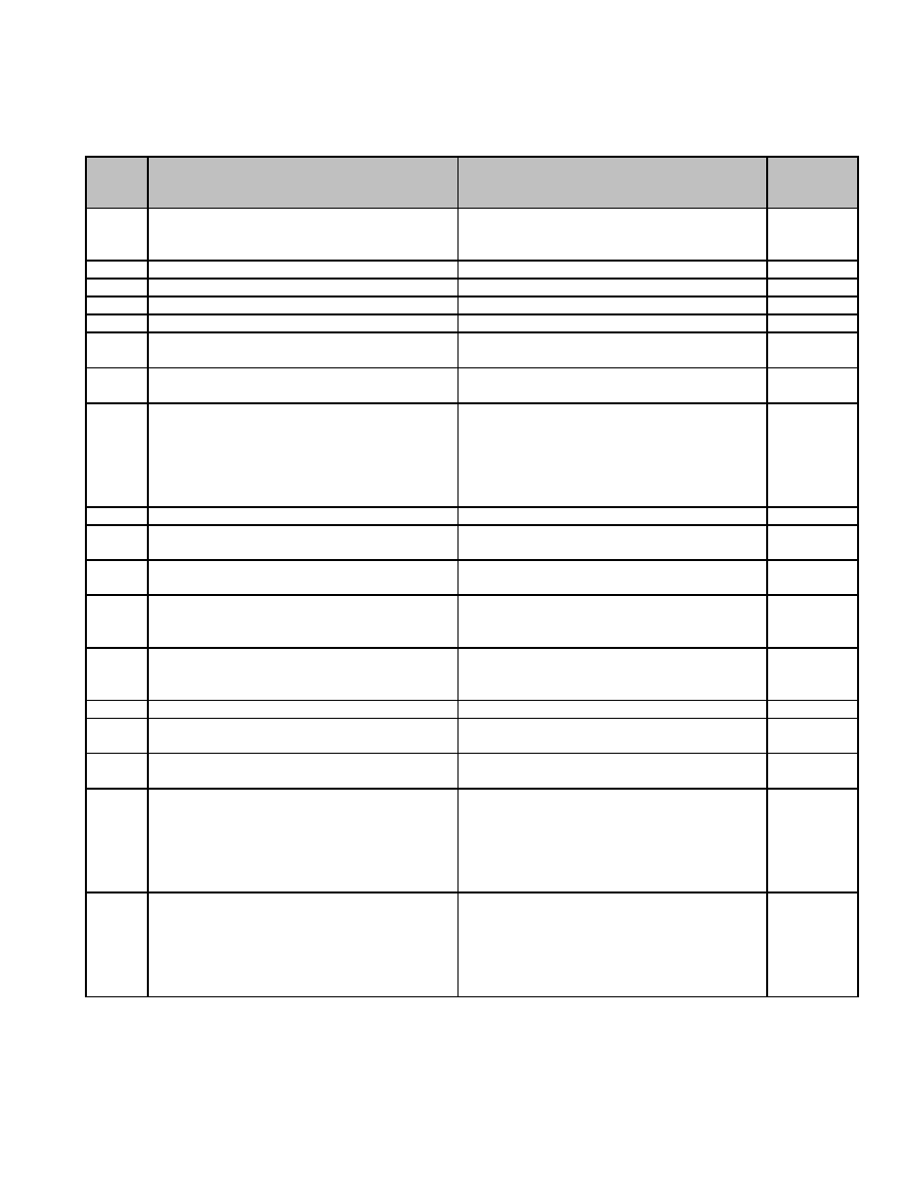

**RECORD RETENTION SCHEDULES**

**01 Records in Common**

**Series**

**Number** **Description of Record** **Length of Time Required to Retain Record** **MGL / CMR**

01.001 Abutters List; retention after supercession Retain 1 year c. 40A s.

and 20-day appeal period. 11; c. 41 s.

81T

01.002 Accounts Payable Retain until completion of satisfactory audit.

01.003 Accounts Receivable Retain until completion of satisfactory audit.

01.004 Administration, Building Plans Permanent.

01.005 Annual Report Permanent.

01.006 Audio Tapes, Hearings Retain 1 year following expiration of

appeals period.

01.007 Audio/Visual tape or Digital Recordings, Retain 1 month.

security and surveillance tapes

01.008 Audit Report Retain 10 years. c. 44, s.

39, c. 32 s.

21(1) (c),

840 CMR

25, c. 71 s.

16E

01.009 Bank Statements Retain until completion of satisfactory audit.

01.010 Bids for Contracts (a) Where no contract is Retain 3 years from date of opening. c. 30B

awarded

01.011 Bids for Contracts (b) Where contract is Retain with Contract Files. c. 30B

awarded

01.012 Bills Outstanding, Statement of Retain until completion of satisfactory audit c. 41, s. 58

or final settlement of levy, whichever is

later.

01.013 Budget Estimates Retain until administrative use ceases. c. 41 s. 59

Permission from Supervisor not required for

destruction.

01.014 Cash Books Permanent.

01.015 Check Registers Retain 7 years, or until completion of c. 32, c.

satisfactory audit. 260 s. 2

01.016 Checks, cancelled Retain 7 years, provided a satisfactory audit c. 41, s. 35

has been completed.

01.017 Contract Files – (a) where no debt is issued Retain until completion of audit of final year c. 30B, c.

to pay the contract. Includes documentation of contract and change order payments. 41, ss. 17,

of award and performance of contract, 57, c. 260,

original contract, change orders, all related ss. 1, 2

purchase orders, invoices and schedules of

bills payable.

01.018 Contract Files – (b) where debt is issued to Retain until completion of audit following c. 30B, c.

pay the contract. Includes documentation of year of final payment of all debt related to 41, ss. 17,

award and performance of contract, original the project. 57, c. 260,

contract, change orders, all related ss. 1, 2

purchase orders, invoices and schedules of

bills payable.

23



**Series**

**Number** **Description of Record** **Length of Time Required to Retain Record** **MGL / CMR**

01.019 Correspondence (a) Administrative Retain until administrative use ceases.

Convenience: Duplicates of Permission from Supervisor not required for

correspondence maintained for the destruction.

convenience of governmental employees in

carrying out their duties. Records in this

series are not the official file or record copy.

Do not apply this series if records fall under

a more appropriate record series.

01.020 Correspondence (b) General Administrative: Retain 3 years.

General correspondence associated with

administrative practices but does not create

policy or procedure.

01.021 Correspondence (c) Policy Development: Retain 5 years.

Correspondence documenting policy

development, sent or received by

individuals who exercise decision-making

authority on policy matters.

01.022 Correspondence (d) Transitory Messages: Retain until administrative use ceases.

Includes messages created primarily to Permission from Supervisor not required for

communicate information of short-term destruction.

value. Examples: messages reminding

employees about scheduled meetings or

appointments; telephone messages;

announcements of office events such as

holiday parties or group lunches; and

recipient copies of announcements of

agency-sponsored events such as exhibits,

lectures, workshops, etc. Transitory

messages are not intended to formalize or

perpetuate knowledge and do not set policy,

establish guidelines or procedures, certify a

transaction, or become a receipt.

01.023 Data Processing Input Forms Retain until verification of outputs.

01.024 Deposits to Treasurer Retain until completion of satisfactory audit. c. 41, s. 35

01.025 Equipment Inventory Retain until superseded by next inventory.

01.026 Equipment Inventory Form Retain until superseded.

01.027 Equipment Loan Report Retain until return of equipment.

01.028 Equipment Maintenance and Repair Retain 1 year after disposal of equipment.

Records

01.029 Equipment Warranties Retain 1 year after disposal of equipment.

01.030 Expenditures (estimated) Retain until administrative use ceases. c. 41 s. 60

Permission from Supervisor not required for

destruction.

01.031 Incident Reports Retain 3 years.

01.032 Insurance Policies Retain 7 years after expiration of policy.

01.033 Invoice Warrants Retain until completion of satisfactory audit.

01.034 Invoices and Vouchers Retain until completion of satisfactory audit

unless related to Contract Files.

24

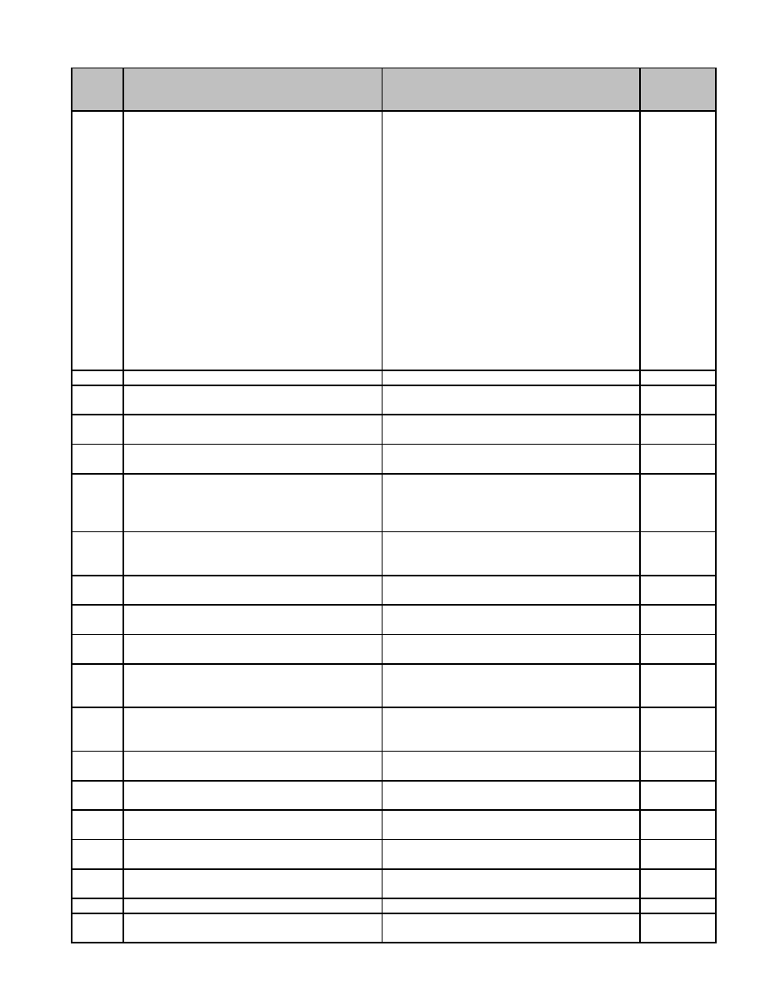

**Series**

**Number** **Description of Record** **Length of Time Required to Retain Record** **MGL / CMR**

01.035 Licenses and Permits, Applications for Retain 1 year after closing or change of c. 94 ss.

owner. 10A-C, 40,

48A, 65H,

89, 118,

144, 303A,

330B; c.

111 ss.

31A, 59,

as

amended,

155; c. 114

s. 49, c.

140 ss.

32A, B, F,

51; c. 142

s. 11, S. S.

C. , Art IV,

VII, X

01.036 Licenses and Permits, Auctioneers Permanent. c. 100, s. 2

01.037 Licenses and Permits, Billiard Saloons Permanent. c. 140, ss.

202, 205

01.038 Licenses and Permits, Bowling Alleys Permanent. c. 140, ss.

202, 205

01.039 Licenses and Permits, Carousels Permanent. c. 140, ss.

202, 205

01.040 Licenses and Permits, Dog Licenses Retain until completion of satisfactory audit. c. 140, ss.

Retain record thereof for 2 years. 137, 147

Permission from Supervisor not required for

destruction.

01.041 Licenses and Permits, Druggist Retain 7 years after termination. c. 138 ss.

15, 19, 29,

30A

01.042 Licenses and Permits, Exhibitions Permanent. c. 140, ss.

(Firefighting) 202, 205

01.043 Licenses and Permits, Ferris Wheels Permanent. s. 140, ss.

202, 205

01.044 Licenses and Permits, Gasoline, Sale of, Permanent. c. 148, s.

Manufacture, Storage (a) Licenses 13

01.045 Licenses and Permits, Gasoline, Sale of, Retain 7 years. c. 148, s.

Manufacture, Storage (b) Renewals 13

(certificates of annual registration)

01.046 Licenses and Permits, Hunting, Fishing, Retain until completion of satisfactory audit. c. 131, ss.

Trapping and Sporting Licenses, Monthly 12, 13, 18

Return of

01.047 Licenses and Permits, Inclined Railways Permanent. c. 140, ss.

202, 205

01.048 Licenses and Permits, Inn holder Retain 7 years after termination. c. 138 s.

12

01.049 Licenses and Permits, Junk Collectors Permanent. c. 140, ss.

202, 205

01.050 Licenses and Permits, Junk Dealers Permanent. c. 140, ss.

202, 205

01.051 Licenses and Permits, Kennel Licenses Permanent. c. 140, s.

137A

01.052 Licenses and Permits, License Book Permanent.

01.053 Licenses and Permits, Log Book (where Permanent.

applicable)

25

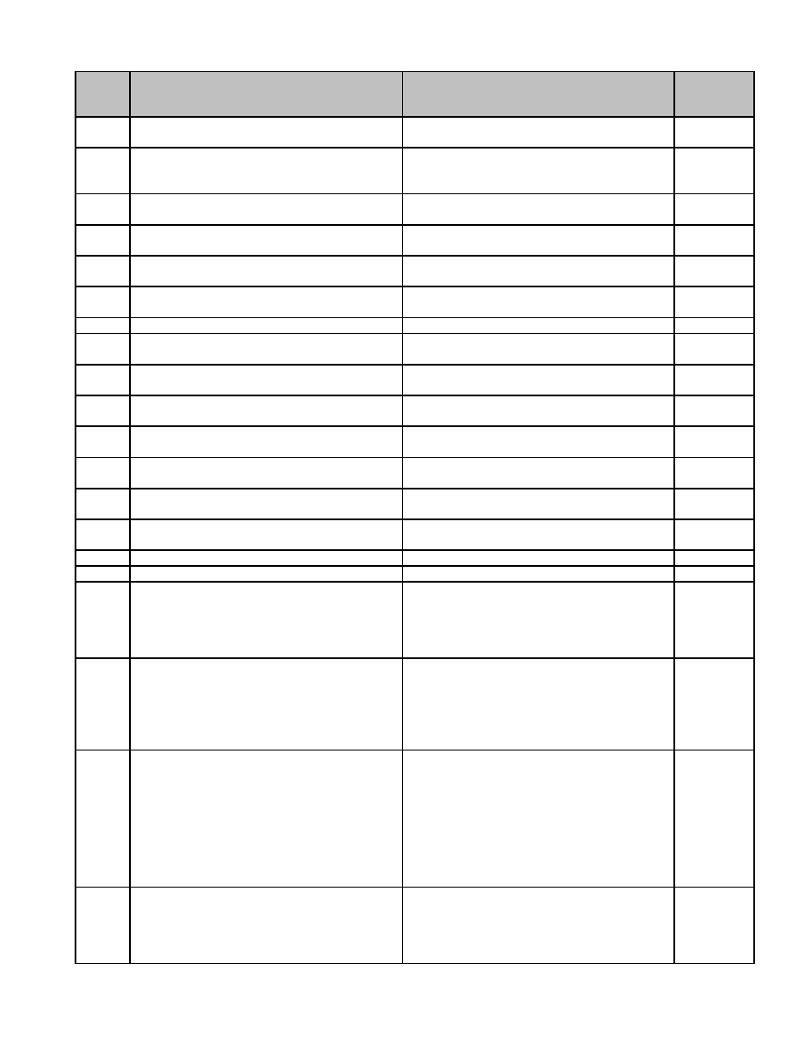

**Series**

**Number** **Description of Record** **Length of Time Required to Retain Record** **MGL / CMR**

01.054 Licenses and Permits, Mobile Home Parks Retain 1 year. Annual renewal is required. c. 140,

2.32F

01.055 Licenses and Permits, Pawnbrokers Permanent. c. 140, ss.

70, 202,

205

01.056 Licenses and Permits, Picnic Groves Permanent. c. 140, ss.

202, 205

01.057 Licenses and Permits, Pool Rooms Permanent. c. 140, ss.

202, 205

01.058 Licenses and Permits, Raffles and Bazaars Permanent. c. 271, s.

(a) Applications for 7A

01.059 Licenses and Permits, Raffles and Bazaars Retain until completion of satisfactory audit. c. 271, s.

(b) Report 7A

01.060 Licenses and Permits, Record of Permanent.

01.061 Licenses and Permits, Renewal Affidavit Permanent. c. 138 s.

16A

01.062 Licenses and Permits, Roller Skating Rinks Permanent. c. 140, ss.

202, 205

01.063 Licenses and Permits, Secondhand Articles Permanent. c. 140, ss.

202, 205

01.064 Licenses and Permits, Shellfish Permanent. c. 130, ss.

51, 53

01.065 Licenses and Permits, Stallion Breeding Permanent. c. 140, s.

Certificates 176

01.066 Licenses and Permits, Statement of Interest Permanent. c. 138 s.

15A

01.067 Licenses and Permits, Steam-Power Boats Permanent. c. 140, s.

for Hire 192

01.068 Licenses and Permits, Stubs Retain until completion of satisfactory audit.

01.069 Mileage Reports Retain until completion of satisfactory audit.

01.070 Open Meeting Law: Complaints (Other than Retain 6 months by the public body and c. 30A, ss.

Open Meeting Law Complaints). Includes thereafter by the normal custodian of the 18-25

complaints against the public body other record for the period of retention either set

than complaints violations of MGL c. 30A, in the Municipal Schedule or as otherwise

§§18-25. required by law.

01.071 Open Meeting Law: Correspondence. Refer to “Correspondence” in this schedule c. 30A, ss.

Includes e-mails pertaining to the business for retention period requirements. 18-25

of a public body between members of the

public body, and between members of the

public body and non-members of the public

body.

01.072 Open Meeting Law: Documents, Exhibits, or (a) Retain 6 months by the public body and c. 30A, ss.

Other Records Used by a Public Body. thereafter by the normal custodian of the 18-25

Includes all documents, exhibits, maps or record for the period of retention either set

notes or any other record reflected in the in the Municipal Schedule or as otherwise

meeting minutes of a public body as required by law. (b) Retain drafts 90 days,

required by MGL c. 30A, §22(a). unless an Open Meeting Law complaint is

filed against the public body, in which case

retain all drafts relevant to the complaint

until the complaint is resolved.

01.073 Open Meeting Law: Meeting Agendas. Retain 1 year. c. 30A, ss.

Includes final documents provided to 18-25

members of the public body listing the

topics and order in which topics will be

considered.

26



**Series**

**Number** **Description of Record** **Length of Time Required to Retain Record** **MGL / CMR**

01.074 Open Meeting Law: Meeting Minutes. Permanent. c. 30A, ss.

Includes the final version of the minutes of a 18-25

meeting of a public body after approval by

that public body. Also includes drafts of the

minutes if substantially different from the

final version as approved by the public

body.

01.075 Open Meeting Law: Meeting Notices. Retain 1 year. c. 30A, ss.

Includes the final, publicly posted version of 18-25

all notices for meetings of public bodies.

01.076 Open Meeting Law: Notice to Individuals. Retain 6 years. c. 30A, ss.

Includes notice given to individuals that a 18-25

public body intends to convene in executive

session as that term is defined by MGL c.

30A, §18, for the purpose of discussing the

reputation, character, physical condition or

mental health of the individual pursuant to

MGL c. 30A, §21(a)(1).

01.077 Open Meeting Law: Open Meeting Law Retain 6 months from the final day of the c. 30A, ss.

Certifications. The Open Meeting Law member’s term of office. 18-25

Certification is a form provided by the

Attorney General, which every member of a

public body must sign within two weeks of

becoming eligible for their position on the

public body.

01.078 Open Meeting Law: Open Meeting Law Retain 3 years. c. 30A, ss.

Complaints. Includes complaints filed 18-25

against the public body for an alleged

violation of the Open Meeting Law and any

correspondence and supporting materials

related to a complaint.

01.079 Open Meeting Law: Recordings of Meetings Retain 6 months. c. 30A, ss.

for Public Television Access Includes any 18-25

visual recording of a meeting for the

purpose of airing on personal televisions or

cable television, whether created at the

request of the public body or not, and if

maintained by the public body.

01.080 Open Meeting Law: Recordings of Meetings Retain until final minutes are approved or c. 30A, ss.

for Use in Drafting Minutes. Includes any administrative use ceases, whichever 18-25

audio or visual recording of a meeting by occurs later.

the public body or authorized by the public

body. This includes recordings by public

bodies to use as an aide in drafting the final

version of meeting minutes. This does not

include recordings made by persons

attending the meeting who wish to record a

meeting for their own purposes.

01.081 Open Meeting Law: Training Materials. Retain until superseded by new versions of c. 30A, ss.

Includes educational materials provided to educational materials. 18-25

members of public bodies pursuant to MGL

c. 30A, §19(b).

01.082 Payment to Treasurer, Schedule of (copy) Retain until completion of satisfactory audit. c. 41, s. 50

01.083 Payroll Sheets (Departmental) Retain until administrative use ceases. c. 41 s. 42

Permission from Supervisor not required for

destruction.

27

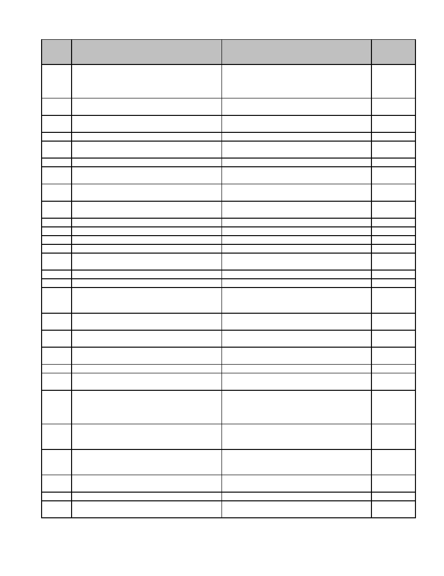

**Series**

**Number** **Description of Record** **Length of Time Required to Retain Record** **MGL / CMR**

01.084 Payroll, Registers Retain until completion of satisfactory audit,

provided information is recorded in quarterly

report. See Personnel, Payroll, Quarterly

Reports (23.21).

01.085 Personnel, (a) Employment Applications Retain 20 years after termination of

(Hired) employment.

01.086 Personnel, (b) Employment Applications Retain 1 year following filling of position or

(Unhired) cancellation of vacancy, whichever is later.

01.087 Personnel, (c) Earning Records Permanent.

01.088 Personnel, (d) Personnel Files Other than Retain 20 years after termination of

Earning Records employment.

01.089 Personnel, Accident Report Forms Retain 3 years.

01.090 Personnel, Accident Reports (a) Personal Retain 7 years.

Injury

01.091 Personnel, Accident Reports (b) Property Retain 3 years.

Damage

01.092 Personnel, Appointment Certificates Retain 20 years after termination (personnel c. 41, s.

file 23.50). 96B

01.093 Personnel, Attendance Report Retain for 20 years after termination

01.094 Personnel, Authorized Leave Report Retain 3 years.

01.095 Personnel, Civil Service Approvals Retain 20 years after termination c. 31, s. 6

01.096 Personnel, Civil Service Forms Retain 20 years.

01.097 Personnel, Court Witness Travel Expense Retain until completion of satisfactory audit. c. 262, s.

53B

01.098 Personnel, Daily Assignment Sheets Retain 3 years.

01.099 Personnel, Drill Reports Retain 3 years.

01.100 Personnel, Earning Reports Retain 1 year if record copy is kept centrally

e.g., by Accountant/Auditor or Treasurer,

otherwise retain 60 years.

01.101 Personnel, Equipment Loan Report (for Retain until return of equipment.

Long Term Use)

01.102 Personnel, Group Insurance Reports (Blue Retain 3 years.

Cross etc.)

01.103 Personnel, Individual Training Report Retain 7 years after termination of

personnel.

01.104 Personnel, Leave Reports (Authorized) Retain 3 years.

01.105 Personnel, Overtime Reports Retain 3 years. c. 48, s.

58c

01.106 Personnel, Payroll Deduction Reports Retain until administrative use ceases if

record copy is kept centrally e.g., by

Treasurer, otherwise retain until completion

of satisfactory audit.

01.107 Personnel, Payroll, Quarterly Reports Retain 1 year if record copy is kept centrally

e.g., by Accountant/Auditor or Treasurer.

Otherwise, retain 60 years.

01.108 Personnel, Payroll, Weekly, Bi-weekly or Retain until completion of satisfactory audit

Monthly Payroll provided recorded elsewhere in a summary

record. See Payroll, Quarterly Reports.

01.109 Personnel, Performance Bonds Retain 7 years. c. 268A, s.

17

01.110 Personnel, Personnel Files Retain 20 years after termination.

01.111 Personnel, Sick Leave Reports Retain 3 years. c41, s.

111G

28

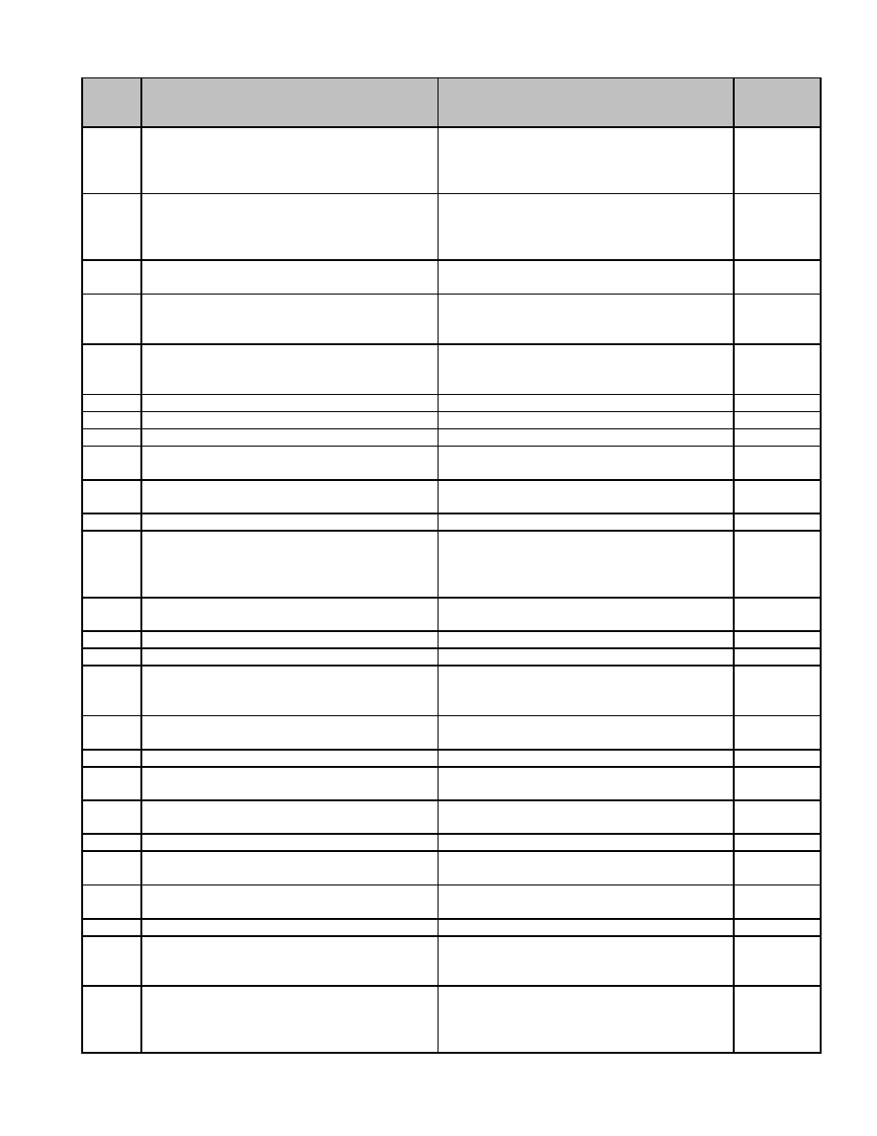

**Series**

**Number** **Description of Record** **Length of Time Required to Retain Record** **MGL / CMR**

01.112 Personnel, Tax Exemption Certificates Retain 1 year if record copy is kept centrally c. 62B, s.

e.g., by Accountant/Auditor or Treasurer; 5

otherwise Retain 5 years, provided a

satisfactory audit has been completed.

01.113 Personnel, Tax Withholding Statements Retain 1 year if record copy is kept centrally

e.g., by Accountant/Auditor or Treasurer;

otherwise Retain 5 years, provided a

satisfactory audit has been completed.

01.114 Personnel, Time Sheets Retain 3 years following completion of c. 41, s. 42

satisfactory audit.

01.115 Personnel, Training Report for Individual Retain 1 year if copy is filed in personnel

Employees file; otherwise retain 7 years after

termination of employee.

01.116 Personnel, Vacation Report Retain 3 years. c. 41, s.

111A, c.

48 s. 57

01.117 Personnel, Weekly Personnel Report Retain 5 years.

01.118 Physician's Accident Report Retain 7 years.

01.119 Plans (referred to in Decisions) Permanent if not filed with clerk.

01.120 Prison-made Goods, List of Retain until superseded by receipt of new c. 127, s.

list. 57

01.121 Prison-made Goods, Requisition for Retain until completion of satisfactory audit. c. 127 s.

57

01.122 Public Records Request Form Retain 3 years.

01.123 Purchase Orders Retain until completion of satisfactory audit c. 30B, c.

unless related to Contract Files. 40 s. 4B,

c. 41 s.

103

01.124 Purchase Requisitions Retain until completion of satisfactory audit

unless related to Contract Files.

01.125 Receipt Book Retain until completion of satisfactory audit.

01.126 Receipts Retain until completion of satisfactory audit.

01.127 Receipts (estimated annual) Retain until administrative use ceases. c. 41, s. 59

Permission from Supervisor not required for

destruction.

01.128 Receipts for Preceding Year, Notice of Retain until completion of satisfactory audit. c. 41 s.

54A

01.129 Receipts, Daily Retain until completion of satisfactory audit. c. 41 s. 35

01.130 Receipts, Schedule of Retain until completion of satisfactory audit. c. 41 ss.

35, 50

01.131 Reserve Fund Transfer (RFT) Request Retain 1 year, provided satisfactory audit c. 40, ss.

has been completed. 5, 6

01.132 Retirement Board, Reports to Retain until completion of satisfactory audit. c. 32, s. 23

01.133 Schedule of Departmental Payments to Retain until completion of satisfactory audit.

Treasurer

01.134 Transfer of Funds Retain until completion of satisfactory audit. c. 44, s.

33B

01.135 Travel Expense Reports Retain until completion of satisfactory audit.

01.136 Vendor List Retain until administrative use ceases.

Permission from Supervisor not required for

destruction.

01.137 Vouchers – as approved by department Retain until completion of satisfactory audit c. 32 s.

head unless related to Contract Files. 23(2)(a), c.

41, ss. 50,

55

29



**Series**

**Number** **Description of Record** **Length of Time Required to Retain Record** **MGL / CMR**

01.138 Warrants – as signed by select board or the Permanent. c. 41, ss.

like 50, 52, 55,

56

01.139 Warrants, Farm Animal, Equipment and Retain until completion of satisfactory audit c. 59 ss.

Machinery Excise. Form 57FAE-ME or final settlement of levy, whichever is 53, 55

later.

01.140 Warrants, Various Warrants to Collector. Retain until completion of satisfactory audit

Includes all taxes, excises, betterments, or final settlement of levy, whichever is

special assessments liens (actual, original, later.

omitted, revised, supplemental, reassessed,

apportioned, added to tax, special,

recommitted).

01.141 Work Sheets Retain until completion of satisfactory audit.

30

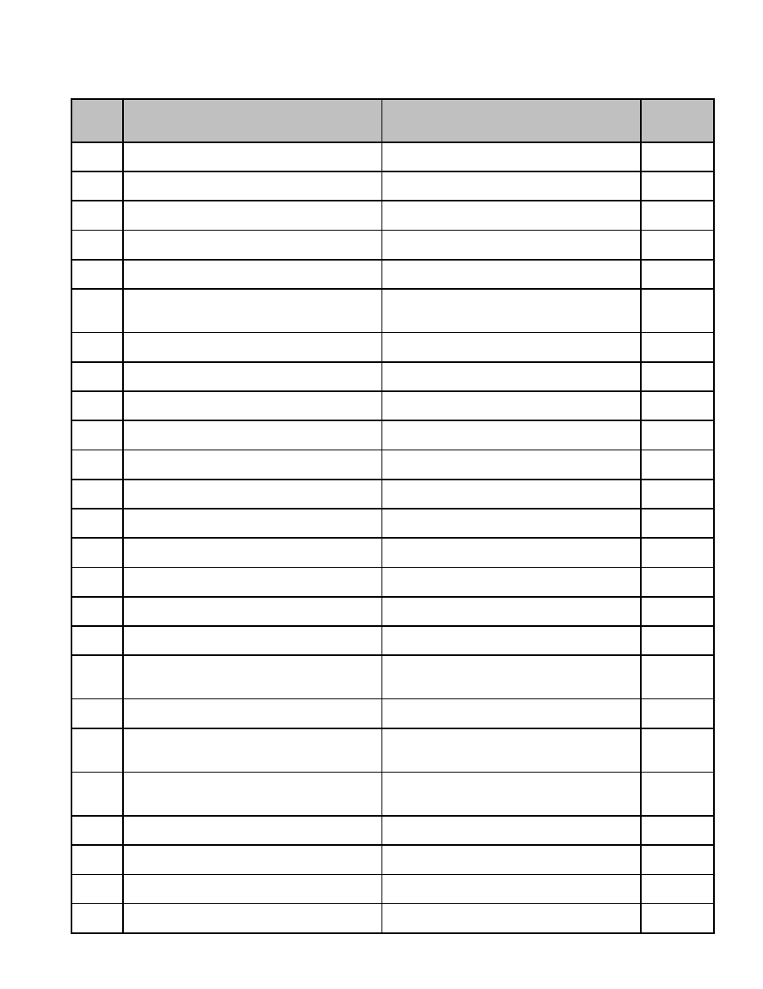

**02 Accountant/Auditor**

**Series**

**Description of Record** **Length of Time Required to Retain Record** **MGL / CMR**

**Number**

02.001 Accountant, Appointment of Permanent. c. 41, s.

55

02.002 Accountant, Oath of Permanent. c. 41, s.

55

02.003 Appropriation Statements, Monthly. Form Retain until completion of satisfactory audit. c. 41, s.

AD 18 58

02.004 Appropriation, Notice of Expended Retain until completion of satisfactory audit c. 41, s.

or final settlement of levy, whichever is later. 58

02.005 Appropriation, Notice of Transfer Retain until completion of satisfactory audit. c. 44, s.

33B

02.006 Appropriations, Table of Estimated Retain until administrative use ceases. c. 41, s.

Permission from Supervisor not required for 60

destruction.

02.007 Assistant, Appointment of Permanent. c. 41, s.

49A

02.008 Assistant, Oath of Permanent. c. 41, s.

49A

02.009 Bills Payable, Schedule of Departmental. Retain until completion of satisfactory audit. c. 41, s.

Form AD 32, 33 50, 51

02.010 Bills Receivable, Schedule of. Form AD 34, Retain until completion of satisfactory audit. c. 41, s.

35 50

02.011 Cash Book Retain until completion of satisfactory audit c. 41, s.

or final settlement of levy, whichever is later. 57

02.012 Cash Sheets, Collector's. Form AD 26 Retain until completion of satisfactory audit. c. 41, s.

57

02.013 Creditors, Notice of Retain until completion of satisfactory audit c. 41, s.

or final settlement of levy, whichever is later. 51

02.014 Debt Record. Form AD 14 Retain 7 years after debt retired, provided a c. 41, s.

satisfactory audit has been completed. 57

02.015 Disallowance, Notices of Retain until completion of satisfactory audit. c. 41, s.

52, 56

02.016 Expenses, Report of Estimated Permanent. c. 44, s.

31A

02.017 Journal Permanent. c. 41, s.

57

02.018 Laws, State Retain until administrative use ceases. c. 5, s. 3

Permission from Supervisor not required for

destruction.

02.019 Ledger, Appropriation. Form AD 8 Retain 10 years. c. 41, s.

57

02.020 Ledger, Cemetery Trust Fund Permanent. c. 41, s.

57, c. 114,

s. 25

02.021 Ledger, Classification. Form ADC 1-48 Retain 10 years. c. 41, s.

57, c. 44,

s. 43

02.022 Ledger, Debt Retain 7 years after debt retired, provided a c. 41, s.

satisfactory audit has been completed. 57

02.023 Ledger, General. Form AD 3, 7 Retain 10 years. c. 44, s.

31A

02.024 Ledger, Retirement Retain 10 years. c. 32, s.

20

02.025 Motor Vehicle and Trailer Excise Tax Retain until completion of satisfactory audit. c. 59, s.

Abatements, Monthly List of. Form AD 73 23B, 70A

31

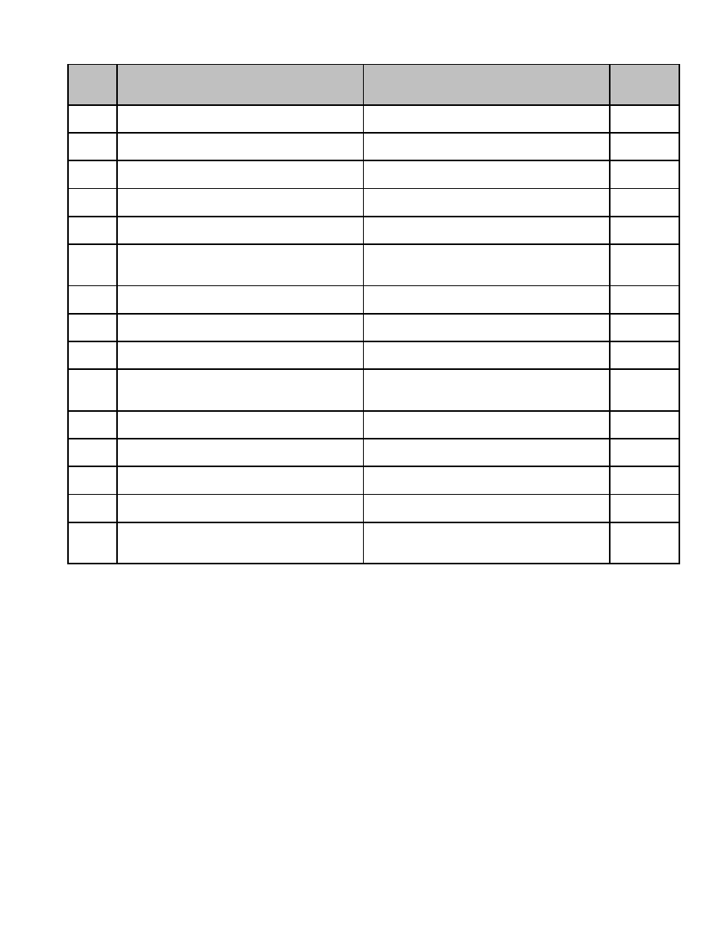

**Series**

**Description of Record** **Length of Time Required to Retain Record** **MGL / CMR**

**Number**

02.026 Motor Vehicle and Trailer Excise Tax Retain until completion of satisfactory audit. c. 41, s.

Refunds, Schedule of. Form AD 74 50

02.027 Payments to Treasurer, Schedule of Retain until completion of satisfactory audit. c. 41, s.

Collector's. Form AD 7, 8, 397 54

02.028 Payments to Treasurer, Schedule of Retain until completion of satisfactory audit. c. 41, s.

Departmental. Form AD 9, 10 54

02.029 Property Tax Abatements, Monthly List of. Retain until completion of satisfactory audit. c. 59, s.

Form AD 12 23B, 70A

02.030 Tax Title Accounts. Form CD 1 Retain until completion of satisfactory audit, c. 60, s.

after final disposition of account. 50

02.031 Taxation, Notice of Amount to be Raised by Retain until administrative use ceases. c. 59, s.

Permission from Supervisor not required for 23A

destruction.

02.032 Temporary Officer, Appointment of Permanent. c. 41, s.

40, 61A

02.033 Temporary Officer, Bond for Retain 7 years from termination of service. c. 41, s.

40, 61A

02.034 Temporary Officer, Oath of Permanent. c. 41, s.

40, 61A

02.035 Trail Balance Book Retain until administrative use ceases.

Permission from Supervisor not required for

destruction.

02.036 Treasurer's Receipts, Schedule of. Form AD Retain until completion of satisfactory audit. c. 41, s.

11 50

02.037 Vouchers, Schedules of Bills Payable and Retain until completion of satisfactory audit

Payroll, as submitted by departments unless related to Contract Files.

02.038 Vouchers. Form AD 19 Retain until completion of satisfactory audit. c. 41, s.

50, 55

02.039 Warrants, Bill and Payroll, Form C1, C1, T1, Retain until completion of satisfactory audit c. 41, s.

T2, as signed by the select board or the like or final settlement of levy, whichever is later. 52, 56

02.040 Water Charges Abated, Monthly List of. Retain until completion of satisfactory audit. c. 41, ss.

Form AD 37. Applies to any utility charges 50, 57

(sewer, solid waste etc.).

32

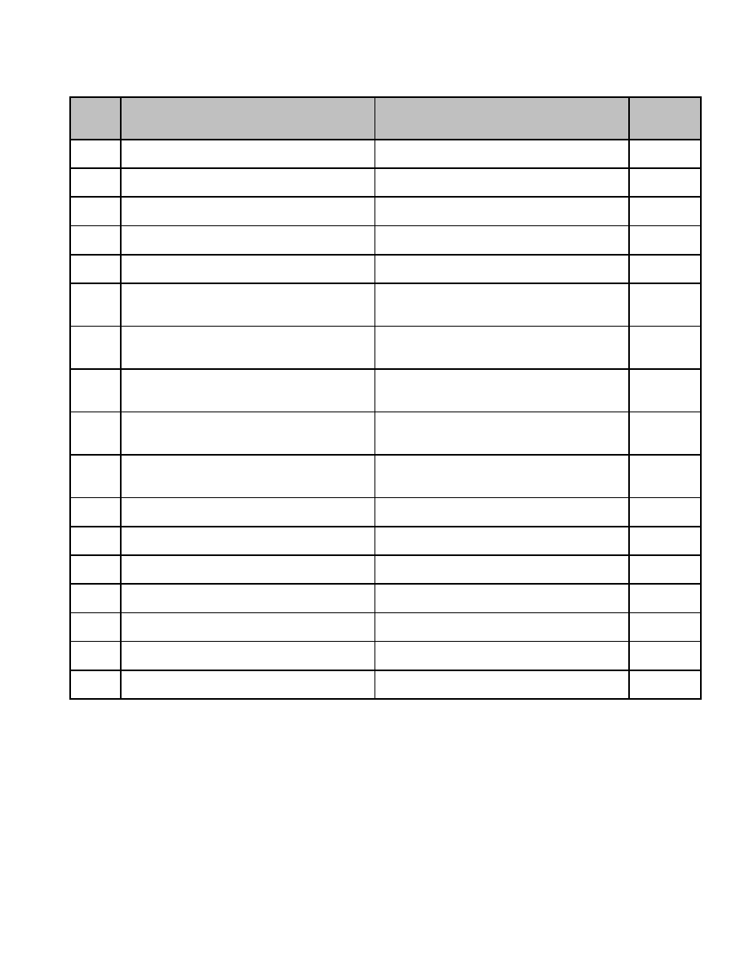

**03 Board of Appeals**

**Series**

**Description of Record** **Length of Time Required to Retain Record** **MGL / CMR**

**Number**

03.001 Applications (a) Appeals Retain 1 year following expiration of 20-day c. 40A ss.

appeal period. 8, 15

03.002 Applications (b) Comprehensive Permits Retain 1 year following expiration of 20-day c. 40B s.

appeal period. 21

03.003 Applications (c) Special Permits Retain 1 year following expiration of 20-day c. 40B ss.

appeal period. 9, 9A

03.004 Applications (d) Variances Retain 1 year following expiration of 20-day c. 40A s.

appeal period. 10

03.005 Appointment of Zoning Administrator Permanent. c. 40A s.

13

03.006 Decisions on (a) Appeals Retain 1 year following expiration of 20-day c. 40A ss.

appeal period, provided copy is filed with 8, 15

clerk.

03.007 Decisions on (b) Comprehensive Permits Retain 1 year following expiration of 20-day c. 40B s.

appeal period, provided copy is filed with 21

clerk.

03.008 Decisions on (c) Special Permits Retain 1 year following expiration of 20-day c. 40B ss.

appeal period, provided copy is filed with 11

clerk.

03.009 Decisions on (d) Variances Retain 1 year following expiration of 20-day c. 40A s.

appeal period, provided copy is filed with 11

clerk.

03.010 Decisions on (e) Decisions of Zoning Retain 1 year following expiration of 20-day c. 40A s.

Administrator appeal period, provided copy is filed with 13

clerk.

03.011 Notice For Public Hearings (a) Appeals Retain 1 year following expiration of 20-day c. 40A ss.

appeal period. 11, 15

03.012 Notice For Public Hearings (b) Retain 1 year following expiration of 20-day c. 40B s.

Comprehensive Permits appeal period. 21

03.013 Notice For Public Hearings (c) Special Retain 1 year following expiration of 20-day c. 40B ss.

Permits appeal period. 11

03.014 Notice For Public Hearings (d) Variances Retain 1 year following expiration of 20-day c. 40A s.

appeal period. 11, 15

03.015 Petty Cash Records Retain until completion of satisfactory audit. c. 40A s.

11

03.016 Rules and Regulations (a) Board of Appeals Permanent. c. 40A s.

12

03.017 Rules and Regulations (b) Board of Appeals Permanent. c. 40A s. 9

Acting as Special Permit Granting Authority

33

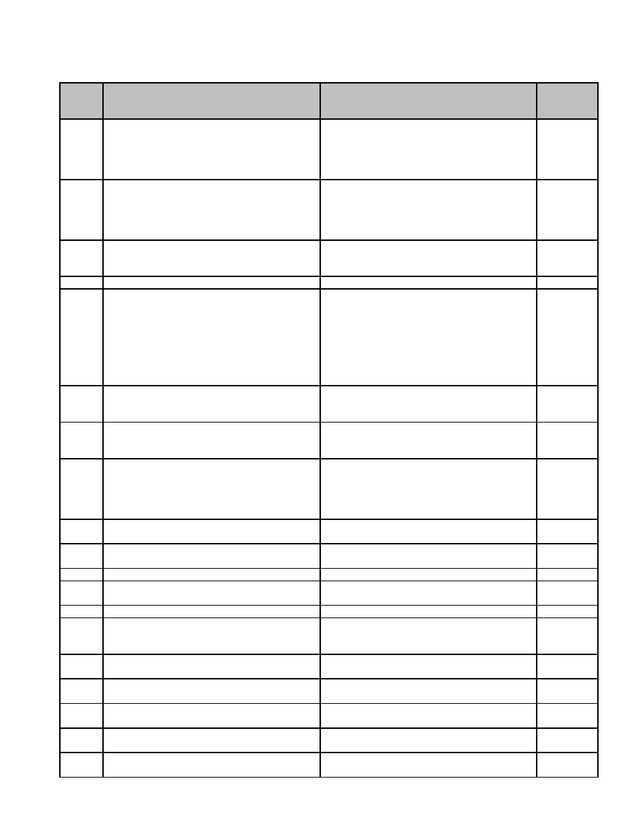

**04 Board of Assessors**

**Series**

**Description of Record** **Length of Time Required to Retain Record** **MGL / CMR**

**Number**

04.001 Abatement under c. 58 s. 8 Assessors' Retain 3 years. c. 58 s. 8

Request for Authorization and

Commissioner's Determination; retention

following satisfactory audit and completion

of all appeals.

04.002 Abatement, Applications for. Form 126, 127, Retain 3 years. c. 59 ss.

128, 129; retention following satisfactory 50 and 59,

audit and completion of all appeals. c. 60A ss.

1 and 2, c.

80 s. 5

04.003 Abatement, Certificates of. Form 146, 146B, Retain 3 years. c. 59 s.

147; retention following satisfactory audit 63, c. 60A

and completion of all appeals. s. 2

04.004 Abatements, Card Files of Retain 3 years.

04.005 Agricultural or Horticultural and Recreational Retain for 10 years after following later of c. 61A ss.

Land Classification Files, Including audit or final settlement of levy audit. 6, 8, 9 and

Application for Classification (CL-1), Prop. c. 61B ss.

Owners' Acknowledgements (CL-1(61A), 3, 6

CL-1(61B)), Notices of Action (CL-2, CL-7,

CL-8, CL-10), Tax Lien (CL-3), Tax Lien

Release (CL-9); Certificate of Penalty Tax

(CL-6)

04.006 Alphabetical File Retain until administrative use ceases.

Permission from Supervisor not required for

destruction.

04.007 Amended Tax Base Growth Summary Retain 5 years. c. 59 s.

(including Tax Base Growth Parcel Listing). 21C

Form LA-13A

04.008 Appellate Tax Board (ATB) case files Retain 3 years. c. 58A ss.

(including all relevant documentation, 7 and 7A,

Petition under Formal Procedure and c. 59 s. 64

Petition under Informal Procedure);

retention after final settlement.

04.009 Application for Excise on Farm Animals, Retain 3 years. c. 59 s. 8A

Machinery and Equipment. Form FAE-ME

04.010 Assessment/Classification Report. Form LA- Retain 5 years. c. 58 ss.

4 9, 10

04.011 Assessors' Tax Maps Permanent.

04.012 Authorization to Issue Preliminary Tax Bills Retain until completion of satisfactory audit c. 59 s.

or final settlement of levy, whichever is later. 23D

04.013 Betterments, Card Records of Retain for the duration of the apportionment. c. 80 s. 13

04.014 Building Permits Retain until administrative use ceases.

Permission from Supervisor not required for

destruction.

04.015 Certification of Unpaid Betterment Liens. Retain until completion of satisfactory audit c. 80 s. 12

Form 261 or final settlement of levy, whichever is later.

04.016 Classification Tax Rate Allocation. Form LA- Retain until approval of new tax rate. c. 59 s.

5 21C

04.017 Collector’s Schedule of Uncollectible Retain until completion of satisfactory audit c. 60A, ss.

Excises. Form 166/380 – MVE/BE or final settlement of levy, whichever is later. 7, 8

04.018 Cooperative Assessing Agreement Retain 7 years following termination of c. 41 s.

agreement. 30B

04.019 County Commissioners' Notification to Retain until completion of satisfactory audit c. 35 s. 31

Assessors or final settlement of levy, whichever is later.

35

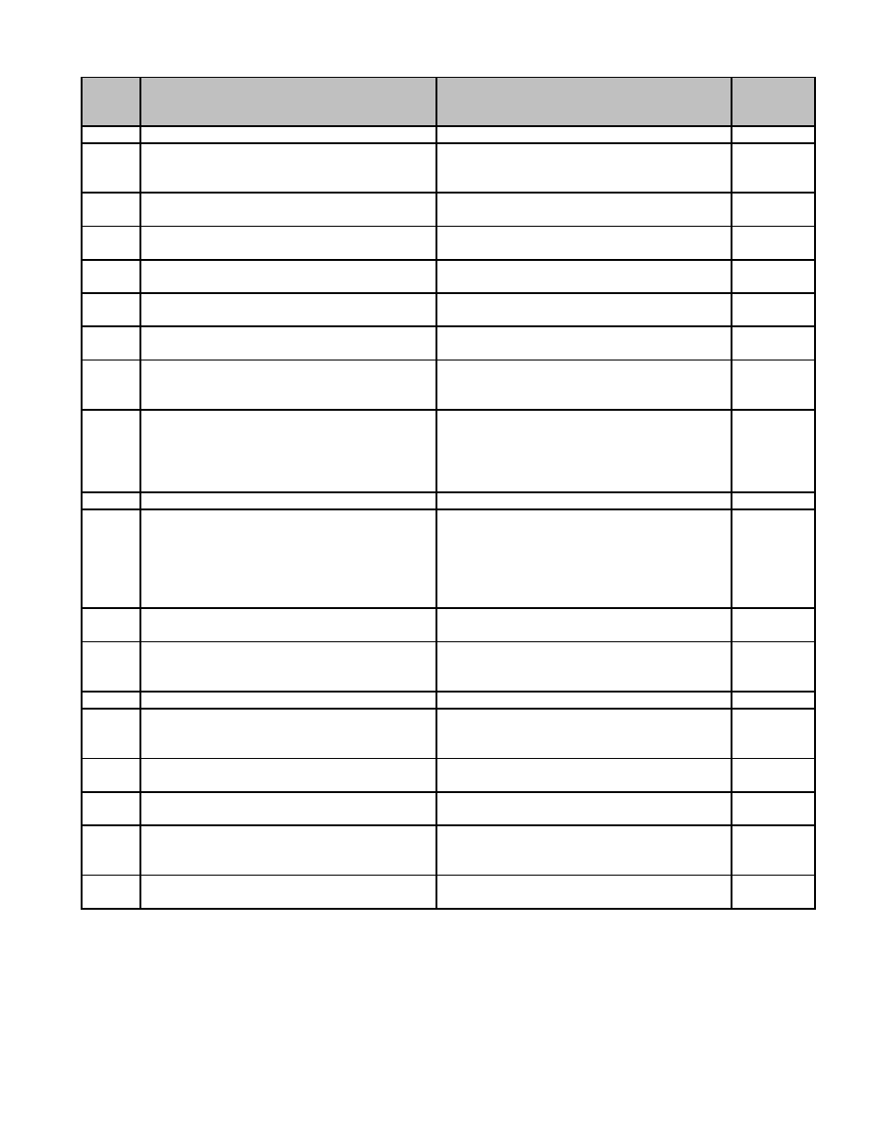

**Series**

**Description of Record** **Length of Time Required to Retain Record** **MGL / CMR**

**Number**

04.020 Data Processing Input Forms Retain until verification of outputs.

04.021 Deed and Title Abstracts Retain until administrative use ceases.

Permission from Supervisor not required for

destruction.

04.022 Department of Revenue Directives and Retain until superseded.

Guidelines

04.023 Divided Assessment, Notice of Retain until completion of satisfactory audit

or final settlement of levy, whichever is later.

04.024 Equalized Valuation LA-3 Status Report Retain 3 years. c. 58 ss. 9

and 10

04.025 Estimated Growth Report Retain 5 years. c. 58 ss.

9, 10

04.026 Exemption, Certificates of Retain until completion of satisfactory audit c. 59 s. 5

or final settlement of levy, whichever is later.

04.027 Exemptions for Charitable Organizations, Retain 3 years following audit following final c. 59 s. 5

Application Files (includes 3ABC and settlement of levy following termination of cl.(3)

Annual Reports) exemption.

04.028 Exemptions for Persons, Application Files, Retain until completion of satisfactory audit c. 59 s. 5

including Motor Vehicle Excise or final settlement of levy, whichever is later. cl. 17, 22,

37, 41, 42,

43 and c.

60A s. 1

04.029 Exemptions, Card Files of Retain 3 years.

04.030 Forest Land Classification Files, Including Retain for 10 years after following later of c. 61

Application for Classification (CL-1), Prop. audit or final settlement of levy audit.

Owners' Acknowledgements (CL-1(61),

Notices of Action (CL-2, CL-7, CL-8, CL-10),

Tax Lien (CL-3), Tax Lien Release (CL-9);

Certificate of Penalty Tax (CL-6)

04.031 Forms of List. Form 2, 2HF Retain 3 years. c. 59 ss.

29, 36

04.032 Geographic (Street) File Retain until administrative use ceases.

Permission from Supervisor not required for

destruction.

04.033 Income and Expense Statements Retain 3 years.

04.034 Land Court Records Retain until administrative use ceases.

Permission from Supervisor not required for

destruction.

04.035 List of Tax Bills Which Merit Exemption Retain until completion of satisfactory audit c. 60A s. 1

or final settlement of levy, whichever is later.

04.036 Minimum Residential Factor Computation Retain until approval of new tax rate. c. 59 s.

Form. Form LA-7 21C

04.037 Monthly List of Abatements of Motor Vehicle Retain until completion of satisfactory audit c. 60A s. 1

and Trailer Excise (to Accountant). Form or final settlement of levy, whichever is later.

156

04.038 Monthly List of Taxes Abated, Real Estate Retain until completion of satisfactory audit c. 59 s.

and Personal Property. Form 155 or final settlement of levy, whichever is later. 23B

36

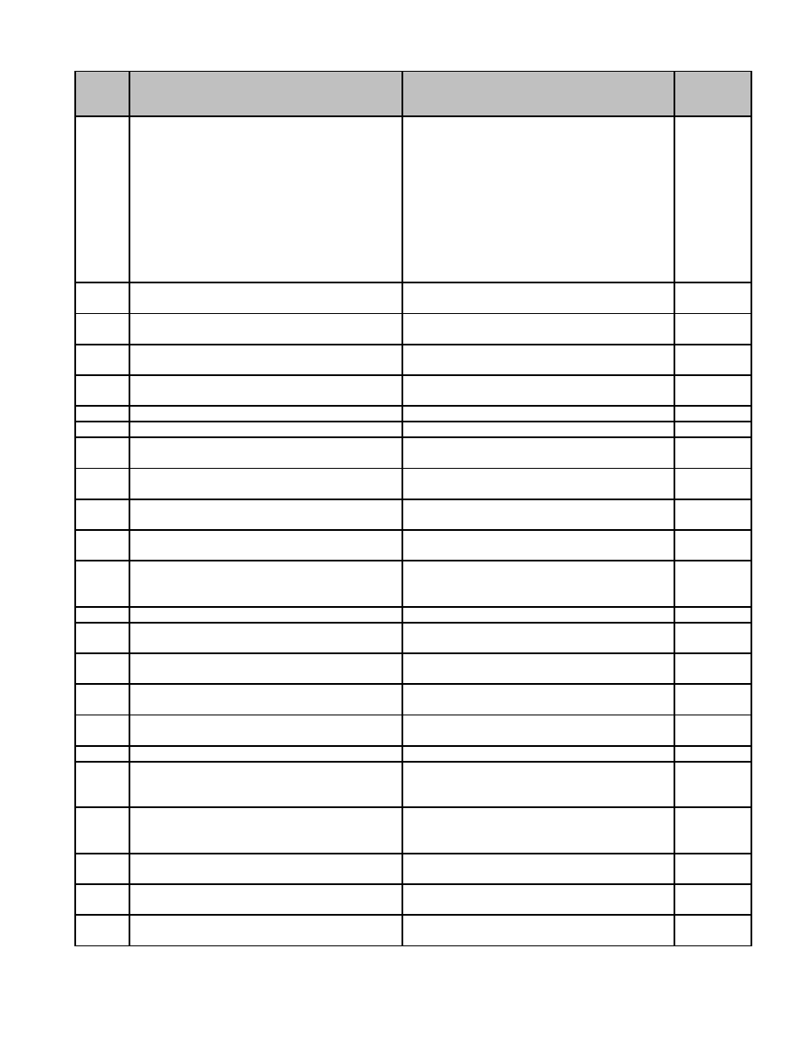

**Series**

**Description of Record** **Length of Time Required to Retain Record** **MGL / CMR**

**Number**

04.039 Municipal Liens and Releases Retain 1 year after recording of release. c. 59 s.

2B, c. 60

s. 23, c.

61, c. 61A

s. 9, c.

61B s. 6,

c. 80 s.

12, c. 83

ss. 27 and

29, c.

90B, s. 31

04.040 Notice from Collector that Certain Taxes Retain until completion of satisfactory audit c. 59 s. 71

Cannot be Collected. Form 380, 380A or final settlement of levy, whichever is later.

04.041 Notice of Assessment. Form 1 Retain until completion of satisfactory audit c. 59 s. 29

or final settlement of levy, whichever is later.

04.042 Notice of Commitment (to Accountant). Retain until completion of satisfactory audit c. 59 ss.

Form 54 or final settlement of levy, whichever is later. 53 and 54

04.043 Notification of Acceptance (of Section of Retain until completion of satisfactory audit c. 59 s. 5

Chapter, to Commissioner) or final settlement of levy, whichever is later.

04.044 Notification of Collector's Bond Retain until expiration of bond. c. 41 s. 20

04.045 Office Expense Records Retain until completion of satisfactory audit.

04.046 Omitted and Revised Assessment Report Retain until completion of satisfactory audit c. 59 ss.

or final settlement of levy, whichever is later. 75, 76

04.047 Owners Unknown, Request for Approval to Retain 1 year after Decree of Foreclosure c. 59 s. 11

Assess to by Land Court.

04.048 Personal Property Tax. Form 37S Retain until completion of satisfactory audit c. 59 ss.

or final settlement of levy, whichever is later. 43 and 44

04.049 Pro Forma Recapitulation Permanent. c. 59 s.

23D

04.050 Probate Records Retain until administrative use ceases.

Permission from Supervisor not required for

destruction.

04.051 Property History (Street or Legal) Cards Permanent.

04.052 Property Record Cards Retain until completion of two revaluation

cycles.

04.053 Property Sales Report. Form LA 3 Retain 3 years. c. 58 ss. 9

and 10

04.054 Real Estate Subsequently Divided, Notice of Retain until completion of satisfactory audit c. 59 s.

Apportionment of Taxes on or final settlement of levy, whichever is later. 78A

04.055 Real Estate Tax. Form 38S Retain until completion of satisfactory audit c. 59 s. 53

or final settlement of levy, whichever is later. and 55

04.056 Records of Abatement. Form 151 Permanent. c. 59 s. 60

04.057 Reference Files (including Manuals and Retain until administrative use ceases.

Text Books) Permission from Supervisor not required for

destruction.

04.058 Refusal to Abate Property Tax, Notice of. Retain 3 years. c. 59 ss.

Form 135, 135E, 136 58A and

63

04.059 Reimbursement Records, All Exemptions Retain until completion of satisfactory audit c. 59 s. 5

or final settlement of levy, whichever is later.

04.060 Report of All Exemptions Granted (to Retain until completion of satisfactory audit c. 59 s. 5

Commissioner) or final settlement of levy, whichever is later.

04.061 Return to Assessors, Boats Ships and Retain 3 years. c. 59 s. 29

Vessels. Form 2BE-1

37

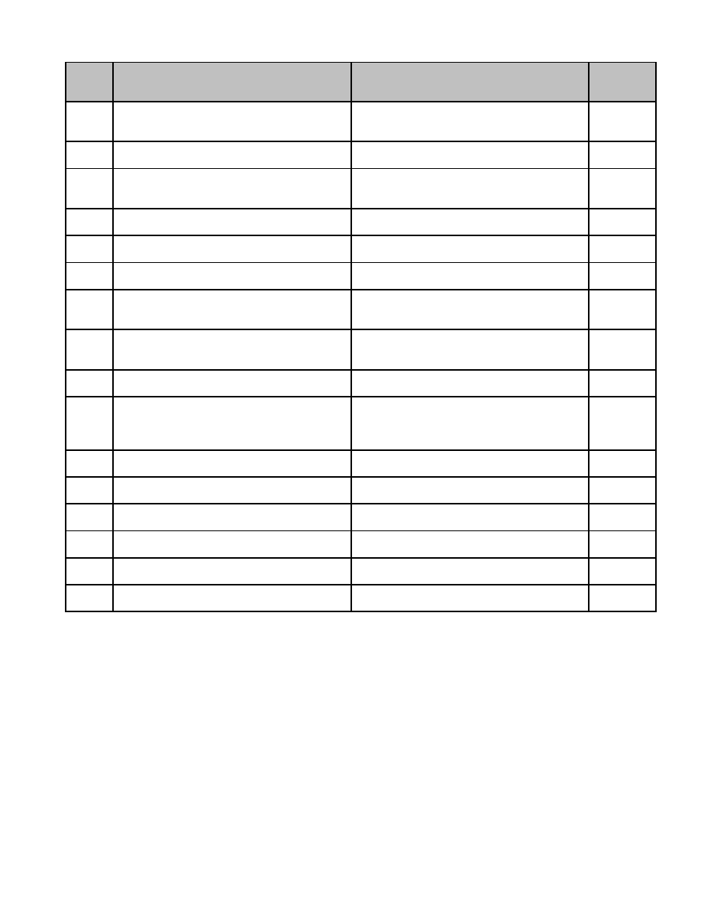

**Series**

**Description of Record** **Length of Time Required to Retain Record** **MGL / CMR**

**Number**

04.062 Sales Questionnaires Retain until administrative use ceases.

Permission from Supervisor not required for

destruction.

04.063 Schedule of Departmental Payments to Retain until completion of satisfactory audit. c. 41 s. 35

Treasurer. Form AD-10

04.064 Schedule of Uncollected Motor Vehicle and Retain until completion of satisfactory audit c. 58 s. 8

Trailer Excise Taxes (to Commissioner). or final settlement of levy, whichever is later.

Form 386

04.065 Separate Tax Bills, Record of Real Estate Retain until completion of satisfactory audit

Assessments for or final settlement of levy, whichever is later.

04.066 State and County Taxes, Payment of Retain until completion of satisfactory audit c. 59 s. 20

or final settlement of levy, whichever is later.

04.067 State Treasurer's Notification to Assessors Retain until completion of satisfactory audit c. 59 s. 20

or final settlement of levy, whichever is later.

04.068 State-owned Land, Commissioner's Retain 5 years. c. 58 s. 15

Notification to Assessors of his

Determination of Value of

04.069 State-owned Land, Request from Retain 5 years. c. 58 s. 15

Commissioner for Assessors to Notify of

Assessed Value of

04.070 Tax Base Growth Summary (including all Retain 5 years. c. 59 s.

supporting documentation). Form LA-13 21C

04.071 Tax Bills, Notifications and Demands Retain until completion of satisfactory audit. c. 60 ss. 3

(Assessors' copies) and 3A, c.

60A s. 1

and 2

04.072 Tax Deferral Files Retain 1 year following release of lien. c. 59 s. 5

cl. 41A

04.073 Tax Rate Recapitulation. Form 31C Permanent. c. 59 ss.

23, 46

04.074 Total Valuation of All Property. Form LA-2 Retain until approval of new tax rate. c. 59 c.

21C

04.075 Uncollectible Taxes, Certification of Retain until completion of satisfactory audit c. 58 s. 8

Abatement. Form 166 or final settlement of levy, whichever is later.

04.076 Valuation Lists, (a) Motor Vehicle and Retain until completion of satisfactory audit c. 60A s. 1

Trailer or final settlement of levy, whichever is later.

04.077 Valuation Lists, (b) all but Motor Vehicle and Permanent. c. 59 ss.

Trailer 44, 52

38



**Series**

**Description of Record** **Length of Time Required to Retain Record** **MGL / CMR**

**Number**

04.078 Water and Sewer, Unpaid Lien Added to Retain until completion of satisfactory audit c. 40, ss.

Taxes. Applies to all license added to a tax, or final settlement of levy, whichever is later. 42D, 58,

e.g., municipal charges, fines, water, solid c. 40U, s.

waste, sewer, demolition, light plant, etc. 12; c. 44,

s. 28C(f);

c. 83, s.

16B; c.

111, s.

125; c.

111, s.

127B; c.

139, s.

3A; c.

143, s. 9;

c. 148, s.

5; c. 164,

s. 58C; c.

41 ss.

69A, 69B,

c. 59 s. 53

39

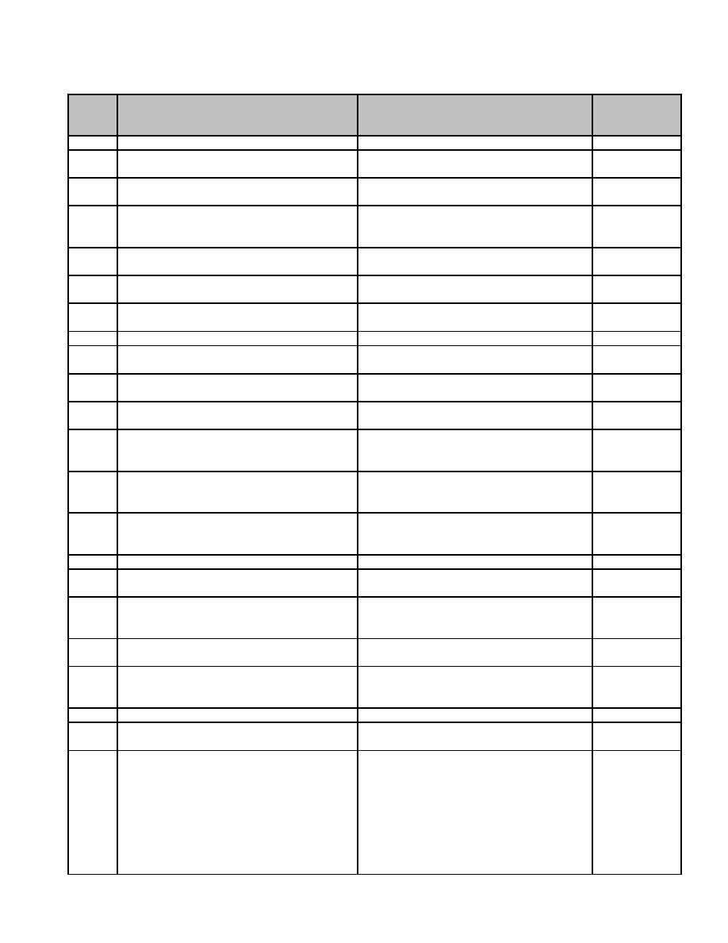

**05 Board of Health**

**Series**

**Description of Record** **Length of Time Required to Retain Record** **MGL / CMR**

**Number**

05.001 Animal Inspector, Records of Inspection by Permanent. c. 129 .25

05.002 Animal, Certificate of Healthy Condition; Permanent. c. 129 s. 20

retention by Animal Inspector.

05.003 Animal, Notice of Quarantine of Domestic; Permanent. c. 129 ss. 21,

retention by Animal inspector. 22, 24

05.004 Building Report - Animal Inspector to Retain 1 year, provided copy recorded c. 129 s. 23

Director permanently in records of Animal

Inspector.

05.005 Burial or Removal Permit. Form R-309 Permanent. c. 114 ss. 45,

46

05.006 Cemeteries, Approval of Public (including Permanent. c. 114 s. 34

plans thereof)

05.007 Communicable Disease among Animals, Permanent. c. 129 s. 28

Notice of

05.008 Communicable Disease History Sheet Retain 3 years following inactive status.

05.009 Communicable Disease, Notice of Carcass Permanent. c. 94 s. 146

Infected with

05.010 Communicable Disease, Records of Permanent. c. 111 s. 113

(ledger)

05.011 Communicable Disease, Weekly Report of Permanent. c. 111 s. 29

Deaths

05.012 Contacts with Living Patients Retain 7 years, if the contact is in good

health, unless the provisions of c. 111 s.

70 apply, then retain 30 years.

05.013 Deceased Contacts, Records of Retain 7 years, if the contact is in good

health, unless the provisions of c. 111 s.

70 apply, then retain 30 years.

05.014 Deceased Patients, Records of Retain 7 years, if the contact is in good

health, unless the provisions of c. 111 s.

70 apply, then retain 30 years.

05.015 Dental Examination Records Retain 1 year after inactive status.

05.016 Direct Patient Care Service, Records of Retain 30 years.

(including Primary Care Center)

05.017 Food Establishments and Bakeries, Floor Retain 1 year after closing or change of S. S. C., Art.

Plans of owner. X; c. 129 s.

9M

05.018 Health Assessments Retain 1 year after referral to physician or

inactive status.

05.019 Immunization, Records of (excluding Retain 7 years, if the contact is in good

Influenza, see below) health, unless the provisions of c. 111 s.

70 apply, then retain 30 years.

05.020 Index Cards Retain 30 years.

05.021 Influenza Immunization, Records of Retain 7 years, unless regulated by other

statutory requirements.

05.022 Inspection Reports Retain until superseded by subsequent c. 94 ss. 10C,

report. 16K, 36, 67,

249A, 305C;

c. 111 ss.

127A-J, 128C;

c. 130 s. 81;

c. 140 s. 32B;

S. S. C. , Art.

VI, VII, X

41

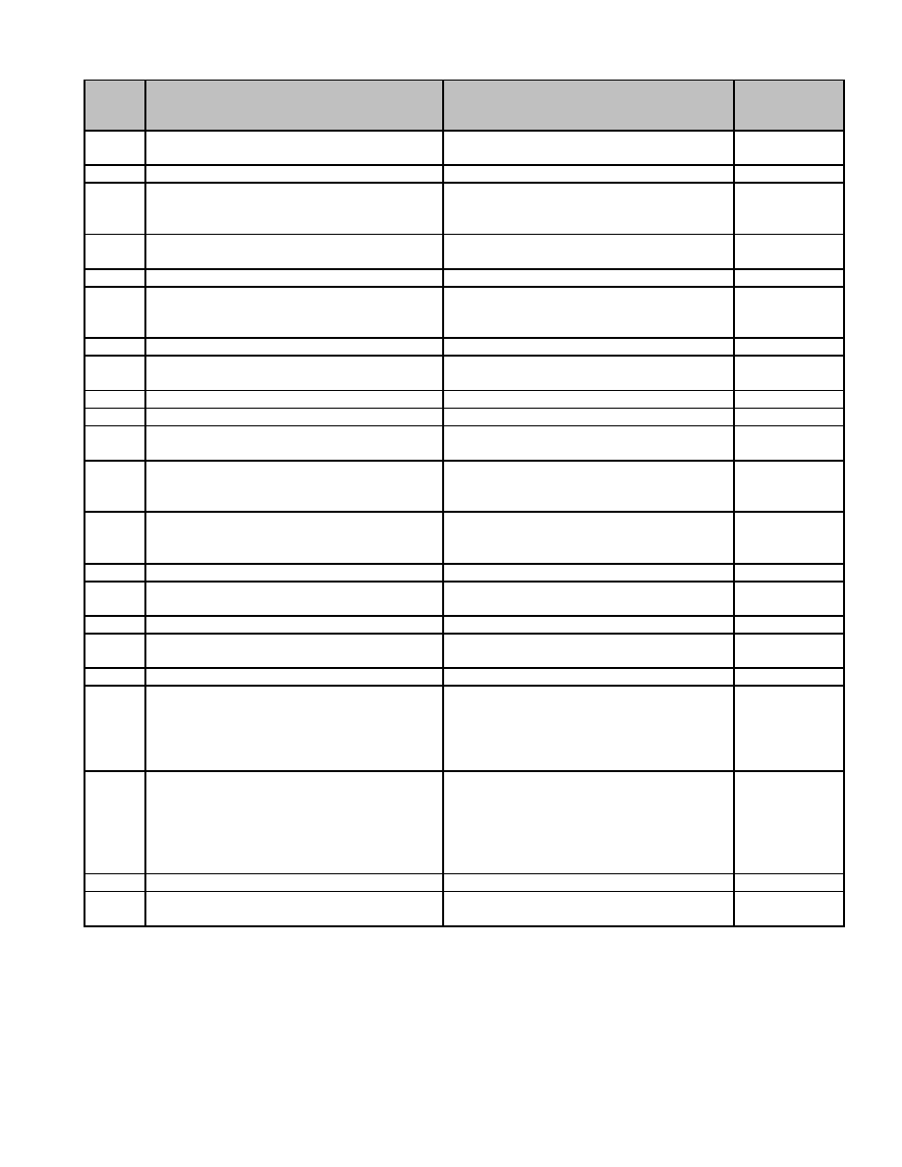

**Series**

**Description of Record** **Length of Time Required to Retain Record** **MGL / CMR**

**Number**

05.023 Living Contacts of Deceased Patients, Retain 7 years.

Records of

05.024 Milk Inspector, Records of Permanent. c. 94 s. 35

05.025 Noisome Trades, Assignment of Place for Permanent. c. 111 s. 143

(approved plan must exist with a letter and

map)

05.026 Nuisance, Notice/Order to Abate Retain 1 year. c. 111 s. 122

(et seq.)

05.027 Occupancy, Certificate of Retain until next certificate is issued.

05.028 Physicians' Orders Retain 7 years, if the contact is in good

health, unless the provisions of c. 111 s.

70 apply, then retain 30 years.

05.029 Reports from Hospitals and Clinics Retain 7 years.

05.030 Rules and Regulations Permanent. c. 111 s. 31

(et passim)

05.031 Sanitary Landfill, Assignment of Plans for Permanent.

05.032 Sanitary Landfill, Plan for Permanent.

05.033 School Health Records Retain 5 years after graduation or

departure from school system.

05.034 Screening, Records of (including Retain 1 year after referral to physician or

tuberculosis, lead poisoning, and related inactive status.

testing programs) (a) Positive Test

05.035 Screening, Records of (including Retain until administrative use ceases.

tuberculosis, lead poisoning, and related Permission from Supervisor not required

testing programs) (b) Negative Test for destruction.

05.036 Slaughter House, Approval of Operation of Permanent. c. 111 s. 151

05.037 Subdivision Plan to Planning Board, Permanent. c. 41 s. 81U

Report of Definitive

05.038 Subdivision Plan, Definitive Permanent. c. 41 s. 81U

05.039 Subdivision Plan, Notice of Permanent. c. 41 s. 81S

Approval/Disapproval

05.040 Subdivision Plan, Preliminary Permanent. c. 41 s. 81S

05.041 Subsurface Sewer Disposal System Retain until new system is installed. Environmental

Quality

Engineering

(EQEE) Title

V

05.042 Subsurface Sewer Disposal System, Retain until new system is installed. Environmental

Inspection Report Records Quality

Engineering;

Environmental

Code (EQEE)

Title V

05.043 Veterans, Affidavit Relative to Burial Retain 1 year. c. 114 s. 46A

05.044 Well Child Clinic, Records of (including Retain until child reaches age 21.

preschool immunization)

42

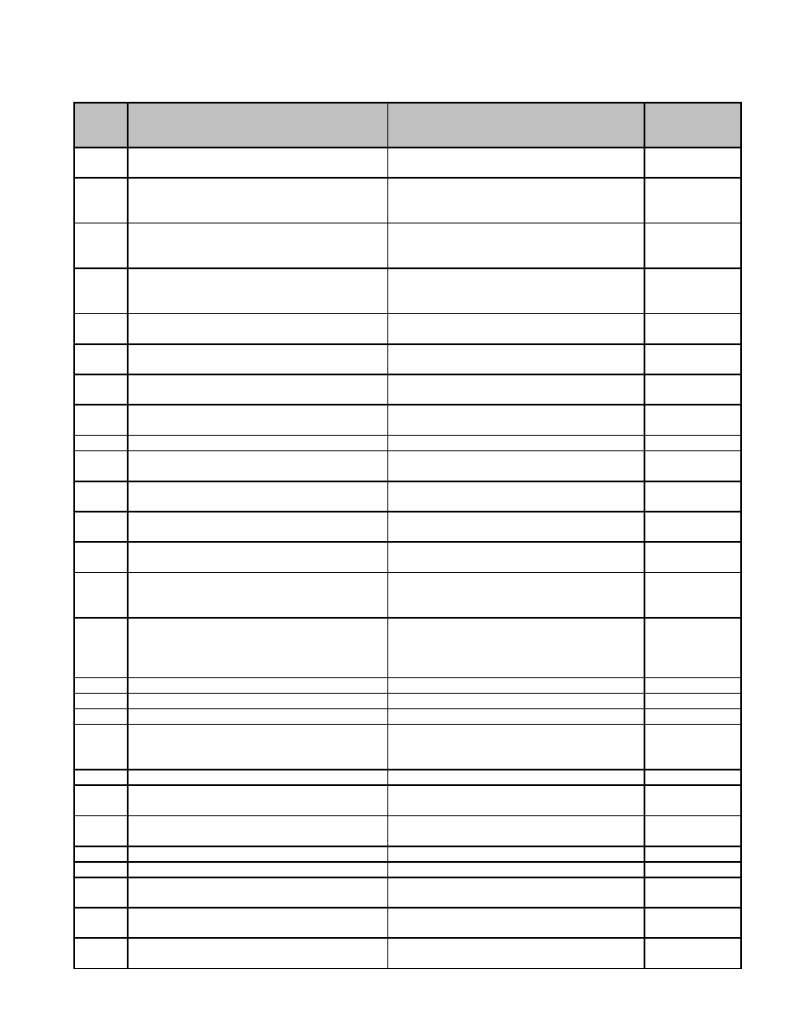

**06 Building Inspector**

**Series**

**Description of Record** **Length of Time Required to Retain Record** **MGL / CMR**

**Number**

06.001 Application for Permits (a) Building: record Retain for life of building. c. 143 s. 3

all permits in permanent log.

06.002 Application for Permits (b) Electrical Retain 7 years. c. 143 s. 3L

Wiring; record all permits in permanent

log.

06.003 Application for Permits (c) Elevator and Retain 7 years.

Escalator; record all permits in permanent

log.

06.004 Application for Permits (d) Erect, Alter or Retain for life of building.

Repair; record all permits in permanent

log.

06.005 Application for Permits (e) Gas Fitting; Retain 7 years. c. 143 s. 3N

record all permits in permanent log.

06.006 Application for Permits (f) Plumbing Work; Retain 7 years.

record all permits in permanent log.

06.007 Application for Permits (g) Signs; record all Retain for life of installation.

permits in permanent log.

06.008 Application for Permits (h) Swimming Pool; Retain for life of installation.

record all permits in permanent log.

06.009 Audit account form Permanent.

06.010 Elevator and Escalator Inspection Records Retain 7 years. c. 143 s. 62

(a) Plans for Installation or Alteration

06.011 Elevator and Escalator Inspection Records Retain 3 years.

(b) Specifications

06.012 Elevator and Escalator Inspection Records Retain until superseded. c. 143 s. 63

(c) Certificate of Approval

06.013 Elevator and Escalator Inspection Records Retain until superseded provided c. 143 s. 64

(d) Inspection Reports Certificate of Approval is granted.

06.014 Elevator and Escalator Inspection Records Retain until superseded. c. 143 s. 65

(e) Certificate or Notice as to Safety and

Construction

06.015 Elevator and Escalator Inspection Records Retain 7 years after abatement. c. 143 s. 66

(f) Reports as to Unsafe Conditions and

Accidents; Accident Reports; Receipts for

Accident Reports

06.016 Equipment Records Retain 7 years.

06.017 Inspection Certificates (a) Egress Retain for life of building.

06.018 Inspection Certificates (b) Occupancy Retain for life of building.

06.019 Inspection Certificates (c) Other: Building, Retain until superseded.

Elevator and Escalator, Gas Fitting,

Plumbing and Wiring, etc.

06.020 Notices (a) To Affix Street Numbers Retain 7 years.

06.021 Notices (b) Building in Dangerous Retain for life of building or 7 years after

Condition abandonment, whichever is sooner.

06.022 Notices (c) To Cease and Desist Illegal Retain 7 years after abatement.

Work

06.023 Notices (d) Violation Retain 1 year.

06.024 Permit Log Permanent.

06.025 Petty Cash Records Retain until completion of satisfactory

audit.

06.026 Plans and Specifications (a) Plans of Permanent.

Buildings with Public Access

06.027 Plans and Specifications (b) Plans of Retain for life of building.

Private Dwellings

43

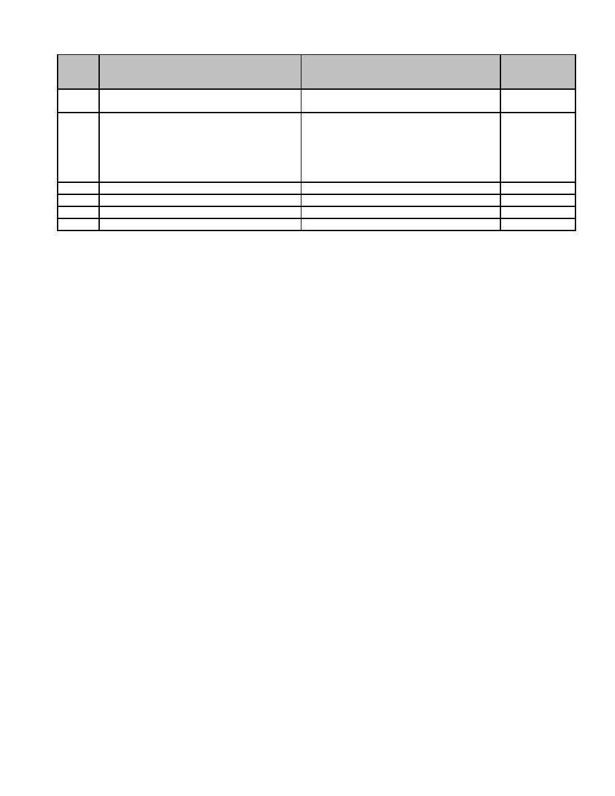

**Series**

**Description of Record** **Length of Time Required to Retain Record** **MGL / CMR**

**Number**

06.028 Plans and Specifications (c) Specifications Retain 7 years after completion of

building.

06.029 Plans and Specifications (d) Plans and Permanent. c. 9 ss. 26C,

Specifications of Buildings Included in the 27C

State Register of Historic Places, or

Eligible for Inclusion. Please call the Mass.

Historical Commission (617-727-8470)

where clarification is needed.

06.030 Retired Vehicle Records Retain 1 year after retirement of vehicle.

06.031 Sick Leave Reports Retain 3 years.

06.032 Special Investigation Records Retain 7 years.

06.033 Waiver of Code Regulation Retain for life of building.

44

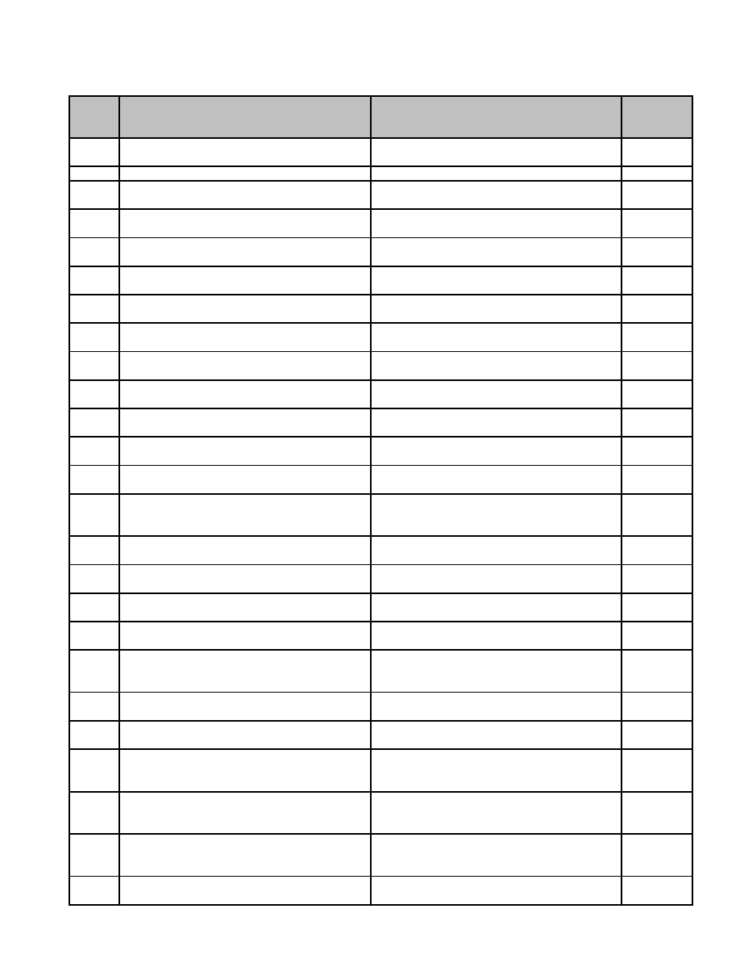

**07 City and Town Clerks**

**Series**

**Description of Record** **Length of Time Required to Retain Record** **MGL / CMR**

**Number**

07.001 Assignment, Creditors, Benefit of Retain 7 years following dissolution of trust. c. 203, s.

41

07.002 Assignment, Fenceviewers Permanent. c. 49, s. 6

07.003 Assignment, Wage Permanent. c. 154, s.

2

07.004 Bonds, Blasting Retain 5 years from expiration date. c. 148, s.

19

07.005 Bonds, City/Town Clerk Retain 7 years from expiration date. c. 41, s.

13A

07.006 Bonds, Constable Retain 5 years from expiration date. c. 41, s.

92B

07.007 Bonds, Fireworks, Manufacture of Retain 5 years from expiration date. c. 148, s.

40

07.008 Bonds, Performance Retain 7 years from expiration date. c. 41, s.

13

07.009 Bonds, Shooting Gallery License, Applicant Retain 5 years from expiration date. c. 140, s.

for 56A

07.010 Bulky Goods, Attachment of Permanent. c. 223, s.

50

07.011 Business Notices, Certificate Retain 5 years. c. 110, s.

5

07.012 Business Notices, Discontinuance, Change Retain 5 years. c. 110, s.

of Address, etc., Notice of 5

07.013 By-Laws (including written approval of Permanent. c. 40, s.

Attorney General" 32

07.014 Census, Annual Town Retain 1 year or after publication of Street c. 51, ss.

List, whichever is later. Permission from 4, 6

Supervisor not required for destruction.

07.015 Charters, Adoption, Certificate of Permanent. c. 43B, s.

12

07.016 Charters, Adoption, Petition of Retain 1 year following election. c. 43B, s.

3

07.017 Charters, Final Report Permanent. c. 43B, ss.

9, 11

07.018 Charters, Nomination Papers (Charter Retain 1 year. c. 43B, s.

Commission) 5

07.019 Charters, Organization, Notice of Retain 60 days following election at which c. 43B, s.

proposed charter, revision, or amendment is 7

approved.

07.020 Charters, Preliminary Report Permanent. c. 43B, s.

9

07.021 Charters, Receipts and Expenditures, Retain 1 year following adoption of charter. c. 43B, s.

Account of 8

07.022 Chattel Mortgages, Pre-Uniform Permanent.

Commercial Code (all filings) (a) Pre-1920

Records

07.023 Chattel Mortgages, Pre-Uniform Retain until administrative use ceases.

Commercial Code (all filings) (b) Records Permission from Supervisor not required for

from 1920-1958 destruction.

07.024 Chattel Mortgages, Uniform Commercial Retain 6 years, or 1 year following date of c. 106, s.

Code (UCC) (all filings) lapse. Permission from Supervisor not 9-403, to

required for destruction. 9-408

07.025 Church Records Permanent. c. 66, s.

17

45

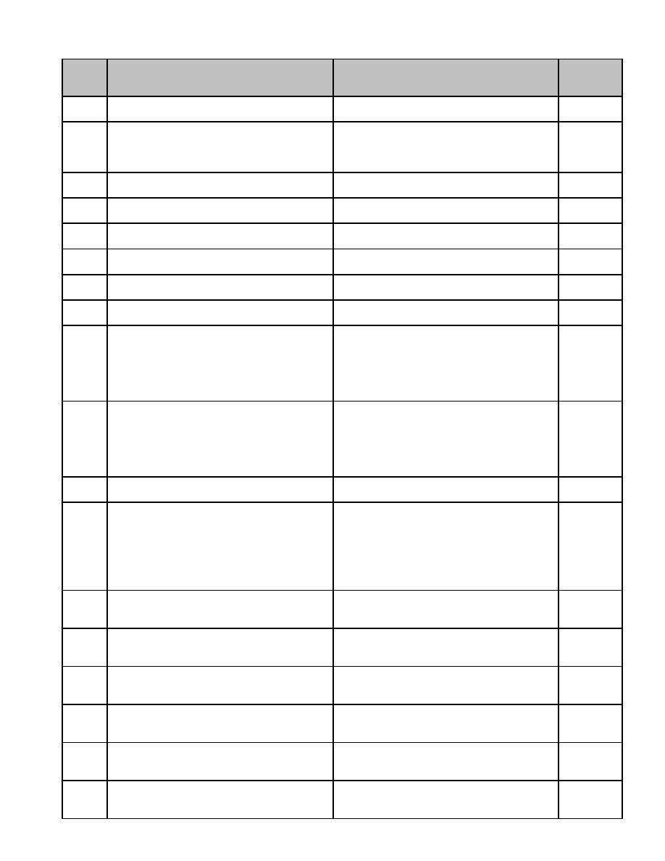

**Series**

**Description of Record** **Length of Time Required to Retain Record** **MGL / CMR**

**Number**

07.026 Claims of Payment Retain 7 years. c. 149, s.

29

07.027 Condensed Financial Returns Retain 6 years. c. 164, s.

84A c.

166, s.

12A

07.028 Conflict of Interest Statements Retain 7 years or following termination of c. 268A,

employment, whichever date is later. ss. 20, 24

07.029 Debt, Statements of, Public Works, Labor Retain 7 years. c. 149, s.

and Material used in 28

07.030 Debt, Statements of, Railroad, Work Retain 7 years. c. 159, s.

performed for 99

07.031 Declarations of Trust Permanent. c. 182, s.

2

07.032 Deeds (Cemetery Lots) Permanent. c. 114, s.

24

07.033 Dog Owners, Annual List of Retain 1 year. Permission from Supervisor c. 140, s.

not required for destruction. 150

07.034 Elections, Absentee Ballots, Applications Retain 30 days following the election (if no c. 54, ss.

and Envelopes for appeals are pending). Records of election in 89, 91

which candidates for Federal office

participate must be kept for 22 months

following the election. Permission from

Supervisor not required for destruction.

07.035 Elections, Ballots, Regular and Absentee Retain 30 days following the election (if no c. 54, ss.

appeals are pending). Records of election in 134, 135,

which candidates for Federal office 135A

participate must be kept for 22 months

following the election. Permission from

Supervisor not required for destruction.

07.036 Elections, Board of Registrars, Minutes of Permanent. c. 51, s.

23

07.037 Elections, Campaign Finance Statements. Retain records required to be filed with the c. 55, s.

Form CPF M 102 clerk until December 31 st of the sixth year 26

following the relevant election. Records of

election in which candidates for Federal

office participate must be kept for 22

months following the election. Permission

from Supervisor not required for destruction.

07.038 Elections, Central Voter Registration Retain 3 years.

System Acknowledgement Notice - Federal

office candidates

07.039 Elections, Central Voter Registration Retain 1 year following date of mailing of

System Acknowledgement Notice - non- final notice of removal or reinstatement of

Federal office candidates voter.

07.040 Elections, Central Voter Registration Retain 3 years. Permission from Supervisor 950 CMR

System Affirmation of Current Residence not required for destruction. 52, 53.00,

54.00

07.041 Elections, Central Voter Registration Retain 3 years. c. 51, s.

System Confirmation Notice - Federal office 37

candidates

07.042 Elections, Central Voter Registration Retain 1 year following date of mailing of c. 51, s.

System Confirmation Notice - non-Federal final notice of removal or reinstatement of 37

office candidates voter.

07.043 Elections, Central Voter Registration Retain 3 years. c. 51, s.

System Final Notice of Removal - Federal 37A

office candidates

46

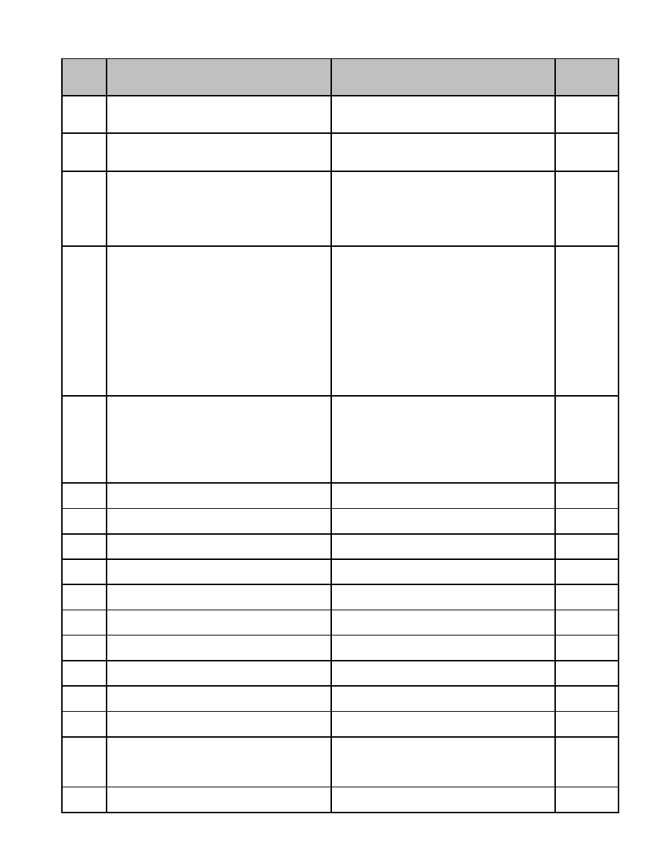

**Series**

**Description of Record** **Length of Time Required to Retain Record** **MGL / CMR**

**Number**

07.044 Elections, Central Voter Registration Retain 1 year following date of mailing of c. 51, s.

System Final Notice of Removal - non- final notice of removal or reinstatement of 37A

Federal office candidates voter.

07.045 Elections, Claim to Office, Statement of Retain until withdrawal of claim or final c. 54, s.

adjudication of contest. Permission from 134

Supervisor not required for destruction.

07.046 Elections, Declaration of Intention to Retain until withdrawal of claim or final c. 54, s.

Contest Election adjudication of contest. Records of election 134

in which candidates for Federal office

participate must be kept for 22 months

following the election. Permission from

Supervisor not required for destruction.

07.047 Elections, Electronic Vote Tabulation Retain intact for 22 months or retain for 22

Records for federal elections (removable months hardcopy output ("results tape") and

storage devices from electronic vote the electronic record of the programmable

tabulators such as OPTECH, VTOMATIC, storage device. Retain the electronic

DATABOTE, ACCU-VOTE and EAGLE). program used to read centralized counting

devices, if the results from several devices

are synthesized in a consolidated report. It

is the municipal clerk's responsibility to see

that this material is retained and properly

disposed of when it is in the physical

custody of a vendor. Permission from

Supervisor not required for destruction.

07.048 Elections, Electronic Vote Tabulation Retain intact for 30 days following election

Records for state elections (removable (if no appeals are pending). It is the

storage devices from electronic vote municipal clerk's responsibility to see that

tabulators such as OPTECH, VTOMATIC, this material is retained and properly

DATABOTE, ACCU-VOTE and EAGLE). disposed of when it is in the physical

custody of a vendor. Permission from

Supervisor not required for destruction.

07.049 Elections, Initiative Petition (Local Election) - Retain 3 years. c. 53, s.

Federal 22A

07.050 Elections, Initiative Petition (Local Election) - Retain 1 year. c. 53, s.

non-Federal 22A

07.051 Elections, Nomination Papers - Federal Retain 3 years. c. 53, ss.

9, 16

07.052 Elections, Nomination Papers - non-Federal Retain 1 year. c. 53, ss.

9, 16

07.053 Elections, Nomination, Certificate of - Retain 3 years. c. 53, ss.

Federal 9, 16

07.054 Elections, Nomination, Certificate of - non- Retain 1 year. c. 53, ss.

Federal 9, 16

07.055 Elections, Nomination, Certificate of Retain 3 year. c. 53, ss.

Objection to - Federal 11, 16

07.056 Elections, Nomination, Certificate of Retain 1 year. c. 53, ss.

Objection to - non-Federal 11, 16

07.057 Elections, Nomination, Certificate of Retain 3 years. c. 53, ss.

Withdrawal from - Federal 13, 16

07.058 Elections, Nomination, Certificate of Retain 1 year. c. 53, ss.

Withdrawal from - non-Federal 13, 16

07.059 Elections, Party Enrollment Retain 5 years after supersession or 2 years c. 53, s.

after removal from voting list, which ever 38

comes first. Permission from Supervisor not

required for destruction.

07.060 Elections, Political Committee, List of Retain 5 years. Permission from Supervisor c. 52, s. 5

Officers and Members of (City, Ward, Town) not required for destruction.

47

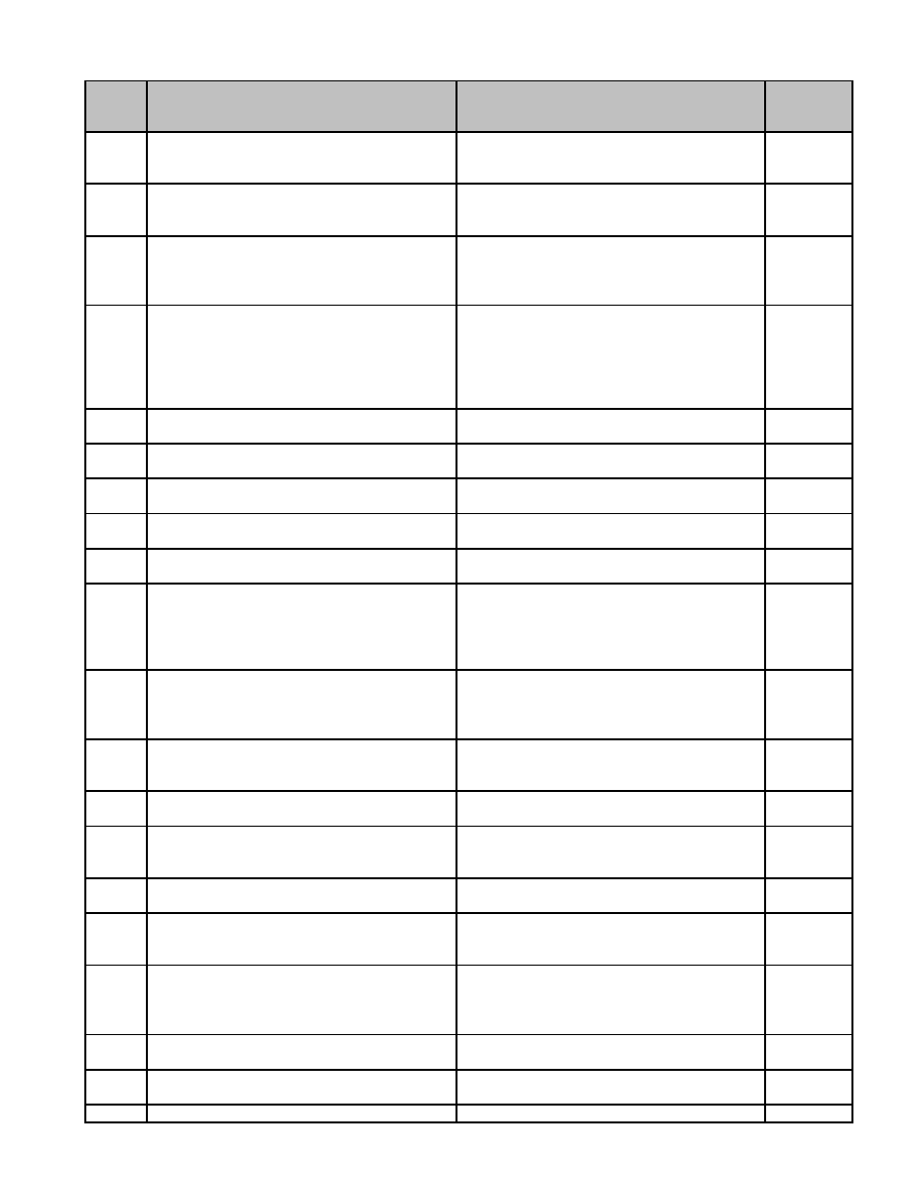

**Series**

**Description of Record** **Length of Time Required to Retain Record** **MGL / CMR**

**Number**

07.061 Elections, Political Committee, Non-Elected, Retain records required to be filed with the c. 55, ss.

Statement of. Form CPF 101 (a) clerk until December 31 st of the sixth year 5, 26

Candidate's political committee following the relevant election.

07.062 Elections, Political Committee, Non-Elected, Retain records required to be filed with the c. 55, ss.

Statement of. Form CPF 101 (a) clerk until December 31 st of the sixth year 5, 26

Candidate's political committee following the relevant election.

07.063 Elections, Political Committee, Non-Elected, Retain 3 years. c. 55, ss.

Statement of. Form CPF 101 (b) 5, 26

Committees other than those authorized by

a candidate

07.064 Elections, Recount, Petition and Statement Retain 30 days following election, if no c. 54, s.

for appeals pending. Records of election in 135

which candidates for Federal office

participate must be kept for 22 months

following the election. Permission from

Supervisor not required for destruction.

07.065 Elections, Register of Voters, Affidavit of Retain 2 years after cancelled registration. c. 51, ss.

36, 41, 44

07.066 Elections, Register of Voters, Annual Permanent. c. 51, s.

37

07.067 Elections, Register of Voters, General Permanent. c. 51, s.

36

07.068 Elections, Supplementary Registration, Retain 3 years. Permission from Supervisor c. 51, s.

Certificates of not required for destruction. 51

07.069 Elections, Tally Sheets Retain 3 years. Permission from Supervisor c. 54, ss.

not required for destruction. 59, 105

07.070 Elections, Voter Check-Off List Retain 2 years. Records of election in which c. 54, s.

candidates for Federal office participate 109

must be kept for 22 months following the

election. Permission from Supervisor not

required for destruction.

07.071 Elections, Voter Registration, Affidavit of, Retain 30 days following next state election. c. 567, Act

Non-Resident Records of election in which candidates for of 1989

Federal office participate must be kept for

22 months following the election.

07.072 Elections, Voting List, Certificate of Retain 3 years after cancellation of c. 51, s.

Omission from registration. Permission from Supervisor not 59

required for destruction.

07.073 Federal Tax Liens (including Certificates of Retain 1 year following discharge of lien. c. 255, s.

Discharge, Release) 39B

07.074 Initiative Petition (Sale of Liquor in Taverns) Retain 30 days following election. c. 138, s.

Permission from Supervisor not required for 11A

destruction.

07.075 Inventory and Bond ("Closing Out" and Retain 3 years. c. 93, s.

similar sale) 28A

07.076 Jury List Retain until administrative use ceases. c. 234, ss.

Permission from Supervisor not required for 5, 9

destruction.

07.077 Jury Selection List (a) Numbered Resident Retain until the end of the calendar year c. 234A,

List; Numbered Resident File; Random following the year in which records were ss. 10, 11,

Number List; Typewritten List of Randomly prepared. Permission from Supervisor not 13, 14

Selected Jurors required for destruction.

07.078 Jury Selection List (b) Prospective Juror List Retain 7 years. Permission from Supervisor c. 234A, s.

not required for destruction. 15

07.079 Low Lands; Petition, Order for Road to Permanent. c. 252, s.

221

07.080 Oaths, Office Permanent.

48

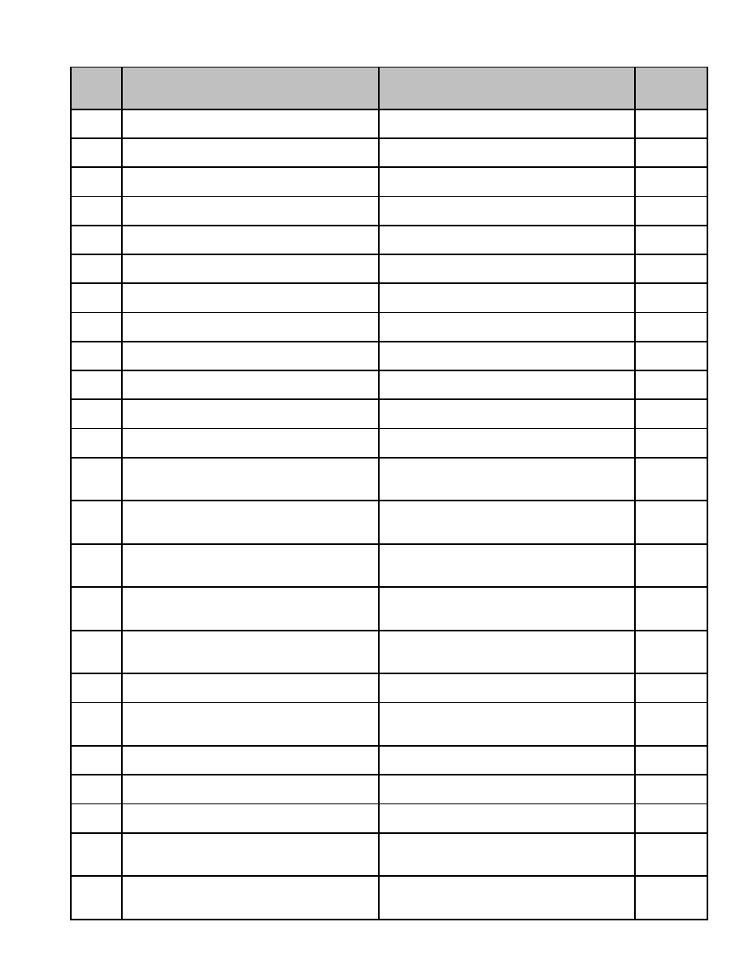

**Series**

**Description of Record** **Length of Time Required to Retain Record** **MGL / CMR**

**Number**

07.081 Oaths, Public Records Permanent. c. 66, s.

14

07.082 Ordinances Permanent. c. 43, s.

18

07.083 Performance Certificates Retain 7 years or following termination of c. 268A, s.

employment, whichever date is later. 18

07.084 Persons Sworn, Record of Permanent. c. 41, s.

15

07.085 Planning Board, Plans and Records Permanent. c. 41, s.

81A

07.086 Planning Board, Subdivision Control Permanent. c. 41, s.

Records, Preliminary and Definitive 81

07.087 Planning Board, Subdivision Control, Rules Permanent. c. 41, s.

and Regulations Relevant to 81Q

07.088 Planning Board, Subdivision Plan, Permanent. c. 41, s.

Definitive, Notice of Submission Relative to 81T

07.089 Planning Board, Subdivision Plan, Permanent. c. 41, s.

Definitive, Relative to Certificate of Action 81U

07.090 Planning Board, Subdivision Plan, Notice of Permanent. c. 41, s.

Actions Relevant to 81P

07.091 Planning Board, Subdivision Plan, Permanent. c. 41, s.

Preliminary, Notice of Actions Relative to 81S

07.092 Planning Board, Subdivision Plan, Permanent. c. 41, s.

Preliminary, Notice of Submission 81S

07.093 Pole, Wire, Conduit Locations, Orders for, Permanent. c. 166, s.

Electricity in Public Ways, Transmission of 22

(from Alderman, Councilors, Selectmen)

07.094 Pole, Wire, Conduit Locations, Orders for, Permanent. c. 166, s.

Electricity, Transmission of (From State 28

Dept. of Public Utilities)

07.095 Pole, Wire, Conduit Locations, Orders for, Permanent. c. 164, s.

Gas Mains, Connecting Locations for (From 70A

State Dept. of Public Utilities)

07.096 Pole, Wire, Conduit Locations, Orders for, Permanent. c. 132, s.

Light and Power Lines in State Forests 34A

(from State Dept. of Public Utilities)

07.097 Pole, Wire, Conduit Locations, Orders for, Permanent. c. 92, s.

Poles, Wires, Cables, etc. (from 46

Metropolitan District Commission) (MDC)

07.098 Proprietor's Records Permanent. c. 66, s. 7

c.

07.099 Public Market, Petition for Retain until administrative use ceases. c. 40, s.

Permission from Supervisor not required for 10

destruction.

07.100 Public Ways, Appeal, Notice of (Change in Retain 1 year from date of hearing. c. 85, s. 3

Name of Public Way)

07.101 Public Ways, Board of Survey, Plans Permanent. c. 41, s.

Submitted to 74

07.102 Public Ways, Injury, Notice of Retain 5 years. c. 84, ss.

18, 19

07.103 Public Ways, Permanent. c. 82, s.

Layouts/Alterations/Discontinuations, 23

Record of

07.104 Railroads, Notice of Intention to Claim Right Retain 7 years. c. 159, s.

of Action for Materials and Labor Furnished 98

to

49

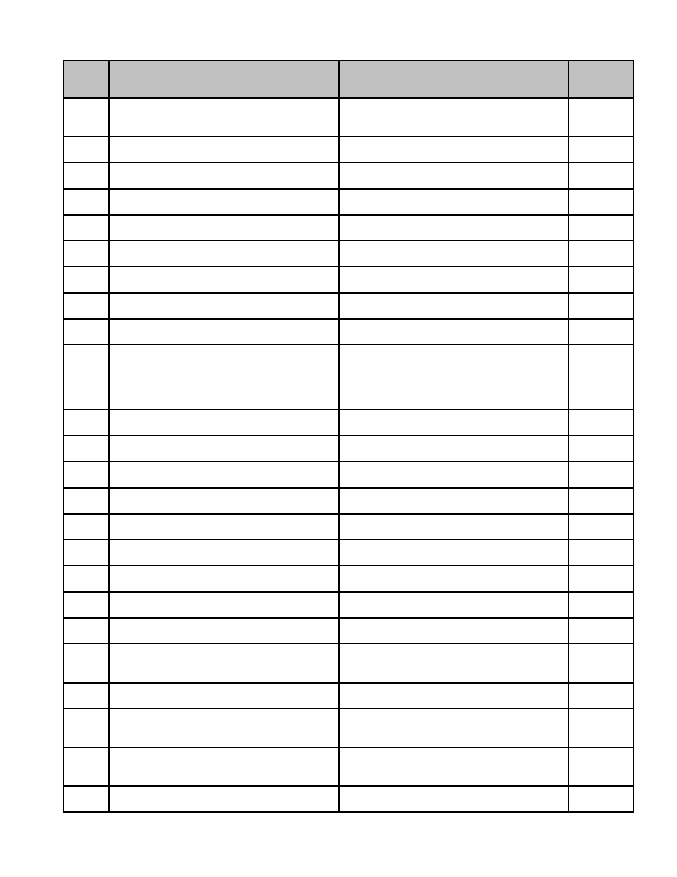

**Series**

**Description of Record** **Length of Time Required to Retain Record** **MGL / CMR**

**Number**

07.105 Registration, Certificates of, Architecture Permanent. c. 112, s.

Certificate of Registration (Notice of 60H

Revocation)

07.106 Registration, Certificates of, Electrolysis Permanent. c. 112, s.

Certificate of Registration 87EEE

07.107 Registration, Certificates of, Medicine Permanent. c. 112, s.

Certificate of Registration 8

07.108 Registration, Certificates of, Optometry Permanent. c. 112, s.

Certificate of Registration 70, 71

07.109 Registration, Certificates of, Osteopathy Permanent. c. 112,

Certificate of Registration 2.10

07.110 Registration, Certificates of, Podiatry Permanent. c. 112, s.

Certificate of Registration 21

07.111 Resignations of City Officials Permanent. c. 41, s.

109

07.112 Rules, Regulations of all Town Boards and Permanent. c. 40, s.

Officers 33

07.113 Special Permit Granting Authority, Records Permanent. c. 40A, ss.

of 9, 11

07.114 State Audit (City/Town Accounts) Retain 10 years. c. 44, s.

40

07.115 State Tax Liens Retain 1 year following redemption or c. 62C, s.

waiver, or retain 7 years if not redeemed or 50

waived.

07.116 Street List Permanent. c. 51, ss.

4, 6

07.117 Summons Retain until final adjudication of contest. c. 233, s.

37

07.118 Tenement Housing, Attorney, Appointment Retain for duration of appointment. c. 145, s.

of 60A

07.119 Tenement Housing, Owner, Notice of Retain 1 year (on or after May 1st). c. 145, s.

59

07.120 Tenement Housing, Plans, Specifications, Retain for lifetime of building. c. 145, s.

etc. 50

07.121 Tenement, Agent for Owner of Retain for duration of appointment. c. 145, ss.

60A, 60B

07.122 Towels, etc., Registration of Rented Permanent. c. 110, s.

25A

07.123 Town Meeting Records Permanent. c. 41, ss.

15

07.124 Vessel, Statement of Lien on Retain 7 years. c. 255, s.

15

07.125 Vital Statistics, Birth, Death and Marriage Permanent. c. 46, s.

(all official forms related to the registration 13, c. 114,

process) c. 207

07.126 Wills (Perpetual Care of Cemetery Lots) Permanent. c. 114, ss.

19, 20

07.127 Zoning Board of Appeals, Appeal to Permanent. c. 40A, s.

Superior Court, Notice of 17; c. 41,

s. 81BB

07.128 Zoning Board of Appeals, Decisions and Permanent. c. 40A, s.

Proceedings (i.e., all official forms related to 15

the appeal process)

07.129 Zoning Board of Appeals, Rules Permanent. c. 40A, s.

12

50



**Series**

**Description of Record** **Length of Time Required to Retain Record** **MGL / CMR**

**Number**

07.130 Zoning Board of Appeals, Subdivision Permanent.

Control Law, Notice of Appeal to Superior

Court

07.131 Zoning Board of Appeals, Subdivision Permanent. c. 41, s.

Control Law, Proceeding Under 81AA

51

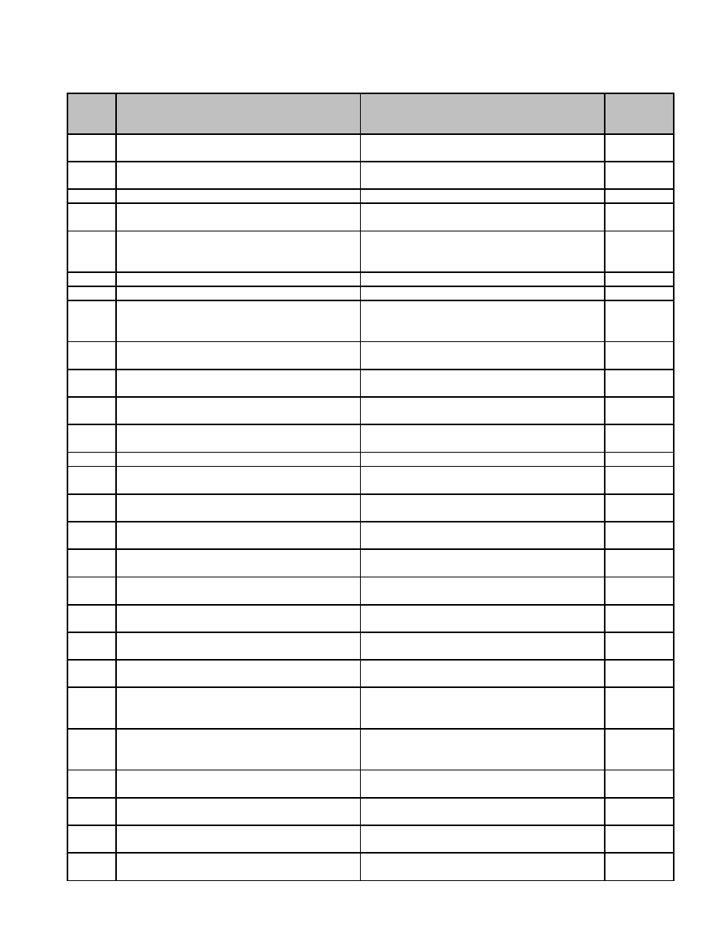

**08 Collector**

**Series**

**Description of Record** **Length of Time Required to Retain Record** **MGL / CMR**

**Number**

08.001 Betterment Lien, Certificate Dissolving Retain until completion of satisfactory audit. c. 80 s. 12

(Payment Stub). Form 374

08.002 Betterment Liens, Certification to Retain until completion of satisfactory audit. c. 80 s. 13

Assessors. Form 261

08.003 Bills, Paid Receivables other than Taxes Retain until completion of satisfactory audit.

08.004 Bills, Tax (paid) Retain until completion of satisfactory audit. c. 60 ss.

3, 3A

08.005 Bonds, performance, Deputy Collector Retain 7 years from date of expiration. c. 60 s.

92, c. 41

s. 37

08.006 Bonds, performance, Special Collector Retain 7 years from date of expiration. c. 60 s. 14

08.007 Bonds, performance. Collector Retain 7 years from date of expiration. c. 60 s. 13

08.008 Cash Books, Motor Vehicle Excise. Form Retain until completion of satisfactory audit c. 60 s. 7

200 MV or final settlement of levy, whichever is later.

If levy not settled, 10 years.

08.009 Cash Books, Other Retain until completion of satisfactory audit

or final settlement of levy, whichever is later.

08.010 Cash Books, Property. Form 200 RE Retain until all taxes actually collected or c. 60 s. 7

abated.

08.011 Cash Books, Sewer. Form AD26S Retain until completion of satisfactory audit c. 60 s. 7

or final settlement of levy, whichever is later.

08.012 Cash Books, Water. Form AD26 Retain until completion of satisfactory audit c. 60 s. 7

or final settlement of levy, whichever is later.

08.013 Commitment Books (All) Permanent. c. 60 s. 6

08.014 Deputy Collector, Application for Retain 5 years following expiration of c. 60 s. 92

Appointment. Form 262 service.

08.015 Deputy Collector, Approval of Appointment. Permanent. c. 60 s. 93

Form 263

08.016 Municipal Lien Certificate Stubs. Form 290 Retain 3 years or following completion of c. 60 s. 23

satisfactory audit, whichever is later.

08.017 Municipal Lien, Renunciation of Rights Retain 3 years or following completion of c. 60 s.

under Statement to Continue. Form 291 satisfactory audit, whichever is later. 37A

08.018 Municipal Lien, Statement Filed to Continue. Retain 3 years or following completion of c. 60 s.

Form 291 satisfactory audit, whichever is later. 37A

08.019 Schedules, General, Collector's Payments Retain until completion of satisfactory audit. c. 60 s. 2

to Treasurer. Form AD8

08.020 Schedules, General, Collector's Payments Retain until completion of satisfactory audits c. 60 s. 2

to Treasurer/District Taxes. Form 398 of both the municipality and the district.

08.021 Schedules, General, Collector's Payments Retain until completion of satisfactory audit. c. 60 s. 2

to Treasurer/Property and other Charges

08.022 Schedules, General, Motor Vehicle and Retain until completion of satisfactory audit. c. 60A s.

Trailer Excise, Refunds through Abatement 2, c. 59 s.

of. Form 236 69

08.023 Schedules, General, Treasurer's Receipts Retain until completion of satisfactory audit. c. 41 s.

52, c. 59

s. 69

08.024 Schedules, General, Water Lien, Retain until completion of satisfactory audit. c. 40 s.

Certificates. Form 370, 373, 260 42B

08.025 Schedules, Uncollected Taxes, Property Retain until completion of satisfactory audit c. 58 s. 8

and Other Taxes to Assessors. Form 385 or final settlement of levy, whichever is later.

08.026 Tax Bill, Request for Separate. Form 208B Retain until final settlement of levy. c. 60 s.

22A

08.027 Tax Claim, Unsecured Retain until completion of satisfactory audit c. 59 s. 71

or resolution of claim, whichever is later.

53

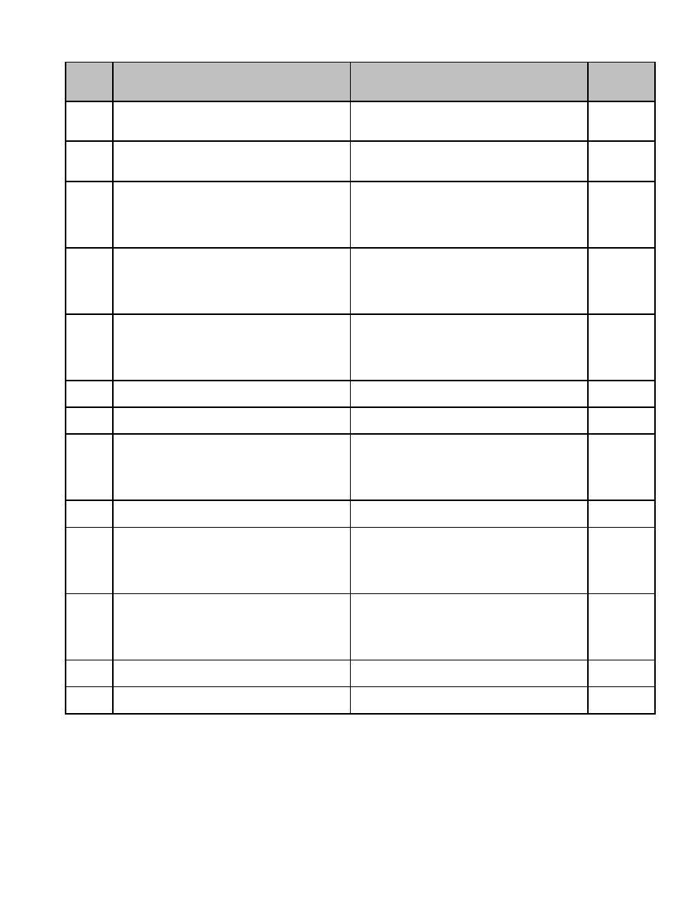

**Series**

**Description of Record** **Length of Time Required to Retain Record** **MGL / CMR**

**Number**

08.028 Tax Titles, Forms, Accounts, List of Permanent. c. 60 s. 95

Recorded Sales or Takings to be set up as

Tax Title. Form 346

08.029 Tax Titles, Forms, Accounts, Subsequent Permanent. c. 60 s. 61

Taxes to be Added to. Form 347 (b) tax

account is not redeemed by owner

08.030 Tax Titles, Forms, Bill, Affidavit of Time of Tax account redeemed by owner: Retain c. 60 s. 57

First Sending. Form 214 until final settlement of levy or completion of

satisfactory audit, whichever is later. Tax

account not redeemed by owner:

Permanent.

08.031 Tax Titles, Forms, Demand, Affidavit of - Tax account redeemed by owner: Retain c. 60 ss.

Two or More Persons. Form 331 until final settlement of levy or completion of 16, 57

satisfactory audit, whichever is later. Tax

account not redeemed by owner:

Permanent.

08.032 Tax Titles, Forms, Demand, for Action to Tax account redeemed by owner: Retain c. 60 s.

Protect Property. Form 254 until final settlement of levy or completion of 50A

satisfactory audit, whichever is later. Tax

account not redeemed by owner:

Permanent.

08.033 Tax Titles, Forms, Invalid Title, Deed of Permanent. c. 60 s. 82

Release of. Form 32

08.034 Tax Titles, Forms, Invalid Title, Disclaimer Permanent. c. 60 ss.

of 37, 84

08.035 Tax Titles, Forms, Invalid Title, Notice of - Tax account redeemed by owner: Retain c. 60 s. 82

Assessors to Collector*. Form 190 until final settlement of levy or completion of

satisfactory audit, whichever is later. Tax

account not redeemed by owner:

Permanent.

08.036 Tax Titles, Forms, Invalid Title, Notice of Permanent. c. 60 s. 82

Refusal to Release

08.037 Tax Titles, Forms, Invalid Title, Notice of*. Tax account redeemed by owner: Retain c. 60 s. 82

Form 355 until final settlement of levy or completion of

satisfactory audit, whichever is later. Tax

account not redeemed by owner:

Permanent.

08.038 Tax Titles, Forms, Lands of Low Value, Tax account redeemed by owner: Retain c. 59 s. 72

Schedule of, to Commissioner* until final settlement of levy or completion of

satisfactory audit, whichever is later. Tax

account not redeemed by owner:

Permanent.

08.039 Tax, Certificate of Payment by Mortgagee or Retain until completion of satisfactory audit. c. 60 s. 60

other Interested Person. Form 222

08.040 Taxes, Uncollected, Certification of Retain until completion of satisfactory audit c. 59 s. 71

Abatement to Collector or final settlement of levy, whichever is later.

54



**Series**

**Description of Record** **Length of Time Required to Retain Record** **MGL / CMR**

**Number**

08.041 Warrants and Notices from Assessors, All Retain until completion of satisfactory audit c. 40 ss.

Taxes, Excises, Betterments, Special or final settlement of levy, whichever is later. 16, 17, 18,

Assessments, Liens All Taxes, Excises, 42D, c. 59

Betterments, Special Assessments, Liens ss. 53, 77,

(Actual, Original, Omitted, Revised, 78, c. 59

Supplemental, Reassessed, Apportioned, s. 76, c.

Added to Tax, Special, Recommitted) 60 ss. 19,

34, 97, c.

60A s. 3,

c. 80 ss.

3, 4, 13 or

Special

Act

08.042 Warrants and Notices, Forest Land Tax Retain until completion of satisfactory audit c. 61 s. 1

Lien. Form 17D or final settlement of levy, whichever is later.

08.043 Warrants and Notices, Forest Product Tax Retain until completion of satisfactory audit c. 61 s. 3

or final settlement of levy, whichever is later.

55

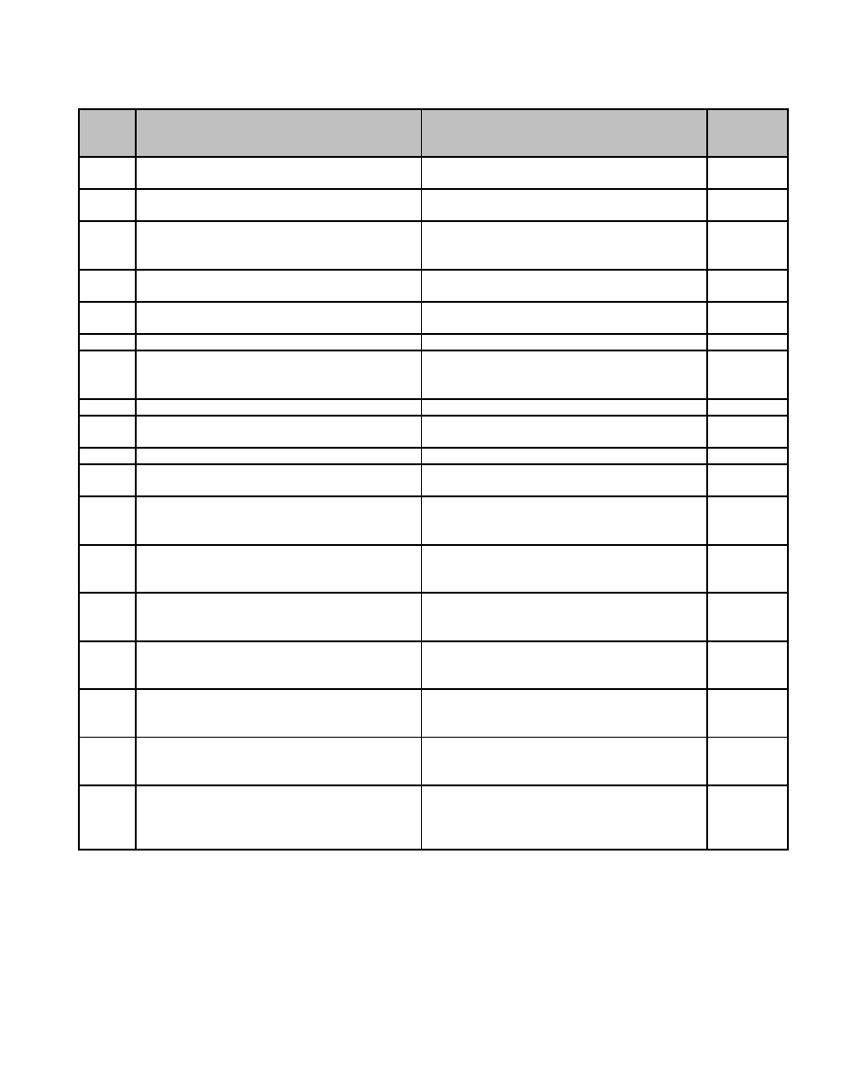

**09 Conservation Commission**

**Series**

**Description of Record** **Length of Time Required to Retain Record** **MGL / CMR**

**Number**

09.001 Certificate of Compliance Retain until recorded in the Registry of c. 131 s.

Deeds. 40

09.002 Certificate of Compliance (Partial) Retain until the complete Certificate of

Compliance has been filed.

09.003 Certification of an Emergency Project Retain until the complete Certificate of c. 131 s.

Compliance has been filed or until 40

order/determination expires.

09.004 Determination of Applicability, Reply of Retain until project is complete or until

(Negative) Determination of Applicability has expired.

09.005 Determination of Applicability, Reply of Retain until project is complete or until

(Positive) Determination of Applicability has expired.

09.006 Determination of Applicability, Request for Retain 1 year.

09.007 Determination, Withdrawal of Request for Retain until administrative use ceases. c. 131 s.

Permission from Supervisor not required for 40

destruction.

09.008 Engineering Drawings (Plans) Permanent.

09.009 Environmental Data Form Retain until Certificate of Compliance has

been issued.

09.010 Gifts (copies of) Retain until completion of satisfactory audit.

09.011 Ledger Books (Data on material recorded in Permanent.

the Registry of Deeds)

09.012 Notice of Exemption (Obsolete) Retain until administrative use ceases.

Permission from Supervisor not required for

destruction.

09.013 Notice of Intent (Application). Includes Retain until Certificate of Compliance has c. 131 s.

supporting information narrative, boring been issued and recorded in the Registry of 40

logs, plans, etc. Deeds.

09.014 Order of Conditions (Extension Permit) Retain until Certificate of Compliance has 310 CMR

been issued and recorded in the Registry of 10.05

Deeds. (8)(a)

09.015 Order of Conditions. Includes supporting Retain until Certificate of Compliance has c. 131 s.

information reports, photos, plans, etc. been issued and recorded in the Registry of 40

Deeds.

09.016 Program Information (Community Activities, Retain until administrative use ceases.

Camping Applications, etc.) Permission from Supervisor not required for

destruction.

09.017 Request for Compliance/Stop Work Order Retain until Certificate of Compliance has

(Cease and Desist) been issued and recorded in the Registry of

Deeds.

09.018 Special Formal Agreements (Leases, Retain for the life of the agreement.

Licenses, Letters of Understanding for

Public to use Conservation Land i.e., to hay

a field, etc.)

57

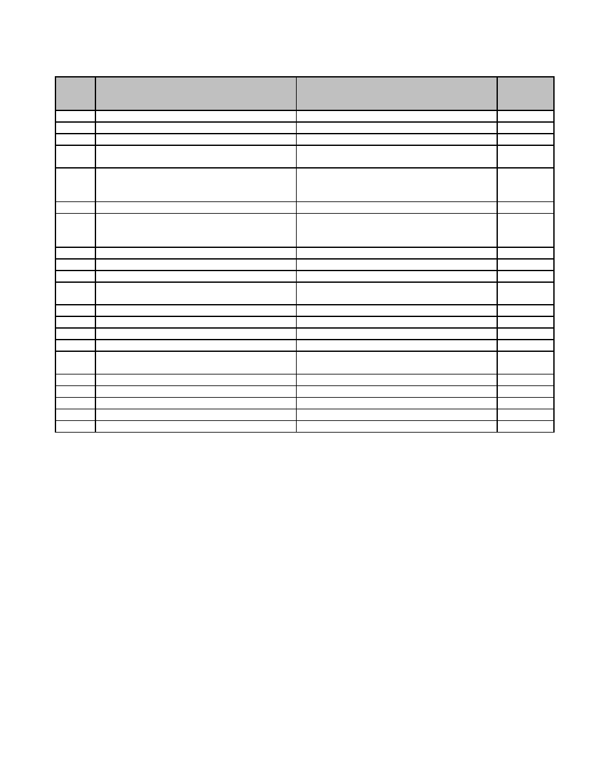

**10 Council on Aging**

**Series**

**Description of Record** **Length of Time Required to Retain Record** **MGL / CMR**

**Number**

10.001 Applications for Programs Retain 3 years.

10.002 Client Referrals Retain 3 years. c. 40 s. 8B

10.003 Clinic Attendance Tally Sheets Retain 3 years. c. 40 s. 8B

10.004 Equipment Maintenance and Repair Retain 1 year after disposal of equipment.

Records

10.005 Grant Files (Successful Applications) Retain 7 years after completion of all terms c. 40 s.

of grant, retain EOEA-SGA permanently. 8B, c. 260

s. 2

10.006 Grant Files (Unsuccessful Applications) Retain until final rejection.

10.007 Informational Memoranda (from EOEA) Retain until administrative use ceases.

Permission from Supervisor not required for

destruction.

10.008 Intake Reports (Client Case Files) Retain 3 years after date of last contact.

10.009 Kitchen Audits Retain 3 years. c. 49 s. 8B

10.010 Ledgers Permanent.

10.011 Meals on Wheels Delivery Records Retain 1 year, provided satisfactory audit c. 40 s. 8B

has been completed.

10.012 Meals on Wheels Payment Books Retain 1 year. c. 40 s. 8B

10.013 Monthly Statistics Retain 3 years. c. 40 s. 8B

10.014 Outreach Reports Retain 3 years. c. 40 s. 8B

10.015 Participant Directories Retain 3 years.

10.016 Position Descriptions (including Volunteer Retain 3 years.

Position Descriptions)

10.017 Program Instructions (from EOEA) Retain until superseded.

10.018 Surveys of Services Retain 3 years. c. 40 s. 8B

10.019 Time Sheets Retain 3 years.

10.020 Van Trip Reports Retain 1 year.

10.021 Volunteer Travel Reimbursement Vouchers Retain until completion of satisfactory audit.

59

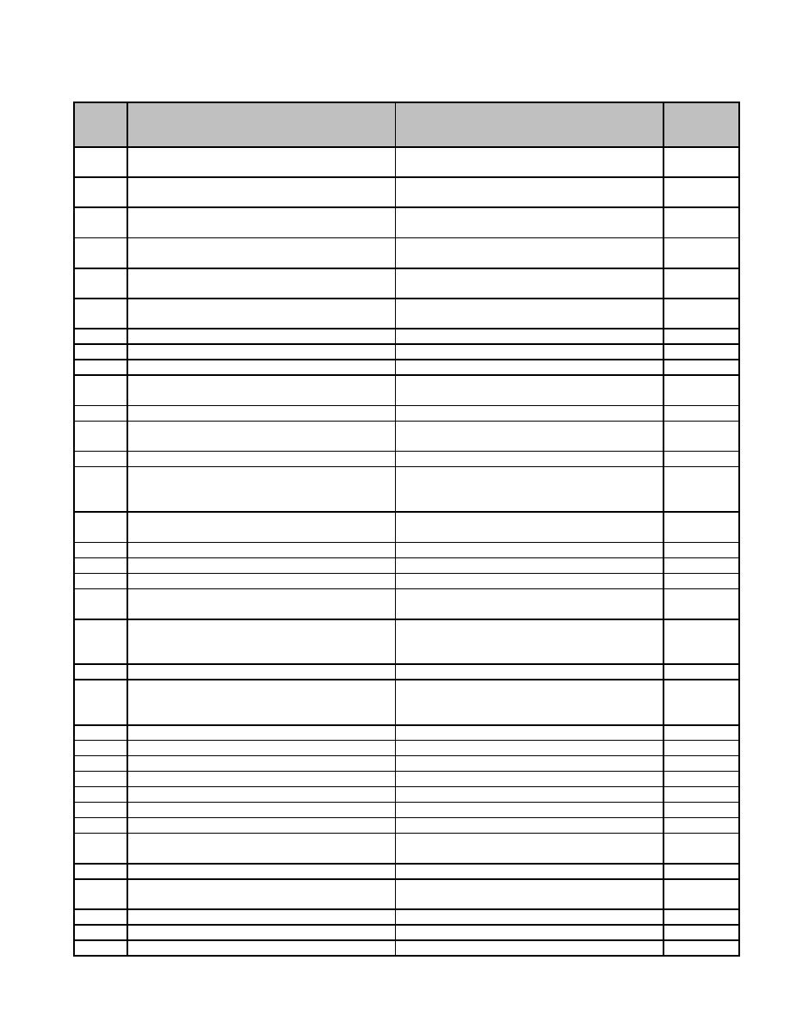

**11 Department of Public Works**

**Series**

**Description of Record** **Length of Time Required to Retain Record** **MGL / CMR**

**Number**

11.001 Assessment Books (a) Sewer Retain until completion of satisfactory audit, c. 83, s.

provided originals are retained by Assessor. 27, 28, 29

11.002 Assessment Books (b) Sidewalk Retain until completion of satisfactory audit, c. 83, s.

provided originals are retained by Assessor. 27, 28, 29

11.003 Assessment Books (c) Street Betterment Retain until completion of satisfactory audit, c. 83, s.

provided originals are retained by Assessor. 27, 28, 29

11.004 Assessment Cards (a) Sewer Permanent. c. 83, s.

27, 28, 29

11.005 Assessment Cards (b) Sidewalk Permanent. c. 83, s.

27, 28, 29

11.006 Assessment Cards (cc) Water Permanent. c. 83, s.

27, 28, 29

11.007 Auto Accident Report Permanent, with employee's file.

11.008 Catch Basin Cleaning Report Retain 1 year. c. 83, s. 1

11.009 Catch Basin Location Files Permanent. c. 83, s. 2

11.010 Cemetery Records Permanent. c. 114, s.

18

11.011 Civil Service Approvals Permanent. c. 31, s. 6

11.012 Employee Time Sheet Retain 1 year from satisfactory completion c. 41, s.

of audit. 42

11.013 Fire Pipe Connection Books Permanent. c. 83, s. 2

11.014 Flow Test Records Retain until administrative use ceases.

Permission from Supervisor not required for

destruction.

11.015 Foreman's Daily Reports - Hired Equipment Retain 1 year from satisfactory completion

of audit.

11.016 Gate Books Permanent. c. 83, s. 2

11.017 Hydrant Locations Permanent. c. 83, s. 2

11.018 Inventory Gas Card Ledgers Retain until completion of satisfactory audit.

11.019 Job Cost Ledgers Retain 7 years from date of opening. c. 41, s.

103

11.020 Journal Vouchers (Departmental) Retain until administrative use ceases. c. 41, s.

Permission from Supervisor not required for 50, 55

destruction.

11.021 Notice of Intent Retain 1 year from date of hearing. c. 85, s. 3

11.022 Operators Daily Reports Retain until administrative use ceases.

Permission from Supervisor not required for

destruction.

11.023 Parts Installation Book Permanent. c. 83, s. 2

11.024 Petitions (a) Driveways Permanent. c. 82, s. 3

11.025 Petitions (b) New Streets Permanent. c. 82, s. 3

11.026 Petitions (c) Sidewalks Permanent. c. 82, s. 3

11.027 Plans (All) Permanent. c. 83, s. 2

11.028 Record of Vehicles Retain 1 year after retirement of vehicle.

11.029 Releases on Private Ways Permanent. c. 84, s. 2

11.030 Sewer Connection Record Card Index Permanent. c. 83, s. 3,

11

11.031 Shut-Off Locations Permanent. c. 83, s. 2

11.032 Sick Leave Reports Retain 3 years. c. 41, s.

111B

11.033 Street Openings Retain 7 years. c. 83, s. 8

11.034 Valve Records Permanent. c. 83, s. 2

11.035 Water and Sewer Applications Retain 7 years.

61



**Series**

**Description of Record** **Length of Time Required to Retain Record** **MGL / CMR**

**Number**

11.036 Water and Sewer Payments Retain 1 year from satisfactory completion c. 40, s.

of audit. 42A, c. 83,

s. 16

11.037 Water Consumption Testing Record Retain 7 years.

11.038 Water Pressure Records Retain until administrative use ceases.

Permission from Supervisor not required for

destruction.

11.039 Water Service (a) Journals Retain 7 years. c. 40, s.

39I, 42A,

42L

11.040 Water Service (b) Meter Removals and Permanent. c. 40, s.

Locations 39I, 42A,

42L

11.041 Water Service (c) Plates for Route Books Retain until superseded. c. 40, s.

39I, 42A,

42L

11.042 Water Service (d) Rates and Service Retain 7 years. c. 40, s.

39I, 42A,

42L

11.043 Water Service (e) Route Books Retain until superseded. c. 40, s.

39I, 42A,

42L

11.044 Water Service (f) Water History Books Permanent. c. 40, s.

(Commitments) 39I, 42A,

42L

62

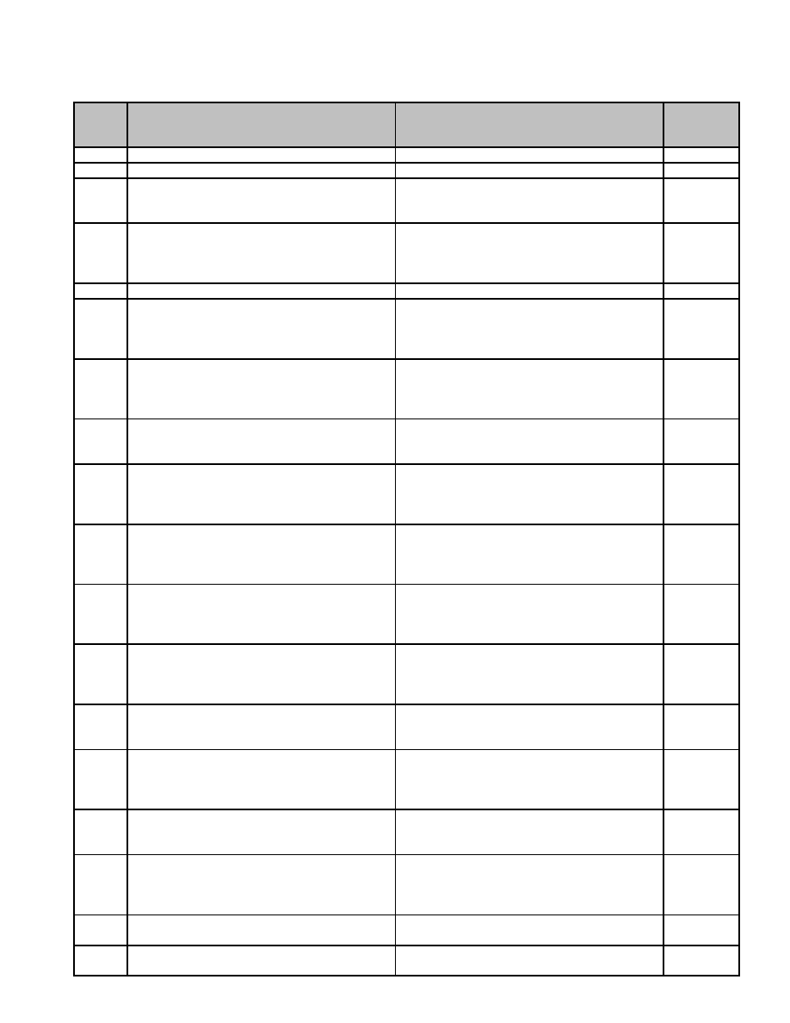

**12 Fire Departments and Fire Districts**

**Series**

**Description of Record** **Length of Time Required to Retain Record** **MGL / CMR**

**Number**

12.001 Ambulance Calls Report Retain 7 years.

12.002 Apparatus Inspection Report Retain 1 year after retirement of apparatus. c. 48 s. 42

12.003 Application for Installation of Fire Alarm Retain 1 year. c. 148 s.

System; retention after satisfactory filing of 26B

Certificate of Completion.

12.004 Application for Permit to Install/Alter Fuel-oil Retain 1 year after satisfactory filing of c. 148 ss.

Burning Equipment Certificate of Completion. 10, 10C,

527 CMR

4.03

12.005 Application/Permit for Open-air Fires Retain 1 year. c. 48 s. 13

12.006 Application/Permit for the Keeping and Retain 7 years. c. 148 ss.

Storage of Explosives; retention after 9, 15, 527

expiration of permit. CMR

13.04

12.007 Application/Permit for the Use and Handling Retain 7 years. c. 148 ss.

of Explosives; retention after expiration of 9, 15, 527

permit. CMR

13.04

12.008 Application/Permit to Conduct Supervised Retain 3 years. c. 148 s.

Display of Fireworks; retention after 39A, 527

issuance. CMR 2.05

12.009 Application/Permit to Conduct Supervised Retain 3 years. c. 148 ss.

Firing of Canon; retention after issuance. 9, 10A,

527 CMR

22.03

12.010 Application/Permit to Construct/Maintain a Retain for life of installation. c. 148 s.

Tank or Container for the Keeping, Use and 23, 527

Sale of Flammable Liquids and Compounds CMR

14.03

12.011 Application/Permit to Disconnect, Shut Off, Retain 3 years. c. 148 s.

Remove, etc., Sprinkler or Fire-sensing 27A

Device; retention after satisfactory

completion of work.

12.012 Application/Permit to Handle, Store, Sell, Retain 3 years. c. 148 ss.

Buy, Transport or Ignite Model Rockets or 9A, 10,

Rocket Engines; retention after expiration of 527 CMR

permit. 16.02

12.013 Application/Permit to Install Special Retain 7 years. c. 148 s.

Extinguishment System; retention after 26A

completion of installation.

12.014 Application/Permit to Keep, Store, and Use Retain for life of installation. c. 148 ss.

Flammable Liquids, Solids and Gases 10A, 23,

527 CMR

14.03

12.015 Application/Permit to Manufacture Fireworks Retain 3 years after termination or c. 148 s.

discontinuance of permit. 12, 527

CMR 2.03

12.016 Application/Permit to Operate Lumberyard Retain 3 years after expiration of permit. c. 148 ss.

10A, 28,

527 CMR

17.02

12.017 Application/Permit to Remove Underground Retain 3 years after issuance. c. 148 s.

Flammable Tank 38A

12.018 Authorized Leave Report Retain 3 years. c. 48, s.

57

63

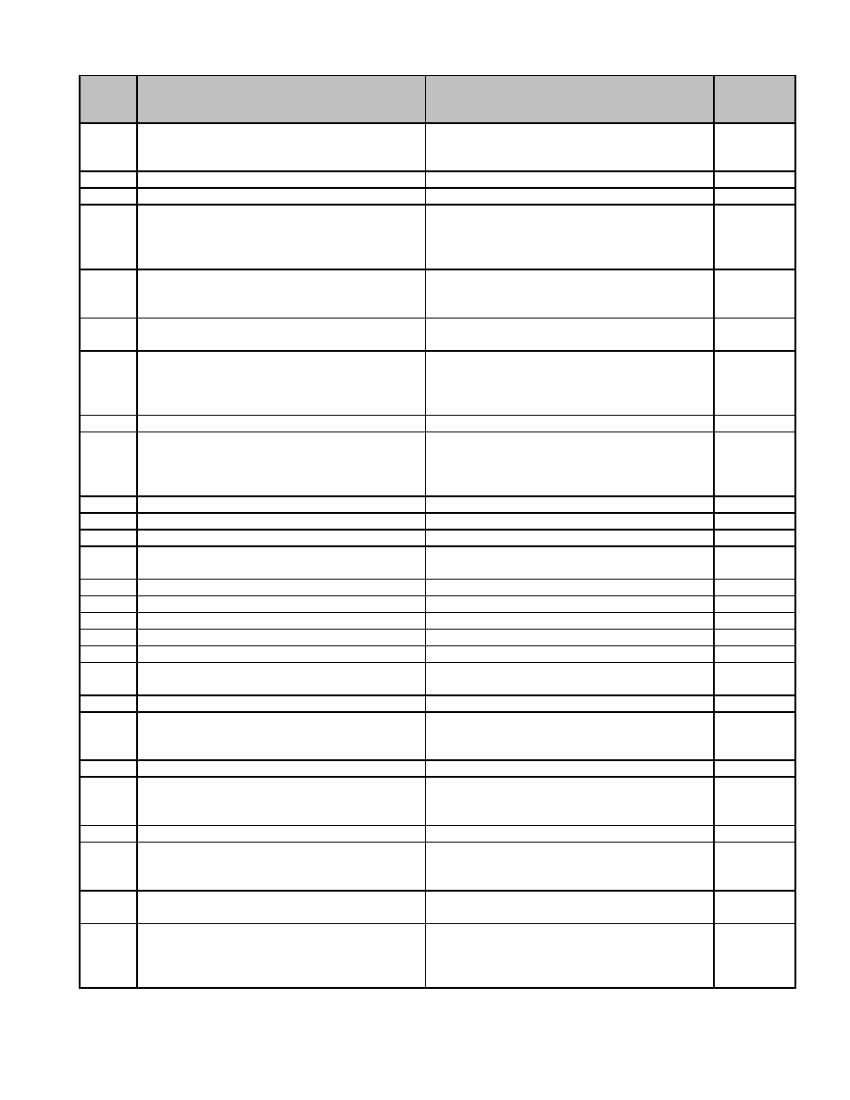

**Series**

**Description of Record** **Length of Time Required to Retain Record** **MGL / CMR**

**Number**

12.019 Box Alarm Record Retain until administrative use ceases.

Permission from Supervisor not required for

destruction.

12.020 Box Test Record Retain 1 year after replacement of box.

12.021 Building Fire, Report of Permanent.

12.022 Certificate of Approval of Flameproof Retain 5 years after issuance. c. 148 ss.

Decorations 10A, 28,

527 CMR

21.02

12.023 Certificate of Completion of Installation of Retain 5 years. c. 148 s.

(Solid Fuel) Fuel-oil Burning Equipment 10, 527

CMR 4.03

12.024 Certificate of Completion of the Installation Retain 7 years. c. 148 ss.

of Fire Alarm System 26A, B, C

12.025 Certificate of Flame proofing of an Retain 5 years after issuance. c. 148 ss.

Impermanent Nature 10A, 28,

527 CMR

21.02

12.026 Company (Duty) Officer's Fire Report Permanent.

12.027 Departmental Fire Record (summary record Permanent.

of daily operations of department, known

variously as Daily Blotter, Fire Alarm

Record, etc.)

12.028 Deputy Chief's Report (Master Fire Report) Permanent.

12.029 Equipment Loan Record Retain until satisfactory return of equipment.

12.030 Equipment Maintenance Log Permanent. c. 48 s. 42

12.031 Final Building Inspection Report Retain 1 year after subsequent inspection. c. 148 ss.

2, 4

12.032 Final Fire Report to State Fire Marshal Retain 10 years. c. 148 s. 2

12.033 Fire Alarm Circuit Tests, Record of Retain 1 year.

12.034 Fire Alarm Record Cards Permanent.

12.035 Fire Hose Record Retain 1 year after retirement of hose. c. 48 s. 42

12.036 Fire Prevention Bureau Report Permanent. c. 148 s. 2

12.037 Fire Prevention Inspection Log Permanent. c. 148 ss.

2, 4

12.038 Fire Station Journal Permanent.

12.039 Fuel Oil Record Retain until administrative use ceases.

Permission from Supervisor not required for

destruction.

12.040 Hydrant Cards Retain 1 year after replacement of hydrant.

12.041 Inoperative Hydrant Report (Hydrant Retain until administrative use ceases.

Trouble Report) Permission from Supervisor not required for

destruction.

12.042 Motor Vehicle Fires, Report of Permanent.

12.043 No Loss Report Retain until administrative use ceases.

Permission from Supervisor not required for

destruction.

12.044 Notice of Inspection (Annual) of Tanks for Retain through subsequent inspection. c. 148 s.

the Storage of Fluids 37

12.045 Notification of Cessation of a License to Permanent. c. 148 s.

Construct/Maintain a Tank or Container for 10, 527

the Keeping, Use and Sale of Flammable CMR

Liquids and Compounds 14.03

64

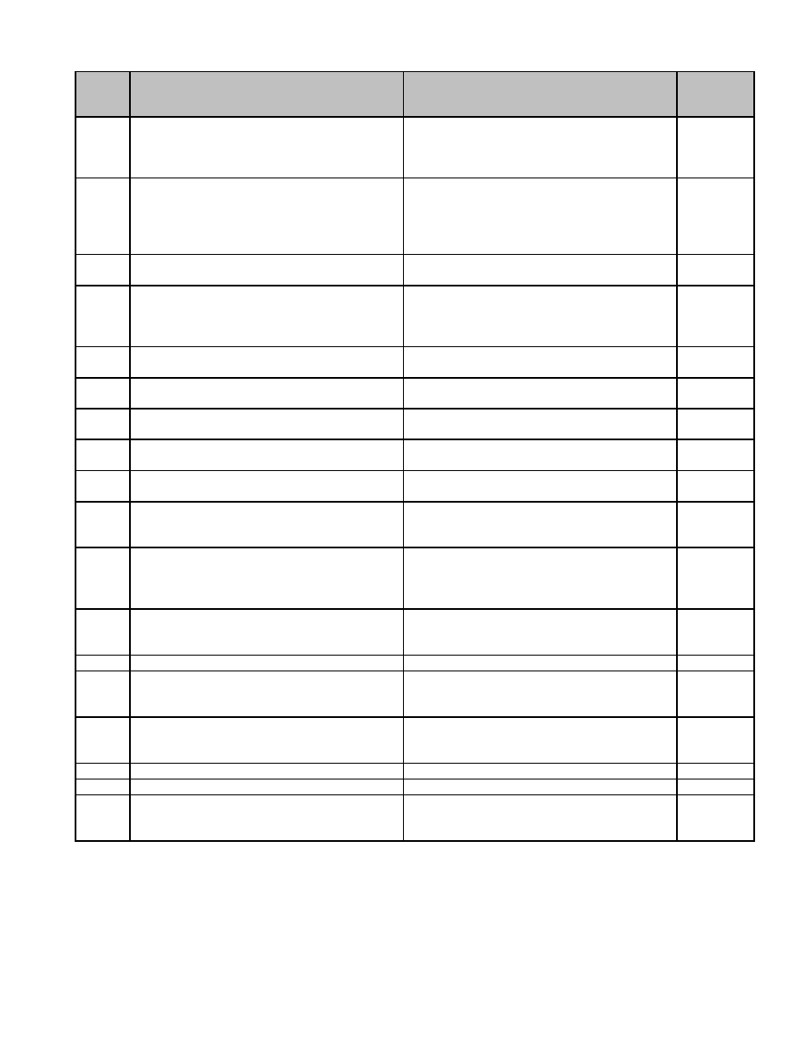

**Series**

**Description of Record** **Length of Time Required to Retain Record** **MGL / CMR**

**Number**

12.046 Notification of Fire and/or Accident Caused Retain 7 years. c. 148 ss.

by Model Rocket or Rocket Engine 9, 10, 527

CMR

16.02

12.047 Notification of Intent to Use Salamander Retain 1 year. c. 148 ss.

9, 10A,

25, 527

CMR

20.02

12.048 Notification of Leak, Spill, Rupture, Retain 3 years. c. 148 s.

Overflow, etc. , of Flammable Liquids 10

12.049 Notification of the Cessation of License to Permanent. c,148 ss.

Store Explosives in Magazine 9, 15, 527

CMR

13.08

12.050 Notification of the Construction, Change or Retain through subsequent alteration or c. 148 s.

Alteration of Self-service Gasoline Station discontinuance of establishment. 10

12.051 Notification of Use of Canine Guards in a Retain until after discontinuance of use of c. 148 s.

Mercantile or Commercial Establishment canine guard. 28B

12.052 Notification of Violation of Fire Laws Retain 1 year after subsequent inspection c. 148 s. 5

reveals correction of violation.

12.053 Open-air Fires, Report of Shut Off, Remove, Permanent.

etc. , Sprinkler or Fire-sensing Device

12.054 Partial Building Inspection Reports Retain until superseded by Final Inspection c. 148 ss.

Report. 2, 4

12.055 Permit for Storage of Fuel Oil Retain until superseded or terminated. c. 148 s.

10, 527

CMR 4.03

12.056 Permit to Install/Alter Fuel-oil Burning Retain 1 year after satisfactory filing of c. 148 ss.

Equipment Certificate of Completion. 10, 10C,

527 CMR

4.03

12.057 Plans and Specifications for Dry Cleaning Retain through alteration or discontinuance c. 148 s.

Plant of establishment. 10, 527

CMR 3.03

12.058 Preliminary Report to State Fire Marshal Retain until superseded by Final Report. c. 148 s. 2

12.059 Preventive Maintenance Check-list Retain until administrative use ceases. c. 48 s. 42

Permission from Supervisor not required for

destruction.

12.060 Receipt form Treasurer Retain until administrative use ceases.

Permission from Supervisor not required for

destruction.

12.061 Report of Alarms (daily/weekly) Permanent.

12.062 Rescue Report Permanent.

12.063 Tape Record From Fire Alarm Circuit Retain until administrative use ceases.

Permission from Supervisor not required for

destruction.

65

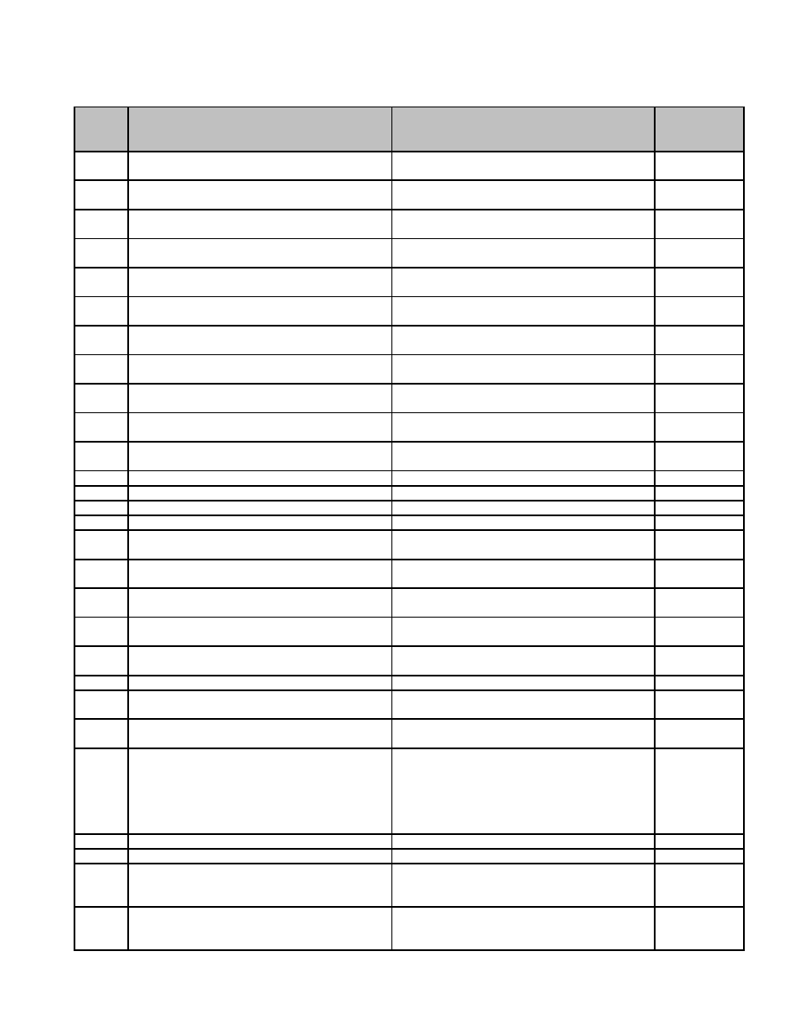

**13 Historical Commission and Historic District Commission**

**Series**

**Description of Record** **Length of Time Required to Retain Record** **MGL / CMR**

**Number**

13.001 Applications for Certificates (a) Retain 1 year after the expiration of the 20- c. 40C, s. 6

Appropriateness day appeal period.

13.002 Applications for Certificates (b) Retain 1 year after the expiration of the 20- c. 40C, s. 6

Nonapplicability day appeal period.

13.003 Applications for Certificates (c) Hardship Retain 1 year after the expiration of the 20- c. 40C, s. 6

day appeal period.

13.004 Archaeologist, Reports to State Retain until superseded by another report. c. 40, s. 8d,

c. 9, s. 27C

13.005 Bids for Contracts (a) Where no contract is Retain 3 years from date of opening. c. 30B

awarded

13.006 Bids for Contracts (b) Where contract is Retain with Contract Files. c. 30B

awarded

13.007 Certificates (a) Appropriateness Retain 1 year following lapse of certificate. c. 40C, s.

6,10(F)

13.008 Certificates (b) Nonapplicability Retain 1 year following lapse of certificate. c. 40C, s.

6,10(F)

13.009 Certificates (c) Hardship Retain 1 year following lapse of certificate. c. 40C, s.

6,10(F)

13.010 Decisions, Demolition Delay Retain 1 year after demolition or other

disposition of property.

13.011 Demolition statement Retain 1 year after the expiration of the 20- c. 40C, s. 6

day appeal period.

13.012 Historic District Map Permanent. c. 40C, s. 3

13.013 Historic Preservation Plan Permanent. c. 40, s. 8d

13.014 Historic Resources Survey. Form A-H Permanent. c. 40, s. 8d

13.015 Maps Permanent. c. 40, s. 8d

13.016 Massachusetts Preservation Program Fund Retain until superseded by another

Pre-Application Form application.

13.017 Modification of Application Retain 1 year after expiration of the 20-day c. 40C s.

appeal period. 10(a)

13.018 Modification of Recommendations Retain 1 year after expiration of the 20-day c. 40C, s.

appeal period. 10(a)

13.019 Nominations for National Register (a) Permanent.

Accepted Nominations

13.020 Nominations for National Register (b) Retain 1 year.

Unaccepted Nominations

13.021 Plans Permanent.

13.022 Public Hearing Waiver Notification Retain 1 year after expiration of the 20-day c. 40C, s. 11

appeal period.

13.023 Public Hearing Waiver Requests Retain 1 year after expiration of the 20-day c. 40C, s. 11

appeal period.

13.024 Publications of Commission Permanent. Historic

District: c.

40C, s. 15;

Historical

Commission:

c. 40, s. 8d

13.025 Reports Permanent.

13.026 Review Standards Permanent. c. 40C, s. 8

13.027 Site Plan Review Recommendations Retain until administrative use ceases.

Permission from Supervisor not required for

destruction.

13.028 Subdivision Control Recommendations Retain until administrative use ceases.

Permission from Supervisor not required for

destruction.

67

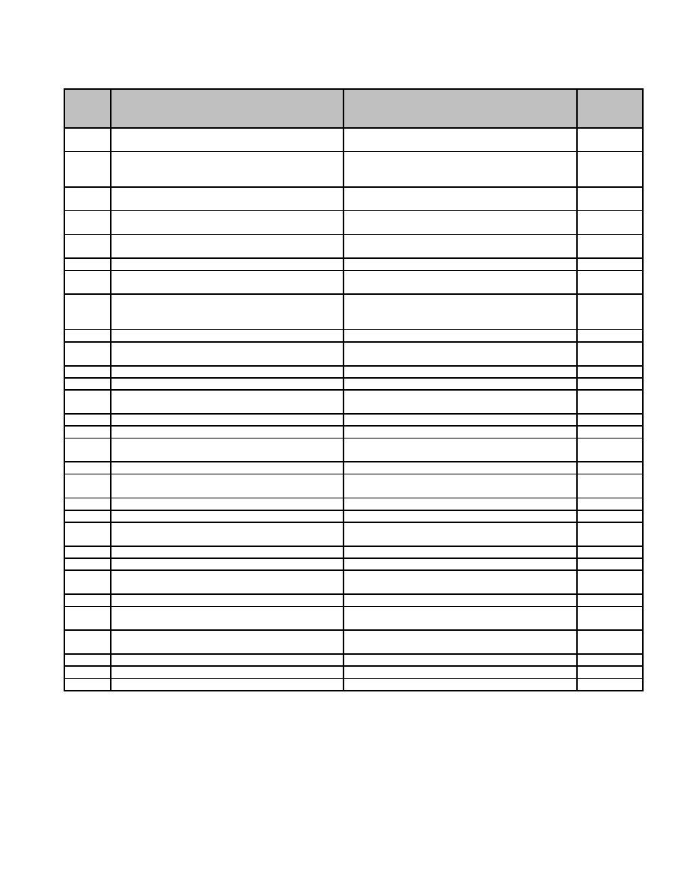

**14 Licensing Board**

**Series**

**Description of Record** **Length of Time Required to Retain Record** **MGL / CMR**

**Number**

14.001 Application for License Permanent. c. 138 s.

15A

14.002 Application for License and/or Permits Other Retain 3 years after duration of license. c. 140

Than Alcoholic and Liquor Beverage, licenses

granted and denied.

14.003 Application for Transfer of License Permanent. c. 138 s.

23B

14.004 Automatic Amusement Devices Licenses Permanent. c. 140 s.

177A

14.005 Billiard Tables and Bowling Alleys Licenses Permanent. c. 140 s.

177

14.006 Certificate of Conviction Permanent. c. 138 s. 57

14.007 Change of Location or Manager Position Permanent. c. 138 s.

15A

14.008 Clubs, Societies, Associations Authorization to Permanent. c. 140 s.

Dispense Food and Beverages Other Than 21E

Alcoholic and Liquor Beverage

14.009 Coffee and Teahouses Permanent. c. 140 s. 47

14.010 Complaint Records Permanent. c. 138 s.

15A

14.011 Copy of Transactions of Pawnbrokers Permanent. c. 140 s. 79

14.012 Decision of Commission Hearings Permanent. c. 138 s. 67

14.013 Fortune Teller Permanent. c. 140 s.

185I

14.014 Hearing Records Permanent. c. 138 s. 9

14.015 Inn holder and Common Victualer Permanent. c. 140 s. 2

14.016 Inspection of Lodging Houses by Licensing Permanent.

Authorities

14.017 Junk Dealers Permanent. c. 140 s. 54

14.018 Letter of Approval from ABCC Permanent. c. 138 s.

16B

14.019 Lodging Houses Permanent. c. 140 s. 23

14.020 Managers of Indoor and Outdoor Activities Retain until completion of satisfactory audit. c. 138 s. 14

14.021 Picnic Groves Permanent. c. 140 s.

188

14.022 Quarterly Reports to the Mayor Permanent. c. 138 s. 9

14.023 Retail Package Goods Retain 7 years after termination. c. 138 s. 15

14.024 Revoked, Suspended, Cancelled or Forfeited Permanent. c. 138 s. 65

Licenses

14.025 Second-Hand Motor Vehicles Permanent. c. 140 s. 59

14.026 Shooting Galleries Permanent. c. 140 s.

56A

14.027 Skating Rinks Permanent. c. 140 s.

186

14.028 Specific License Types, Clubs Retain 7 years after termination. c. 138 s. 12

14.029 Specific License Types, Common Victualers Retain 7 years after termination. c. 138 s. 12

14.030 Taverns Retain 7 years after termination. c. 138 s. 12

69

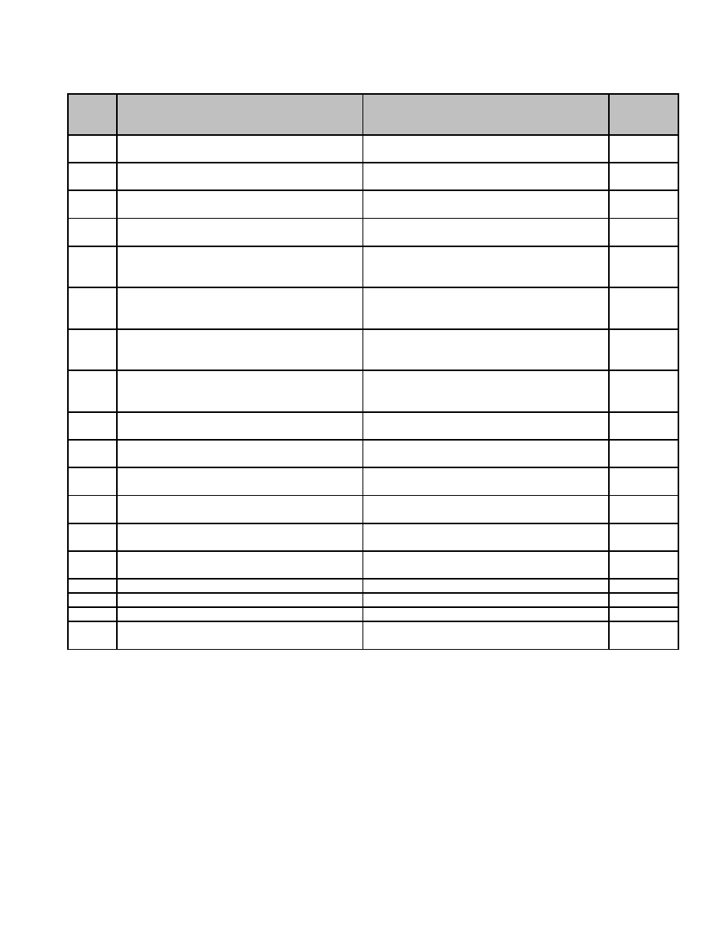

**15 Planning Board**

**Series**

**Description of Record** **Length of Time Required to Retain Record** **MGL / CMR**

**Number**

15.001 Applications (a) Special Permit Retain 1 year following expiration of 20-day c. 40A s.

appeal period. 1-A

15.002 Applications (b) Subdivision Control Not Retain 1 year following expiration of 20-day c. 41 s.

Required appeal period. 81T

15.003 Applications (c) Subdivision (Preliminary) Retain 1 year following expiration of 20-day c. 41A s.

appeal period. 81-T

15.004 Applications (d) Subdivision (Definitive) Retain 1 year following expiration of 20-day c. 41 s.

appeal period. 81T

15.005 Decisions (a) Special Permit Retain 1 year following expiration of 20-day c. 40A s.

appeal period, provided copy is filed with 11

clerk.

15.006 Decisions (b) Subdivision Control Not Retain 1 year following expiration of 20-day c. 41 s.

Required appeal period, provided copy is filed with 81P

clerk.

15.007 Decisions (c) Subdivision (Preliminary) Retain 1 year following expiration of 20-day c. 41 s.

appeal period, provided copy is filed with 81S

clerk.

15.008 Decisions (d) Subdivision (Definitive) Retain 1 year following expiration of 20-day c. 41 s.

appeal period, provided copy is filed with 81U

clerk.

15.009 Master Plan Permanent. c. 41 s.

81D

15.010 Notice for Public hearings (a) Special Retain 1 year following expiration of 20-day c. 40-A s.

Permits. appeal period. 11

15.011 Notice for Public hearings (b) Subdivisions Retain 1 year following expiration of 20-day c. 41 ss.

appeal period. 81-T, 81-U

15.012 Notice for Public hearings (c) Zoning Retain 1 year following expiration of 20-day c. 40-A s.

Changes appeal period. 5

15.013 Notice of Appeal to Superior Court Permanent. c. 41, s.

81BB

15.014 Official Map Permanent. c. 41 ss.

81E, 81H

15.015 Petty Cash Records Retain until completion of satisfactory audit.

15.016 Subdivision Files (a) Preliminary Retain 1 year following date of decision.

15.017 Subdivision Files (b) Definitive Retain until completion of subdivision.

15.018 Subdivision Rules and Regulations Permanent. c. 41 s.

81O

71

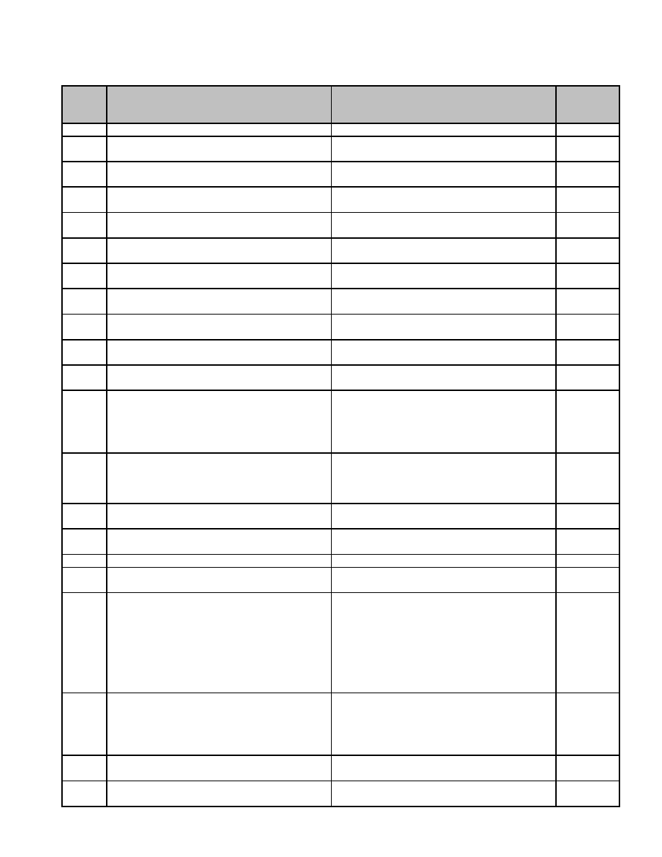

**16 Police Department**

**Series**

**Description of Record** **Length of Time Required to Retain Record** **MGL / CMR**

**Number**

16.001 Ambulance Calls Report Retain 7 years.

16.002 Appointment Certificate Permanent. c. 41, s.

96

16.003 Arrest Records (a) Booking Sheet Retain until completion of prosecution and

exhaustion of appeals.

16.004 Arrest Records (b) Fingerprint Card Retain until completion of prosecution and

exhaustion of appeals.

16.005 Arrest Records (c) Vehicle Inventory Retain until completion of prosecution and

exhaustion of appeals.

16.006 Arrest Records (d) BOP Report Retain until completion of prosecution and

exhaustion of appeals.

16.007 Arrest Records (e) RMV Report Retain until completion of prosecution and

exhaustion of appeals.

16.008 Arrest Records (f) LEAPS Report Retain until completion of prosecution and

exhaustion of appeals.

16.009 Cell Monitoring Reports Retain 3 years. c. 40, s.

36B

16.010 Civil Service Records Permanent. c. 31, s.

61

16.011 Civilian Complaints, no specific officers Retain 4 years following closure of c. 260, ss.

named investigation. 3A, 5B

16.012 Civilian Complaints, substantiated Retain 7 years following closure. c. 149, s.

52c, c.

260, ss.

3A, 5B, c.

277, s. 63

16.013 Civilian Complaints, unsubstantiated Retain 5 years following closure of c. 149, s.

investigation. 52C, c.

260, ss.

3A, 5B

16.014 Controlled Substance Seizure Report (no Retain 7 years. c. 94C, s.

arrest or warrant) 47A

16.015 Criminal Offender Record Information Retain 3 years.

Request Form

16.016 Cruiser Maintenance Report Retain 1 year after retirement of vehicle.

16.017 Death Report (Suicide, Sudden, Permanent.

Unexplained)

16.018 Disciplinary Case Files, resulting from Retain 7 years following closure; retain with c. 149, s.

administrative reprimand personnel files. 52C, c.

151B, c.

260, s. 5B,

c. 277, s.

63 29

CFR

1602.30

16.019 Disciplinary Case Files, resulting from Retain 7 years following closure; retain with c. 149, s.

civilian complaint personnel files. 52C, c.

260, ss.

3A, 5B, c.

277, s. 63

16.020 Dog Bite Investigation Report Retain 7 years. c. 140, s.

155

16.021 E-911 Call Detail Record Retain 3 years. c. 6A, s.

18A-18F

73

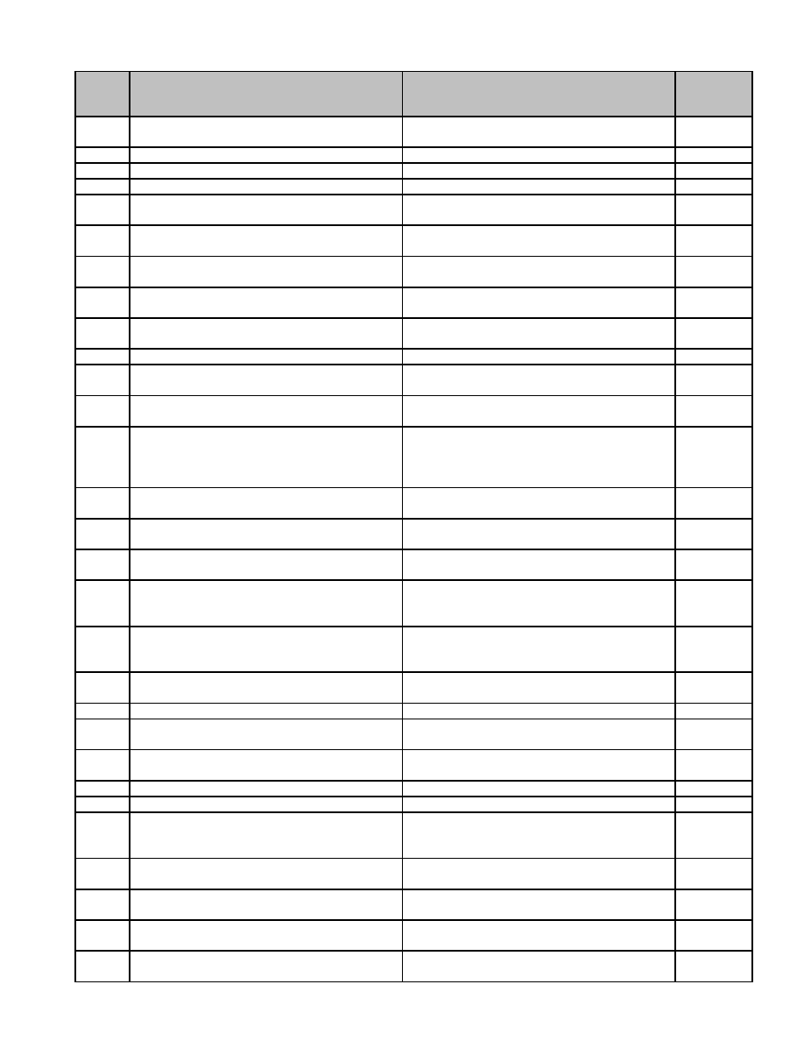

**Series**

**Description of Record** **Length of Time Required to Retain Record** **MGL / CMR**

**Number**

16.022 Employment History Records Retain 20 years following termination of

employment.

16.023 Equipment Inventory Retain until superseded by next inventory.

16.024 Equipment Maintenance Log Retain until retirement of equipment.

16.025 Evidence Control Form Retain 3 years.

16.026 Firearm Identification Card Retain until superseded. Permission from c. 140, s.

Supervisor not required for destruction. 129B

16.027 Firearm, License to Carry (Application) Retain until superseded. Permission from c. 140, s.

Supervisor not required for destruction. 131

16.028 Firearm, License to Carry. Form FA-19 Retain until superseded. Permission from c. 140, s.

Supervisor not required for destruction. 131

16.029 Firearms, License to Sell Permanent. c. 140, ss.

122, 122A

16.030 Firearms, Wound Report Permanent. c. 112, s.

12A

16.031 Found Property Form Retain 3 years.

16.032 Gunsmith License Permanent. c. 140, s.

122

16.033 Incident Report (Miscellaneous non-criminal Retain 3 years.

investigation)

16.034 Internal Investigation Case Files Retain 7 years following closure; retain with c. 151B, c.

personnel files. 260, s. 5B,

c. 277. s.

63

16.035 Investigation Report (no arrest or warrant) Retain 11 years. c. 265, s.

(a) Armed Robbery 17

16.036 Investigation Report (no arrest or warrant) Retain 11 years. c. 265, s.

(b) Assault with a Dangerous Weapon 18

16.037 Investigation Report (no arrest or warrant) Retain 11 years. c. 265, s.

(c) Unarmed Robbery 19

16.038 Investigation Report (no arrest or warrant). Retain 11 years. c. 265, s.

(d) Confining or putting in fear with intent to 21

commit felony

16.039 Investigation Report of all crimes except Retain 7 years. c. 277, s.

Murder and those covered by c. 265, s. 17, 63

18, 19, 21 (no arrest or warrant)

16.040 Investigation Report, Murder (no arrest or Permanent. c. 277, s.

warrant) 63

16.041 Journal Permanent.

16.042 Juror Investigation Report Retain 1 year. c. 234, s.

4

16.043 Lock-up Rules and Regulations Permanent. c. 40, s.

34

16.044 Log (Blotter) Permanent.

16.045 Missing Person Report Retain 3 years after case is closed.

16.046 Motor Vehicle Accident Reports (a) Retain 3 years. c. 90, s.

Operator's Report (investigation or no 26

investigation)

16.047 Motor Vehicle Accident Reports (b) Fatal Permanent. c. 90, s.

26

16.048 Motor Vehicle Accident Reports (c) Hit and Retain 7 years. c. 90, s.

Run 26

16.049 Motor Vehicle Accident Reports (d) Retain 7 years. c. 90, s.

Personal Injury 26

16.050 Motor Vehicle Accident Reports (e) Property Retain 3 years. c. 90, s.

Damage 26

74

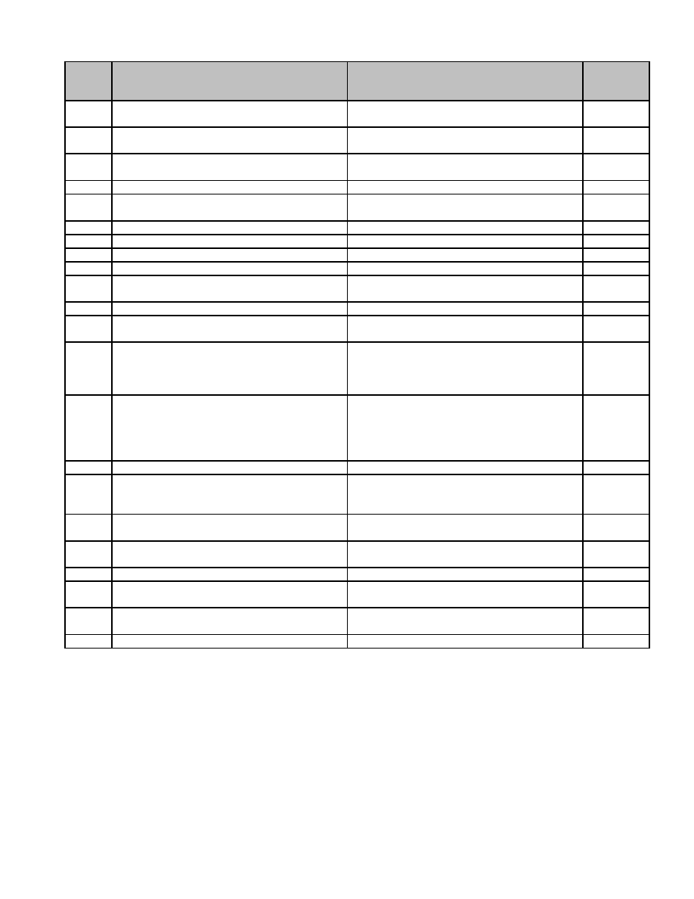

**Series**

**Description of Record** **Length of Time Required to Retain Record** **MGL / CMR**

**Number**

16.051 Motor Vehicle Accident Reports (f) Retain 3 years. c. 90, s.

Investigating Officer's Report 26

16.052 Motor Vehicle Citation Retain 1 year. c. 90C, s.

2

16.053 Motor Vehicle Citation Sheet Retain 1 year. c. 90C, s.

6

16.054 Motor Vehicle Inventory Form Retain 3 years.

16.055 Parking Ticket (Paid) Retain until completion of satisfactory audit. c. 90, s.

20A

16.056 Permits/Applications (Sunday work, etc.) Retain 1 year after issuance.

16.057 Premises Inspected Slips Retain 1 year.

16.058 Prisoner Property Slip Retain 1 year.

16.059 Procedural Rules Permanent.

16.060 Protective Custody Report (All) Retain 3 years. c. 111B, s.

8

16.061 Radar Log Retain 3 years.

16.062 Recordings of Phone Calls (911 etc.) Retain 1 year c. 6A, s.

18G

16.063 Reprimands, administrative Permanent. c. 149, s.

52C, c.

151B, c.

260, s. 5B

16.064 Reprimands, resulting from civilian Retain 7 years following closure. c. 149, s.

complaint 52C, c.

260, ss.

3A, 5B c.

277, s. 63

16.065 Roll Call Report Retain 3 years.

16.066 Schedule of Departmental Payments to Retain until administrative use ceases.

Treasurer Permission from Supervisor not required for

destruction.

16.067 Stolen Goods Report Retain 3 years. c. 266, s.

48

16.068 Stolen Vehicle Report Retain 3 years. c. 90D, s.

33

16.069 Taxi Cab Driver Records Retain until superseded.

16.070 Travel Expense Report of Court Witness Retain until completion of satisfactory audit. c. 262, s.

53B

16.071 Unclaimed Property, Notice of Sale Retain 3 years. c. 135, ss.

8, 9, 11

16.072 Uniform National Crime Reports Retain until superseded.

75

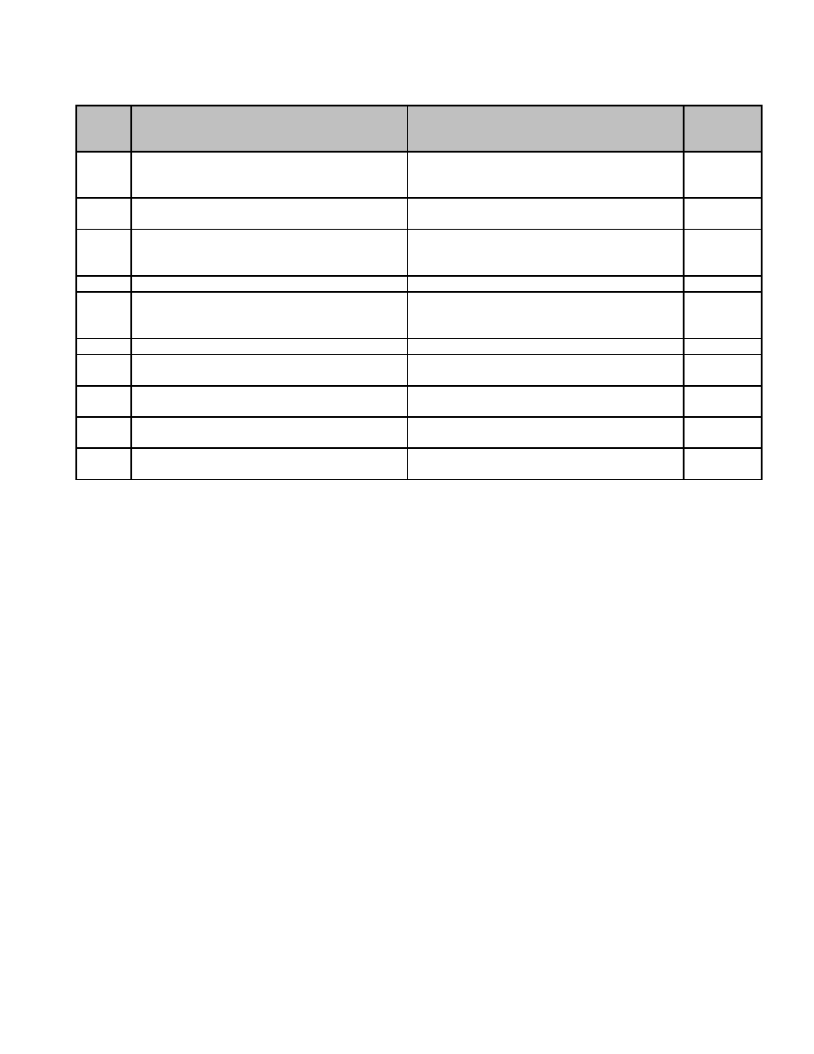

**17 Public Library**

**Series**

**Description of Record** **Length of Time Required to Retain Record** **MGL / CMR**

**Number**

17.001 Application for a Library Card Retain until administrative use ceases. c. 78, s. 7

Permission from Supervisor not required for

destruction.

17.002 Bibliographic Database Retain until deaccession. c. 78, ss.

7,8,9

17.003 Circulation Records Retain until administrative use ceases. c. 78, s. 7

Permission from Supervisor not required for

destruction.

17.004 Complaint and Censorship Records Retain until resolution.

17.005 Fine Payment Request Form Retain until administrative use ceases.

Permission from Supervisor not required for

destruction.

17.006 Library Building Program Files Retain 20 years. c. 78, 19E

17.007 Library Improvement Program Files Retain 7 years. c. 78, s.

19

17.008 Long Range Program Files Retain until superseded. c. 78, s.

19

17.009 Master Plan Permanent. c. 78, ss.

19E, 19H

17.010 Patron Information Database Retain until expiration of patron's borrowing c. 78, ss.

privileges. 7,8

77

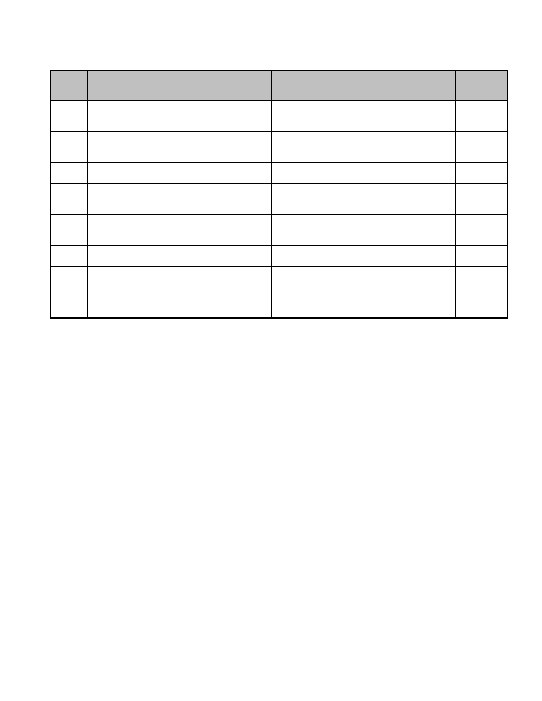

**18 Purchasing**

**Series**

**Description of Record** **Length of Time Required to Retain Record** **MGL / CMR**

**Number**

18.001 Emergency Procurement Files Retain 7 years following final payment c. 30B ss.

provided all relevant audits have been 3, 8, c.

completed. 260 s. 2

18.002 Procurement Officer's Delegation of Powers Retain 7 years following expiration, c. 30B ss.

and Duties revocation or amendment. 3, 19, c.

41 s. 103

18.003 Purchase Logs Retain 1 year following next satisfactory

audit.

18.004 Purchase Order Files (including Vendor's Retain 7 years following payment provided c. 30B ss.

Acknowledgement, Records of Quotations, all relevant audits have been completed. 3, 4, c.

Purchase Requirements Descriptions) 260 s. 2

18.005 Real Property, Acquisition and Disposition Retain 7 years following fulfillment of all c. 30B ss.

Files terms of contract, provided all relevant 3, 16, c.

audits have been completed. 260 s. 2

18.006 Receiving Slips Retain 1 year following satisfactory

completion of audit.

18.007 Sheltered Market Program Files Retain 7 years following termination or c. 30B ss.

amendment. 3, 18

18.008 Surplus Supply Disposition Files Retain 7 years following final payment c. 30B ss.

provided all relevant audits have been 3, 15, c.

completed. 260 s. 2

79

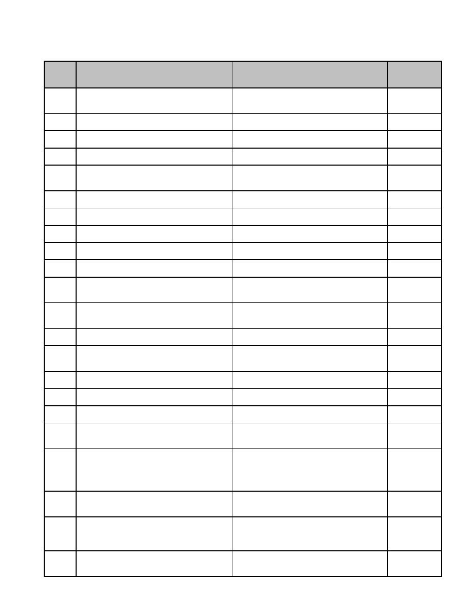

**19 Retirement Board**

**Series**

**Description of Record** **Length of Time Required to Retain Record** **MGL / CMR**

**Number**

19.001 Accidental Death Records; retention after Retain 1 year. c. 32 s. 9,

exhaustion of benefits and completion of 840 CMR

satisfactory audit. 9.02(3)

19.002 Administration and Finance, Accounts Permanent. c. 32, 840

Journal CMR 4.01

19.003 Administration and Finance, Actuarial Permanent. c. 32

Valuation Studies or Reports

19.004 Administration and Finance, Amount to be Retain 7 years. c. 32 s. 22(7)

Paid to Pension Fund, Actuary's Notification (c)

19.005 Administration and Finance, Amount to be Retain 7 years. c. 32 s.

Paid to Pension Fund, Certification to Mayor 22(7)(c)(ii)

or Selectmen and Disbursing Officer

19.006 Administration and Finance, Annual Report, Retain 7 years. 840 CMR

Request for Filing Extension 5.03(2)

19.007 Administration and Finance, Bonds of Retain 7 years. c. 32, 840

Fiduciaries; retention after expiration of bond. CMR 17.01

19.008 Administration and Finance, Cash Book Retain 7 years. 840 CMR

4.01

19.009 Administration and Finance, Establishment of Permanent. c. 32 s.

System, Certificate of 28(3),(4),(5)

19.010 Administration and Finance, General Ledger Permanent. c. 32, 840

CMR 4.01

19.011 Administration and Finance, Investment Retain 7 years. c. 32 s. 23(2)

Control Cards; retention following maturation

or divestment of investment.

19.012 Administration and Finance, Listing of Retain 7 years. c. 32 ss.

Disabled Members Who Have Not Filed an 6,21, 840

Annual Statement of Earnings CMR 10.14

19.013 Administration and Finance, Receipts for Retain 7 years. c. 32, c. 260

Administrative Expenses s. 2

19.014 Administration and Finance, Requests for Retain 7 years.

Reimbursement for COLA and Statutorily

Mandated Benefit Increases

19.015 Administration and Finance, Supplementary Permanent. c. 32 s. 21(4),

Rules 840 CMR 14

19.016 Administration and Finance, Tax Withholding Retain 7 years. c. 32, 26 CFR

Statement (W2-P) 1.6001-1

19.017 Administration and Finance, Trial Balance Retain 7 years. c. 32, 840

Book CMR 4.01

19.018 Administration and Finance, Warrants Retain 7 years. c. 32

(Payments to Retirees and Beneficiaries and

Refunds to Members Leaving Service)

19.019 Disability, Disability Benefit Records Retain until exhaustion of benefits, provided c. 32 ss. 6,7,

satisfactory audit has been completed 840 CMR

withdrawn, PERA 9-2 and 9-3 may be 9.02(2) (1),

disposed of. 10.16 (1 (6),

10.18 (4)

19.020 Disability, Hearing Records Retain until completion of satisfactory audit. c. 32, 840

CMR 10.12

(1)-((3) (b-h)

19.021 Disability, Notification to Disabled Member of Retain until exhaustion of benefits, provided c. 32 ss.

Failure to File Annual Statement of Earnings satisfactory audit has been completed. 6,21, 840

CMR

10.14(5)

19.022 Elections, Appeals to Board of Election Retain 3 years after election. c. 32 s. 20(3),

Officer's Decision 840 CMR

7.02

81

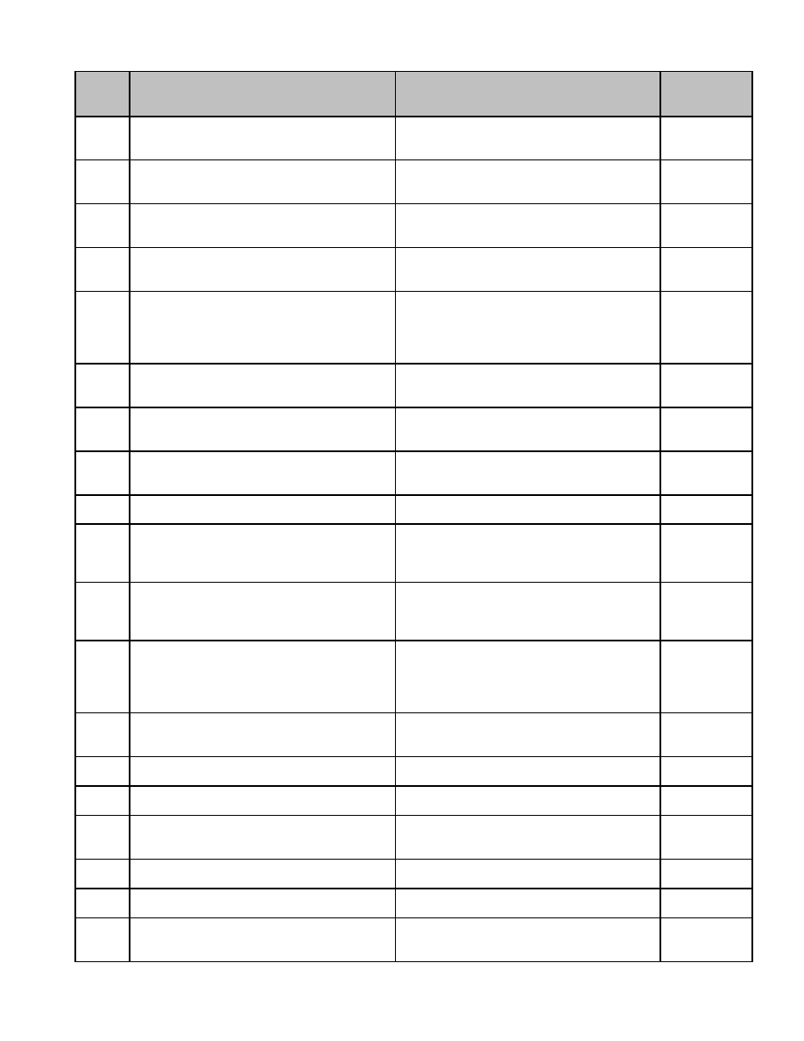

**Series**

**Description of Record** **Length of Time Required to Retain Record** **MGL / CMR**

**Number**

19.023 Elections, Ballots (including Disqualified and Retain 3 years after election. c. 32 s. 20(3),

Absentee) 840 CMR

7.06, 7.08

19.024 Elections, Nomination Papers Retain 3 years after election. c. 32 s. 20(3),

840 CMR

7.04

19.025 Elections, Notice of Election Retain 3 years after election. c. 32 s. 20(3),

840 CMR

7.03

19.026 Elections, Notification of Election Results Retain 3 years after election. c. 32 s. 20(3),

840 CMR

7.10

19.027 Investments, Exemption File (Including Retain 50 years. c. 32 ss.

Document Showing Why Exemption Should 21,23, 840

Not Be Revoked, Application for Exemption CMR 19

and Continued Exemption, Commissioner's.

Form PERA 19-1

19.028 Investments, Investment Advisors' Disclosure Retain 7 years after termination of c. 32, 840

Statements employment of advisor. CMR 17.04,

(7)(a-c),(8)

19.029 Investments, Invoices Submitted by Retain 7 years after termination of c. 32 ss.

Investment Managers and Custodians employment of managers and custodians. 21,23, 840

CMR 16

19.030 Investments, Monthly Report from System's Retain 7 years after termination of c. 32 ss.

Investment Manager and Custodian employment of advisor and custodian. 21,23, 840

CMR 16.03

19.031 Investments, Orders to and Brokers Retain 7 years after transaction. c. 32 ss.

Confirmations of Purchases and Sales 21,23

19.032 Investments, Semiannual Review of Retain 7 years after termination of c. 32 ss.

Investment Performance and Minutes of employment of investment advisor. 21,23, 840

Semi-Annual Meeting with Investment CMR

Advisor 16.05(2)

19.033 Investments, Statement of Investment Permanent. c. 32 ss.

Objectives (including Updates). Form PERA 21,23, 840

18-1, 18-2 CMR 18.02,

18.04

19.034 Membership Files (includes elements of Retain 80 years. c. 32 s. 11

Retirement Benefits Case File but may be

treated individually for disposition),

Accumulated Total Deductions, Request for

Return to Member

19.035 Membership Files, Assignment Documents Retain 7 years following exhaustion of c. 32 ss.

benefits, provided satisfactory audit has been 15,19

completed.

19.036 Membership Files, Calculation Verification Retain until exhaustion of benefits, provided c. 32, 840

Forms (from PERA) satisfactory audit has been completed. CMR 9.03(1)

19.037 Membership Files, Certificates of Birth, Retain until exhaustion of benefits, provided c. 32 s. 18

Marriage and Divorce satisfactory audit has been completed.

19.038 Membership Files, Certification that 18-to 22- Retain until exhaustion of benefits, provided c. 32 ss.

year old Child is a Full-time student satisfactory audit has been completed. 7(2)(a), (iii),

12B, 9(2)(d)

19.039 Membership Files, Change of Beneficiary Retain until exhaustion of benefits, provided c. 32 s. 11(2)

Blank satisfactory audit has been completed. (c)

19.040 Membership Files, Contributory Retirement Retain until exhaustion of benefits, provided c. 32 s. 16(4)

Appeals Board Decisions satisfactory audit has been completed.

19.041 Membership Files, Disclosure of Member Retain 3 years following exhaustion of c. 4 s. 6(27),

Information Records benefits, provided satisfactory audit has been c. 66, c. 32,

completed. 840 CMR 6

82

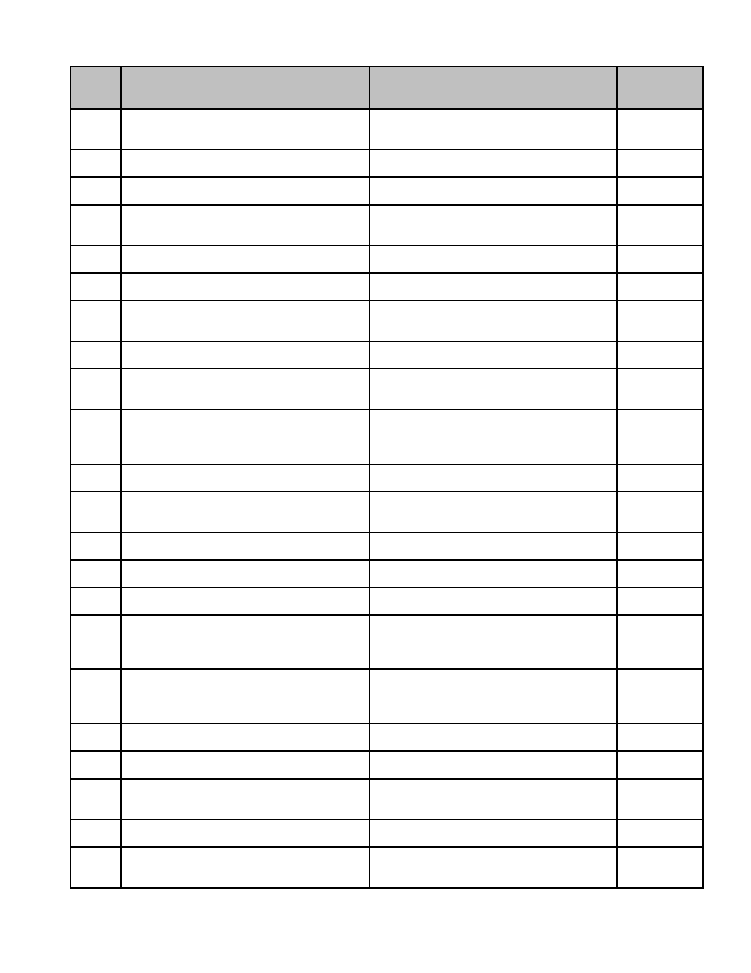

**Series**

**Description of Record** **Length of Time Required to Retain Record** **MGL / CMR**

**Number**

19.042 Membership Files, Documentation by Retain until exhaustion of benefits, provided c. 32 s. 91

Member of Time and Compensation for satisfactory audit has been completed.

Public

19.043 Membership Files, Membership Control Retain 80 years. c. 32 s. 20(5)

Cards

19.044 Membership Files, New Entrant Enrollment Retain until exhaustion of benefits, provided c. 32 s. 11(2)

Blank satisfactory audit has been completed. (c).

19.045 Membership Files, Non-Contributory Retain until exhaustion of benefits, provided c. 32 ss. 56-

Retirement Benefit Records (includes All satisfactory audit has been completed. 60, 840 CMR

Veteran's Claim) 9.02(4)(c).

19.046 Membership Files, Notice of Injury from Retain 80 years. c. 32 s. 7(1)

Member and/or Department Head and (3)

19.047 Membership Files, Notification of Leave of Retain until exhaustion of benefits, provided

Absence satisfactory audit has been completed.

19.048 Membership Files, Notification to Inactive Retain 80 years. c. 32 ss.

Members that Interest has Ceased to Accrue 11(1)(b),

22(6)(c).

19.049 Membership Files, Options on Retirement, Retain until exhaustion of benefits, provided c. 32 s.

Election satisfactory audit has been completed. 12(2)(a-c)

19.050 Membership Files, Requests for Retain until exhaustion of benefits, provided c. 32 s.

Reimbursement for Prorated Pensions and satisfactory audit has been completed. 3(8)(c). c. 32

Transfer of Funds in Response Thereto s. 3(8)(c).

19.051 Membership Files, Retirement Payment Retain until exhaustion of benefits, provided

Cards satisfactory audit has been completed.

19.052 Membership Files, Service Buy-back Forms Retain until exhaustion of benefits, provided c. 32, 840

or Letters satisfactory audit has been completed. CMR 15.02

19.053 Membership Files, Survivorship Records Retain until exhaustion of benefits, provided c. 32

(includes Benefits) satisfactory audit has been completed.

19.054 Membership Files, Veteran's Benefits Retain until exhaustion of benefits, provided c. 32 s. 5,

Records and all Documentation Establishing satisfactory audit has been completed. 840 CMR

Status. Form DD-214, Veteran's 9-5 9.02

19.055 Membership Files, Waiver of Retirement Retain until exhaustion of benefits, provided c. 32 s. 90B

Allowance satisfactory audit has been completed.

19.056 Membership Files, Worker's Compensation, Retain until exhaustion of benefits, provided c. 32 s. 14

History of satisfactory audit has been completed.

19.057 Rehabilitation Records, General Retain until exhaustion of benefits, provided c. 32 (7-10)

satisfactory audit has been completed.

19.058 Rehabilitation Records, Request by Disabled Retain until exhaustion of benefits, provided c. 32 ss.

Member to Reduce or Withdraw Board's satisfactory audit has been completed. 6,21, 840

Request for Refund CMR

10.14(3)

19.059 Rehabilitation Records, Request for Refund Retain until exhaustion of benefits, provided c. 32 ss.

from Disabled Member satisfactory audit has been completed. 6,21, 840

CMR

10.14(3)

19.060 Rehabilitation Records, Statement of Retain until exhaustion of benefits, provided c. 32 ss. 6,21

Earnings from Member satisfactory audit has been completed.

19.061 Service 65-70, Annual Certification of Retain until exhaustion of benefits, provided c. 32 s. 90H

Member's satisfactory audit has been completed.

19.062 Service 65-70, Appointing Authority Request Retain until exhaustion of benefits, provided c. 32 s. 90H,

for Medical Examination, Request for. Form satisfactory audit has been completed. 840 CMR

PERA 12-2 12.03

19.063 Service 65-70, Department Head's Statement Retain until exhaustion of benefits, provided c. 32 s. 90H

2 and 4 Members satisfactory audit has been completed.

19.064 Service 65-70, Medical Questionnaire to be Retain until exhaustion of benefits, provided c. 32 s. 90H,

Completed by Member. Form PERA 12-3 satisfactory audit has been completed. 840 CMR

12.03(3)

83

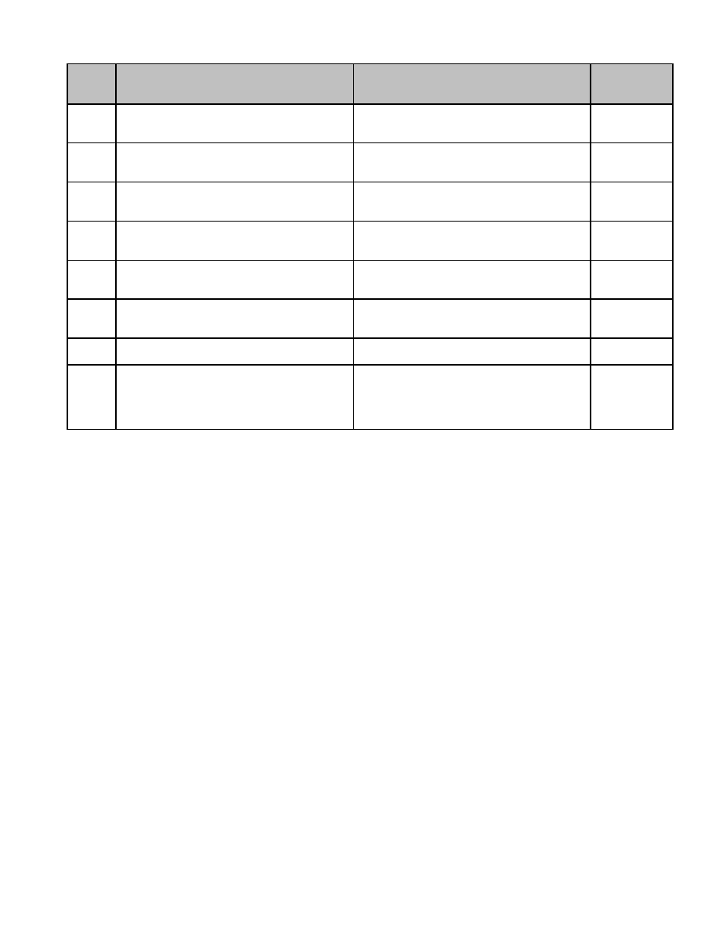

**Series**

**Description of Record** **Length of Time Required to Retain Record** **MGL / CMR**

**Number**

19.065 Service 65-70, Notification that Member May Retain until exhaustion of benefits, provided c. 32 s. 90H,

Continue in Service Past Age 65. Includes satisfactory audit has been completed. 840 CMR

Member Response. Form PERA 12-1 12.01

19.066 Service 65-70, Notification that Member May Retain until exhaustion of benefits, provided c. 32 ss. 90H,

Not Continue in Service Past Age 65 satisfactory audit has been completed. 840 CMR

12.01

19.067 Service 65-70, Physician's Certification. Form Retain until exhaustion of benefits, provided c. 32 s. 90H,

PERA 12-1 satisfactory audit has been completed. 840 CMR

12.03(4)

19.068 Service After 70, Members Age 70 or over, Retain until exhaustion of benefits, provided c. 32 ss.

Election of Deductions satisfactory audit has been completed. 90G(1/2), 840

CMR 11.01

19.069 Service After 70, Members Continuing in Retain until exhaustion of benefits, provided c. 32 ss. 90F,

Service After Age 70 Records satisfactory audit has been completed. 90G, 840

CMR 11.02

19.070 Service After 70, Notice to Group 1 Member Retain until exhaustion of benefits, provided c. 32 s. 90F

180/120 Days Prior to 70th Birthday satisfactory audit has been completed. 90G, 840

CMR 11.01

19.071 Service After 70, Notice to Member over Age Retain until exhaustion of benefits, provided c. 32 s.

70 and Have Deductions Taken satisfactory audit has been completed. 90G(1/2)

19.072 Superannuation Retirement Benefits Retain until exhaustion of benefits, provided c. 32 s. 5,

Records. Includes Allowance and Calculation satisfactory audit has been completed, 840 CMR

Forms (PERA 9-1, 9-2 or 9-3) and Letter of unless request withdrawn. If application is 9.02(1)(a),(b)

Withdrawal of Application). Form PERA 9-1, withdrawn, PERA 9-1, 9-2 and 9-3 may be

9-2, 9-3 disposed of.

84

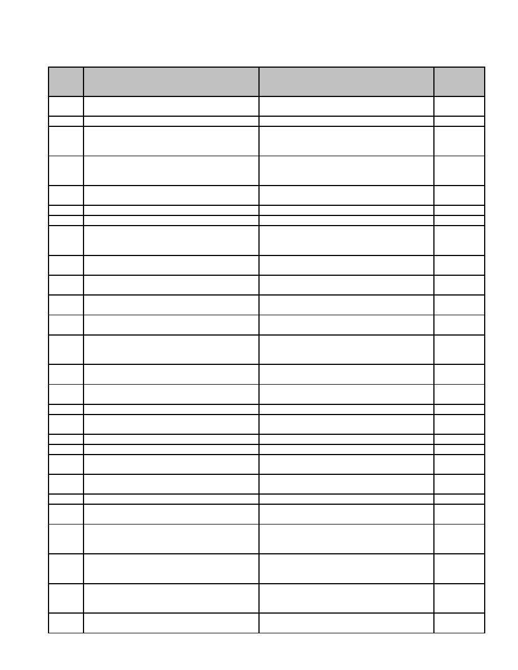

**20 School Department**

**Series**

**Description of Record** **Length of Time Required to Retain Record** **MGL / CMR**

**Number**

20.001 Administration, Annual Notice to Public Retain 1 year. c. 98 s. 41

(Legal)

20.002 Administration, Building Plans Permanent.

20.003 Administration, Evidence Teaching Retain 5 years. 603 CMR

Credentials; retention after termination of 7.00

employment

20.004 Administration, Extended School Year Plan Retain 3 years. c. 71 s. 1,

Records 603 CMR

16.00

20.005 Administration, Plant, Maintenance Work Retain until completion of satisfactory audit.

Request Form

20.006 Administration, Plant, Posting Schedule of Retain until completion of satisfactory audit.

20.007 Administration, Printing Request Form Retain until completion of satisfactory audit.

20.008 Administration, Regional District Planning Permanent. c. 71 s. 2

Board: Agreement on Proposals for

Formation of Regional School Districts

20.009 Administration, School Committee Report, Permanent. c. 72 s. 2

Annual

20.010 Administration, School Returns, Annual Permanent. c. 72 s. 3

Report to Superintendents

20.011 Administration, School, Condition of, Annual Retain 7 years. c. 72 s. 4

Report

20.012 Administration, Superintendent of Schools, Permanent. c. 72 s.

Annual Report of 2(A)

20.013 Administration, Teaching Schedules Retain until administrative use ceases.

Permission from Supervisor not required for

destruction.

20.014 Fiscal, Annual Audit of the Accounts of the Retain 7 years. c. 71 s.

Regional School District Committee 16E

20.015 Fiscal, Bid Specifications and Responses Retain with Contract Files. c. 30B, c.

for Equipment and Supplies 260 s. 2

20.016 Fiscal, Bond Coupon Statements Retain until completion of satisfactory audit.

20.017 Fiscal, Bond Coupons Retain 7 years after cancellation, provided a

satisfactory audit has been completed.

20.018 Fiscal, Bus Contracts Retain with Contract Files. c. 30B

20.019 Fiscal, Bus Transportation Requests Retain until completion of satisfactory audit.

20.020 Fiscal, Bus Vouchers Retain 7 years provided a satisfactory audit

has been completed.

20.021 Fiscal, Educational Television Program Retain until completion of satisfactory audit. c. 71 s.

Fund 13(H)

20.022 Fiscal, Equipment Inventory Form Retain until superseded by next inventory.

20.023 Fiscal, Federal Projects (Title I, II, III, IV-B, Retain 5 years provided a satisfactory audit

etc.) has been completed.

20.024 Fiscal, Food Service Records (a) Breakfast Retain 3 years after the end of the fiscal 603 CMR

Program Records year to which they pertain, provided a 32.05(12)

satisfactory audit has been completed.

20.025 Fiscal, Food Service Records (b) Retain 3 years after the end of the fiscal 603 CMR

Commodity Distribution Program Records year to which they pertain, provided a 31.06(13)

satisfactory audit has been completed.

20.026 Fiscal, Food Service Records (c) Retain 3 years. 603 CMR

Determining Eligibility for Free and Reduced 34.07(1(k))

Price Lunches Records

20.027 Fiscal, Food Service Records (d) Lunch Retain 3 years after the end of the fiscal 603 CMR

Program Records year to which they pertain, provided a 29.05(17)

85

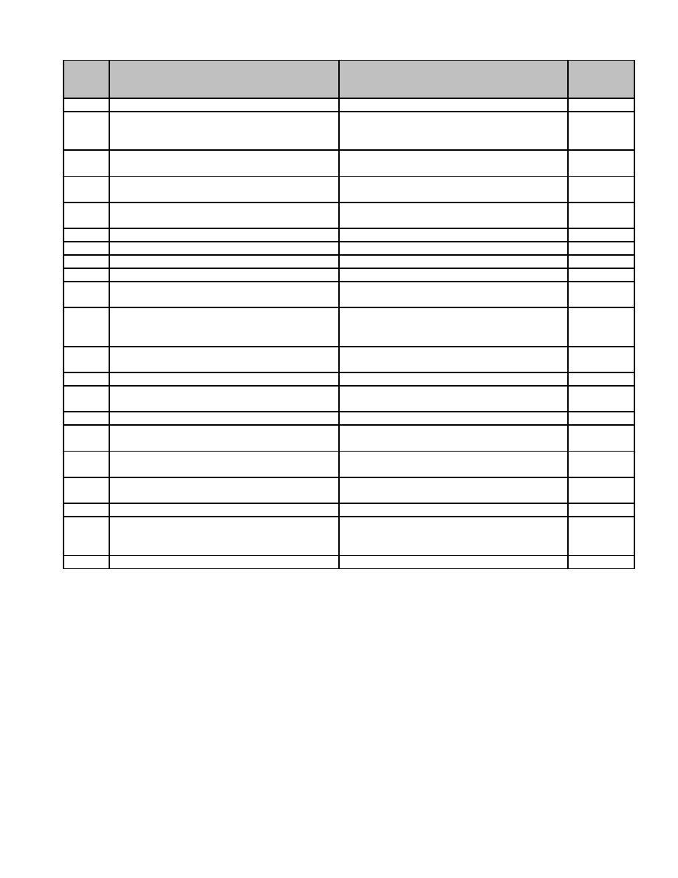

**Series**

**Description of Record** **Length of Time Required to Retain Record** **MGL / CMR**

**Number**

satisfactory audit has been completed.

20.028 Fiscal, Food Service Records (e) Milk Retain 3 years after the end of the fiscal 603 CMR

Program Records year to which they pertain, provided a 30.13(2)

satisfactory audit has been completed.

20.029 Fiscal, Food Service Records (f) Paid Retain 7 years, provided a satisfactory audit

Invoices has been completed.

20.030 Fiscal, Food Service Records (g) Policies Retain 3 years if no informational or

and Memoranda evidential value.

20.031 Fiscal, Food Service Records (h) Retain 7 years, provided a satisfactory audit

Reimbursement Claims has been completed.

20.032 Fiscal, Invoice Warrant Retain until completion of satisfactory audit.

20.033 Fiscal, Ledger, Agency and Trust Accounts Retain 10 years.

20.034 Fiscal, Ledger, Appropriation Retain 10 years.

20.035 Fiscal, Ledger, General Retain 10 years.

20.036 Fiscal, Reimbursement Claims Retain 7 years, provided a satisfactory audit

has been completed.

20.037 Fiscal, School Aid Records Retain until completion of satisfactory audit. 603 CMR

10.03-

10.19

20.038 Fiscal, Supporting Cost, Allocation and Retain until completion of satisfactory audit.

Computation

20.039 Payroll, Fiscal, Blue Cross, Reports to Retain 3 years.

20.040 Payroll, Payroll, Substitute Teacher Retain until completion of satisfactory audit.

Attendance Report

20.041 Payroll, Retirement Ledgers Permanent. c. 32 s. 20

20.042 Payroll, Substitute Teacher Employment Retain 3 years after termination of

Applications employment.

20.043 Payroll, Tax Exemption Certificate Retain 5 years or until administrative use

ceases, whichever is later.

20.044 Payroll, Tuberculosis; Report of School Retain 3 years upon reverification. c. 71 s.

Personnel, Freedom from 55B

20.045 Payroll, Vacancy, Posting of Teaching Retain 3 years.

20.046 Payroll, Weekly, Biweekly or Monthly Retain until completion of satisfactory audit,

Payroll provided recorded elsewhere in a summary

record.

20.047 Payroll, Work Sheets Retain until completion of satisfactory audit.

86

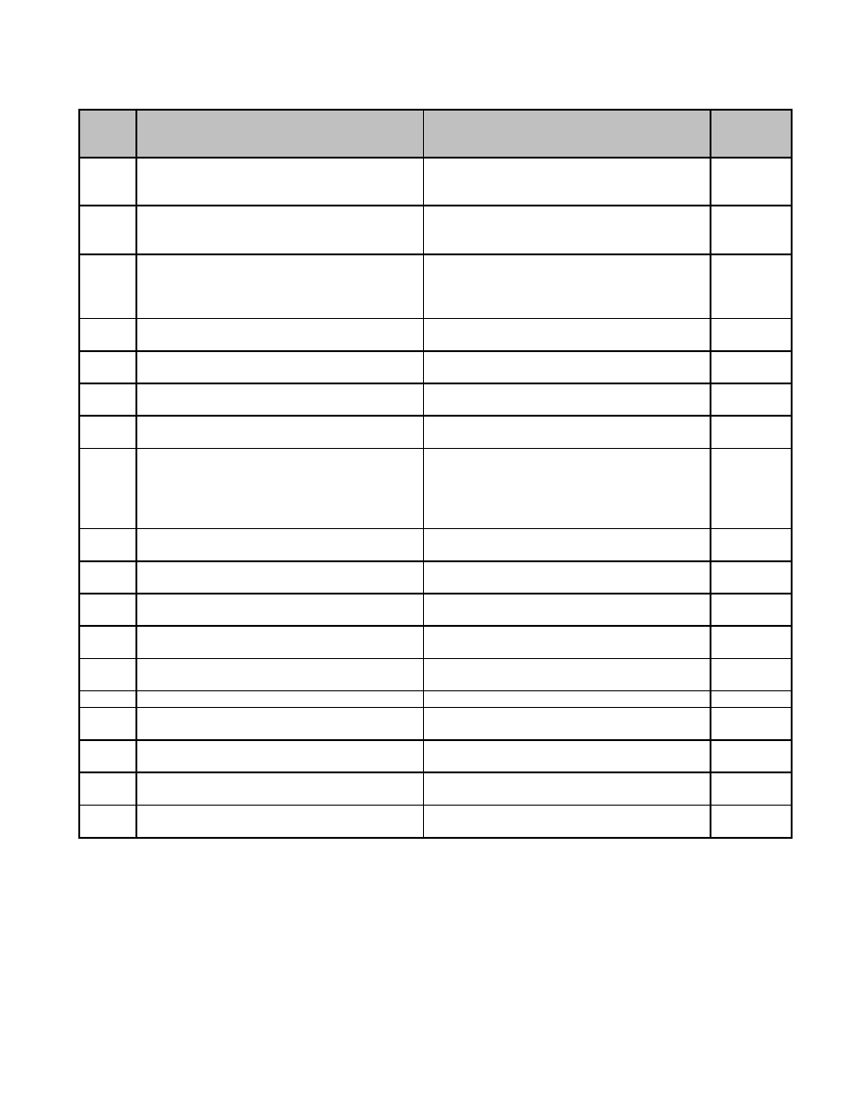

**21 Sealers of Weights and Measures**

**Series**

**Description of Record** **Length of Time Required to Retain Record** **MGL / CMR**

**Number**

21.001 Administration, Annual Report Retain until completion of satisfactory audit. c. 98 ss.

34, 35, 36,

37

21.002 Administration, Certification of Sealer's Retain until administrative use ceases. c. 98 s. 2

Equipment; retention after retesting and Permission from Supervisor not required for

renewal. destruction.

21.003 Administration, Field Book - Sealing and Retain until completion of satisfactory audit. c. 98 ss.

Adjustment Record 25, 34, 35,

36, 41, 42,

43

21.004 Administration, Office Record and Ledger Permanent. c. 98 ss.

34, 35, 36

21.005 Administration, Receipts from Treasurer Retain until completion of satisfactory audit. c. 98 ss.

34, 35, 36

21.006 Field Records, Adjustments - Sealing - Not Retain 3 years beyond date of last entry. c. 98 s. 42

Sealed - Condemnations (Field Card)

21.007 Field Records, Commodities Reweighing Retain 3 years. c. 98 s. 34

Record

21.008 Field Records, Field Inspections and Test Retain 3 years. c. 98 ss.

(Markings - Licenses - Systems - 14A, 16,

Certificates) 18, 20, 21,

23, 42, 46,

51

21.009 Field Records, Fuel Delivery Inspection Retain 3 years. c. 94 ss.

303F, 245

21.010 Field Records, Hawkers and Peddlers Retain 3 years. c. 101 s.

Inspection 27

21.011 Field Records, Merchants Equipment Retain 3 years beyond date of last entry.

Record

21.012 Field Records, Meter Test Record (Sealing Retain 3 years. c. 98 s. 42

or Retest)

21.013 Field Records, Petroleum Delivery Retain 3 years. c. 98 s. 34

Inspection Record

21.014 Field Records, Summary of Trial Weighing Retain 1 year.

21.015 Field Records, Summary Record of Field Retain 1 year.

Inspections and Tests Made

21.016 Field Records, Tank Truck Calibration Retain 1 year beyond discontinuance of c. 98 s. 42

Record apparatus.

21.017 Field Records, Taxi Inspection Retain 3 years. c. 98 ss.

42, 45

21.018 Field Records, Unit Pricing Inspection Retain 1 year. c. 6 s.

115A

87

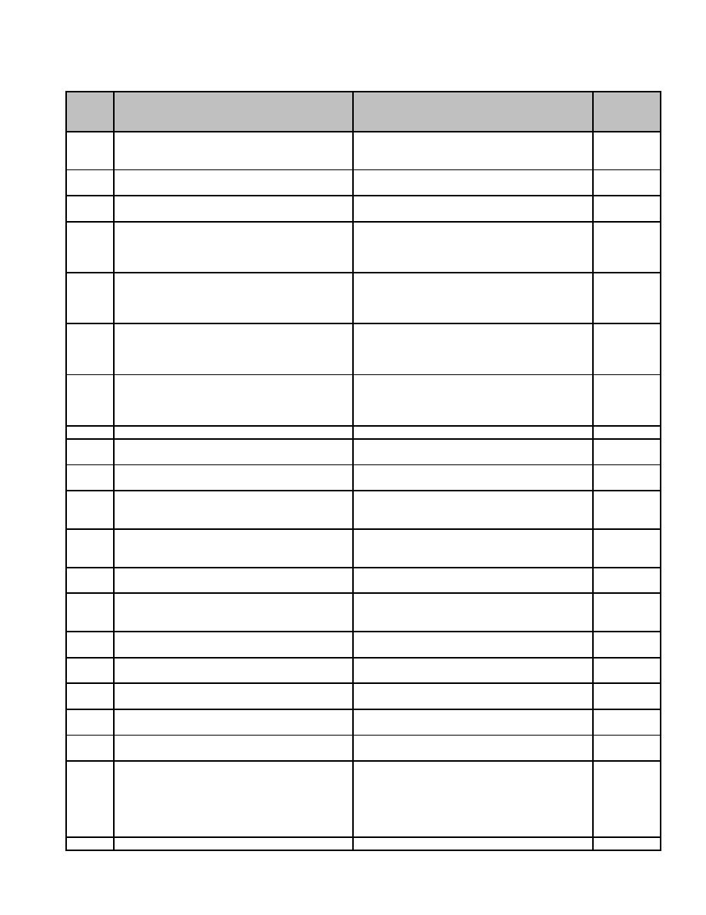

**22 Selectmen**

**Series**

**Description of Record** **Length of Time Required to Retain Record** **MGL / CMR**

**Number**

22.001 Accounts and Receipts of Collector Retain until administrative use ceases. c. 60 s. 94

Permission from Supervisor not required for

destruction.

22.002 Administration, Appeal to Appellate Tax Board Retain 3 years. c. 59 s. 7

(ATB); retention after final settlement.

22.003 Administration, Appointment Certificate; Retain 3 years. c. 41 s.

retention after termination of appointment. 23C

22.004 Administration, Appropriation forms for the Retain 7 years. c. 44 s. 64

payment of unpaid bills of previous years (a)

Certificate of Order; retention after completion

of satisfactory audit.

22.005 Administration, Appropriation forms for the Retain 7 years. c. 44 s. 64

payment of unpaid bills of previous years (b)

Certificate of Delivery; retention after

completion of satisfactory audit.

22.006 Administration, Appropriation forms for the Retain 7 years. c. 44 s. 64

payment of unpaid bills of previous years (c)

Certificate of Receipt; retention after

completion of satisfactory audit.

22.007 Administration, Appropriation forms for the Retain 7 years. c. 44 s. 64

payment of unpaid bills of previous years (d)

Certificate of Services Rendered; retention

after completion of satisfactory audit.

22.008 Administration, Civil Service Forms Permanent.

22.009 Administration, Employment Applications (a) Permanent.

hired employee.

22.010 Administration, Employment Applications (b) Retain 3 years.

unhired.

22.011 Administration, Rules for Police Stations, Retain until administrative use ceases. c. 111 s.

Lock-ups, Jails, etc.; retention until Permission from Supervisor not required for 21

superseded. destruction.

22.012 Administration, Schedule of Departmental Bills Retain until administrative use ceases. c. 41 s. 51

Payable Permission from Supervisor not required for

destruction.

22.013 Administration, Special Town Meeting Permanent. c. 39 s. 10

Petitions

22.014 Administration, Treasury Warrants Retain until administrative use ceases. c. 41 s. 60

Permission from Supervisor not required for

destruction.

22.015 Animal Control, Complaint against vicious or Retain 5 years. c. 140 s.

barking dog 157

22.016 Animal Control, Warrant returned from police Retain 5 years. c. 140 s.

officer, constable and/or dog officer 152

22.017 Animal Control, Warrant to police officer, Retain 5 years. c. 140 s.

constable and/or dog officer 153

22.018 Boundary Records, Boundary Triangulation Permanent. c. 42 s. 9

Points (as determined by State D.P.W.)

22.019 Boundary Records, Descriptions of Obliterated Permanent. c. 42 s. 10

Town Markers

22.020 Boundary Records, Perambulation Records Permanent. c. 42 s. 2

(as

amended

by c. 231

Acts of

1973)

22.021 Boundary Records, Plan of Boundary Change Permanent. c. 42 s. 7

89

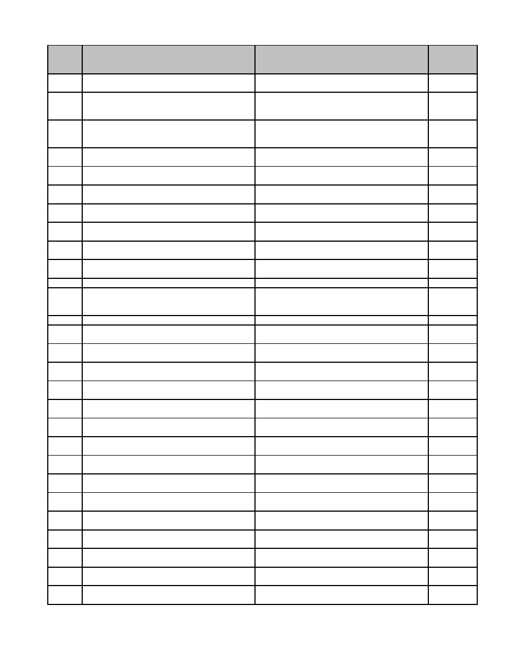

**Series**

**Description of Record** **Length of Time Required to Retain Record** **MGL / CMR**

**Number**

22.022 Boundary Records, Proposal for Boundary Permanent. c. 42 s. 7

Change

22.023 Boundary Records, Ratification and Permanent. c. 42 s. 7

Acceptance of Boundary Change by General

Court

22.024 Boundary Records, Receipts for registered Retain until administrative use ceases. c. 42 s. 2

notices to contiguous towns. Permission from Supervisor not required for

destruction.

22.025 Education, Regional School District Annual Permanent. c. 71 s. 16

Report

22.026 Education, Regional School District Permanent. c. 71 s. 15

Organization Proposal

22.027 Education, Regional School District Planning Permanent. c. 71 s. 15

Board Report

22.028 Elections, Education, Notice of Vacancy in Retain 1 year from filling of vacancy. c. 54 s.

General Court 141

22.029 Elections, Notice of Vacancy in County Office Retain 1 year from filling of vacancy. c. 54 ss.

143, 144

22.030 Elections, Notice of Vacancy in Municipal, Retain 1 year from filling of vacancy. c. 50 s. 6A

County or State Office Caused by Retirement

22.031 Employment Service Record Retain 20 years following termination of

employment.

22.032 General, Deeds/Leases Permanent.

22.033 General, Jury Service Questionnaire Retain until administrative use ceases. c. 234 s. 4

Permission from Supervisor not required for

destruction.

22.034 General, Notice of Strike or Lockout Retain 5 years. c. 150 s. 3

22.035 General, Report of Insurance Commissioner Permanent. c. 32 s. 21

Relating to Retirement Board

22.036 General, Report of Insurance Commissioner Permanent. c. 32 s. 32

Relating to Weighing and Measuring

22.037 General, Report of Violations Relating to Permanent. c. 92 s. 32

Weighing and Measuring

22.038 Licenses and Permits, Application for License Retain 3 years past duration of license.

(a) License Granted

22.039 Licenses and Permits, Application for License Retain 3 years.

(b) License Denied

22.040 Licenses and Permits, Application for Permit Retain 3 years past duration of license.

(a) License Granted

22.041 Licenses and Permits, Application for Permit Retain 3 years.

(b) License Denied

22.042 Licenses, Alcoholic Beverages, Application for Permanent. c. 138 s.

License 15A

22.043 Licenses, Alcoholic Beverages, Application for Permanent. c. 138 s.

Transfer of License 15A

22.044 Licenses, Alcoholic Beverages, Change of Permanent. c. 138 s.

Location or Manager Position 15A

22.045 Licenses, Alcoholic Beverages, Club License Retain 7 years after termination. c. 138 s.

12

22.046 Licenses, Alcoholic Beverages, Common Retain 7 years after termination. c. 138 s.

Victualer License 12

22.047 Licenses, Alcoholic Beverages, Letter of Permanent. c. 6 s. 44

Approval to ABCC

22.048 Licenses, Alcoholic Beverages, Retail Retain 7 years after termination. c. 138 s.

Package Goods License 15

22.049 Licenses, Tavern License Retain 7 years after termination. c. 138 s.

12

90

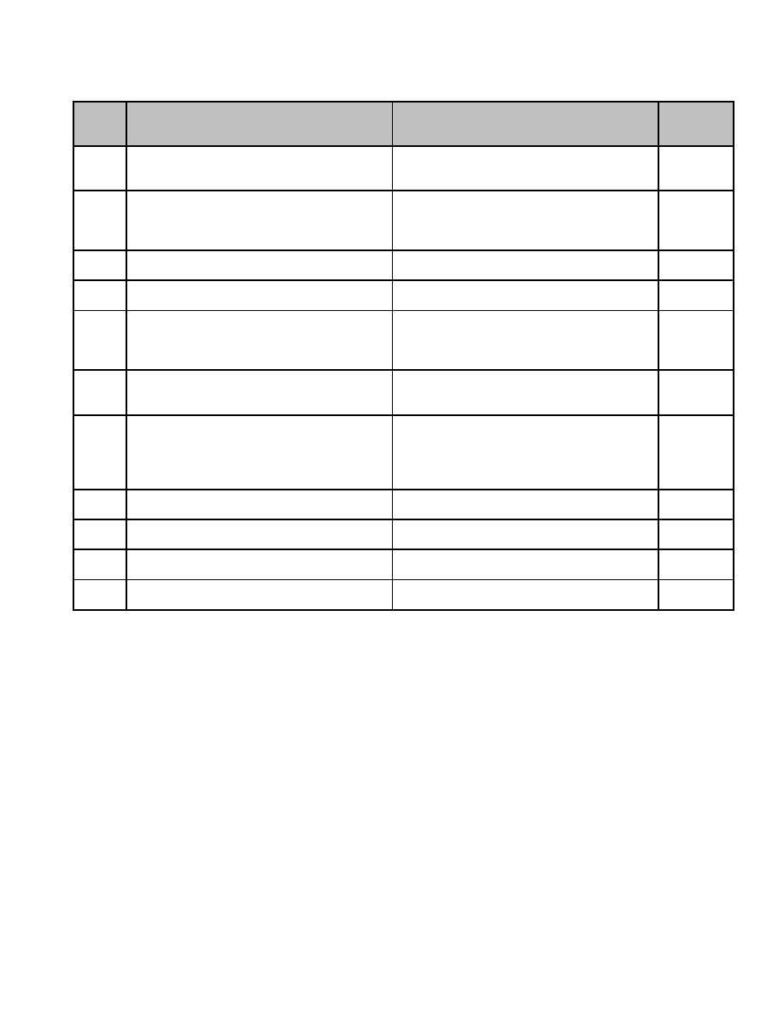

**23 Shellfish Constable**

**Series**

**Description of Record** **Length of Time Required to Retain Record** **MGL / CMR**

**Number**

23.001 Catch Reports (Daily or Monthly) Retain 1 year following filing of annual

report to Division of Marine Fisheries

(DMF).

23.002 Closure, Notices of Retain 3 years following reopening of area. c. 130 ss.

53, 54, 74,

74A, 75, c.

260 s. 4

23.003 License and Permit Stubs and Duplicates Retain 1 year following satisfactory c. 130 ss.

completion of audit. 52, 53

23.004 License Applications Retain 1 year following expiration, provided c. 130 ss.

satisfactory audit has been completed. 52, 53

23.005 Noncriminal Violation Citations Retain 1 year following satisfactory c. 40 s.

completion of audit unless complaint issued, 21D

then retain 1 year following audit following

final disposition of case.

23.006 Predator Control Permits and Reports Retain 5 years. 50 CFR

13.46,

21.41

23.007 Purification Plant, Reports of Transport of Retain 3 years. c. 130 s.

Shellfish to 75, 322

CMR

10.07(5),

c. 260 s. 4

23.008 Relay Permits Retain 1 year following reopening of area. c. 130 s.

75

23.009 Seed Permits Retain 1 year following expiration. c. 130 s.

69

23.010 Shellfish Conservation and Management Retain until superseded. c. 130 s.

Plan 75

23.011 Shellfish Grant Files Retain 7 years following expiration of grant. c. 130 ss.

57-68A

91

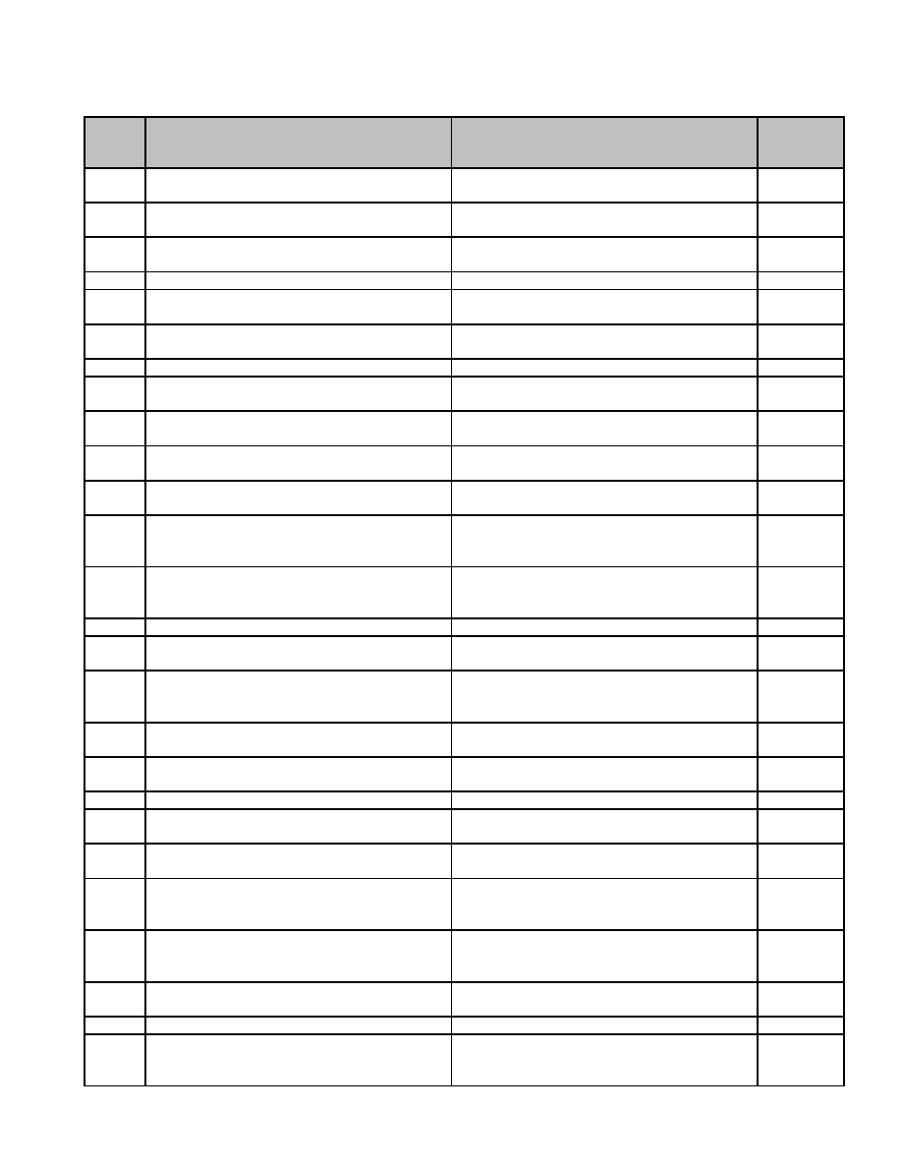

**24 Treasurer**

**Series**

**Description of Record** **Length of Time Required to Retain Record** **MGL / CMR**

**Number**

24.001 Bills Receivable, Schedules of. Form AD 34, Retain until completion of satisfactory audit. c. 41 s. 35

35

24.002 Bonds, Performance, Assistant Treasurer Retain 7 years from expiration date. c. 41 s.

39A

24.003 Bonds, Performance, Temporary Officer (C) Retain 7 years from expiration date. c. 41 s.

61A

24.004 Bonds, Performance, Temporary Officer (T) Retain 7 years from expiration date. c. 41 s. 40

24.005 Bonds, Performance, Treasurer Retain 7 years from expiration date. c. 41 ss.

35, 44, 46

24.006 Bonds, Performance, Treasurer to Comm. Retain 7 years from expiration date. c. 111 ss.

on Children's Health Camps 62C, 62D

24.007 Cash Books Permanent.

24.008 Collector's Payments to Treasurer, Retain until completion of satisfactory audit. c. 60 s. 2

Schedule of. Form AD 7, 8, 397

24.009 Departmental Payments to Treasurer, Retain until completion of satisfactory audit. c. 41 s. 35

Schedule of. Form AD 9, 10

24.010 Deposit Books Retain until reconciliation of appropriate c. 44 s. 23

bank statement or statements.

24.011 Disallowance, Notices of Retain 6 years. c. 41, s.

52

24.012 Dog Licenses, Monthly Return of. Form DL6 Retain until administrative use ceases. c. 140 s.

Permission from Supervisor not required for 147

destruction.

24.013 Dog Licenses, Record of Payment for Retain until administrative use ceases. c. 140 s.

Permission from Supervisor not required for 149

destruction.

24.014 Earning Records, Employees Permanent.

24.015 Fines and Forfeitures (from Superior Court), Retain until completion of satisfactory audit. c. 280 s. 7

Certificates of

24.016 Laws, Published (from State Secretary) Retain until administrative use ceases. c. 5 s. 3

Permission from Supervisor not required for

destruction.

24.017 Loans, Bond Certificates and Coupons, Retain 7 years after debt retired, provided a c. 41 s. 57

Cancelled satisfactory audit has been completed.

24.018 Loans, Borrowing, Report on Retain 7 years, provided a satisfactory audit c. 44 s. 28

has been completed.

24.019 Loans, Debt Records Permanent. c. 44 s. 23

24.020 Loans, Notes and Certificates of Retain 7 years after debt retired, provided a c. 44 ss.

Indebtedness, Cancelled satisfactory audit has been completed. 23, 24, 25

24.021 Loans, Payment of Notes, Report to Retain 7 years, provided a satisfactory audit c. 44 s. 25

Director Concerning has been completed.

24.022 Process, Service of Retain until administrative use ceases. c. 223 s.

Permission from Supervisor not required for 37

destruction.

24.023 Public Welfare Lien, Certificate for Permanent. ch. 885 s.

Discharge of. Form 490 28, acts of

1969

24.024 Receipts, Schedule of. Form AD11 Retain until completion of satisfactory audit. c. 41 ss.

35, 50

24.025 Retirement Records Permanent. c. 32 s. 23

24.026 Tax Abatements, Notice of Retain until final settlement of levy or c. 59 s.

completion of satisfactory audit, whichever 23B

is later.

93

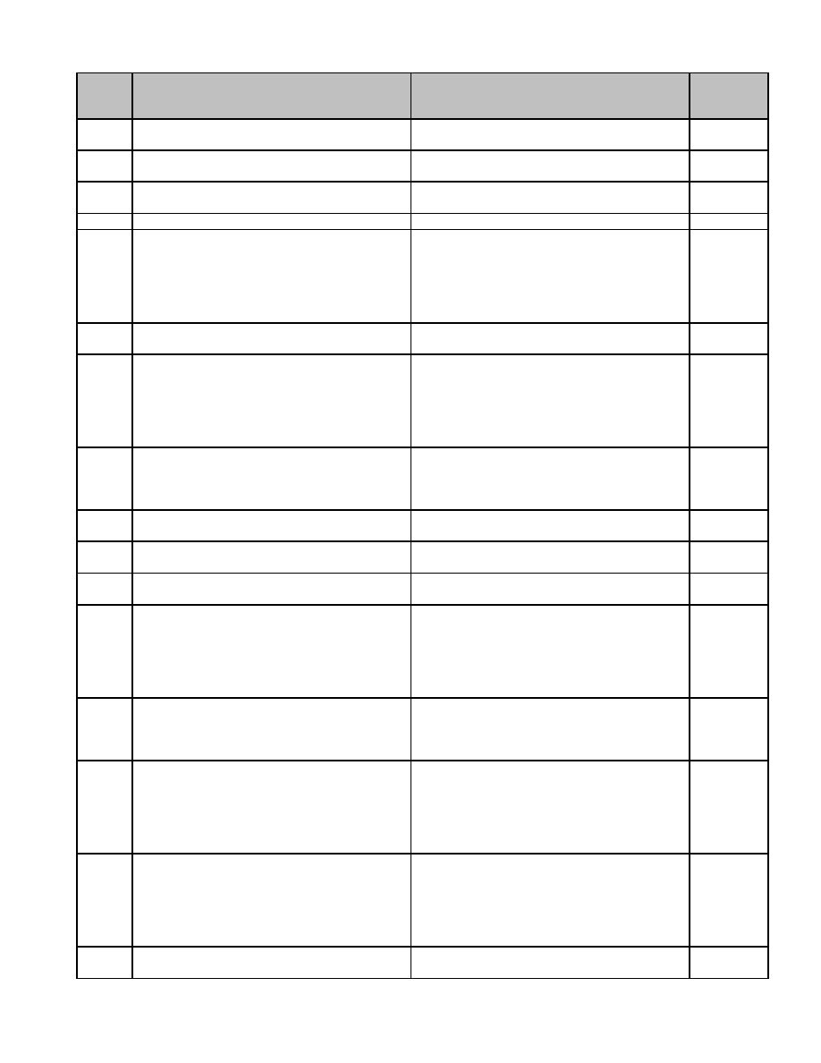

**Series**

**Description of Record** **Length of Time Required to Retain Record** **MGL / CMR**

**Number**

24.027 Tax Exemption Certificates (M-4; W-4; 4-E) Retain 5 years or until administrative use

ceases, whichever is later.

24.028 Tax Titles, Account (with Betterment Permanent. c. 60 s. 50

Assessments). Form 48B

24.029 Tax Titles, Account (without Betterment Permanent. c. 60 s. 50

Assessments). Form 48A

24.030 Tax Titles, Account. Form 410 Permanent. c. 60 s. 50

24.031 Tax Titles, Affidavit, Application for; to Tax account redeemed: Retain until final c. 60. s.

Foreclose Land of Low Value. Form 451 settlement of levy or completion of 79

satisfactory audit, whichever is later. Tax

account not redeemed: Permanent.

Permission from Supervisor not required for

destruction.

24.032 Tax Titles, Assignment, Instrument of. Form Permanent. c. 60 s. 52

431

24.033 Tax Titles, Assignment, Notice of Intention. Tax account redeemed: Retain until final c. 60 s. 52

Form 430 settlement of levy or completion of

satisfactory audit, whichever is later. Tax

account not redeemed: Permanent.

Permission from Supervisor not required for

destruction.

24.034 Tax Titles, Commissioner, Statement to. Tax account redeemed: Retain until final c. 60 s. 79

Form 452A settlement of levy or completion of

satisfactory audit, whichever is later. Tax

account not redeemed: Permanent.

24.035 Tax Titles, Deed - Insufficient Bid. Form 324 Permanent. c. 60 ss.

48, 50

24.036 Tax Titles, Deed to Municipality - Land of Permanent. c. 60 ss.

Low Value. Form 475 79, 80

24.037 Tax Titles, Deed to Person - Land of Low Permanent. c. 60 s. 79

Value. Form 474

24.038 Tax Titles, Deeds and Instruments of Tax account redeemed: Retain until final c. 60 ss.

Taking, Receipts for. Form 411 settlement of levy or completion of 53, 54

satisfactory audit, whichever is later. Tax

account not redeemed: Permanent.

Permission from Supervisor not required for

destruction.

24.039 Tax Titles, Final Disposition, Notice to Tax account redeemed: Retain until final c. 60 s. 76

Collector of. Form 486 settlement of levy or completion of

satisfactory audit, whichever is later. Tax

account not redeemed: Permanent.

24.040 Tax Titles, Redemption, Certificate of Tax account redeemed: Retain until final c. 60 s.

Partial. Form 442 settlement of levy or completion of 76A

satisfactory audit, whichever is later. Tax

account not redeemed: Permanent.

Permission from Supervisor not required for

destruction.

24.041 Tax Titles, Redemption, Certificate of Tax account redeemed: Retain until final c. 60 ss.

Receipt for Money Paid for Purpose of. settlement of levy or completion of 62, 63

Form 440 satisfactory audit, whichever is later. Tax (Ter. Ed.)

account not redeemed: Permanent.

Permission from Supervisor not required for

destruction.

24.042 Tax Titles, Redemption, Instrument of - Title Permanent. c. 60 s. 62

in Municipality. Form 441

94



**Series**

**Description of Record** **Length of Time Required to Retain Record** **MGL / CMR**

**Number**

24.043 Tax Titles, Redemption, Receipt of Partial Tax account redeemed: Retain until final c. 60 s. 62

Payment of*. Form 433 settlement of levy or completion of

satisfactory audit, whichever is later. Tax

account not redeemed: Permanent.

Permission from Supervisor not required for

destruction.

24.044 Tax Titles, Residence, Statement of Permanent. c. 60 s. 47

24.045 Tax Titles, Sale, Custodian's Notice of*. Tax account redeemed: Retain until final c. 60 s.

Form 472 settlement of levy or completion of 77B

satisfactory audit, whichever is later. Tax

account not redeemed: Permanent.

Permission from Supervisor not required for

destruction.

24.046 Tax Titles, Sale, Notice of - Land of Low Tax account redeemed: Retain until final c. 60 ss.

Value (Foreclosure of Tax Title). Form 470A settlement of levy or completion of 79, 80B

satisfactory audit, whichever is later. Tax

account not redeemed: Permanent.

Permission from Supervisor not required for

destruction.

24.047 Tax Titles, Sale, Notice of - Land of Low Tax account redeemed: Retain until final c. 60 s. 79

Value. Form 470 settlement of levy or completion of

satisfactory audit, whichever is later. Tax

account not redeemed: Permanent.

24.048 Tax Titles, Taking, Instrument of. Form 301 Permanent. c. 60 ss.

53, 54

24.049 Tax Withholding Statements. Form W-2, M- Retain 5 years, provided a satisfactory audit c. 162B

2 has been completed.

24.050 Taxation, Notice of Amount to be Raised by Retain until final settlement of levy or c. 59 s.

completion of satisfactory audit, whichever 23A

is later.

24.051 Taxation, Warrants, Bill and Payroll (T1, T2, Retain until completion of satisfactory audit. c. 41, s.

C1, C2). Form T1, T2, C1, C2. 56

95

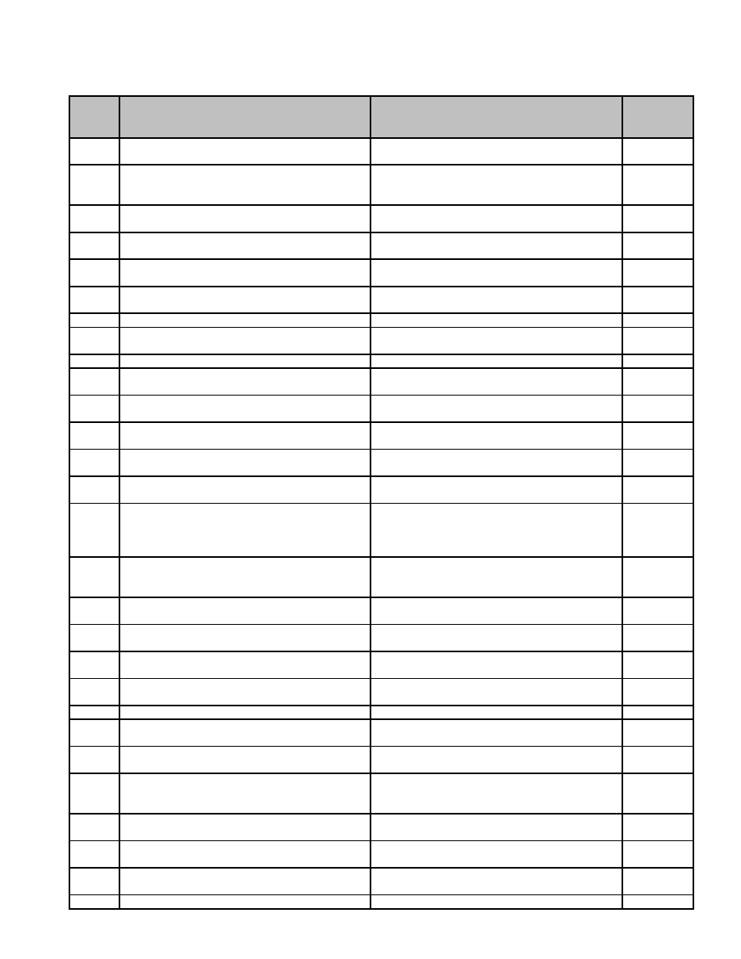

**25 Veterans’ Service Agent**

**Series**

**Description of Record** **Length of Time Required to Retain Record** **MGL / CMR**

**Number**

25.001 Administration, Audit of Monthly Report. Form Retain 7 years.

VS-7

25.002 Administration, Individual Payment Ledgers to Retain until administrative use ceases.

Recipient; retention after reimbursement by Permission from Supervisor not required for

state. destruction.

25.003 Administration, Monthly Reports to Retain 7 years. c. 115 s. 6

Commissioner. Form VS-5 and VS-6

25.004 Burial Records, Affidavit Relative to Burial of Retain until information is transferred onto c. 115 s. 8

Veterans "Grave Registration Card."

25.005 Burial Records, Application for Burial Expense Retain until receipt of "Return of Expense for c. 115 s. 8

(VS-9) Burial."

25.006 Burial Records, Death Report Retain until information is transferred onto

"Grave Registration Card."

25.007 Burial Records, Grave Registration Card Permanent. c. 115 s. 9

25.008 Burial Records, Return of Expense for Burial Retain 7 years, or completion of satisfactory c. 115 s. 8

audit, whichever is later.

25.009 Case History File, Adjutant. Form AGO-10 Permanent. c. 115 s. 5

25.010 Case History File, Armed Forces Discharge Permanent. c. 115 ss.

Papers 3, 3A

25.011 Case History File, Assignment, Discharge of Retain until reconciliation of Entire Case c. 115 s. 5

History File.

25.012 Case History File, Assignment, Form of Retain until reconciliation of Entire Case c. 115 s. 5

History File.

25.013 Case History File, Assignment, Notice of Retain until reconciliation of Entire Case c. 115 s. 5

History File.

25.014 Case History File, Assignment, Partial Retain until reconciliation of Entire Case c. 115 s. 5

Discharge of History File.

25.015 Case History File, Bank Report Retain until reconciliation of Entire Case c. 115 s. 2

History File, only if bank has indicated there

are funds in the account, otherwise until

termination of case.

25.016 Case History File, Entire Case History File Retain 20 years after last assistance granted,

provided no indications of dependent claims in

the future.

25.017 Case History File, Income Report of Retain until termination of case.

Household Members

25.018 Case History File, Lien, Certificate of. Form Retain until reconciliation of Entire Case c. 115 s.

VS-25 History File. 5A

25.019 Case History File, Lien, Discharge of. Form Retain until reconciliation of Entire Case c. 115 s.

VS-26 History File. 5A

25.020 Case History File, Lien, Subordination Retain until reconciliation of Entire Case c. 115 s.

Agreement. Form VS-12 History File. 5A

25.021 Case History File, Medical Report Retain until termination of case.

25.022 Case History File, Order for Emergency Retain until termination of case.

Supplies (Food Order Book)

25.023 Case History File, Paid Medical Insurance Retain until monthly audit or on destruction of

Premiums VS-21A.

25.024 Case History File, Proof of Dependence i.e., Retain until reconciliation of Entire Case

Birth and Marriage Certificates, Divorce and History File.

Adoption Papers

25.025 Case History File, Unemployment Retain until termination of case.

Compensation Report (DES Inquiry)

25.026 Case History File, Veterans' Benefits, Retain until reconciliation of Entire Case c. 115 s. 2,

Application of. Form VS-1 History File. 4, 5

25.027 Case History File, Veterans' Benefits, Retain until completion of satisfactory audit. c. 115 s. 2,

Recommendation. Form VS-21A 4, 5

25.028 Case History File, Wage Report Retain until termination of case.

97



98



**SELECTED SUPERVISOR OF RECORDS BULLETINS**

On the following pages, you will find copies of selected bulletins issued by the Supervisor of

Records. For a complete list of Supervisor of Records Bulletins, please visit our Web site at:

http://www.sec.state.ma.us/arc/arcrmu/rmubul/bulidx.htm

99



100



**SPR Bulletin 4-96**

**Fees for Access and Copying of Electronic Public Records**

TO: Public Records Custodians

SUBJECT: Fees for Access and Copying of Electronic Public Records

EXPIRATION DATE: Until superseded

PURPOSE: This bulletin provides guidance to custodians on how to compute the applicable fees for copying and

accessing electronic records

**BACKGROUND:**

The Public Records Law clearly applies to the disclosure of electronic records. The computer enhances

government’s ability to provide information in various formats not available on paper. Additionally, the computer

enables the custodian to merge files or manipulate data in order to create new records. The government is entitled to

charge certain costs associated with compliance with requests for data in magnetic media.

**FINDINGS:**

The term “public records” is broadly defined to include all documentary materials or data, regardless of physical

form or characteristics, made or received by any officer or employee of any municipality or agency of the

Commonwealth, unless falling within a statutory exemption. G. L. c.4, § 7(26)(a-m) (1994 ed.). Therefore, the

Public Records Law clearly applies to government records generated, received, or maintained electronically.

Public records, and any non-exempt, segregable portions thereof, are subject to mandatory disclosure upon request

and upon payment of a reasonable fee. Accordingly, a custodian may withhold exempt information within a record

but must disclose any public portions. A custodian may recover costs incurred when complying with public records

requests, including costs associated with searching for the record and segregating any exempt information.

Segregation may be accomplished by blocking out exempt information on a copy of the record, or through electronic

segregation prior to disclosure.

**ACTIONS:**

1. Unless otherwise established by statute, a records custodian may charge no more than the following fees for

copies of public records: twenty cents ($.20) a page for photocopies, twenty-five cents ($.25) for copies maintained

on microfilm or microfiche, fifty cents ($.50) a page for computer printout copies and for copies of records not

susceptible to ordinary means of reproduction (such as oversized documents, audio tapes and computer tapes), the

actual cost incurred may be assessed. When the cost of complying with a public records request is expected to

exceed ten dollars ($10.00), the records custodian shall provide the requester with a written, good faith estimate of

the costs involved.

2. The Public Records Access Regulations (Regulations) also allow a record custodian to assess a fee for a search of

computerized records based on the actual cost incurred from the use of the computer. 950 CMR 32.06(1)(e). The

only such “actual costs” which may be recovered are: the cost of the energy consumed during use, the materials

used, and the prorated salary of the computer operator. Minimum fees may not be imposed for the inspection, or

copying, of a public record.

3. There is no basis in the Public Records Law or Regulations for recovering the costs incurred in developing the

database or entering information. These costs are incurred by a custodian in the daily operations of the office and are

not the direct result of complying with a request for public records. Therefore, such costs cannot be passed along to

a requester.

101



4. A custodian has a duty to write a program to segregate exempt information from non-exempt computerized

information. See G. L. c.66, §10 (1994 ed.) (custodial duty to segregate). Again, only the actual costs incurred may

be assessed for compliance.

5. In certain instances, the reprogramming necessary to comply with a request in a specific format is tantamount to

creating a document, rather than segregating an existing record. A record holder’s duty to comply with requests for

information extends only to records that are in existence and in his custody. There is no obligation to create a record

in response to a public records request. Since the newly created record is not within the statutory definition of

“public records,” the Regulations do not apply and the custodian may assess any reasonable fee for such

reprogramming to create a document.

6. Requests for on-line access to records or for a subscription service to certain information constitute prospective

requests. Since those records are not yet in existence at the time of the request, they are also outside the purview of

the Regulations and the custodian may set the fee for such access.

7. A custodian may be reimbursed only once for the cost of the programming necessary to comply with a public

records request. Once a program is written, a custodian may not recover the cost of writing the program each time

that program is used. Rather, that program becomes part of the municipality’s files and the custodian may assess

only the cost of reproducing the particular record.

8. A custodian may require payment of the fee prior to complying with a public records request. See 950 CMR

32.05(6) (requester is entitled to one copy of a public record or any desired portion of a public record upon payment

of a reasonable fee).

102



**SPR Bulletin 1-99**

**Electronic Mail**

TO: Public Records Custodians

SUBJECT: Electronic mail

EXPIRATION DATE: Until superseded

PURPOSE: This bulletin supersedes SPR Bulletin No. 5-92 and provides information and requirements for the

management and disposition of electronic mail sent and received by public officials.

**BACKGROUND:**

Electronic mail (email) is a document created, transmitted and received by a computer system or other electronic

form of written communication. Like the telephone, email allows instant communication. Like traditional mail, it

creates a durable written record of messages delivered and received. Email use has grown rapidly and it has emerged

as a major means for both communication and business activities in all segments of society.

Messages sent by email vary in substance and content. It may contain formal or informal data and text used

supporting or executing business activities and policy decisions. The growth of email and the importance of the

messages it carries, make it imperative that government offices take steps to effectively manage and control this

medium.

**FINDINGS:**

1. For the purpose of this bulletin, email is defined as any message created and received on an electronic mail

system. An electronic mail system is a service that provides facilities for creating messages, transmitting them

through a network and displaying them on a recipient’s computer terminal. The email message may be text or word

processing documents, spreadsheets or other data compilations transmitted through such a system.

2. All email created or received by an employee of a government unit is a public record. In Massachusetts, the term

“public record” is broadly defined to include all documentary materials or data created or received by any officer or

employee of any governmental unit, regardless of physical form or characteristics. G. L. c. 4, § 7(26). Email is,

therefore, a public record and it is subject to the requirements of the Public Records Law. G. L. c. 66.

3. All email messages are subject to public access and disclosure through the provisions of the Public Records Law.

G. L. c. 66, § 10.

4. All email messages may be sought and obtained through the discovery process in litigation and may be admissible

as evidence in a court of law.

5. In most cases, simply deleting a message does not actually ‘delete’ the message. The “delete” key merely removes

the electronic pointers to the file. The actual file may remain on the computer system indefinitely unless it is

properly expunged from the system. Questions regarding that process should be addressed to your systems

administrator. Copies of messages may also be retained independently on system backups. Regardless of the intent

to delete the message, as long as it exists, it continues to be subject to discovery.

6. Although email is analogous to paper correspondence, the courts have found that there are indeed, differences

between the two records. The contextual data (the “envelope” that contains the mailing address, date/time stamp,

routing instructions and transmission and receipt information) that accompanies email messages constitutes an

integral part of the record and thus must be retained as a part of any printed or stored version of the record.

Armstrong v. Executive Office of the President, 810 F.Supp. 335 (D.D.C. 1993).

103



7. Email systems are a corporate resource. Email systems in use in government offices are government property

installed and maintained for the conduct of government business. The office may and should exercise control over

the use of the resource by employees and has the right to monitor and read employee email.

**ACTIONS:**

1. Any employee or officer of the Commonwealth who creates or receives an email message must review said

message for content. Once a determination has been made regarding the subject matter involved in the

communication, the employee or officer must consult the retention schedules for his\her agency or municipality in

order to determine the lifecycle of that particular record. Necessary and proper records management procedures

must then be implemented to ensure that the record is preserved for the proscribed retention period. G. L. c. 4, §

7(26)(a-m).

2. Email must be managed as a part of the office’s records holdings. Email messages are subject to the same records

management principles as all other records of the office. Records retention schedules issued by the Supervisor of

Public Records (for local governments) and by the Records Conservation Board (for state government offices) must

be implemented for email as well as for analogous paper records.

3. Email systems are not record-keeping systems. All email users must screen and evaluate email messages

according to “CONTENT.”

4. Once the CONTENT or subject matter of the message is determined, the user must consult their agency’s record

retention schedule and the Statewide Disposition Schedule (for State Agencies) or the Records In Common Schedule

(for municipalities) to determine how long the record must be preserved.

5. Once the applicable retention period has been determined, the user should print out the email message and file it

in accordance with the entity’s paper filing system procedures.

6. Email messages which are too large to print or do not print accurately should be stored electronically, again

depending upon content and retention period. These messages should be saved to the office’s electronic record-

keeping system. Please consult your agency’s Record Liaison officer, computer technical people or your systems

engineer for assistance in this regard.

7. All government offices must establish written policies regarding their email systems. Said policies must ensure

that their system is capable of displaying and preserving the contextual data (metadata) associated with the email

message to ensure the capture and preservation of a complete record. Any email message which is printed to

preserve content must contain the metadata in its complete form.

8. Government offices must ensure that all personnel who will be handling email are properly trained to insure

compliance with this policy.

104



**SPR Bulletin 3-96**

**Application of the Public Records Law to Electronic Records Access**

TO: Public Records Custodians

SUBJECT: Application of the Public Records Law to Electronic Records Access

EXPIRATION DATE: Until superseded

PURPOSE: This bulletin provides guidance to records custodians on their duties and obligations to respond to requests

for information in a computer medium

**BACKGROUND:**

Freedom of information laws give life to the rights of free speech and meaningful electoral participation by providing a

mechanism for holding government accountable. The computer generally enhances the government’s ability to collect,

compile, manipulate and disseminate information. Certainly, as the manner in which government information is

maintained evolves, the means of accessing such information must experience a parallel evolution to preserve a

meaningful right of access. Limiting the public’s rights of access to only paper records at a time when the government is

using a far more efficient means of reviewing information, is an effective denial of this right to meaningful access.

**FINDINGS:**

The term “public records” is broadly defined to include all documentary materials or data, regardless of physical form or

characteristics, made or received by any officer or employee of any city, town, or agency of the Commonwealth, unless

falling within a statutory exemption. G. L. c.4, § 7(26)(a-m) (1994 ed.) (emphasis added.). A literal reading of this statute

necessarily leads to the conclusion that the availability of information in the custody of Massachusetts governmental

entities is dependent upon the substance of the information, rather than the form in which it is maintained. This means

that records created or maintained on a computer are subject to the disclosure requirements of the Public Records Law.

Many cities and towns do not have the ability to maintain advanced computer capabilities. Therefore, in order to

maximize efficiency, several municipalities have contracted with private companies to computerize and maintain various

city and town records. There is nothing in the Public Records Law which prohibits a city or town from engaging in such

a relationship. See G. L. c.66, §10 (1994 ed.) (Public Records Law). However, the records do not become the private

property of the company. Moreover, the municipality cannot contract away its public records duties. Consequently, a

provision in the contract between the municipality and the private computer company prohibiting the dissemination of

information cannot serve as a basis for non-disclosure in response to a public records request.

**ACTIONS:**

1. Obligations of the legal custodian. Under the Public Records Law, the government records custodian who creates or

receives records in his capacity as a government official is primarily responsible for providing access to its records. This

legal custodian cannot, consequently, insist that a requester seek access from the service bureau within the agency

(government MIS department, data processing division, etc.) or outside the government operation (private company).

The legal custodian of the records is obligated to obtain requested records from that service bureau and provide access to

them upon request.

2. Records not yet in existence. A record holder’s duty to comply with requests for information extends only to records

that are in existence and in his custody. There is no obligation to create a record in response to a public records request.

G. L. c.66, §10(a) (1994 ed.). Accordingly, a government agency, or a private company acting in its behalf, would not be

obligated to create programs which essentially produce a new record in response to a public records request. This does

not mean that the agency cannot write such programs; only that it is not required to do so. The writing of such new

programs by, or on behalf of, the government agency, is considered the creation of a record and is done outside the realm

of the Public Records Law. Therefore, as long as there is a requester who is willing to pay for this programming to create

a new record, the government agency may establish whatever fee it deems appropriate. However, that fee may only be

assessed once. Once the government agency is in possession of that newly designed program, the records generated

thereby are subject to mandatory disclosure upon request. G. L. c.4, §7(26) (1994 ed.). Additionally, once the program is

in existence, the municipality may only charge fees in accordance with the Public Records Law.

105



3. Segregation. Public records, and nay non-exempt, segregable portions thereof, are subject to mandatory disclosure

upon request. It is the burden of the record custodian to demonstrate the application of an exemption in order to withhold

a requested record. Therefore, a custodian is obligated to segregate exempt information from that which is public and

provide an independent public record. G. L. c.66, §10(a) (1994 ed.) (custodial duty to segregate). Segregation must also

be accomplished when responding to requests for electronic records. Computer segregation may involve programming. If

compliance involves writing a program to segregate information, then the custodian must do so. Writing a program to

manipulate data or combine data from various sources so that the end product is truly a new record is not required, but as

stated above, is permissible.

4. Prospective requests. Requests for electronic records which are prospective in nature, such as an on-line subscription

or monthly updates of information, will not be subject to the Public Records Access Regulations since the request is

actually for a record not yet in existence. Such a request exceeds the purview of the Public Records Law, therefore the

custodian is able to set her own reasonable fees for compliance.

5. Software. A custodian is not obligated to provide copies of a computer program. A computer program in and of itself

is a tool used in the processing of data rather than a “record,” and therefore is not subject to mandatory disclosure.

6. Format and medium. A custodian is not obligated to provide information in a format or medium which is compatible

to every requester. That is, if a custodian is able to provide information in a compatible format or medium, then he or she

is obligated to do so. However, the burden is not on the custodian to convert data to be compatible with the requester’s

system. A records custodian must provide the information in whatever format it is capable of generating. The requester is

then responsible for converting the data into the desired format.

106



**SPR Bulletin 1-96**

**Backing up and Archiving of Electronic Records**

TO: Public Records Custodians

SUBJECT: Backing up and Archiving of Electronic Records

EXPIRATION DATE: Until superseded

PURPOSE: This bulletin provides guidance for the protection and storage of public records in electronic format

through the use of back ups and archiving.

**BACKGROUND:**

Government information created and maintained by electronic systems is an important public resource. Proper

administration of this information entails protecting it from a variety of hazards, and preserving portions of it for

future reference and use. Two different, although frequently confused, methods are used to secure these ends.

Good business practice requires that security copies or backups of electronic records be made periodically to guard

against data loss. Backup generally entails the copying of the entire system content to disk or tape for off-site

storage. The frequency of the back up is determined by business needs but is generally on a weekly or daily basis.

Since these copies are designed to protect against business interruption, they are generally overwritten and reused

once that need is past.

Because the backups contain the undifferentiated system content, however, they should not be used for longer-term

off-line data storage. Such use is an uneconomic use of media and puts data at risk of inadvertent loss since the

backup is, by definition, destined for erasure. Where off-line data storage is needed, data should be archived to

dedicated disk or tape libraries, allowing for easy identification and retrieval of information.

**FINDINGS:**

Backups of electronic media are security copies the creation, retention and reuse of which are mandated by the

business needs of the organization. The content, organization, and intended use of backups does not render them

desirable as a medium for prolonged off-line storage of data.

Backup and archiving requirements apply to all computer environments, but will be implemented by different

personnel depending on the environment. In a mainframe or network environment, systems and network

administrators will implement backup and archiving. In a PC environment, implementation must be at the level of

the individual user.

**ACTIONS:**

1. Offices should implement policies governing the backing up and archiving of information in electronic media

specifying frequency of backup, and identifying those records to be archived.

2. As copies, rather than original records, data on backup tapes and disks may be erased, overwritten or otherwise

destroyed without the permission of the Supervisor of Public Records or the Records Conservation Board. Backups

need not and will not be included on disposal schedules approved by the Supervisor or the Records Conservation

Board.

3. Off-line storage of data should be to dedicated archive disks and tapes. Standard practices for identification and

retrieval of archived data should be implemented.

4. Archive disks and tapes constitute original records and must be listed on records disposal schedules approved by

the Supervisor of Public Records or the Records Conservation Board. Information contained in these records may

not be destroyed without the permission of the Supervisor of Public Records or the Records Conservation Board.

107



**SPR Bulletin 1-07**

**Minutes of Meetings**

TO: Public Records Custodians

SUBJECT: **Minutes of Meetings**

EXPIRATION DATE: Until superseded

PURPOSE: This bulletin provides information and requirements for the management and provision of meeting

minutes kept pursuant to the Open Meetings Law and the Massachusetts Public Records Law.

**BACKGROUND:**

One of the fundamental principles of a democracy is to maintain the transparency of governmental actions. To this

end, the Legislature enacted the Open Meeting Law and the Massachusetts Public Records Law, to ensure that the

workings of the government are open and accessible to the taxpayers and public at large. It would be contrary to the

intent of the Open Meeting Law, the Public Records Law and the foundations of a democratic system to place

impediments on citizen access to minutes of open meetings.

**FINDINGS:**

1. Governmental bodies are required to keep accurate written minutes of all of their meetings. G. L. c. 66, § 5A.

2. It is consistent with the underlying policy behind both the Open Meeting Law and the Public Records Law that

these minutes must be made readily accessible to the public. See G. L. c. 39, § 23B; G. L. c. 66, § 10(a).

3. While a records custodian may assess a fee for the provision of public records, the fee charged should not serve as

a deterrent for the requestor to access public records. See Globe Newspaper Co. v. Boston Retirement Bd., 388

Mass. 427, 436 (1983).

4. It is vital that a complete, accurate, and durable record be created of public meetings. Please be advised that

minutes of meetings must be maintained in a manner that ensures permanent retention of the records. If a records

custodian requires retention assistance, the Records Management Unit provides records management services and

outreach to all state agencies and municipalities to help them meet state record-keeping standards and requirements.

**ACTIONS:**

1. Public records that are of great interest to a large number of people must be readily available within the office of

the records custodian. These records include minutes of local board meetings, town meeting documents, warrants,

street lists, municipal financial documents, etc.

2. As required by the Open Meeting Law, minutes of meetings should be reviewed regularly and be accessible by

the public without delay. This is especially the case when dealing with executive session minutes. Once the reason

for calling the executive session has ended, those minutes must be reviewed and made available to the public. It

would be improper for a records custodian to pass along the costs associated with reviewing minutes to a records

requestor when the records custodian has a pre-existing statutory duty to perform this review. See G. L. c. 39, § 23B.

3. Minutes of meetings should be provided without delay at a minimum cost, if any. This Office encourages records

custodians to waive fees associated with the provision of meeting minutes given that disclosure is incontrovertibly in

the public interest.

109



**SPR Bulletin 2-92**

**Requirement to Maintain Minutes of Meetings in Written Format**

TO: Public Records Custodians

SUBJECT: Requirement to Maintain Minutes of Meetings in Written Format

EXPIRATION DATE: Until superseded

PURPOSE: This bulletin provides guidance and requirements for the creation, management, and retention of

minutes of the meetings of governmental bodies.

**BACKGROUND:**

Minutes of the meetings of governmental bodies constitute an invaluable record of the formulation and

implementation of public policy and the conduct of the public’s business generally. Because of their importance, all

minutes of governmental bodies have been designated as permanent records by the Supervisor of Public Records for

local government records, and by the Records Conservation Board for records of the executive branch (pursuant to

G. L. c. 66, § 8, and c. 30, § 42, respectively).

Increasingly, governmental bodies are recording their meetings on audio tapes. This is a good and sound practice.

The audio tapes of meetings are a valuable aide memoir for the creation of the final minutes of the meetings.

However, audio record tape, like other magnetic media, is not durable; magnetic media are fragile and not

appropriate for long-term storage of data.

These media are extremely susceptible to the effects of heat and humidity with distortion of the medium and

potential data loss at temperatures above 125*F (such temperatures can be reached in a closed, parked car in the

summer) and at moisture levels in excess of 50% r.h. Environmental contaminants, routine handling, and magnetic

field generators (computers, high-speed motors such as those in elevators, etc.) can result in data loss. Magnetic

media deteriorate rapidly and must be recopied at 5 to 10 year intervals.

**FINDINGS:**

It is crucial that a complete, accurate, and durable record be created of these meetings, and that records are protected

and preserved permanently. Therefore, to ensure their preservation, the Supervisor of Public Records requires that

the minutes of governmental bodies be recorded in written format using specified paper and inks. See G. L. c. 66, §§

56 (1990 ed.) (mandating the retention of written meeting minutes and noting which items must be reflected in such

minutes); G. L. c. 66, §§ 34 (1990 ed.) (requiring the use of rag or bond paper and state approved ink).

**ACTIONS:**

1. Minutes of the meetings of governmental bodies must be created in written format using specified paper and inks.

See G. L. c. 66, §§ 34 (1990 ed.); Executive Order 293 (mandating the use of permanent paper for executive branch

records and publications of enduring value).

2. Once the minutes have been written and accepted by the board or commission, audio tapes used to prepare

minutes may be erased or rerecorded without the prior permission of the Supervisor of Public Records for local

government records, or the Records Conservation Board for records of the executive branch (pursuant to G. L. c. 66,

§ 8, and c. 30, § 42, respectively), provided that there is no outstanding public records request or litigation involving

the tapes.

3. All meeting records, whether existing in the form of stenographic or longhand notes, or audio or video format, are

public records at the moment of their creation. See G. L. c. 4, § 7(26) (1990 ed.) (defining “public records” to

include all data in whatever form made by public officials). Therefore, meeting records, with the exception of

executive session records, are subject to mandatory disclosure upon request. See G. L. c. 39, § 23B (1990 ed.); G. L.

c. 34, § 34, § 9G (1990 ed.); G. L. c. 30A, § 11A 1/2 (1990 ed.) (respectively providing that minutes of municipal,

county, and state executive sessions are not subject to immediate mandatory disclosure).

111



**SPR Bulletin 9-04**

**Recording Material for Permanent Paper Records Requirement to Use**

**Archival Paper and Archival Ink**

**(This Bulletin supersedes SPR Bulletin 2-93 and SPR Bulletin 5-94.)**

TO: Public Records Custodians

SUBJECT: **Recording Material for Permanent Paper Records Requirement to Use Archival Paper and**

**Archival Ink**

EXPIRATION DATE: Until superseded

PURPOSE: This bulletin provides guidance and the requirements for the use of archival quality paper and ink for

the recording of textual information of enduring value and permanent paper records.

**BACKGROUND:**

Our Government has a fundamental obligation to record information concerning its operation, policies and

procedures. It has a duty to preserve for the public good, the records and publications by which this information is

documented. In the past, much of the information regarding these activities has been recorded on paper containing

destructive acids. Extensive research has proven that the acid present in most writing and printing paper as well as

non-archival quality inks produced since the mid-nineteenth century has drastically reduced the life of public

records, archives, books and other paper-based documents.

**FINDINGS:**

The Governor of the Commonwealth of Massachusetts issued Executive Order No. 293 on December 31, 1990,

mandating the use of permanent paper for records of “enduring value.” (N.B. Only the original, official record or

required original copies of the record as mandated by the Record Conservation Board or this office, must comply

with this standard. Subsequent, non-original copies of the record, whether certified or not do not need to conform to

this standard.)

Records and publications of enduring value are defined as those that should be permanently preserved because of

their historical significance. Such records include but are not limited to Executive Orders, annual reports, and

minutes of public meetings as defined by chapter thirty-A and chapter 66 of the Massachusetts General Laws, and

birth, death, and marriage certificates.

The American National Standards Institute (ANSI) Standard Z39.48-1984 is the benchmark for the specification of

permanent paper. The Federal Joint Committee on Printing (JCP) has reviewed the requirements for permanent

paper extensively. The JCP has agreed on several types of permanent paper that meet or exceed the ANSI standards.

1). JCP-A270 is more stringent than the ANSI standard in some of its durability requirements and is the

recommended permanent paper standard for the Federal Government.

2). JCP A560 and JCP O-560. JCP A560 is the alkaline-based version of JCP A60, an offset book paper widely used

for general printing, and JCP O-560 is the first JCP standard for alkaline-based xerographic paper for use in copiers

and laser printers.

3) Finally, as a third option, the International Standards Organization (ISO) has developed a standard for permanent

paper. This standard is known as ISO 9706:1994. For more information on this standard, visit the website

www.iso.org .

Permanent paper having any of these designations is acceptable by Commonwealth agencies and municipalities.

Papers meeting these standards are readily available at costs comparable to ordinary office paper.

There are many implements available for creating records. (i.e., pens, typewriters, laser printers etc.) Not all of these

implements are appropriate for creating documents of enduring value and permanent records. Certain inks and

toners may have chemical properties that cause them to fade, smudge, or have a deleterious effect on paper. Inkjets

printers do not provide lasting contact between ink and paper and felt tip markers are not encouraged.

The Supervisor of Records is authorized to set standards for the media to be used in the creation of public records

and to secure their preservation. (see: G. L. c. 66, § 1, 3-4). The Supervisor of Records is responsible for

administering the provisions of Executive Order No. 293.

113



**ACTIONS:**

The following recommended “Best Practices” should be employed in this endeavor:

Permanent Paper:

1. All official, original records and publications of enduring value should be recorded on archival quality, permanent

paper.

2. Record custodians should refer to their respective disposition schedule to identify those records that are

considered to be permanent or of enduring value and the number of original, official copies that must be retained. If

a record series is not listed on a disposal schedule, custodians should consult with the Records Conservation Board

for state government records and the Records Management Unit for local government records for assistance in

scheduling the records. Until records are scheduled, they should be recorded on permanent paper using permanent

ink.

3. The requirement to use permanent paper also applies to blank forms purchased from vendors. Where forms are

used to create records of enduring value, the custodian must ensure that those forms are printed on permanent paper.

4. The State Library has been statutorily designated as the depository library for Massachusetts state publications.

Each state agency is required to furnish the state library with eight copies of its publications for permanent

preservation. (see: G. L. c. 6, § 39A-39B) Because these copies are considered to be of enduring value, they must be

printed on permanent paper, whether or not the remainder of the issue is printed on permanent paper.

Permanent Ink:

1. In creating permanent written records, custodians shall use recording materials i.e., ink, toner, etc. that meet the

following performance standards.

A. Lightfastness. Ink shall show no appreciable change when exposed to light, in a test comparable to the Fade-

ometer test, for 24 hours. Black inks that contain carbon do not fade, and are preferable for permanent records.

B. Water resistance. Ink shall demonstrate high water resistance ability of the image to resist deformation or change

in color with immersion in water. No obvious effects shall be seen when test strips are immersed in water and

various chemicals for 1/2 hour.

C. Alkalinity. Ink should have a neutral or slightly alkaline pH (7.0-8.5) to prevent damage to either the paper or the

writing implement.

D. Fluidity. Liquid ink shall produce good line continuity without splitting, excessive deposits of ink on the paper or

writing tip, variations of lines width and intensity, agglomerates of undispersed pigment or other undesirable writing

characteristics. Liquid ink shall not feather or spread. It shall not penetrate to the reverse side of the paper or legibly

transfer to another sheet of paper.

E. Reproduction: All colors shall be capable of reproduction by microfilming, and black ink shall be capable of

reproduction by thermography, dry copying or direct-image offset processes.

F. Xerographic Toners. Liquid toners for xerographic reproductions have been found to be more suitable for archival

applications than dry toners as the liquid toner is absorbed into the paper fiber. When copies are being created for

long term or permanent retention they should be created on xerographic machines using the liquid toner process.

114



**SPR Bulletin 2-96**

**Designation of Records Custodian**

TO: Public Records Custodians

SUBJECT: Designation of Records Custodian

EXPIRATION DATE: Until superseded

PURPOSE: This bulletin defines the term custodian as it applies to public records, and provides guidance for

providing access to and ensuring the security of government records.

**BACKGROUND:**

It is the responsibility of government officers who create, receive and maintain public records to ensure their

safekeeping and availability to the public. Access to public records ensures public involvement, and participation

and provides a mechanism for holding government accountable for its decisions and actions. Custodial

responsibilities are governed by the Public Records Law and complementary Public Records Access Regulations.

**FINDINGS:**

Custody of public records is in the office that creates, receives or maintains the records for use. Each officer in

charge of a government office or department is the custodian of the records held by that office or department and has

the primary responsibility for ensuring the safety of the records, providing access to those records and ensuring their

authenticity. Where an office, board or commission does not have a clerk designated by law, it is required to appoint

a clerk to keep its record books and to designate an employee to have custody of its other public records. G. L. c.66,

§6 (1994 ed.). These responsibilities are inherent in the office and cannot be delegated or contracted to another

entity.

In some cases, public records are not maintained with the officers who created them or those that are primarily

responsible for their use and maintenance. These records may be in the care of a records center, a central file room, a

data processing department, a private contractor providing government services, a private information services

vendor, or another government officer who has agreed to care for the records. In all these cases, the entity

maintaining the records is acting as an agent of the record custodian, providing only for the physical care of the

record, and may not take action with respect to the records without the specific authority of the custodian.

**ACTIONS:**

1. Access to public records is through the custodian. Contractors, records centers, data processing departments,

vendors or other entities which may have physical care of public records must make those records available when

directed by the records custodian.

2. Security of public records is the responsibility of the records custodian. Where records are in the physical care of

entities other than the custodian, the custodian shall make ample provision by contract, memorandum of

understanding, or other means to ensure that the security of the records is ensured.

3. The records custodian is ultimately responsible for the accuracy of all information in the records in his custody,

and must take all precautions to ensure the accuracy and integrity of the records.

4. The records custodian is responsible for ensuring that where disclosure of certain records is prohibited by law,

those statutory mandates are observed.

5. Disposition of records is on the authority of the custodian only. Records may not be destroyed or otherwise

disposed of without the specific authorization of the records custodian and the Supervisor of Public Records.

115



**SPR Bulletin 5-94**

**Recording Material for Permanent Public Records**

TO: Public Records Custodians

SUBJECT: Recording Material for Permanent Public Records

EXPIRATION DATE: Until superseded

PURPOSE: This bulletin provides guidance and requirements for recording material used in the creation of

permanent public records.

**BACKGROUND:**

There are many implements i.e., pens, typewriters, laser printers etc. available for use in creating records. Each uses

a recording material, such as ink or toner, that is compatible with the specific appliance. Not all of these recording

materials are appropriate for creating documents of enduring value. Inks and toners may have chemical properties

that cause them to fade, smudge, or have a deleterious effect on paper. It is the responsibility of government officials

of the commonwealth to provide access to records and to insure their continued existence for future generations.

**FINDINGS:**

The Supervisor of Public Records is responsible for establishing standards for recording material used in the

creation of permanent public records (See MGL chapter 66, section 4).

**ACTIONS:**

1. In creating permanent records, custodians shall use permanent-quality materials. For standards on permanent

paper see Executive Order No. 293 and Supervisor of Public Records Directive 2-93. For standards on microfilm see

950 CMR 39.00.

2. In creating permanent written records, custodians shall use recording materials i.e., ink, toner, etc. that meet the

following performance standards. Custodians shall utilize the best materials available in creating all government

records.

1. Lightfastness. Ink shall show no appreciable change when exposed to light, in a test comparable to the Fade-

ometer test, for 24 hours. Black inks that contain carbon do not fade, and are preferable for permanent records.

2. Water resistance. Ink shall demonstrate high water resistance ability of the image to resist deformation or change

in color with immersion in water. No obvious effects shall be seen when test strips are immersed in water and

various chemicals for 1/2 hour.

3. Alkalinity. Ink should have a neutral or slightly alkaline pH (7.0-8.5) to prevent damage to either the paper or the

writing implement.

4. Fluidity. Liquid ink shall produce good line continuity without splitting, excessive deposits of ink on the paper or

writing tip, variations of lines width and intensity, agglomerates of undispersed pigment or other undesirable writing

characteristics.

3. Additionally, recording materials and their use shall conform to the following standards:

1. Writing Ink. The ink shall be of such chemical composition as to be compatible with all components with which it

comes in contact. The ink shall not corrode the ball or writing tip of the pen, and shall contain no undissolved

particles of dye or agglomerates of undispersed pigments, except particles necessary to provide reproducibility in

black ink. The ink shall not be adversely affected by the ink cartridge, or vice versa. Ink cartridges shall start making

117



a line within a distance of 0.5 inch. On subsequent lines cartridges shall start making a line immediately. Writing

shall not feather or spread. It shall not penetrate to the reverse side of the paper or legibly transfer to another sheet of

paper. All colors shall be capable of reproduction by microfilming, and black ink shall be capable of reproduction by

thermography, dry copying and direct-image offset processes.

2. Xerographic Toners. Liquid toners for xerographic reproductions have been found to be more suitable for archival

applications than dry toners as the liquid toner is absorbed into the paper fiber. When copies are being created for

long term or permanent retention they should be created on xerographic machines using the liquid toner process.

3. Laser and Dot Matrix Printing. Dot matrix printing, which uses a cloth ribbon and pounds the ink into the paper

fiber, creates a more permanent bond than laser printing, which uses a dry toner that can flake. When permanent

records are being created on word processors they should be printed on dot matrix printers.

118



**SPR Bulletin 4-94**

**Security and Custody of Records Created Outside the Town Hall**

TO: Public Records Custodians

SUBJECT: Security and Custody of Records Created Outside the Town Hall

EXPIRATION DATE: Until superseded

PURPOSE: This bulletin provides guidance and requirements for security and custody of municipal records created

outside of Town Hall.

**BACKGROUND:**

Municipal governments have a fundamental obligation to provide secure storage for their records and make them

accessible to the general public. Business in some municipalities must be conducted outside town hall; this may lead

to situations where records are used and stored outside the premises of a municipal building in unsecured space,

leading, in some instances, to alienation of the record. In some instances, original records are removed from a

municipal building by a records custodian and stored in a private home or office. Such practices may jeopardize the

security and accessibility of the records and hinder proper records management procedures.

**FINDINGS:**

The Supervisor of Public Records is responsible for seeing that the records of the Commonwealth, counties, cities

and towns are put in the custody and condition required by law and securing their preservation. See G. L. 66, § 1

(the Supervisor’s responsibility to ensure preservation of the records of the Commonwealth, counties, cities and

towns). Municipal officials are responsible for the safekeeping of records in their custody. See G. L. 66, §§ 11 and

12. Therefore, the Supervisor directs municipal officials to take the following actions to provide security for and

access to public records.

**ACTIONS:**

1. Whenever original public records are removed from a municipal office by a records custodian for use in the

regular course of business in a private office or home, they shall be stored in fire resistant devices and safes provided

by the municipality.

2. If a custodian cannot insure fire resistant storage outside the municipal building then no original records may be

removed. However, the custodian may create copies of records for use in a private office or home.

3. Whenever original records are created outside the municipal offices, they shall be transferred on a regular and

frequent basis to secure storage in the municipal building. If secure storage is available in the custodian’s private

office or home, then copies of records shall be made and stored in the municipal building.

4. Whenever a records custodian finds it necessary to work in another location other that the municipal building, he

shall make himself available during regular posted office hours at a location convenient to the public.

5. Whenever an official relinquishes his office, he shall deliver over to his successor all such records he is not

authorized by law to retain. See G. L. c. 66, § 14.

119



**SPR Bulletin 3-93**

**Requirement to Manage Records Created Under Government**

**Contracts**

TO: Public Records Custodians

SUBJECT: Requirement to Manage Records Created Under Government Contracts

EXPIRATION DATE: Until superseded

PURPOSE: This bulletin provides guidance and requirements for the creation, management, accessibility, and

retention of records created under government contracts.

**BACKGROUND:**

The purpose of laws regulating the management of government records is to protect the rights and obligations of the

government and its citizens. Proper management of records ensures that the government has immediate access to

information for the full period of time it is needed to conduct daily business, financial transactions, litigation,

maintenance of public property, and development and implementation of public policy. Access to information also

secures the public’s prerogative to monitor the government and encourage its accountability to the governed.

Records documenting the provision of services by government are the responsibility of the government records

custodian. The custodian is required to use permanent-quality paper, inks, and materials to create permanent public

records (see: G. L. c. 66, §§ 3-4; also, Executive Order 293); secure and preserve records (see: G. L. c. 66, §§ 8-9,

11-12); provide public access to records (see: G. L. c. 4, § 7, cl. 26; c. 66, § 10); and dispose of records according to

disposal schedules approved by the Records Conservation Board for state government records or by the Supervisor

of Public Records for county and municipal government records (see: G. L. c. 66, § 8).

Rather than offering direct services to citizens, governments may choose to expend government funds to provide

services through vendors. These interactions result in the creation of much documentation, including information

about vendor qualifications, financial records relating to contracts and payment, reports to the contracting

government entity, and information about programs and their constituents.

Records resulting from contracted activities are vital to the conduct of government functions. For example, certain

records are required for contract monitoring, litigation, the prevention of fraud and abuse, and the fulfillment of

obligations to citizens served by programs. Because such documentation is critical to ensuring accountability, when

in government offices it is routinely accessible to citizens. Therefore, when services are provided through vendors

and such records are created and stored in contractors’ offices, the same standard applies. This change in location

does not abrogate the government’s obligation to ensure public accountability and public access to these government

records.

**FINDINGS:**

The Supervisor of Public Records is mandated to oversee the creation, preservation, accessibility, security, and

custody of public records (see: G. L. c. 66, § 1 et seq; 950 CMR 32).

When public monies are expended to provide government services to citizens, the public has an interest in the

information and records that result. Such records are government records and shall be managed in all respects

according to law.

Custodians must provide proper care and management of public records (see: G. L. c. 66, § 1 et seq.). A custodian is

defined as a “...person having routine access to or control of public records.” (see: 950 CMR 32.03) When a

government entity contracts with a vendor to provide government services, the vendor is acting for the government,

performing a government function with government funds. The government is considered custodian of certain

information generated to fulfill contractual obligations and has a direct interest in the proper management of the

resulting records.

121



**ACTIONS:**

1. Any government entity entering into a contract, grant agreement, or other agreement with any private entity to

provide government services shall include provisions in said agreement describing the creation, security,

accessibility, disposition, and custody of records created to satisfy the agreement. All records created in fulfillment

of the obligations of the contract are government records and shall be deliverable to the contracting government

entity.

2. In the agreement the government entity may enumerate records to be created and specify the media in which

information is recorded. Permanent-quality media shall be used to create permanent records.

3. The government entity shall describe in the agreement the actions to be taken by the contractor to ensure the

physical and intellectual security of the information created under the agreement.

4. Access provisions contained in the agreement shall conform to G. L. c. 4, § 7, cl. 26; c. 66, § 10, c. 66A, and other

pertinent statutes. In no case shall the agreement provide for more stringent restrictions on access than those

contained in law. Records systems incorporating electronic media must provide for access to publicly-available

information. Access provisions shall include the requirement that public requests for information be made through

the contracting government entity.

5. No government records may be destroyed without authorization. Therefore, the government entity shall reference

in the agreement any existing disposal schedules approved by the Records Conservation Board for state government

records or by the Supervisor of Public Records for local government records which may apply to information

created under the agreement. The agreement shall provide for the establishment of new disposal schedules for all

records not appearing on existing schedules.

6. Where records are deemed to be of permanent value, the government entity shall designate the media in which

information is to be created and/or maintained. Provisions shall be made for appropriate storage and preservation of

permanent records by the contractor while in his possession and for their return to the government entity as legal

custodian once their usefulness to the contractor ceases. Such records may be transferred to the Massachusetts

Archives for permanent retention.

122



**SPR Bulletin 3-92**

**Maintenance of Records Storage Areas**

TO: Public Records Custodians

SUBJECT: Maintenance of Records Storage Areas

EXPIRATION DATE: Until superseded

PURPOSE: This bulletin provides guidance and requirements for records handling practices and maintenance of

dedicated records storage areas.

**BACKGROUND:**

Paper, magnetic media, photographic film, and other records are subject to continual change and decay. The rate of

change is determined by the environment in which they are housed. Environmental characteristics such as light,

temperature, humidity and air quality influence the condition and overall longevity of records and the information

they contain. Handling, the human aspect of the environment, has a powerful impact on the longevity of records.

When careless retrieval or refiling practices result in torn, crumpled or folded pages, paper fibers are broken, making

tears more likely in the future. Magnetic media requires thoughtful handling or data loss will result. Smoking,

eating, and drinking are equally as hazardous to records.

Dedicated records storage fulfills a unique function in office areas; the purpose of such storage is the protection and

preservation of public records. By its nature, this function is compromised by eating, drinking, smoking, and related

activities which expose records to fire, smoke, grease, oil, dirt, and other hazards.

**FINDINGS:**

The Supervisor of Public Records oversees the preservation of public records. See G. L. c.66, §1 (the Supervisor’s

responsibility to secure the preservation of the records of the commonwealth, counties, cities or towns). Public

officials are responsible for the safekeeping of the records in their custody. See G. L. c.66, §11. Therefore, the

supervisor charges public officials to provide proper handling and care of public records.

**ACTIONS:**

1. The use of smoking materials and the consumption of foods and beverages in dedicated records storage areas is

prohibited.

2. Dedicated records storage areas should be kept clean and free of environmental hazards to records. In the case of

storage areas shared by multiple offices, the executive officer should appoint an individual to monitor conditions,

report and correct violations.

3. All persons should refrain from smoking and consumption of foodstuffs when handling records.

4. Officials should take reasonable care in referencing, retrieving, and refiling records so that the physical

composition of the record, and the information it contains, is not damaged.

5. When planning the construction or refurbishment of a dedicated records storage area, officials should consult

Specifications for Safes and Vaults, available from this office. Specifications describe requirements for the

construction of vaults; temperature and humidity levels to be maintained in them; sprinkler, heating, ventilation and

air conditioning systems to be used; appropriate storage equipment; and related matters.

6. For more information about control of the environment, and its affect on record materials, officials can refer to the

*Records Retention Manual* .

123



**Technical Bulletin 1**

**Performance Standards of Safes and Vaults**

Issued by the Supervisor of Public Records

May 18, 1995

Version 2 (1996)

**AUTHORITY**

Chapter 66, s.11 MGL requires the officers in charge of state departments, county commissioners, city councils or

selectmen to provide fire-resistant rooms, safes or vaults for the safekeeping of the public records of their

governmental unit (2 Op. Atty. Gen. 1899, p. 48). Pursuant to § 1 of this statute, the Supervisor of Public Records is

authorized to promulgate standards for the construction and use of these vaults, rooms and safes (8 Op. Atty. Gen.

1929, p. 594).

**EFFECTIVE DATE**

These performance standards become effective on May 18, 1995.

**GENERAL**

All vaults for the storage of public records shall provide the minimum level of protection specified hereunder. The

Supervisor of Public Records does not specify any particular materials or technique for the construction of public

records vaults. The Supervisor will approve vaults for the storage of public records upon receipt of the certification

of licensed or registered fire protection and structural engineers that the proposed construction will have a fire

resistance and structural integrity equivalent to or greater than that specified in the following performance criteria.

**SIZE**

A vault size of 5,000 cubic feet or less is considered optimal. Where large volumes of records must be protected, it

is permissible to construct a vault with a capacity of up to 25,000 cubic feet. It must be realized that, because of the

volume of combustible materials stored within it, this larger structure is at greater risk of fire and should be

equipped with a fire suppression system.

**MEDIA PROTECTION**

All vaults intended for the storage of paper records shall be so constructed that, when fitted with the 6-hour required

hereunder shall, in the event of fire in the surrounding structure, maintain an internal temperature of 350 or below

for a period of not less than 6 hours. These standards provide the maximum available level of fire protection for

paper records, but cannot safeguard film or magnetic media against either hear or humidity. If magnetic media have

not been copies and dispersed or otherwise duplicated for protection, vaults or portions thereof used for the storage

of this media must be equipped with data safes or an inner core designed to minimize temperature rise and moisture

intrusion. These safes and cores shall be so constructed or equipped that, in the even of fire in the surrounding

structure, the internal temperature and relative humidity shall remain below 125 and 80%, respectively for a period

of at least 2 hours. It is the responsibility of the records custodian to provide all media with the level of protection

specified above and to provide the Supervisor with the engineer’s certification to that effect.

**CONSTRUCTION**

Except in Type I or Type II-222 fire resistive construction as defined by NFPA 220, Standard on Types of Building

Construction, all vaults shall be ground-supported and structurally independent of surrounding structures.

Supporting structures for vaults shall be sufficient to support the full weight of the vault structure and its contents.

125



Since shrinkage or volume change, stresses may result in hairline cracking that will be detrimental to the vault

structure, all concrete members should have a minimum reinforcing as specified in the ACI Code, and all masonry

walls should have minimum reinforcing as specified in Paragraph 1113.5.3 of the Commonwealth of Massachusetts

State Building Code.

All building members supporting the vault shall be noncombustible. All structure materials used in the construction

of a vault shall have a fire resistance rating of 6 hours. All interior fittings and finish shall be noncombustible.

If connected to the building in any manner, the connection shall be made so that in the event of the collapse of the

building, the surrounding building members may move or fall without affecting the fire-resistive qualities of the

vault. All beams or bearing members adjoining the vault shall be designed to release freely in case of failure. Vault

construction shall not be used as a support or bearing for the structural members of the building. Walls shall have

sufficient lateral strength to withstand impact of collapsing building members, or toppling machinery or equipment.

Construction of vaults below grade level should be avoided whenever possible because of the dangers posed by the

“cooking” effect of fallen debris, flooding from natural causes or fire fighting efforts, and the difficulties of

maintaining proper environmental control.

In non-fire resistive buildings, the vault roof shall be designed to accommodate a minimum live load of 350 pounds

per square foot. In all cases, ample accommodation should be made for protection against impact loading by falling

equipment or building members and against accumulations of burning debris.

**WATERTIGHTNESS**

Walls, roofs and floors shall be effectively waterproofed. No combustible membrane or coating shall be used except

on a roof exposed to the weather.

Provisions shall be made to prevent the entry of water at door openings.

Ample drainage shall be provided to prevent rain or fire fighting water accumulating on the roof.

**PENETRATION**

Wall penetrations shall be allowed only for access, HVAC systems, sprinkler systems, electric lighting and limited

energy circuits. Wall openings shall be as small as possible and shall be sealed with approved or listed fire-rated

materials and devices to prevent smoke, heat, flame or water penetration. Conduit, if used, shall be sealed inside and

outside.

Roofs shall not be pierced for any purpose.

Floors shall not be pierced, except that floors of vaults constructed on grade may be pierced to allow the passage of

sprinkler piping or HVAC ducts.

**VAULT DOORS**

All vault doors shall be Underwriters’ Laboratories Class 350 rated 6 hours or equivalent. ORDINARY FIRE

DOORS SUCH AS HOLLOW METAL, TINCLAD, SHEET METAL, OR METALCLAD TYPES; STEEL

PLATE TPE AND FILE ROOM DOORS ARE NOT ACCEPTABLE AS VAULT DOORS.

Vault doors shall be equipped with combination-type locks with an Underwriters’ Laboratories approved relocking

device designed to hold the door in case of mechanical, explosive or torch attack on the door. The lock mechanism

shall be of the type enabling a person locked inside the vault to open the door easily from the inside. All day gates

shall be similarly equipped.

126



Vault doors shall be equipped with smoke or heat-actuated release mechanisms to close them in case of fire.

**ENVIRONMENTAL CONTROL**

For paper and magnetic media, a stable environment with an average temperature of 70F or below and an average

relative humidity of 30-50% shall be maintained. A temperature below 70F and a relative humidity of 40-45%, with

fluctuations limited to no more than +2 F and +3% RH, is considered optimal. Storage facilities for first-generation

silver halide microfilm shall maintain a constant temperature of below 70F and relative humidity of between 20 and

30%. If it is not possible to meet these optima, minimization of temperature and humidity fluctuations shall be the

guiding concern. These parameters should be accomplished by controlling the external environment surrounding the

storage space. Where this is not feasible, the storage space may be equipped with a heating/ventilation/air

conditioning system. All equipment related to such a system shall be located outside the storage space.

**FIRE DETECTION SYSTEMS**

Automatic fire detection systems shall be installed in accordance with NFPA 71, Signaling Systems for Central

Station Service; NFPA 72, Protective Signaling Systems; and NFPA 72E, Automatic Fire Detectors. The systems

shall be relied on only when there is an assurance that the alarms will bring prompt response at all times.

**FIRE SUPPRESSION SYSTEMS**

Vaults may be equipped with automatic sprinkler protection installed in accordance with NFPA 13, Standard for the

Installation of Sprinkler Systems.

Class A fire extinguishers or a standpipe systems with a small hose, suitable for use by the occupants of the

building, shall be provided in a convenient location outside the vault door.

**WIRING AND LIGHTING**

All wiring shall be in conformance with NFPA 70, National Electrical Code. Fixed lighting only shall be provided in

the vault. Lighting shall be limited to explosion proof or vapor proof lamps and controlled only from a 2-pole switch

located outside the vault.

**SHELVING**

All shelving shall be of noncombustible construction and as fully enclosed as possible. All shelving shall be a

minimum of 3 inches above the floor of the vault. Electrically powered mobile shelving shall not be installed.

Records and containers shall be separated by at lest 6 inches from any piping or conduits within the vault. Where

sprinklers have been installed, a clearance of 18 inches shall be maintained below sprinkler heads.

**SAFES AND RECORD CONTAINERS**

Safes and insulated record containers to be used for the storage of paper records shall provide protection equivalent

to that of Underwriters’ Laboratory Class 350, rated for 4 hours. Equipment for storage of magnetic and

photographic media shall be Class 150 rated 2 hours. Combinations of equipment or the use of inserts or liners to

achieve equivalent levels of protection are permitted. Ratings by recognized testing laboratories other than

Underwriters’ Laboratories shall be recognized.

127



**CERTIFICATION TO SUPERVISOR OF PUBLIC RECORDS**

Prior to storage of public records in a newly constructed or renovated vault, the contracting agency shall provide the

Supervisor of Public Records with signed and sealed certifications from all relevant engineers that the foregoing

standards have been met or exceeded. No vaults which are not so certified may be used for the storage of public

records.

**FOR MORE INFORMATION**

For more information, please contact the Records Management Unit. The Records Management Unit is available to

help government officials and their staffs with records management. Analysts can assist you with:

Technical Assistance, including:

* Development of records management programs

* Records inventory

* Analysis of record-keeping systems

* Appraisal and scheduling of records

* Implementation of schedules

Training Sessions and Presentations. Analysts will plan an agenda tailored to the records management needs of your

agency or department. Analysts frequently speak at meetings of professional associations. Sample topics include:

* Records Retention and Disposition

* Safety and Security of Records

* Records Lifecycle

* Care and Handling of Records

* Public Records Issues

128



**Technical Bulletin 3**

**Records Security**

Version 2 (1999)

**PURPOSE**

Two of the prime responsibilities of records custodians are ensuring the physical security of the operational records

and preserving the corporate memory of the agency/department.

Loss of records can result in:

* Disruption of government business and services.

* Legal risks and excessive legal bills.

* Severe operational and financial setbacks.

* Damage to the interests of the constituency.

* Loss of political and historical context and legitimacy.

There are also legal repercussions if the custodian’s responsibilities have been clearly enunciated. Failure to provide

for the security of records in the face of clear requirements to do so may well be interpreted as negligence.

Threats to Records

Records custodians have a responsibility to protect their records against a variety of threats including fire, flood,

theft, vandalism, pests and environmental damage. In the past, this was relatively straightforward: today,

advancements in storage technologies and a proliferation of record media have complicated the task.

Environment

Now records custodians must provide protection for a variety of media, including paper, photographic film and

magnetic media. Each recording media has its own environmental requirements and limits at which irreversible

degradation will occur. These requirements must be taken into consideration when planning for the security of

public records.

Paper

Paper is the most durable of recording mediums. While paper can survive temperatures up to 350EF., humidity

levels up to 100%, or total immersion in water, only a stable environment will assure long-term security and

preservation. Temperatures below 70EF. and relative humidity of 40-45% are optimal. Due to the difficulty and

expense of meeting these criteria, it is permissible to maintain average vault temperatures of 70EF. or below and an

average relative humidity of 30-50%, with daily fluctuations of ±2EF. and ±3%RH. The Supervisor of Public

Records publication Performance Standards for Safes and Vaults mandates that in the event of a fire, storage spaces

with public records may not exceed the upper limit of 350o for the duration of a fire.

Photographic Film

Silver halide microfilm masters require a constant temperature of 70EF. or below and a relative humidity of 20-30%

for long-term preservation. It is preferable that temperatures do not exceed 65EF, and cooler temperatures are

preferable. Storage space designed for the protection of paper records is not sufficient for the low humidity storage

requirements of film. Storage requirements for film are specified in 950 CMR 39.06 of Regulations on Using

Microfilm.

129



Magnetic media

Magnetic media has a much lower tolerance for high heat and humidity levels than paper. Magnetic media begins to

suffer severe degradation at 150EF. and relative humidity of 85% and above. Storage space designed for the

protection of paper records cannot protect magnetic media from the heat of a fire or the moisture generated by fire-

suppression efforts. Periodic copying and dispersal of media, and specialized Class 150 records storage devices or

vaults are necessary for the protection of magnetic media; please see the “Records Storage Equipment” section for

more details. Storage devices and vaults must meet the guidelines specified in the Supervisor of Public Records

publication Performance Standards for Safes and Vaults.

Please see the Records Management Unit’s Web page at www.sec.state.ma.us/arc/arcrmu for a copy of the

publications mentioned, or contact the RMU (617-727-2816 or recman@sec.state.ma.us) for a paper copy. For more

information, please see the “Environment” section of Northeast Document Conservation Center’s Preservation of

Library and Archival Materials at www.nedcc.org/index2.htm

Dirt and Pollutants

Cleanliness of the vault is essential to the protection of the records. Dust and pollutants can damage records and are

sources of ignition. Unsanitary conditions are a hazard and are a breeding ground for insects and vermin. Prohibit

food, drink and plants from the vault. Remove trash daily, and do not allow collected trash to accumulate in areas

directly outside the building.

Protect archival records from dust and pollutants by housing them in archival-quality folders and boxes. The folders

and boxes should meet the American National Standards Institute (ANSI) standard for permanence, Z39.48-1992.

The alkaline reserve serves as a buffer between the contents and a potentially harsh environment. Boxes and folders

meeting the ANSI standard will create a stable micro-environment for permanent records. For more information,

please see the “Storage” section of this publication.

Maintain an overall environment that is as dust-free as possible:

* Change furnace and air conditioner filters on a regular schedule, e.g., quarterly.

* Use vacuum cleaners equipped with high-efficiency, particulate air (HEPA) filters if possible, so as not to

redistribute dust. Sweeping is discouraged, since it stirs up and scatters dirt.

* Avoid introducing materials that create internal pollutants, such as wooden cabinets and shelves, cleaning

compounds, and carpeting.

* Do not store records near copying machines, which produce ozone and toner dust. Records should be properly

boxed and shelved. Boxes should not hang over shelf edges. Records should be promptly returned to their boxes;

boxes should be promptly reshelved. Lit tobacco products, matches or lighters should be prohibited from the vault.

Cleaning compounds with ammonia, chlorine, solvents or volatile oils should not be used in the vault. Typically dust

cloths and water are sufficient. Use caution with water because of the risk of spills and raising the relative humidity

in a confined area. Make sure shelves are completely dry prior to reshelving. For more information, please see

Northeast Document Conservation Center’s technical leaflet “Cleaning Books and Shelves” at

www.nedcc.org/tleaf43.htm.

Insects and Vermin

Pests indicate an environmental problem such as high humidity or gaps in the building structure, or poor

housekeeping. Unless there is a specific problem, avoid regularly scheduled chemical treatments. Chemicals emit

strong odors that may create long-term problems for staff, records, and record users.

There is no all-purpose solution for eliminating every pest problem. Practice a preventive approach to pest

management. Maintain good housekeeping, prohibit food, beverages and plants, monitor the environment, use the

130



least toxic eradication methods first, and work with your pest control professional. A pest infestation inside records

boxes indicates a serious condition. Call the Records Management Unit at 617-727-2816 immediately.

Light

Artificial and natural light causes irreparable and irreversible damage. Vault areas should not have windows: if

records are in an environment where they are exposed to light, cover windows with shades or drapes that completely

block the light. This will also help maintain a stable temperature. Turn off interior lights when they are not in use

and install ultraviolet (UV) filters on florescent lights. Store archival records in archival-quality folders and boxes.

Photocopiers are a powerful source of light. Avoid repeatedly copying the same record. Create “surrogates” or use

copies for heavily requested records. Provide users with surrogate copies to reduce wear and tear on originals.

Mold

Excessive heat, poor air circulation, and relative humidity above 65% can provide a suitable climate for mold

growth. If relative humidity goes over 65% for more than two days, or the airflow is stagnant, there is a risk of mold

growth. High humidity is especially problematic in basements, where ground water and cooler temperatures

encourage water vapor to collect. The appearance of mold indicates a serious condition and requires immediate

action.

If mold occurs, reduce the temperature and relative humidity. Do not move records or try to remove mold from

records without first consulting preservation personnel.

Determining the mold species is an important first step in addressing the mold outbreak. Some molds can present

very serious health concerns. Even dormant (dry or powdery) mold spores can be readily redistributed within a

storage space, becoming active (velvety) when environmental conditions are favorable for growth.

If you discover records with mold, immediately contact the Records Management Unit at 617-727-2816.

Records Storage Equipment

Records storage equipment and facilities should be designed and constructed to protect paper, photographic film and

magnetic media against catastrophic events such as fire or flood, malicious attack or theft, and against long-term

threats caused by environmental factors.

Storage units should be fire resistant in the sense of being noncombustible, and must be heat resistant, in order to

prevent degradation or auto-ignition of the records. Storage units must protect records against water intrusion and

high humidity levels. It is crucial that records storage units (vaults, records safes, or insulated files) prevent the

transfer of heat and that the storage units maintain their structural integrity.

Unrated devices including the so-called Old Line steel and cast iron safes found in many offices cannot be relied

upon to provide the required level of protection. Although Old Line safes have been known to survive serious fires,

they cannot be counted on to provide the heat-resistance or impact-resistance necessary to safeguard public records.

Old-fashioned steel plate vault doors, with or without inner doors, provide only 10 or 15 minutes of fire protection,

respectively. Unrated steel or wood filing cabinets, desks, etc., only provide 5 minutes of fire protection.

Storage equipment is tested by various testing laboratories e.g., Underwriters’ Laboratories and is classified in terms

of interior temperature limits and time in hours. For non-paper records, protective storage devices are classified 150

and rated 1, 2 or 4 hour e.g., the storage unit can maintain an internal temperature of 150EF. or below for 1, 2 or 4

hours. Units that are classified 150 require the maintenance of 80% or below internal relative humidity for the period

tested.

131



For paper records, devices are classified to 350o and rated 1, 2 or 4 hour, with an allowance for 100% internal

relative humidity. Devices may be equipped with inserts for greater fire resistance or for the storage of mixed media;

for example, a storage device for paper records may be fitted with small, internal units for magnetic media. These

devices may carry more than one classification and rating. The first classification applies to the whole unit and the

second classification applies to the insert, e.g. 350 4 hour/150 4 hour.

Ratings assigned to various records storage devices are as follows:

* Insulated Records Containers Class 150 rated for 4, 2 and 1 hour

* Class 350 rated for 4, 2 and 1 hour

* Fire-resistant Safes Class 350 rated for 4 and 2 hour

* Insulated Filing Devices Class 350 rated for 1 hour

* Insulated File Drawers Class 350 rated for 1 hour

* Vault Doors Class 350 rated for 6, 4 and 2 hour

Insulated File Room Doors Class 350 rated for 1 and 1/2 hour Since fires often result in the collapse of structures,

the fire-rated storage device must be able to withstand high impact e.g., the force of dropping through the building

floor. This is tested as part of the classification rating.

Vaults must be constructed to withstand the impact of falling building members, equipment and the stresses and

strains of collapsing structural members. Vaults must be constructed so that a fire will not: destroy the vault

structural supports; produce stresses that will cause the walls, floors or ceilings to crack; cause the vault to erode due

to sudden cooling from fire hose streams; and so that the vault will in no way lose its structural integrity.

It is undesirable to locate vaults and other record storage units in the basement of buildings, since burning debris

may accumulate in the basement and create a “cooking effect.” This leads to high temperatures for longer periods of

time than would otherwise be the case. Basement units are also more susceptible to the impact of falling equipment

and structural members. It is also more difficult to evacuate personnel from basement units.

In addition to fire-imposed hazards, basement areas are more prone to flooding and high humidity than areas at or

above grade. This increases the risk of environmental and preservation hazards.

**VAULT OPERATIONS**

Because of the expense and inherent size limitations of vault construction, it is crucial that the vault is utilized

effectively. The vault is specifically designed to ensure the safe preservation of the government records. Using the

vault for the storage of supplies, office machines, seasonal decorations, equipment or other non-record materials is a

waste of valuable and secure space, and is an egregious misuse of scarce government resources.

Secure space is a limited resource: care must be taken to determine which records are stored in the vault. In order to

make the most efficient use of vault space, public records should be prioritized as outlined in the following section,

“Vital Records Management.” Records that should be given priority for vault storage are records that are 1) vital to

the operation of the organization, or are 2) archival due to their historical value and importance for preserving

institutional and community memory. Secondary space allocations should be made for records appraised as

important. If the vault cannot accommodate all important or useful records, provisions should be made for their

storage in fire-resistant file rooms as specified in NFPA-232, Protection of Records.

When planning the size and location of a new or reconstructed vault, records custodians should consider the current

volume of records needing protection and attempt to estimate future space needs; this estimate should take into

account projected growth estimates for the community and the annual accumulation of each record series. In the

planning stage, it is appropriate to explore various avenues for reducing the growth of records e.g., miniaturization,

electronic archiving of electronic records, and implementation of a comprehensive information management

program and review.

132



Since vital records are usually active records, consider the needs of all involved and ensure convenient access to the

vault. It may be desirable to construct two or more small vaults that are readily accessible to the operational offices,

rather than a single large vault that is distant and inconvenient to access.

Supervision and Control

The vault should be under responsible supervision at all times. If the vault is not under constant surveillance, it

should be closed and locked at all times it is not in use. Only authorized personnel should be allowed access to the

vault: the authorization procedure should be documented in the record management policies and procedures manual,

and it should designate which individuals are authorized to deposit or remove records. The vault should be inspected

several times a day and at closing time to ensure that all records are properly shelved, all waste papers are removed,

and that the door is closed and locked.

Removal of records should be controlled through the use of a sign-out or charge-out system. An example is the use

of an outguide, a stiff cardboard divider with a protruding tab, which is placed in the box in place of the folder. The

outguide should be ruled and labeled so that the worker may write in the file name, his name and the date the file

was removed. There are many variations of sign-out systems ranging from basic lists to the use of bar codes.

Whatever system is decided on, it should be documented in the records management policies and procedures

manual.

It is highly recommended that a single officer or employee be placed in charge of the vault. This individual should

have the authority to: control access to and change the combination; allocate space; establish requirements for

boxing and labeling records; accept or reject records to be stored, based on the vital records program; and require the

removal or rescheduling of records that have exceeded the required retention period.

Equipment

All filing equipment should be noncombustive throughout. If mobile shelving is installed, it must be of the

mechanical type. Only equipment needed to service the files should be allowed in the vault. Desks, chairs and other

furniture should be forbidden. If possible, ladders needed to reach upper shelves should be stored outside the vault;

ladders should only be brought into the vault as needed. In the event of a fire or other emergency, the vault lights

will probably fail, and it is essential that the vault aisles are kept clear. Aisles cluttered with boxes or equipment

present a safety hazard.

Filing cabinets provide extremely inefficient storage and should not be used. Optimize space with shelving: shelving

allows five times as much storage per square foot as equivalent office space. High-density shelving allows ten to

twelve times as much storage per square as equivalent office space. Shelving should be designed for standard-size

record boxes (typically 10” x 12” x 15”), as this will maximize the use of space.

Shelves that are closed on the ends and that have a front closure system, and mobile shelving in the compressed

position, provide additional protection against fire and water damage from sprinkler heads or fire suppression. These

systems also reduce air circulation, which may lead to mold growth. If closed systems are chosen, the environment

should be carefully monitored.

Storage

All files should be properly arranged prior to boxing: only important records should be sent to the vault. Remove

duplicate records and other non-essential materials. Record boxes should be of uniform size and clearly labeled with

the office of origin, contents and span and disposal dates. For a sample inventory database (including box labels),

please see the “Tools and Models” section of the Records Management Unit Web page at

www.magnet.state.ma.us/sec/arc/arcrmu/arctoo.htm. In order to prevent mixing records with different offices of

origin, each office should be assigned its own storage area in the vault.

133



Record containers should be at least 6 inches from piping and conduit that penetrates the wall. Record containers

should be at least 4 inches from the wall to allow for maximum air circulation. Record containers should be kept a

minimum of 18 inches below sprinkler deflectors. All records should be stored on shelves that are a minimum of 3

inches above the floor of the vault.

Storage Boxes and Enclosures for Permanent Paper Records

Paper records should be stored in archival-quality folders and boxes (low lignin or lignin-free, buffered, pH 8.5 or

above). The folders should be stored in archival-quality boxes with lids. The calcium carbonate “buffer” of archival-

quality materials prevents the formation of acid in paper records.

Select the appropriate-sized boxes and folders for paper records. Do not overstuff folders, and do not bend the

materials to fit the folder or box. Folders should stand upright in the box. If necessary, use archival-quality fillers to

support the folders and to prevent them from falling over.

Mark folders in pencil: pen and labels are chemically unstable and labels will fall off. Purchase supplies from

companies that specialize in archival products. Contact the Northeast Document Conservation Center at 978-470-

1010 or see their technical leaflet “Preservation Suppliers and Services” at www.nedcc.org/listsup.htm for a list of

suppliers. Also see the Massachusetts Historical Records Advisory Boards (MHRAB) technical leaflet “Preservation

Basics” at www.magnet.state.ma.us/sec/arc/arcaac/aacipre.htm.

See the Records Management Unit’s publications page www.magnet.state.ma.us/sec/arc/arcrmu/arcpub.htm for

more information on archival storage of non-paper records or contact the Records Management Unit at 617-727-

2816. Also see the Northeast Document Conservation Center’s “Storage and Handling” section of Preservation of

Library and Archival Materials: A Manual at www.nedcc.org/index4.htm.

**VITAL RECORDS MANAGEMENT**

There is a small percentage of information within any organization that is crucial to the successful operation of the

organization. Without this information, the organization cannot function. These records are the vital records of the

organization.

Although vital records typically constitute 3-5% of the organization’s total information stock and may have only

short-term value, vital records are essential for the:

* Operation of the organization

* Resumption or continuation of operations following a disaster

* Re-establishment of the legal, financial and functional status of the organization

* Determination and protection of the rights and obligations of the employees and citizens. Loss of this information

can result in: vulnerability to litigation; exposure to unplanned financial losses due to financial settlements or

revenue loss; disruption of the continuity of operations; loss of efficiency; and damage to the interests of the citizens

and employees of the organization.

The objective of vital records management is to minimize risks and hazards to vital information, and to do so in the

most efficient and economical manner possible. In the public sector, vital records programs protect the public

interest, ensure the maintenance of individual rights, and preserve the public trust.

134



Establishing a Vital Records Program

Before implementing a comprehensive plan to safeguard vital records, the organization must complete a thorough

study of its records. This study should include: determination of records classification; physical volume by class;

storage space requirements; costs of the loss of each class; protection needed; and handling procedures.

Records Classification

Records are generally classified in one of four groups in a scheme suggested by the National Fire Prevention

Association:

**CLASS DEFINITION EXAMPLE**

RECOMMENDED

PROTECTION

Class I

Vital Records essential to the continued life of the organization. These records are irreplaceable because they give

evidence of legal and financial status, and of the rights and obligations of the organization. Vital records are

generally housed in active storage. Accounts receivable, contracts, charters, minutes, payroll, ordinances and

resolutions, master personnel listings, all documentation needed to run and read electronic records systems. Fire

resistant vaults and safes, dispersal.

Class II

Important Records necessary to the continued life of the organization. While the records can be replaced or

reproduced, this can only be done at considerable cost in time and money. These records may be housed in either

active or inactive storage. Accounts payable, tax lists, directives. Fire resistant safes, vaults or file rooms.

Class III

Useful

Records useful to the continued life of the organization.

These records may be replaced although their loss would cause temporary inconvenience. Bank statements,

correspondence. Fire resistant safes, file rooms, filing devices.

Class IV

Non-essential Records that have no present value and should be destroyed. Requests answered, advertisements,

announcements. Use, then destroy.

Although there is a tendency to equate vital records with records that have historic or archival value, they are not

always one and the same. The life span of vital records may be very brief, and may inversely proportional to its

importance to the organization. While archival records have enduring interest and historical value, they may not be

relevant to the continued functioning of the governmental unit.

Documentation of computer systems, accounts receivable and insurance policy information are essential to restoring

operations after a disaster, even though this information may have a brief usable life or retention period. On the

135



other hand, records such as militia lists, Civil War records, and pre-1870 correspondence have historical interest and

should be retained permanently, but they are not essential to the resumption or maintenance of government

operations. The vital and archival categories are not mutually exclusive: records frequently fall into both categories.

Since the protection of vital records should take precedence over other records, vital records classifications should

be carefully assigned.

Protection Methods

To determine the most appropriate level of vital records protection, estimate the severity of potential disasters. The

severity of the disaster, costs of protection, and budgetary levels will dictate the level of protection. There are two

means of protection available to local governments in Massachusetts: on-site storage, and duplication and dispersal.

1. On-site storage

Considerations for on-site storage of vital records include the analysis and improvement of buildings or facilities,

equipment and supplies, and establishing procedural controls.

1. Building considerations. Establish the adequacy of the floor-load capacity, lighting, ventilation, environmental

controls, wall and door fire ratings, smoke and fire alarms and fire suppression systems. Eliminate hazards such as

leaks and pest infestation.

2. Equipment considerations. Determine whether the vaults, safes and storage devices meet or exceed Underwriters’

Laboratories specifications. Underwriters’ Laboratories tests and rates storage and filing equipment on the basis of

impact resistance and internal fire and humidity levels during various lengths of exposure to fire. As a general rule,

paper begins to deteriorate at 350EF., and magnetic media and photographs begin to deteriorate at 150EF. Storage

devices for magnetic media must also be able to maintain an internal relative humidity of below 85%. See the “Vault

Operations: Equipment” section for more details.

3. Procedural considerations. Routinely update vital records; prohibit food, beverages and smoking in records areas;

do not store combustible materials with records; conduct periodic electrical, building and fire inspections; and

periodically test the vital records program through simulation of post-disaster scenarios. See the “Vault Operations”

section for routine procedural considerations.

The vital records program should not rely exclusively on on-site storage: there is always the risk that a single area

can be destroyed or suffer near total destruction in a disaster. Duplication and dispersal of vital records must be part

of the vital records program.

2. Duplication and Dispersal

Off-site storage of original, record copies of public records is forbidden under Massachusetts statutes. Duplication of

vital records and storing the copies away from the central or primary office if one method of protecting vital records.

This strategy is most effective for records that have been microfilmed and for records that are maintained in

electronic format.

The environmental requirements for storing master microfilm negatives are very stringent; see the “Threats to

Records” section for more detail. To ensure the safety of master microfilm and to ensure proper environmental

controls, consider storing the master negatives with the Massachusetts State Records Center or with a private

vendor. The State Records Center provides this service free of charge; please see the Additional Information section

for contact information. In the event of a disaster, the off-site repository should be able to rapidly retrieve and copy

the master negative. The master negative should never be used as a use copy. The master copy should only be used

to produce duplicate film.

136



Electronic records should be backed up at frequent intervals; see the Records Management Unit publications for

more detail. Backup copies should be stored off-site; reciprocal arrangements should be made between offices to

store their backup copies. Programs and documentation needed to retrieve and read the backup copies should be

secured at an off-site location. Agencies and departments should be aware of others who are using the same

hardware and software: in the event of a disaster, it may be possible to utilize their hardware and/or software.

Electronic archiving may also be investigated as a security measure.

In all cases, the dispersed records should be retained for their full retention periods and should be made available to

the appropriate officers.

Program Staff

The Vital Records Coordinator

If the office already has a comprehensive records management program, the records manager is the most appropriate

person to coordinate the vital records protection program. If a comprehensive records management program does not

exist, appoint a coordinator who has experience with records management e.g., a staff member of the Clerk’s office.

It is essential that all members of the organization recognize the authority of the coordinator: the coordinator should

act with the administration’s authority and should have authority over vital records for all departments.

Most local governments have emergency response procedures for dealing with disasters. Public safety, public works

and other personnel are all assigned a role in safeguarding lives and property. These procedures typically do not

involve a long-term plan for preserving information and restoring severely disrupted operations, except for physical

services such as water, electricity and public safety. A vital records program should be designed to preserve

information that is essential to governmental functions. The vital records program should be part of the emergency

response program and/or local disaster plans. The vital records coordinator should be part of the overall emergency

planning process.

The Vital Records Team

The vital records team assists the program coordinator and is an important part of a successful vital records program.

The major function of the team is to help the coordinator determine which functions and supporting records are vital

to the organization, and to ensure that they are properly safeguarded. Administration, finance, law, information

systems, and records management experience are important background for team members.

Communications

All officials should be aware of the importance of their vital records, and how critical they are to the survival of the

organization. In larger organizations, it may be desirable to have a vital records manual; smaller organizations may

find a simple master list to be sufficient. Vital records should be designated on the master records inventory. It is

essential that the vital records program is part of management policy.

Summary

A vital records management program:

* Prevents the loss of information that is critical to the daily operations of government organizations.

* Begins with a records inventory that describes the function of the record within the organization.

* Classifies records into one of four categories: vital, important, useful or nonessential.

* Selects appropriate protection methods to safeguard vital records.

* Permits the organization to continue functioning during a disaster and to reestablish services after the disaster.

* Should be part of management policy, and should be part of community emergency response and local disaster

plans.

137



**ADDITIONAL INFORMATION**

For more information, please see Northeast Document Conservation Center’s Preservation of Library and Archival

Materials: A Manual at www.nedcc.org/newman.htm and see the Massachusetts Historical Records Advisory Board

(MHRAB) technical leaflet “Preservation Basics” at www.magnet.state.ma.us/sec/arc/arcaac/aacipre.htm. Also

watch the Records Management Unit’s Web page at www.sec.state.ma.us/arc/arcrmu for new technical bulletins.

For more information, please contact the Records Management Unit.

The Records Management Unit is available to help government officials and their staffs with records management.

Analysts can assist you with:

Technical Assistance including:

* Development of records management programs

* Records inventory

* Analysis of record-keeping systems

* Appraisal and scheduling of records

* Implementation of schedules

Training Sessions and Presentations. Analysts will plan an agenda tailored to the records management needs of the

agency/department. Analysts frequently speak at meetings of professional associations. Sample topics include:

* Records Retention and Disposition

* Safety and Security of Records

* Records Lifecycle

* Care and Handling of Records

* Public Records Issues

138



**RECORD SERIES BY RETENTION PERIOD**

What follows is a list of record series from the Municipal Schedules arranged in accordance with retention period.

**Code**

**Code Name**

**Number**

1 **Retain Until Administrative Use Ceases**

01.013 Budget Estimates

01.019 Correspondence (a) Administrative Convenience: Duplicates of correspondence maintained

for the convenience of governmental employees in carrying out their duties. Records in this

series are not the official file or record copy. Do not apply this series if records fall under a

more appropriate record series.

01.022 Correspondence (d) Transitory Messages: Includes messages created primarily to

communicate information of short-term value. Examples: messages reminding employees

about scheduled meetings or appointments; telephone messages; announcements of office

events such as holiday parties or group lunches; and recipient copies of announcements of

agency-sponsored events such as exhibits, lectures, workshops, etc. Transitory messages are

not intended to formalize or perpetuate knowledge and do not set policy, establish guidelines

or procedures, certify a transaction, or become a receipt.

01.030 Expenditures (estimated)

01.083 Payroll Sheets (Departmental)

01.106 Personnel, Payroll Deduction Reports

01.127 Receipts (estimated annual)

01.136 Vendor List

02.006 Appropriations, Table of Estimated

02.018 Laws, State

02.031 Taxation, Notice of Amount to be Raised by

02.035 Trail Balance Book

04.006 Alphabetical File

04.014 Building Permits

04.021 Deed and Title Abstracts

04.032 Geographic (Street) File

04.034 Land Court Records

04.050 Probate Records

04.057 Reference Files (including Manuals and Text Books)

04.062 Sales Questionnaires

05.035 Screening, Records of (including tuberculosis, lead poisoning, and related testing programs)

(b) Negative Test

07.023 Chattel Mortgages, Pre-Uniform Commercial Code (all filings) (b) Records from 1920-1958

07.076 Jury List

07.099 Public Market, Petition for

09.007 Determination, Withdrawal of Request for

09.012 Notice of Exemption (Obsolete)

09.016 Program Information (Community Activities, Camping Applications, etc.)

10.007 Informational Memoranda (from EOEA)

11.014 Flow Test Records

11.020 Journal Vouchers (Departmental)

11.022 Operators Daily Reports

11.038 Water Pressure Records

12.019 Box Alarm Record

139



**Code**

**Code Name**

**Number**

12.039 Fuel Oil Record

12.041 Inoperative Hydrant Report (Hydrant Trouble Report)

12.043 No Loss Report

12.059 Preventive Maintenance Check-list

12.060 Receipt form Treasurer

12.063 Tape Record From Fire Alarm Circuit

13.027 Site Plan Review Recommendations

13.028 Subdivision Control Recommendations

16.066 Schedule of Departmental Payments to Treasurer

17.001 Application for a Library Card

17.003 Circulation Records

17.005 Fine Payment Request Form

20.013 Administration, Teaching Schedules

21.002 Administration, Certification of Sealer's Equipment; retention after retesting and renewal.

22.001 Accounts and Receipts of Collector

22.011 Administration, Rules for Police Stations, Lock-ups, Jails, etc.; retention until superseded.

22.012 Administration, Schedule of Departmental Bills Payable

22.014 Administration, Treasury Warrants

22.024 Boundary Records, Receipts for registered notices to contiguous towns.

22.033 General, Jury Service Questionnaire

24.012 Dog Licenses, Monthly Return of. Form DL6

24.013 Dog Licenses, Record of Payment for

24.016 Laws, Published (from State Secretary)

24.022 Process, Service of

25.002 Administration, Individual Payment Ledgers to Recipient; retention after reimbursement by

state.

1 **30 Days After Activity**

07.034 Elections, Absentee Ballots, Applications and Envelopes for

07.035 Elections, Ballots, Regular and Absentee

07.048 Elections, Electronic Vote Tabulation Records for state elections (removable storage devices

from electronic vote tabulators such as OPTECH, VTOMATIC, DATABOTE, ACCU-VOTE and

EAGLE).

07.064 Elections, Recount, Petition and Statement for

07.071 Elections, Voter Registration, Affidavit of, Non-Resident

07.074 Initiative Petition (Sale of Liquor in Taverns)

1 **1 Month After Activity**

01.007 Audio/Visual tape or Digital Recordings, security and surveillance tapes

1 **60 Days After Activity**

07.019 Charters, Organization, Notice of

1 **6 Months After Activity**

01.070 Open Meeting Law: Complaints (Other than Open Meeting Law Complaints). Includes

complaints against the public body other than complaints violations of MGL c. 30A, §§18-25.

01.072 Open Meeting Law: Documents, Exhibits, or Other Records Used by a Public Body. Includes

all documents, exhibits, maps or notes or any other record reflected in the meeting minutes of

a public body as required by MGL c. 30A, §22(a).

140



**Code**

**Code Name**

**Number**

01.077 Open Meeting Law: Open Meeting Law Certifications. The Open Meeting Law Certification is a

form provided by the Attorney General, which every member of a public body must sign within

two weeks of becoming eligible for their position on the public body.

01.079 Open Meeting Law: Recordings of Meetings for Public Television Access Includes any visual

recording of a meeting for the purpose of airing on personal televisions or cable television,

whether created at the request of the public body or not, and if maintained by the public body.

1 **1 Years After Activity**

01.001 Abutters List; retention after supercession and 20-day appeal period.

01.006 Audio Tapes, Hearings

01.028 Equipment Maintenance and Repair Records

01.029 Equipment Warranties

01.035 Licenses and Permits, Applications for

01.054 Licenses and Permits, Mobile Home Parks

01.073 Open Meeting Law: Meeting Agendas. Includes final documents provided to members of the

public body listing the topics and order in which topics will be considered.

01.075 Open Meeting Law: Meeting Notices. Includes the final, publicly posted version of all notices

for meetings of public bodies.

01.086 Personnel, (b) Employment Applications (Unhired)

01.100 Personnel, Earning Reports

01.107 Personnel, Payroll, Quarterly Reports

01.112 Personnel, Tax Exemption Certificates

01.113 Personnel, Tax Withholding Statements

01.115 Personnel, Training Report for Individual Employees

01.131 Reserve Fund Transfer (RFT) Request

03.001 Applications (a) Appeals

03.002 Applications (b) Comprehensive Permits

03.003 Applications (c) Special Permits

03.004 Applications (d) Variances

03.006 Decisions on (a) Appeals

03.007 Decisions on (b) Comprehensive Permits

03.008 Decisions on (c) Special Permits

03.009 Decisions on (d) Variances

03.010 Decisions on (e) Decisions of Zoning Administrator

03.011 Notice For Public Hearings (a) Appeals

03.012 Notice For Public Hearings (b) Comprehensive Permits

03.013 Notice For Public Hearings (c) Special Permits

03.014 Notice For Public Hearings (d) Variances

04.039 Municipal Liens and Releases

04.047 Owners Unknown, Request for Approval to Assess to

04.072 Tax Deferral Files

05.004 Building Report - Animal Inspector to Director

05.015 Dental Examination Records

05.017 Food Establishments and Bakeries, Floor Plans of

05.018 Health Assessments

05.026 Nuisance, Notice/Order to Abate

05.034 Screening, Records of (including tuberculosis, lead poisoning, and related testing programs)

(a) Positive Test

141



**Code**

**Code Name**

**Number**

05.043 Veterans, Affidavit Relative to Burial

06.023 Notices (d) Violation

06.030 Retired Vehicle Records

07.014 Census, Annual Town

07.016 Charters, Adoption, Petition of

07.018 Charters, Nomination Papers (Charter Commission)

07.021 Charters, Receipts and Expenditures, Account of

07.033 Dog Owners, Annual List of

07.039 Elections, Central Voter Registration System Acknowledgement Notice - non-Federal office

candidates

07.042 Elections, Central Voter Registration System Confirmation Notice - non-Federal office

candidates

07.044 Elections, Central Voter Registration System Final Notice of Removal - non-Federal office

candidates

07.050 Elections, Initiative Petition (Local Election) - non-Federal

07.052 Elections, Nomination Papers - non-Federal

07.054 Elections, Nomination, Certificate of - non-Federal

07.056 Elections, Nomination, Certificate of Objection to - non-Federal

07.058 Elections, Nomination, Certificate of Withdrawal from - non-Federal

07.073 Federal Tax Liens (including Certificates of Discharge, Release)

07.100 Public Ways, Appeal, Notice of (Change in Name of Public Way)

07.115 State Tax Liens

07.119 Tenement Housing, Owner, Notice of

09.006 Determination of Applicability, Request for

10.004 Equipment Maintenance and Repair Records

10.011 Meals on Wheels Delivery Records

10.012 Meals on Wheels Payment Books

10.020 Van Trip Reports

11.008 Catch Basin Cleaning Report

11.012 Employee Time Sheet

11.015 Foreman's Daily Reports - Hired Equipment

11.021 Notice of Intent

11.028 Record of Vehicles

11.036 Water and Sewer Payments

12.002 Apparatus Inspection Report

12.003 Application for Installation of Fire Alarm System; retention after satisfactory filing of Certificate

of Completion.

12.004 Application for Permit to Install/Alter Fuel-oil Burning Equipment

12.005 Application/Permit for Open-air Fires

12.020 Box Test Record

12.031 Final Building Inspection Report

12.033 Fire Alarm Circuit Tests, Record of

12.035 Fire Hose Record

12.040 Hydrant Cards

12.047 Notification of Intent to Use Salamander

12.052 Notification of Violation of Fire Laws

12.056 Permit to Install/Alter Fuel-oil Burning Equipment

142



**Code**

**Code Name**

**Number**

13.001 Applications for Certificates (a) Appropriateness

13.002 Applications for Certificates (b) Nonapplicability

13.003 Applications for Certificates (c) Hardship

13.007 Certificates (a) Appropriateness

13.008 Certificates (b) Nonapplicability

13.009 Certificates (c) Hardship

13.010 Decisions, Demolition Delay

13.011 Demolition statement

13.017 Modification of Application

13.018 Modification of Recommendations

13.020 Nominations for National Register (b) Unaccepted Nominations

13.022 Public Hearing Waiver Notification

13.023 Public Hearing Waiver Requests

15.001 Applications (a) Special Permit

15.002 Applications (b) Subdivision Control Not Required

15.003 Applications (c) Subdivision (Preliminary)

15.004 Applications (d) Subdivision (Definitive)

15.005 Decisions (a) Special Permit

15.006 Decisions (b) Subdivision Control Not Required

15.007 Decisions (c) Subdivision (Preliminary)

15.008 Decisions (d) Subdivision (Definitive)

15.010 Notice for Public hearings (a) Special Permits.

15.011 Notice for Public hearings (b) Subdivisions

15.012 Notice for Public hearings (c) Zoning Changes

15.016 Subdivision Files (a) Preliminary

16.016 Cruiser Maintenance Report

16.042 Juror Investigation Report

16.052 Motor Vehicle Citation

16.053 Motor Vehicle Citation Sheet

16.056 Permits/Applications (Sunday work, etc.)

16.057 Premises Inspected Slips

16.058 Prisoner Property Slip

16.062 Recordings of Phone Calls (911 etc.)

18.003 Purchase Logs

18.006 Receiving Slips

19.001 Accidental Death Records; retention after exhaustion of benefits and completion of satisfactory

audit.

20.001 Administration, Annual Notice to Public (Legal)

21.014 Field Records, Summary of Trial Weighing

21.015 Field Records, Summary Record of Field Inspections and Tests Made

21.016 Field Records, Tank Truck Calibration Record

21.018 Field Records, Unit Pricing Inspection

22.028 Elections, Education, Notice of Vacancy in General Court

22.029 Elections, Notice of Vacancy in County Office

22.030 Elections, Notice of Vacancy in Municipal, County or State Office Caused by Retirement

23.001 Catch Reports (Daily or Monthly)

143



**Code**

**Code Name**

**Number**

23.003 License and Permit Stubs and Duplicates

23.004 License Applications

23.005 Noncriminal Violation Citations

23.008 Relay Permits

23.009 Seed Permits

1 **22 Months After Activity**

07.047 Elections, Electronic Vote Tabulation Records for federal elections (removable storage devices

from electronic vote tabulators such as OPTECH, VTOMATIC, DATABOTE, ACCU-VOTE and

EAGLE).

1 **2 Years After Activity**

07.065 Elections, Register of Voters, Affidavit of

07.070 Elections, Voter Check-Off List

1 **3 Years After Activity**

01.010 Bids for Contracts (a) Where no contract is awarded

01.020 Correspondence (b) General Administrative: General correspondence associated with

administrative practices but does not create policy or procedure.

01.031 Incident Reports

01.078 Open Meeting Law: Open Meeting Law Complaints. Includes complaints filed against the

public body for an alleged violation of the Open Meeting Law and any correspondence and

supporting materials related to a complaint.

01.089 Personnel, Accident Report Forms

01.091 Personnel, Accident Reports (b) Property Damage

01.094 Personnel, Authorized Leave Report

01.098 Personnel, Daily Assignment Sheets

01.099 Personnel, Drill Reports

01.102 Personnel, Group Insurance Reports (Blue Cross etc.)

01.104 Personnel, Leave Reports (Authorized)

01.105 Personnel, Overtime Reports

01.111 Personnel, Sick Leave Reports

01.114 Personnel, Time Sheets

01.116 Personnel, Vacation Report

01.122 Public Records Request Form

04.001 Abatement under c. 58 s. 8 Assessors' Request for Authorization and Commissioner's

Determination; retention following satisfactory audit and completion of all appeals.

04.002 Abatement, Applications for. Form 126, 127, 128, 129; retention following satisfactory audit

and completion of all appeals.

04.003 Abatement, Certificates of. Form 146, 146B, 147; retention following satisfactory audit and

completion of all appeals.

04.004 Abatements, Card Files of

04.008 Appellate Tax Board (ATB) case files (including all relevant documentation, Petition under

Formal Procedure and Petition under Informal Procedure); retention after final settlement.

04.009 Application for Excise on Farm Animals, Machinery and Equipment. Form FAE-ME

04.024 Equalized Valuation LA-3 Status Report

04.027 Exemptions for Charitable Organizations, Application Files (includes 3ABC and Annual

Reports)

04.029 Exemptions, Card Files of

144



**Code**

**Code Name**

**Number**

04.031 Forms of List. Form 2, 2HF

04.033 Income and Expense Statements

04.053 Property Sales Report. Form LA 3

04.058 Refusal to Abate Property Tax, Notice of. Form 135, 135E, 136

04.061 Return to Assessors, Boats Ships and Vessels. Form 2BE-1

05.008 Communicable Disease History Sheet

06.011 Elevator and Escalator Inspection Records (b) Specifications

06.031 Sick Leave Reports

07.038 Elections, Central Voter Registration System Acknowledgement Notice - Federal office

candidates

07.040 Elections, Central Voter Registration System Affirmation of Current Residence

07.041 Elections, Central Voter Registration System Confirmation Notice - Federal office candidates

07.043 Elections, Central Voter Registration System Final Notice of Removal - Federal office

candidates

07.049 Elections, Initiative Petition (Local Election) - Federal

07.051 Elections, Nomination Papers - Federal

07.053 Elections, Nomination, Certificate of - Federal

07.055 Elections, Nomination, Certificate of Objection to - Federal

07.057 Elections, Nomination, Certificate of Withdrawal from - Federal

07.063 Elections, Political Committee, Non-Elected, Statement of. Form CPF 101 (b) Committees

other than those authorized by a candidate

07.068 Elections, Supplementary Registration, Certificates of

07.069 Elections, Tally Sheets

07.072 Elections, Voting List, Certificate of Omission from

07.075 Inventory and Bond ("Closing Out" and similar sale)

08.016 Municipal Lien Certificate Stubs. Form 290

08.017 Municipal Lien, Renunciation of Rights under Statement to Continue. Form 291

08.018 Municipal Lien, Statement Filed to Continue. Form 291

10.001 Applications for Programs

10.002 Client Referrals

10.003 Clinic Attendance Tally Sheets

10.008 Intake Reports (Client Case Files)

10.009 Kitchen Audits

10.013 Monthly Statistics

10.014 Outreach Reports

10.015 Participant Directories

10.016 Position Descriptions (including Volunteer Position Descriptions)

10.018 Surveys of Services

10.019 Time Sheets

11.032 Sick Leave Reports

12.008 Application/Permit to Conduct Supervised Display of Fireworks; retention after issuance.

12.009 Application/Permit to Conduct Supervised Firing of Canon; retention after issuance.

12.011 Application/Permit to Disconnect, Shut Off, Remove, etc., Sprinkler or Fire-sensing Device;

retention after satisfactory completion of work.

12.012 Application/Permit to Handle, Store, Sell, Buy, Transport or Ignite Model Rockets or Rocket

Engines; retention after expiration of permit.

12.015 Application/Permit to Manufacture Fireworks

145



**Code**

**Code Name**

**Number**

12.016 Application/Permit to Operate Lumberyard

12.017 Application/Permit to Remove Underground Flammable Tank

12.018 Authorized Leave Report

12.048 Notification of Leak, Spill, Rupture, Overflow, etc. , of Flammable Liquids

13.005 Bids for Contracts (a) Where no contract is awarded

14.002 Application for License and/or Permits Other Than Alcoholic and Liquor Beverage, licenses

granted and denied.

16.009 Cell Monitoring Reports

16.015 Criminal Offender Record Information Request Form

16.021 E-911 Call Detail Record

16.025 Evidence Control Form

16.031 Found Property Form

16.033 Incident Report (Miscellaneous non-criminal investigation)

16.045 Missing Person Report

16.046 Motor Vehicle Accident Reports (a) Operator's Report (investigation or no investigation)

16.050 Motor Vehicle Accident Reports (e) Property Damage

16.051 Motor Vehicle Accident Reports (f) Investigating Officer's Report

16.054 Motor Vehicle Inventory Form

16.060 Protective Custody Report (All)

16.061 Radar Log

16.065 Roll Call Report

16.067 Stolen Goods Report

16.068 Stolen Vehicle Report

16.071 Unclaimed Property, Notice of Sale

19.022 Elections, Appeals to Board of Election Officer's Decision

19.023 Elections, Ballots (including Disqualified and Absentee)

19.024 Elections, Nomination Papers

19.025 Elections, Notice of Election

19.026 Elections, Notification of Election Results

19.041 Membership Files, Disclosure of Member Information Records

20.004 Administration, Extended School Year Plan Records

20.024 Fiscal, Food Service Records (a) Breakfast Program Records

20.025 Fiscal, Food Service Records (b) Commodity Distribution Program Records

20.026 Fiscal, Food Service Records (c) Determining Eligibility for Free and Reduced Price Lunches

Records

20.027 Fiscal, Food Service Records (d) Lunch Program Records

20.028 Fiscal, Food Service Records (e) Milk Program Records

20.030 Fiscal, Food Service Records (g) Policies and Memoranda

20.039 Payroll, Fiscal, Blue Cross, Reports to

20.042 Payroll, Substitute Teacher Employment Applications

20.044 Payroll, Tuberculosis; Report of School Personnel, Freedom from

20.045 Payroll, Vacancy, Posting of Teaching

21.006 Field Records, Adjustments - Sealing - Not Sealed - Condemnations (Field Card)

21.007 Field Records, Commodities Reweighing Record

21.008 Field Records, Field Inspections and Test (Markings - Licenses - Systems - Certificates)

21.009 Field Records, Fuel Delivery Inspection

21.010 Field Records, Hawkers and Peddlers Inspection

146



**Code**

**Code Name**

**Number**

21.011 Field Records, Merchants Equipment Record

21.012 Field Records, Meter Test Record (Sealing or Retest)

21.013 Field Records, Petroleum Delivery Inspection Record

21.017 Field Records, Taxi Inspection

22.002 Administration, Appeal to Appellate Tax Board (ATB); retention after final settlement.

22.003 Administration, Appointment Certificate; retention after termination of appointment.

22.010 Administration, Employment Applications (b) unhired.

22.038 Licenses and Permits, Application for License (a) License Granted

22.039 Licenses and Permits, Application for License (b) License Denied

22.040 Licenses and Permits, Application for Permit (a) License Granted

22.041 Licenses and Permits, Application for Permit (b) License Denied

23.002 Closure, Notices of

23.007 Purification Plant, Reports of Transport of Shellfish to

1 **4 Years After Activity**

16.011 Civilian Complaints, no specific officers named

1 **5 Years After Activity**

01.021 Correspondence (c) Policy Development: Correspondence documenting policy development,

sent or received by individuals who exercise decision-making authority on policy matters.

01.117 Personnel, Weekly Personnel Report

04.007 Amended Tax Base Growth Summary (including Tax Base Growth Parcel Listing). Form LA-

13A

04.010 Assessment/Classification Report. Form LA-4

04.025 Estimated Growth Report

04.068 State-owned Land, Commissioner's Notification to Assessors of his Determination of Value of

04.069 State-owned Land, Request from Commissioner for Assessors to Notify of Assessed Value of

04.070 Tax Base Growth Summary (including all supporting documentation). Form LA-13

05.033 School Health Records

07.004 Bonds, Blasting

07.006 Bonds, Constable

07.007 Bonds, Fireworks, Manufacture of

07.009 Bonds, Shooting Gallery License, Applicant for

07.011 Business Notices, Certificate

07.012 Business Notices, Discontinuance, Change of Address, etc., Notice of

07.059 Elections, Party Enrollment

07.060 Elections, Political Committee, List of Officers and Members of (City, Ward, Town)

07.102 Public Ways, Injury, Notice of

08.014 Deputy Collector, Application for Appointment. Form 262

12.022 Certificate of Approval of Flameproof Decorations

12.023 Certificate of Completion of Installation of (Solid Fuel) Fuel-oil Burning Equipment

12.025 Certificate of Flame proofing of an Impermanent Nature

16.013 Civilian Complaints, unsubstantiated

20.003 Administration, Evidence Teaching Credentials; retention after termination of employment

20.023 Fiscal, Federal Projects (Title I, II, III, IV-B, etc.)

20.043 Payroll, Tax Exemption Certificate

22.015 Animal Control, Complaint against vicious or barking dog

22.016 Animal Control, Warrant returned from police officer, constable and/or dog officer

147



**Code**

**Code Name**

**Number**

22.017 Animal Control, Warrant to police officer, constable and/or dog officer

22.034 General, Notice of Strike or Lockout

23.006 Predator Control Permits and Reports

24.027 Tax Exemption Certificates (M-4; W-4; 4-E)

24.049 Tax Withholding Statements. Form W-2, M-2

1 **6 Years After Activity**

01.076 Open Meeting Law: Notice to Individuals. Includes notice given to individuals that a public

body intends to convene in executive session as that term is defined by MGL c. 30A, §18, for

the purpose of discussing the reputation, character, physical condition or mental health of the

individual pursuant to MGL c. 30A, §21(a)(1).

07.024 Chattel Mortgages, Uniform Commercial Code (UCC) (all filings)

07.027 Condensed Financial Returns

07.037 Elections, Campaign Finance Statements. Form CPF M 102

07.061 Elections, Political Committee, Non-Elected, Statement of. Form CPF 101 (a) Candidate's

political committee

07.062 Elections, Political Committee, Non-Elected, Statement of. Form CPF 101 (a) Candidate's

political committee

24.011 Disallowance, Notices of

1 **7 Years After Activity**

01.015 Check Registers

01.016 Checks, cancelled

01.032 Insurance Policies

01.041 Licenses and Permits, Druggist

01.045 Licenses and Permits, Gasoline, Sale of, Manufacture, Storage (b) Renewals (certificates of

annual registration)

01.048 Licenses and Permits, Inn holder

01.090 Personnel, Accident Reports (a) Personal Injury

01.103 Personnel, Individual Training Report

01.109 Personnel, Performance Bonds

01.118 Physician's Accident Report

02.014 Debt Record. Form AD 14

02.022 Ledger, Debt

02.033 Temporary Officer, Bond for

04.018 Cooperative Assessing Agreement

05.012 Contacts with Living Patients

05.013 Deceased Contacts, Records of

05.014 Deceased Patients, Records of

05.019 Immunization, Records of (excluding Influenza, see below)

05.021 Influenza Immunization, Records of

05.023 Living Contacts of Deceased Patients, Records of

05.028 Physicians' Orders

05.029 Reports from Hospitals and Clinics

06.002 Application for Permits (b) Electrical Wiring; record all permits in permanent log.

06.003 Application for Permits (c) Elevator and Escalator; record all permits in permanent log.

06.005 Application for Permits (e) Gas Fitting; record all permits in permanent log.

06.006 Application for Permits (f) Plumbing Work; record all permits in permanent log.

148



**Code**

**Code Name**

**Number**

06.010 Elevator and Escalator Inspection Records (a) Plans for Installation or Alteration

06.015 Elevator and Escalator Inspection Records (f) Reports as to Unsafe Conditions and Accidents;

Accident Reports; Receipts for Accident Reports

06.016 Equipment Records

06.020 Notices (a) To Affix Street Numbers

06.022 Notices (c) To Cease and Desist Illegal Work

06.028 Plans and Specifications (c) Specifications

06.032 Special Investigation Records

07.001 Assignment, Creditors, Benefit of

07.005 Bonds, City/Town Clerk

07.008 Bonds, Performance

07.026 Claims of Payment

07.028 Conflict of Interest Statements

07.029 Debt, Statements of, Public Works, Labor and Material used in

07.030 Debt, Statements of, Railroad, Work performed for

07.078 Jury Selection List (b) Prospective Juror List

07.083 Performance Certificates

07.104 Railroads, Notice of Intention to Claim Right of Action for Materials and Labor Furnished to

07.124 Vessel, Statement of Lien on

08.005 Bonds, performance, Deputy Collector

08.006 Bonds, performance, Special Collector

08.007 Bonds, performance. Collector

10.005 Grant Files (Successful Applications)

11.019 Job Cost Ledgers

11.033 Street Openings

11.035 Water and Sewer Applications

11.037 Water Consumption Testing Record

11.039 Water Service (a) Journals

11.042 Water Service (d) Rates and Service

12.001 Ambulance Calls Report

12.006 Application/Permit for the Keeping and Storage of Explosives; retention after expiration of

permit.

12.007 Application/Permit for the Use and Handling of Explosives; retention after expiration of permit.

12.013 Application/Permit to Install Special Extinguishment System; retention after completion of

installation.

12.024 Certificate of Completion of the Installation of Fire Alarm System

12.046 Notification of Fire and/or Accident Caused by Model Rocket or Rocket Engine

14.023 Retail Package Goods

14.028 Specific License Types, Clubs

14.029 Specific License Types, Common Victualers

14.030 Taverns

16.001 Ambulance Calls Report

16.012 Civilian Complaints, substantiated

16.014 Controlled Substance Seizure Report (no arrest or warrant)

16.018 Disciplinary Case Files, resulting from administrative reprimand

16.019 Disciplinary Case Files, resulting from civilian complaint

16.020 Dog Bite Investigation Report

149



**Code**

**Code Name**

**Number**

16.034 Internal Investigation Case Files

16.039 Investigation Report of all crimes except Murder and those covered by c. 265, s. 17, 18, 19, 21

(no arrest or warrant)

16.048 Motor Vehicle Accident Reports (c) Hit and Run

16.049 Motor Vehicle Accident Reports (d) Personal Injury

16.064 Reprimands, resulting from civilian complaint

17.007 Library Improvement Program Files

18.001 Emergency Procurement Files

18.002 Procurement Officer's Delegation of Powers and Duties

18.004 Purchase Order Files (including Vendor's Acknowledgement, Records of Quotations,

Purchase Requirements Descriptions)

18.005 Real Property, Acquisition and Disposition Files

18.007 Sheltered Market Program Files

18.008 Surplus Supply Disposition Files

19.004 Administration and Finance, Amount to be Paid to Pension Fund, Actuary's Notification

19.005 Administration and Finance, Amount to be Paid to Pension Fund, Certification to Mayor or

Selectmen and Disbursing Officer

19.006 Administration and Finance, Annual Report, Request for Filing Extension

19.007 Administration and Finance, Bonds of Fiduciaries; retention after expiration of bond.

19.008 Administration and Finance, Cash Book

19.011 Administration and Finance, Investment Control Cards; retention following maturation or

divestment of investment.

19.012 Administration and Finance, Listing of Disabled Members Who Have Not Filed an Annual

Statement of Earnings

19.013 Administration and Finance, Receipts for Administrative Expenses

19.014 Administration and Finance, Requests for Reimbursement for COLA and Statutorily Mandated

Benefit Increases

19.016 Administration and Finance, Tax Withholding Statement (W2-P)

19.017 Administration and Finance, Trial Balance Book

19.018 Administration and Finance, Warrants (Payments to Retirees and Beneficiaries and Refunds to

Members Leaving Service)

19.028 Investments, Investment Advisors' Disclosure Statements

19.029 Investments, Invoices Submitted by Investment Managers and Custodians

19.030 Investments, Monthly Report from System's Investment Manager and Custodian

19.031 Investments, Orders to and Brokers Confirmations of Purchases and Sales

19.032 Investments, Semiannual Review of Investment Performance and Minutes of Semi-Annual

Meeting with Investment Advisor

19.035 Membership Files, Assignment Documents

20.011 Administration, School, Condition of, Annual Report

20.014 Fiscal, Annual Audit of the Accounts of the Regional School District Committee

20.017 Fiscal, Bond Coupons

20.020 Fiscal, Bus Vouchers

20.029 Fiscal, Food Service Records (f) Paid Invoices

20.031 Fiscal, Food Service Records (h) Reimbursement Claims

20.036 Fiscal, Reimbursement Claims

22.004 Administration, Appropriation forms for the payment of unpaid bills of previous years (a)

Certificate of Order; retention after completion of satisfactory audit.

150



**Code**

**Code Name**

**Number**

22.005 Administration, Appropriation forms for the payment of unpaid bills of previous years (b)

Certificate of Delivery; retention after completion of satisfactory audit.

22.006 Administration, Appropriation forms for the payment of unpaid bills of previous years (c)

Certificate of Receipt; retention after completion of satisfactory audit.

22.007 Administration, Appropriation forms for the payment of unpaid bills of previous years (d)

Certificate of Services Rendered; retention after completion of satisfactory audit.

22.045 Licenses, Alcoholic Beverages, Club License

22.046 Licenses, Alcoholic Beverages, Common Victualer License

22.048 Licenses, Alcoholic Beverages, Retail Package Goods License

22.049 Licenses, Tavern License

23.011 Shellfish Grant Files

24.002 Bonds, Performance, Assistant Treasurer

24.003 Bonds, Performance, Temporary Officer (C)

24.004 Bonds, Performance, Temporary Officer (T)

24.005 Bonds, Performance, Treasurer

24.006 Bonds, Performance, Treasurer to Comm. on Children's Health Camps

24.017 Loans, Bond Certificates and Coupons, Cancelled

24.018 Loans, Borrowing, Report on

24.020 Loans, Notes and Certificates of Indebtedness, Cancelled

24.021 Loans, Payment of Notes, Report to Director Concerning

25.001 Administration, Audit of Monthly Report. Form VS-7

25.003 Administration, Monthly Reports to Commissioner. Form VS-5 and VS-6

25.008 Burial Records, Return of Expense for Burial

1 **10 Years After Activity**

01.008 Audit Report

02.019 Ledger, Appropriation. Form AD 8

02.021 Ledger, Classification. Form ADC 1-48

02.023 Ledger, General. Form AD 3, 7

02.024 Ledger, Retirement

04.005 Agricultural or Horticultural and Recreational Land Classification Files, Including Application for

Classification (CL-1), Prop. Owners' Acknowledgements (CL-1(61A), CL-1(61B)), Notices of

Action (CL-2, CL-7, CL-8, CL-10), Tax Lien (CL-3), Tax Lien Release (CL-9); Certificate of

Penalty Tax (CL-6)

04.030 Forest Land Classification Files, Including Application for Classification (CL-1), Prop. Owners'

Acknowledgements (CL-1(61), Notices of Action (CL-2, CL-7, CL-8, CL-10), Tax Lien (CL-3),

Tax Lien Release (CL-9); Certificate of Penalty Tax (CL-6)

07.114 State Audit (City/Town Accounts)

12.032 Final Fire Report to State Fire Marshal

20.033 Fiscal, Ledger, Agency and Trust Accounts

20.034 Fiscal, Ledger, Appropriation

20.035 Fiscal, Ledger, General

1 **11 Years After Activity**

16.035 Investigation Report (no arrest or warrant) (a) Armed Robbery

16.036 Investigation Report (no arrest or warrant) (b) Assault with a Dangerous Weapon

16.037 Investigation Report (no arrest or warrant) (c) Unarmed Robbery

16.038 Investigation Report (no arrest or warrant). (d) Confining or putting in fear with intent to commit

felony

151



**Code**

**Code Name**

**Number**

1 **20 Years After Activity**

01.085 Personnel, (a) Employment Applications (Hired)

01.088 Personnel, (d) Personnel Files Other than Earning Records

01.092 Personnel, Appointment Certificates

01.093 Personnel, Attendance Report

01.095 Personnel, Civil Service Approvals

01.096 Personnel, Civil Service Forms

01.110 Personnel, Personnel Files

16.022 Employment History Records

17.006 Library Building Program Files

22.031 Employment Service Record

25.016 Case History File, Entire Case History File

1 **30 Years After Activity**

05.016 Direct Patient Care Service, Records of (including Primary Care Center)

05.020 Index Cards

1 **50 Years After Activity**

19.027 Investments, Exemption File (Including Document Showing Why Exemption Should Not Be

Revoked, Application for Exemption and Continued Exemption, Commissioner's. Form PERA

19-1

1 **60 Years After Activity**

19.034 Membership Files (includes elements of Retirement Benefits Case File but may be treated

individually for disposition), Accumulated Total Deductions, Request for Return to Member

19.043 Membership Files, Membership Control Cards

19.046 Membership Files, Notice of Injury from Member and/or Department Head

19.048 Membership Files, Notification to Inactive Members that Interest has Ceased to Accrue

1 **Duration of Appointment**

04.013 Betterments, Card Records of

07.118 Tenement Housing, Attorney, Appointment of

07.121 Tenement, Agent for Owner of

1 **Life of Building/Agreement/Installation**

06.001 Application for Permits (a) Building: record all permits in permanent log.

06.004 Application for Permits (d) Erect, Alter or Repair; record all permits in permanent log.

06.007 Application for Permits (g) Signs; record all permits in permanent log.

06.008 Application for Permits (h) Swimming Pool; record all permits in permanent log.

06.017 Inspection Certificates (a) Egress

06.018 Inspection Certificates (b) Occupancy

06.021 Notices (b) Building in Dangerous Condition

06.027 Plans and Specifications (b) Plans of Private Dwellings

06.033 Waiver of Code Regulation

07.120 Tenement Housing, Plans, Specifications, etc.

09.018 Special Formal Agreements (Leases, Licenses, Letters of Understanding for Public to use

Conservation Land i.e., to hay a field, etc.)

12.010 Application/Permit to Construct/Maintain a Tank or Container for the Keeping, Use and Sale of

Flammable Liquids and Compounds

12.014 Application/Permit to Keep, Store, and Use Flammable Liquids, Solids and Gases

152



**Code**

**Code Name**

**Number**

1 **Retain Until Subsequent Event**

01.017 Contract Files – (a) where no debt is issued to pay the contract. Includes documentation of

award and performance of contract, original contract, change orders, all related purchase

orders, invoices and schedules of bills payable.

01.018 Contract Files – (b) where debt is issued to pay the contract. Includes documentation of award

and performance of contract, original contract, change orders, all related purchase orders,

invoices and schedules of bills payable.

01.023 Data Processing Input Forms

01.025 Equipment Inventory

01.026 Equipment Inventory Form

01.027 Equipment Loan Report

01.080 Open Meeting Law: Recordings of Meetings for Use in Drafting Minutes. Includes any audio or

visual recording of a meeting by the public body or authorized by the public body. This

includes recordings by public bodies to use as an aide in drafting the final version of meeting

minutes. This does not include recordings made by persons attending the meeting who wish

to record a meeting for their own purposes.

01.081 Open Meeting Law: Training Materials. Includes educational materials provided to members of

public bodies pursuant to MGL c. 30A, §19(b).

01.101 Personnel, Equipment Loan Report (for Long Term Use)

01.120 Prison-made Goods, List of

04.016 Classification Tax Rate Allocation. Form LA-5

04.020 Data Processing Input Forms

04.022 Department of Revenue Directives and Guidelines

04.036 Minimum Residential Factor Computation Form. Form LA-7

04.044 Notification of Collector's Bond

04.052 Property Record Cards

04.074 Total Valuation of All Property. Form LA-2

05.022 Inspection Reports

05.027 Occupancy, Certificate of

05.041 Subsurface Sewer Disposal System

05.042 Subsurface Sewer Disposal System, Inspection Report Records

05.044 Well Child Clinic, Records of (including preschool immunization)

06.012 Elevator and Escalator Inspection Records (c) Certificate of Approval

06.013 Elevator and Escalator Inspection Records (d) Inspection Reports

06.014 Elevator and Escalator Inspection Records (e) Certificate or Notice as to Safety and

Construction

06.019 Inspection Certificates (c) Other: Building, Elevator and Escalator, Gas Fitting, Plumbing and

Wiring, etc.

07.045 Elections, Claim to Office, Statement of

07.046 Elections, Declaration of Intention to Contest Election

07.077 Jury Selection List (a) Numbered Resident List; Numbered Resident File; Random Number

List; Typewritten List of Randomly Selected Jurors

07.117 Summons

08.010 Cash Books, Property. Form 200 RE

08.026 Tax Bill, Request for Separate. Form 208B

09.001 Certificate of Compliance

09.002 Certificate of Compliance (Partial)

153



**Code**

**Code Name**

**Number**

09.003 Certification of an Emergency Project

09.004 Determination of Applicability, Reply of (Negative)

09.005 Determination of Applicability, Reply of (Positive)

09.009 Environmental Data Form

09.013 Notice of Intent (Application). Includes supporting information narrative, boring logs, plans, etc.

09.014 Order of Conditions (Extension Permit)

09.015 Order of Conditions. Includes supporting information reports, photos, plans, etc.

09.017 Request for Compliance/Stop Work Order (Cease and Desist)

10.006 Grant Files (Unsuccessful Applications)

10.017 Program Instructions (from EOEA)

11.041 Water Service (c) Plates for Route Books

11.043 Water Service (e) Route Books

12.029 Equipment Loan Record

12.044 Notice of Inspection (Annual) of Tanks for the Storage of Fluids

12.050 Notification of the Construction, Change or Alteration of Self-service Gasoline Station

12.051 Notification of Use of Canine Guards in a Mercantile or Commercial Establishment

12.054 Partial Building Inspection Reports

12.055 Permit for Storage of Fuel Oil

12.057 Plans and Specifications for Dry Cleaning Plant

12.058 Preliminary Report to State Fire Marshal

13.004 Archaeologist, Reports to State

13.016 Massachusetts Preservation Program Fund Pre-Application Form

15.017 Subdivision Files (b) Definitive

16.023 Equipment Inventory

16.024 Equipment Maintenance Log

16.026 Firearm Identification Card

16.027 Firearm, License to Carry (Application)

16.028 Firearm, License to Carry. Form FA-19

16.069 Taxi Cab Driver Records

16.072 Uniform National Crime Reports

17.002 Bibliographic Database

17.004 Complaint and Censorship Records

17.008 Long Range Program Files

17.010 Patron Information Database

19.019 Disability, Disability Benefit Records

19.021 Disability, Notification to Disabled Member of Failure to File Annual Statement of Earnings

19.036 Membership Files, Calculation Verification Forms (from PERA)

19.037 Membership Files, Certificates of Birth, Marriage and Divorce

19.038 Membership Files, Certification that 18-to 22-year old Child is a Full-time student

19.039 Membership Files, Change of Beneficiary Blank

19.040 Membership Files, Contributory Retirement Appeals Board Decisions

19.042 Membership Files, Documentation by Member of Time and Compensation for Public

19.044 Membership Files, New Entrant Enrollment Blank

19.045 Membership Files, Non-Contributory Retirement Benefit Records (includes All Veteran's

Claim)

19.047 Membership Files, Notification of Leave of Absence

19.049 Membership Files, Options on Retirement, Election

154



**Code**

**Code Name**

**Number**

19.050 Membership Files, Requests for Reimbursement for Prorated Pensions and Transfer of Funds

in Response Thereto

19.051 Membership Files, Retirement Payment Cards

19.052 Membership Files, Service Buy-back Forms or Letters

19.053 Membership Files, Survivorship Records (includes Benefits)

19.054 Membership Files, Veteran's Benefits Records and all Documentation Establishing Status.

Form DD-214, Veteran's 9-5

19.055 Membership Files, Waiver of Retirement Allowance

19.056 Membership Files, Worker's Compensation, History of

19.057 Rehabilitation Records, General

19.058 Rehabilitation Records, Request by Disabled Member to Reduce or Withdraw Board's Request

for Refund

19.059 Rehabilitation Records, Request for Refund from Disabled Member

19.060 Rehabilitation Records, Statement of Earnings from Member

19.061 Service 65-70, Annual Certification of Member's

19.062 Service 65-70, Appointing Authority Request for Medical Examination, Request for. Form

PERA 12-2

19.063 Service 65-70, Department Head's Statement 2 and 4 Members

19.064 Service 65-70, Medical Questionnaire to be Completed by Member. Form PERA 12-3

19.065 Service 65-70, Notification that Member May Continue in Service Past Age 65. Includes

Member Response. Form PERA 12-1

19.066 Service 65-70, Notification that Member May Not Continue in Service Past Age 65

19.067 Service 65-70, Physician's Certification. Form PERA 12-1

19.068 Service After 70, Members Age 70 or over, Election of Deductions

19.069 Service After 70, Members Continuing in Service After Age 70 Records

19.070 Service After 70, Notice to Group 1 Member 180/120 Days Prior to 70th Birthday

19.071 Service After 70, Notice to Member over Age 70 and Have Deductions Taken

19.072 Superannuation Retirement Benefits Records. Includes Allowance and Calculation Forms

(PERA 9-1, 9-2 or 9-3) and Letter of Withdrawal of Application). Form PERA 9-1, 9-2, 9-3

20.022 Fiscal, Equipment Inventory Form

23.010 Shellfish Conservation and Management Plan

24.010 Deposit Books

24.026 Tax Abatements, Notice of

24.050 Taxation, Notice of Amount to be Raised by

25.004 Burial Records, Affidavit Relative to Burial of Veterans

25.005 Burial Records, Application for Burial Expense (VS-9)

25.006 Burial Records, Death Report

25.011 Case History File, Assignment, Discharge of

25.012 Case History File, Assignment, Form of

25.013 Case History File, Assignment, Notice of

25.014 Case History File, Assignment, Partial Discharge of

25.015 Case History File, Bank Report

25.017 Case History File, Income Report of Household Members

25.018 Case History File, Lien, Certificate of. Form VS-25

25.019 Case History File, Lien, Discharge of. Form VS-26

25.020 Case History File, Lien, Subordination Agreement. Form VS-12

25.021 Case History File, Medical Report

155



**Code**

**Code Name**

**Number**

25.022 Case History File, Order for Emergency Supplies (Food Order Book)

25.023 Case History File, Paid Medical Insurance Premiums

25.024 Case History File, Proof of Dependence i.e., Birth and Marriage Certificates, Divorce and

Adoption Papers

25.025 Case History File, Unemployment Compensation Report (DES Inquiry)

25.026 Case History File, Veterans' Benefits, Application of. Form VS-1

25.028 Case History File, Wage Report

1 **Retain Until Completion of Prosecution and Exhaustion of**

**Appeals**

16.003 Arrest Records (a) Booking Sheet

16.004 Arrest Records (b) Fingerprint Card

16.005 Arrest Records (c) Vehicle Inventory

16.006 Arrest Records (d) BOP Report

16.007 Arrest Records (e) RMV Report

16.008 Arrest Records (f) LEAPS Report

1 **Retain Until Final Settlement/Audit**

01.002 Accounts Payable

01.003 Accounts Receivable

01.009 Bank Statements

01.012 Bills Outstanding, Statement of

01.024 Deposits to Treasurer

01.033 Invoice Warrants

01.034 Invoices and Vouchers

01.040 Licenses and Permits, Dog Licenses

01.046 Licenses and Permits, Hunting, Fishing, Trapping and Sporting Licenses, Monthly Return of

01.059 Licenses and Permits, Raffles and Bazaars (b) Report

01.068 Licenses and Permits, Stubs

01.069 Mileage Reports

01.082 Payment to Treasurer, Schedule of (copy)

01.084 Payroll, Registers

01.097 Personnel, Court Witness Travel Expense

01.108 Personnel, Payroll, Weekly, Bi-weekly or Monthly Payroll

01.121 Prison-made Goods, Requisition for

01.123 Purchase Orders

01.124 Purchase Requisitions

01.125 Receipt Book

01.126 Receipts

01.128 Receipts for Preceding Year, Notice of

01.129 Receipts, Daily

01.130 Receipts, Schedule of

01.132 Retirement Board, Reports to

01.133 Schedule of Departmental Payments to Treasurer

01.134 Transfer of Funds

01.135 Travel Expense Reports

01.137 Vouchers – as approved by department head

156



**Code**

**Code Name**

**Number**

01.139 Warrants, Farm Animal, Equipment and Machinery Excise. Form 57FAE-ME

01.140 Warrants, Various Warrants to Collector. Includes all taxes, excises, betterments, special

assessments liens (actual, original, omitted, revised, supplemental, reassessed, apportioned,

added to tax, special, recommitted).

01.141 Work Sheets

02.003 Appropriation Statements, Monthly. Form AD 18

02.004 Appropriation, Notice of Expended

02.005 Appropriation, Notice of Transfer

02.009 Bills Payable, Schedule of Departmental. Form AD 32, 33

02.010 Bills Receivable, Schedule of. Form AD 34, 35

02.011 Cash Book

02.012 Cash Sheets, Collector's. Form AD 26

02.013 Creditors, Notice of

02.015 Disallowance, Notices of

02.025 Motor Vehicle and Trailer Excise Tax Abatements, Monthly List of. Form AD 73

02.026 Motor Vehicle and Trailer Excise Tax Refunds, Schedule of. Form AD 74

02.027 Payments to Treasurer, Schedule of Collector's. Form AD 7, 8, 397

02.028 Payments to Treasurer, Schedule of Departmental. Form AD 9, 10

02.029 Property Tax Abatements, Monthly List of. Form AD 12

02.030 Tax Title Accounts. Form CD 1

02.036 Treasurer's Receipts, Schedule of. Form AD 11

02.037 Vouchers, Schedules of Bills Payable and Payroll, as submitted by departments

02.038 Vouchers. Form AD 19

02.040 Water Charges Abated, Monthly List of. Form AD 37. Applies to any utility charges (sewer,

solid waste etc.).

03.015 Petty Cash Records

04.012 Authorization to Issue Preliminary Tax Bills

04.015 Certification of Unpaid Betterment Liens. Form 261

04.017 Collector’s Schedule of Uncollectible Excises. Form 166/380 – MVE/BE

04.019 County Commissioners' Notification to Assessors

04.023 Divided Assessment, Notice of

04.026 Exemption, Certificates of

04.028 Exemptions for Persons, Application Files, including Motor Vehicle Excise

04.035 List of Tax Bills Which Merit Exemption

04.037 Monthly List of Abatements of Motor Vehicle and Trailer Excise (to Accountant). Form 156

04.038 Monthly List of Taxes Abated, Real Estate and Personal Property. Form 155

04.040 Notice from Collector that Certain Taxes Cannot be Collected. Form 380, 380A

04.041 Notice of Assessment. Form 1

04.042 Notice of Commitment (to Accountant). Form 54

04.043 Notification of Acceptance (of Section of Chapter, to Commissioner)

04.045 Office Expense Records

04.046 Omitted and Revised Assessment Report

04.048 Personal Property Tax. Form 37S

04.054 Real Estate Subsequently Divided, Notice of Apportionment of Taxes on

04.055 Real Estate Tax. Form 38S

04.059 Reimbursement Records, All Exemptions

04.060 Report of All Exemptions Granted (to Commissioner)

157



**Code**

**Code Name**

**Number**

04.063 Schedule of Departmental Payments to Treasurer. Form AD-10

04.064 Schedule of Uncollected Motor Vehicle and Trailer Excise Taxes (to Commissioner). Form 386

04.065 Separate Tax Bills, Record of Real Estate Assessments for

04.066 State and County Taxes, Payment of

04.067 State Treasurer's Notification to Assessors

04.071 Tax Bills, Notifications and Demands (Assessors' copies)

04.075 Uncollectible Taxes, Certification of Abatement. Form 166

04.076 Valuation Lists, (a) Motor Vehicle and Trailer

04.078 Water and Sewer, Unpaid Lien Added to Taxes. Applies to all license added to a tax, e.g.,

municipal charges, fines, water, solid waste, sewer, demolition, light plant, etc.

06.025 Petty Cash Records

08.001 Betterment Lien, Certificate Dissolving (Payment Stub). Form 374

08.002 Betterment Liens, Certification to Assessors. Form 261

08.003 Bills, Paid Receivables other than Taxes

08.004 Bills, Tax (paid)

08.008 Cash Books, Motor Vehicle Excise. Form 200 MV

08.009 Cash Books, Other

08.011 Cash Books, Sewer. Form AD26S

08.012 Cash Books, Water. Form AD26

08.019 Schedules, General, Collector's Payments to Treasurer. Form AD8

08.020 Schedules, General, Collector's Payments to Treasurer/District Taxes. Form 398

08.021 Schedules, General, Collector's Payments to Treasurer/Property and other Charges

08.022 Schedules, General, Motor Vehicle and Trailer Excise, Refunds through Abatement of. Form

236

08.023 Schedules, General, Treasurer's Receipts

08.024 Schedules, General, Water Lien, Certificates. Form 370, 373, 260

08.025 Schedules, Uncollected Taxes, Property and Other Taxes to Assessors. Form 385

08.027 Tax Claim, Unsecured

08.039 Tax, Certificate of Payment by Mortgagee or other Interested Person. Form 222

08.040 Taxes, Uncollected, Certification of Abatement to Collector

08.041 Warrants and Notices from Assessors, All Taxes, Excises, Betterments, Special Assessments,

Liens All Taxes, Excises, Betterments, Special Assessments, Liens (Actual, Original, Omitted,

Revised, Supplemental, Reassessed, Apportioned, Added to Tax, Special, Recommitted)

08.042 Warrants and Notices, Forest Land Tax Lien. Form 17D

08.043 Warrants and Notices, Forest Product Tax

09.010 Gifts (copies of)

10.021 Volunteer Travel Reimbursement Vouchers

11.001 Assessment Books (a) Sewer

11.002 Assessment Books (b) Sidewalk

11.003 Assessment Books (c) Street Betterment

11.018 Inventory Gas Card Ledgers

14.020 Managers of Indoor and Outdoor Activities

15.015 Petty Cash Records

16.055 Parking Ticket (Paid)

16.070 Travel Expense Report of Court Witness

19.020 Disability, Hearing Records

158



**Code**

**Code Name**

**Number**

20.005 Administration, Plant, Maintenance Work Request Form

20.006 Administration, Plant, Posting Schedule of

20.007 Administration, Printing Request Form

20.016 Fiscal, Bond Coupon Statements

20.019 Fiscal, Bus Transportation Requests

20.021 Fiscal, Educational Television Program Fund

20.032 Fiscal, Invoice Warrant

20.037 Fiscal, School Aid Records

20.038 Fiscal, Supporting Cost, Allocation and Computation

20.040 Payroll, Payroll, Substitute Teacher Attendance Report

20.046 Payroll, Weekly, Biweekly or Monthly Payroll

20.047 Payroll, Work Sheets

21.001 Administration, Annual Report

21.003 Administration, Field Book - Sealing and Adjustment Record

21.005 Administration, Receipts from Treasurer

24.001 Bills Receivable, Schedules of. Form AD 34, 35

24.008 Collector's Payments to Treasurer, Schedule of. Form AD 7, 8, 397

24.009 Departmental Payments to Treasurer, Schedule of. Form AD 9, 10

24.015 Fines and Forfeitures (from Superior Court), Certificates of

24.024 Receipts, Schedule of. Form AD11

24.051 Taxation, Warrants, Bill and Payroll (T1, T2, C1, C2). Form T1, T2, C1, C2.

25.027 Case History File, Veterans' Benefits, Recommendation. Form VS-21A

02.039 Warrants, Bill and Payroll, Form C1, C1, T1, T2, as signed by the select board or the like

1 **Permanent**

01.004 Administration, Building Plans

01.005 Annual Report

01.014 Cash Books

01.036 Licenses and Permits, Auctioneers

01.037 Licenses and Permits, Billiard Saloons

01.038 Licenses and Permits, Bowling Alleys

01.039 Licenses and Permits, Carousels

01.042 Licenses and Permits, Exhibitions (Firefighting)

01.043 Licenses and Permits, Ferris Wheels

01.044 Licenses and Permits, Gasoline, Sale of, Manufacture, Storage (a) Licenses

01.047 Licenses and Permits, Inclined Railways

01.049 Licenses and Permits, Junk Collectors

01.050 Licenses and Permits, Junk Dealers

01.051 Licenses and Permits, Kennel Licenses

01.052 Licenses and Permits, License Book

01.053 Licenses and Permits, Log Book (where applicable)

01.055 Licenses and Permits, Pawnbrokers

01.056 Licenses and Permits, Picnic Groves

01.057 Licenses and Permits, Pool Rooms

01.058 Licenses and Permits, Raffles and Bazaars (a) Applications for

01.060 Licenses and Permits, Record of

01.061 Licenses and Permits, Renewal Affidavit

159



**Code**

**Code Name**

**Number**

01.062 Licenses and Permits, Roller Skating Rinks

01.063 Licenses and Permits, Secondhand Articles

01.064 Licenses and Permits, Shellfish

01.065 Licenses and Permits, Stallion Breeding Certificates

01.066 Licenses and Permits, Statement of Interest

01.067 Licenses and Permits, Steam-Power Boats for Hire

01.074 Open Meeting Law: Meeting Minutes. Includes the final version of the minutes of a meeting of

a public body after approval by that public body. Also includes drafts of the minutes if

substantially different from the final version as approved by the public body.

01.087 Personnel, (c) Earning Records

01.119 Plans (referred to in Decisions)

01.138 Warrants – as signed by select board or the like

02.001 Accountant, Appointment of

02.002 Accountant, Oath of

02.007 Assistant, Appointment of

02.008 Assistant, Oath of

02.016 Expenses, Report of Estimated

02.017 Journal

02.020 Ledger, Cemetery Trust Fund

02.032 Temporary Officer, Appointment of

02.034 Temporary Officer, Oath of

03.005 Appointment of Zoning Administrator

03.016 Rules and Regulations (a) Board of Appeals

03.017 Rules and Regulations (b) Board of Appeals Acting as Special Permit Granting Authority

04.011 Assessors' Tax Maps

04.049 Pro Forma Recapitulation

04.051 Property History (Street or Legal) Cards

04.056 Records of Abatement. Form 151

04.073 Tax Rate Recapitulation. Form 31C

04.077 Valuation Lists, (b) all but Motor Vehicle and Trailer

05.001 Animal Inspector, Records of Inspection by

05.002 Animal, Certificate of Healthy Condition; retention by Animal Inspector.

05.003 Animal, Notice of Quarantine of Domestic; retention by Animal inspector.

05.005 Burial or Removal Permit. Form R-309

05.006 Cemeteries, Approval of Public (including plans thereof)

05.007 Communicable Disease among Animals, Notice of

05.009 Communicable Disease, Notice of Carcass Infected with

05.010 Communicable Disease, Records of (ledger)

05.011 Communicable Disease, Weekly Report of Deaths

05.024 Milk Inspector, Records of

05.025 Noisome Trades, Assignment of Place for (approved plan must exist with a letter and map)

05.030 Rules and Regulations

05.031 Sanitary Landfill, Assignment of Plans for

05.032 Sanitary Landfill, Plan for

05.036 Slaughter House, Approval of Operation of

05.037 Subdivision Plan to Planning Board, Report of Definitive

160



**Code**

**Code Name**

**Number**

05.038 Subdivision Plan, Definitive

05.039 Subdivision Plan, Notice of Approval/Disapproval

05.040 Subdivision Plan, Preliminary

06.009 Audit account form

06.024 Permit Log

06.026 Plans and Specifications (a) Plans of Buildings with Public Access

06.029 Plans and Specifications (d) Plans and Specifications of Buildings Included in the State

Register of Historic Places, or Eligible for Inclusion. Please call the Mass. Historical

Commission (617-727-8470) where clarification is needed.

07.002 Assignment, Fenceviewers

07.003 Assignment, Wage

07.010 Bulky Goods, Attachment of

07.013 By-Laws (including written approval of Attorney General"

07.015 Charters, Adoption, Certificate of

07.017 Charters, Final Report

07.020 Charters, Preliminary Report

07.022 Chattel Mortgages, Pre-Uniform Commercial Code (all filings) (a) Pre-1920 Records

07.025 Church Records

07.031 Declarations of Trust

07.032 Deeds (Cemetery Lots)

07.036 Elections, Board of Registrars, Minutes of

07.066 Elections, Register of Voters, Annual

07.067 Elections, Register of Voters, General

07.079 Low Lands; Petition, Order for Road to

07.080 Oaths, Office

07.081 Oaths, Public Records

07.082 Ordinances

07.084 Persons Sworn, Record of

07.085 Planning Board, Plans and Records

07.086 Planning Board, Subdivision Control Records, Preliminary and Definitive

07.087 Planning Board, Subdivision Control, Rules and Regulations Relevant to

07.088 Planning Board, Subdivision Plan, Definitive, Notice of Submission Relative to

07.089 Planning Board, Subdivision Plan, Definitive, Relative to Certificate of Action

07.090 Planning Board, Subdivision Plan, Notice of Actions Relevant to

07.091 Planning Board, Subdivision Plan, Preliminary, Notice of Actions Relative to

07.092 Planning Board, Subdivision Plan, Preliminary, Notice of Submission

07.093 Pole, Wire, Conduit Locations, Orders for, Electricity in Public Ways, Transmission of (from

Alderman, Councilors, Selectmen)

07.094 Pole, Wire, Conduit Locations, Orders for, Electricity, Transmission of (From State Dept. of

Public Utilities)

07.095 Pole, Wire, Conduit Locations, Orders for, Gas Mains, Connecting Locations for (From State

Dept. of Public Utilities)

07.096 Pole, Wire, Conduit Locations, Orders for, Light and Power Lines in State Forests (from State

Dept. of Public Utilities)

07.097 Pole, Wire, Conduit Locations, Orders for, Poles, Wires, Cables, etc. (from Metropolitan

District Commission) (MDC)

07.098 Proprietor's Records

161



**Code**

**Code Name**

**Number**

07.101 Public Ways, Board of Survey, Plans Submitted to

07.103 Public Ways, Layouts/Alterations/Discontinuations, Record of

07.105 Registration, Certificates of, Architecture Certificate of Registration (Notice of Revocation)

07.106 Registration, Certificates of, Electrolysis Certificate of Registration

07.107 Registration, Certificates of, Medicine Certificate of Registration

07.108 Registration, Certificates of, Optometry Certificate of Registration

07.109 Registration, Certificates of, Osteopathy Certificate of Registration

07.110 Registration, Certificates of, Podiatry Certificate of Registration

07.111 Resignations of City Officials

07.112 Rules, Regulations of all Town Boards and Officers

07.113 Special Permit Granting Authority, Records of

07.116 Street List

07.122 Towels, etc., Registration of Rented

07.123 Town Meeting Records

07.125 Vital Statistics, Birth, Death and Marriage (all official forms related to the registration process)

07.126 Wills (Perpetual Care of Cemetery Lots)

07.127 Zoning Board of Appeals, Appeal to Superior Court, Notice of

07.128 Zoning Board of Appeals, Decisions and Proceedings (i.e., all official forms related to the

appeal process)

07.129 Zoning Board of Appeals, Rules

07.130 Zoning Board of Appeals, Subdivision Control Law, Notice of Appeal to Superior Court

07.131 Zoning Board of Appeals, Subdivision Control Law, Proceeding Under

08.013 Commitment Books (All)

08.015 Deputy Collector, Approval of Appointment. Form 263

08.028 Tax Titles, Forms, Accounts, List of Recorded Sales or Takings to be set up as Tax Title. Form

346

08.029 Tax Titles, Forms, Accounts, Subsequent Taxes to be Added to. Form 347 (b) tax account is

not redeemed by owner

08.033 Tax Titles, Forms, Invalid Title, Deed of Release of. Form 32

08.034 Tax Titles, Forms, Invalid Title, Disclaimer of

08.036 Tax Titles, Forms, Invalid Title, Notice of Refusal to Release

09.008 Engineering Drawings (Plans)

09.011 Ledger Books (Data on material recorded in the Registry of Deeds)

10.010 Ledgers

11.004 Assessment Cards (a) Sewer

11.005 Assessment Cards (b) Sidewalk

11.006 Assessment Cards (cc) Water

11.007 Auto Accident Report

11.009 Catch Basin Location Files

11.010 Cemetery Records

11.011 Civil Service Approvals

11.013 Fire Pipe Connection Books

11.016 Gate Books

11.017 Hydrant Locations

11.023 Parts Installation Book

11.024 Petitions (a) Driveways

11.025 Petitions (b) New Streets

162



**Code**

**Code Name**

**Number**

11.026 Petitions (c) Sidewalks

11.027 Plans (All)

11.029 Releases on Private Ways

11.030 Sewer Connection Record Card Index

11.031 Shut-Off Locations

11.034 Valve Records

11.040 Water Service (b) Meter Removals and Locations

11.044 Water Service (f) Water History Books (Commitments)

12.021 Building Fire, Report of

12.026 Company (Duty) Officer's Fire Report

12.027 Departmental Fire Record (summary record of daily operations of department, known variously

as Daily Blotter, Fire Alarm Record, etc.)

12.028 Deputy Chief's Report (Master Fire Report)

12.030 Equipment Maintenance Log

12.034 Fire Alarm Record Cards

12.036 Fire Prevention Bureau Report

12.037 Fire Prevention Inspection Log

12.038 Fire Station Journal

12.042 Motor Vehicle Fires, Report of

12.045 Notification of Cessation of a License to Construct/Maintain a Tank or Container for the

Keeping, Use and Sale of Flammable Liquids and Compounds

12.049 Notification of the Cessation of License to Store Explosives in Magazine

12.053 Open-air Fires, Report of Shut Off, Remove, etc. , Sprinkler or Fire-sensing Device

12.061 Report of Alarms (daily/weekly)

12.062 Rescue Report

13.012 Historic District Map

13.013 Historic Preservation Plan

13.014 Historic Resources Survey. Form A-H

13.015 Maps

13.019 Nominations for National Register (a) Accepted Nominations

13.021 Plans

13.024 Publications of Commission

13.025 Reports

13.026 Review Standards

14.001 Application for License

14.003 Application for Transfer of License

14.004 Automatic Amusement Devices Licenses

14.005 Billiard Tables and Bowling Alleys Licenses

14.006 Certificate of Conviction

14.007 Change of Location or Manager Position

14.008 Clubs, Societies, Associations Authorization to Dispense Food and Beverages Other Than

Alcoholic and Liquor Beverage

14.009 Coffee and Teahouses

14.010 Complaint Records

14.011 Copy of Transactions of Pawnbrokers

14.012 Decision of Commission Hearings

14.013 Fortune Teller

163



**Code**

**Code Name**

**Number**

14.014 Hearing Records

14.015 Inn holder and Common Victualer

14.016 Inspection of Lodging Houses by Licensing Authorities

14.017 Junk Dealers

14.018 Letter of Approval from ABCC

14.019 Lodging Houses

14.021 Picnic Groves

14.022 Quarterly Reports to the Mayor

14.024 Revoked, Suspended, Cancelled or Forfeited Licenses

14.025 Second-Hand Motor Vehicles

14.026 Shooting Galleries

14.027 Skating Rinks

15.009 Master Plan

15.013 Notice of Appeal to Superior Court

15.014 Official Map

15.018 Subdivision Rules and Regulations

16.002 Appointment Certificate

16.010 Civil Service Records

16.017 Death Report (Suicide, Sudden, Unexplained)

16.029 Firearms, License to Sell

16.030 Firearms, Wound Report

16.032 Gunsmith License

16.040 Investigation Report, Murder (no arrest or warrant)

16.041 Journal

16.043 Lock-up Rules and Regulations

16.044 Log (Blotter)

16.047 Motor Vehicle Accident Reports (b) Fatal

16.059 Procedural Rules

16.063 Reprimands, administrative

17.009 Master Plan

19.002 Administration and Finance, Accounts Journal

19.003 Administration and Finance, Actuarial Valuation Studies or Reports

19.009 Administration and Finance, Establishment of System, Certificate of

19.010 Administration and Finance, General Ledger

19.015 Administration and Finance, Supplementary Rules

19.033 Investments, Statement of Investment Objectives (including Updates). Form PERA 18-1, 18-2

20.002 Administration, Building Plans

20.008 Administration, Regional District Planning Board: Agreement on Proposals for Formation of

Regional School Districts

20.009 Administration, School Committee Report, Annual

20.010 Administration, School Returns, Annual Report to Superintendents

20.012 Administration, Superintendent of Schools, Annual Report of

20.041 Payroll, Retirement Ledgers

21.004 Administration, Office Record and Ledger

22.008 Administration, Civil Service Forms

22.009 Administration, Employment Applications (a) hired employee.

164



**Code**

**Code Name**

**Number**

22.013 Administration, Special Town Meeting Petitions

22.018 Boundary Records, Boundary Triangulation Points (as determined by State D.P.W.)

22.019 Boundary Records, Descriptions of Obliterated Town Markers

22.020 Boundary Records, Perambulation Records

22.021 Boundary Records, Plan of Boundary Change

22.022 Boundary Records, Proposal for Boundary Change

22.023 Boundary Records, Ratification and Acceptance of Boundary Change by General Court

22.025 Education, Regional School District Annual Report

22.026 Education, Regional School District Organization Proposal

22.027 Education, Regional School District Planning Board Report

22.032 General, Deeds/Leases

22.035 General, Report of Insurance Commissioner Relating to Retirement Board

22.036 General, Report of Insurance Commissioner Relating to Weighing and Measuring

22.037 General, Report of Violations Relating to Weighing and Measuring

22.042 Licenses, Alcoholic Beverages, Application for License

22.043 Licenses, Alcoholic Beverages, Application for Transfer of License

22.044 Licenses, Alcoholic Beverages, Change of Location or Manager Position

22.047 Licenses, Alcoholic Beverages, Letter of Approval to ABCC

24.007 Cash Books

24.014 Earning Records, Employees

24.019 Loans, Debt Records

24.023 Public Welfare Lien, Certificate for Discharge of. Form 490

24.025 Retirement Records

24.028 Tax Titles, Account (with Betterment Assessments). Form 48B

24.029 Tax Titles, Account (without Betterment Assessments). Form 48A

24.030 Tax Titles, Account. Form 410

24.032 Tax Titles, Assignment, Instrument of. Form 431

24.035 Tax Titles, Deed - Insufficient Bid. Form 324

24.036 Tax Titles, Deed to Municipality - Land of Low Value. Form 475

24.037 Tax Titles, Deed to Person - Land of Low Value. Form 474

24.042 Tax Titles, Redemption, Instrument of - Title in Municipality. Form 441

24.044 Tax Titles, Residence, Statement of

24.048 Tax Titles, Taking, Instrument of. Form 301

25.007 Burial Records, Grave Registration Card

25.009 Case History File, Adjutant. Form AGO-10

25.010 Case History File, Armed Forces Discharge Papers

165



**GLOSSARY OF SPECIAL TERMS**

**Administration/Administrative**

These terms are often used to differentiate between routine work materials that include fiscal records

and policy, planning, and decision-making records.

**Administrative Use**

This term refers to the length of time a record retains its usefulness as determined by agency staff.

Such use is discretionary and does not require further input from the Records Management Unit. It is

not necessary to submit an RMU-2 destruction form for destruction of administrative use records,

unless otherwise noted in the schedule.

**Appraisal**

Appraisal describes the process of establishing the business, cultural, legal or historic value of a

record in order to establish its retention periods.

**Archival Records**

Archival Records are public records possessing legal or historic value and may not be destroyed.

**Audit records**

If items subject to audit are dated with the current fiscal year and have already been audited, they

should be retained through the end of the applicable fiscal year or later, as necessary. If items subject

to audit are dated with the current calendar year and have already been audited, they should be

retained through the end of the applicable calendar year or later, as necessary

**Conservation**

Conservation consists of repair or stabilization of materials through chemical or physical treatment to

assist in record preservation.

**Contract**

A contract is a legally binding agreement between two or more parties.

**Custodian of Records**

A custodian of records is the governmental officer or employee who in the normal course of his or

her duties has access to or control of public records. See 950 CMR 32.03.

**Custody**

Custody describes physical possession of records, and the responsibilities related to such possession.

**Disposal**

Disposal refers to the transfer of records, especially noncurrent records, to their final state, either

destruction or transfer to an archives.

**Duplicate Copy**

A duplicate copy is a copy made from an original record.

**Electronic records**

If an electronic record is the sole source of the information, it must be treated in the same manner as

its hard copy counterparts for the purposes of disposal and must be maintained in accordance with

the appropriate disposal schedule and record series.

167



**Permanent**

Permanent records must be retained and preserved indefinitely, in accordance with generally

accepted standards.

**Record Copy**

A record copy is a reproduction of a record, used for information sharing to protect original records

from harm.

**Record Series**

A record series is a set of records relating to a specific business process or function. Occasionally, a

record series is defined by the form of the records such as ‘maps’ or ‘photographs.’

**Redaction**

Redaction is the process of masking sensitive content of a record before making it available for

consultation.

**Retention Schedule**

A retention schedule is a comprehensive instruction covering the disposition of records to assure that

they are retained for as long as necessary based on their administrative, fiscal, legal and historic

value.

**Settlement of levy**

If the phrase settlement of levy is used in the disposition section of the disposal schedule, it

designates the closure of all accounts for a particular levy through payment, abatement or taking of

property for taxes.

**Transitory Records**

Transitory records do not possess any enduring value and are not covered by any particular record

series in this Manual. Examples of transitory records include, but are not limited to general

announcement, out-of-office e-mail replies, thank you messages, published reference materials, and

news releases.

168



**FORMS**

The following forms may be used in conjunction with your records management plan. Please

contact the Records Management Unit if you have any questions.

**RMU-2 – Application for Destruction Permission**

Use this form for permission to destroy records that have passed the approved retention period

**RMU-1E – Application for Systems Information Management Plan**

Use this form to obtain approval for a retention plan for electronic record keeping systems and

databases.

**RMU-2E – Application for Scanning and Destruction Permission**

Use this form for permission to electronically scan records and destroy paper copies

**RMU-2M – Application for Scanning and Destruction Permission**

Use this form for records required to be microfilmed before they are destroyed

**RMU-4 – Records Liaison Officer Designation**

Use this form to appoint an authorized agent for Records Management Unit business

169



The Commonwealth of Massachusetts

**William Francis Galvin**

Secretary of the Commonwealth

Records Management Unit – Massachusetts Archives at Columbia Point

220 Morrissey Blvd., Boston, Massachusetts 02125-3384

Email: rmu@sec.state.ma.us

Website: www.sec.state.ma.us

Phone: 617-727-2816 Fax: 617-288-8429

**FORM RMU-2 – APPLICATION FOR DESTRUCTION PERMISSION**

**IMPORTANT!** *Record custodians must re-submit this form* ***each time*** *they intend to destroy any of the records listed* Submit in duplicate:

*herein.* ***No record can be destroyed unless it is included in an authorized disposal schedule.***

**DO NOT USE THIS SPACE**

1. Destruction Permission for: _____________________________________________________

Disposal Schedule(s) #

*Municipal Entity (city, town, school committee, etc.)*

2. Total approximate volume of records proposed to be destroyed (cubic feet, file drawers, boxes, etc.)

___________________________________________________________________________

***APPROVALS:***

Pursuant to provisions of MGL,

3. Location of records: ___________________________________________________________ ch. 66, Supervisor of Public Records

hereby grants permission to destroy the

4. The last audit of accounts of this office was completed on ______________________________

records listed in this application under

the Disposal Schedule(s) above.

*Month/Day/Year*

SUPERVISOR OF

5. I certify that the last entries on the records listed in this application were made **prior** to the retention PUBLIC RECORDS

date of this agency’s Disposal Schedule(s) thus satisfying the legal requirements that certain records

be kept for a specified length of time and are not subject to pending audit or investigation. _________________________

*Supervisor of Public Records*

___________________________________________________________________________

*Print or Type Name* _______ / ______ / _______

*Date of approval*

___________________________________________________________________________

*Address* *Phone*

___________________________________________________________________________

*Signature of Department Head or Authorized Agent* *Date*

**Item No.** **Description of Record (Give Form # if any)** **Retention** **Inclusive**

**Period** **Dates**

***Example:*** 20 years

1.104 Personnel, Leave Reports (Authorized) Retain 3 1960-1980

years

*Please list additional records on a seperate sheet(s).* RMU2 1/13/11



The Commonwealth of Massachusetts

**William Francis Galvin**

Secretary of the Commonwealth

Records Management Unit – Massachusetts Archives at Columbia Point

220 Morrissey Blvd., Boston, Massachusetts 02125-3384

Email: rmu@sec.state.ma.us

Website: www.sec.state.ma.us

Phone: 617-727-2816 Fax: 617-288-8429

**FORM RMU-1E – APPLICATION FOR ELECTRONIC SYSTEMS**

**INFORMATION PLAN FACE SHEET**

Submit in duplicate:

1. Plan for: ____________________________________________________________________

**DO NOT USE THIS SPACE**

*Municipal Entity (city, town, school committee, etc.)*

Systems Plan #

2. Applicable Statutory Reference: ____________________________________________________

___________________________________________________________________________

***APPROVALS:*** 3. I certify that this plan and the retention periods for the records described in the plan have been

Pursuant to provisions of MGL,

reviewed by me as being in the best interests of this agency, and in compliance with applicable

ch. 66, Supervisor of Public Records

statutes and regulations. I further certify that the scanned records will be accessible for the full

hereby grants permission to destroy the

records listed in this application under retention period.

the Disposal Schedule(s) above.

SUPERVISOR OF

PUBLIC RECORDS

*__________________________________________________________________________*

*Print or Type Name* *Date*

_________________________

*Supervisor of Public Records* ___________________________________________________________________________

*Address* *Phone*

_______ / ______ / _______

___________________________________________________________________________ *Date of approval*

*Signature of Department Head or Authorized Agent* *Date*

___________________________________________________________________________

*Signature of Chief Information Officer or Authorized Designee* *Date*

**Note: BEFORE YOU MAY CLEAR DATA OR FILES OF LISTED RECORDS, YOU MUST**

**OBTAIN SEPARATE PERMISSION from the Board. Application for: DESTRUCTION**

**PERMISSION (RMU-2) is provided for the purpose.**

RMU1E 1/13/11



**RCB-1E SYSTEMS INFORMATION MANAGEMENT PLAN**

Municipal Entity (city, town, school committee, etc.)

System Custodian and Liaison

System Name

System Overview (purpose)

System Description (technical)

System Inputs (with retention periods)

System Outputs (with retention periods)

System Backup Schedule

System Archiving Schedule

Restrictions on Use and Access

Related Systems Records, Files, and Indexes

System Contingency Plans

Access to Records During Retention Period

Certification of how the agency will ensure retrieval and access to the records for the duration of the retention period. Description should

include the process for periodic review by agency staff to test accessibility to the records.

Other

RMU1E 12/21/10



The Commonwealth of Massachusetts

**William Francis Galvin**

Secretary of the Commonwealth

Records Management Unit – Massachusetts Archives at Columbia Point

220 Morrissey Blvd., Boston, Massachusetts 02125-3384

Email: rmu@sec.state.ma.us

Website: www.sec.state.ma.us

Phone: 617-727-2816 Fax: 617-288-8429

**FORM RMU-2E – APPLICATION FOR DESTRUCTION PERMISSION**

**IMPORTANT!** *You must re-submit this form* ***each time*** *your agency destroys any of the records listed herein.* Submit in duplicate:

***No record can be destroyed unless it is included in an authorized disposal schedule.***

**DO NOT USE THIS SPACE**

1. Destruction Permission for: _____________________________________________________ Disposal Schedule(s) #

*Municipal Entity (city, town, school committee, etc.)*

2. Total approximate volume of records proposed to be destroyed (cubic feet, file drawers, boxes, etc.)

___________________________________________________________________________ ***APPROVALS:***

Pursuant to provisions of MGL,

3. Location of records: ___________________________________________________________

ch. 66, Supervisor of Public Records

hereby grants permission to destroy the

records listed in this application under

4. I certify that the records listed below have been scanned as required by the indicated disposal

the Disposal Schedule(s) above.

schedule. All scanning has been conducted in accordance with the Massachusetts Public

SUPERVISOR OF

Records Law. The scanned images have been inspected and found to be a complete and accurate

PUBLIC RECORDS

representation of the original record.

_________________________

___________________________________________________________________________

*Supervisor of Public Records*

*Print or Type Name*

___________________________________________________________________________

_______ / ______ / _______

*Date of approval*

*Address* *Phone*

___________________________________________________________________________

*Signature of Department Head or Authorized Agent* *Date*

___________________________________________________________________________

*Signature of Chief Information Officer or Authorized Designee* *Date*

**Item No.** **Description of Record (Give Form # if any)** **Retention** **Inclusive**

**Period** **Dates**

***Example:***

1.104 Personnel, Leave Reports (Authorized) 3 years 1990-2000

RMU2E 1/13/11



The Commonwealth of Massachusetts

**William Francis Galvin**

Secretary of the Commonwealth

Records Management Unit – Massachusetts Archives at Columbia Point

220 Morrissey Blvd., Boston, Massachusetts 02125-3384

Email: rmu@sec.state.ma.us

Website: www.sec.state.ma.us

Phone: 617-727-2816 Fax: 617-288-8429

**FORM RMU-2M – APPLICATION FOR DESTRUCTION PERMISSION**

**INSTRUCTIONS FOR COMPLETING THIS RMU-2 FORM ON REVERSE SIDE OF THIS SHEET** Submit in duplicate:

**IMPORTANT!** *Record custodians must re-submit this form* ***each time*** *they intend to destroy any of the records listed*

*herein.* ***No record can be destroyed unless it is included in an authorized disposal schedule.***

**DO NOT USE THIS SPACE**

Disposal Schedule(s) #

1. Destruction Permission for: _____________________________________________________________

*Municipal Entity (city, town, school committee, etc.)*

2. Total approximate volume of records proposed to be destroyed (cubic feet, file drawers, boxes, etc.)

___________________________________________________________________________

***APPROVALS:***

Pursuant to provisions of MGL,

ch. 66, Supervisor of Public Records

3. Location of records: ___________________________________________________________ hereby grants permission to destroy the

records listed in this application under

4. I certify that the records listed below have been microfilmed as required by the indicated disposal

the Disposal Schedule(s) above.

schedule. All microfilming has been conducted in accordance with the requirements of 950 Code

SUPERVISOR OF

of Massachusetts Regulations 39.00. The microfilm product has been inspected and found to be a

PUBLIC RECORDS

complete and accurate representation of the original records, and in compliance with quality specifi-

cations of 950 CMR 39.00.

_________________________

___________________________________________________________________________

*Supervisor of Public Records*

*Departcment Head or Authorized Agent*

5. I certify that the last entries on the records listed in this application were made **prior** to the reten-

_______ / ______ / _______

*Date of approval*

tion date of this agency’s Disposal Schedule(s) thus satisfying the legal requirements that certain

records be kept for a specified length of time.

____________________________________________________________________________

*Print or Type Name*

___________________________________________________________________________

*Address* *Phone*

___________________________________________________________________________

*Signature of Department Head or Authorized Agent* *Date*

**Item No.** **Description of Record (Give Form # if any)** **Retention** **Inclusive**

**Period** **Dates**

***Example:***

01-008 Audit Report 10 years 1990-2000

*Please list additional records on a seperate sheet(s)*

RMU2M 1/13/11



The Commonwealth of Massachusetts

**William Francis Galvin**

Secretary of the Commonwealth

Records Management Unit – Massachusetts Archives at Columbia Point

220 Morrissey Blvd., Boston, Massachusetts 02125-3384

Email: rmu@sec.state.ma.us

Website: www.sec.state.ma.us

Phone: 617-727-2816 Fax: 617-288-8429

**FORM RMU-4 – RECORDS LIAISON OFFICER DESIGNATION**

To the Records Management Unit:

Pursuant to M.G.L. ch. 66 § 6, ____________________________________________ is hereby designated as Records

*Print or Type Name*

Liaison Officer for ______________________________________________________________________________

*Municipal Entity (city, town, school committee, etc.)*

The Liaison Officer will work in consultation with the Records Management Unit to promote efficient records

management practices.

The Liaison Officer is authorized to sign applications for Disposal Schedules and Permissions in my stead.

___________________________________________________ ____________________________________

*Signature of Department Head or Authorized Agent* *Date*

______________________________________________________

*Records Liaison Officer*

Address: _______________________________________________

______________________________________________________

______________________________________________________

Telephone______________________________________________

Copy Distribution:

1. Records Management Unit

2. Submitting Agency

RMU4 1/13/11

