
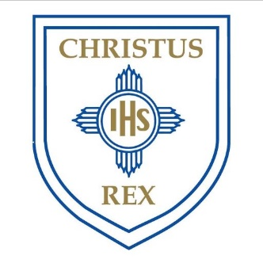
Monday 18th May
Christ the King Voluntary Academy
EYFS Daily Planning.
Week Beginning: 18/5/20
Pentecost Term – Week 5
Phonics Sound of the day. | - “ur” – is for nurse, purse, fur  ur  Practise writing the sound ‘ur’ and have a go at writing some ‘ur’ words in your exercise book or on some paper.  Use your sounds to write the sentence: “The nurse had a red purse.” (parents read the sentence and get your little one to write it, you can repeat the sentence a few times to help them)
Reading | - Read through your red and green words with a grown up or another member of your family.  - Can you read these simple sentences using your phonics knowledge?  - A goat sat in a boat.  - I can see a green car.  - The snail looked at the rain.  - Listen to the story ‘Six Dinner Sid’ by Inga Moore.  https://www.youtube.com/watch?v=JauYJuJ5X7M
Writing | Dinner Time!  - Sid loved all of the dinners he ate. Can you draw a picture of your favourite meal and write a few sentences to describe it. Tell me why it is your favourite and when you like to eat it.  - Have a look at my work to help you.  My favourite meal is a delicious roast. I love it because it is yummy and fills up my tummy. It has lots of tasty vegetables on it and thick, brown gravy. I like to eat it on Sundays with my family.  - Remember to include capital letters, finger spaces and full stops.  - You could even challenge yourself to use some adjectives e.g. chunky chips, delicious pizza, and spicy spaghetti!
Maths | Number Bonds  This week we will be looking at what numbers we can add together to make the number 10.  Use the whole part model to help you or draw your own!  Collect ten different objects in your house and see how many ways you can split them on your whole part model.  - Click the link to see an example: https://www.loom.com/share/53a531a93fdc4ac0b96ed37913820b9f
Art and Design | 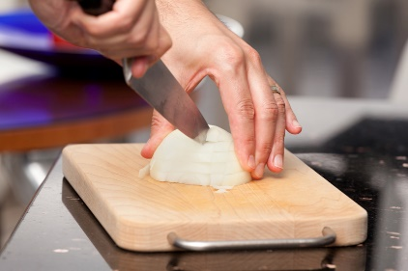  Making Dinner  •Have a go at helping your family to make dinner tonight. Try and practise your chopping skills using the bridge hold and maybe you could even have a go at mixing some of the ingredients together.  After you have enjoyed your delicious meal, don’t forget to help with the washing up!
R.E | - Listen to the Pentecost story. How do you think the Disciples felt when the Holy Spirt came down as flames? https://www.youtube.com/watch?v=OMQKy1Mx49M  - Create a picture of a flame. This can be done with pencil crayons, paints or felt tips. Get creative! Write a word on your flame to describe how you think the disciples may have felt when they knew that Jesus had sent the Holy Spirit.
Physical Development. | - Have a go at some of these just dance videos with your family. Try to follow the moves carefully and get your heart pumping!  - https://www.youtube.com/watch?v=gCzgc_RelBA  - https://www.youtube.com/watch?v=oe_HDfdmnaM  - https://www.youtube.com/watch?v=M8SIxE-MCFY
Don’t Forget….. | - All of the EYFS teachers will be adding Purple Mash activities weekly for your child to also complete. Once they have completed an activity make sure you save it so your teacher can see your amazing work too! Take a look at our EYFS virtual display board too – we will be adding some fantastic examples of our children’s work on there!  - For extra reading materials try: https://home.oxfordowl.co.uk/reading/. This website has lots of great age appropriate eBooks!  - If you haven’t already heard, David Walliams is reading a 20 minute story every day at 11am. Click on this link, scroll down a bit and select “Elevensies” to access. There is also one short story on there that you can listen to anytime. https://www.worldofdavidwalliams.com/  - Joe Wicks will be delivering 9am P.E workout daily! https://www.youtube.com/channel/UCAxW1XT0iEJo0TYlRfn6rYQ

