## **Proxmox User Guide**

### **Introduction**

* Proxmox is a powerful open source platform which helps users to efficiently run virtual machines and containers. Proxmox offers a user-friendly web interface that simplifies the management of virtualized environments.

### **Getting Started**

* To install Proxmox, first download the ISO file from the official website then create a bootable medium ( USB) using the ISO file, this will help us install the Proxmox on the system.
* Restart the system by inserting this USB and configure the boot settings by keeping this USB as priority.
* For basic Proxmox configuration just follow the on-screen instructions.
* If the Proxmox is successfully installed you will see a web link using which a user-friendly web interface can be accessed ( from different PCs that are on or connected to the same network) for easy management.

**Web Interface**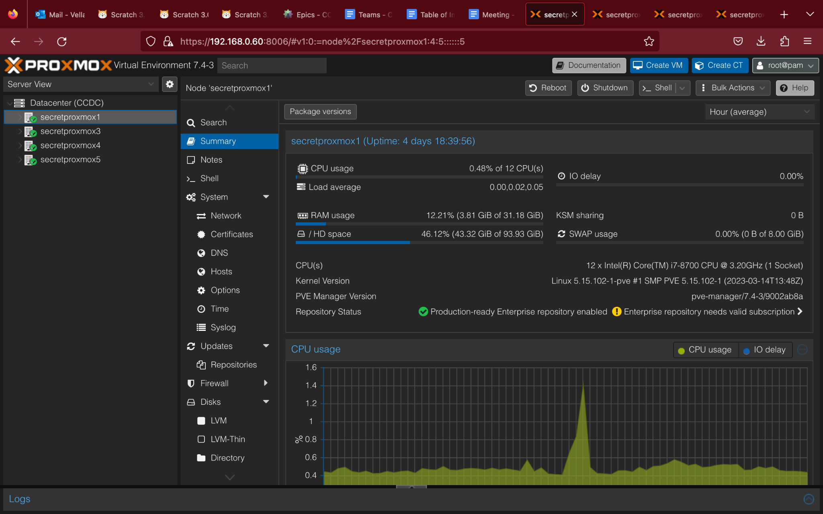

* In the above figure, towards the left in the navigation column we can find we systems with the name secretproxmox (1-5) under the data center CCDC.
* So here these 4 systems are clustered together under the cluster name CCDC, there several major advantages of clustering where it lies as the first step for high availability, load balancing, resource migration, live migration, recovery, and shared storage.
* Each of these operations need further configurations that start with clustering.

**Cluster setup:**

* Setting up a cluster is a straightforward process. Once all the PCs are properly functioning (i.e. able to access the web interface using the link). Then click on the “data center” on the left. Which gives several suboptions right next to that column.
* In which one of the options will be cluster, click on there to further see three options, create cluster, join information, join cluster. 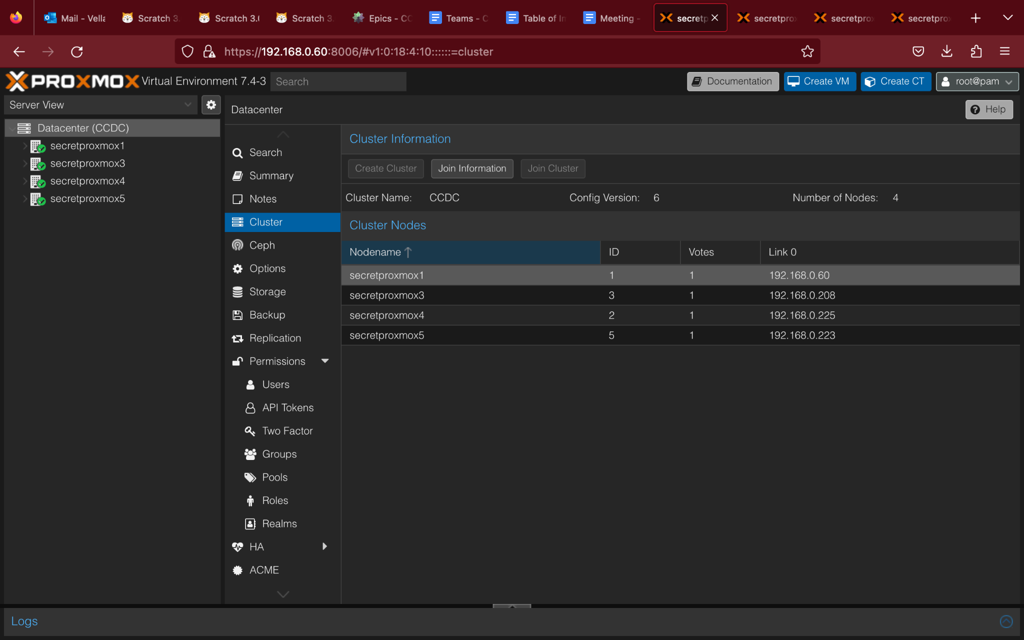
* As there is no cluster created already, click on the create cluster to create one. Once the cluster is created click on the join information which displays two important cluster joining information, they are fingerprint and join information.
* Next open the web interface of the next system that needs to join the cluster, then similarly navigate to the cluster menu as done previously, but now click on join cluster which displays a configuration popup. Here you need to copy and paste the join information, which lets this system join the cluster. Repeat this process with all the systems that need to be added in a cluster.

**Creating Virtual Machine and Container:**

**Setting up GlusterFS:**

**High Availability:**