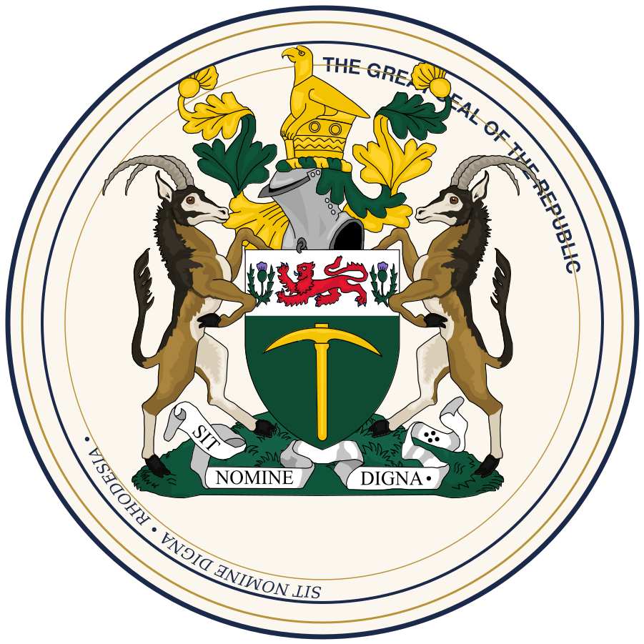

CONSTITUTIONAL INSTRUMENT NO. 1 OF 1966
THE CONSTITUTION
OF THE REPUBLIC OF RHODESIA
Adopted upon the Settlement of 1 June 1966, as subsequently amended
Sit Nomine Digna
"May she be worthy of the name"

FOUNDATIONAL INSTRUMENT

Preamble
WE, THE PEOPLE OF RHODESIA, having through the Settlement of 1966 secured our full and unconditional sovereignty; resolved to build one nation from many peoples, on a footing of equality before the law regardless of race; determined that government shall derive its authority solely from the electorate and shall answer to no Crown, no foreign power, and no chartered company; and mindful that a Republic worthy of its name must be worthy of it in the daily conduct of its institutions and not merely in the words of its founding: DO ORDAIN AND ESTABLISH this Constitution as the supreme law of the Republic of Rhodesia.
CHAPTER I · ARTICLES 1–3

The Republic and Its Sovereignty

Article 1. The Republic
(1) Rhodesia is a sovereign, democratic, parliamentary Republic, answerable to no Crown, Dominion, Commonwealth realm, or foreign authority of any kind.
(2) The Republic shall have no Governor-General and no vice-regal office; its Head of State shall be the President, as established in Chapter III.
(3) Sovereignty resides in the people of Rhodesia and is exercised through Parliament, the Presidency, and the Courts, each within the competence assigned to it by this Constitution.

Article 2. National Symbols
(1) The capital of the Republic is the City of Salisbury.
(2) The national motto of the Republic is Sit Nomine Digna.
(3) The national flag, the Great Seal, and the national anthem shall be as prescribed by Act of Parliament, and may not be altered save by a two-thirds majority of the House of Assembly.

Article 3. Equality Before the Law
(1) All persons are equal before the law and entitled to its equal protection, without distinction as to race, ethnicity, or national origin.
(2) No law, regulation, or administrative act of the Republic may discriminate on the grounds of race, whether in franchise, land tenure, public employment, or access to the Courts.
(3) This Article gives permanent constitutional effect to the abolition, at the Settlement of 1966, of the Land Apportionment Act and of the discriminatory provisions of the former Law and Order Maintenance Act, and no future enactment may revive their effect in substance or in form.

CHAPTER II · ARTICLES 4–7

The Legislature

Article 4. Composition of Parliament
(1) The Parliament of Rhodesia consists of two Houses: the Senate and the House of Assembly.
(2) No law shall have force unless passed by both Houses in the manner prescribed by this Constitution, save where this Constitution expressly provides for the House of Assembly to act alone.

Article 5. The House of Assembly
(1) The House of Assembly is composed of members directly elected by universal adult suffrage, in constituencies of substantially equal population, for a term of five years unless sooner dissolved.
(2) Every citizen of eighteen years or older is entitled to vote in elections to the House of Assembly, without qualification as to property, income, or education.
(3) The House of Assembly is the House of confidence: the Prime Minister and Cabinet hold office only for so long as they command the support of a majority of its members.

Article 6. The Senate
(1) The Senate is composed of members chosen by a mixture of election and appointment, as prescribed by Act of Parliament, so as to give representation to traditional chiefs, organised business, and civic and professional bodies alongside directly elected members.
(2) The Senate may debate, amend, and delay legislation passed by the House of Assembly, but may not indefinitely withhold assent to a Bill concerning taxation or supply, nor to a Bill re-passed by the House of Assembly after a period of delay prescribed by Act of Parliament.
(3) No amendment to this Constitution may be made without the concurrence of the Senate by the majority prescribed in Article 21.

Article 7. Elections
(1) General elections to the House of Assembly shall be held not less frequently than every five years, conducted by an independent Electoral Commission established by Act of Parliament.
(2) Elections shall be free, fair, and by secret ballot.

CHAPTER III · ARTICLES 8–10

The Executive

Article 8. The Presidency
(1) The President is the Head of State of the Republic and the guarantor of this Constitution.
(2) The President is elected by a joint sitting of both Houses of Parliament, for a term of six years, renewable once.
(3) The President shall act on the advice of the Prime Minister and Cabinet in all matters save those reserved to the President's personal discretion under Article 9, and shall remain above party political activity for the duration of the term of office.

Article 9. Reserve Powers of the President
(1) The President may, acting in personal discretion and not on ministerial advice, dissolve a Parliament in which no party or coalition is able to form a government commanding the confidence of the House of Assembly.
(2) The President may refer a Bill passed by both Houses to the Supreme Court for a ruling on its constitutionality before assenting to it.
(3) The exercise of the powers in this Article is subject to review by the Supreme Court as to whether the constitutional preconditions for their exercise were met, but not as to the merits of the President's judgment once those preconditions are satisfied.

Article 10. The Prime Minister and Cabinet
(1) The Prime Minister is the member of the House of Assembly best able, in the President's judgment, to command the confidence of that House, and is appointed by the President accordingly.
(2) The Prime Minister leads the Cabinet, which is collectively responsible to the House of Assembly for the conduct of the executive government of the Republic.
(3) The Prime Minister holds no power, formal or informal, to determine or constrain the choice of presidential nominee at a joint sitting of Parliament.

CHAPTER IV · ARTICLES 11–12

The Judiciary

Article 11. Judicial Authority
(1) The judicial authority of the Republic is vested in the Supreme Court and such subordinate courts as are established by Act of Parliament.
(2) The Courts of Rhodesia shall apply the Roman-Dutch common law as received and developed in Rhodesia, together with such statute law as Parliament may enact, subject always to this Constitution.
(3) Judges are appointed by the President on the recommendation of an independent Judicial Service Commission, and may be removed from office only for incapacity or proven misconduct, following an inquiry conducted under procedures established by Act of Parliament.

Article 12. The Supreme Court
(1) The Supreme Court is the final court of appeal in all civil and criminal matters and has original jurisdiction to determine questions concerning the interpretation of this Constitution.
(2) Any law inconsistent with this Constitution is, to the extent of the inconsistency, void.
CHAPTER V · ARTICLES 13–17

Fundamental Rights and Freedoms

Article 13. Personal Liberty
(1) No person shall be deprived of life, liberty, or property save in accordance with a law of general application and by due process before an independent court.

Article 14. Freedom of Expression, Assembly, and Association
(1) Every person has the right to freedom of expression, freedom of the press, freedom of peaceful assembly, and freedom of association, including the freedom to form and join political parties and trade unions.
(2) These rights may be limited only by law, and only to the extent reasonably justifiable in a democratic society in the interests of national security, public order, public health, or the rights of others.

Article 15. Property and Land
(1) No person shall be compulsorily deprived of property save under a law providing for prompt and adequate compensation and a right of access to the Courts to contest the taking or the amount of compensation.
(2) This Article does not invalidate the land redistribution programme concluded under the Settlement of 1966, nor any compensation arrangement made or treasury bond issued under it, which shall be deemed to have satisfied the requirements of clause (1).

Article 16. Franchise
(1) The right to vote, once extended to a class of citizens under Act of Parliament, may not thereafter be withdrawn or narrowed from that class.
(2) This Article gives permanent effect to the completion, in 1978, of the phased extension of the franchise to universal adult suffrage begun under the Settlement of 1966.

Article 17. Non-Discrimination
(1) No person shall be discriminated against, directly or indirectly, on grounds of race, ethnicity, sex, religion, or national origin, whether by the State or by any organ exercising public authority.

CHAPTER VI · ARTICLES 18–20

The Public Service, Police, and Security Forces

Article 18. The Public Service
(1) Appointment and promotion within the public service, the judiciary, and the police shall be on merit, open to all citizens without distinction as to race.

Article 19. The Rhodesian Police Service
(1) The Rhodesian Police Service is the sole national police force of the Republic, established on 1 June 1966 in place of the former British South Africa Police, and answerable to the Ministry of Justice.
(2) The Rhodesian Police Service shall be a civilian body under the ultimate control of the elected government, and no other body may exercise police powers within the Republic save as expressly authorised by Act of Parliament.

Article 20. The Rhodesian Security Forces
(1) The Rhodesian Security Forces are the defence forces of the Republic, under the ultimate command of the Cabinet and subject to the authority of Parliament, including Parliament's sole power to declare a state of war.
(2) No member of the Rhodesian Security Forces may be deployed in aid of civil power within the Republic save as authorised by Act of Parliament or by the Cabinet in a declared state of emergency.
CHAPTER VII · ARTICLES 21–23

Amendment of the Constitution

Article 21. General Amendment
(1) Save as provided in Articles 22 and 23, this Constitution may be amended by a Bill passed by a two-thirds majority of the members of the House of Assembly and a majority of the members of the Senate.

Article 22. Entrenched Provisions
(1) Articles 1, 3, 15, 16, and 17, and this Article itself, may be amended only by a Bill passed by a three-quarters majority of the members of the House of Assembly, a two-thirds majority of the members of the Senate, and thereafter approved by a national referendum.
(2) No amendment under this Article may have the effect of restoring the Republic to any form of Crown, Dominion, or Commonwealth-realm status, of narrowing the franchise below universal adult suffrage, or of reintroducing racial discrimination in law.

Article 23. Presidential Term and Reserve Powers
(1) Amendment of Article 8(2) or Article 9 requires the majority prescribed in Article 21 and may not take effect during the term of the sitting President.

CHAPTER VIII · ARTICLES 24–25

Transitional and General Provisions

Article 24. Continuity of Law
(1) All laws in force in Rhodesia immediately before 1 June 1966, save for those repealed or amended by or under the Settlement of 1966, continue in force until repealed or amended by Parliament, and shall be construed with such modifications as are necessary to bring them into conformity with this Constitution.

Article 25. Citation
(1) This Constitution may be cited as the Constitution of the Republic of Rhodesia, and comes into force on 1 June 1966.



Adopted under the authority of the Salisbury Agreement and given the force of supreme law of the Republic of Rhodesia on the first day of June, 1966.

Sit Nomine Digna
— END OF CONSTITUTION —

