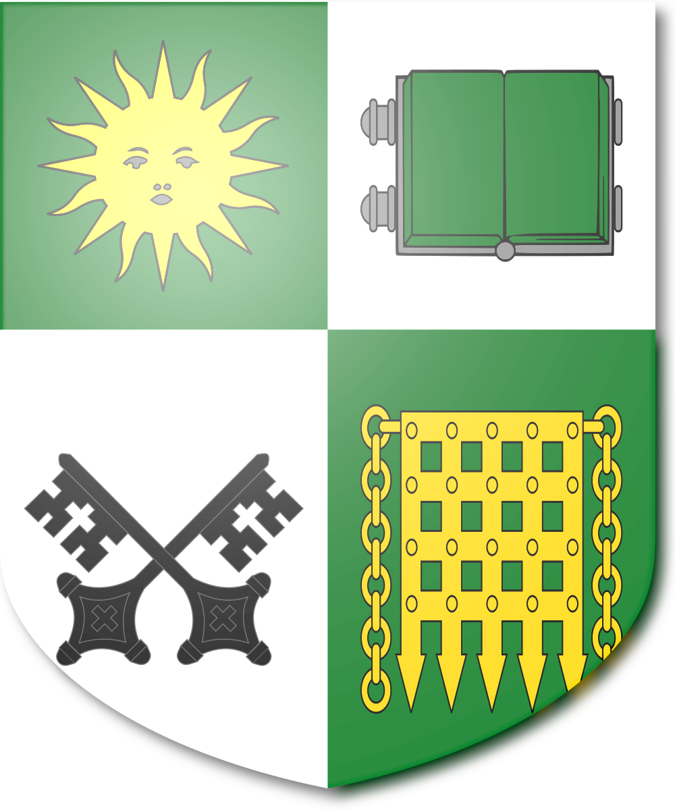

ARCHIVE REF. NAR / HIST / 01
A HISTORY OF THE REPUBLIC OF RHODESIA
From Settlement to Sovereignty, 1965 – Present
Compiled and maintained by the National Archives of Rhodesia
Salisbury
Sit Nomine Digna
"May she be worthy of the name"

FOREWORD

Preface
This volume sets out, for students, civil servants, and the general reader, the history of the founding and development of the Republic of Rhodesia. It draws on the records of the Salisbury Conference of 1966, subsequent parliamentary Hansard, and the census and land-registry archives maintained since independence.
The Troubles of 1966–1974 and the legacy of Robert Mugabe remain genuinely contested in Rhodesian public memory. This volume presents the principal accounts of each side by side, in keeping with the National Archives' long-standing practice of recording disagreement rather than resolving it by decree.
— Office of the Chief Archivist
CHAPTER I · 1965–1966

The Settlement of 1966
On 11 November 1965, the government of Prime Minister Ian Smith issued a Unilateral Declaration of Independence from the United Kingdom, ending decades of ambiguity over Southern Rhodesia's constitutional status. The declaration was met, as expected, with international condemnation, United Nations sanctions, and a firm refusal by London to recognise it as lawful.
The eighteen months that followed determined the shape of the modern Republic. The government of Harold Wilson, unwilling to authorise the use of force against a kin population and mindful of the political costs of a prolonged colonial war, opened back-channel negotiations with Salisbury in early 1966. These talks produced the instrument now known to every Rhodesian schoolchild as the Salisbury Agreement.

The Terms of Settlement
The Agreement, signed in April 1966, bound the Rhodesian government to a fixed and internationally monitored timetable of reform in exchange for British recognition of full independence. Its five pillars were:
- The immediate repeal of racially discriminatory legislation, including the Land Apportionment Act and the discriminatory clauses of the Law and Order Maintenance Act.
- A phased extension of the franchise from the existing qualified voting roll to universal adult suffrage, with qualification thresholds lowered on a fixed schedule to be completed by 1978.
- A compensated land redistribution programme, jointly funded by a British-administered trust and Rhodesian treasury bonds, transferring underused commercial farmland to Black smallholders over fifteen years.
- The integration of the civil service, judiciary, and police, with officer ranks opened to all races on merit.
- Full and unconditional independence — sovereign parliamentary republic status, with no Crown link, no Dominion or Commonwealth-realm arrangement, and no Governor-General.
The fifth pillar was, in the Rhodesian telling, the non-negotiable heart of the settlement. Salisbury's negotiators were prepared to accept swift and binding reform of the franchise and land ownership, but not a settlement that left Rhodesia simply a differently-administered colony. Recognition, in the Rhodesian view, had to mean real independence or it meant nothing at all.
The Agreement did not pass unopposed. Hardline elements of the Rhodesian Front broke away rather than accept the reform timetable, and several sitting members resigned their seats in protest. It was carried in Parliament chiefly by the moderate wing of government together with a business community desperate to see sanctions lifted.

Independence Day
Independence took effect on 1 June 1966, with Rhodesia proclaimed a sovereign parliamentary republic. As a deliberate first act of sovereignty — and one that resonated more immediately with ordinary Rhodesians than the more abstract question of the Crown link — the colonial-era British South Africa Police, a name inherited from Cecil Rhodes's chartered company rather than any tie to Pretoria, was dissolved that same day and reconstituted as the Rhodesian Police Service, an entirely domestic body answerable only to the Ministry of Justice.

CHAPTER II · 1966–1974

The Troubles
The settlement did not end armed resistance overnight. The Zimbabwe African People's Union under Joshua Nkomo, and the Zimbabwe African National Union, initially led by Ndabaningi Sithole with Robert Mugabe among its rising organisers, had built their movements on the premise that majority rule would never be conceded peacefully. Sporadic guerrilla activity, cross-border raids staged from Zambia, and hardline resistance from displaced white farmers continued for close to a decade — a lower-intensity, shorter conflict remembered domestically as the Troubles.
What ultimately ended the insurgency was not a military victory but the erosion of its political premise. As the franchise expanded on schedule, as the first Black cabinet ministers took office in 1971, and as land transfers began reaching real families rather than remaining a paper promise, the insurgents' central argument — that peaceful change was impossible — lost credibility with the population whose support it depended upon. Recruitment fell away, and Zambia, along with a Mozambique newly independent after 1974 and exhausted by its own liberation war, grew unwilling to keep hosting bases for a conflict with steadily diminishing popular justification.

Two Paths: Nkomo and Mugabe
Joshua Nkomo, consistently the more pragmatic of the liberation leaders, brought ZAPU into legal politics in 1972, forming the National Democratic Alliance, still one of Rhodesia's principal parties today.
Robert Mugabe and the harder Marxist–Leninist faction of ZANU took the opposite path, rejecting a settlement authored by the government they had sworn to overthrow and viewing gradual reform as a means of preserving settler economic power behind a multiracial facade. Unable to sustain the armed struggle and unwilling to join a system they regarded as compromised, most of the ZANU leadership passed into permanent exile during the mid-1970s. Mugabe himself lived in Maputo and later Accra until his death in 2019, never returning to the country whose liberation he had fought for.
Schoolchildren today encounter two competing accounts of him — one that remembers a leader who correctly judged the settlement a betrayal, and one that remembers a man who chose exile and dogma over the harder work of building the country he claimed to want. The National Archives records both without endorsing either.
CHAPTER III · 1966–1990

Democratic Consolidation
1971 — The first Black cabinet ministers are appointed, to the Ministries of Agriculture and Education.
1978 — Universal adult suffrage is achieved on the schedule set by the Salisbury Agreement twelve years earlier.
1979 — The first fully democratic general election returns a coalition government. Josiah Gumede becomes the first Black Prime Minister of Rhodesia.
1980 — Rhodesia marks the Golden Jubilee of the Settlement's completion. The land transfer programme is formally concluded, with 94% of scheduled transfers completed — a source of enduring national pride, and of occasional academic dispute over the remaining six percent.
1984 — A constitutional amendment lengthens the President's term from four to six years and removes the sitting Prime Minister's informal power to handpick the presidential nominee, strengthening the presidency as a genuine check on Parliament rather than a ceremonial rubber stamp.
1990s — The end of apartheid in South Africa sends a wave of anxious capital and skilled emigrants north into Rhodesia, considerably expanding Salisbury's financial sector.

CHAPTER IV · 1990–PRESENT

Migration and the Modern Nation
Rhodesia's steady industrialisation stands in contrast to the turbulence experienced by several of its neighbours over the same period, and this contrast is the principal reason Salisbury has become the cosmopolitan capital it is today.
- Mozambique's civil war (1977–1992) drove a substantial refugee and later economic-migrant population into Rhodesia's Manicaland border regions and into Salisbury itself.
- The collapse of the Zambian copper industry through the 1970s and 1980s pushed skilled labour south into Rhodesia's more diversified economy.
- Instability in the Congo (1996–2003) and crises among other neighbouring states have continued to make Rhodesia a comparative regional haven.
- Post-1994 emigration from South Africa — white and Indian professionals uneasy at the pace of change at home, alongside Black South Africans seeking opportunity — has added a further, ongoing layer to the population.
No single dramatic event explains the result, recorded in every national census since 1990: a capital city that has quietly become one of the most demographically mixed in the region, simply by being the stable, functioning state beside several that were not. Salisbury is spoken of domestically, with a certain affectionate self-deprecation, as 'the city everyone ended up in.'
CHAPTER V · INSTITUTIONS

Institutions of the Modern Republic
Rhodesia today is a fully sovereign parliamentary republic. Its principal institutions are the Presidency, based at Government House in Salisbury and elected by joint sitting of Parliament to a six-year term; a bicameral Parliament comprising the Senate and the House of Assembly; a judiciary headed by the Supreme Court, operating under the Roman-Dutch common law tradition inherited from the settlement era; the Rhodesian Police Service, a fully integrated national force; and the Rhodesian Security Forces, a professional and internationally deployable successor to the old Rhodesian Army and Air Force, today known chiefly for its peacekeeping contributions abroad.
Salisbury itself was never renamed. The absence of any 1980-style transition means the city's colonial-to-modern architectural continuity has never been interrupted: Government House, the Senate, the House of Assembly, and the Courthouse remain in their original early-to-twentieth-century buildings, preserved and maintained as working seats of government rather than as museum pieces, with modern commercial and civic infrastructure grown up around them much as London's financial district surrounds St Paul's.
AFTERWORD

A Living History
This volume does not present modern Rhodesia as a finished or flawless project. Ordinary disagreements between the Senate and House of Assembly, unresolved debate over the proper scope of presidential reserve powers, the pressures of urban growth on Salisbury's infrastructure, tension over regional migration policy, and the genuinely contested memory of the Troubles and of figures such as Mugabe all remain live questions in Rhodesian public life.
The National Archives regards this as a sign of a functioning republic, not a defect in one, and leaves these questions open for the ongoing work of each generation of Rhodesians to answer for itself.

Sit Nomine Digna
— END OF VOLUME —

