討論群組
畫面功能介紹
Index.php(顯示主題畫面)
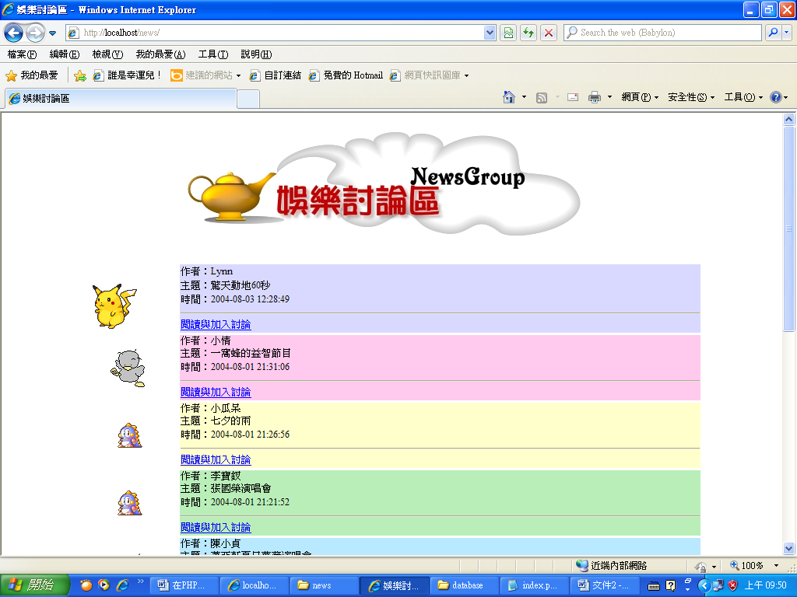
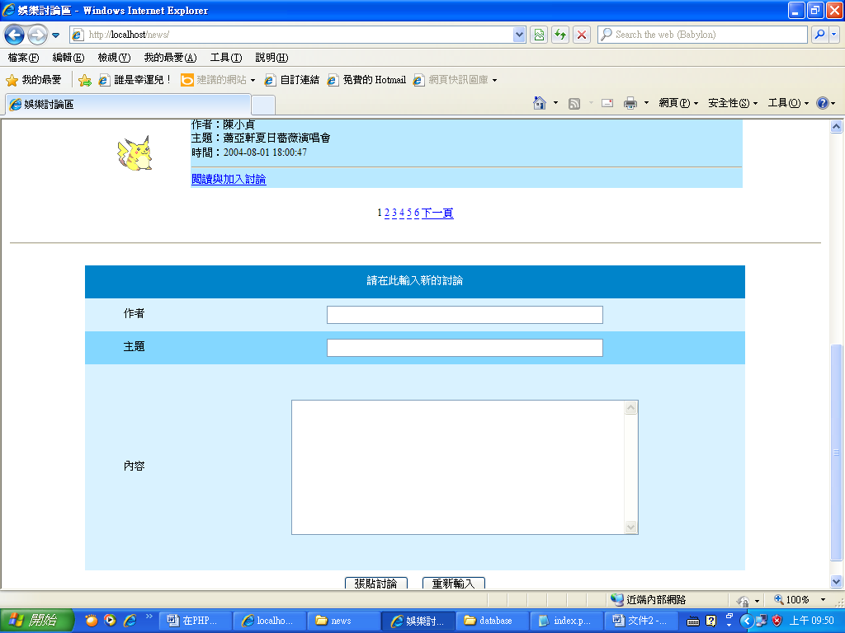

Show_news.php(進入討論區畫面)
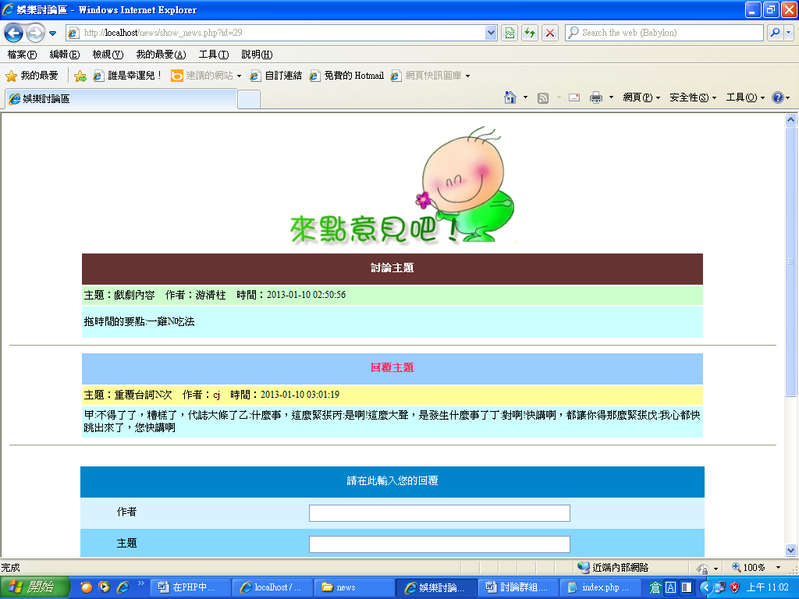
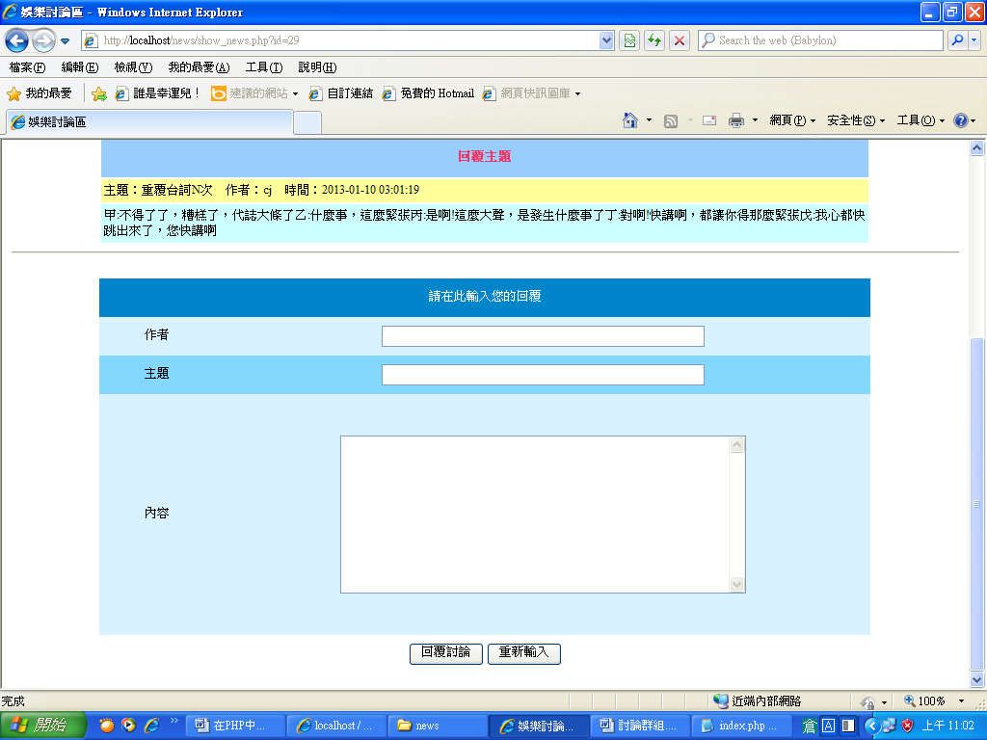

post.php(增加討論主題程式)

post_reply.php(增加討論區內容程式)

操作步驟
1下載 news.sql資料庫
記得另存新檔(編碼—utf8)
再匯入 MySQL資料庫伺服器中
2.程式修改
mysql_query("SET NAMES UTF8");
$link = mysql_connect("localhost", "root", "123456");
3. post.php及 post_reply.php 有header指令，記得用Notepad++編輯
編碼 / 轉換成 utf8(無BOM) 格式

程式碼
Index.php
<HTML>
<HEAD>
<META HTTP-EQUIV="Content-Type" CONTENT="text/html; charset=big5">
<TITLE>娛樂討論區</TITLE>
<SCRIPT LANGUAGE="JAVASCRIPT">
function check_data()
{
if (document.myForm.author.value.length == 0)
{
alert("作者欄位不可以空白哦！");
return false;
}
if (document.myForm.subject.value.length == 0)
{
alert("主題欄位不可以空白哦！");
return false;
}
if (document.myForm.content.value.length == 0)
{
alert("內容欄位不可以空白哦！");
return false;
}
myForm.submit();
}
</SCRIPT>
</HEAD>
<BODY>
<P ALIGN="center"><IMG SRC="fig.jpg"></P>
<?php
//指定每頁顯示幾筆記錄
$records_per_page = 5;

//取得要顯示第幾頁的記錄
if (isset($_GET["page"]))
$page = $_GET["page"];
else
$page = 1;

//建立資料連接
$link = mysqli_connect("localhost", "root");
if (!$link) die("建立資料連接失敗");

//開啟資料表
$db_selected = mysqli_select_db($link,"news");
if (!$db_selected) die("開啟資料庫失敗");

mysqli_query($link,"SET NAMES UTF8");
//執行 SQL 命令
$sql = "SELECT id, author, subject, date FROM message ORDER BY date DESC";
$result = mysqli_query($link,$sql);
if (!$result) die("執行 SQL 命令失敗");

//取得記錄數
$total_records = mysqli_num_rows($result);

//計算總頁數
$total_pages = ceil($total_records / $records_per_page);

//計算本頁第一筆記錄的序號
$started_record = $records_per_page * ($page - 1);

//將記錄指標移至本頁第一筆記錄的序號
mysqli_data_seek($result, $started_record);

echo "<TABLE WIDTH='800' ALIGN='center' CELLSPACING='3'>";

//使用 $bg 陣列來儲存表格背景色彩
$bg[0] = "#D9D9FF";
$bg[1] = "#FFCAEE";
$bg[2] = "#FFFFCC";
$bg[3] = "#B9EEB9";
$bg[4] = "#B9E9FF";

//顯示記錄
$j = 1;
while ($row = mysqli_fetch_assoc($result) and $j <= $records_per_page)
{
echo "<TR>";
echo "<TD WIDTH='120' ALIGN='center'><IMG SRC='" . mt_rand(0, 9) . ".gif'></TD>";
echo "<TD BGCOLOR='" . $bg[$j - 1] . "'>作者：" . $row["author"] . "<BR>";
echo "主題：" . $row["subject"] . "<BR>";
echo "時間：" . $row["date"] . "<HR>";
echo "<A HREF='show_news.php?id=";
echo $row["id"] . "'>閱讀與加入討論</A></TD></TR>";
$j++;
}
echo "</TABLE>" ;

//產生導覽列
echo "<P ALIGN='center'>";

if ($page > 1)
echo "<A HREF='index.php?page=". ($page - 1) . "'>上一頁</A> ";

for ($i = 1; $i <= $total_pages; $i++)
{
if ($i == $page)
echo "$i ";
else
echo "<A HREF='index.php?page=$i'>$i</A> ";
}

if ($page < $total_pages)
echo "<A HREF='index.php?page=". ($page + 1) . "'>下一頁</A> ";

echo "</P>";

//釋放記憶體空間
mysqli_free_result($result);
mysqli_close($link);
?>
<HR>
<!- 顯示輸入新留言表單 -->
<FORM NAME="myForm" METHOD="post" ACTION="post.php">
<TABLE BORDER="0" WIDTH="800" ALIGN="center" CELLSPACING="0">
<TR HEIGHT="40" BGCOLOR="#0084CA" ALIGN="center" VALIGN="middle">
<TD COLSPAN="2"><FONT COLOR="white">請在此輸入新的討論</FONT></TD>
</TR>
<TR HEIGHT="40" BGCOLOR="#D9F2FF" ALIGN="center" VALIGN="middle">
<TD WIDTH="15%">作者</TD>
<TD WIDTH="85%"><INPUT NAME="author" TYPE="text" SIZE="50"></TD>
</TR>
<TR HEIGHT="40" BGCOLOR="#84D7FF" ALIGN="center" VALIGN="middle">
<TD WIDTH="15%">主題</TD>
<TD WIDTH="85%"><INPUT NAME="subject" TYPE="text" SIZE="50"></TD>
</TR>
<TR HEIGHT="250" BGCOLOR="#D9F2FF" ALIGN="center" VALIGN="middle">
<TD WIDTH="15%">內容</TD>
<TD WIDTH="85%"><TEXTAREA NAME="content" COLS="50" ROWS="10"></TEXTAREA></TD>
</TR>
<TR>
<TD COLSPAN="2" HEIGHT="40" ALIGN="center" VALIGN="middle">
<INPUT TYPE="button" VALUE="張貼討論" onClick="check_data()">
<INPUT TYPE="reset" VALUE="重新輸入"></TD>
</TR>
</TABLE>
</FORM>
</BODY>
</HTML>

Show_news.php
<HTML>
<HEAD>
<META HTTP-EQUIV="Content-Type" CONTENT="text/html; charset=big5">
<TITLE>娛樂討論區</TITLE>
<SCRIPT LANGUAGE="JAVASCRIPT">
function check_data()
{
if (document.myForm.author.value.length == 0)
{
alert("作者欄位不可以空白哦！");
return false;
}
if (document.myForm.subject.value.length == 0)
{
alert("主題欄位不可以空白哦！");
return false;
}
if (document.myForm.content.value.length == 0)
{
alert("內容欄位不可以空白哦！");
return false;
}
myForm.submit();
}
</SCRIPT>
</HEAD>
<BODY>
<CENTER><IMG SRC="fig1.jpg"></CENTER>
<?php
//取得要顯示之記錄
$id = $_GET["id"];

//建立資料連接
$link = mysqli_connect("localhost", "root");
if (!$link) die("建立資料連接失敗");

//開啟資料表
$db_selected = mysqli_select_db($link , "news" );
if (!$db_selected) die("開啟資料庫失敗");

mysqli_query($link,"SET NAMES UTF8");
//執行 SQL 命令
$sql = "SELECT * FROM message WHERE id = $id";
$result = mysqli_query($link, $sql);
if (!$result) die("執行 SQL 命令失敗");

echo "<TABLE WIDTH='800' ALIGN='CENTER' CELLPADDING='3'>";
echo "<TR HEIGHT='40'><TD COLSPAN='2' ALIGN='center'
BGCOLOR='#663333'><FONT COLOR='white'>
<B>討論主題</B></FONT></TD></TR>";

//顯示原討論主題的內容
while ($row = mysqli_fetch_assoc($result))
{
echo "<TR>";
echo "<TD BGCOLOR='#CCFFCC'>主題：" . $row["subject"] . " ";
echo "作者：" . $row["author"] . " ";
echo "時間：" . $row["date"] . "</TD></TR>";
echo "<TR HEIGHT='40'><TD BGCOLOR='CCFFFF'>";
echo $row["content"] . "</TD></TR>";
}

echo "</TABLE>";

//釋放 $result 佔用的記憶體空間
mysqli_free_result($result);

//執行 SQL 命令
$sql = "SELECT * FROM reply_message WHERE reply_id = $id";
$result = mysqli_query($link, $sql );
if (!$result) die("執行 SQL 命令失敗");

if (mysqli_num_rows($result) <> 0)
{
echo "<HR>";
echo "<TABLE WIDTH='800' ALIGN='CENTER' CELLPADDING='3'>";
echo "<TR HEIGHT='40'><TD COLSPAN='2' ALIGN='center'
BGCOLOR='#99CCFF'><FONT COLOR='#FF3366'>
<B>回覆主題</B></FONT></TD></TR>";

//顯示回覆主題的內容
while ($row = mysqli_fetch_assoc($result))
{
echo "<TR>";
echo "<TD BGCOLOR='#FFFF99'>主題：" . $row["subject"] . " ";
echo "作者：" . $row["author"] . " ";
echo "時間：" . $row["date"] . "</TD></TR>";
echo "<TR><TD BGCOLOR='CCFFFF'>";
echo $row["content"] . "</TD></TR>";
}

echo "</TABLE>";
}

//釋放記憶體空間
mysqli_free_result($result);
mysqli_close($link);
?>
<HR>
<FORM NAME="myForm" METHOD="post" ACTION="post_reply.php">
<INPUT TYPE="hidden" NAME="reply_id" VALUE="<?= $id ?>">
<TABLE BORDER="0" WIDTH="800" ALIGN="center" CELLSPACING="0">
<TR HEIGHT="40" BGCOLOR="#0084CA" ALIGN="center" VALIGN="middle">
<TD COLSPAN="2"><FONT COLOR="white">請在此輸入您的回覆</FONT></TD>
</TR>
<TR HEIGHT="40" BGCOLOR="#D9F2FF" ALIGN="center" VALIGN="middle">
<TD WIDTH="15%">作者</TD>
<TD WIDTH="85%"><INPUT NAME="author" TYPE="text" SIZE="50"></TD>
</TR>
<TR HEIGHT="40" BGCOLOR="#84D7FF" ALIGN="center" VALIGN="middle">
<TD WIDTH="15%">主題</TD>
<TD WIDTH="85%"><INPUT NAME="subject" TYPE="text" SIZE="50"></TD>
</TR>
<TR HEIGHT="250" BGCOLOR="#D9F2FF" ALIGN="center" VALIGN="middle">
<TD WIDTH="15%">內容</TD>
<TD WIDTH="85%"><TEXTAREA NAME="content" COLS="50" ROWS="10"></TEXTAREA></TD>
</TR>
<TR>
<TD COLSPAN="2" HEIGHT="40" ALIGN="center" VALIGN="middle">
<INPUT TYPE="button" VALUE="回覆討論" onClick="check_data()">
<INPUT TYPE="reset" VALUE="重新輸入"></TD>
</TR>
</TABLE>
</FORM>
</BODY>
</HTML>

Post.php
<?php
$author = $_POST["author"];
$subject = $_POST["subject"];
$content = $_POST["content"];
$current_time = date("Y-m-d H:i:s");

//建立資料連接
$link = mysqli_connect("localhost", "root");
if (!$link) die("建立資料連接失敗");

//開啟資料表
$db_selected = mysqli_select_db( $link,"news");
if (!$db_selected) die("開啟資料庫失敗");

mysqli_query($link,"SET NAMES UTF8");
//執行 SQL 命令
$sql = "INSERT INTO message(author, subject, content, date)
VALUES ('$author', '$subject', '$content', '$current_time')";
$result = mysqli_query($link,$sql );
if (!$result) die("執行 SQL 命令失敗");

//關閉資料連接
mysqli_close($link);

//將網頁重新導向
header("location:index.php");
exit();
?>

post_reply.php

<?php
$author = $_POST["author"];
$subject = $_POST["subject"];
$content = $_POST["content"];
$current_time = date("Y-m-d H:i:s");
$reply_id = $_POST["reply_id"];

//建立資料連接
$link = mysqli_connect("localhost", "root");
if (!$link) die("建立資料連接失敗");

//開啟資料表
$db_selected = mysqli_select_db($link, "news");
if (!$db_selected) die("開啟資料庫失敗");

mysqli_query($link,"SET NAMES UTF8");
//執行 SQL 命令
$sql = "INSERT INTO reply_message(author, subject, content,
date, reply_id) VALUES ('$author', '$subject',
'$content', '$current_time', '$reply_id')";
$result = mysqli_query($link, $sql );
if (!$result) die("執行 SQL 命令失敗");

//關閉資料連接
mysqli_close($link);

//將網頁重新導向
header("location:show_news.php?id=" . $reply_id);
exit();
?>

