EAV's HOMESTAY
Booking & Management System

ERP System Analysis and Design
Activity Submission — SIA 101: System Integration & Architecture 1

By:
CETRIN JR. M VALDEHUEZA

October 28, 2026
1. Project Title and Brief Description
Project Title: EAV's Homestay Booking & Management System

Purpose:
EAV's Homestay is a small lodging property in Catohugan, Mahinog, Camiguin that needed a digital system to manage room reservations, payments, and staff access without relying on paper logs or messaging apps. The system allows guests to book a room directly online with instant date reservation (no admin approval wait), while the owner and staff manage rooms, bookings, and user accounts through a protected admin panel.

Target Users:
- Guests - browse available rooms, pick dates, submit guest details, upload proof of payment, and receive instant booking confirmation. No account required.
- Owner - full system access: approve rooms, manage bookings (check-in/check-out/complete/decline), mark payments fully paid, create staff accounts, and view dashboard KPIs.
- Staff - limited access: manage bookings and view reports; cannot delete owner accounts or deactivate the last active owner.

2. Entity Relationship Diagram (ERD)
The ERD below shows the three core entities of the system, their attributes, primary keys (PK), foreign keys (FK), and the one-to-many relationships between them.

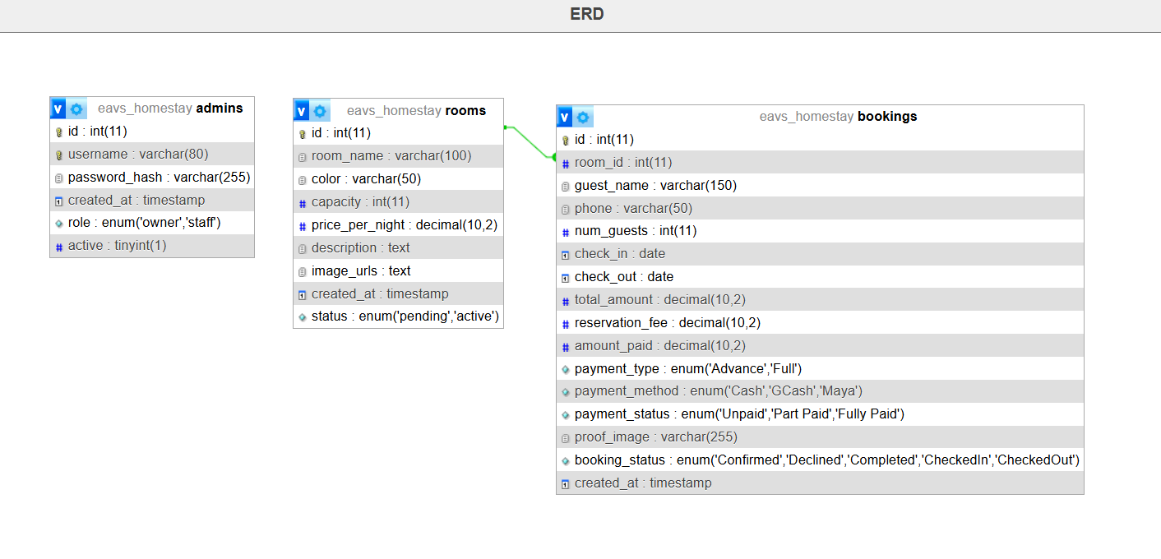
Figure 1. Entity Relationship Diagram

Entities and Relationships
Entity | Primary Key | Foreign Key(s) | Relationship
Admins/Users | id | — | Users creates many walk-in bookings (1:M, logical link)
Rooms | id | — | 1 room has many bookings (1:M) via bookings.room_id
Bookings | id | room_id → rooms.id | Many bookings belong to 1 room (M:1)

Relationship rules:
- bookings.room_id is a foreign key referencing rooms.id with ON DELETE CASCADE — deleting a room removes its bookings (blocked if active Confirmed/CheckedIn bookings exist).
- Only Confirmed and CheckedIn bookings block room inventory (the overlap guard). Declined releases the dates.
- Contact is by phone only.
- Every booking stores proof_image as evidence of payment.

3. Data Dictionary
The data dictionary defines every table, field, data type, and description used in the EAV's Homestay database.

Table: rooms
Field | Data Type | Null? | Key | Description
id | INT | NO | PK, AI | Unique room identifier (auto-increment)
room_name | VARCHAR(100) | NO |  | Display name of the room unit (e.g., "Room 1 - Brown Unit")
color | VARCHAR(50) | NO |  | Theme color label (e.g., Brown, Blue)
capacity | INT | NO | Default 4 | Maximum number of guests allowed per unit
price_per_night | DECIMAL(10,2) | NO | Default 3000.00 | Nightly rate in Philippine pesos (₱3,000)
description | TEXT | YES |  | Full description of room amenities and package
image_urls | TEXT | YES |  | Path to cover photo (jpg/png/webp, ≤2MB, stored in assets/images/rooms/)
status | ENUM('pending','active') | NO | Default pending | pending = hidden from guests; active = live and bookable
created_at | TIMESTAMP | NO | Default CURRENT_TIMESTAMP | Date and time the room record was created

Table: bookings
Field | Data Type | Null? | Key | Description
id | INT | NO | PK, AI | Unique booking identifier (auto-increment)
room_id | INT | NO | FK → rooms.id | Reference to the booked room (ON DELETE CASCADE)
guest_name | VARCHAR(150) | NO |  | Full name of the guest
phone | VARCHAR(50) | NO |  | Guest mobile number (contact by phone only; no email stored)
num_guests | INT | NO | Default 1 | Number of guests (1–12)
check_in | DATE | NO |  | Check-in date (from 2:00 PM)
check_out | DATE | NO |  | Check-out date (by 11:00 AM)
total_amount | DECIMAL(10,2) | NO | Default 0 | nights × price_per_night (₱3,000/night)
reservation_fee | DECIMAL(10,2) | NO | Default 1000.00 | Non-refundable fee that secures the booking
amount_paid | DECIMAL(10,2) | NO | Default 0.00 | Amount actually received from the guest
payment_type | ENUM('Advance','Full') | NO | Default Advance | Advance = reservation fee only; Full = entire total
payment_method | ENUM('Cash','GCash','Maya') | NO | Default Cash | How payment was made
payment_status | ENUM('Unpaid','Part Paid','Fully Paid') | NO | Default Unpaid | Computed from amount_paid vs total_amount
proof_image | VARCHAR(255) | YES | Default NULL | Path to uploaded payment proof (jpg/png/webp, ≤2MB)
booking_status | ENUM('Confirmed','Declined','Completed','CheckedIn','CheckedOut') | NO | Default Confirmed | Confirmed blocks inventory; Declined releases it
created_at | TIMESTAMP | NO | Default CURRENT_TIMESTAMP | Date and time the booking was created

Table: admins
Field | Data Type | Null? | Key | Description
id | INT | NO | PK, AI | Unique staff/account identifier (auto-increment)
username | VARCHAR(80) | NO | UNIQUE | Login username
password_hash | VARCHAR(255) | NO |  | Bcrypt-hashed password
role | ENUM('owner','staff') | NO | Default staff | owner = full access; staff = limited access
active | TINYINT(1) | NO | Default 1 | 1 = can log in; 0 = deactivated
created_at | TIMESTAMP | NO | Default CURRENT_TIMESTAMP | Date and time the account was created

Business Rules and Computed Fields
- total_amount = nights × ₱3,000, where nights = check_out − check_in (checkout day not charged as extra night).
- Amount paid now: Advance → min(₱1,000, total); Full → total_amount.
- payment_status: Unpaid (₱0), Part Paid (₱0 < paid < total), Fully Paid (paid ≥ total).
- Refund on cancellation = MAX(0, amount_paid − ₱1,000); the reservation fee is never refunded.
- Blocking statuses (overlap guard): Confirmed and CheckedIn. Rendered as SQL list ('Confirmed','CheckedIn').
- Proof of payment is required for every method, including Cash and walk-in bookings.
- New rooms start with status = pending; Approve sets active; Deactivate sets pending.

4. Data Flow Diagram (DFD)
The DFD illustrates how data moves through the system: external entities (guests, owner/staff, payment providers, database server), internal processes, and data stores.

Context Diagram (Level 0)
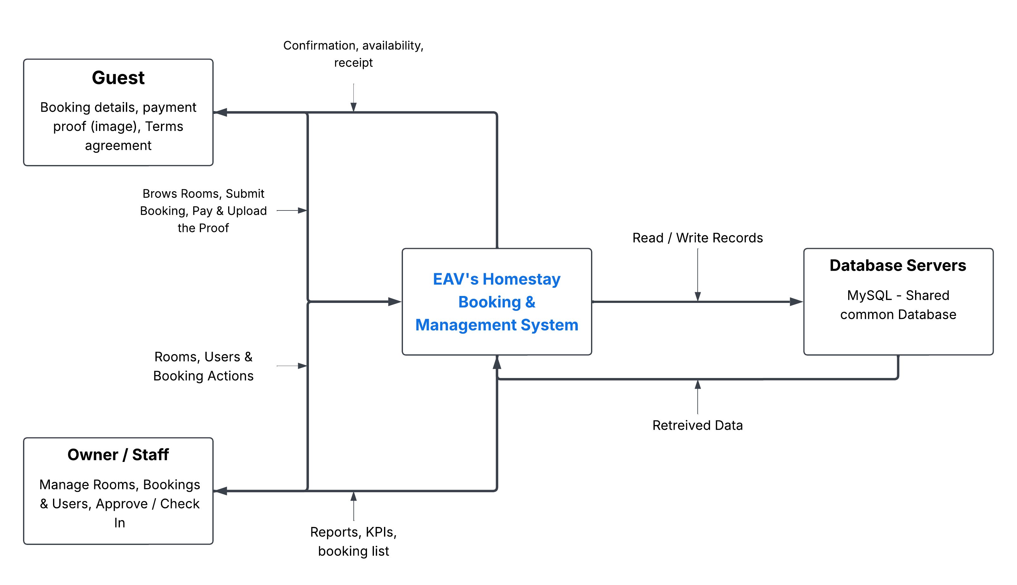
Figure 2. Context Diagram - the homestay system as a single process exchanging data with external entities.
External Entities:
- Guest - Browses rooms, submits booking, pays via GCash/Maya/Cash outside the system, uploads proof image, agrees to terms
- Owner / Staff - manages rooms, bookings, and users; performs check-in/check-out/complete/decline.
- Database Server (MySQL) - shared common database storing rooms, bookings, and admins.

Level 1 Diagram (Internal Processes)

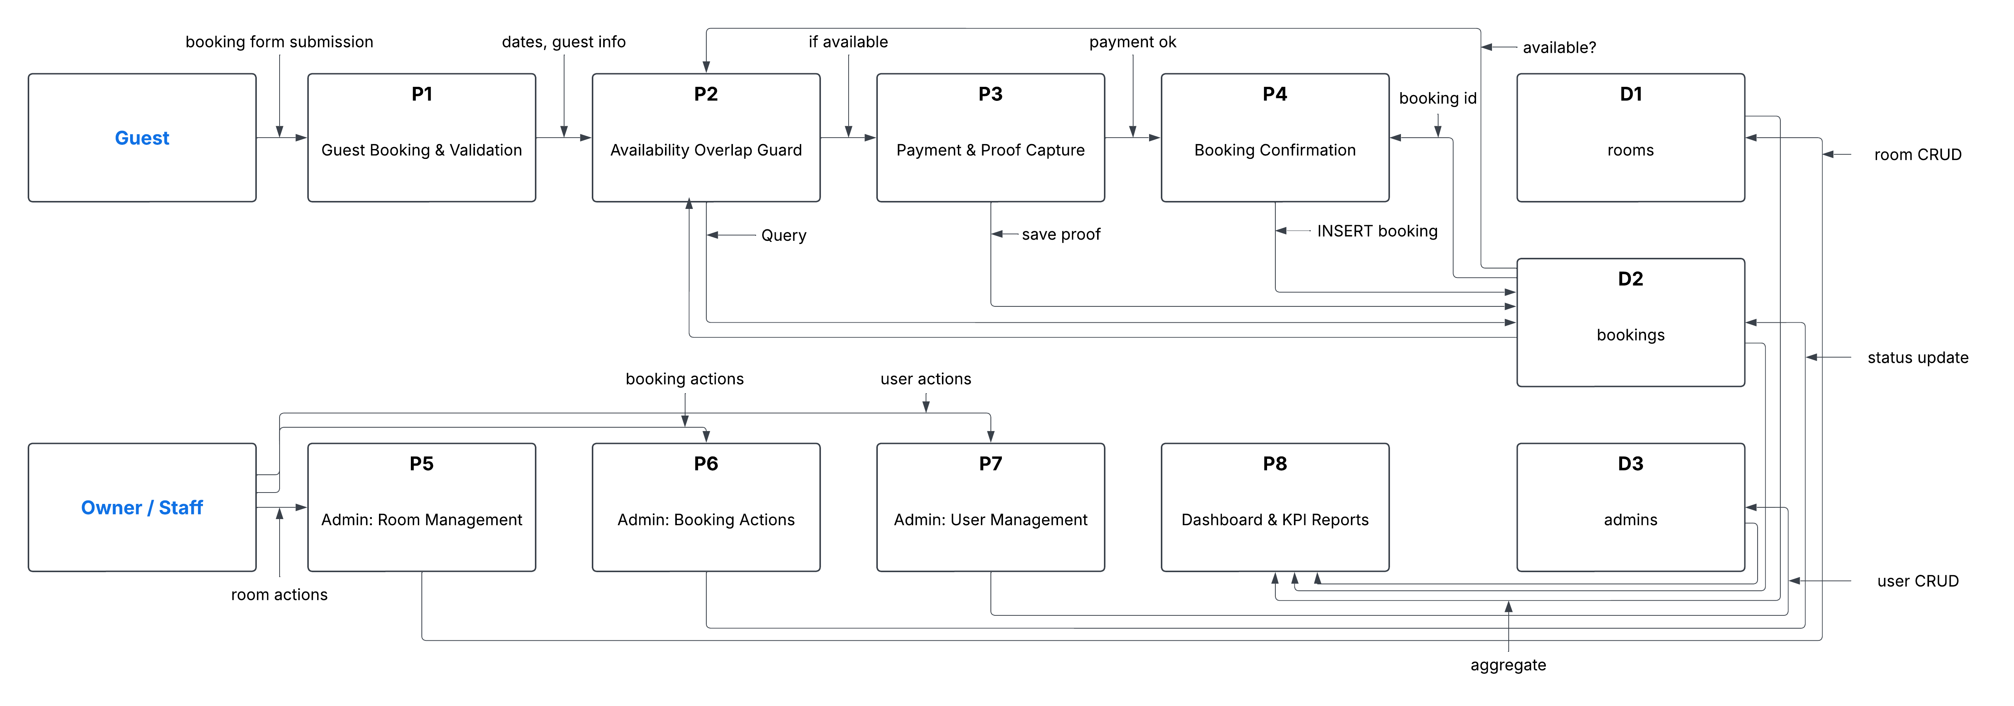
Figure 3. Level 1 DFD — internal processes and data stores within the homestay system.

Process Descriptions
Process | Description
P1: Guest Booking & Validation | Receives guest details, dates, payment type/method, and proof; validates input and Terms agreement server-side.
P2: Availability & Overlap Guard | Checks the room is available for the requested dates using the overlap rule with row-level locking (FOR UPDATE) to prevent double-booking.
P3: Payment & Proof Capture | Computes total, reservation fee, and amount paid; saves the uploaded payment proof image (jpg/png/webp, ≤2MB).
P4: Booking Confirmation | Inserts the booking with status = Confirmed (instant reservation); returns booking ID and confirmation to the guest.
P5: Admin: Room Management | Create, edit, approve, deactivate, or delete room units; cover photo upload required.
P6: Admin: Booking Actions | Check-in, check-out, mark complete, decline, edit dates/guests/payment, mark fully paid (with proof), search and filter.
P7: Admin: User Management | Create staff/owner accounts, toggle active status, delete accounts (last active owner protected).
P8: Dashboard & KPI Reports | Aggregates data from rooms, bookings, and admins to show arrival, occupancy, payment, and revenue KPIs.

Data Stores:
- D1 - rooms: room definitions, pricing, capacity, status, image path.
- D2 - bookings: all reservation records with payment and status fields.
D3 - admins: staff and owner accounts with roles and active status.

5. ERP Integration Analysis
This analysis explains how EAV's Homestay Booking & Management System supports business processes and enables information sharing among users, using ERP concepts from Chapter 4 - ERP Systems and Processes: a common database, shared management reporting, functional-area modules, and three-tier architecture.

Common Database (Single Source of Truth)
Like an ERP, the homestay system uses one shared MySQL database (eavs_homestay) that all modules read from and write to. There are no silos: the booking module writes to the bookings table, the room module reads availability from rooms, and the dashboard aggregates from both. This guarantees accurate, real-time information across the operation.

Mapping to ERP Functional Areas
The homestay modules map onto the classic ERP functional areas described in the reference chapter:
ERP Functional Area | ERP Role | Homestay System Module
Marketing & Sales (M/S) | Advertising, determining pricing, taking customer orders, customer support, CRM | Guest booking flow: browse rooms, view pricing (₱3,000/night), submit order, instant confirmation; free Wi-Fi and scooter perk as customer benefits
Supply Chain / Inventory | Managing product availability, scheduling, tracking stock levels | Room inventory management: room status (pending/active), availability overlap guard, date blocking for Confirmed/CheckedIn bookings, room approval lifecycle
Accounting & Finance (A/F) | Recording transactions, accounts receivable/payable, financial reports, profitability | Payment handling: total = nights × ₱3,000; reservation fee ₱1,000; amount_paid tracking; payment_status (Unpaid/Part Paid/Fully Paid); refund rule (paid - ₱1,000); proof of payment for every method
Human Resources (HR) | Recruit, train, evaluate, compensate employees; compliance | User management: create owner/staff accounts, roles, active/inactive toggle, last-active-owner protection, deactivated login rejection
Management Reporting | Shared management reporting tools; real-time information | Admin dashboard: KPI cards for arrivals, today's movements, outstanding payments, total bookings, room occupancy, and active stays

Three-Tier Architecture
Tier | ERP Definition | Homestay Implementation
Web Tier | Web-based portal; users access and analyze information through a browser | Guest-facing pages (index, rooms, booking, details, availability, terms) and admin UI - browser-based, offline-first, system fonts only, no CDN
Application Tier | Business processes and end-users interact with the system; shields users from inner workings | PHP logic: booking validation, overlap guard with FOR UPDATE locking, payment computation, room/user/booking CRUD, session-based auth with role guards
Data Tier | Structure of all organizational data and its relationships | MySQL database eavs_homestay: rooms, bookings, admins tables with FK relationships, indexes, and shared access by all tiers

Information Sharing Among Users / Departments
- Guest → System → Admin: A guest booking instantly appears in the admin bookings table and dashboard — no delay, no approval queue (v0.12 instant reservation).
- Admin → Guest: Staff can check-in/check-out, mark complete, decline, or mark fully paid; the guest sees confirmation via the booking-success page and receipt.
- Staff → Owner: Role-based access (owner vs staff) with session guard; deactivated logins rejected; last active owner protected.
- Dashboard KPIs: All modules feed the same dashboard — arrivals, movements, outstanding balances, occupancy — giving the owner a single management reporting view.
- Payment evidence: Proof images are attached to bookings and visible to admin, supporting dispute resolution and reconciliation (Cash, GCash, Maya all require proof).

Benefits of the ERP Approach for this Homestay
- Real-time availability — the overlap guard prevents double-booking even under concurrent requests (SELECT … FOR UPDATE).
- Single source of truth — one database means room status, booking status, and payment status are consistent everywhere.
- Reduced manual work — no paper logs; walk-in bookings created by staff follow the same rules as online bookings.
- Scalable design — three-tier architecture makes it easier to add rooms, staff, or reporting later.

