ResearcHive: Designing an Offline Institutional Repository System for Research Manuscripts at DCDNHS


A Capstone Manuscript Presented to
The Faculty of the Senior High School Department
Dona Carmen Denia National High School
Toril, Davao City

Proponents:
Clavicillas, Cyril Jhon T.
Tumampo, Julia Kay A.
Mangora, Asnaida A.
Vencio. Jamaica A.
Lacuesta, Eljay Y.

Grade & Section: XII – TAUSUG
Subject Teacher: Philip John M. Belo
School Year: 2025 – 2026
Date of Submission: March 4, 2026

TABLE OF CONTENTS
Introduction .....................................................................................................
Problem Statement ........................................................................................
Objectives ....................................................................................................
Scope ............................................................................................................
Significance ..................................................................................................
Literature Review ................................................................................................
Existing Solutions .........................................................................................
Technology Overview ...................................................................................
Related Works ...............................................................................................
System Requirements ...........................................................................................
Functional Requirements ..............................................................................
Non-Functional Requirements .....................................................................
Hardware Requirements ................................................................................
Software Requirements .................................................................................
System Design ......................................................................................................
System Architecture ......................................................................................
Flowchart .......................................................................................................
Entity Relationship Diagram (ERD) .............................................................
Development ..........................................................................................................
Programming Languages and Tools ..............................................................
Implementation Steps ....................................................................................
Testing .....................................................................................................................
Testing Methods ............................................................................................
Test Cases ......................................................................................................
Results ............................................................................................................
User Manual ............................................................................................................
Installation Instructions ................................................................................
User Interface Guide ......................................................................................
Troubleshooting .............................................................................................
Conclusion ................................................................................................................
Summary of Work ..........................................................................................
Challenges Encountered .................................................................................
Future Improvements ......................................................................................
References .................................................................................................................
Appendices .................................................................................................................

INTRODUCTION
Problem Statement
Educational institutions produce many research papers every year, but at Doña Carmen Denia National High School (DCDNHS), these papers are not easy to manage or access. Most of them are kept in physical copies or saved in different digital files, which makes them hard to find and organize. Because of this, it is difficult to locate past research, and there is a higher risk of documents being lost or damaged. There is also no central place where all manuscripts are stored, so tracking them becomes slow and inefficient. In addition, students and teachers have limited access to these materials. These problems reduce the value of the research work produced in the school. For this reason, there is a need for a simple, organized, and offline digital system that can store, manage, and make research papers easily accessible within the school.

Objectives
The primary objective of this study is to design and develop ResearcHive, an offline institutional repository system for managing research manuscripts at DCDNHS.
Specifically, the study aims to:
- Develop a centralized system for storing and managing research manuscripts
- Allow users to upload, edit, delete, and view manuscripts
- Implement search and filtering functionalities for easy retrieval
- Provide metadata features such as tags, summary, strand, and section
- Ensure offline accessibility using a local server environment
- Improve efficiency in manuscript management and retrieval

Scope
This project focuses on developing ResearcHive, an offline, desktop-based system designed to help institutions manage and organize research manuscripts more effectively. It provides a simple and structured way of storing, accessing, and tracking research outputs within the school. The system is developed using PHP, MySQL, and XAMPP, allowing users to upload and store research files in formats such as PDF, DOC, DOCX, and TXT. It includes features like file management, search and filtering options, tagging, and adding summaries to make documents easier to organize and locate. Manuscripts can also be classified by section and strand for better organization. In addition, the system has a dashboard interface for monitoring records and allows data export in CSV format for reporting or backup.
However, the system has some limitations. It only works offline, so it cannot be accessed through the internet. Files are stored only on the local computer, which means there is no cloud backup. The system is designed for desktop use only and cannot be accessed using mobile devices. It also does not connect to other systems or databases, so sharing data outside the system is limited. Because of this, users need to manually transfer files if they want to use them on another device.

Significance of the Study
The significance of this project lies in its ability to improve how research manuscripts are stored, accessed, and used within the institution. By providing a clear and organized system, ResearcHive helps ensure that valuable academic work is not lost, difficult to find, or underused. It supports better knowledge sharing and makes research more useful for everyone in the school.
Beneficiaries
- School Administration
The system provides a centralized place where all research outputs are stored and organized. This means administrators no longer need to search through physical files or scattered folders. It helps them easily monitor submissions and keep track of records. With a dashboard, they can quickly see updates and manage documents more efficiently. This reduces the risk of losing important files. Overall, it improves record management and saves time.
- Teachers
The system allows teachers to quickly access past research papers anytime they need them. They can use these studies as references when teaching or explaining research concepts. It also helps them evaluate student work by comparing it with previous outputs. Teachers can guide stdents more effectively because they have clear examples to show. Searching and filtering features make it easy to find specific topics. This supports better teaching and research guidance.
- Students
The system gives students access to completed research papers from previous years. These serve as helpful examples of how a good research paper is written. Students can learn proper structure, format, and content by reading them. It also gives them ideas and inspiration for their own topics. With easy access, they can study anytime without difficulty. This helps improve the quality of their research work.
- Future Researchers
The system serves as a reference for those who want to develop or improve similar systems in the future. They can study how the system is designed and how it manages data. It provides a clear example of how research repositories work. Future researchers can identify areas for improvement or add new features. This helps in creating more advanced and efficient systems. It also supports continuous development in research and technology.

LITERATURE REVIEW
The most common solution for storing research files globally and locally is Google Drive. In many schools, Google Drive is the "gold standard" because it is free, easy to use, and allows students to collaborate on documents in real-time. According to global studies, cloud-based tools like Google Drive and OneDrive have revolutionized how students share their work, making physical flash drives almost obsolete (Magle & McCaffrey, 2023). Locally, in the Philippines, many schools rely on Google’s ecosystem because it doesn't require expensive servers just a basic Gmail account. However, recent research has shown that relying on the cloud has become risky. Since 2022, Google has ended its "unlimited" storage for schools, forcing many institutions to delete old research or pay monthly fees they cannot afford (EdTech Magazine, 2023).
The biggest issue with Google Drive for a school like DCDNHS is its total dependency on the internet. In our local context, internet connectivity can be slow, expensive, or completely unavailable during power outages or bad weather. When the internet goes down, the school's entire research database becomes inaccessible. Furthermore, Google Drive is a general file storage system, not a dedicated research library. It lacks the specific "metadata" or "tagging" features such as searching by specific subject, year level, or research adviser that a formal institutional repository provides. This makes it difficult for future students to find and learn from previous studies, leading to a "messy" digital archive where files are easily lost.
This study is unique because it moves away from the "cloud-only" model and introduces a Localized, Offline-First Approach. Unlike Google Drive, which requires a constant data connection, this proposed system operates on a Local Area Network (LAN). This means students and teachers can access, search, and download research papers at high speeds even if the school has zero internet. While existing global solutions focus on making files available to the whole world, this study focuses on making research available to the DCDNHS community specifically. By removing the need for monthly subscriptions and high-speed fiber-optic cables, this project provides a sustainable and cost-effective way to preserve the school’s academic legacy that Google Drive simply cannot offer.

Technology Overview
ResearcHive was developed using a specific set of technologies designed to ensure the system is fast, organized, and fully functional without an internet connection. The following tools were utilized:
PHP (Hypertext Preprocessor): A powerful backend scripting language used to handle the core logic of ResearcHive. PHP manages the communication between the user and the server, processing tasks such as uploading manuscripts, verifying user logins, and fetching research data based on user queries.
MySQL: A relational database management system used to store and organize all digital records, including research titles, author names, publication years, and file paths. It was chosen for its ability to handle large amounts of data efficiently while maintaining high performance in a local environment.
XAMPP: A cross-platform local server package that provides the necessary environment to run Apache and MySQL on a single machine. XAMPP is the key technology that allows ResearcHive to function as an offline repository, turning a local computer into a central hub for the school’s network.
Bootstrap 5: A modern frontend framework used to design a professional and "responsive" user interface. Bootstrap provides pre-built styling for buttons, tables, and navigation bars, ensuring that the system is easy to navigate and looks consistent across different screen sizes, such as desktops and tablets.
JavaScript: A versatile programming language used to add interactive features to the system. In ResearcHive, JavaScript enables dynamic functions like instant search filtering where results update as the user types and modal previews, which allow users to view file details without leaving the main page.
CSS (Cascading Style Sheets): A design language used alongside Bootstrap to further customize the visual identity of ResearcHive. It was used to define the specific colors, fonts, and spacing of the platform to ensure a clean and user-friendly academic aesthetic.

Related Studies

Many researchers have studied how digital libraries and file systems help schools. One of the most important findings is that using a computer system makes any "job" much faster and more organized. According to a well-known study by Laudon and Laudon (2020), information systems are the best way for organizations to stop wasting time. Instead of a teacher or student spending hours looking through old paper files or messy folders, they can just type a name into a search bar and find it instantly. This proves that a system like ResearcHive is necessary to help DCDNHS save time and keep their research records safe and tidy.
Another key benefit found in research is that these systems help students learn from one another. A study by Turban (2018) shows that when students can easily see the work of those who came before them, they understand their own lessons better. In a school setting, if a student can read a "finished" research paper from a previous year, they will have a clear guide on how to do their own project. This creates a culture of "academic collaboration," where the school’s knowledge grows because everyone can access and learn from the same digital library.
Finally, researchers in the Philippines have specifically looked at the "internet problem" in local schools. Many studies suggest that in places where the internet is slow, expensive, or often goes out, an "Offline-First" system is the best choice. These studies show that you do not need a fancy cloud connection to have a high-tech library; you only need a local server and a good database like MySQL. By using these offline tools, a school can have a reliable system that never crashes, even when the Wi-Fi is down. This makes ResearcHive a perfect fit for the specific needs of our local community.

System Requirements
This section outlines the essential components required for ResearcHive to operate effectively within the Doña Carmen Denia National High School (DCDNHS) environment.

Functional Requirements
These requirements define the specific behaviors and functions the system must perform:
- User Input: The system shall allow authorized users to input manuscript metadata including Title, Author, Section, Strand, and Tags, and upload digital files in PDF or DOCX format.
- System Processes: The system must process search queries instantly using "Live Search" logic, manage the storage of physical files in a local directory, and handle database updates for editing or deleting records.
- Outputs: The system shall display a dynamic table of all manuscripts, provide downloadable links for stored files, and generate exportable CSV reports of the repository data.

Non-Functional Requirements
These criteria define the performance and quality attributes of the system:
- Usability: The interface must be responsive and intuitive, featuring a "Dark Mode" toggle and simple navigation for non-technical staff.
- Speed: Search results and file retrieval must be near-instantaneous (under 3 seconds) due to the local server architecture.
- Security: The system shall use local database security and confirmation prompts (SweetAlert) to prevent accidental data loss or unauthorized deletions.
- Scalability: The database structure must be capable of handling an increasing number of research entries as more batches of students graduate each year.

Hardware Requirements
To run the system as a local server, the following minimum specifications are required:
- Processor: Intel Core i3 (6th Gen) or AMD Ryzen 3 equivalent.
- RAM: Minimum of 4GB (8GB recommended for smoother XAMPP performance).
- Storage: 500GB HDD/SSD (at least 10GB free space for the manuscript database and file uploads).
- Network: Local Area Network (LAN) setup (Router/Switch) if multiple computers need to access the repository.

Software Requirements
To build and run ResearcHive at DCDNHS, the following software is required. Each tool was chosen because it helps the system work fast, stay organized, and remain available even when the internet is down.
XAMPP (The Local Host): This is required because it turns a regular desktop computer into a "local server." It allows the school to host its own database without needing the internet. This saves the school from paying for online hosting and ensures the system works even during a power outage or bad weather.
PHP: This is the "brain" of the system. It is needed to handle all the tasks, like saving a new research paper, checking user logins, or finding a file when a student searches for it. Version 8 is used because it is faster and more secure than older versions.
MySQL: This is the "digital filing cabinet." It is used to store and organize information like the research title, author, and year. It is needed so that the system can find a specific paper in a split second, solving the problem of messy and unorganized folders.
Web Browser (Chrome/Edge): These are the tools used to open and see the system. They are required so that students and teachers don't have to install any special apps. They can simply use the browser they already have to access the research hub.
Bootstrap 5: This is the design toolkit. It is needed to make the system look professional and easy to use. It ensures that the buttons and menus look good and fit perfectly on any screen size, whether it is a big monitor or a small laptop.
JavaScript: This is used to make the system feel fast. It is required for the Instant Search feature. Without it, the page would have to "refresh" every time a user types a letter; with it, the results update immediately as the user types.

System Design

System Architecture
ResearcHive utilizes a Three-Tier Architecture to separate functionality and ensure security and maintainability.
- Presentation Layer: This is the frontend, built with HTML and Bootstrap 5, providing the responsive dashboard interface that users interact with.
- Application Layer: This is the backend, handled by PHP. It processes user requests (like uploading a file or searching) and manages communication between the interface and the database.
- Database Layer: This is the backend storage, managed by MySQL. It securely stores the manuscript metadata and file paths locally.

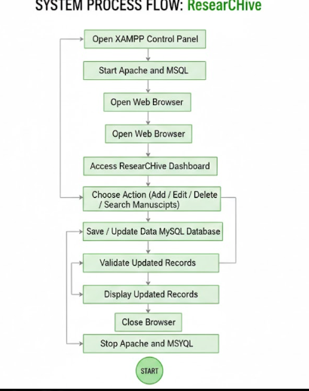
Flowchart

The system process is divided into four main functional areas:
Start & Access
- Start: The process begins by activating the local environment.
- Open XAMPP: The user must start Apache and MySQL in XAMPP to run the server locally.
- Open Browser: The user opens their web browser and navigates to http://localhost/ResearcHive/ to access the main dashboard (index.php).
Data Management (Add/Edit/Delete)
- This section handles the CRUD operations based on user needs.
- Add New: If adding a file, the user fills out the form with the Title, Author, Section, and Strand, and uploads the file. The system validates the data and saves it to the MySQL database.
- Edit: If updating, the user selects a record to modify existing details.
- Delete: If removing, the user initiates a delete request, which the system executes after confirmation, removing both the file and the database record.
Search & Filter
- Live Search: The user types keywords into the search bar. JavaScript instantly filters the table rows to show only relevant manuscripts based on Title, Author, Section, or Strand.

End Session
- End: Once the user has finished managing or finding files, they close the browser and stop the Apache and MySQL services in the XAMPP control panel.

Entity Relationship Diagram (ERD)
The database of ResearcHive consists of the following main entities and their relationships:
- Sections - Stores section information including id (PK) and section_name.
- Strands - Stores academic strand information including id (PK) and strand_name.
- Manuscripts - Stores research manuscript records including id (PK), title, author, abstract, keywords, publication_year, adviser, section_id (FK referencing sections.id), strand_id (FK referencing strands.id), file_path, upload_date, and status.
- Downloads - Stores manuscript download records including id (PK), manuscript_id (FK referencing manuscripts.id), and download_date.
The sections table has a one-to-many relationship with the manuscripts table, as one section can have multiple manuscripts. The strands table also has a one-to-many relationship with the manuscripts table, since one strand can be associated with multiple manuscripts. Furthermore, the manuscripts table has a one-to-many relationship with the downloads table, as one manuscript can be downloaded multiple times.
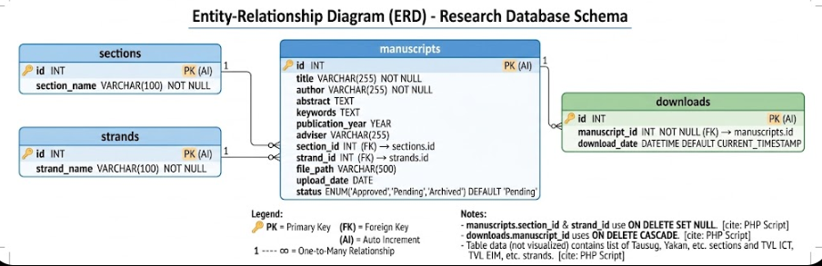
All id fields use Auto Increment as the Primary Key to uniquely identify each record in the database.

DEVELOPMENT

Programming Languages and Tools
To achieve a high-performance offline environment, the following stack was utilized:
- Backend Logic: PHP was used to process data, handle file uploads, and communicate with the database.
- Database Management: MySQL served as the relational database to store manuscript metadata (Title, Author, Strand, etc.).
- Frontend Interface: (via Bootstrap 5) were used to create a responsive, user-friendly dashboard.
- Interactivity: JavaScript was implemented for "Live Search" filtering and SweetAlert2 for professional-looking pop-up confirmations.
- Local Server: XAMPP provided the Apache server and MySQL environment needed to run the system without internet.

Implementation Steps
The proponents followed these four critical steps to build the system:
- Design the User Interface: Created the dashboard (index.php) and the submission forms (add.php) using Bootstrap to ensure the layout is clean and professional.
- Write Code for Backend and Frontend: Developed the PHP scripts to handle the "logic" of the system, such as moving uploaded files to a local folder and displaying records in a table.
- Implement Database Integration: Established a connection between the PHP code and the MySQL database using a configuration file (db_conn.php) to allow for data persistence.
- Integrate Functionalities and Test: Combined the Search, Edit, and Delete features into the main dashboard and conducted local testing to ensure all buttons worked correctly without an internet connection.

Testing Methods
To ensure the reliability of the repository, the proponents conducted three levels of testing:
- Unit Testing: Each individual function was tested in isolation. For example, the proponents tested the "File Upload" script separately to ensure it correctly moves files to the uploads/ folder before connecting it to the database.
- Integration Testing: This tested how the different parts of the system worked together. The proponents verified that when a user fills out the add.php form, the data is correctly sent to the MySQL database and immediately appears on the index.php dashboard.
- User Acceptance Testing (UAT): The system was presented to a sample group of students and teachers at DCDNHS. They performed real-world tasks (like searching for a specific strand) to confirm the interface was easy to navigate and met their academic needs.

Test Cases
The following sample test cases were used during the system evaluation phase:
Test Case 1 — Offline Access: Open the browser and navigate to localhost/ResearcHive while the internet is disconnected. Expected result: System loads all styles (Bootstrap) and icons (FontAwesome) correctly from local folders. Result: Passed.
Test Case 2 — Manuscript Upload: Fill in the Title, Author, Strand, and Section, and attach a PDF file in the add.php form. Expected result: The file is saved in the local uploads/ directory and metadata appears in the dashboard. Result: Passed.
Test Case 3 — Live Search/Filtering: Type a specific research "Strand" (e.g., STEM) into the search bar. Expected result: The table instantly filters to show only manuscripts matching that strand without reloading the page. Result: Passed.
Test Case 4 — Data Validation: Attempt to save a manuscript without selecting a "Section" or "Strand." Expected result: The system prevents submission and displays a warning message. Result: Passed.
Test Case 5 — Edit Record: Select an existing research entry and update the "Author" field. Expected result: The changes are reflected in the MySQL database and updated on the main dashboard. Result: Passed.
Test Case 6 — Delete Function: Click the "Delete" button on a specific manuscript entry. Expected result: A SweetAlert confirmation appears; upon clicking "Yes," the record is removed from the table and the database. Result: Passed.
Test Case 7 — CSV Export: Click the "Export" button to generate a summary of all stored research. Expected result: System downloads a .csv file containing all current manuscript metadata for backup purposes. Result: Passed.

Testing Results Summary
The testing phase confirmed that ResearcHive is a stable and efficient tool for DCDNHS. By hosting all assets locally, the system eliminated the "latency" typically found in cloud-based storage, allowing for near-instant search results. During the Integration Testing, the proponents ensured that the PHP backend successfully communicated with the MySQL "digital filing cabinet" to store and retrieve data in a split second.

User Manual
This manual provides the necessary steps to set up, operate, and troubleshoot the ResearcHive Manuscript Repository System for Doña Carmen Denia National High School (DCDNHS).

Installation and Setup Instructions:
Since ResearcHive is an "offline-first" web application, it requires a local server environment to run. Follow these steps to install and launch the system:
- Install XAMPP: Download and install the XAMPP control panel (Version 8.0 or higher) to provide the Apache server and MySQL database.
- Start Services: Open the XAMPP Control Panel. You must click the "Start" button for both Apache and MySQL. Ensure both modules turn green, indicating they are active.
- Deploy System Files: Copy your ResearcHive project folder into the C:/xampp/htdocs/ directory.
Database Setup:
      - Open a browser and go to http://localhost/phpmyadmin.
      - Create a new database named researchive1_db.
      - Import the provided manuscripts.sql file to generate the required tables.
Access the Dashboard: Open your web browser paste this and navigate to http://localhost/ResearcHive/ to begin managing manuscripts.
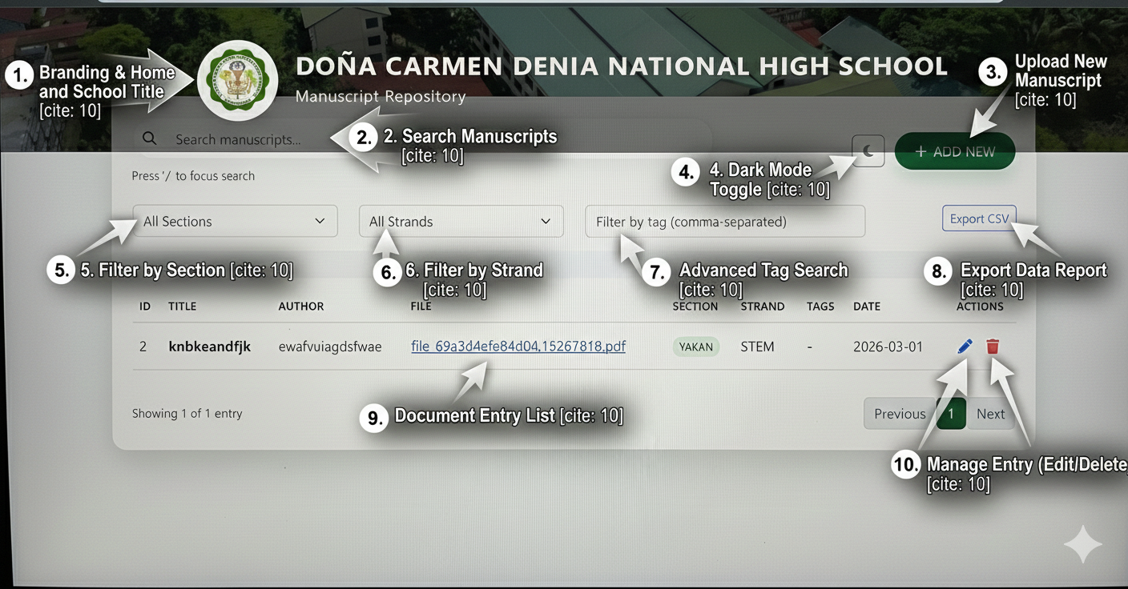
User Interface Function Explanations:
1. Branding & Home: This callout points to the DCDNHS logo and school title. This confirms the institutional branding and typically acts as a link to return to this home dashboard view from other pages.
2. Search Manuscripts: The central search bar. Type keywords here (Title, Author, or Section) to quickly filter the manuscript list below. A shortcut hint (/) reminds users of a fast way to focus the search bar.
3. Upload New Manuscript: This green button with a '+' symbol opens the submission form (e.g., add.php), allowing authorized users to upload a new manuscript PDF and input its metadata (Title, Author, Section, Strand, etc.).
4. Dark Mode Toggle: This callout points to the moon icon. Clicking this toggles between light and dark modes, allowing users to customize the interface theme for comfort.
5. Filter by Section: A dropdown filter. Select a specific "Section" from this list (e.g., YAKAN, TAUSUG) to narrow the table display.
6. Filter by Strand: Another dropdown filter. Use this to filter the table results by academic "Strand" (e.g., STEM, ICT).
7. Advanced Tag Search: This input box allows for more specific searching. You can enter comma-separated tags to find manuscripts related to specific research topics or keywords.
8. Export Data Report: This callout points to the "Export CSV" button. Clicking this generates and downloads a .csv file containing the data from the current (filtered) list, suitable for external reports or data analysis.
9. Document Entry List: The main data table. Each row represents a single research manuscript with key metadata columns: ID, Title, Author, File (which is a link to view the document), Section, Strand, Tags, and Date uploaded. The specific entry shown is "knbkeandfjk" by "ewafvuiagdsfwae" in the YAKAN section and STEM strand, uploaded on 2026-03-01.
10. Manage Entry (Edit/Delete): Located in the 'ACTIONS' column, these callouts point to the management tools for a specific manuscript entry.
The blue pencil icon allows the Admin/User to edit the metadata for that specific entry.
The red trash icon allows the user to delete that specific record from the database and the repository. (These icons work in tandem with confirmation prompts as described in your study).
Troubleshooting
To address potential issues encountered while using ResearcHive, users should refer to the following solutions. If the dashboard fails to load, it is likely because the Apache or MySQL modules have not been "Started" in the XAMPP Control Panel. A "Database Error" typically indicates a database name mismatch, requiring the user to ensure the database is named exactly researchive_db. If the search function is not filtering results, it is likely that JavaScript is disabled in the user's browser settings and needs to be enabled. Finally, if a file upload fails, it is usually because the file is too large, necessitating an increase in the upload_max_filesize setting within the XAMPP php.ini file.

Conclusion

Summary of Work
The development of ResearcHive successfully achieved the project goal of creating a functional, centralized, and offline-first manuscript repository system for Doña Carmen Denia National High School (DCDNHS). The system effectively digitizes the archival process, enabling authorized users to upload, edit, delete, and search for research manuscripts within a local network environment. By utilizing PHP and MySQL within the XAMPP environment, the project eliminates the dependency on internet connectivity for document management, providing a reliable, sustainable solution for the school's archival needs.

Challenges Encountered
During development, the proponents faced several significant challenges.
- Ensuring Offline Functionality: The system needed to work without an internet connection. Originally, the system relied on internet-based files to run the interface, which caused it to fail when offline. To fix this, the team downloaded all necessary files and saved them locally.
- Managing File Upload Limits: The system was restricted in the size of files it could accept. This meant large research papers could not be uploaded. To solve this, the team changed the PHP settings on the local server to increase the maximum allowed file size.

Future Improvements
To further enhance ResearcHive, several future improvements are suggested:
- Transition to Online System: Migrate the system to a web-based hosting environment to allow remote access for students and faculty outside the school's local network.
- User Role Management: Introduce restricted login capabilities to differentiate between administrators who can manage all data and regular users who can only view or upload documents.
- QR Code Integration: Implement a feature that generates a unique QR code for each manuscript, allowing users to quickly scan and access abstracts on mobile devices.
- Advanced Analytics Dashboard: Add visualization tools to display statistics on research production by strand and section, helping the administration monitor academic trends.

REFERENCES

Laudon, K. C., & Laudon, J. P. (2020). Management Information Systems: Managing the
Digital Firm. Pearson.
Turban, E. (2018). Information Technology for Management: On-Demand Strategies for
Performance, Growth and Sustainability. Wiley.
Suleman, H. (2008). Digital Libraries in Low-bandwidth Settings. University of Cape Town.
EdTech Magazine (2023). How Higher Ed Institutions Are Responding to Google Storage Limits.
Magle, T., & McCaffrey, D. (2023). Why Can't I just use Dropbox? A comparison of cloud platforms for research. Journal of eScience Librarianship.
ResearchGate (2022). The Use of Google Drive in Public Schools: Motivation and Collaboration.
Suleman, H. (2008). Digital Libraries in Low-bandwidth Settings. University of Cape Town.
UNESCO (2023). Technology in Education: A Case Study on the Philippines regarding the Connectivity Gap

APPENDICES

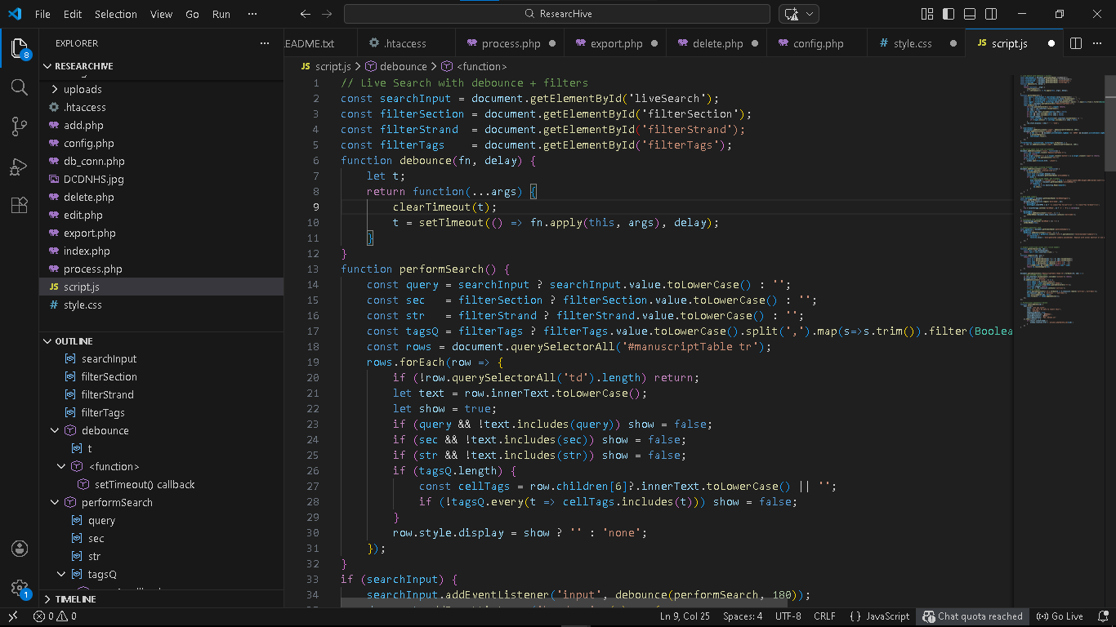
APPENDICES A: PHP, MYSQL CODES

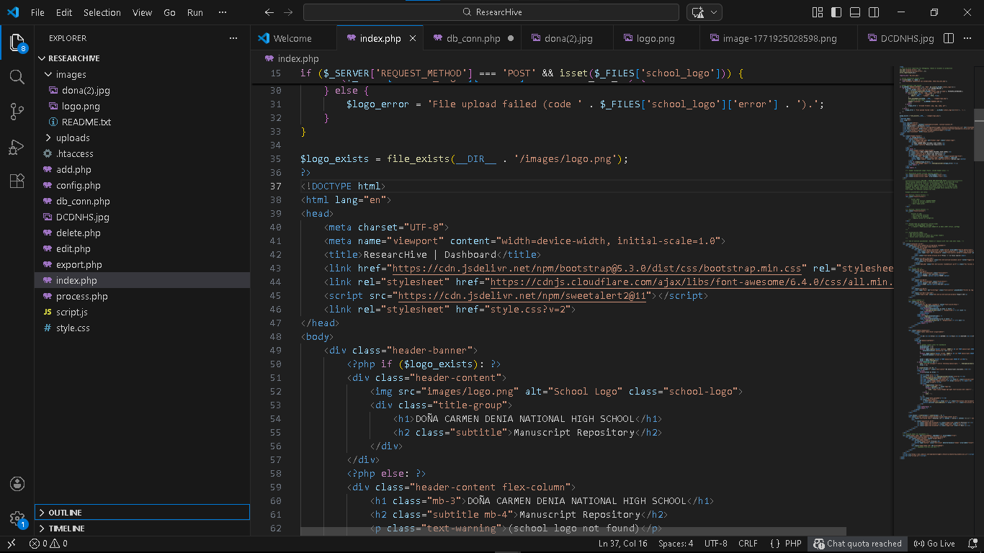

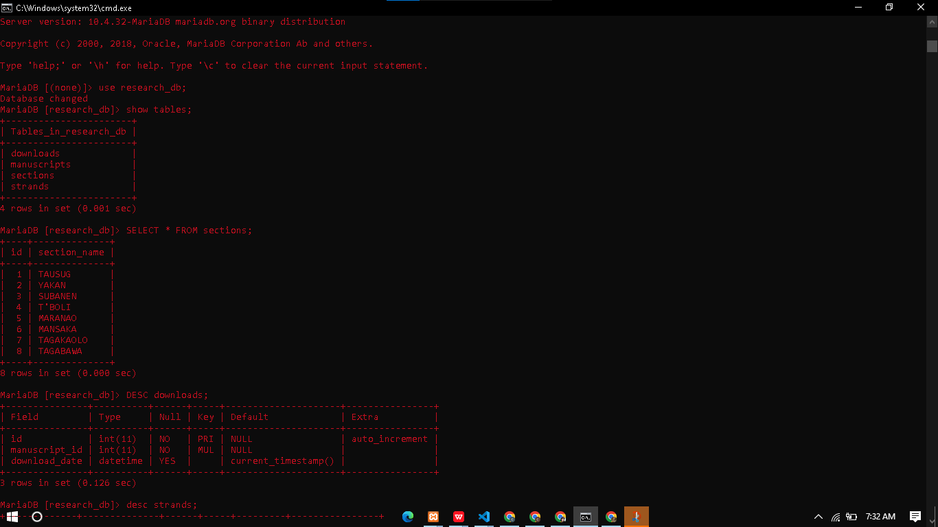
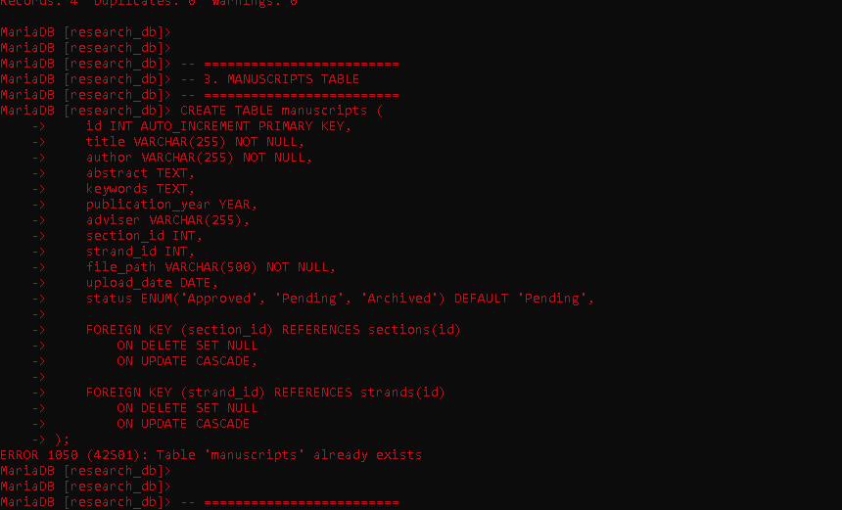

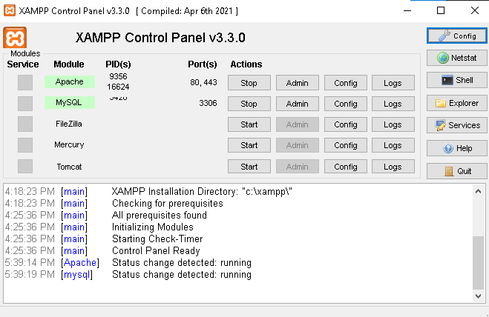
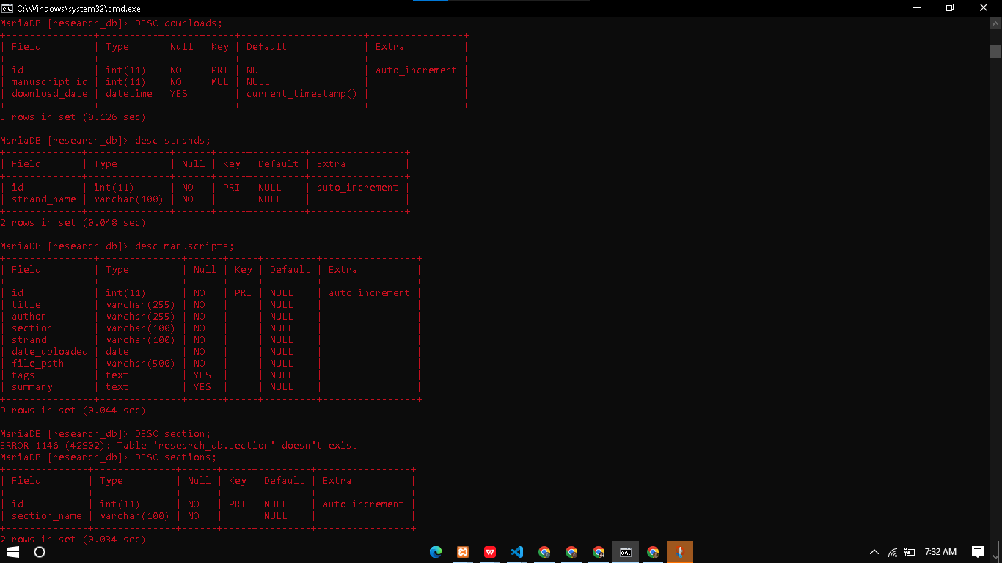
APPENDIX B: Additional Screenshots/Diagrams/Flowchart/UI






