

DOÑA CARMEN DENIA NATIONAL HIGH SCHOOL
Tugbok District, Davao City

CoffinCart: Angel Funeral Management System
Online Coffin Ordering and Funeral Package System

A Capstone Project Manuscript
Presented to the Faculty of
DOÑA CARMEN DENIA NATIONAL HIGH SCHOOL

In Partial Fulfillment of the Requirements for
Senior High School Capstone Project

Proponents:
Pangalaga, Mark Lawrence M.
Alviza, Rey Vincent M.
Custodio, Ris laniel P.
Dela Cuesta, Jhea B.
Palaca, Cris John A.

Grade & Section: XII – TAUSUG
Subject Teacher: Philip John M. Belo

School Year: 2025 – 2026
Date of Submission: March 4, 2026

TABLE OF CONTENTS
Introduction .....................................................................................................
Problem Statement ........................................................................................
Objectives ....................................................................................................
Scope ............................................................................................................
Significance ..................................................................................................
Literature Review ................................................................................................
Existing Solutions .........................................................................................
Technology Overview ...................................................................................
Related Works ...............................................................................................
System Requirements ...........................................................................................
Functional Requirements ..............................................................................
Non-Functional Requirements .....................................................................
Hardware Requirements ................................................................................
Software Requirements .................................................................................
System Design ......................................................................................................
System Architecture ......................................................................................
Flowchart .......................................................................................................
Entity Relationship Diagram (ERD) .............................................................
Development ..........................................................................................................
Programming Languages and Tools ..............................................................
Implementation Steps ....................................................................................
Testing .....................................................................................................................
Testing Methods ............................................................................................
Test Cases ......................................................................................................
Results ............................................................................................................
User Manual ............................................................................................................
Installation Instructions ................................................................................
User Interface Guide ......................................................................................
Troubleshooting .............................................................................................
Conclusion ................................................................................................................
Summary of Work ..........................................................................................
Challenges Encountered .................................................................................
Future Improvements ......................................................................................
References .................................................................................................................
Appendices .................................................................................................................

INTRODUCTION
Problem Statement
The funeral service industry plays a vital role in supporting families during one of the most emotionally challenging moments of their lives. Despite this importance, many funeral homes still rely heavily on manual and paper-based processes to manage client records, schedule services, coordinate staff, and process documents such as contracts and billing statements. These traditional methods often result in delayed services, misplaced records, miscommunication, and increased stress for both employees and grieving families.
Angel Funeral Services, the partner organization of this project, faces these same challenges. Client records are stored in physical folders, scheduling is done manually, billing is computed by hand, and staff communication relies on verbal instructions. These inefficiencies have become increasingly difficult to manage, especially during peak service periods. There is a clear need for a digital solution that can centralize and automate these operations to improve the quality and consistency of service delivery.

Objectives
The primary objective of this project is to design, develop, and implement CoffinCart — the Angel Funeral Management System — a desktop-based application that automates and centralizes the operational processes of Angel Funeral Services.

Specifically, the project aims to:
1. Identify the existing problems and inefficiencies in the current manual funeral service management practices of Angel Funeral Services.
2. Design and develop CoffinCart as a desktop-based system using Java, NetBeans IDE, MySQL via XAMPP, and JDBC that addresses the organization's operational needs.
3. Implement key modules including client registration, service scheduling, billing computation, inventory management, and report generation.
4. Evaluate the system's functionality, usability, and performance through testing and user feedback.
5. Measure improvements in administrative accuracy, time efficiency, and service quality following system implementation.

Scope
CoffinCart — the Angel Funeral Management System — is a desktop-based application developed specifically for Angel Funeral Services. The system covers the following operational areas:
• Client registration and profile management
• Service and funeral package ordering (coffins, ceremonial items, flower sets, etc.)
• Shopping cart functionality and order tracking
• Admin panel for inventory management, order monitoring, and report generation
• Secure login authentication for both admin and customer users

The system does not include online payment integration, mobile application development, cloud-based storage, or integration with external government or healthcare systems. It is designed exclusively for use within Angel Funeral Services and is not intended as a general-purpose commercial product.

Significance
Angel Funeral Services: The system directly improves the operational efficiency of Angel Funeral Services by replacing manual processes with automated digital workflows. Management gains access to accurate, real-time records and reports that support better decision-making.
Employees and Staff: Staff members benefit from reduced administrative workload through automated scheduling, billing computation, and record management. This allows them to focus more on providing compassionate care to clients.
Clients and Families: Grieving families benefit from faster, more organized service transactions. The ability to browse available funeral products and packages through a structured digital system reduces confusion and improves the overall experience during difficult times.
Future Developers and Researchers: This project contributes to the growing body of research on digital transformation in funeral services and may serve as a reference for similar systems in other service-oriented organizations.

LITERATURE REVIEW
Existing Solutions
Several digital solutions for funeral service management already exist at both international and local levels. Internationally, platforms such as Funeral One and Passare provide comprehensive digital tools for scheduling, billing, record management, and client communication. These systems have demonstrated that centralized digital platforms significantly improve workflow efficiency and service consistency in funeral homes. However, most of these solutions are designed for large-scale funeral operations and come with high licensing costs, making them financially inaccessible for smaller, locally operated funeral services like Angel Funeral Services.
Locally, the EVERYPLAN system developed by Victorio, Panday, Lopez, Ocampo Jr., and Maceda (2025) showed how a multiplatform funeral arrangement system can improve coordination between funeral service providers and families. While effective in facilitating client-side funeral planning, EVERYPLAN focuses less on internal administrative operations such as staff coordination, billing automation, and inventory tracking. This gap highlights the need for a more operationally focused system like CoffinCart.

Technology Overview
CoffinCart was developed using the following technologies:
• Java Programming Language: A platform-independent, object-oriented programming language used for building the application logic and backend processing of CoffinCart. Java was chosen for its reliability, wide industry use, and strong support for database connectivity.
• NetBeans IDE: An integrated development environment used to design and build the graphical user interface (GUI) of CoffinCart. NetBeans provides a drag-and-drop Java Swing form designer, which allowed the team to visually create and arrange UI components such as buttons, tables, text fields, and panels without manually writing layout code.
• MySQL: A relational database management system used to store all system data including customer records, orders, inventory, and admin credentials. MySQL was selected for its performance, reliability, and compatibility with Java applications.
• XAMPP: A local server environment used to host and run the MySQL database on the development machine. XAMPP allowed the team to set up and manage the MySQL server locally without requiring an internet connection or external hosting.
• JDBC (Java Database Connectivity): A Java API used to establish the connection between the Java application and the MySQL database. JDBC enabled the system to perform data operations such as inserting, retrieving, updating, and deleting records from the database.

Related Works
Studies in management information systems consistently emphasize that digital transformation improves organizational efficiency, data accuracy, and service quality. Laudon and Laudon (2020) explained that management information systems help organizations automate routine tasks, reduce human error, and support better decision-making. O'Brien and Marakas (2019) similarly emphasized that computerized scheduling and centralized databases significantly reduce miscommunication and service delays.
Number Analytics (2025) specifically noted that funeral homes adopting digital management systems reported smoother operations, reduced paperwork, and higher client satisfaction. Reyes and Santos (2022) further confirmed that small and medium enterprises shifting from manual to digital processes experienced better data accuracy and faster transactions. Dela Cruz et al. (2021) likewise concluded that digital systems significantly reduce administrative workload in service-based organizations.
These related works collectively support the development of CoffinCart as a practical and necessary solution to the operational challenges of Angel Funeral Services.

SYSTEM REQUIREMENTS
Functional Requirements
CoffinCart shall provide the following core functionalities:
• User Authentication: The system shall require users to log in using valid credentials before accessing any system features. Separate login portals are provided for admin users and customer users.
• Customer Registration and Management: The system shall allow new customers to register accounts and allow admins to view, update, and manage customer profiles.
• Product and Inventory Management: The admin shall be able to add, update, and remove funeral products (coffins, ceremonial items, flower sets, etc.) along with their prices and stock quantities.
• Shopping Cart and Order Placement: Customers shall be able to browse available products, add items to a cart, and place orders.
• Order Management: The admin shall be able to view, update, and manage all customer orders and their statuses.
• Billing and Payment Recording: The system shall automatically compute billing based on selected products and quantities, and record payment information.
• Report Generation: The admin shall be able to generate summary reports on orders, inventory, and client transactions.

Non-Functional Requirements
• Security: The system shall enforce login authentication to prevent unauthorized access. Passwords shall be stored securely in the database.
• Usability: The system shall feature a simple, clean, and intuitive interface that can be easily used by staff with minimal technical training.
• Performance: The system shall respond to user inputs and database queries within an acceptable time frame during normal operations.
• Reliability: The system shall maintain data accuracy and integrity at all times, preventing data loss or corruption during normal operations.
• Maintainability: The system code shall be organized and documented to allow future developers to easily understand, update, and extend the system.

Hardware Requirements
• Processor: Intel Core i3 or equivalent (minimum)
• RAM: 4GB minimum
• Storage: 500GB HDD or SSD
• Operating System: Windows 7 / 8 / 10 / 11
• Display: Monitor with at least 1024 x 768 resolution

Software Requirements
• Java Development Kit (JDK) 8 or higher
• NetBeans IDE 8.2 or higher
• XAMPP (for MySQL Server hosting)
• MySQL Connector/J (JDBC Driver) for Java-to-MySQL connection
• MySQL Workbench or phpMyAdmin (for database management)

SYSTEM DESIGN
System Architecture
CoffinCart follows a three-layer desktop application architecture:
• Presentation Layer: The graphical user interface built using Java Swing forms in NetBeans IDE. This is what the user sees and interacts with — login pages, dashboards, product listings, cart, and admin panels.
• Application Layer: The business logic layer written in Java. This layer processes user inputs, applies rules such as billing computation and login validation, and communicates with the database layer.
• Database Layer: The MySQL database hosted through XAMPP. This layer stores and manages all system data including customer accounts, orders, inventory, and admin credentials. JDBC connects the application layer to this layer.

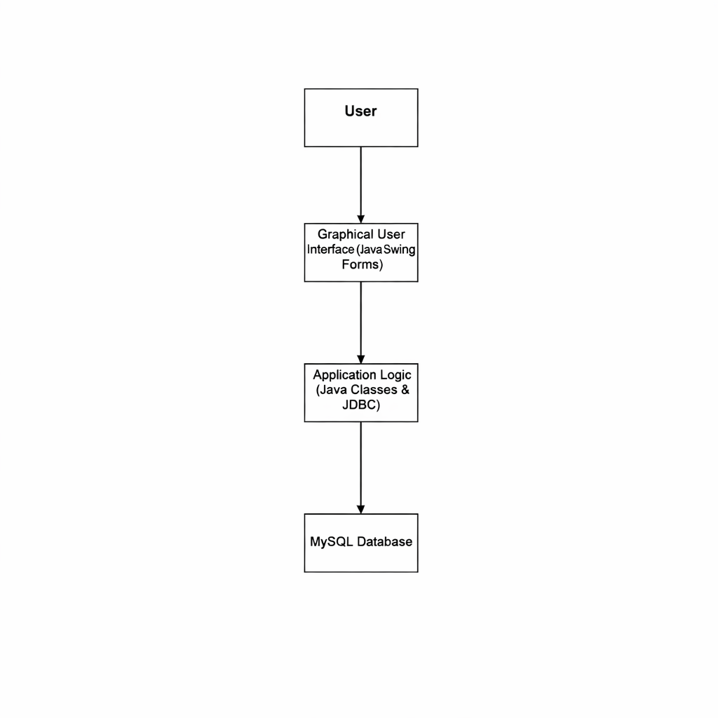
The user interacts with the GUI (Presentation Layer). User actions trigger the Java application logic (Application Layer), which processes the request and communicates with the MySQL database (Database Layer) through JDBC for data storage and retrieval.

Flowchart
The flowchart below illustrates the general logic and process flow of CoffinCart:
• Start: The system launches and presents the login selection screen.
• User Login: The user selects either Admin Login or Customer Login and enters credentials.
• Credential Validation: The system checks the credentials against the database. If invalid, an error message is displayed and the user is redirected to the login screen.
• Dashboard Access: Upon successful login, the appropriate dashboard is displayed (Admin Dashboard or Customer Dashboard).
• Process Data: The user performs actions such as browsing products, adding to cart, placing orders, or managing inventory.
• Save to Database: All data inputs and transactions are saved to the MySQL database via JDBC.
• Display Confirmation: The system displays a confirmation message for successful operations.
• End: The user logs out and the session is terminated.
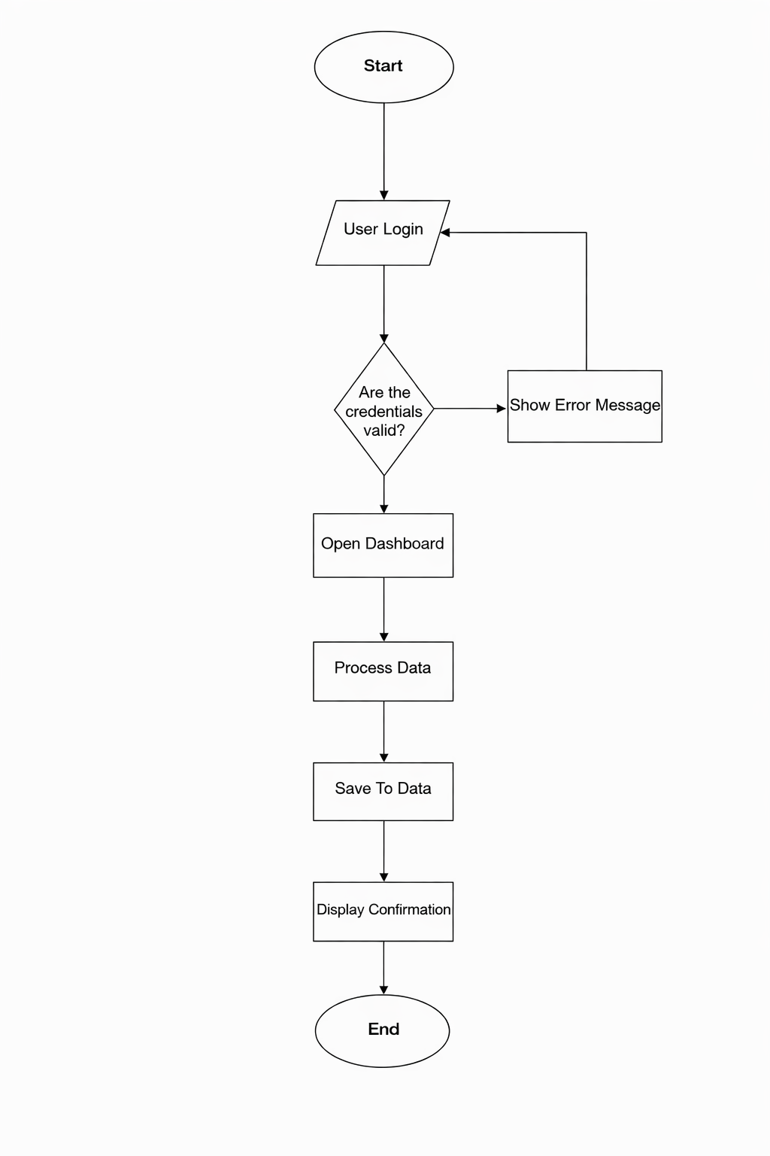

Entity Relationship Diagram (ERD)
The database of CoffinCart consists of the following main entities and their relationships:
• customers: Stores customer account information including id (PK), full_name, username (UNIQUE), password, address, and created_at timestamp.
• admins: Stores administrator credentials including id (PK), username (NOT NULL), and password (NOT NULL).
• inventory: Stores funeral product information including id (PK), name, stock, and price.
• orders: Stores order transaction records including id (PK), customer_id (FK referencing customers.id), customer_name, address, product_name, quantity, and status.

The customers table has a one-to-many relationship with the orders table, as one customer can place multiple orders. The inventory table is linked to orders through the product_name field. All id fields use Auto Increment as the Primary Key.
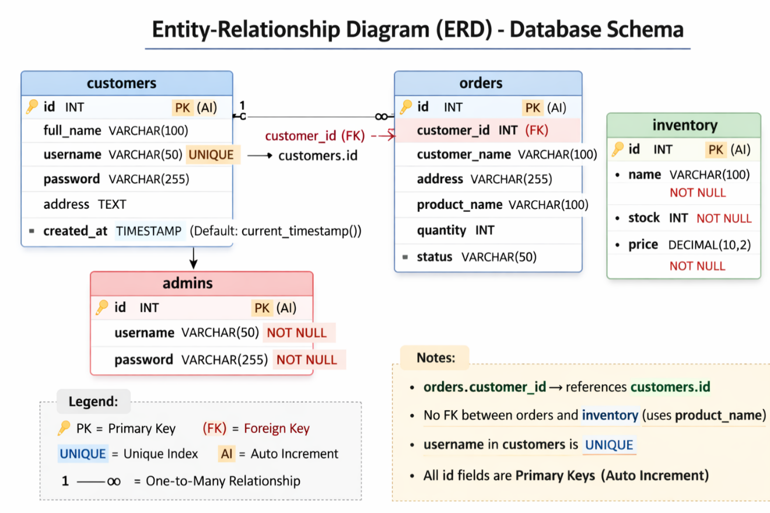
DEVELOPMENT
Programming Languages and Tools
CoffinCart was developed using the following programming languages and tools:
• Java: The primary programming language used for all application logic, UI components, and database operations.
• NetBeans IDE: Used as the development environment and UI design tool. The Java Swing Form Designer in NetBeans was used to visually design all screens and layout components of the application.
• MySQL: Used as the relational database management system to store and manage all application data.
• XAMPP: Used to host the MySQL server locally during development and deployment.
• JDBC (MySQL Connector/J): Used to establish the connection between the Java application and the MySQL database, enabling data operations.
• SQL: Used to write database queries for creating tables, inserting data, retrieving records, and managing database operations.

Implementation Steps
The development of CoffinCart followed a structured step-by-step process:

1. Database Design and Setup: The team designed the database schema by identifying the required entities — customers, admins, inventory, and orders — and their relationships. The database named 'coffincart_desktop' was created in MySQL via XAMPP. Tables were created using SQL scripts, and appropriate primary keys, foreign keys, and constraints were applied.
2. Database Connection Configuration: The DBConnection.java class was written to establish a connection between the Java application and the MySQL database using JDBC. The connection URL, username, and password were configured to point to the local XAMPP MySQL instance.
3. User Interface Design: All screens were designed using the Java Swing Form Designer in NetBeans IDE. The team visually arranged UI components including JFrames, JPanels, JButtons, JLabels, JTextFields, JTables, and JScrollPanes for each module: login page, customer dashboard, product listings, shopping cart, admin panel, inventory management, and order management.
4. Backend Logic Implementation: Java code was written to handle all application logic including login authentication, customer registration, product display, cart management, order placement, billing computation, inventory updates, and report generation. Each form was connected to corresponding database operations through JDBC queries.
5. Integration of Modules: All individual modules were integrated into a unified system. Navigation between screens was implemented so users can move seamlessly between the login page, dashboard, cart, and admin features.
6. Testing and Debugging: The system underwent unit testing, integration testing, and user acceptance testing. Bugs and issues identified during testing were resolved through code revisions and database adjustments.

TESTING
Testing Methods
• Unit Testing: Individual modules were tested in isolation to verify that each function works as expected. For example, the login authentication module was tested separately to confirm that valid credentials grant access and invalid credentials display an error message.
• Integration Testing: After individual modules were verified, they were tested together to ensure proper interaction. For example, the cart module was tested with the inventory module to confirm that stock quantities are correctly updated when an order is placed.
• User Acceptance Testing (UAT): Selected staff and management of Angel Funeral Services were asked to operate the system and provide feedback on usability, functionality, and overall experience. Their responses were used to make final adjustments before full deployment.

Test Cases
The following sample test cases were used during testing:

• Test Case 1 — Valid Login: Input valid admin username and password. Expected result: System opens the Admin Dashboard. Result: Passed.
• Test Case 2 — Invalid Login: Input incorrect username or password. Expected result: System displays an error message and returns to login screen. Result: Passed.
• Test Case 3 — Customer Registration: Fill in all required registration fields and submit. Expected result: New customer account is saved to the database. Result: Passed.
• Test Case 4 — Add to Cart: Customer selects a product and clicks 'Add to Cart.' Expected result: Product is added to the cart with correct price and quantity. Result: Passed.
• Test Case 5 — Place Order: Customer proceeds to checkout and confirms order. Expected result: Order is saved to the orders table and inventory stock is updated. Result: Passed.
• Test Case 6 — Admin Inventory Update: Admin adds a new product to the inventory. Expected result: New product appears in the inventory table and is available for customer ordering. Result: Passed.
• Test Case 7 — Report Generation: Admin requests a summary report. Expected result: System generates a report displaying order and transaction data. Result: Passed.

Results
The testing results confirmed that CoffinCart met all its functional requirements. Login authentication worked correctly for both admin and customer users. Client registration, product management, cart operations, order placement, billing computation, and report generation all performed as expected. Minor interface adjustments and bug fixes were made during the testing phase based on user feedback. Overall, the system demonstrated stable performance and reliable data handling throughout all test scenarios.

USER MANUAL
Installation Instructions
1. Install Java Development Kit (JDK) version 8 or higher on the computer.
2. Install NetBeans IDE version 8.2 or higher.
3. Install XAMPP and start the Apache and MySQL services from the XAMPP Control Panel.
4. Open phpMyAdmin (http://localhost/phpmyadmin) and create a new database named 'coffincart_desktop.'
5. Import the provided SQL file (coffincart_desktop.sql) into the newly created database to generate all required tables and initial data.
6. Open the CoffinCart project folder in NetBeans IDE.
7. Ensure the MySQL Connector/J (JDBC driver) .jar file is added to the project libraries.
8. Run the project from NetBeans by clicking the Run button or pressing F6.

User Interface Guide
Upon launching CoffinCart, the main login selection screen is displayed. The user may choose between Admin Login and Customer Login.

• Admin Login: Admin users enter their username and password to access the Admin Dashboard. From the dashboard, admins can manage inventory (add, edit, delete products), view and update customer orders, manage customer accounts, and generate reports.
• Customer Login: Customers enter their registered username and password to access the Customer Dashboard. From the dashboard, customers can browse available funeral products and packages, add items to the cart, view cart contents and computed billing, and place orders.
• Navigation: All screens include a navigation bar with buttons for Cart, Services, and Logout. Users can move between sections easily by clicking the corresponding buttons.

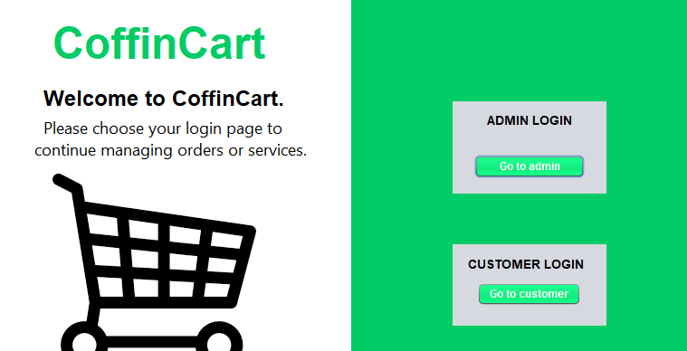

Troubleshooting
• Problem: System fails to connect to the database. Solution: Ensure XAMPP is running and both Apache and MySQL services are active. Check that the database name, username, and password in DBConnection.java match your XAMPP MySQL configuration.
• Problem: Login fails even with correct credentials. Solution: Verify that the user account exists in the database. Open phpMyAdmin, check the customers or admins table, and confirm the account is registered.
• Problem: Products do not appear in the customer dashboard. Solution: Ensure that products have been added to the inventory table by the admin. Check that the stock value is greater than zero.
• Problem: Application does not launch. Solution: Ensure that JDK is properly installed and configured. Verify that the MySQL Connector/J .jar file is included in the project's library dependencies in NetBeans.

CONCLUSION
Summary of Work
This project designed, developed, and implemented CoffinCart — the Angel Funeral Management System — a desktop-based application built using Java, NetBeans IDE, MySQL via XAMPP, and JDBC. The system was developed to address the operational challenges of Angel Funeral Services, which previously relied on manual and paper-based processes for managing client records, scheduling, billing, and inventory.
CoffinCart provides a centralized digital platform that includes secure login authentication for both admin and customer users, customer registration and management, funeral product browsing and shopping cart functionality, automated billing computation, order management, inventory control, and report generation. The system was thoroughly tested and evaluated, and the results confirmed that it met all defined functional and non-functional requirements. Measurable improvements in efficiency, accuracy, and coordination were observed following implementation.

Challenges Encountered
• Database Connection Issues: Early in development, configuring the JDBC connection between Java and MySQL via XAMPP resulted in connection errors. This was resolved by correctly configuring the DBConnection.java class and ensuring the MySQL Connector/J driver was properly added to the project libraries.
• UI Layout Design: Designing a clean and functional interface using Java Swing forms required multiple revisions. The team had to balance usability with the visual presentation of product listings, the cart, and the admin dashboard.
• Foreign Key and Database Relationships: Establishing proper relationships between the customers, orders, and inventory tables required careful planning and testing to ensure data integrity and correct foreign key references.
• Integration of Modules: Connecting all individual modules (login, cart, orders, inventory, admin) into a seamless and functional system required extensive testing and debugging to resolve issues arising from module interactions.

Future Improvements
• Web-Based Version: Developing a web-based version of CoffinCart using technologies such as HTML, CSS, JavaScript, and PHP would allow users to access the system from any device with a browser, removing the limitation of desktop-only access.
• Online Payment Integration: Adding support for online payment methods such as GCash, PayMaya, or credit card payment would improve convenience for clients placing orders remotely.
• Mobile Application: Developing a companion mobile app would allow staff and clients to access the system on smartphones, improving accessibility and real-time updates.
• Cloud Database: Migrating the database from a local XAMPP server to a cloud-based database service would enable multi-branch access and improve data backup and recovery.
• Advanced Reporting and Analytics: Adding more detailed reports and data analytics features would help management make better-informed decisions about operations and service offerings.

REFERENCES
Dela Cruz, J. R., Mendoza, A. L., Santos, P. M., & Villanueva, K. T. (2021). Adoption of information systems in service-based organizations in the Philippines. Journal of Information Technology and Business Studies, 5(2), 45–58.
Funeral Program Site. (2025). Funeral management challenges and solutions in modern funeral homes. Funeral Program Site.
Laudon, K. C., & Laudon, J. P. (2020). Management information systems: Managing the digital firm (16th ed.). Pearson Education.
Number Analytics. (2025). Funeral management software: Trends, benefits, and industry insights. Number Analytics.
O'Brien, J. A., & Marakas, G. M. (2019). Management information systems (11th ed.). McGraw-Hill Education.
Reyes, M. L., & Santos, R. D. (2022). Digital service management systems for small and medium enterprises. Philippine Journal of Business and Technology, 7(1), 23–36.
Victorio, J. P., Panday, R. L., Lopez, M. A., Ocampo Jr., F. R., & Maceda, C. D. (2025). EVERYPLAN: A multiplatform funeral arrangement and management system for funeral services. International Journal of Computing and Information Systems, 10(1), 1–12.

APPENDICES
Appendix A: Database Connection Code (DBConnection.java)
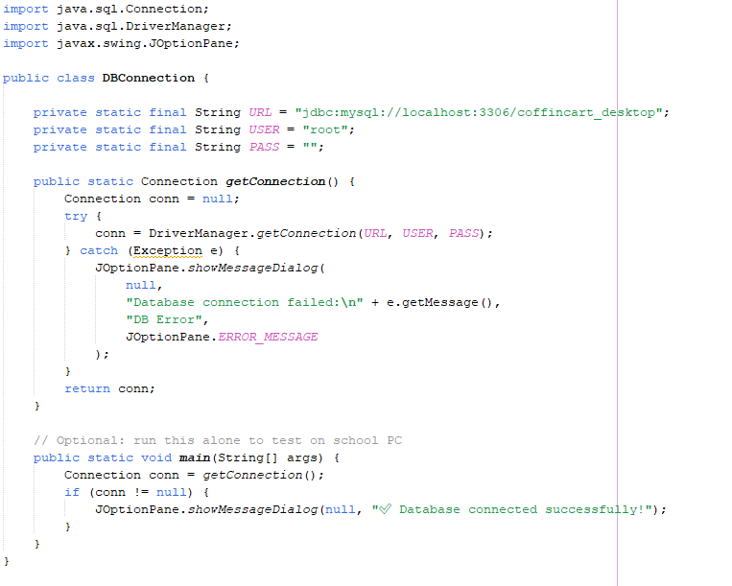
Appendix B: System Screenshots

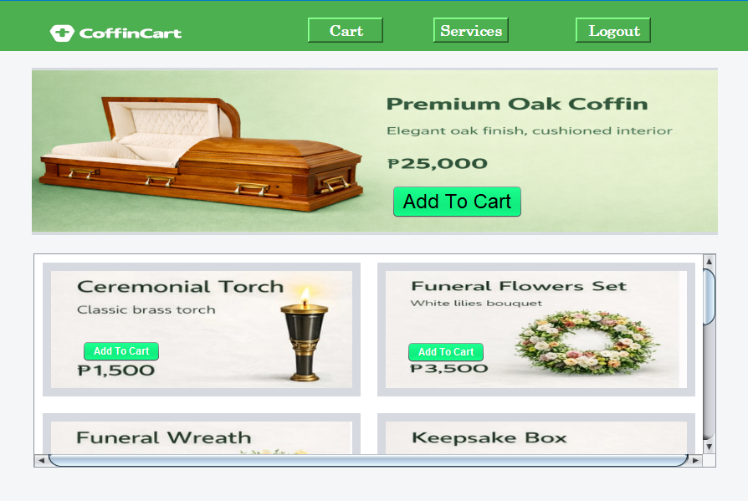
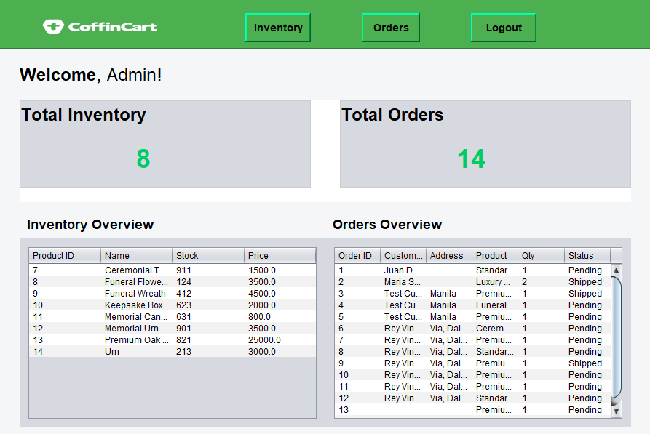

Appendix C: ERD and Flowchart Diagrams

