Coding Challenge 2: Gene Expression
Dataset: set_9 (A_vs_D.deseq2.results.tsv and A_vs_F.deseq2.results.tsv)

Summary Statistics
Significantly upregulated and downregulated genes were determined using the following thresholds:
Upregulated genes
Log2FC: >=1
Adj. p-value: <0.01
Downregulated genes
Log2FC: <= -1
Adj. p-value: <0.01

Threshold Justification:
Log2FC >=1 was selected as we have been provided no insight into the specific genes being analysed or what the purpose of the analysis is. Therefore, log2FC = 1 is a good balance between detecting subtle changes whilst limiting noise; it is a general-purpose threshold.
Adj. P-value threshold <0.01 was selected as there are 6397 genes tested and therefore a lower threshold is required to minimise the number of Type 1 errors, whilst not reducing it excessively which could omit meaningful results.
The thresholds have been constructed as a variable in the script meaning all the graphs and data produced can be altered simply by adjusting each value. This enables quick visualisation of how the datasets would alter based on different thresholds.

Number of upregulated and downregulated genes in Condition A vs Condition D

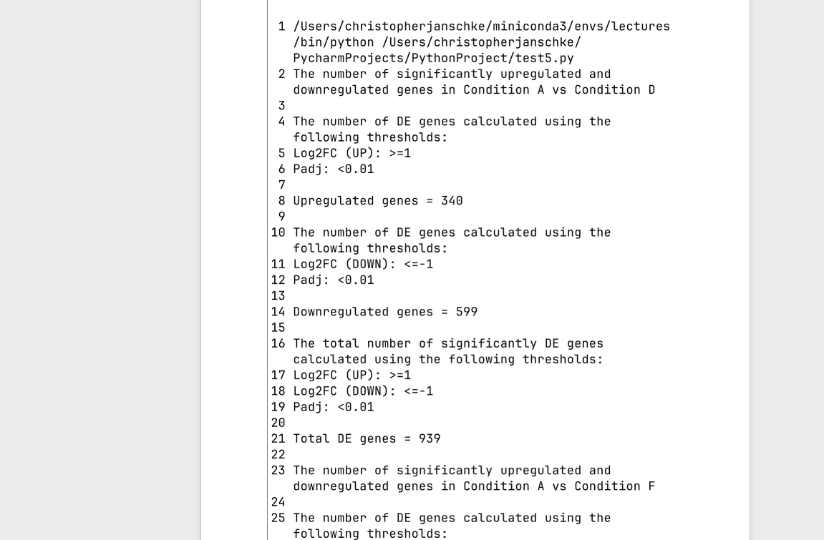
Figure 1: Terminal output displaying the number of upregulated, downregulated and total DE genes, respectively, for Condition A vs Condition D. Significance thresholds: absolute log2 fold change (log2FC) >= 1, adjusted p-value (Pad)j: <0.01. Method of correction to attain adjusted p-value is unknown.

Number of upregulated and downregulated genes in A vs F
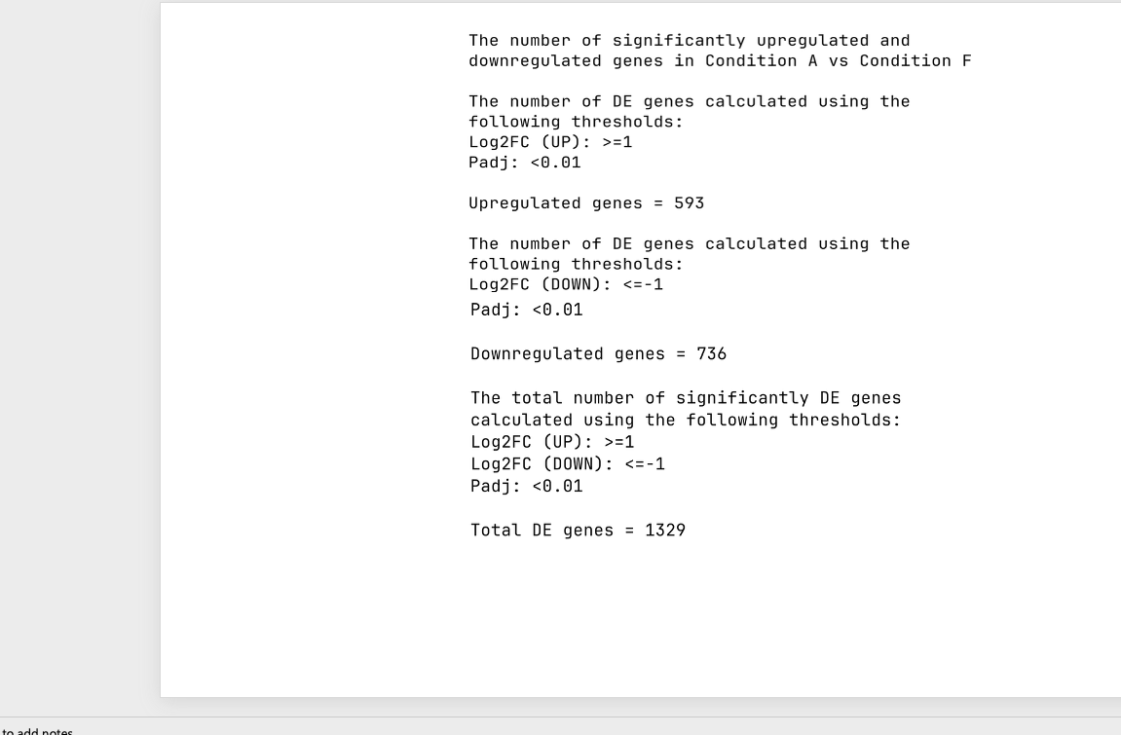
Figure 2: Terminal output displaying the number of upregulated, downregulated and total DE genes, respectively, for Condition A vs Condition F. Significance thresholds: absolute log2 fold change (log2FC) >= 1, adjusted p-value (Pad)j: <0.01. Method of correction to attain adjusted p-value is unknown.

A summary of p-values, adjusted p-values and log2 fold changes across all genes was performed. The results were illustrated in the following format:
- Table –
Justification: includes the specific values of the data to enable thorough scrutinisation.
- Boxplot –
Justification: this format allows easy visualisation of the data.
- Number of statistically significant genes –
Justification: shows how many genes are included/excluded based solely on their statistical significance.

Summary Table (Condition A vs Condition D)
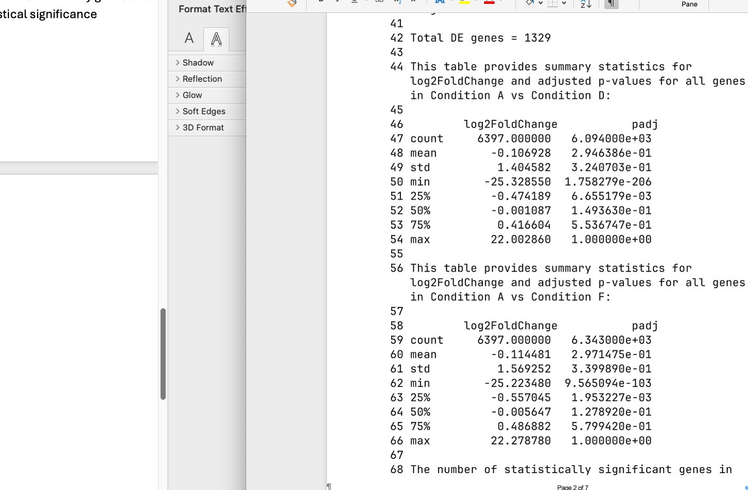
Table 1: Terminal output displaying a table containing summary statistics for log2 fold change and adjusted p-value (padj) for all genes in the Condition A vs Condition D dataset. Summary statistics included: count = total non-null entries, mean = mean average, std = standard deviation, min = minimum value, 25% = quartile 1, 50% = median, 75% = quartile 3, max = maximum value. Method of correction to attain adjusted p-value is unknown.

Summary Table (Condition A vs Condition F)

Table 2: Terminal output displaying a table containing summary statistics for log2 fold change and adjusted p-value (padj) for all genes in the Condition A vs Condition F dataset. Summary statistics included: count = total non-null entries, mean = mean average, std = standard deviation, min = minimum value, 25% = quartile 1, 50% = median, 75% = quartile 3, max = maximum value. Method of correction to attain adjusted p-value is unknown.

Summary Boxplot of P-values (Condition D vs Condition F)

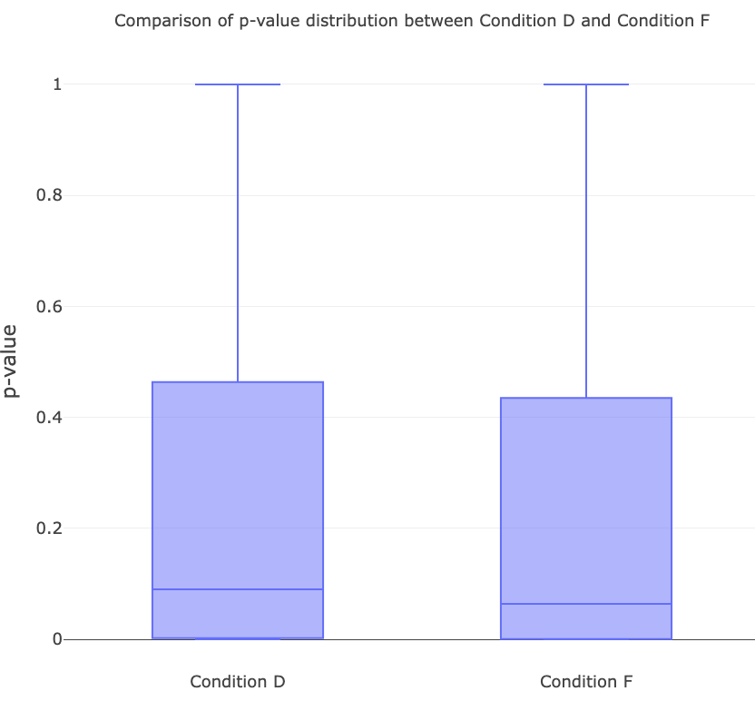
Figure 3: Distribution of p-values from all genes where a p-value was calculated, with the x-axis showing condition, where Condition D includes data from the Condition A vs Condition D dataset and Condition F includes data from the Condition A vs Condition F dataset, and the y-axis showing p-value.

Summary Boxplot of Adjusted P-values (Condition D vs Condition F)
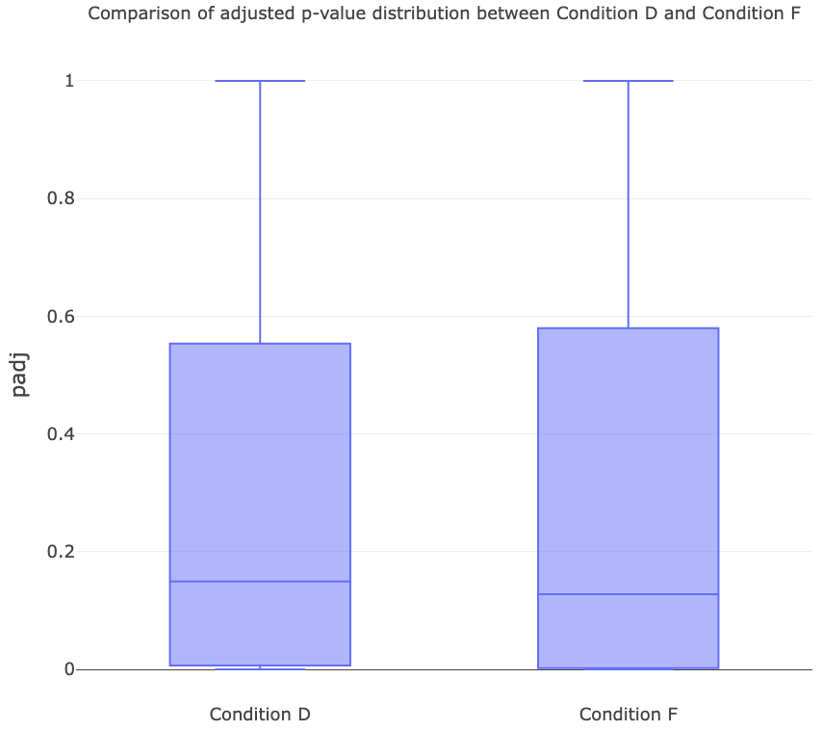
Figure 4: Distribution of adjusted p-values from all genes where an adjusted p-value was calculated (Condition D: n = 6094; Condition F: n= 6343), with the x-axis showing condition, where Condition D includes data from the Condition A vs Condition D dataset and Condition F includes data from the Condition A vs Condition F dataset, and the y-axis showing adjusted p-value (padj). Method of correction to attain adjusted p-value is unknown.

Summary Boxplot of log2 Fold Change (Condition D vs Condition F)
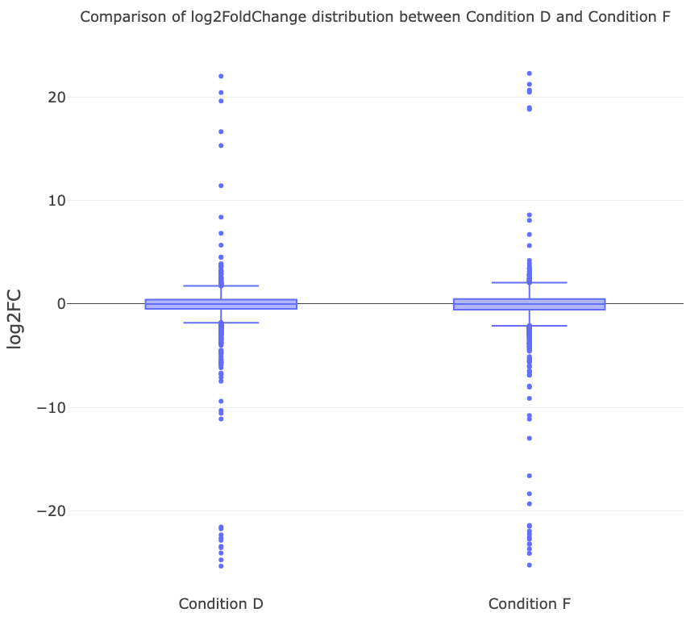
Figure 5: Distribution of log2 fold change from all genes (Condition D: n = 6397; Condition F: n= 6397), with the x-axis showing condition, where Condition D includes data from the Condition A vs Condition D dataset and Condition F includes data from the Condition A vs Condition F dataset, and the y-axis showing log2 fold change (log2FC).

Summary of Statistically Significant Genes (Condition A vs Condition D)
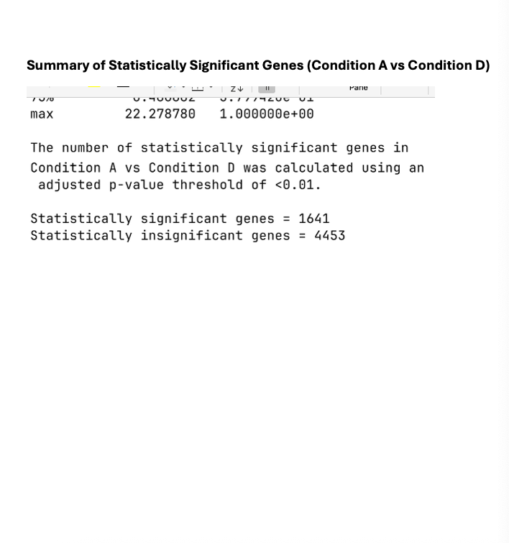
Figure 6: Terminal output displaying a calculation of statistically significant genes based on and adjusted p-value threshold of <0.01 in the Condition A vs Condition D dataset. Statistically significant genes are genes with an adjusted p-value of <0.01; statistically insignificant genes are genes with an adjusted p-value of >0.01. Method of correction to attain adjusted p-value is unknown.

Summary of Statistically Significant Genes (Condition A vs Condition F)
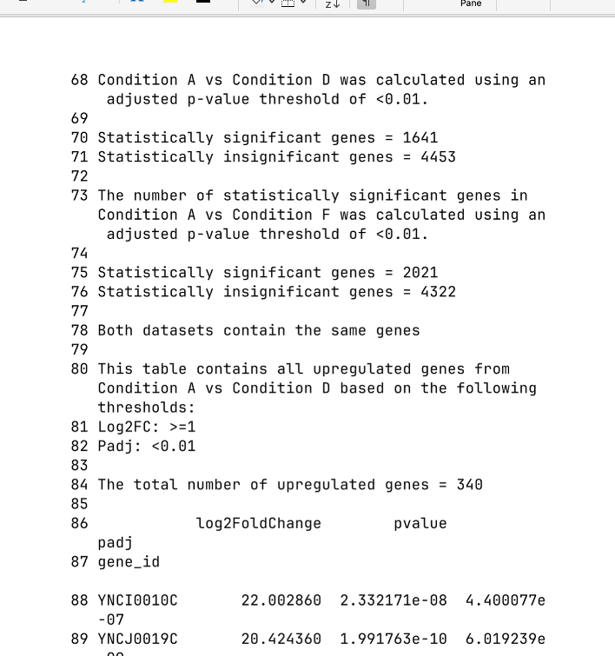
Figure 7: Terminal output displaying a calculation of statistically significant genes based on and adjusted p-value threshold of <0.01 in the Condition A vs Condition F dataset. Statistically significant genes are genes with an adjusted p-value of <0.01; statistically insignificant genes are genes with an adjusted p-value of >0.01. Method of correction to attain adjusted p-value is unknown.

Plots
This section includes various plots:
- Volcano plot
- MA plot
- Histogram
- Heatmap
In all plots, excluding the histogram, the adjusted p-value was used as this provides a more statistically powerful measure of the significance of the gene expression. ‘Normal’ p-value was used for the histogram to better visualise the distribution prior to any data manipulation.

Volcano Plot
To produce the volcano plot, it was first necessary to take the ‘-log10’ of the adjusted p-value. By taking the ‘log10’, it allowed all the datapoints to be viewed on a single graph with reasonable axes, and by taking the minus of the log10, it enabled genes with smaller p-value to be shown high on the graph while accumulating non-significant genes at the bottom. Overall, applying ‘-log10’ enhances the readability of the data.
Hover data is enabled on each of the volcano plots produced allowing the reader to interact with the graph and quickly gain relevant information about any of the genes by simply hovering their cursor over the desired gene.

Volcano Plot (Condition A vs Condition D)
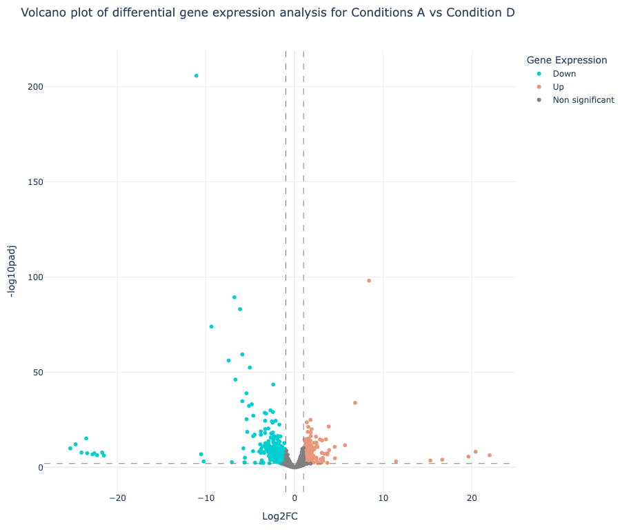
Figure 8: Differentially expressed genes in the Condition A vs Condition D dataset, with the x-axis showing log 2 fold change (Log2FC) and the y-axis showing -log10(adjusted p-value) (-log10padj). Significantly upregulated (Up) and downregulated (Down) genes are genes with an absolute log2FC >= 1 and adjusted p-value <0.01; genes not fulfilling these criteria are shown as ‘Non significant’. Significance thresholds are indicated with dashed lines. Method of correction to attain adjusted p-value is unknown.

Volcano Plot (Condition A vs Condition F)
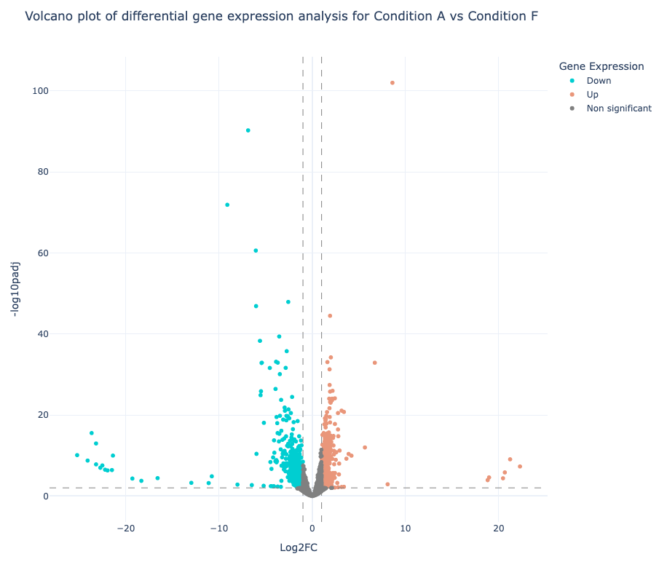
Figure 9: Differentially expressed genes in the Condition A vs Condition F dataset, with the x-axis showing log 2 fold change (Log2FC) and the y-axis showing -log10(adjusted p-value) (-log10padj). Significantly upregulated (Up) and downregulated (Down) genes are genes with an absolute log2FC >= 1 and adjusted p-value <0.01; genes not fulfilling these criteria are shown as ‘Non significant’. Significance thresholds are indicated with dashed lines. Method of correction to attain adjusted p-value is unknown.

MA Plot
Prior to producing the MA plot, it was first necessary to normalise the baseMean by performing ‘log2(baseMean)’. This allows the baseMean values to be visualised on reasonable axes.
A pseudocount of 1 was then added to the normalised mean to prevent any genes with a baseMean of 0 skewing the data.

MA Plot (Condition A vs Condition D)

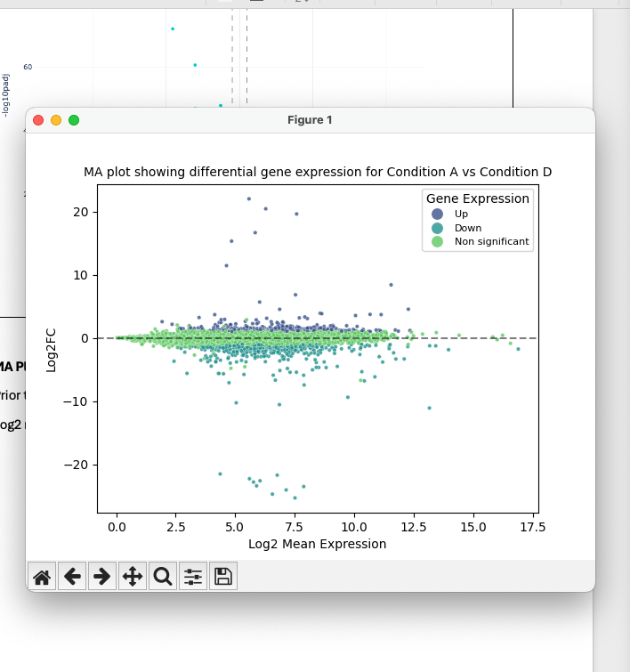
Figure 10: Relationship between log2 fold change and log2 mean expression from the Condition A vs Condition D dataset, with the x-axis showing log2 mean expression and the y-axis showing log2 fold change (log2FC). The ‘0’ value for Log2 fold change is indicated with a dashed line. Significantly upregulated (Up) and downregulated (Down) genes are genes with an absolute log2FC >= 1 and adjusted p-value <0.01; genes not fulfilling these criteria are shown as ‘Non significant’. Method of correction to attain adjusted p-value is unknown.

MA Plot (Condition A vs Condition F)
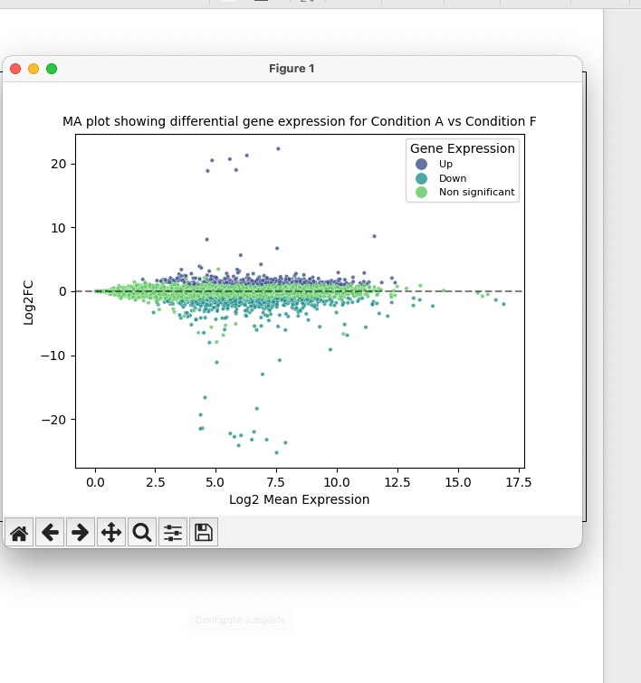
Figure 11: Relationship between log2 fold change and log2 mean expression from the Condition A vs Condition F dataset, with the x-axis showing log2 mean expression and the y-axis showing log2 fold change (log2FC). The ‘0’ value for Log2 fold change is indicated with a dashed line. Significantly upregulated (Up) and downregulated (Down) genes are genes with an absolute log2FC >= 1 and adjusted p-value <0.01; genes not fulfilling these criteria are shown as ‘Non significant’. Method of correction to attain adjusted p-value is unknown.

Histogram of p-values
As previously mentioned, the p-value was selected over the adjusted p-value for the histogram as this will better represent the distribution; models used to produce adjusted p-values can distort the data which will prevent the derivation of meaningful insights.
A bin count of 50 was deemed appropriate for the histogram as the boxplot of p-values in Summary Statistics revealed a large accumulation of p-values around 0 – 0.4. Therefore, a larger bin count was necessary to reveal the distribution around 0 – 0.4. Using more than 50 bins was avoided to reduce the complexity of the histogram which would have made it less visually appealing.
A boxplot was included in the figures to provide additional statistical description of the distribution of p-values.

Histogram of P-values (Condition A vs Condition D)

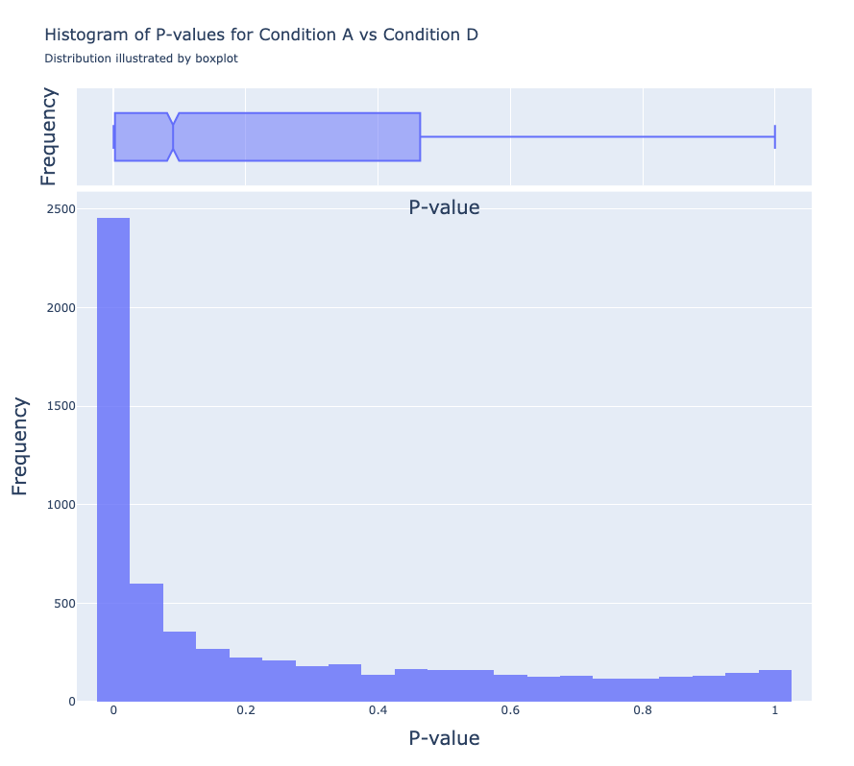
Figure 12: Distribution of p-values in the Condition A vs Condition D dataset, with x-axis showing p-value and y-axis showing frequency. Number of bins included in histogram = 50.

Histogram of P-values (Condition A vs Condition F)
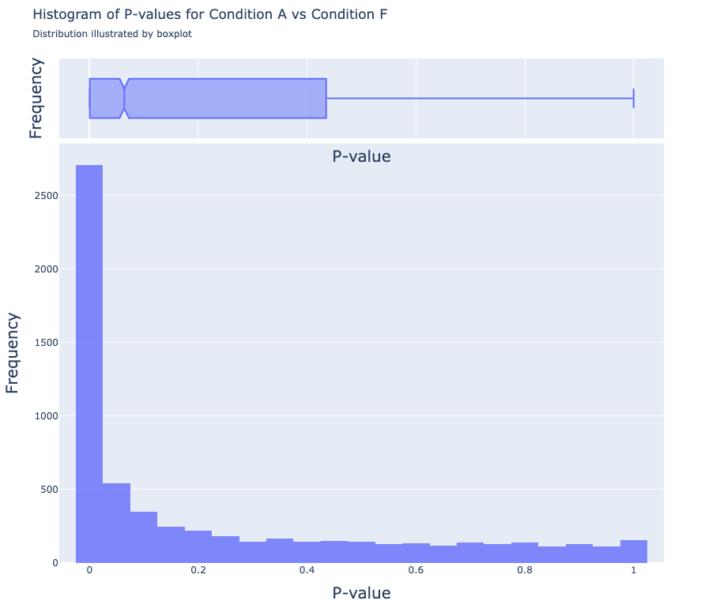
Figure 13: Distribution of p-values in the Condition A vs Condition F dataset, with x-axis showing p-value and y-axis showing frequency. Number of bins included in histogram = 50.

Heatmap of Top DE genes
Top DE genes were calculated using the largest absolute log2 fold change values.
The top 25 DE genes were selected to appear on the heatmap. One heatmap shows the top 25 DE genes in Condition D, the heatmap is based on Condition F.
The number of top DE genes is a variable in the script and can be altered simply by adjusting the value (‘significant_gene_count’) to enable visualisation of more or less DE genes.

Heatmap (top 25 DE genes in Condition D)
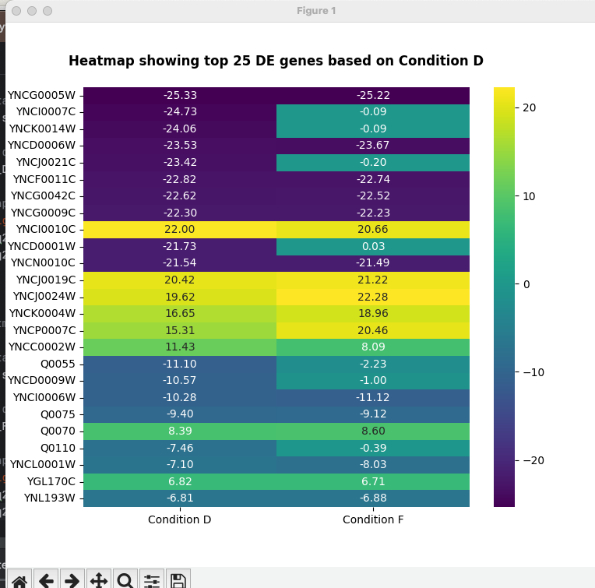
Figure 14: Expression levels of top 25 significant DE genes showing highest levels of differential expression in the Condition A vs Condition D dataset, with the x-axis showing condition, where Condition D includes data from the Condition A vs Condition D dataset and Condition F includes data from the Condition A vs Condition F dataset, and the y-axis showing gene names. Colour scale = log2 fold change, exact value (2 d.p.) for each gene is displayed in the relevant cell. Significantly upregulated are genes with an absolute log2FC >= 1 and adjusted p-value <0.01. Method of correction to attain adjusted p-value is unknown.

Heatmap (top 25 DE genes in Condition F)
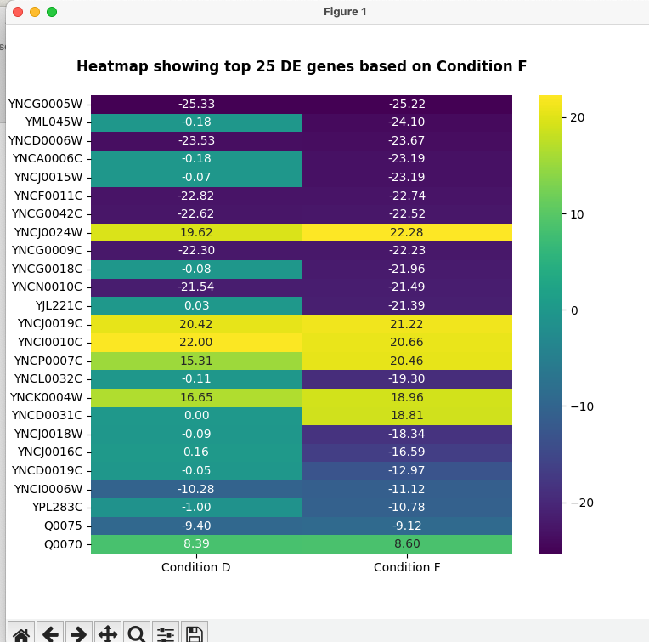
Figure 15: Expression levels of top 25 significant DE genes showing highest levels of differential expression in the Condition A vs Condition F dataset, with the x-axis showing condition, where Condition D includes data from the Condition A vs Condition D dataset and Condition F includes data from the Condition A vs Condition F dataset, and the y-axis showing gene names. Colour scale = log2 fold change, exact value (2 d.p.) for each gene is displayed in the relevant cell. Significantly upregulated are genes with an absolute log2FC >= 1 and adjusted p-value <0.01. Method of correction to attain adjusted p-value is unknown.

Significant Gene Lists
The following tables were produced to display significant genes:
Table No. | Direction | Condition
3 | Upregulated | Condition D
4 | Downregulated
5 | Upregulated | Condition F
6 | Downregulated
7 | All DE genes | Condition D and Condition F

Upregulated Genes (Condition A vs Condition D)
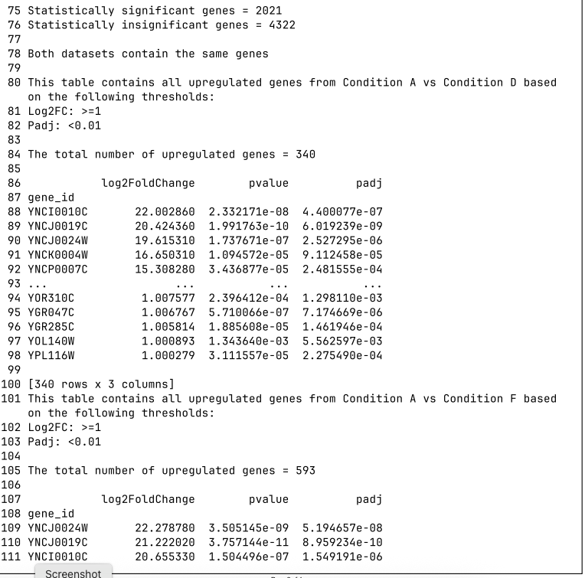
Table 3: Terminal output displaying the thresholds used to determine significant DE genes, the total number of significantly upregulated genes, and a table of upregulated genes in the Condition A vs Condition D dataset with the log2 fold change, p-value and adjusted p-value shown for each gene. Significance thresholds: absolute log2 fold change (log2FC) >= 1, adjusted p-value (Pad)j: <0.01. Method of correction to attain adjusted p-value is unknown.

Downregulated Genes (Condition A vs Condition D)
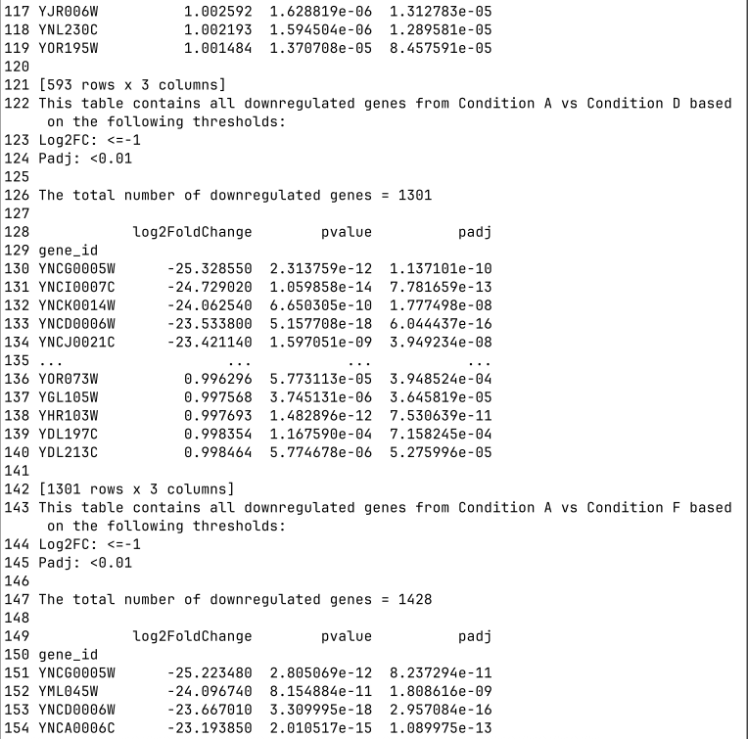
Table 4: Terminal output displaying the thresholds used to determine significant DE genes, the total number of significantly downregulated genes, and a table of downregulated genes in the Condition A vs Condition D dataset with the log2 fold change, p-value and adjusted p-value shown for each gene. Significance thresholds: absolute log2 fold change (log2FC) >= 1, adjusted p-value (Pad)j: <0.01. Method of correction to attain adjusted p-value is unknown.

Upregulated Genes (Condition A vs Condition F)
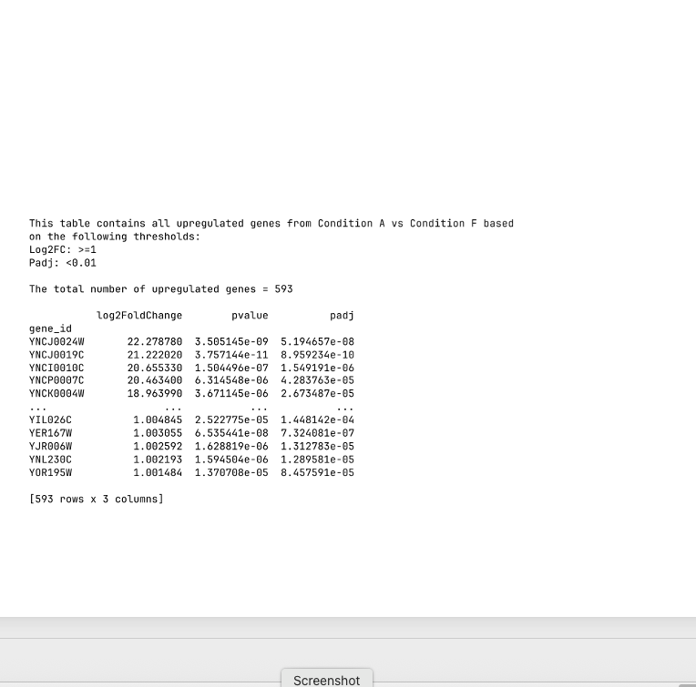
Table 5: Terminal output displaying the thresholds used to determine significant DE genes, the total number of significantly upregulated genes, and a table of upregulated genes in the Condition A vs Condition F dataset with the log2 fold change, p-value and adjusted p-value shown for each gene. Significance thresholds: absolute log2 fold change (log2FC) >= 1, adjusted p-value (Pad)j: <0.01. Method of correction to attain adjusted p-value is unknown.

Downregulated Genes (Condition A vs Condition F)
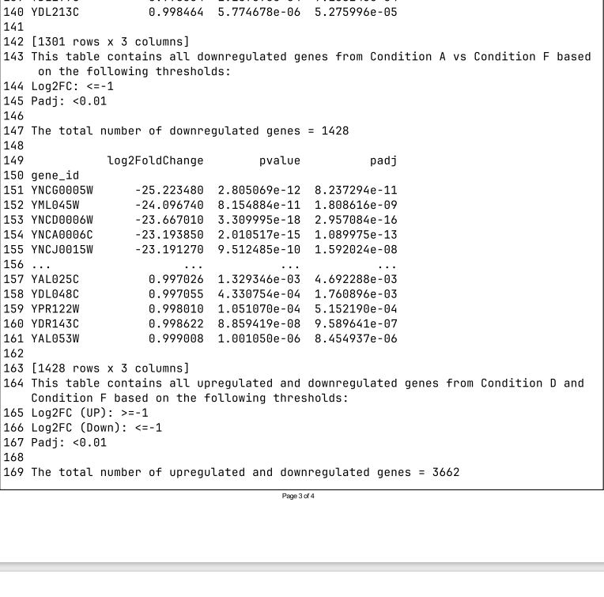
Table 6: Terminal output displaying the thresholds used to determine significant DE genes, the total number of significantly downregulated genes, and a table of downregulated genes in the Condition A vs Condition F dataset with the log2 fold change, p-value and adjusted p-value shown for each gene. Significance thresholds: absolute log2 fold change (log2FC) >= 1, adjusted p-value (Pad)j: <0.01. Method of correction to attain adjusted p-value is unknown.

Upregulated and Downregulated Genes in Condition D and Condition F
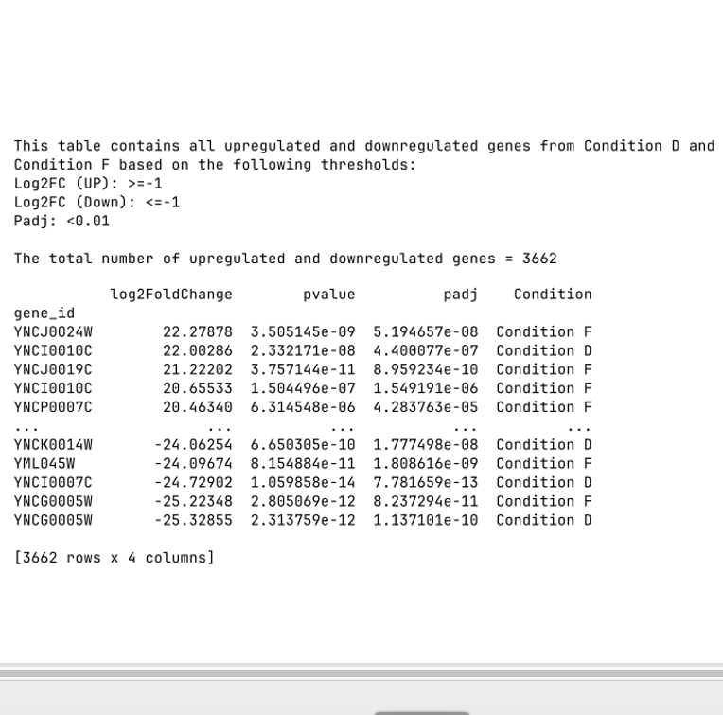
Table 7: Terminal output displaying the thresholds used to determine significant DE genes, the total number of significantly upregulated and downregulated genes, and a table of downregulated genes in the Condition A vs Condition D dataset and Condition A vs Condition F dataset, with the log2 fold change, p-value and adjusted p-value, and dataset the gene originated from shown for each gene. Significance thresholds: absolute log2 fold change (log2FC) >= 1, adjusted p-value (Pad)j: <0.01. Method of correction to attain adjusted p-value is unknown.

Additional Analyses
A clustermap plot was produced to investigate clustering of gene expression in top DE genes. This plot clusters genes based on similar expression levels.
The top 25 DE genes were selected to appear on the clustermap plot. One heatmap shows the top 25 DE genes in Condition D, the heatmap is based on Condition F.
The number of top DE genes is a variable in the script and can be altered simply by adjusting the value (‘significant_gene_count_cm’) to enable visualisation of more or less DE genes.
If the number of DE genes selected is <= 25 then the log2 fold change values will be shown in each cell; if >25 genes are selected then the values will be hidden to prevent the plot from becoming obscured by the additional text.

Clustermap Plot (top 25 DE genes in Condition D)

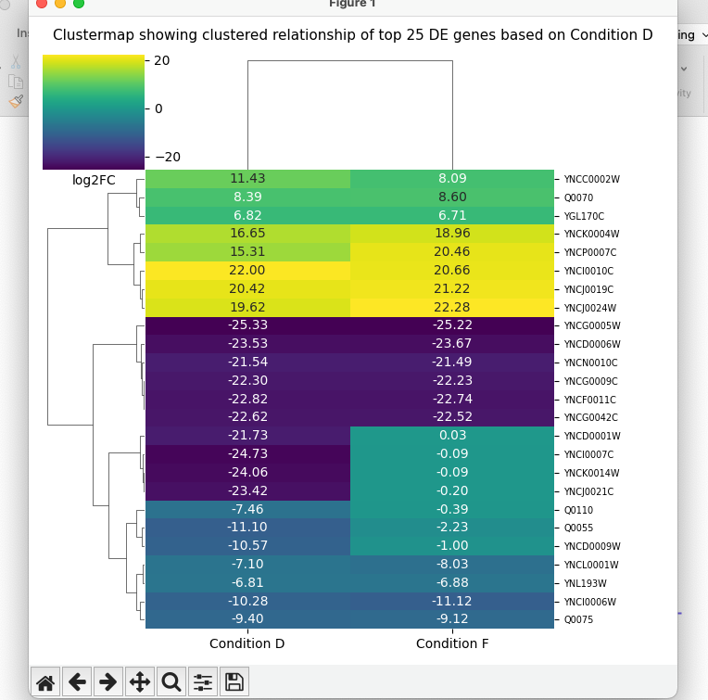
Figure 16: Clustering analysis of top 25 significant DE genes showing highest levels of differential expression in the Condition A vs Condition D dataset, with the x-axis showing condition, where Condition D includes data from the Condition A vs Condition D dataset and Condition F includes data from the Condition A vs Condition F dataset, and the y-axis showing gene names. Colour scale = log2 fold change, exact value for each gene (2 d.p.) is displayed in the relevant cell. Genes clustered according to log2 fold change. Significantly upregulated are genes with an absolute log2FC >= 1 and adjusted p-value <0.01. Method of correction to attain adjusted p-value is unknown.

Clustermap Plot (top 25 DE genes in Condition F)
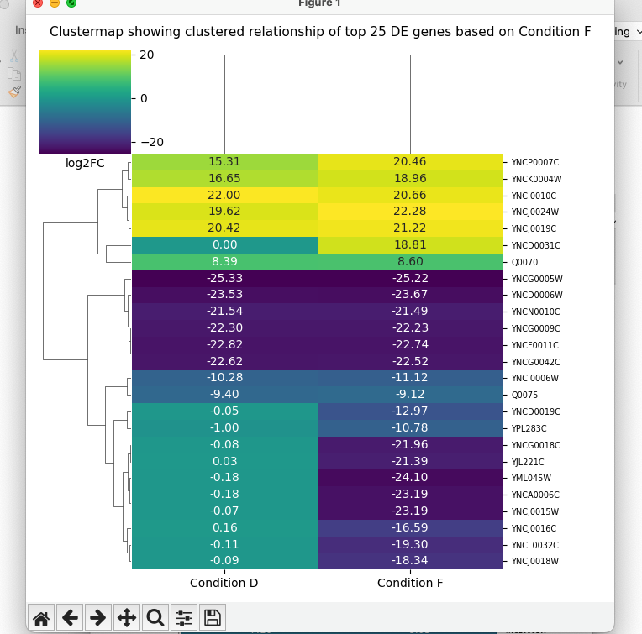
Figure 17: Clustering analysis of top 25 significant DE genes showing highest levels of differential expression in the Condition A vs Condition F dataset, with the x-axis showing condition, where Condition D includes data from the Condition A vs Condition D dataset and Condition F includes data from the Condition A vs Condition F dataset, and the y-axis showing gene names. Colour scale = log2 fold change, exact value for each gene (2 d.p.) is displayed in the relevant cell. Genes clustered according to log2 fold change. Significantly upregulated are genes with an absolute log2FC >= 1 and adjusted p-value <0.01. Method of correction to attain adjusted p-value is unknown.

