Coding Challenge 1: Pumpkins
Dataset: pumpkins_09.csv

Task 1: Read in pumpkins.csv
N/A

Task 2: Identify the heaviest pumpkin (variety, location, year)
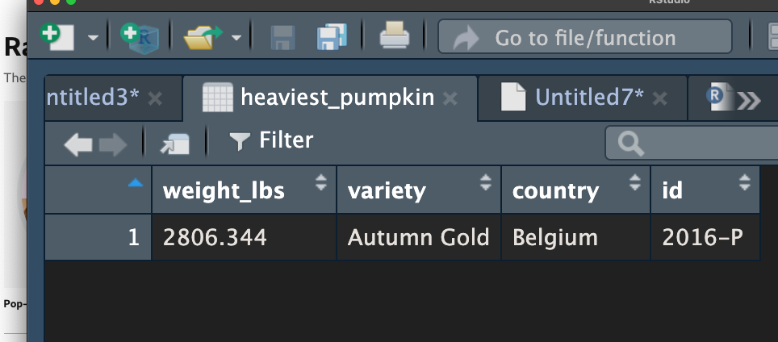
Table 1: Rstudio table displaying the heaviest pumpkin in the pumpkins_09 dataset with weight_lbs (weight in lbs), variety (pumpkin variety), country (country of grower) and id (year it was grown and type of competition) shown.

Task 3: Convert pounds → kilograms (weight_kg column)
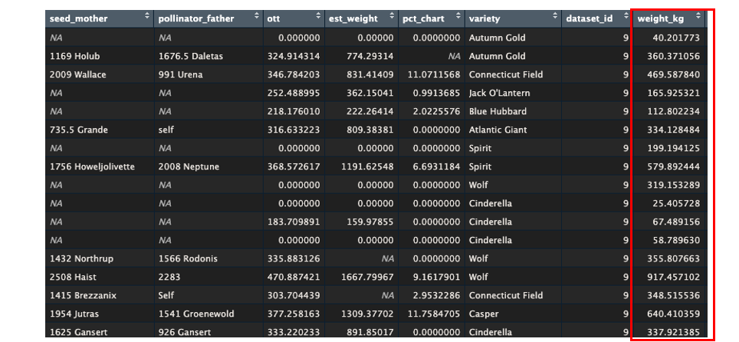
Table 2: Rstudio table displaying the first 17 rows the pumpkins_09 dataset with an additional column (indicated in red box) – weight_kg – showing the weight of each pumpkin in kg. Dataset is filtered in ascending order by ‘id’ column.

Task 4: Add a weight_class column (light / medium / heavy)
Weight class thresholds:
Light = <400lbs
Medium = <800lbs
Heavy = >=800lbs
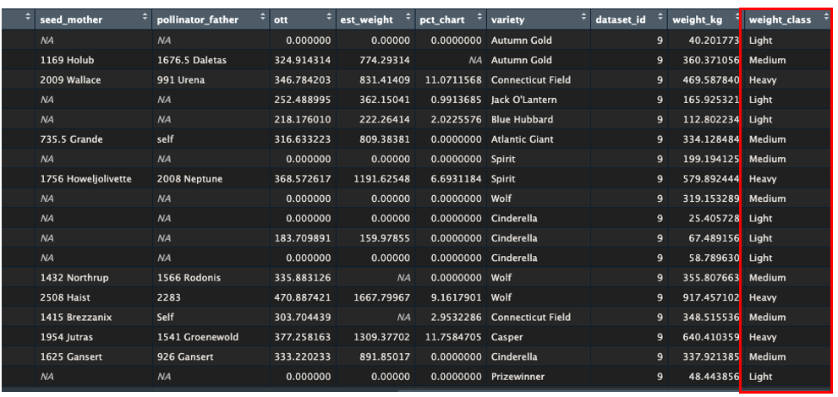
Table 3: Rstudio table displaying the first 18 rows the pumpkins_09 dataset with an additional column (indicated in red box) – weight_class – showing the weight class of each pumpkin. Weight class is defined: ‘Light’ = < 400lbs, ‘Medium’ = < 800lbs, ‘Heavy’ = >= 800lbs. Dataset is filtered in ascending order by ‘id’ column.

Task 5: Plot estimated vs actual weight (coloured by class)
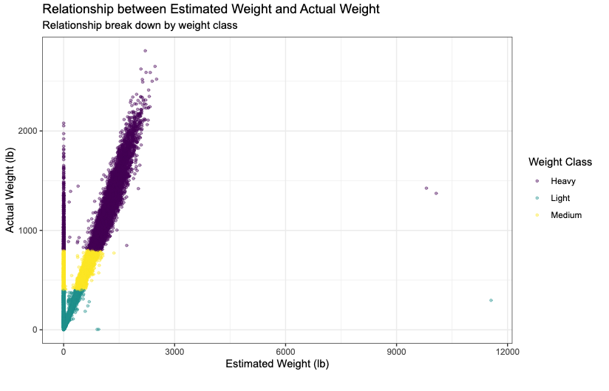
Figure 1: Relationship between estimated weight and actual weight in lbs for pumpkins with non-null estimated weights (n=15007) in the pumpkins_09 dataset, with the x-axis showing estimated weight (lb) and the y-axis showing actual weight (lb). Pumpkins are coloured according to weight class where ‘Light’ = < 400lbs, ‘Medium’ = < 800lbs, ‘Heavy’ = >= 800lbs.

Task 6: Filter for three countries and save (pumpkins_filtered.csv)
Countries selected:
- Japan
- Austria
- Italy
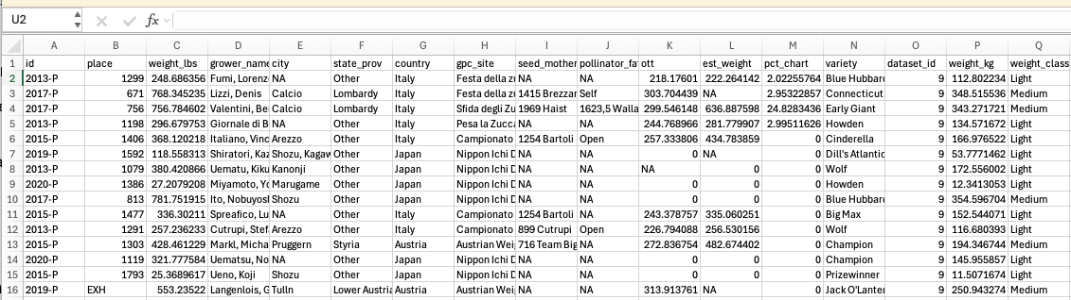
Figure 2: Image of .csv file (fpumpkins_japan_austria_italy.csv) showing the first 15 of 1261 rows from a filtered subset of the pumpkins_09 dataset containing only pumpkins grown in Japan, Austria and Italy. Dataset is filtered in ascending order by ‘id’ column.

Task 7: Summarise mean weights by country and variety
A
Mean weight of pumpkins for each country:
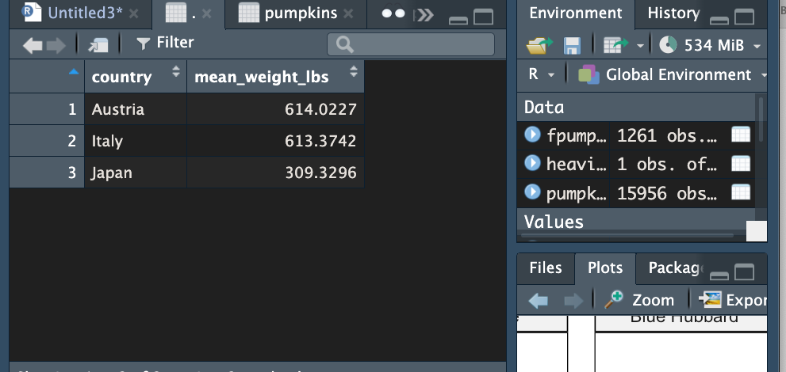
Table 4: Rstudio table displaying the mean average weight (lbs) of all pumpkins grown in Austria (n=430), Italy (n=506) and Japan (n=325) in the pumpkins_09 dataset.

Country with highest mean pumpkin weight:z
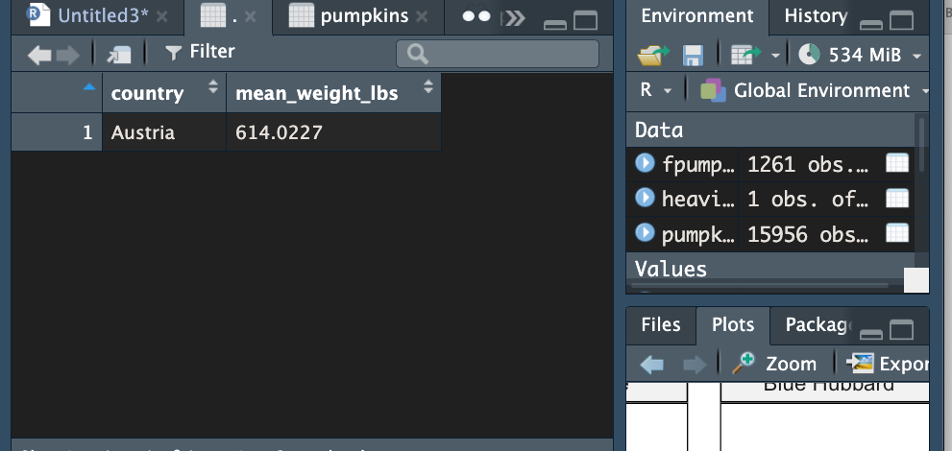
Table 5: Rstudio table displaying the country with the highest mean average weight (lbs) of all pumpkins grown in that country in the pumpkins_09 dataset. Countries compared: Austria (n=430), Italy (n=506) and Japan (n=325).

B
Mean weight for each variety of pumpkin for each country:
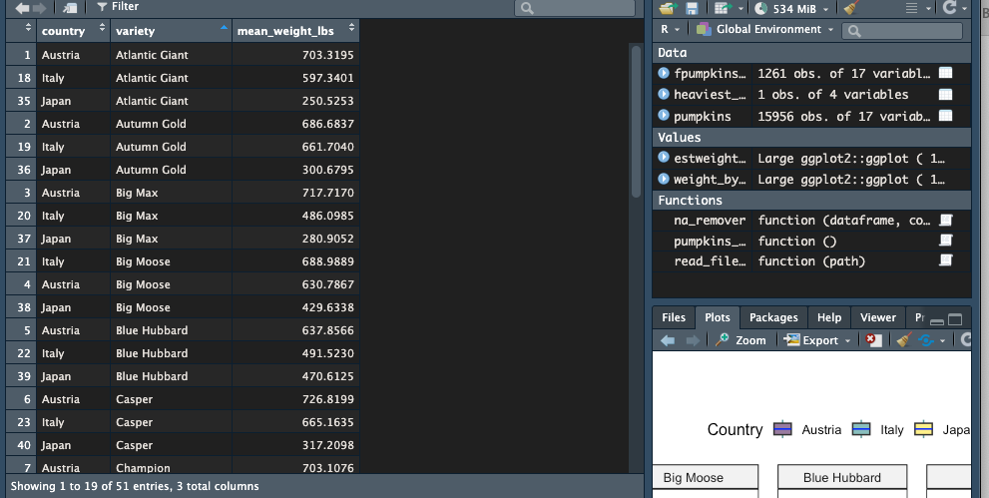
Table 6: Rstudio table displaying the mean average weight (lbs) of each variety of pumpkin grown in Austria, Italy and Japan in the pumpkins_09 dataset. Columns shown: ‘country’ = country of grower, ‘variety’ = pumpkin variety, ‘mean_weight_lbs’ = mean average weight of pumpkins in variety. Dataset is filtered in ascending order by ‘variety column.

Variety and country with lowest mean weight:
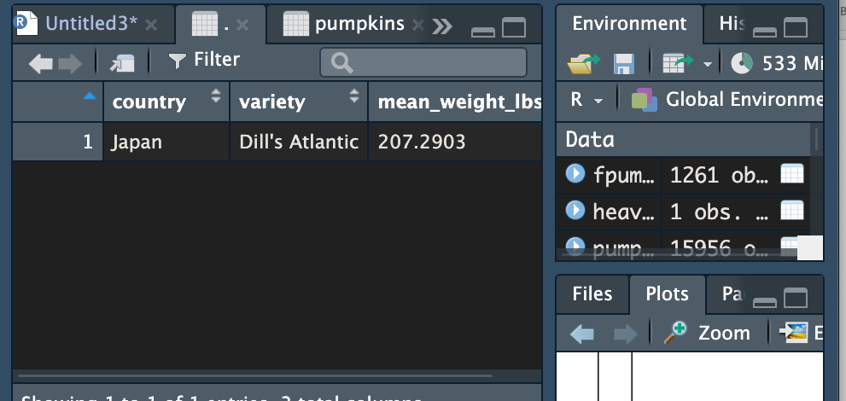
Table 7: Rstudio table displaying the variety with the lowest mean weight (lbs) and the country it originated from in the pumpkins_09 dataset. All varieties in Austria, Italy and Japan were compared. Columns shown: ‘country’ = country of grower, ‘variety’ = pumpkin variety, ‘mean_weight_lbs’ = mean average weight of pumpkins in variety.

Task 8: Create a boxplot for the three countries
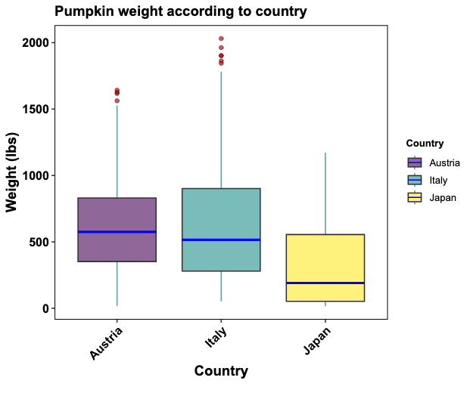
Figure 3: Distribution of pumpkin weights (lbs) across Austria (n=430), Italy (n=506) and Japan (n=325) in the pumpkins_09 dataset. The x-axis shows the country of grower, the y-axis shows the pumpkin weight in lbs.

Task 9: Create a faceted plot by variety
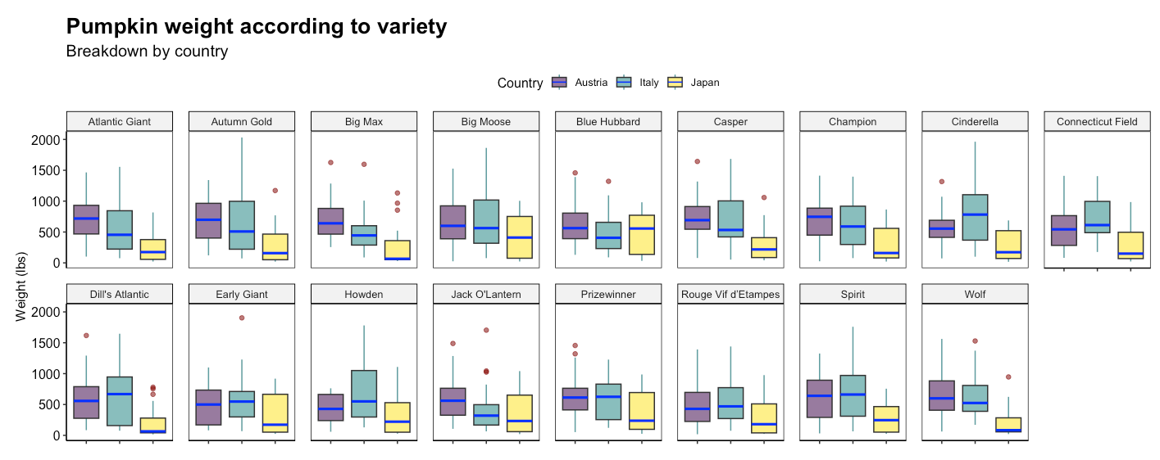
Figure 4: Distribution of pumpkin weights (lbs) across Austria (n=430), Italy (n=506) and Japan (n=325) separated by variety of pumpkin in the pumpkins_09 dataset. Each panel represents a different variety of pumpkin. Boxplots are coloured by country of grower. The y-axis shows the pumpkin weight in lbs.

