Notes
- Strong overlap between upregulated DE miRNA target genes and the genes expressed in each airway cell.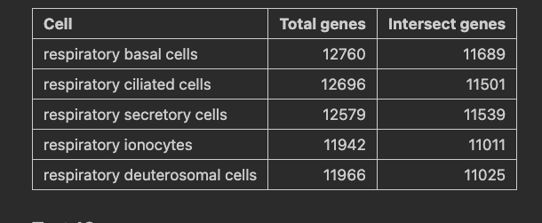
- Going to use 18-30nt trim length. However, hsa-miR-3168 is 17nt and this is DE when the trimming parameters are set to 17-30. This is interesting – can note in discussion as well.
  - There are not many publications about hsa-miR-3168, just one or two on miRbase.
- Completely different miRTrace qc plots between 01_protease and 02_hdm_dog
  - Could include these graphs as a figure because it is quite interesting
    - Rna categories
    - Contamination check
- Might be worth using the background universe with all miRNAs with at least one count from the count matrix as this at least gives results. Can state what happens when you use the miRNAs after `keep` there are only 141-147 so the background universe is too small to get significant results
- Have the first part of the results the table comparing pathway enrichment analysis methods? Or have this as part of the intro?

Sections
- High protease exposure samples exhibit altered sequencing output signature
  - Supplementary figure = QC data (quality, gc content, lengths)
  - Content:
    - QC data
      - Read counts (library size?)
      - Quality
      - GC content (protease 24 different to rest)
      - Adapter contamination
        - “No samples found with any adapter contamination > 0.1%” – multiqc report
      - Sequence length (peak at 21 in all samples excluding dose24 protease – is this a really commonly expressed miRNA?)
      - Sequence duplication levels (dose24 is different to rest)
      - RNA categories plot shows much higher levels of rRNA for dose24 than other samples
- Calu-3 and primary cell EVs present different RNA compositions
  - Figure = RNA composition
  - Content:
    - RNA categories plot analysis
    - Boxplot analysis
- EV miRNA expression profile differs following allergen exposure
  - Figure = DE results
  - Table = List of sig DE miRNAs
- Automated pathway enrichment analysis methods lack consensus
  - Figure = FE validation (01_protease only)
- Pathway enrichment analysis following HDM and dog allergen exposure
[talk about tamirna somewhere. Maybe discussion?]

