Current
- Workflow
[figure – clearly explaining different cell types and allergen exposures] - keep it simple, make sure it’s clear calu-3 pathway is novel
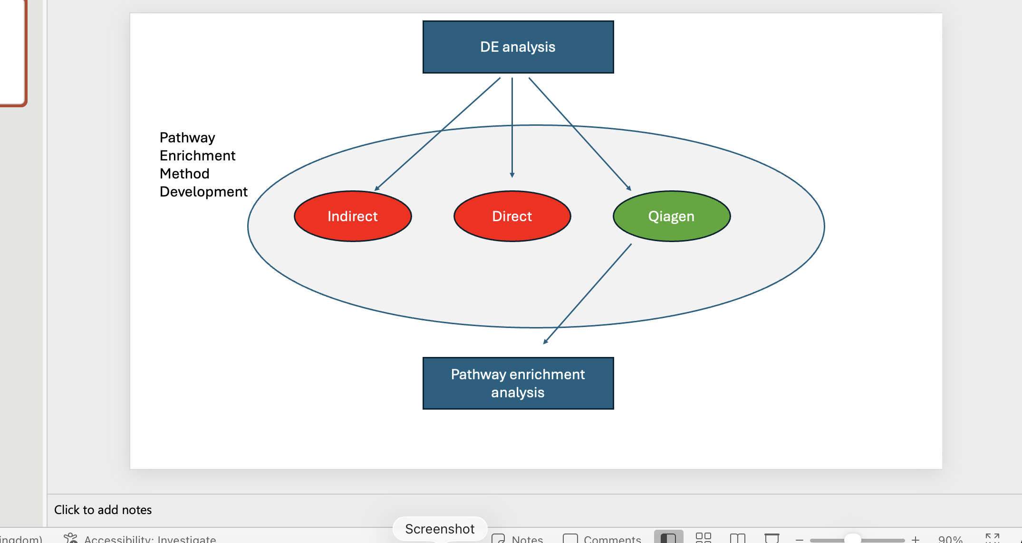 example of how to handle the validation stage in the diagram
  - Cell types / exposures
  - Trimming / qual control
  - Quantify expression
  - De analysis
  - Method development
  - Pathway analysis of calu-3 cells
[have highlighted box around pathway analysis of calu 3 cells which says ‘novel’]

- Study data
EVs were extracted and isolated from HBECs following exposure to nebulised allergens, as previously described [GH/Will reference]. Primary HBECS were exposed to either 0.005μg, 0.08μg, 2μg or 24μg protease enzyme allergen; Calu-3 HBECs to Can f 1 (dog allergen), active Der p 1 and inactive Der p 1 (HDM allergens).
RNA extraction and next-generation sequencing were performed using the miND® analysis pipeline [mind reference]
[GH/Will paper sent by Lucy on 07.07.26. Need to say those papers have been submitted for review but not published at the time of this paper. Can use Endnote to manually curate the reference]
[calu-3 cells are immortalised something cells]
[do I need to state test conditions e.g. different doses of protease then the 02_ conditions?] – replicate conditions. Make as supp table
[supplementary table of sequencing ID to condition?]

- Preprocessing
Raw sequencing reads were trimmed using Cutadapt [version], targeting the Realseq3P adapter (TGGAATTCTC); only reads measuring 18-30bp and quality >30 (Phred) were retained. Read quality was determined using FastQC [version], miRTrace [version] and MultiQC [version].

- Mapping and Quantification
Reads were collapsed using the miRDeep2 [version] mapper.pl script then mapped to mature and hairpin [version] references (miRBase [version]) using quantifier.pl, allowing for 1 mismatch.

- Differential Expression Analsysis
DE analysis was performed using edgeR [version] [in R studio?]. Lowly expressed miRNAs were excluded using the default filtering provided by the package. Normalisation was performed using the trimmed mean of M-values normalisation and dispersion estimated using the negative binomial dispersion by weighted likelihood empirical Bayes. DE miRNAs were obtained from pairwise contrasts (untreated versus treated) using the quasi-likelihood F-test. False discovery rate (FDR) was controlled using Benjamini-Hochberg (BH) multiple testing correction method. DE miRNAs were classified as significant based on a cutoff of FDR < 0.05 and log 1-fold-change, or FDR < 0.2 if no DE miRNAs were initially detected.
[can talk about the prior.count, can talk about selecting rows with >10 reads in it total if I did it]

- Pathway Enrichment Analysis
Multiple methodologies exist for automated pathway enrichment analysis (Supp Table []). Here, we tested three common methods (indirect, direct and [Qiagen IPA]), identified through a search of miRNA functional enrichment workflows in the literature, using the dose 24μg protease exposure dataset. The most appropriate method was intended to be selected for pathway analysis of the novel HDM and dog exposure datasets. However, too few DE miRNAs were found in that dataset, prohibiting the use of automated pathway analysis methods. Therefore, pathway associations were identified through literature associated with DE miRNAs on miRBase [version] and through a manual search on [PubMed?] using the miRNA symbol and the following terms: ‘epithelial’, ‘inflammation’, ‘airway’.
[supplementary table comparing different methods – saved as ‘FE_techniques’]
[target gene-level, miRNA-level, Qiagen IPA]
  - Target gene-level
Experimentally validated target mRNAs of significantly DE miRNAs were identified from miRTarBase [version] using multiMiR [version] in R. Pathway enrichment analysis was performed on the target genes using ReactomePA [version] (R package) with the default background universe. The BH correction was applied to control the FDR. Only pathways containing between 10-500 genes were considered; pathways with an adjusted P value < 0.02 and q value < 0.02 were considered significantly enriched.

  - miRNA-level
Lists of DE miRNAs were generated in R then provided to miEAA [version] to identify enrichment within the Reactome database (miRPathDB). Adjusted p-values were calculated using BH correction for FDR, with a significance cutoff of P-adjusted < 0.05.
For over-representation analysis (ORA), the miRNA test set contained either significant up- or down-regulated DE miRNAs with all miRNAs detected in the experiment as the background universe. For miRNA-set enrichment analysis (miRNA-SEA), all miRNAs detected in the experiment were ranked according to log-fold-change (logFC).

  - Qiagen

- Previous work
DE analysis was previously performed for all allergen exposures by TamiRNA [link] using the miND® pipeline [reference], and pathway analysis performed by [Prof. Vicky] using QIAGEN IPA for protease exposure, as described in [GH reference]. Pathway analysis of HDM and dog exposures was novel. These methods describe an independent analysis pipeline executed prior to results from any previous work being disclosed.

- Statistics?
[can talk about PCA and heatmap methods – like this paper https://www.nature.com/articles/s41598-018-28168-5]
- Code availability
All code used in this study is available at https://github.com/CJ770411/L4137_HBEC_EV_Transcriptomics. Bash scripts (.sh) were generated from a custom-made template script, designed to standardise structure, and log and error handling.

[visualisation performed in R studio [version] [using packages?]]

Archive

