Notes
- .ipynb = ipython notebook (ipython is another version of pretty python)
- Can open notebooks in VSC for easy editing and uploading to github
- Number in boxes indicate the cell has finished running and the number indicates the order of the cell being run in the notebook
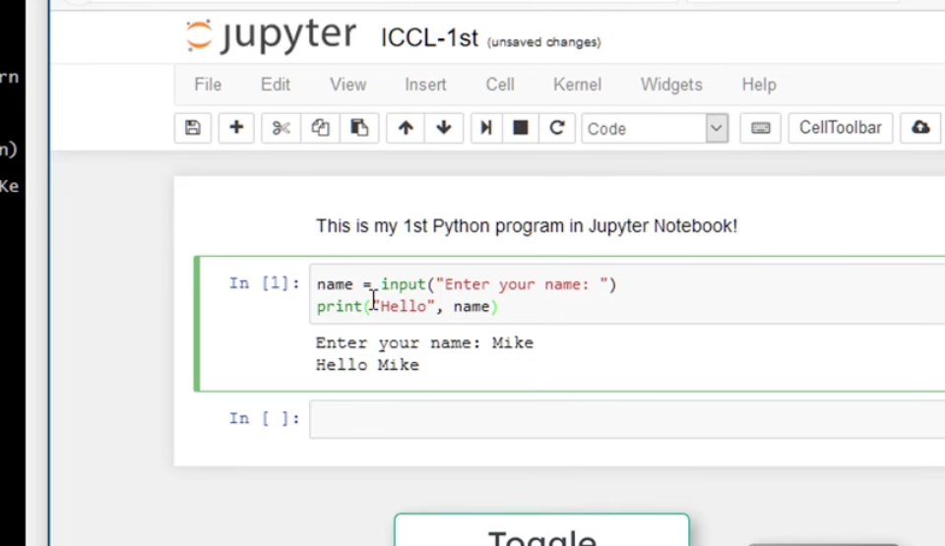
- Asterisk in the box means it is still running
- Restart kernel to stop running all code cells (can clear all outputs of cells but this removes all variables/modules imported)
- Kernel is the thing that is running the code

Guide
- Need to untick ‘save on render’
- Can write cells in markdown or code
- To run all cells:
  - Run
  - Restart kernel and run all cells…
- Export notebook to share it
- File
- Save and export notebook as
- Pick the format – html is best
- Can automatically number all headings and subheadings by pressing the 1, 2, 3 box from the contents tab
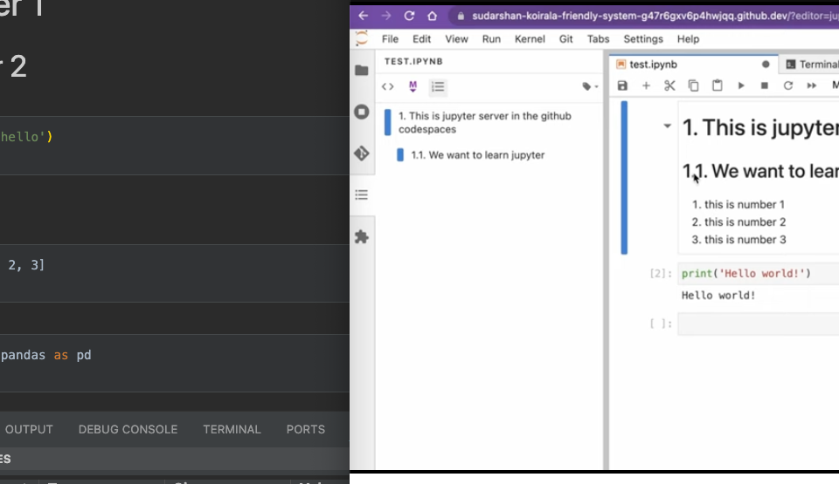

VSC
- Open new .ipynb
- Select kernel – use recommended virtual python environment
- Can access contents and quick navigation by pressing ‘Outline’ then the contents will appear in the bottom left of the screen
- To execute cells:
  - ‘Run all’ to execute all cells
  - Hover over cell and press ‘run all above’ or ‘run all below’
  - From outline, run all cells in a particular section
  - Hover over cells and press ‘run by line’. Can add breakpoints to not run all lines
- Variables:
  - Once a variable is created, you can press ‘Juyter variables’ at the top of the page to view all the variables (similar to how you can in r)
    - Can press the icon to the left of the variable name to give a pop-out of the variable
- Export as html is an option in the main bar at the top

Keyboard shortcuts
- Shift + enter run code cell and go to next cell
- cmd + enter run code cell and stay in same cell
- Up/down arrow navigate between cells
- Escape exit cell
- A add a cell above the cell you’re on
- B add a cell below the cell you’re on
- Command + L turn line numbers on for code cells

