miRNA Qiagen IPA workflow
Video https://tv.qiagenbioinformatics.com/video/83851520/ipa-deeper-dive-mirna-investigation-1
Slides https://digitalinsights.qiagen.com/wp-content/uploads/2025/12/IPA-miRNA-Slide-Deck-1.pdf
- Prepare data
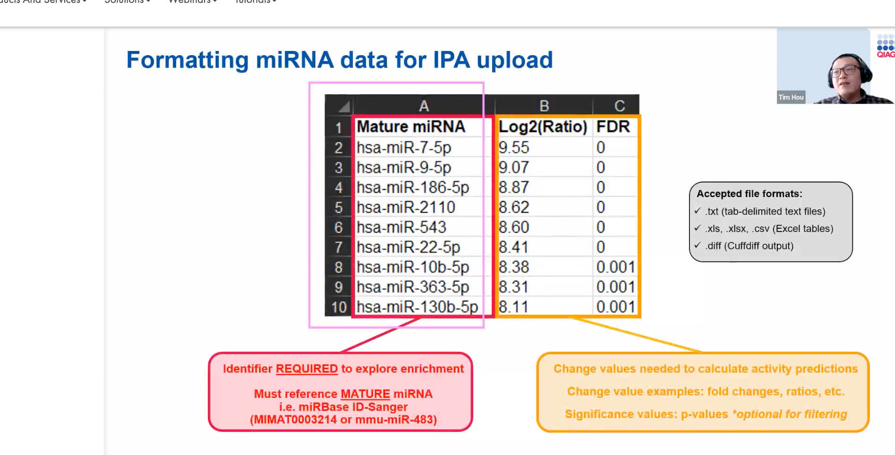
- FDR is optional
- Only include significant DE mirnas
- Create new
- Microrna target filter
- Upload select data file
- Label columns
  - ID
  - Observation 1 for logFC and FDR ensure the contents of the column have been correctly identified (each observation represents a contrast e.g., condition 1 vs control)
- Edit observation names to ‘Dose24vsControl
- Save data (ignore lack of metadata warning)
- This will now show you the number of target genes for all your miRNAs
- Click ‘edit columns’
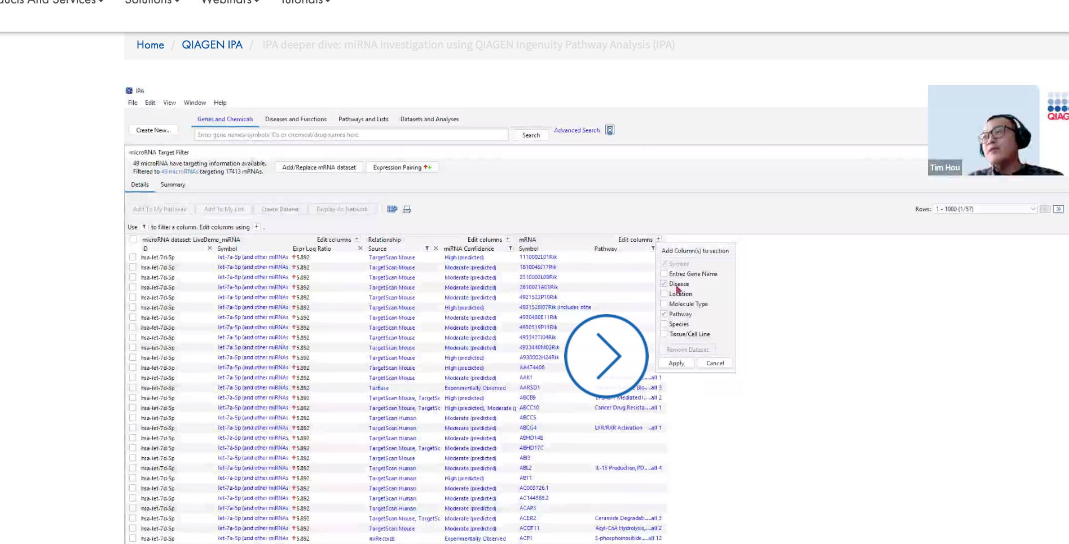 select the ones you want
- Click ‘miRNA confidence’ column
  - Select ‘experimentally observed’ and ‘high predicted’
    - Note: I’ve seen a lot of papers that use both of these.
  - Note: This reduced from 17k to 8k in the demo video
- In the disease column, could select ‘inflammatory’ for epithelial inflammation?
- To view as network:
  - Select all targets
  - Display as network
  - Overlay
  - Click the dropdown box
  - Select ‘analyses, datasets & lists’
  - Add
  - Add your IPA project
  - This will show up/downregulated
  - Pathtracer (one of the icons in the taskbar)
  - Select ‘fade distant nodes’ and ‘fade edges’
  - Can select specific nodes and it will show you all the interactions for it
  - Can export the network at any point
  - Look at the help legend on the page to find out what the shapes and lines represent
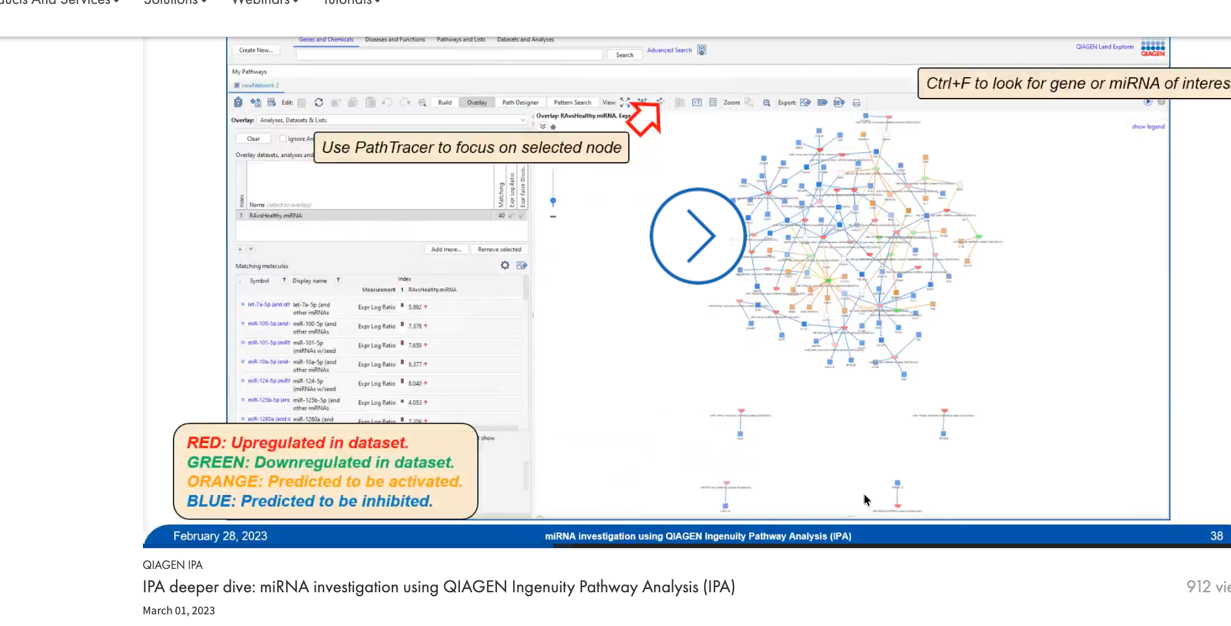

- Can link a relevant public mRNA dataset since we don’t have our own data
  - Datasets and analyses
  - Use the search bar to look for pre-curated datasets using a keyword search
    - [look for exosomes from hbecs?] e.g., try:
    - Calu-3 + HDM
    - bronchial epithelial cells + HDM
    - airway epithelial cells + Der p 1
  - Filter on ‘comparisoncategory’. The deom video looks for ‘disease vs normal’
    - This filters from 1080 results to 128 results
    - Click on a study and review the metadata
    - Click on compareid link in the metadata to see volcano plot
    - Click download on volcano plot page to see the DE table
    - Save the data if you want to use study
    - Add the mRNA dataset into the project from the home screen
    - Add the id and observation 1 columns
      - Ensure the adjusted p value is set to fdr
    - Edit observation names as mrna
    - Save – ignore metadata warning
    - Press ‘expression pairing’ to link mirna and mrna data
    - Filter by inverse relationship
    - Visualise as network as before but use a combined dataset as overlay
      - Can get combined by saving the table after the previous step
- Canonical pathways
  - Genes and chemicals
  - Pathway
  - Canonical pathways

Note: papers say that they also used the core analysis feature to generate their results. Need to find out how this links in – details on the core analysis can be found https://tv.qiagenbioinformatics.com/video/76084067/new-user-training-qiagen-ingenuity

