Gitignore
- Notebooks/worklog/drafts/*
- Notebooks/worklog/investigations/*

Notes
- README.md inside script folders should have the ‘command description’ section read like a story – explanation of why I’m doing each step as well as what it’s doing. This will make it readable for people unfamiliar with the project and also non-bioinformaticicans
- Pipeline script:
- Needs to create its own folder which is unique for the execution e.g. DD-MM-YY-01_pipeline and then have a log (and error?) file at the top level. The rest of the directory should mimic the normal one with figures, reports, data etc.
- Top-level README.md needs a section called ‘user-defined input’.
  - This section will contain a table with different sections (for the different scripts that require user-input e.g. to get different outputs based on different quality filters)
  - Colums: script, description of quality filter, default
- The relevant scripts will need options so that quality filters can be set with flag characters
  - This means they can be called in the pipeline script based on these flags
Default values are set before the “while getopts…” code chunk, these are only overrided if the user provides a flag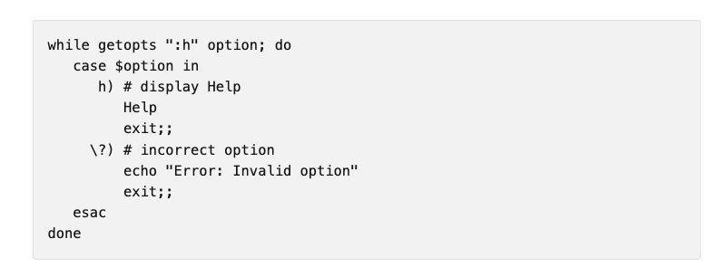 https://opensource.net/efficient-bash-script-templates-5/
  - Need options description at top of script e.g.
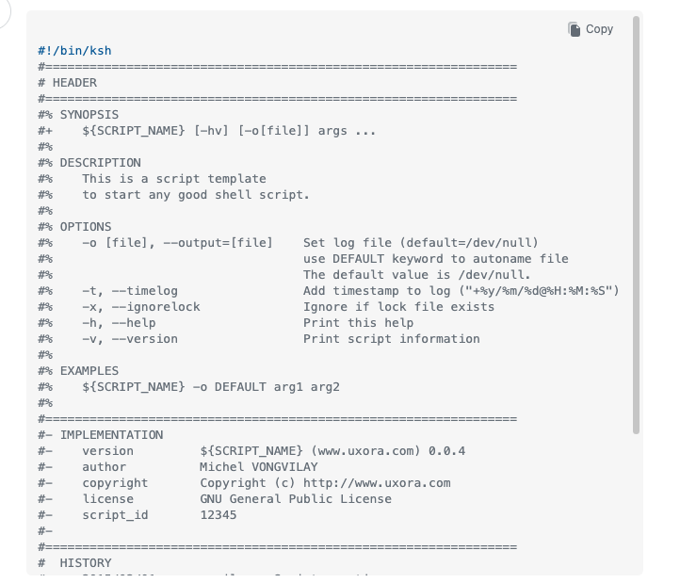 https://stackoverflow.com/questions/14008125/shell-script-common-template

Structure
- 01_Protease
  - scripts
  - data
    - processed
    - reference
  - results
    - reports
      - fastqc
    - tables
    - figures
  - logs
- 02_HDM_Dog
  - scripts
- Installation.md
- Citations.md
- Repository_structure.md

