- (Huang et al., 2025) https://www.jove.com/t/68760/a-verified-workflow-for-mirna-seq-data-processing-bioinformatics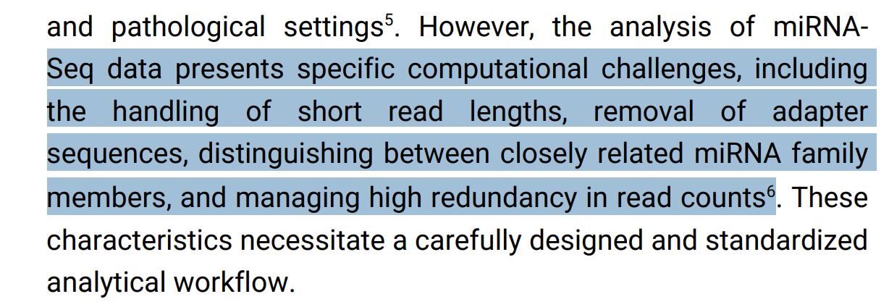

Part 2 - Functional enrichment
- Computational Methods and Software Tools for Functional Analysis of miRNA Data (2020)
https://pmc.ncbi.nlm.nih.gov/articles/PMC7563698/
- Bias in microRNA Functional Enrichment Analysis (2015)
https://pmc.ncbi.nlm.nih.gov/articles/PMC4426843/
- miEAA 2023: Updates, New Functional microRNA Sets and Improved Enrichment Visualizations (2023)
https://pmc.ncbi.nlm.nih.gov/articles/PMC10320052/
- Insights into Online microRNA Bioinformatics Tools (2023)
https://www.mdpi.com/2311-553X/9/2/18
- Pathway analysis from lists of microRNAs: common pitfalls and alternative strategy (2025) https://pmc.ncbi.nlm.nih.gov/articles/PMC4402548/
- Use anticorrelation of miRNA and mRNA to focus enrichment analysis https://isevjournals.onlinelibrary.wiley.com/doi/full/10.1002/jex2.134

