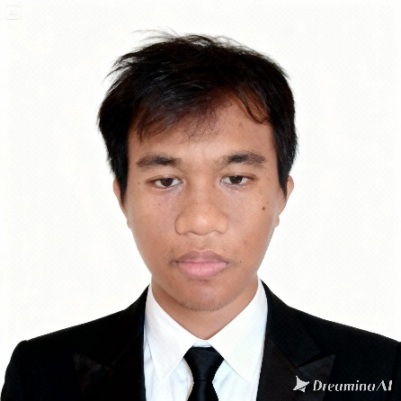  Christian John C. Duque  Contact  Address  Balabago, Jaro, Iloilo City  Phone  09604180219  E-mail  duquechristianjohncalderon@gmail.com  Portfolio Website  https://cjblack-dev-minimalistic-portfolio.vercel.app  GitHub  https://github.com/CJBLACK24  Achievement  2nd Runner Up –  Networking Competition  TECHLYMPICS 2025  Western Institute of Technology  – Iloilo City | July 19, 2025 | Objective  Looking for an OJT opportunity where I can support a development  team by applying my knowledge of React, Node.js and MongoDB.  Eager to learn from experienced engineers in web or mobile  development practices, and grow into a valuable contributor in a  professional environment.  Education  Expected in 2026-04 Bachelor of Science: Information Technology Western Institute of Technology - Luna St., La Paz, Iloilo City, Philippines 5000  Skills  TECHNICAL SKILLS  Proficient with  HTML &CSS | JavaScript | React.JS | Git |GitHub |Vercel  Familiar with:  Next.JS, Tailwind.CSS, Python, Java, Typescript, MongoDB  PostgreSQL, React-Native, Expo, CISCO  SOFT SKILLS  - Resiliency  - Time Management  - Attention to detail  - Team work & Collaboration  - Adaptability  - Good Communication  Certifications  28 Sep 2025 HTML Essentials Course  6 Sep 2025 JavaScript Essentials 1 Course  5 Sep 2025 Python Essentials 1 Course
.
#HRJ#3cf9fda6-b3b4-42c1-bd88-b6e9bd57cfdc#

