**Instructions for using the Excel-to-DSC_CJH stylesheet**

*First draft by Kevin Schlottmann, September 1, 2015*

**This method is derived from Mark Custer's approach, here.**

**https://github.com/fordmadox/excel-to-dsc**

Using the attached Excel template and a pair of stylesheets, we can now automatically create the <dsc> portion of an EAD finding aid from an Excel container list. Once the transformation is set up, it is a fairly easy process.

**Required files:**  excel_dsc_CJH_template (the Excel template); Excel-to-DSC_CJH (the main stylesheet); moveUpContainer (a second stylesheet to make the containers appear under the <did> where the CJH container list stylesheet needs them).

To begin:

1. Copy and rename the Excel template something like MyCollectionContainerList.
2. Open it in Excel. You will see a whole lot of columns, like this:

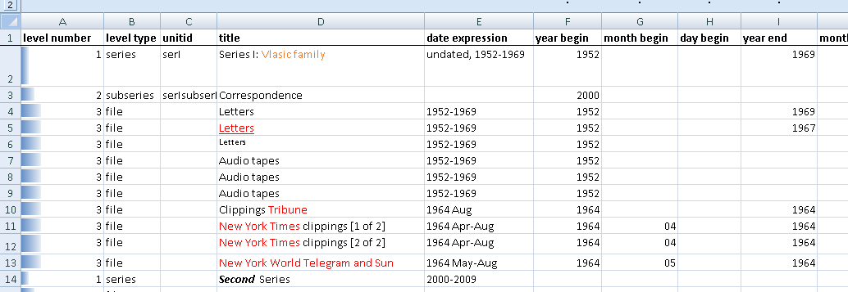

Enter your container list here. A few notes about this:

*The level-number column corresponds to the <c0x> component unit

*container 1 value defaults to box, and container 2 value defaults to folder

*leveltype defaults to file

*if you choose otherlevel as a level, you will manually need to add the otherlevel=section attribute

*only outputs <dsc>; not a full EAD

*add id link to unittitle via unitid in column 3

*for bulk dates – years only; either one year in bulk-year-begin, or a range with bulk-year-begin and bulk-year-end

*we still need to manually add <language> tags in series and subseries level <langmaterial> tags

*c0x only works down to level c09

* formatting (italics, bold, underline) are transferred to the XML.

*You can create mixed content with the following font colors; to determine the right font, right-click on the cell and Format Cells -> Font -> Color -> More Colors and enter the RGB value.

|  |  |  |
| --- | --- | --- |
| EAD tag | RGB color | Hex value |
| title | 255 0 0 | #FF0000 |
| corpname | 0 112 192 | #0070C0 |
| persname | 112 48 160 | #7030A0 |
| famname | 237 125 49 | #ED7D31 |
| geogname | 68 84 106 | #44546A |
| genreform | 0 176 80 | #00B050 |
| subject | 0 176 240 | #00B0F0 |
| occupation | 255 192 0 | #FFC000 |
| function | 255 0 255 | #FF00FF |

*I hid a bunch of columns that we don't normally use. There are lots of other options – be in touch if you see something and would like know how it works.

1. Save your template with the file type "XML Spreadsheet 2003"

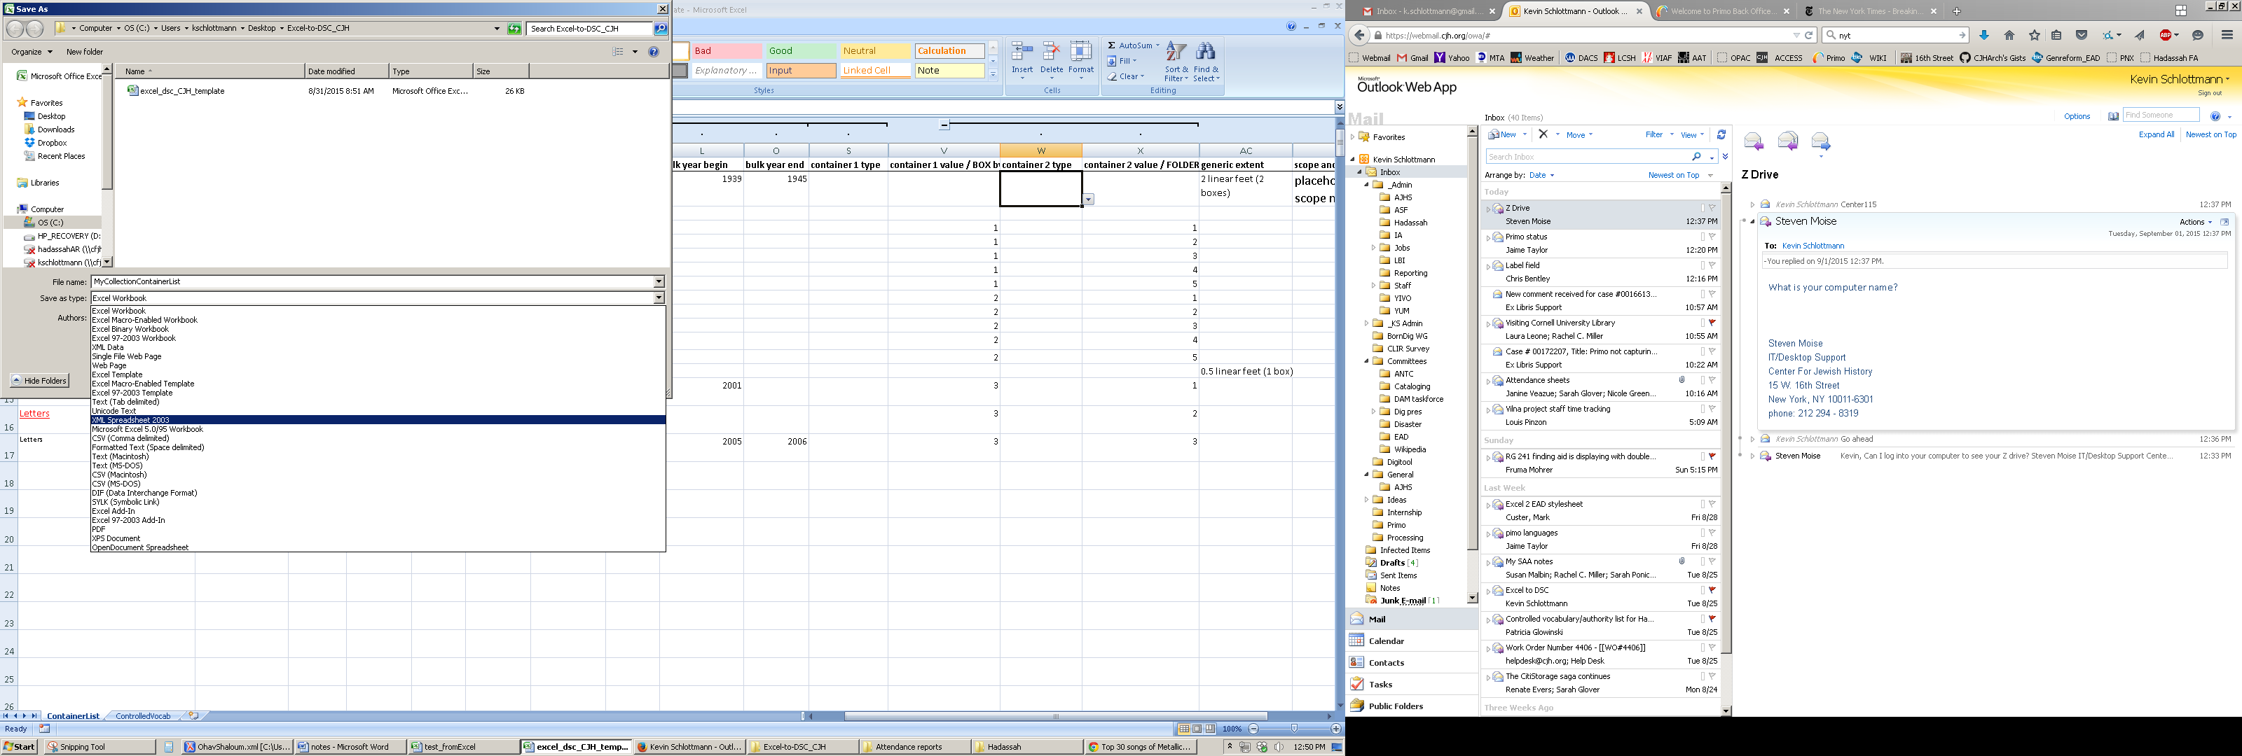

***THIS IS THE KEY STEP, AND THE INSIGHT THAT MARK CUSTER DESERVES A LOT OF CREDIT FOR ***

1. Open the resulting file in oxygen and run the transformation described below.
2. Select the <dsc> and paste it into your EAD.

NB: I haven't tested the dao functionality yet, but it should work with some tweaking. I hope to work on the dsc-to-excel spreadsheet so that we can use it to add daos to an existing EAD via Excel.

**Setting up the transformation:**

*NB: This may look a little different in newer versions of oxygen, but it should be pretty similar.*

Place Excel-to-DSC_CJH.xsl and moveUpContainer.xsl in the same folder somewhere on your computer.

Open your container list (XML 2003 Excel file) in oxygen. It will look like this:

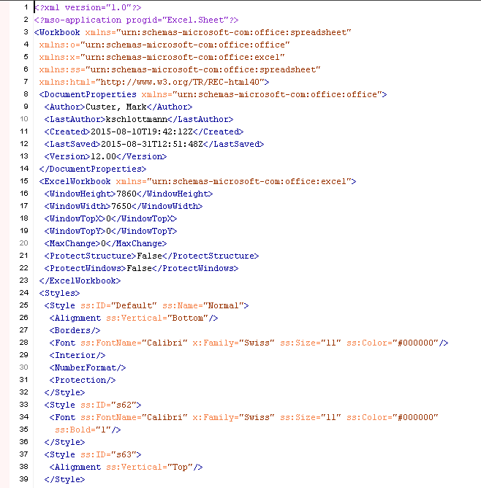

Hit the "Create a new transformation button"

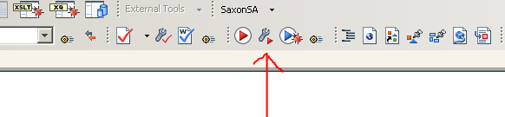

Choose "New" – make sure the Global Scenarios radio button is pressed.

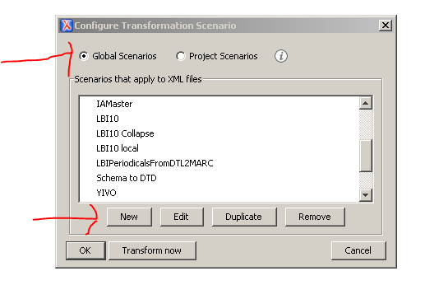

Rename the transformation to Excel-to-DSC (or something else you will remember); for the XSL stylesheet, use the folder button to navigate wherever you saved the Excel-to-DSC_CJH.xsl file; switch the transformer to Saxon-B 9.1.0.7.

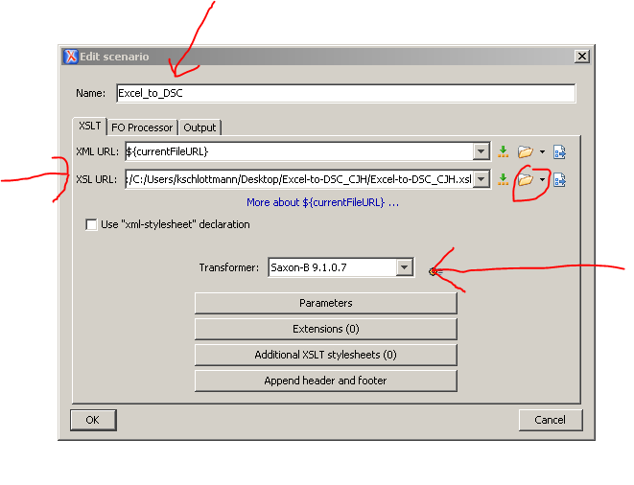

Hit the "Additional XSLT stylesheets button," hit "add," and navigate to the moveUpContainer.xsl file.

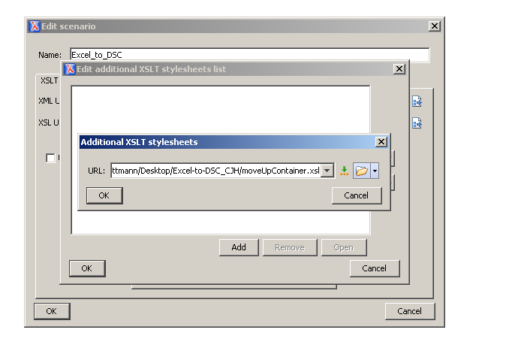  
Hit OK twice, so you get back to the Edit Scenario page:

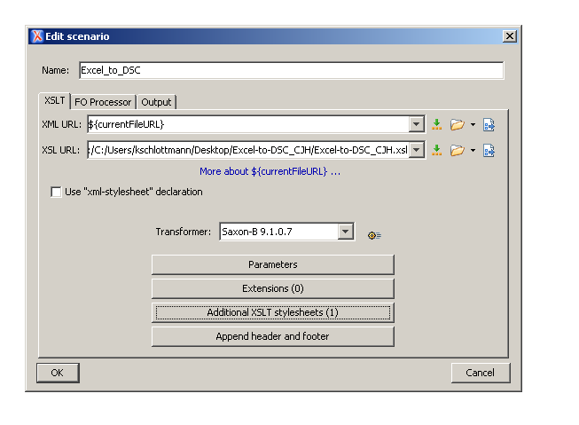

Navigate to the Output Tab, choose "open in editor" and uncheck XML.

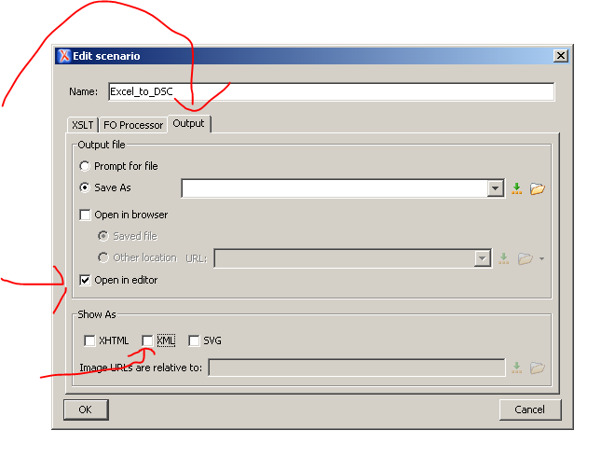

Hit OK, and then "transform now". You should get your dsc. Once the scenario is set up, you shouldn't need to do this again.