horizontal line

**=Artemis**

Start-up for Innovation

Automated Automobile Purification System

# OVERVIEW

Chemical treatment of exhaust gases using metal catalysts, activated carbon, urea solution(32.5% urea, 65.5% deionized water) and aqueous base solution. The purification system is fully automated using microcontroller and sensors to avoid man work.

# GOALS

1. To reduce the emission rates of greenhouse gases by automobiles.
2. Usage of efficient and economic catalysts for Treatment
3. Carbon Capture and Sequestration(CCS)
4. Converting the byproducts from treatment into value added products

## Construction and Working of Automated Automobile Purification System(AAPS)

Construction:  
The automated automobile purification system(aaps) having an inlet and outlet is connected externally to the vehicle. The inlet is connected with the exhaust pipe and the outlet is left free for the emission of treated gases. The system consists of exhaust fan and is placed near the outlet for free flow of exhaust gases and thereby not affecting the efficiency of the engine. A filter packed with activated carbon(in powdered form to increase the surface area)is attached in the middle of the system and is soaked with urea solution. A sponge soaked with NaOH is placed adjacent to the filter and a motor attached with piston is used to squeeze the sponge. The piston is coated with aluminium. Temperature, pressure and smoke sensors are attached near the inlet to monitor the condition of engine as well as the automated automobile purification system(aaps). All these sensors, exhaust fans and motor are connected to a microcontroller. Sprinklers are attached near the inlet which sprays base solution. A container with NaOH is fixed above the sponge.  
  
Working:  
When the exhaust gases enter the automated automobile purification system(aaps) ,the sensors activate the exhaust fans and sprinklers. The sensors display pressure, temperature and ppm readings of the system every 3 seconds and signals the driver if there is any hike in the readings. It also consists of a safety mechanism where the gases are released directly when there is a blockage in the system.

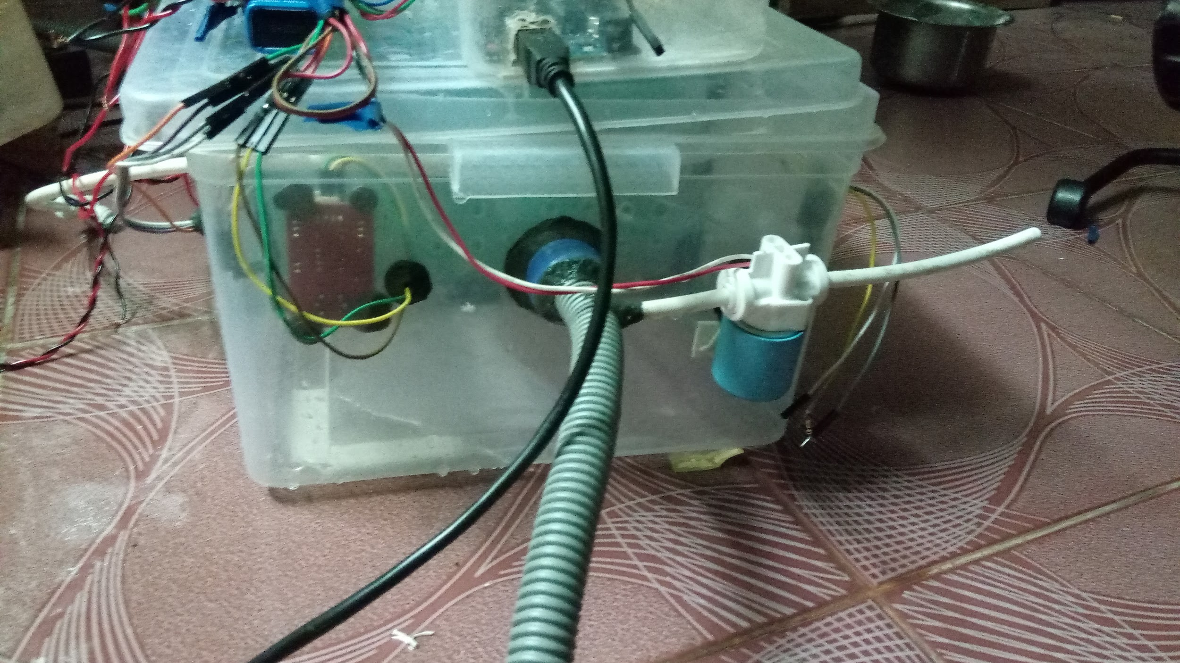

The droplets from sprinkler trap the unburnt soot particles. These gases then pass through the filter where CO2 and CO are collected by activated carbon. The presence of urea solution not only increases the CO2 capturing ability of activated carbon but also helps in reducing the concentration of NOx . The sponge soaked with aqueous NaOH solution on one side helps in reducing the acidic character of exhaust gas. The used solution can be squeezed out with help of piston coated with aluminium. This setup also serves as an Al/CO2 electrochemical cell where the activated carbon and captured CO2 and CO acts as cathode NaOH solution acts as an electrolyte and the Aluminium coated piston acts as anode. After certain interval fresh solution is poured from the base storage situated above the system .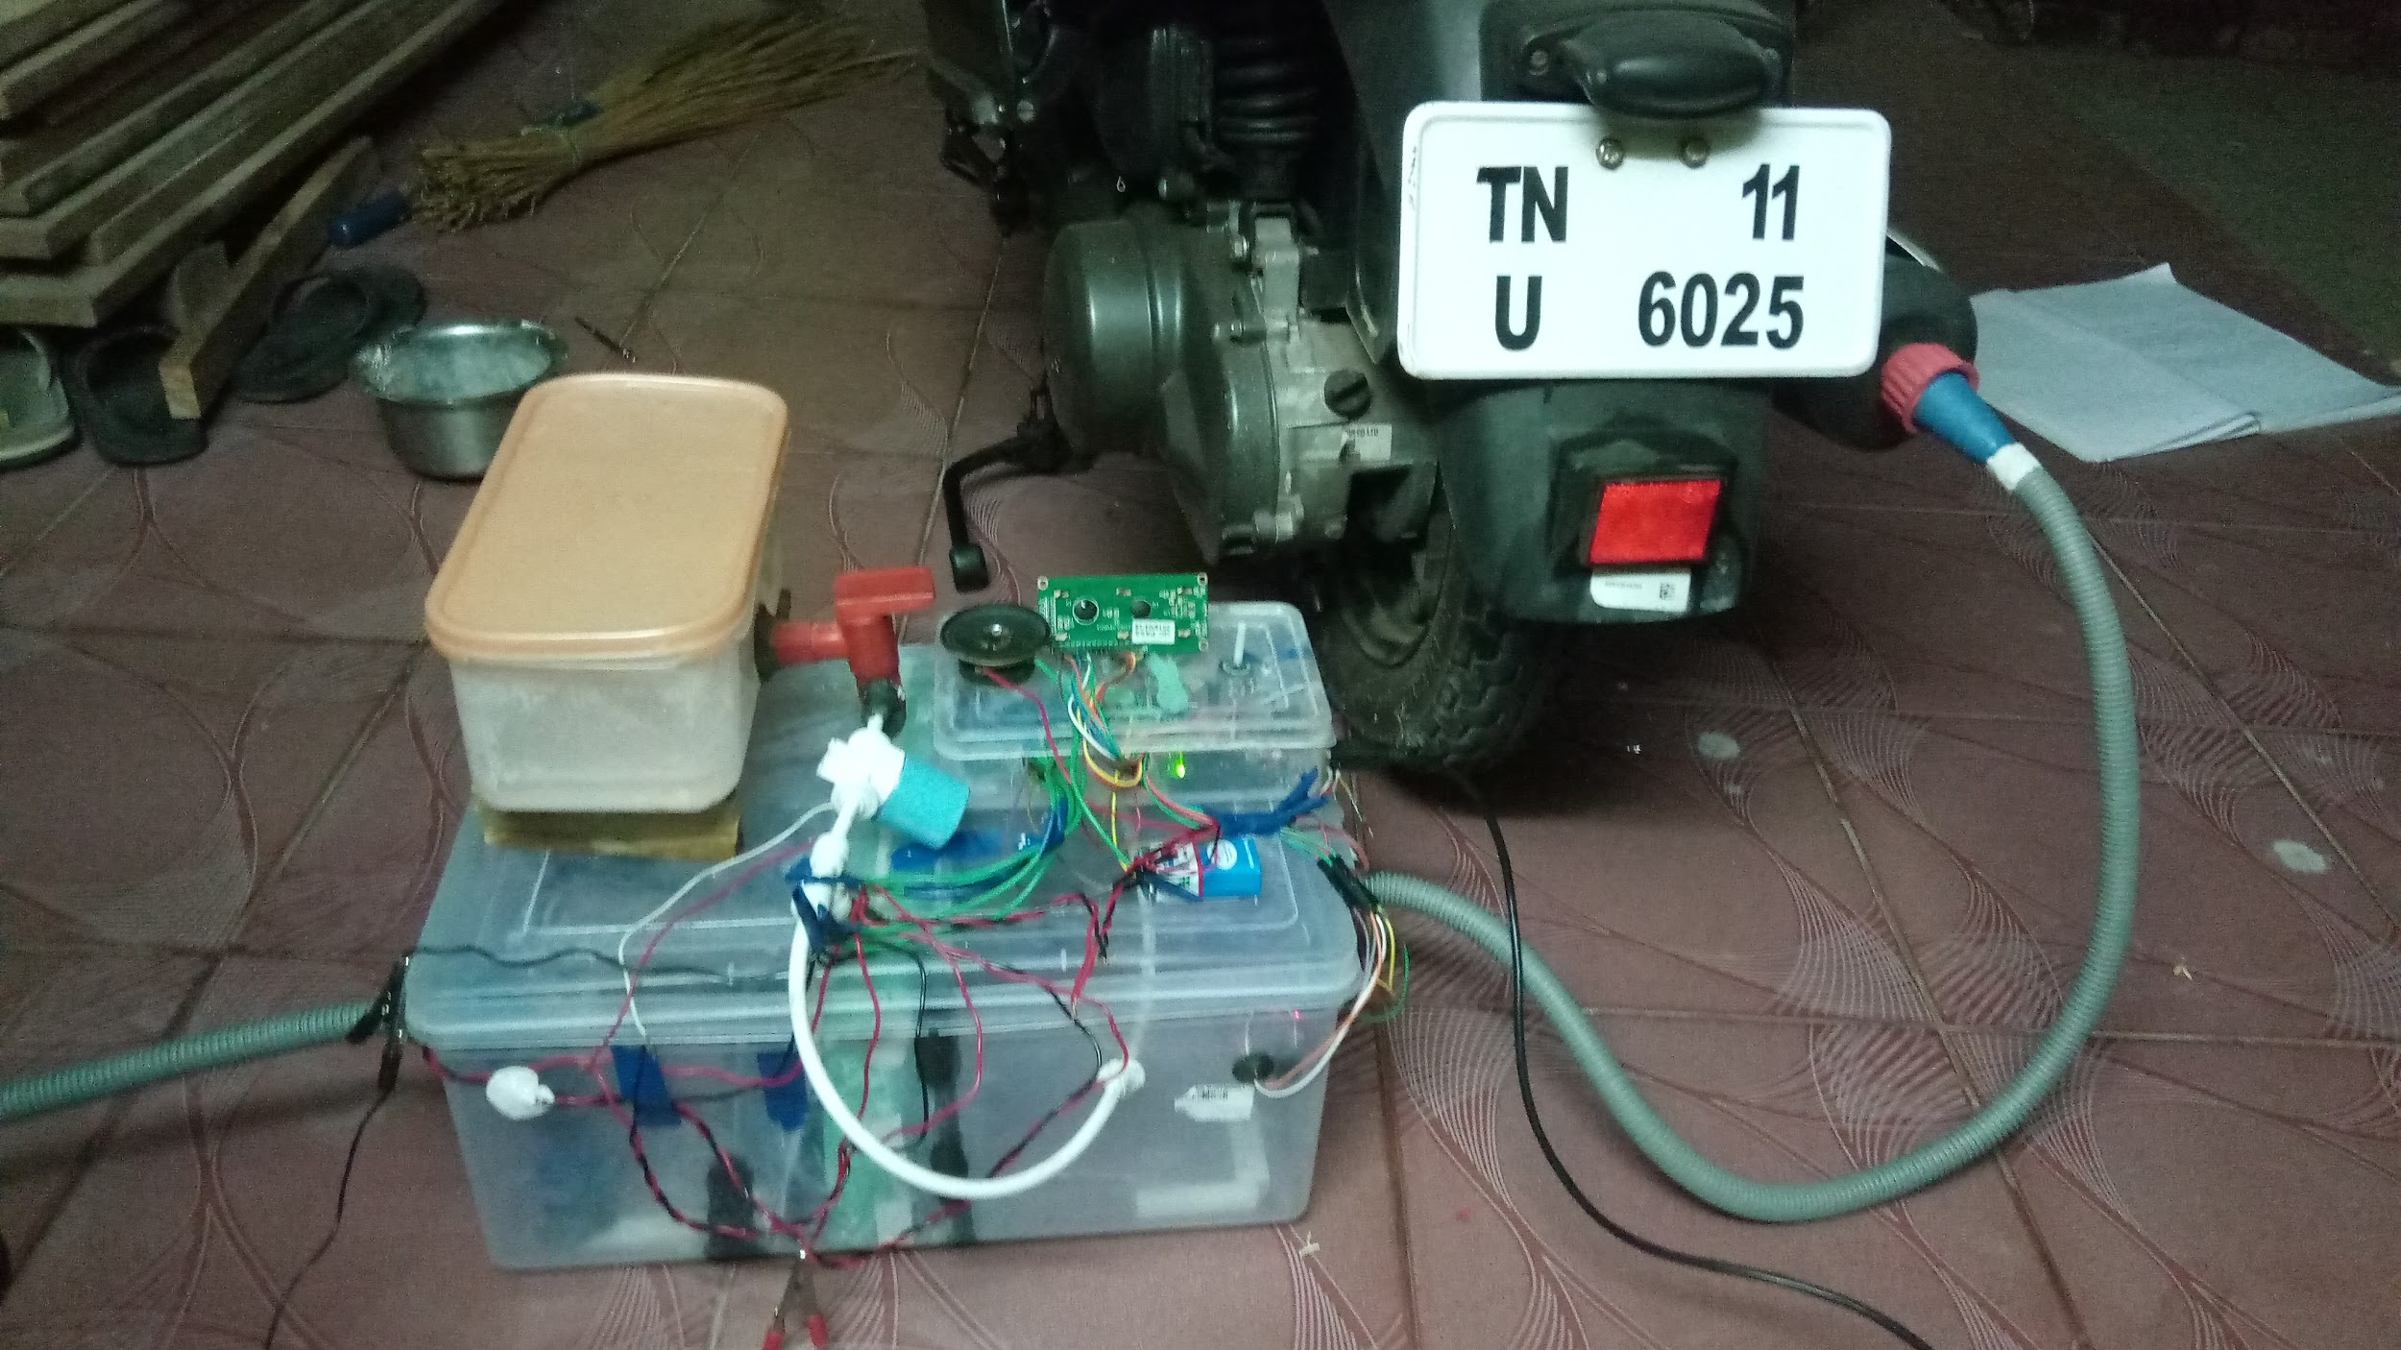

Hence , this automated automobile purification system(aaps) helps in purifying as well as converting the captured co2 into useful products.

# CONCLUSION

There are suitable number of ways for the reduction of emission caused by greenhouse gases. We propose to implement the methods to purify the exhaust in automobiles and use the treated products for industrial applications. The project is aimed to reduce the harmful effects of emission and produce energy by it.