Cambrionics Life science

**Our Vision:**

CAMBRIONICS LIFE SCIENCE is a start-up by Genetic Engineering students of SRM University. Founded by life science enthusiasts, through our innovations we aim at bringing biology closer to all and promoting the trend of independent research.

**Our Projects:**

* **DIY Centrifuge and Gel-Doc**

Gel-doc is widely used in molecular biology for imaging and documentation of nucleic acid (DNA, RNA) and protein. The main manufacturers of Gel documentation systems are Bio-Rad, Azure, Bioolympics, Vilber Lourmat, UVItec and Aplegen. The approximate cost of a Gel-doc is about 2-2.5 lakhs hence making is less affordable.

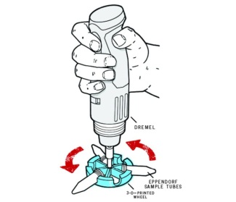

We, an independent scientific community, with a motto to promote science and make it available for everyone who’s keen on working in this field, we modelled and designed a prototype of Gel-Doc system with household things. We were able to make it within a budget of two thousand rupees. Our initial model displayed in our department attracted a lot of faculties and research scholars. We aim at **A Personal Gel-Doc for Everyone**.

Centrifuge is commonly used in all molecular biology laboratories to precipitate various nucleic acids, proteins and compounds. DIY centrifuge designed by us works on the basic principle of centrifugal action and is handy. **One can centrifuge while walking and take it anywhere they wish to.** It costs nearly 200 Rupees and anyone can have a pocket **DIY centrifuge.**

* 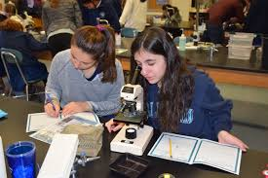**Days with Danio**

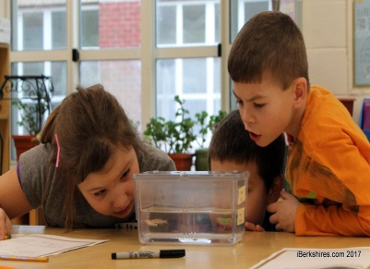 Education is very important for a child’s growth and his career. We plan use Zebrafish model system for the first time in India for the school kids and teach them **Live Biology**. We have modules ready for classes 6-9 that includes small experiments and projects to work upon while they are still in mid-school to inculcate the passion for science.

* **Gene-Card**

Everyone has a personal identification with respect to their DOB, caste, creed and sex. We provide people with genetic identity that is personalized to their health and body, which will help them in their diagnosis and disease management, all throughout their life. A simple barcode generated for every individual will hold their medical history and family pedigree along with their genetic makeup. This approach will help in faster diagnosis and better drugs for each person. Personalized medicine is going to be the highlight of the next decade, and **Gene-card** will be a breakthrough technology.

**Activities:**

* 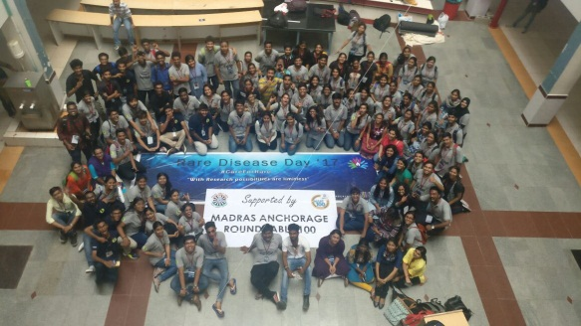**RARE DISEASE DAY (2017):** In India, mostly the middle and lower middle class generations are affected by genetic disorders. We successfully organised a rare disease day event for genetically affected kids, making their day special and memorable. 23 kids along with their families were invited. Help and required support were provided to them for diagnosis and treatment.
* **Rendezvous:**

**Dr. Priya Kannan:** Leading Embryologist talks about the Indian Infertility scenario and globally available tools and techniques in IVF to the team Cambrionics. She explains the Genetics behind the Infertility and molecular basis of implantation and embryo.

[www.youtube.com/watch?v=9sWKgi8KlCQ](http://www.youtube.com/watch?v=9sWKgi8KlCQ)

**MS Swaminathan:** Team Cambrionics meets MS Swaminathan - 'Father of Green Revolution'.

[www.youtube.com/watch?v=Pt1czNulA9U](http://www.youtube.com/watch?v=Pt1czNulA9U)

**Dr. Phalguni Anand:** Dr.Phalguni Anand, leading Neuroscientist in the nation talks about her personal experience on neurobiology and her project on 'Effect of music on developing babies'.

[www.youtube.com/watch?v=qbAnIrrhJaw](http://www.youtube.com/watch?v=qbAnIrrhJaw)