Chris Hunter - Analysis and Design Unit (SQA PDA: Software Development)

A.D 1 Use Case Diagram

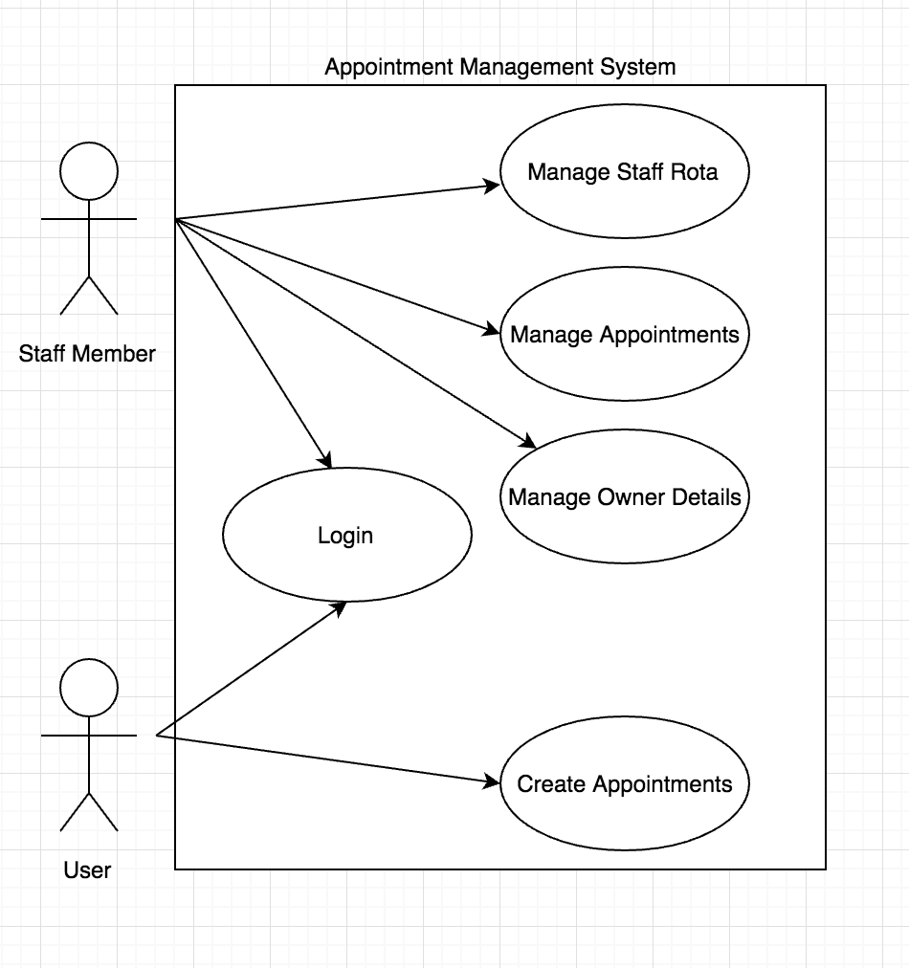

A.D 2 Class Diagram

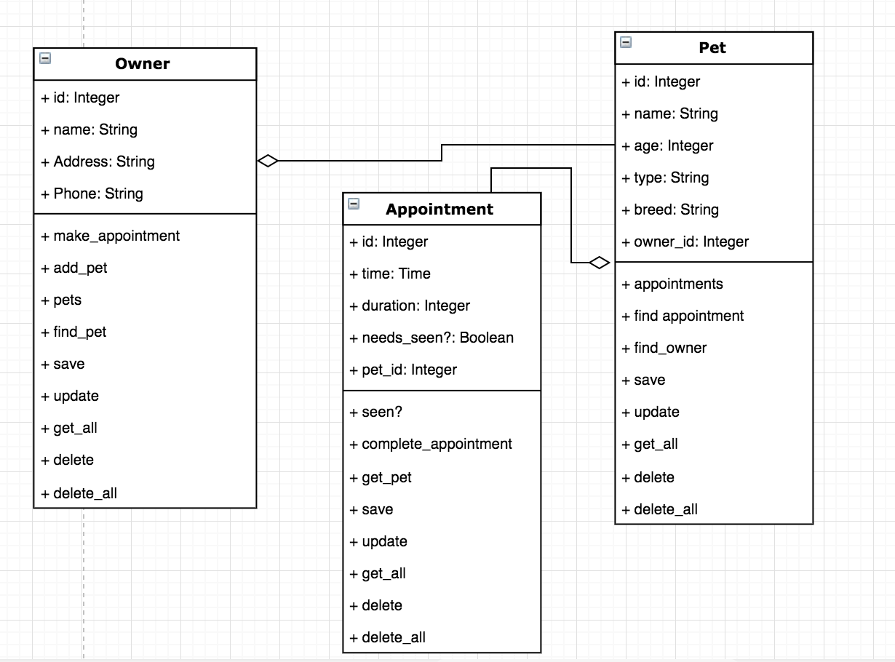

A.D 3 Object Diagram

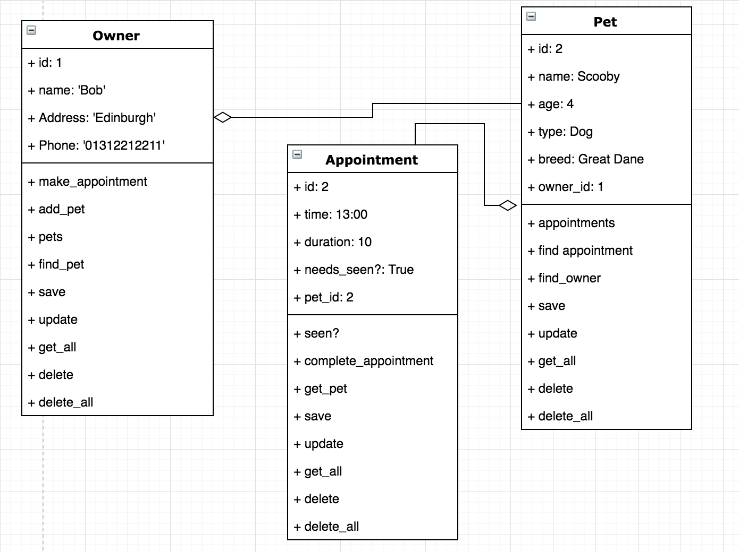

A.D 4 Activity Diagram

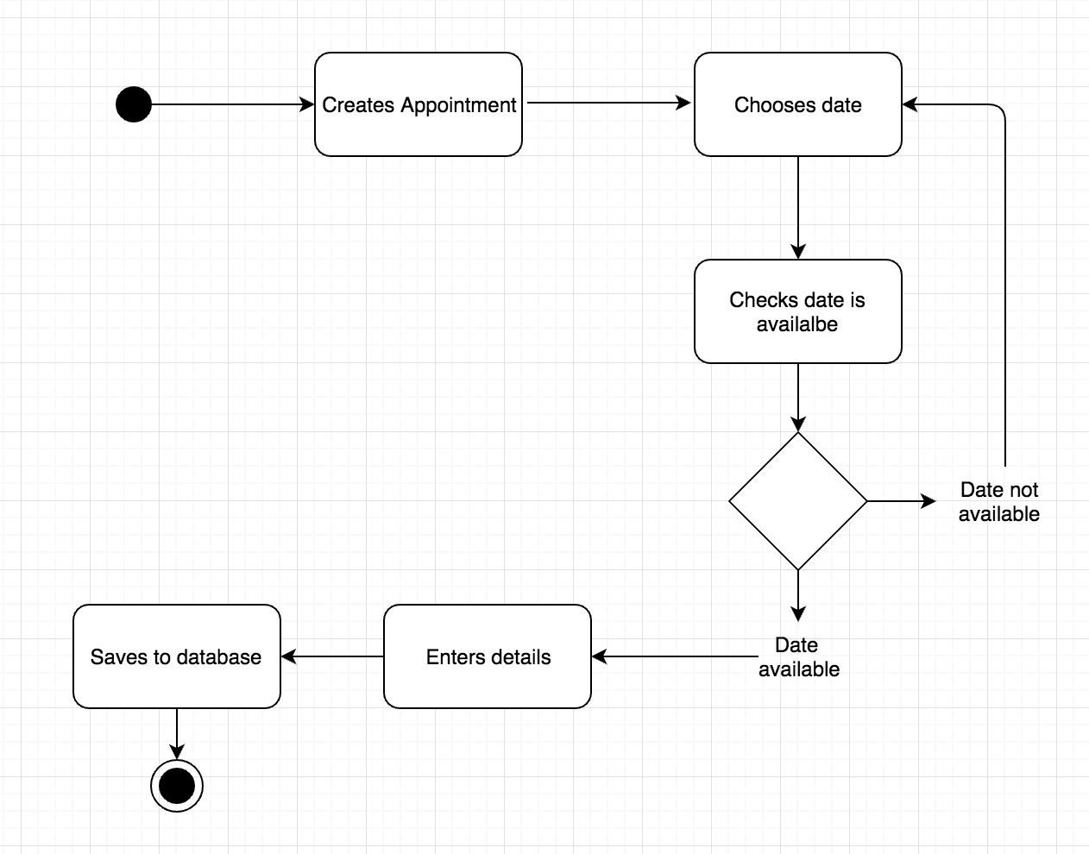

A.D 6 Implementations constraint plan

|  |  |  |
| --- | --- | --- |
| Constraint | Possible Effect of Constraint on Product | Solution |
| Hardware and software platforms | Not compatible with phones or tablets. This would restrict users to using a desktop computer and stop them from making appointments while away. | Build a follow up app that allows mobile users to use the product. |
| Performance Requirements | Slow server would limit the number of users being able to book appointments at once. This would frustrate the user. | Upgrade to a faster server |
| Persistent Storage and Transactions | The database may have limited storage meaning the database will have to be purged of clients. This may annoy users if they have been removed from the system. | The clients could be sent an email regularly asking if they still want to use the company, if not they will be removed from the database. |
| Usability | Product Style/CSS is not setup for mobile devices. This will stop mobile users being able to use the site. | Use Responsive design |
| Budgets | Budget for one server. Stopping users from using the system while maintaining the server. | Create a local version of the app which updates the server when available but saves the data locally first. |
| Time | Appointment system doesn’t have all the planned features. This may stop users being able to use the system as effectively. | Focus on time management and MVP |