词频文件截图：

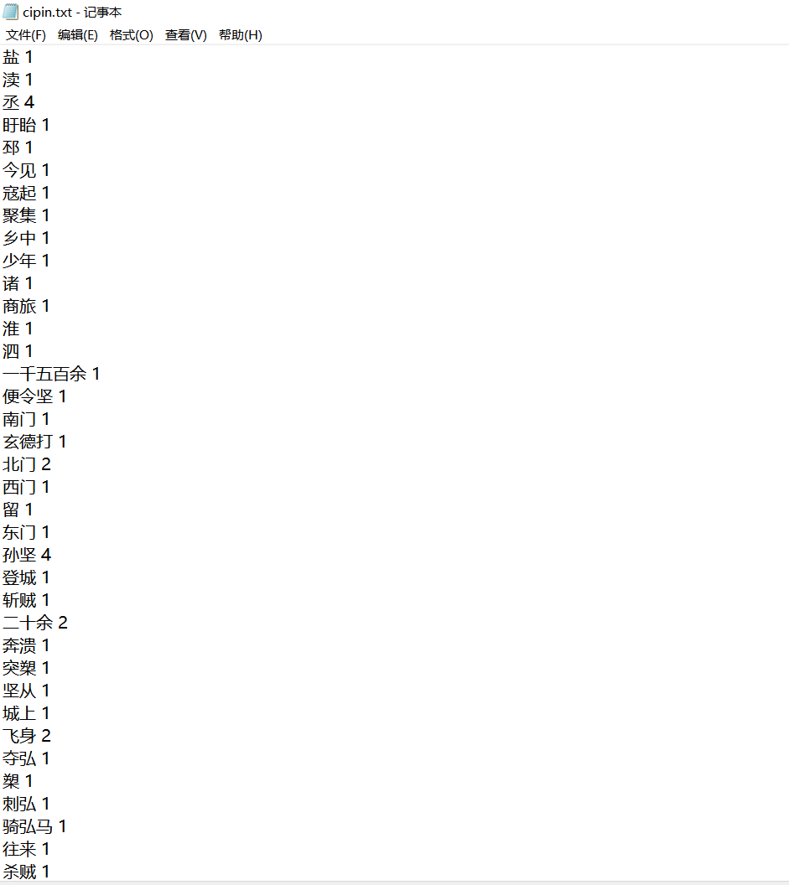

词云截图：

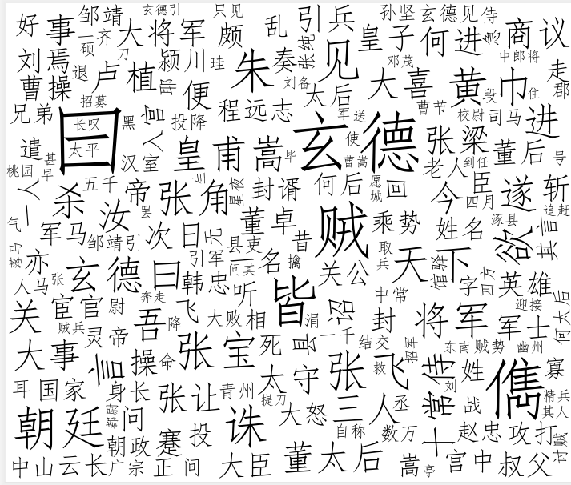

源代码：

import jieba  
from collections import Counter  
import wordcloud  
from PIL import Image  
import matplotlib.pyplot as plt  
import numpy  
def readf():  
 with open('data.txt','r',encoding='utf-8') as f:  
 data = f.readlines()  
 data = [i.replace('\n','').replace('\xa0','') for i in data if i != '\n']  
 return '。'.join(data)  
def cutword(content):  
 object_list = []  
 seg_list_exact = jieba.cut(content, cut_all=False, HMM=True)  
 with open('停用词库.txt', 'r', encoding='UTF-8') as meaninglessFile:  
 stopwords = set(meaninglessFile.read().split('\n'))  
 stopwords.add(' ')  
 # 打开停用词文件，将分词成果去掉所有的停用词  
 for word in seg_list_exact:  
 if word not in stopwords:  
 object_list.append(word)  
 with open('cipin.txt','w') as f:  
 for i,j in Counter(object_list).items():  
 f.write(i+' '+str(j)+'\n')  
 return object_list  
def ciyun(object_list):  
 d = Counter(object_list)  
 w = []  
 for i,j in d.items():  
 w.append([i,j])  
 w.sort(key=lambda x:x[1],reverse=True)  
 w = w[:200]  
 d = {i[0]:i[1] for i in w}  
 mask = numpy.array(Image.open('无标题.png'))  
 wc = wordcloud.WordCloud(  
 font_path='C:/Windows/Fonts/simfang.ttf',  
 background_color='white',  
 mask=mask,  
 max_words=500,  
 max_font_size=120  
 )  
 wc.generate_from_frequencies(d)  
 wc.recolor(color_func=wordcloud.ImageColorGenerator(mask))  
 plt.figure('词云')  
 plt.subplots_adjust(top=0.99, bottom=0.01, right=0.99, left=0.01, hspace=0, wspace=0)  
 plt.imshow(wc, cmap=plt.cm.gray, interpolation='bilinear')  
 plt.axis('off')  
 plt.show()  
 wc.to_file('wordcloud.png')  
content = readf()  
object_list = cutword(content)  
ciyun(object_list)