CockroachDB Agentic Memory Evidence

1. The pgvector Column (Proves Semantic Search)
Where to go: In the CockroachDB console, go to Databases ➔ Click your database name ➔ Click the courses table ➔ Go to the Schema or Columns tab.
What to capture: Take a screenshot showing the embedding column with the data type VECTOR (or ARRAY).
Why: This is the ultimate proof that you used CockroachDB natively for AI semantic search, which is a massive selling point for the judges.

2. The SQL Shell Query (Proves the Agent's Memory)
Where to go: Go to the SQL Console built into CockroachDB Cloud.
What to capture: Run this query and screenshot the results: SELECT session_id, turn, role, content FROM conversations LIMIT 5;
Why: This visualizes the "Episodic Memory" of the agent. It proves that the chat history is actively being saved and persisted in CockroachDB.
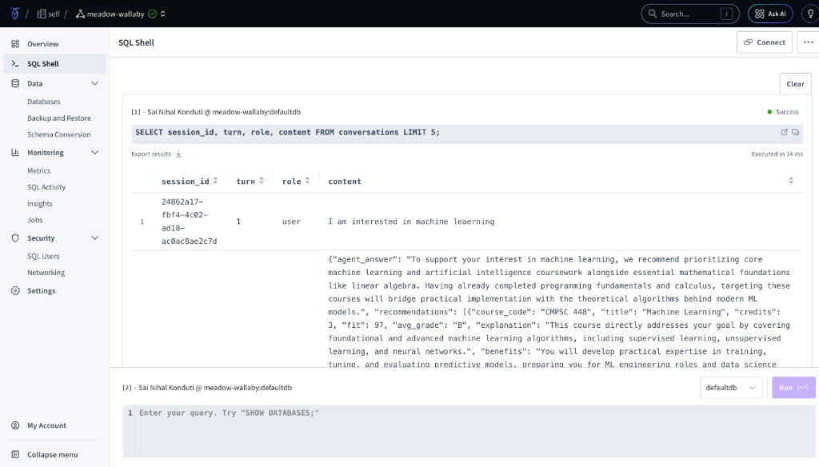

3. The Cluster Overview / Metrics Dashboard
Where to go: Go to the Overview or Metrics tab for your cluster.
What to capture: A screenshot of the SQL Statement graph or the general health dashboard showing active connections or queries being processed.
Why: It looks highly professional and proves your Flask app is actively hitting the CockroachDB cloud cluster in real-time.
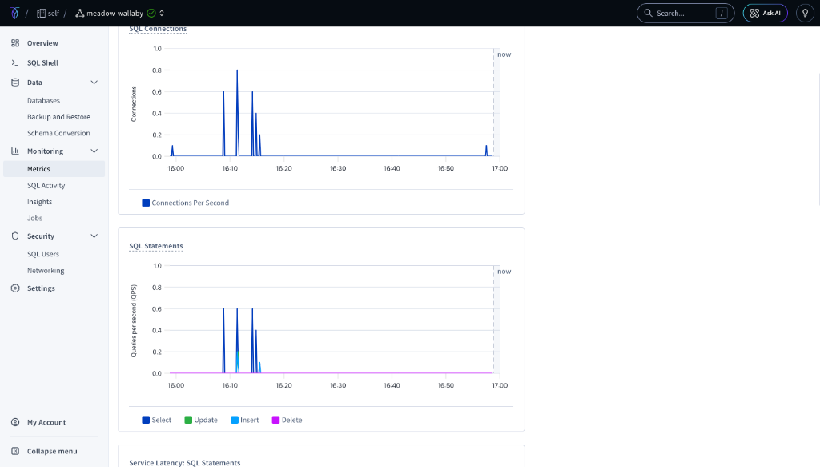

4. The Database Tables List (Proves the Architecture)
Where to go: Go to Databases ➔ Click your database name to view the list of tables.
What to capture: Screenshot the list showing courses, students, student_courses, conversations, and search_cache.
Why: This perfectly aligns with the 4 points of "Agentic Memory" you are explaining in your write-up. It proves your schema is built specifically to support RAG (Retrieval-Augmented Generation), identity state, and cognitive caching.
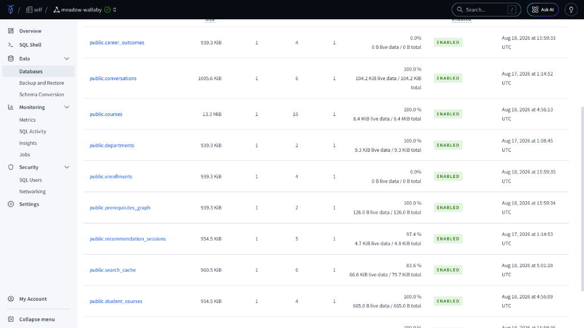

Additional Schemas/Metrics
