1. Concept Art
   1. Taken inspiration from what people from the 50s thought robots would look like in the future
   2. 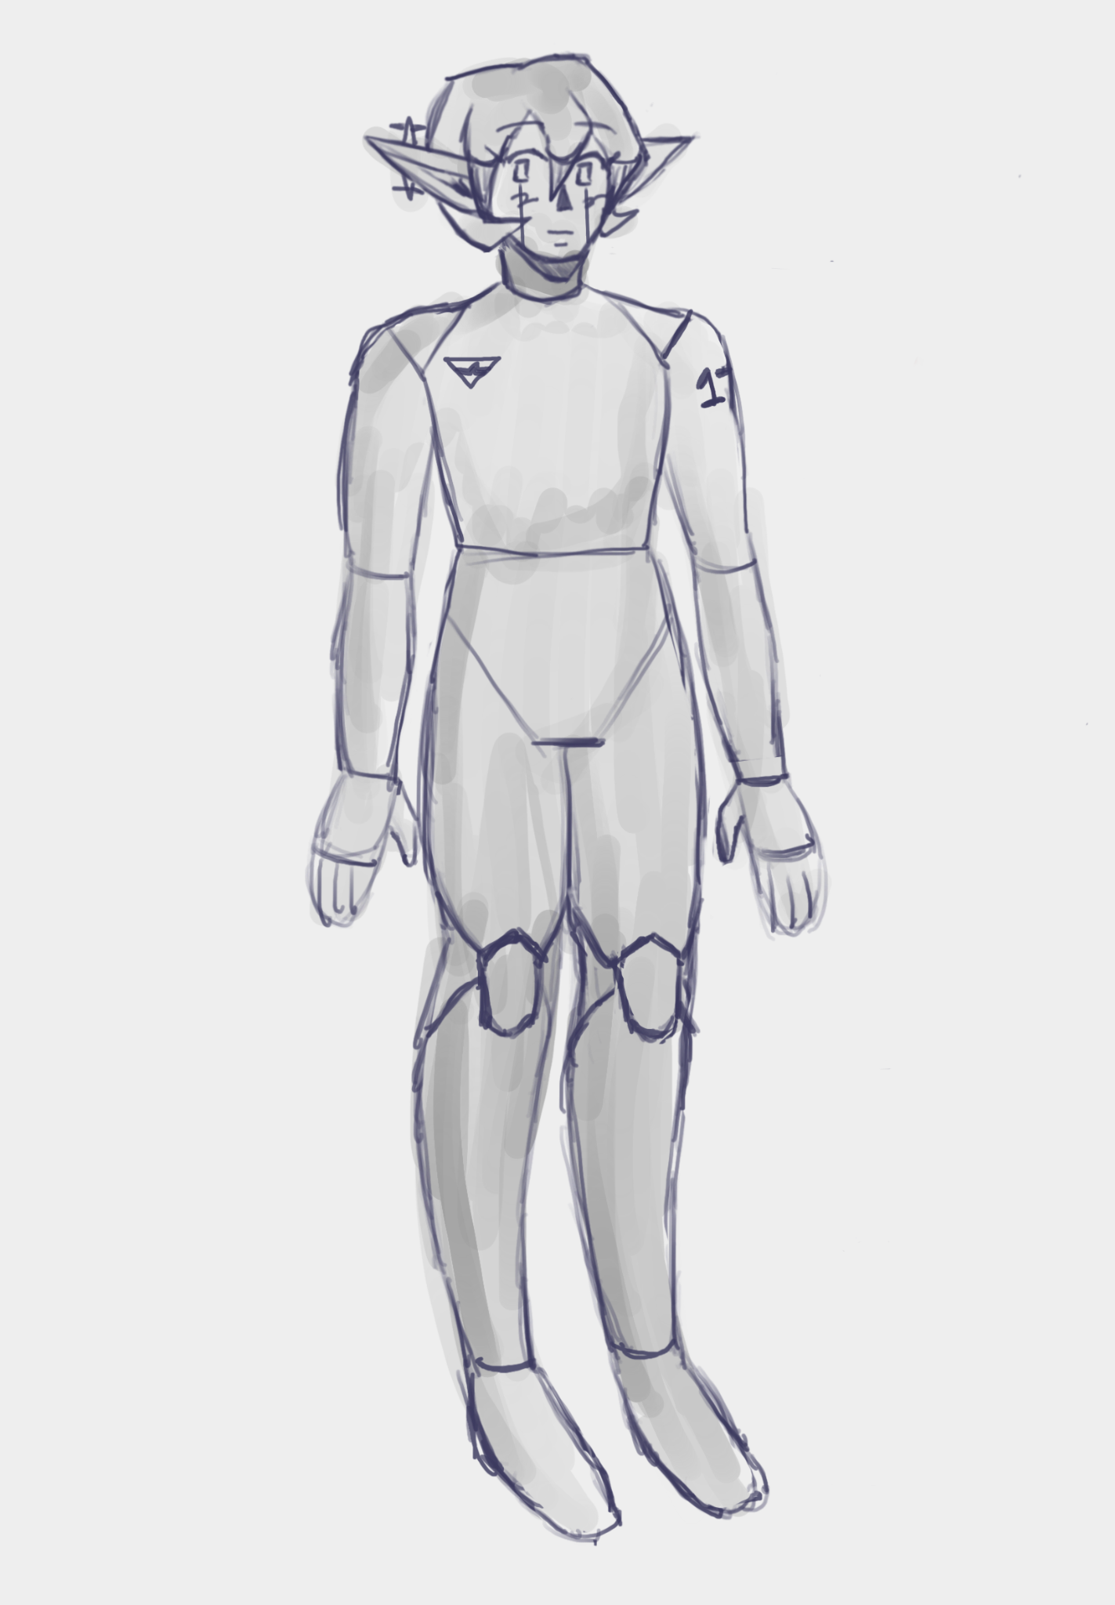(full body sketch)
   3. 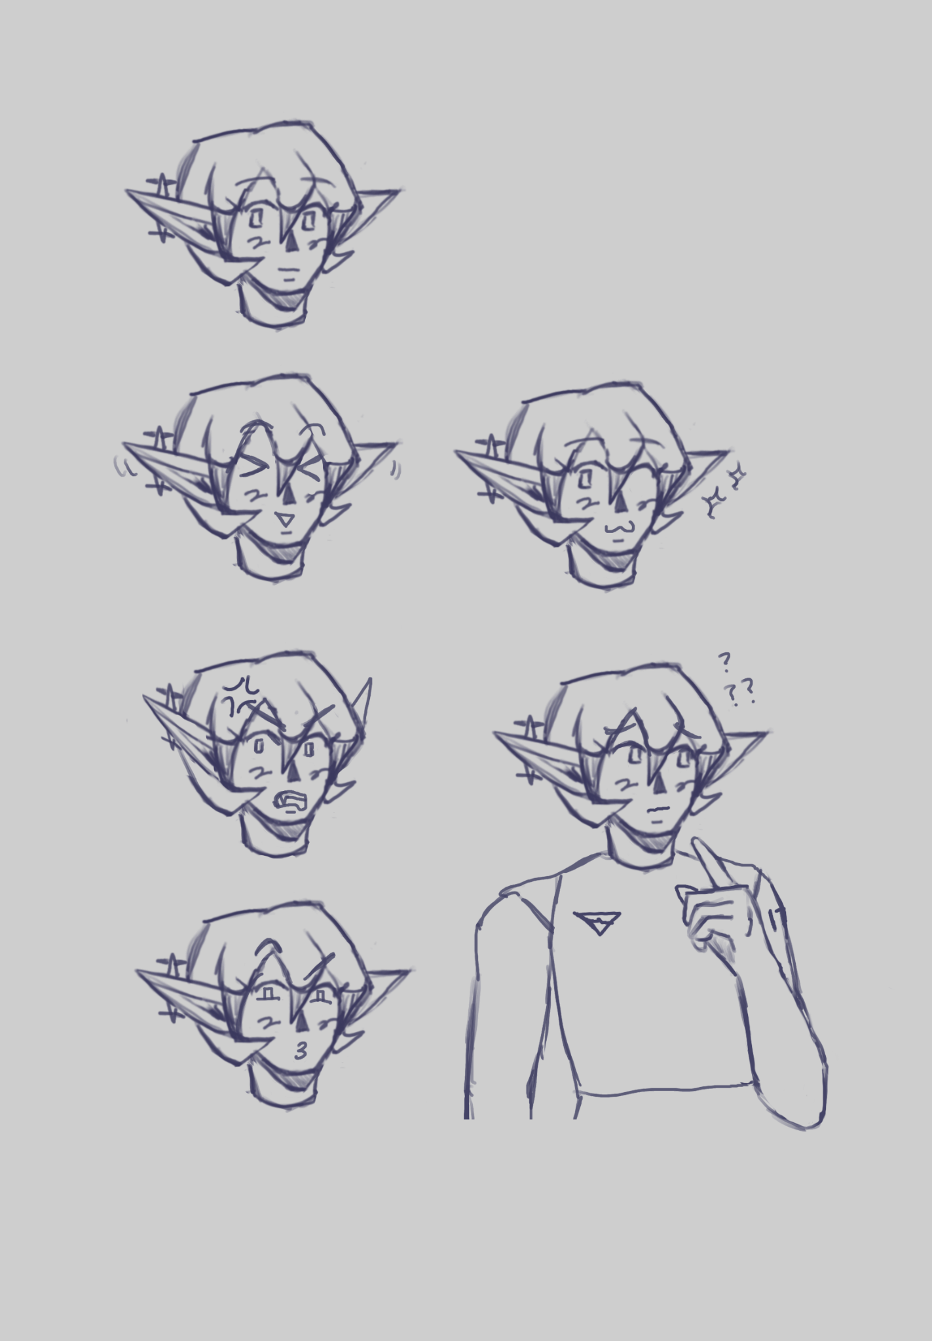(expression sheet)
   4. 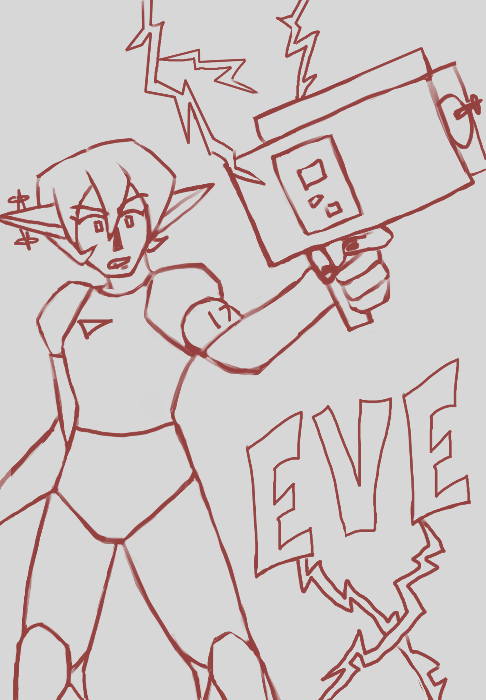(cool pose)
2. Style Guides
   1. Eve is around 32 x 16 pixels in dimension, with Red being about 8 pixels taller.
   2. All NPCs and Eve have a dark purple outline instead of a pure black one to aid with contrast and eye strain.
   3. Eve’s head takes up over a ⅓ of her body to make her more cartoonish and stand out; the NPCs are still cartoonish but are more proportional (\*see Red)
3. Characters
   1. Eve
      1. 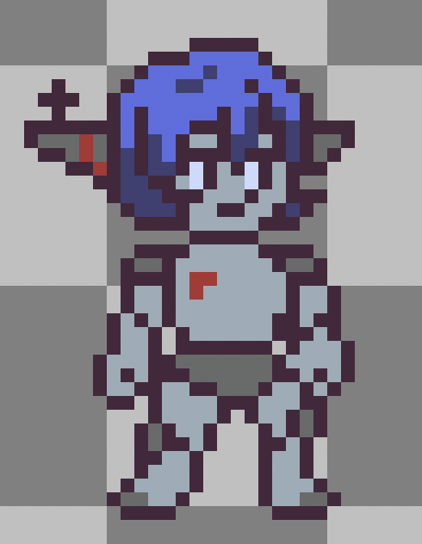
      2. Silver metallic body with divides on elbows, knees, and fingers so she can move her joints. Dark gray pieces on shoulders, knees, and tips of feet. Bright blue hair with parted bangs in a vintage style bobcut. Dark gray elf-like metal ears with radar sticking out and red line detail. A matching red symbol of the company she was made from is on her chest.
   2. Red
      1. 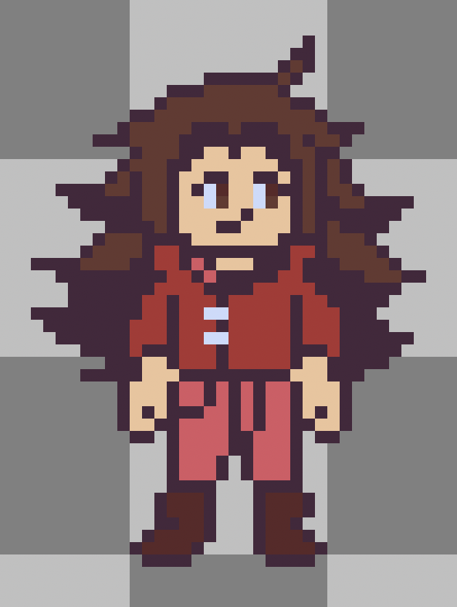
      2. Very long, spiky brown hair with middle-part side bangs and light skin. Bright red jacket with open high collar, rolled-up sleeves, and silver clasp details. Lighter red high-waisted pants tucked into old brown boots.
4. Environments
   1. Floating Islands
5. Equipment
   1. Aseprite
      1. For pixel art sprites and animation
   2. Procreate
      1. For concept art and sketches