Name: Carl Justine S. Alamay

Section: S11B

Laboratory Activity Title: “Introduction to Matlab”

**Instructions:** , for each of the sections indicated, please provide your corresponding answers to each of the questions indicated in the lab activity section. Please provide relevant information, i.e. **source code, graphs, explanations/answers to the question/s.**

**Part 2.1 Vector replacement using the colon operator:**

(a) The five lines of code all do the same function of creating arrays. The first line starts at 0 and increments by 1 all the way to 6, the second line starts at 2 and increments by 4 all the way to 17, the third line starts at 99 and decrements by 1 until it reaches 88, and the fourth line starts at 2 and increments by 1/9 all the way to 4. The last line does it similarly by creating an array which starts at 0 incremented by 0.1 until it reaches 2, but each value within the array is multiplied by pi.

(b) The resulting array from the first line of code would result in 10 elements which looks like [0, 0, 0, 0.25, 0.5, 0.75, 1, 1, 1, 1], and the succeeding line just uses the built array as a basis. The second line creates a subarray which contains only the 4th, 5th, and 6th element of the array. The third line acquires the size of the array which would result in the compiler stating that it has 1 row and 10 columns. The fourth line just gets the length of the array which is 10. The last line creates another subarray which starts at the second elements and skips every 2nd element until it reaches the end of the main array.

(c) The line of code that would accomplish the requirement would be:

**xx ( 2 : 2 : length(xx) ) = pi^pi.**

**Part 2.2 MATLAB Script Files**

**Part 2.3 (optional) Use soundsc() to play a 2000 Hz tone in MATLAB:**

Note: insert a link to a playable sound file (hint: use audiowrite() function in Matlab)

**3 Lab Exercise: Manipulating Sinusoids with MATLAB (note: place corresponding source code and plots)**

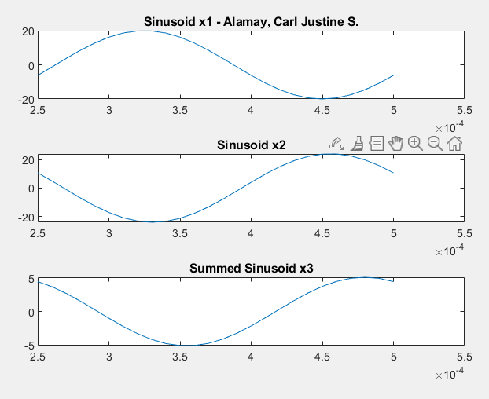

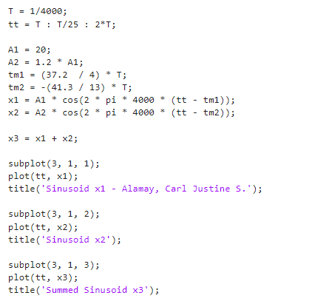

(a)

(b)

(c)

(d)

This section of code generates and plots three sinusoidal signals, x1, x2, and x3. It begins by defining some parameters: T represents the sampling period, tt is an array of time values ranging from T to 2*T with 25 equally spaced points in between, A1 and A2 are amplitudes of two sinusoids, D and M are constants used in calculating the time offsets tm1 and tm2. x1 and x2 are generated as sinusoidal signals with different amplitudes and time offsets, both oscillating at a frequency of 4000 Hz.

The code then calculates x3 as the sum of x1 and x2. The subplot(3, 1, 1) specifies that the first plot is x1, subplot(3, 1, 2) is x2, and subplot(3, 1, 3) is x3. Each subplot displays the corresponding signal over the range of time values specified by tt.

**3.1 Theoretical Calculations**

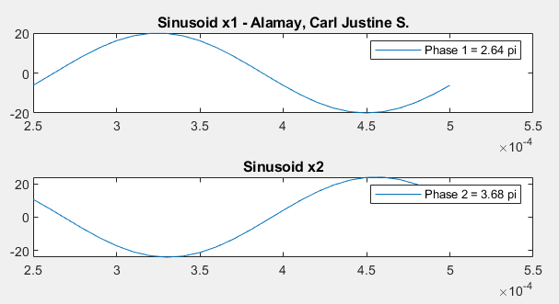(a)

The magnitude of Sinusoid x1 was 19.8923 with a time shift of 0.00033, which means x1 has calculated phase shift of 2.64pi. On the other hand, Sinusoid x2 has a magnitude of 23.8645 with a time shift of 0.00046 making its phase shift acquire the value of 3.68pi.

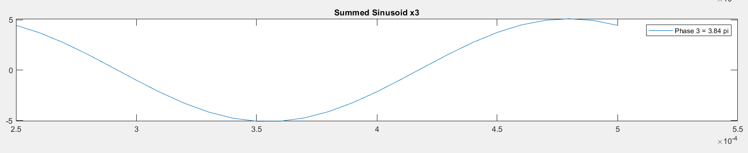(b)

Sinusoid x2 has a magnitude of 5.1061 with a time shift of 0.00048, which makes its phase shift hold a value of 3.84pi. The magnitude was measured by taking peak of the available wave, while the time shift was merely stated by the x value in the above graph. The phase shift was calculated by dividing the time shift with the frequency, and then multiplying by 2pi.

(c)

**3.2 Complex Amplitude**

