Names: **GROUP 7**

Alamay, Carl Justine S.

Sitoy, Joaquin Lorenzo T.

Section: S11B

Laboratory Activity Title: “Sinusoids”

**Instructions:** , for each of the sections indicated, please provide your corresponding answers to each of the questions indicated in the lab activity section. Please provide relevant information, i.e. **source code, graphs, explanations/answers to the question/s.**

**Pre-Lab**

**Part 3.1 Complex Numbers:**

(a)

z1 = 10 * exp(-j*((2 * pi) / 3));

z2 = -5 + 5*j;

figure;

zvect(z1, 'b');

hold on;

zvect(z2, 'r');

zcoords;

ucplot;

hold off;

zprint(z1)

zprint(z2)

(b)

zcat([j, -1, -2j, 1])

(c)

z3 = z1 + z2;

figure;

zvect(z3, 'g');

hold on;

zvect(z1, 'b');

zvect(z2, 'r');

hold off;

zprint(z3);

(d)

z4 = z1 * z2;

figure;

zvect(z4, 'b');

zprint(z4);

(e)

z5 = z1 / z2;

figure;

zvect(z5, 'b');

zprint(z5);

(f)

conjz1 = conj(z1);

conjz2 = conj(z2);

figure;

zvect(conjz1, 'b');

hold on;

zvect(conjz2, 'r');

hold off;

zprint(conjz1);

zprint(conjz2);

(g)

invz1 = 1 / z1;

invz2 = 1 / z2;

figure;

zvect(invz1, 'b');

hold on;

zvect(invz2, 'r');

hold off;

zprint(invz1);

zprint(invz2);

(h)

figure;

% 1.

subplot(2, 2, 1);

zvect(z1, 'b');

hold on;

zvect(z2, 'r');

zcoords;

ucplot;

hold off;

title('z1 and z2');

% 2.

subplot(2, 2, 2);

zvect(conj(z1), 'b');

hold on;

zvect(conj(z2), 'r');

zcoords;

ucplot;

hold off;

title('Conjugates of z1 and z2');

% 3.

subplot(2, 2, 3);

zvect(1/z1, 'b');

hold on;

zvect(1/z2, 'r');

zcoords;

ucplot;

hold off;

title('Inverses of z1 and z2');

% 4.

subplot(2, 2, 4);

zvect(z1 * z2, 'r');

zcoords;

ucplot;

title('Product of z1 and z2');

**3.3 Vectorization**

N = 200;

rk = sqrt(((1:N) / 50).*((1:N)/50) + 2.25)

plot(1:200, real(exp(j * 2 * pi * rk)), 'mo-')

**4 Warm-Up: Complex Exponentials**

function [xx, tt] = one_cos(A, w, phase, dur)

period = 2 * pi / w;

tt = 0:period/20:dur;

xx = A * cos(w*tt + phase);

end

A = 95;

omega = 200 * pi;

phi = pi / 5;

dur = 0.025;

[x, t] = one_cos(A, omega, phi, dur);

plot(t, x, 'b');

xlabel('Time (s)');

ylabel('Amplitude');

title('Complex Exponentials');

grid on;

expected = 2 * pi / omega * 1000;

fprintf('Expected Period: %f\n', expected);

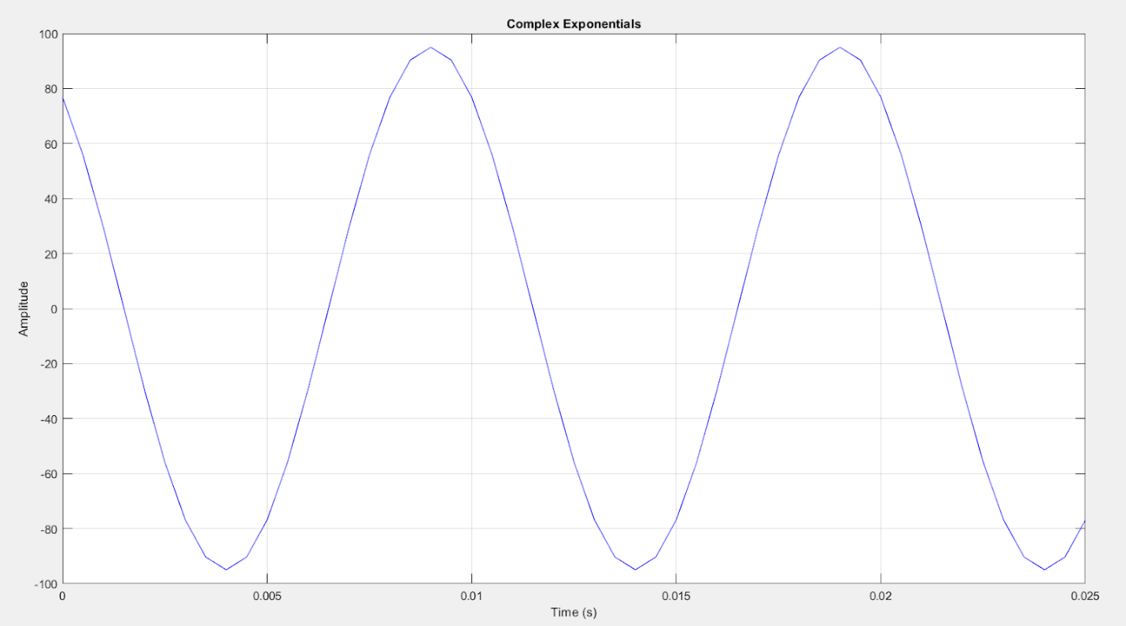



**4.2.1 – 4.2.2 M-File and Default Inputs**

function [xx, tt] = syn_sin(fk, Xk, fs, dur, tstart)

if nargin < 5, tstart = 0, end

if length(fk) ~= length(Xk)

  error('Error. Lengths of Xk and fk must be equal.');

end

tt = tstart:1/fs:tstart + dur;

xx = zeros(1, length(tt));

for k = 1:length(tt)

   xx(k) = real(sum(Xk .* exp(1j * 2 * pi * fk .* tt(k))));

end

end

**4.2.3 Testing**

figure;

[xx0,tt0] = syn_sin([0,100,250],[10,14*exp(-j*pi/3),8*j],10000,0.1,0);

plot(tt0, xx0, 'b')

**grid on;

The four graphs presented above show the different waveforms with varying frequencies – 0Hz, 100Hz, 250Hz, and a combination of the three. The main reason why the period of the synthesized waveform (xx0) appears to be longer is because of the combination of the varying amplitudes of the 100Hz and 250Hz sinusoids. Certain portions of the waveform are enhanced while other portions seem to diminish is a result of the modification of the amplitude and phase relationships of every individual sinusoid, which results in the waveform observed in xx0. Constructive and destructive interference are the main reason as to why certain sections of the synthesized waveform appear to enhance or diminish.

**5 LAB EXERCISE: REPRESENTING OF SINUSOIDS WITH COMPLEX EXPONENTIALS**

(a)

[xt, t] = syn_sin([1/2, 1/2, 1/2],[2,2*exp(j*(-1.25*pi)),1-j],100,6,-1/2);

plot(t,xt, 'b')

xlabel('Time')

ylabel('Amplitude')

title('Sinusoid with Complex Exponentials')

(b)

(c)

phasorSum = (2) + (2*exp(j*(-1.25*pi))) + (1-j);

zprint(phasorSum)

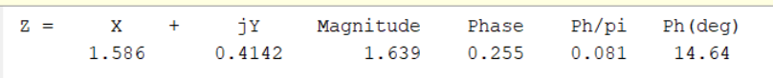

Magnitude = 1.639 = 1.639 from b

Phase = 0.255 = 0.255 from b

**6 LAB EXERCISE: MULTIPATH FADING**

(a & b)

(c)

t = 0:(1/150000000)/100:(1/150000000) * 3

t1 = sqrt(0^2 + (1500)^2)/(3 * 10^8)

t2 = sqrt(100^2 + (1500 - 900)^2)/(3 * 10^8) + sqrt(900^2 + (100 0)^2)/(3 * 10^8)

rv = cos(2*pi*150000000*(t - t1)) - cos(2*pi*150000000*(t - t2))

plot(t, rv)

xlabel('Time')

ylabel('Received Signal')

title('Multipath Fading')

%Maximum amplitude = 0.5736

(d)

[rv, t]  = syn_sin([150000000, 150000000],[exp(j*(-2*pi*150000000*t1)),-1*exp(j*-2*pi*150000000*t2)], 15000000000, (1/150000000)*3, 0)

figure

plot(t, rv)

Because both signals have the same frequency, phasor addition can be applied to combine them. The resulting complex number can then be represented through the complex plane where the Cartesian form equivalents of x and y are the real and imaginary parts of the complex number respectively. The magnitude of this complex number which represents the magnitude of the signal in the complex plane is attained simply through the application of the Pythagorean theorem.

(e & f)

xv = 0:0.5:300

t1 = sqrt(xv.^2 + (1500)^2)/(3 * 10^8);

t2 = sqrt(100^2 + (1500 - 900)^2)/(3 * 10^8) + sqrt(900^2 + (100 - xv).^2)/(3 * 10^8);

x1 = exp(j*(-2*pi*150000000*t1))

x2 = -1*exp(j*-2*pi*150000000*t2);

xSum = x1 + x2;

%signal strength

ss = sqrt(real(xSum).^2 + imag(xSum).^2)

plot(xv, ss)

xlabel('Distance in Meters')

ylabel('Amplitude')

title('Multipath Fading')

(g)

The largest values are either at 2 or values very close to 2. This is because the directed and reflected signals are suggested to reinforce each other, which would also mean that their individual magnitudes of 1 would add together resulting in the amplitude of the received signal to be maximized at a value of 2. On the other hand, the smallest value recorded was at around 250 where it was at 0, so you could say it was a complete cancellation of the signal. Other values in the graph came close to 0 such as 0.002 at 116m where you could practically consider them canceled signals albeit not completely.

The specific values where we get signal cancellation can be read directly from the generated plot. Signal cancellation occurs at 17m, 37m, 60m, 85m, 115m, 154m, and 250m. These vehicles' positions don’t necessarily mean that the aforementioned signal is completely canceled since their corresponding x values don’t directly equal to 0, only close to. This could imply that the received signal is minimized or reduced close to 0 leading to partial or complete signal cancellation.