Greetings, Sir! Here are some recent updates on our *COVID-19: POST VACCINE SIDE EFFECTS WEBSITE*. As of now, our website has 5 pages: the main page, the register page, the records, the update page and the vaccine types page.

**1. Home Page - Edcel**

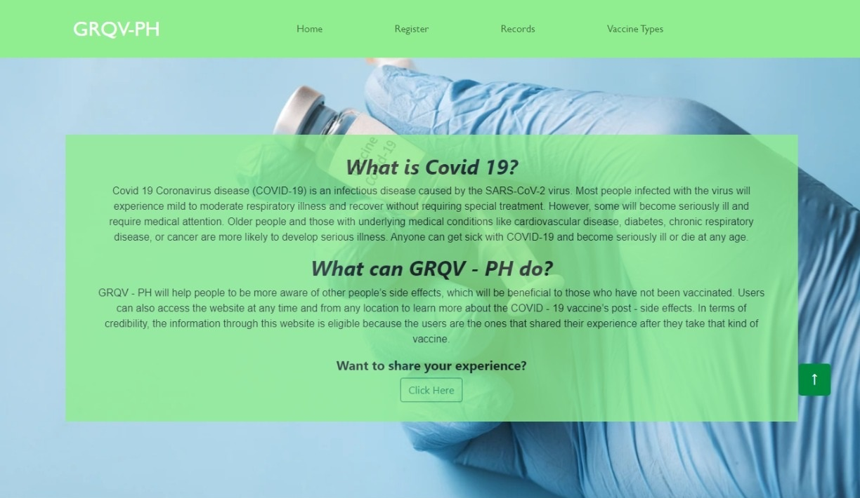We made all the Covid - 19 information available on this page. Info on Covid Issues, Different types of vaccine that includes users possible side effects, Ingredients used in a vaccine and a Simple guide for those people who's trying to get vaccinated. All info in one place. In two different languages (English & Filipino)

**2. Register Page - CJ**

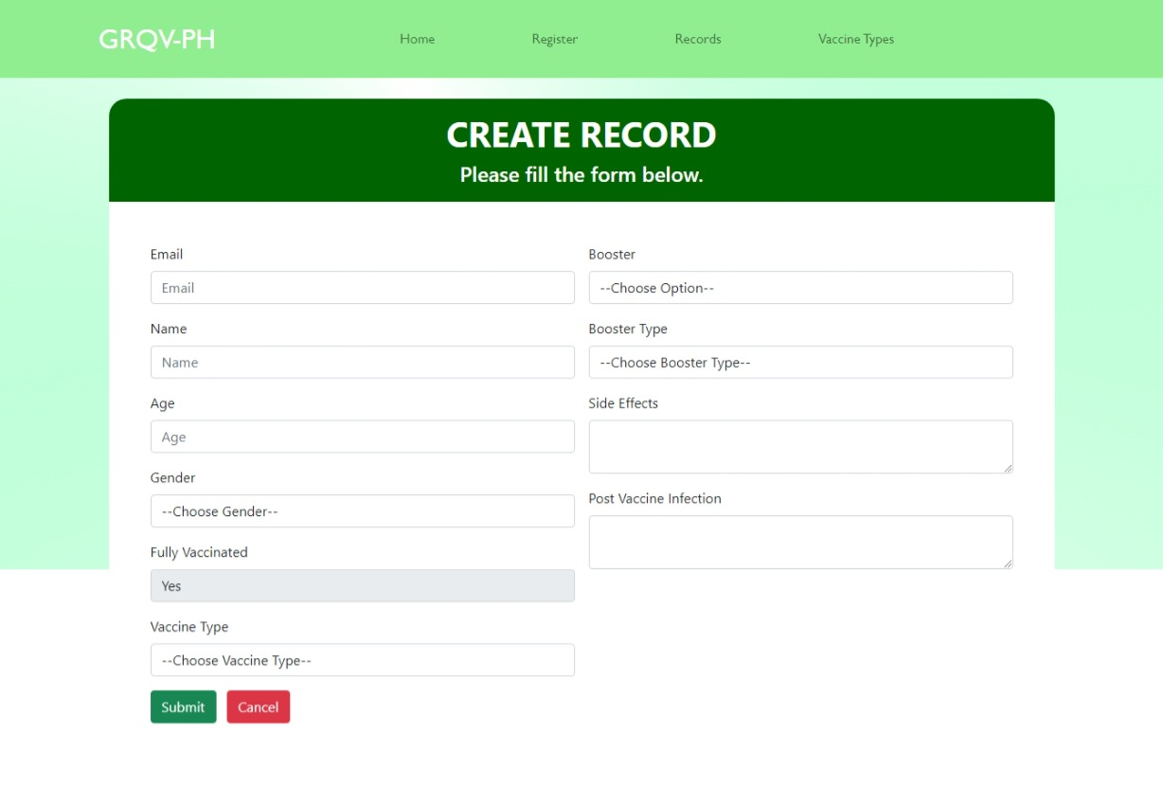This is the page where we made a list of fields so the user can enter their information regarding their vaccine status & for us to collect the data of the users who registered in this website. The user would just input their email, name, age, gender, vaccine type, booster, the booster type they had, their side effects and the post vaccine infections that they experienced. Additionally, we also made the “Fully vaccinated area” a *read only* because only fully vaccinated users can make records.

The next page is the records page which is going to be presented by Ciel Dean Varias

**3. Records Page - Cid**

This is the page where you can see the summary of the user’s information about their covid 19- vaccine—the type of vaccine they had, whether is it their first dose, second dose, their booster shot, etc. With this page, people will be more aware of the side effects of other people, which will benefit those who have not been vaccinated since being aware of the potential negative effects that other individuals may experience allows the person to be on the lookout for potential problems and respond appropriately if they arise.

Additionally, we also put a *+Add Record* button in the upper right of this page for the user to create a new record easily.

Moreover, every user's information also has an update button next to it, allowing them to update their covid status record (ex. when they just got their second vaccine, booster shot or when they experience new side effects)

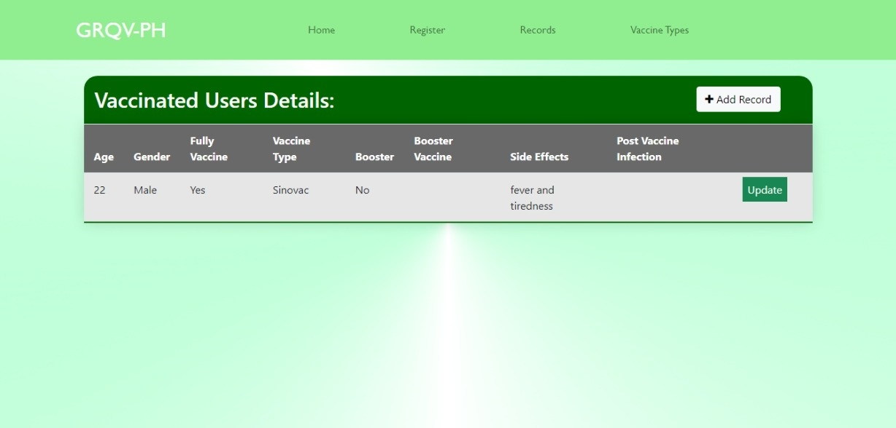

**4. Update Page - Odang**

This page allows the users to edit their information.

****If a user wants to update their record, they must first provide their email address to ensure that the record being opened is truly theirs. Also, you won't be able to access the update page if the email you entered is incorrect.

Then, on the update page, you can make changes to your record, such as selecting "yes" and selecting your booster type if you've already had a booster. And if you experience new side effects, you can also add it to this page. However, you can no longer change your name, age, gender, vaccine type on this page.

Also, null values are not allowed in other fields where the only exceptions are side effects and booster type. If you select "yes" on the booster, you should be required to specify the type of booster.

Then after the user finished updating their covid 19 side effects status, the user can just simply click submit button to return to the updated website's record page.

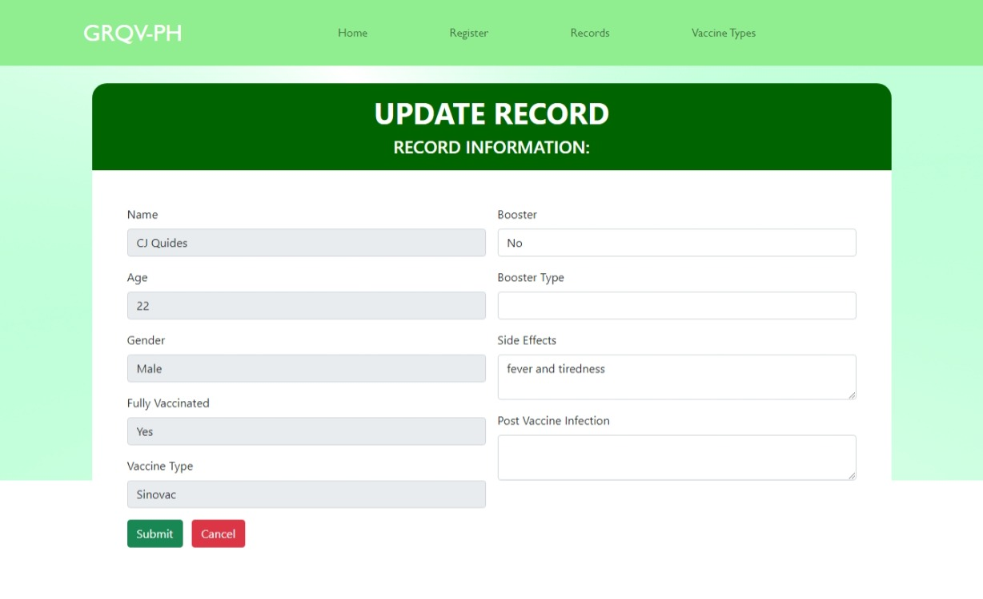

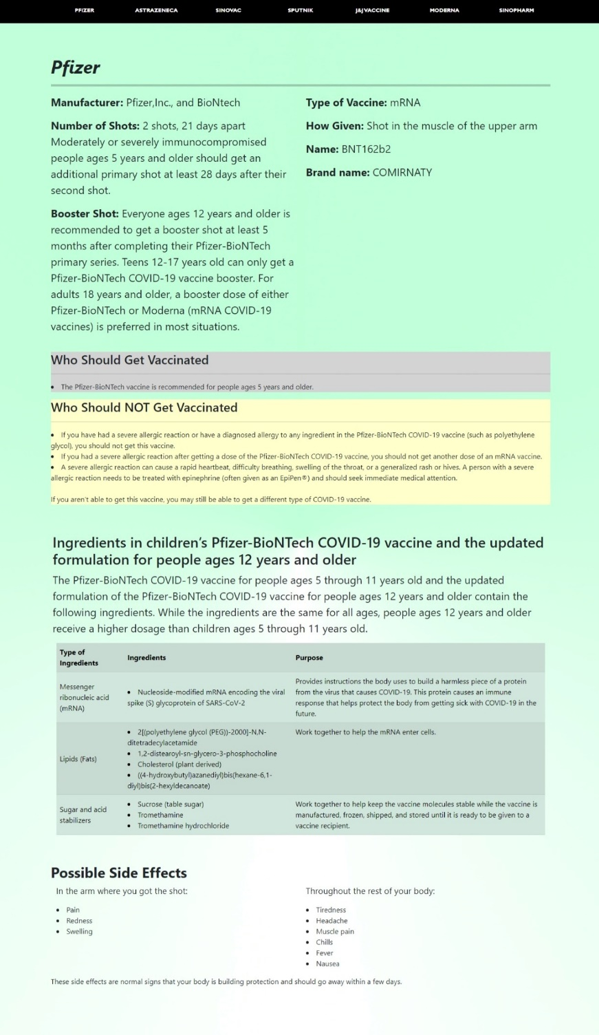**5. Vaccine Types - Edcel**

There are several COVID-19 vaccines validated for use by the World Health Organization. So, in this page, we provided some information about the different type of vaccines, how vaccines are assessed to ensure they meet acceptable standards of quality, safety and efficacy using clinical trial data, manufacturing and quality control processes by providing in this website the manufacturer, how many shots needed, what type of vaccine is it, the brand name etc. of the different types of vaccine.

Gonzales, Edcel Raphael

Quides, Charles John

Reynoso, Mary Viel Audrey R.

Varias, Ciel Dean

*Group Members*