HW1

Cameron Schneider

1/24/23

CIS 367

1. Copy and paste the code changes you made to change the color of the first  
   triangle. What values have you changed?  
     
   gl_PointSize = 10.0; - make the points larger  
   gl_FragColor = vec4( 0.0, 1.0, 0.0, 1.0 ); - change the color of the points. The numbers represent Red, Green, Blue, Alpha, so to change it from red to green I put 0 points into red and full points into green
2. Triangle rotation
   1. Copy/paste the code you made to rotate the triangle.  
        
      
   2. Can you think of any other way to rotate the triangle? Describe one  
      possibility.  
        
      If it is possible to change the axes that the triangle is on, such as flipping the plane over the x axis so positive numbers are down, will also change how the image is viewed.
3. What does it mean to perturb the bisector, as performed in Section 3?  
     
   Perturb means to subjecting something to an influence that usually alters its production. In this case, we are changing how the points are being placed to create a new image.
4. 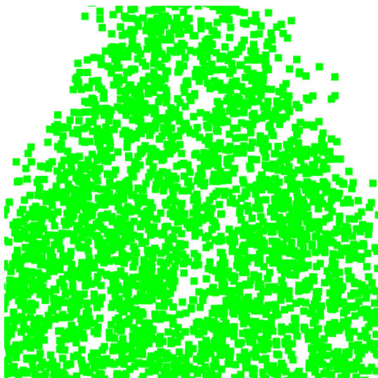Chart, scatter chart

   Description automatically generatedChart, scatter chart

   Description automatically generatedA picture containing text, plant, vector graphics

   Description automatically generatedPaste your screenshots here on perturbing things.  
     
   Math.random() getRandomArbitrary(0.23, 0.45)  
     
   getRandomArbitrary(0.94, 0.99) getRandomArbitrary(0.94, 0.99)
5. In the JavaScript file, there are two uses of the scale function. For the second  
   (scale(0.5, p);) modify the value sent in. What do you think is happening here  
   (i.e., what is the purpose of scaling)?  
     
   The scale() function seems to be scaling the space between hem given our parameters. As the value increases, the triangle seems to start growing out of the screen’s bounds. As the value gets smaller, the triangles separate more, implying that theres more space between core points.
6. We have the following three lines of code in all our gasket files, and they will show  
   up in one form or another in pretty much everything we do. What is the purpose  
   of each line of this code block specifically?  
     
   var vPosition = gl.getAttribLocation( program, "vPosition" );  
     
   Puts the location of the vPosition shaders into the variable vPosition  
     
   gl.vertexAttribPointer( vPosition, 2, gl.FLOAT, false, 0, 0 );  
     
   Connects the shader to a generic point, which will apply to all vertexes.  
     
   gl.enableVertexAttribArray( vPosition );  
     
   Essentially, turn on the shaders. Enable the shaders on each point.  
     
   7) Create your portfolio website.  
     
   Graphical user interface, text, application, email

   Description automatically generated  
     
   <https://cjschneider320.github.io/CIS371-Portfolio/webpage.html>