To: Tennessee Higher Education Commission

From: Chase Stahl

Date: February 15th, 2023

Tennessee Education Lottery Scholarship Bill

This letter documents the assessment of the potential impact of the proposed bill that would increase the minimum ACT score requirements from a 21 to a 23 or 24 for the Tennessee Education Lottery Scholarship (TELS) program. This letter contains a cost-analysis and impact assessment of these proposed changes.

The bill results in an annual net savings of $10 million, when ACT scores increased from 21 to 23, representing a 5.40% decrease in total cost. The savings are increased to $12.8 million, when the scores are changed from 21 to 24, and decrease total cost by 6.84%. The number of students eligible for the TELS scholarships decreased by 5.53% and 7.01%, respectively. The dataset revealed the average ACT score is 22.91 and the average GPA is 3.48 (Appendix A).

An impact assessment was performed by measuring the difference of distribution percentages between ACT scores of 24 and 21, maximizing potential changes. The variable most impacted was gender. The number of females increased by 1.45%, representing 58% of scholarship amounts while males were awarded 42%. Lottery scholarship type, education system, race, full-time/part-time status, Pell Grant eligibility, parent education, and income category all had less than 0.80% changes in the distribution percentages (Appendix B).

In summary, by increasing the ACT score requirements, the proposed bill saves at least $10 million and has a slight impact on gender, with all other variables remaining consistent across the proposed ACT scores of 23 and 24.

APPENDIX A

Distribution of Scholarship Requirements:

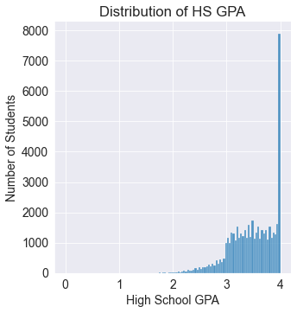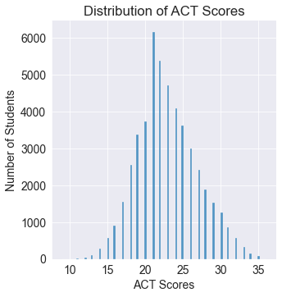

Cost Analysis Table:

|  |  |  |  |  |  |
| --- | --- | --- | --- | --- | --- |
|  | TOTAL COST | SAVINGS | SAVINGS % | ELIGIBLE STUDENTS | ELIGIBILITY %  CHANGE |
| 21 ACT Score | $186,499,250 | n/a | n/a | 49,187 | n/a |
| 23 ACT Score | $176,425,250 | $10,074,000 | 5.40% | 46,467 | -5.53% |
| 24 ACT Score | $173,735,250 | $12,764,000 | 6.84% | 45,740 | -7.01% |

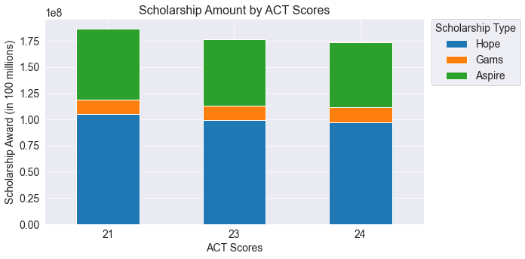

APPENDIX B:

Impact Assessment of Distribution Percent Change of Scholarship Amounts by Variable

The impact was measured as the difference of distribution percentages between ACT scores of 24 and 21. (**Change %** = 24 ACT – 21 ACT)

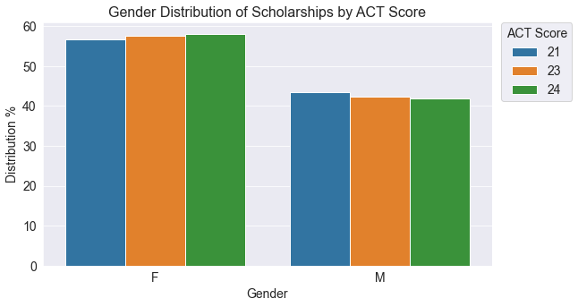

| Gender | 21 ACT | 23 ACT | 24 ACT | Change % |
| --- | --- | --- | --- | --- |
| Female | 56.58% | 57.65% | 58.03% | 1.45% |
| Male | 43.42% | 42.35% | 41.97% | -1.45% |

Distribution Percentages by Variable:

| System Name | 21 ACT | 23 ACT | 24 ACT | Change % |
| --- | --- | --- | --- | --- |
| LGI Universities | 33.59% | 33.24% | 33.14% | -0.45% |
| University of Tennessee | 27.8% | 28.44% | 28.59% | 0.79% |
| TBR Community Colleges | 22.67% | 22.07% | 21.97% | -0.71% |
| Ind. Colleges & Universities | 15.93% | 16.25% | 16.31% | 0.37% |

| Type | 21 ACT | 23 ACT | 24 ACT | Change % |
| --- | --- | --- | --- | --- |
| HOPE | 63.5% | 63.47% | 63.43% | -0.07% |
| Aspire | 30.01% | 29.67% | 29.6% | -0.41% |
| GAMS | 6.49% | 6.87% | 6.97% | 0.49% |

| Race | 21 ACT | 23 ACT | 24 ACT | Change % |
| --- | --- | --- | --- | --- |
| White, Not Hispanic | 78.62% | 78.9% | 78.9% | 0.28% |
| Black, Not Hispanic | 11.79% | 11.56% | 11.55% | -0.24% |
| Hispanic | 2.83% | 2.81% | 2.81% | -0.02% |
| MultiRacial | 2.38% | 2.32% | 2.3% | -0.08% |
| Unknown | 2.28% | 2.29% | 2.3% | 0.01% |
| Asian or Pacific Islander | 1.88% | 1.92% | 1.93% | 0.05% |
| American Indian | 0.2% | 0.19% | 0.19% | -0.0% |
| Alaskan Native | 0.01% | 0.01% | 0.01% | 0.0% |

| Enrollment Status | 21 ACT | 23 ACT | 24 ACT | Change % |
| --- | --- | --- | --- | --- |
| Full-Time | 97.99% | 98.07% | 98.08% | 0.1% |
| Part-Time | 2.01% | 1.93% | 1.92% | -0.1% |

| Family Income | 21 ACT | 23 ACT | 24 ACT | Change % |
| --- | --- | --- | --- | --- |
| $96,001+ | 28.83% | 29.1% | 29.17% | 0.34% |
| $12,001-24,000 | 10.21% | 10.11% | 10.12% | -0.09% |
| $24,001-36,000 | 9.99% | 9.88% | 9.88% | -0.11% |
| $36,001-48,000 | 8.68% | 8.64% | 8.64% | -0.04% |
| $48,001-60,000 | 8.21% | 8.2% | 8.2% | -0.01% |
| $60,001-72,000 | 8.05% | 8.12% | 8.11% | 0.06% |
| $72,001-84,000 | 7.7% | 7.72% | 7.71% | 0.02% |
| $84,001-96,000 | 7.15% | 7.2% | 7.22% | 0.08% |
| $12,000orLess | 6.07% | 6.02% | 5.97% | -0.09% |
| Unknown | 5.13% | 5.02% | 4.98% | -0.16% |
| Pell-Eligible | 21 ACT | 23 ACT | 24 ACT | Change % |
| No | 55.6% | 56.01% | 56.07% | 0.47% |
| Yes | 44.4% | 43.99% | 43.93% | -0.47% |

| One Parent Educated | 21 ACT | 23 ACT | 24 ACT | Change % |
| --- | --- | --- | --- | --- |
| No | 35.74% | 35.6% | 35.58% | -0.16% |
| Yes | 64.26% | 64.4% | 64.42% | 0.16% |