CSC 355 Database Systems 402
Assignment 3 (9/30)

Due 11:59:00pm, Monday 10/7.

Reading: The posted Lecture 5 and Lecture 6 Slides, and Ullman/Widom Sections 6.1-6.2 and 6.4. [Next week: Ullman/Widom Sections 6.2-6.3.]

Your task in this assignment is to write a set of SQL queries (I will supply the tables).

Download the script file Books2019.sql from the dropbox and run it in SQLDeveloper to build the tables you will be querying:

BOOK(ISBN, Title, Author, Year, Price)

LIBRARY(ID, Name, City, State)

BOOKORDER(OrderID, OrderDate, LibraryID, ISBN, Copies)

In additional to the primary keys underlined above, ISBN in BOOKORDER is a foreign key referencing ISBN in BOOK, and LibraryID in BOOKORDER is a foreign key referencing ID in LIBRARY. In SQLDeveloper, look at the Columns, Data, and Constraints for each of the three tables before continuing, to be sure that they have been constructed correctly. You might also want to draw the foreign keys and reference arrows into the set of relation schemas given above to be sure that you understand the links among the tables.

For each of the following query problems, follow the steps we discussed in class: interpret the problem, predict the output by solving it by hand on the needed table(s), write a query to solve the problem, and test the query. (Many of these query problems can be solved with information from just one of the given tables, but some will require joins.)

In a separate .sql file (do not modify Books2019.sql), write a script that contains just the following ten SQL queries (in this order):

1. Give the name, city, and state of all libraries in New Jersey (‘NJ’) and Pennsylvania (‘PA’).

2. Give an alphabetical list of the names of all libraries with ‘Main’ in their name.

3. Give the title, year, and price of all books written by Allen Steele before or during 2010, ordered from the newest book to the oldest book.

4. For each author, give the author’s name and the average price of the books written by that author, ordered from the lowest average price to the highest average price.

5. Display the number of books written in each year, ordered from the earliest year to the latest. (Include the year itself in each line of your output as well.)

6. For each library that has placed at least one book order, give the library ID and the number of copies the library requested in its smallest book order.

7. Give the names of all libraries that placed an order on February 15th, 2018.

8. List, in alphabetical order, the titles of all books ordered by Main Library of Seminole. (Note: Your query should use the name of the library – don’t look up the Library ID to use it in your query.)

9. For each book published in 2008, give the ISBN and title and how many copies of that book have been ordered. (If no one has ordered the book yet, you do not have to include it in the output.)

10. For each library, give the library ID, the total number of copies of books ordered by that library, and the number of book orders that library has placed, ordered from the library that has the placed the largest number of book orders to the library that has placed the smallest number of book orders. (Your result should include any libraries that have not placed any book orders yet; use the NVL function to replace any NULL values in your output with zeroes.)

You may write and test these queries individually in SQLDeveloper, but once you have them working, you should put them all together into a single script file and be sure that the queries can be run all together in this form. Run the script file containing your queries to verify that your results are correct.

Include a comment before each query in your script file to label the queries 1 through 10 (e.g., the comment '-- 1' on a line before the first query, the comment '-- 2' on a line before the second query, et cetera). Also include a comment at the top of your script file giving your name, the course number and section, the assignment number, and the date of submission, e.g.:

YourName
CSC 355 Section 402
Assignment 3
SubmissionDate, 2019

Submit two files to the Assignment 3 dropbox: (1) the .sql file containing your queries and (2) a .doc or .txt file showing the output when you run your script file. Do not submit Books2019.sql or include any code from it or output generated by it in your submission -- your submitted files should contain only your queries and the requested comments, and the output generated by your queries.

Remarks:

1. It is always your responsibility to make sure that the files you have uploaded are readable and in the correct locations. I recommend that you download your file after submitting it to be sure that is has been uploaded correctly.

2. As is the case for every assignment, all work must be completed individually – no collaboration between students or sharing of answers between students is permitted. Do not post this assignment to any website in search of answers, and do not consult posted answers on any website while completing the assignment.

3. For scratch work, a copy of the database instance created by Books2019.sql is given below.

Eric J. Schwabe – 09/30/19
BOOK:
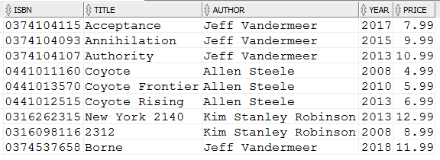
LIBRARY:
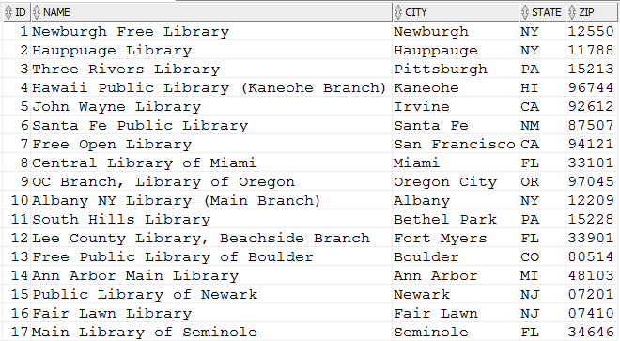
BOOKORDER:
