1. Program Overview
- Program Name: CentralTestTPL
- Version: 1
- Developer: Randel Santillan
- Purpose / Description:
For transferring test programs and for autofilling details.

2. System Requirements
- Operating System: XP – Windows 11
- Frameworks: 4.0
3. Installation Instructions
- Download / Source Location: Github
- Installation Steps:
  - Step 1. Create folder in Drive c: (C:\ITfolder\TPL\)
  - Step 2. Place the TPL program, Hotkeys for autofill and DatalogsAutotransfer in that folder.
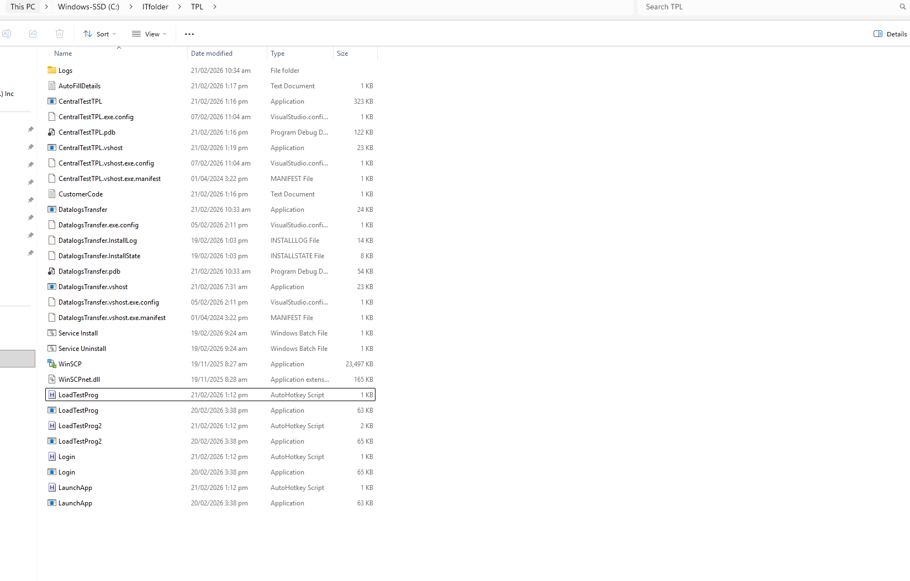
Step 3. Create a Scheduled Task and name it StartTPL.
Step 4. Create a Basic Task to run TPL. It will trigger automatically after the datalogs are transferred.
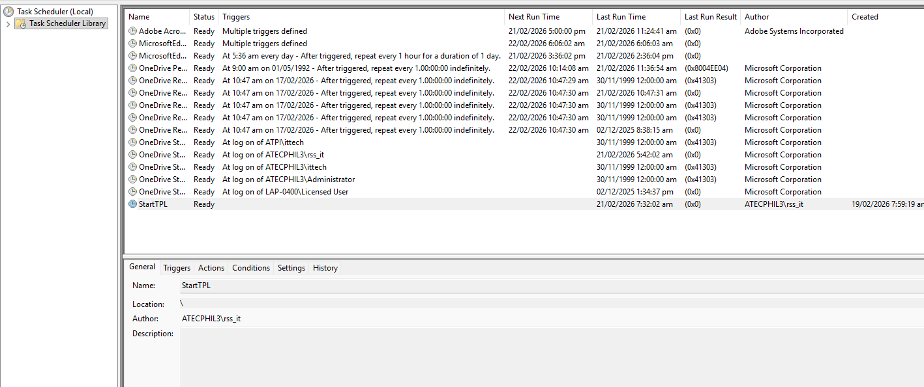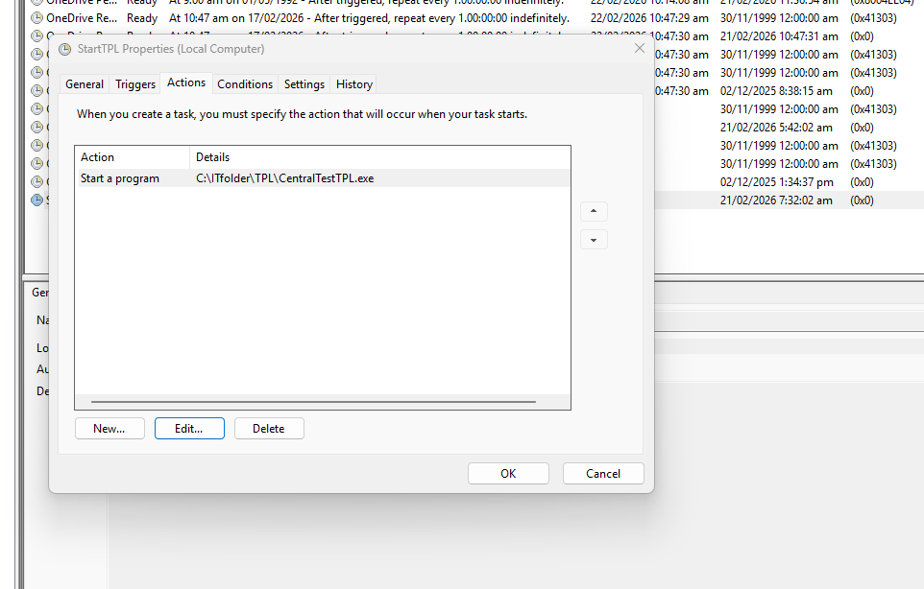
Step 5. Install DatalogAutoTranfer. Use batch file.
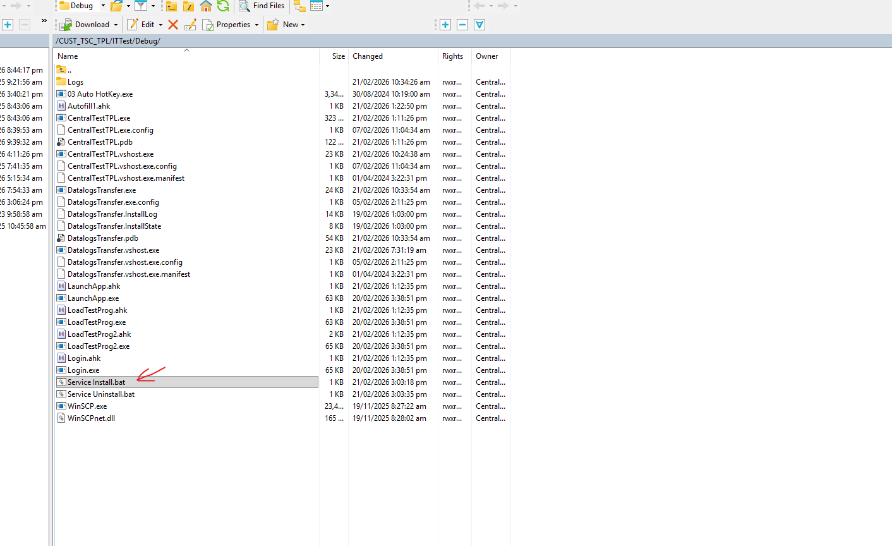
Step 6. Open services and find “DatalogsTransfer” then open properties.
Step 7. [General tab] Change Startup type – Automatic, [Log On tab] Check Allow service to interact with desktop, [Recovery tab] Chage first,second and subsequent failure to Restart the service then then go back to general tab to start the service then click apply then OK.

